while you’re visiting, bookmark our online store so you can check back later and see what’s new! keep up with the latest by signing up for our monthly newsletter.

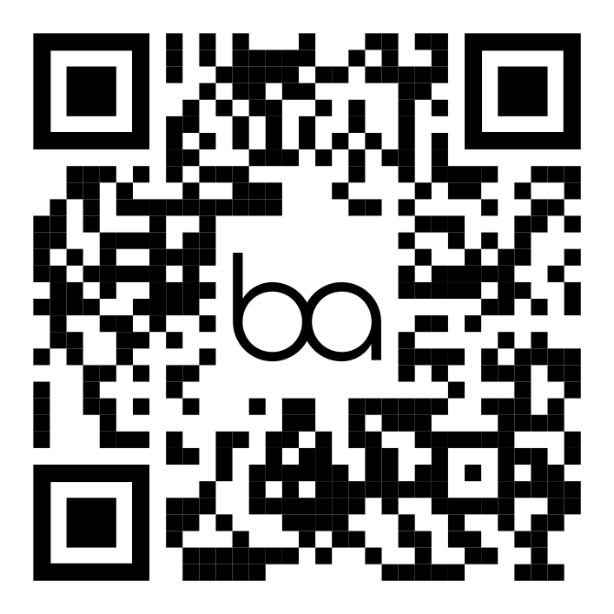
https://www.bonairquiltco.com

scan the codes below to see us on your favorite social channels. add us on instagram, facebook, pinterest, and twitter!

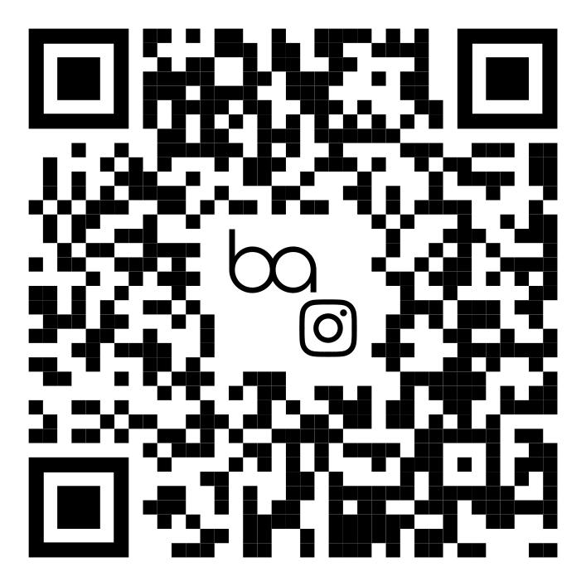 | 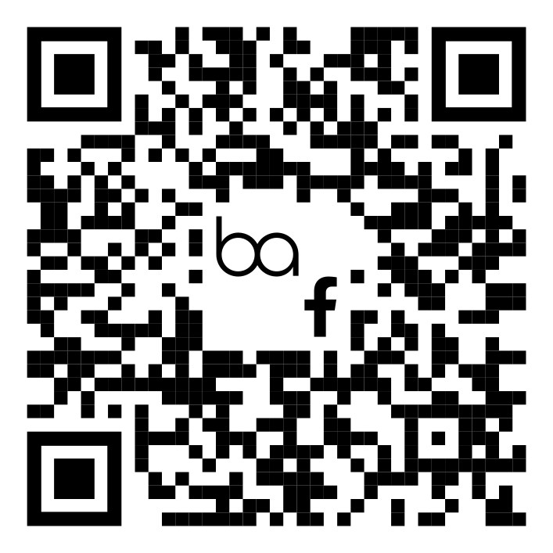
@BonAirQuiltCo on Instagram | @BonAirQuiltCo on Facebook
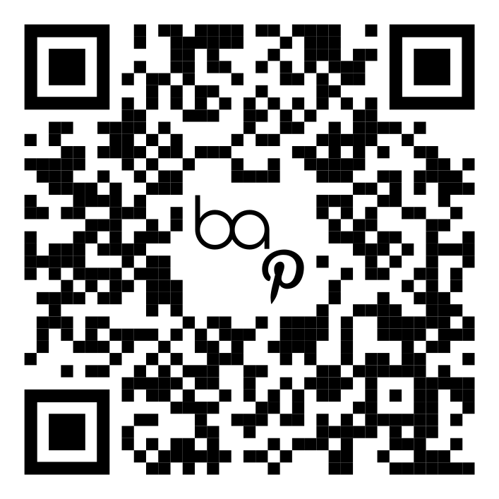 | 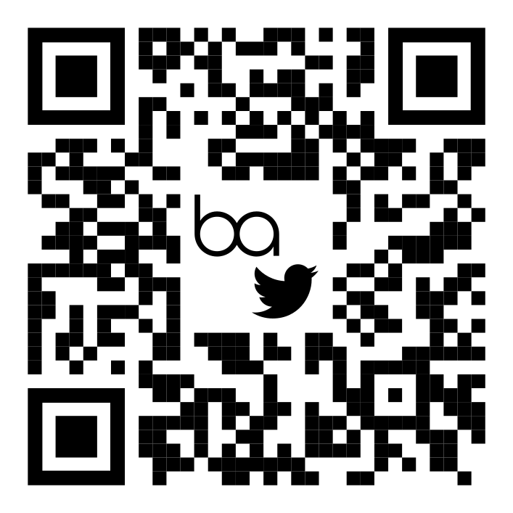
@BonAirQuiltCo on Pinterest | @BonAirQuiltCo on Twitter

