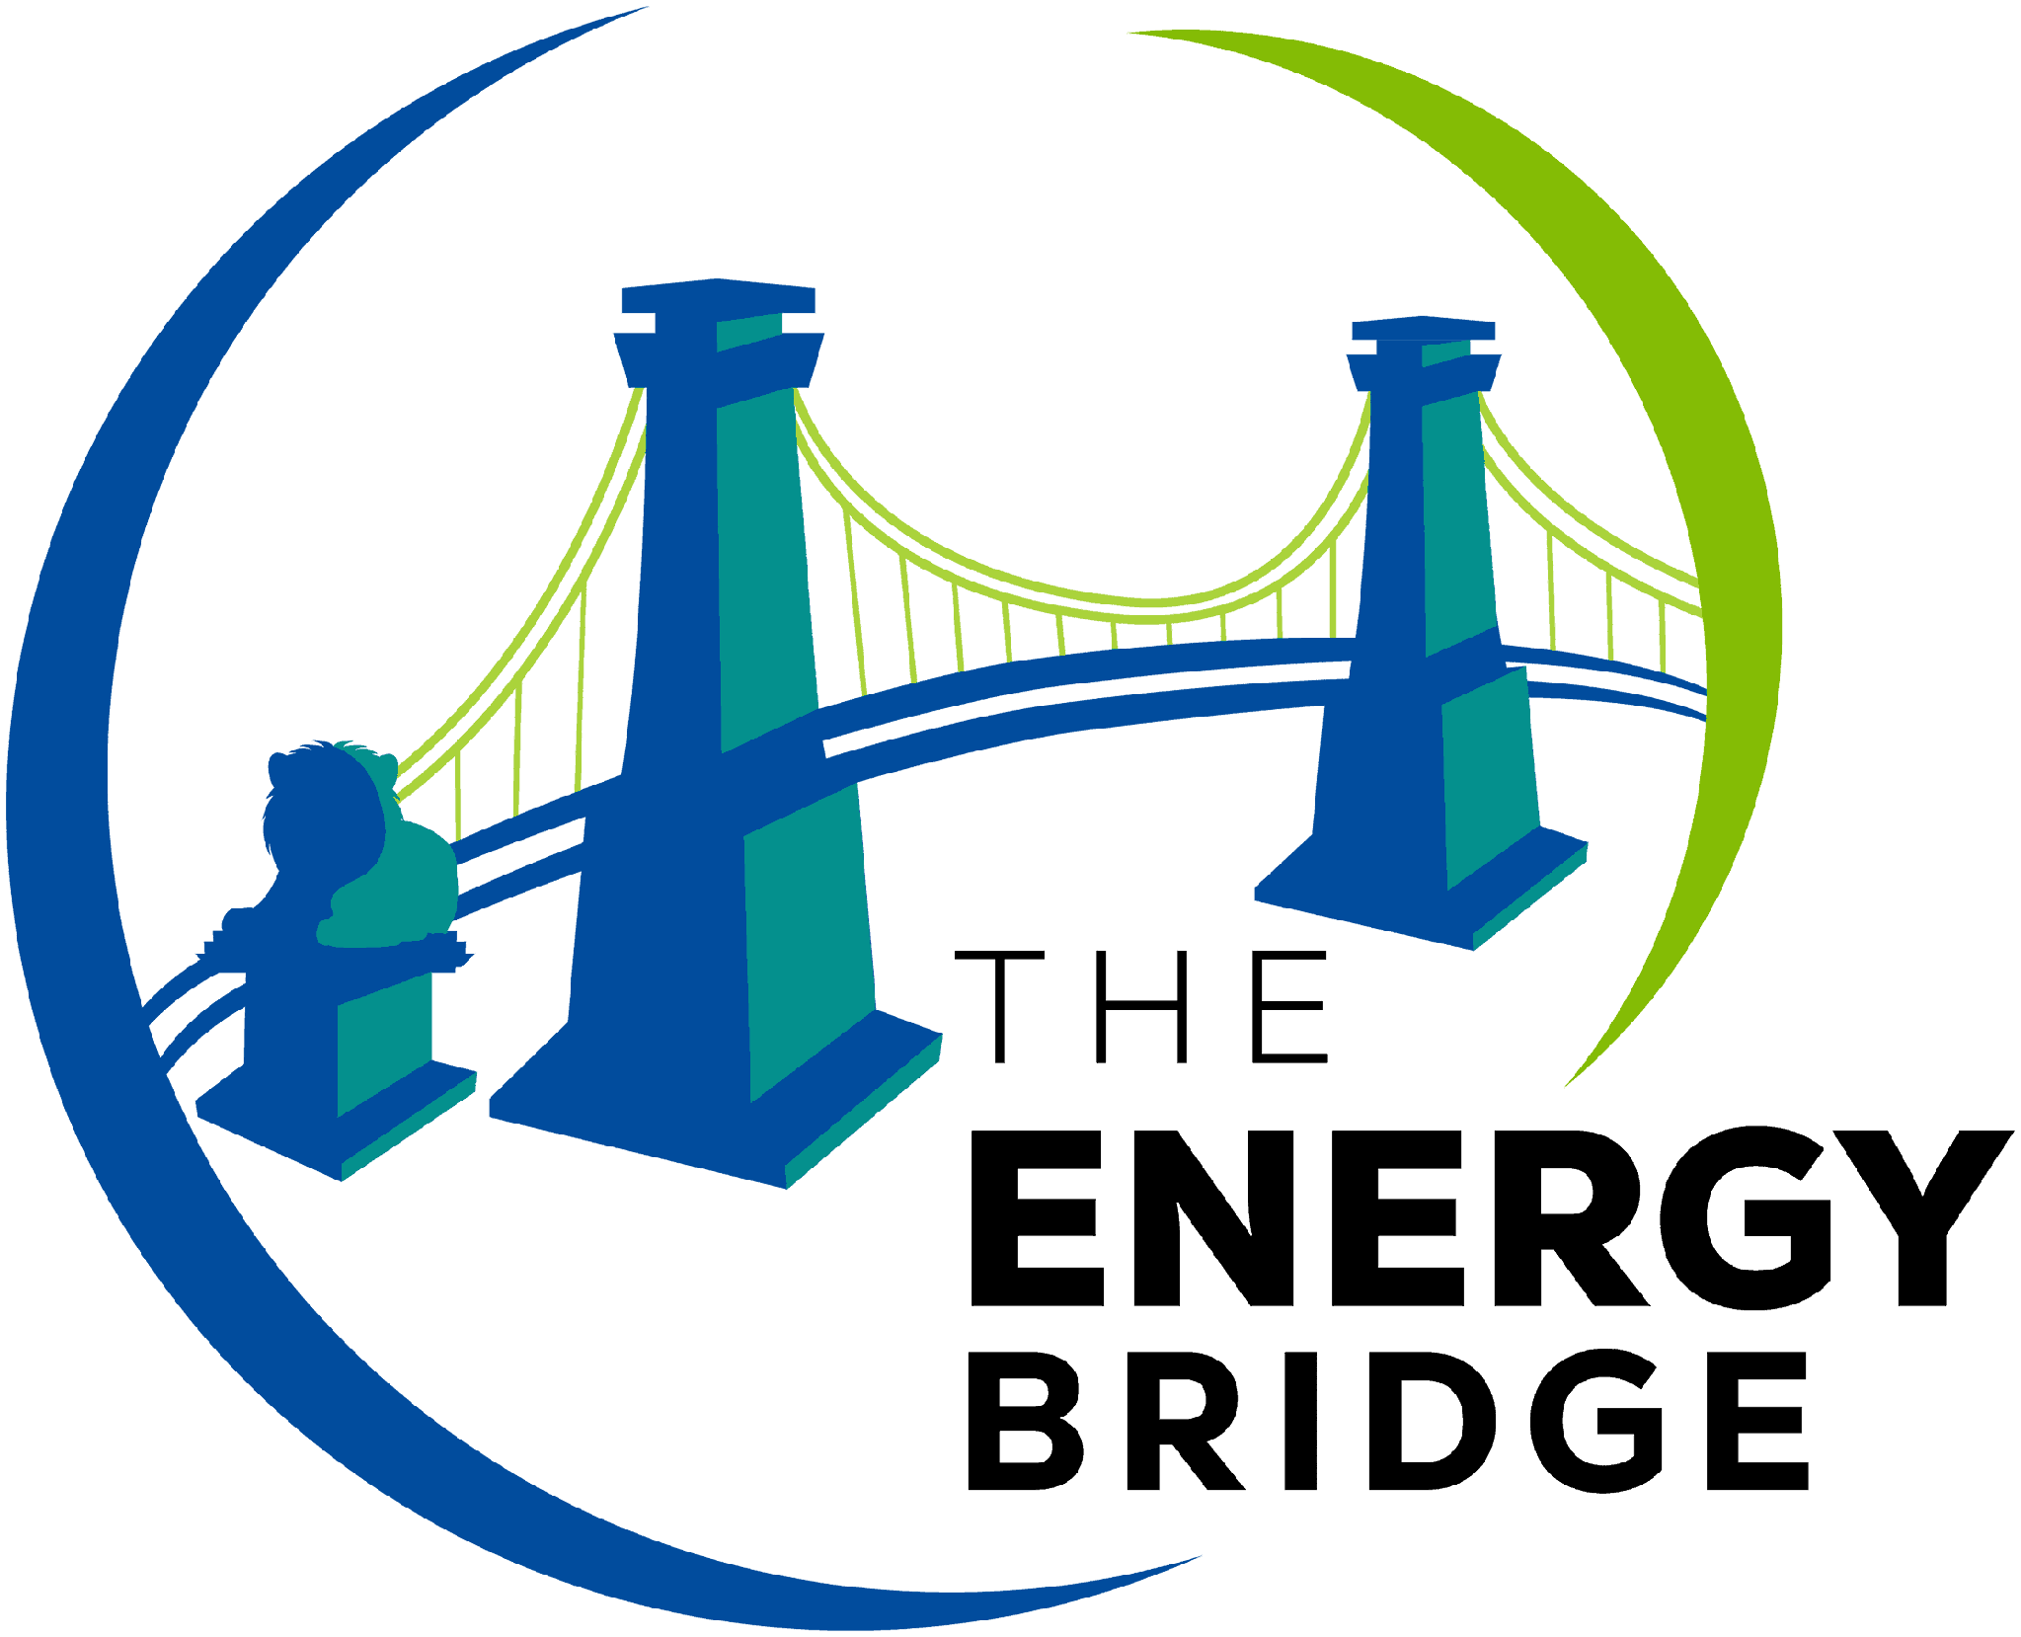
TEB AI HACKATHON
CRITICAL INFRASTRUCTURE & ENERGY SECURITY
Submission Reference
How submissions look at the TEB AI Hackathon — for participants, challenge partners and the jury

What this document is
This is a reference for what a hackathon submission looks like at the TEB AI Hackathon. Teams submit through the TEB submission form at [submission link], where they enter all of this in a structured form that mirrors this document.
We’re sharing this in two contexts: first, so challenge partners and jury members can see the structure and depth of what they’ll be reviewing. Second, so participants can preview what they’ll need to have ready by the submission deadline.
Submission deadline: Sunday, 25 October 2026, 11:30 sharp. Anything not submitted by that point won’t count toward judging. Demo Day and pitches start at 12:00.

1. Project basics
Project title
A name. Short, memorable, ideally a noun.
[Your project name]
One-line pitch
What you built, in one sentence. Imagine telling a stranger in an elevator. If a judge only reads this line, they should know what your project does.
[One sentence describing what your project does]

2. Team
Team name
[Your team name]
Team members
Full names + organisation or university + GitHub handle (if you have one) + role on the team. Order matters — list whoever wants to be the primary contact first. Add lines as needed.
[Name 1 — organisation — @githubhandle1 — role on team]
[Name 2 — organisation — @githubhandle2 — role on team]
[Name 3 — organisation — @githubhandle3 — role on team]
[Name 4 — organisation — @githubhandle4 — role on team]
Primary contact email
[Email address]

3. Challenge track
Track

Challenge prompt (if your track had more than one)
[Name of the prompt you worked on — or skip]

4. What you built

Problem you solved
How you read the challenge. The problem in your own words — which part of the energy system is at risk and who is affected. Judges want to see you understood the brief, not just rebuilt it.
[2–3 sentences on the problem you focused on]
Solution overview
What you built and how it works. Walk through the user flow. Skip implementation details unless they’re the interesting part.
[1 paragraph describing your solution]
How AI is used
What the AI actually does in your solution — detection, prediction, triage, response, planning — which models or tools you used, and where a human stays in the loop. Be specific about what’s real and what’s mocked.
[2–3 sentences on the role of AI]
Security and resilience
The threat or failure you designed for, what you assumed about the attacker or the disruption, and how your solution detects, contains or recovers. If you didn’t model a threat, say so. 5GDHC teams: describe the main risks to your business case instead.
[2–3 sentences on the threat and your response]
Data and environments
What data, simulators or test environments you used — synthetic, public, or provided by a challenge partner. Confirm that nothing was tested against live infrastructure, the venue network or other teams’ systems.
[Data / simulator used — and your confirmation]
Tech stack
Languages, frameworks, APIs, models. List the actual stuff that’s in the repo, not what you wish was there.
[Frontend / Backend / AI / APIs / Other]

5. Links
Code repository
A link to your code. Public, or shared with the TEB organisers and the jury.
[https://github.com/your-team/your-project]
Demo link
A live URL judges can click and try, or a video walkthrough of up to 5 minutes. Working demo > polished slides.
[Live URL or demo video link]
Documentation
A README in your repo is enough if it covers: how to run locally, what the architecture looks like, what’s working vs. what’s mocked.
[Link to README or doc page]
Pitch deck (optional)
If you have slides for Demo Day, link them here so the jury can open everything from one place. If your demo is the pitch, skip this.
[Link to slides — or skip]
Other links (optional)
Anything else you want the jury to see. Architecture diagram, threat model, Loom walkthrough, Figma file, business model canvas.
[Other relevant links]

6. Notes for the jury
Optional. Anything you want the jury to know that isn’t obvious from the demo. Honest call-outs land well: “the SCADA feed is simulated” or “we ran out of time on the alerting dashboard” is more credible than pretending it’s all production-ready.
[Anything you want the jury to know — or skip if nothing]

7. Follow-up (optional)
Tick what applies. None of this affects judging.
☐ We’d like an invitation to TEB Klub, TEB’s community platform.
☐ TEB and the challenge partners may contact our primary contact about our project.
☐ TEB may share our project title, description and event photos on its channels.

By submitting, the team confirms: the work in the linked repository was built during the hacking window (from the start of hacking on Friday 23 October to the submission deadline on Sunday 25 October), with the standard exceptions for libraries, frameworks and pre-existing tools; no live infrastructure or third-party systems were tested; and the team has read and accepts the TEB AI Hackathon rules, including the terms on intellectual property.

