**Inductor and Amplifier Current Measurement Testing**

July 28, 2014

**Experimental Setup:**

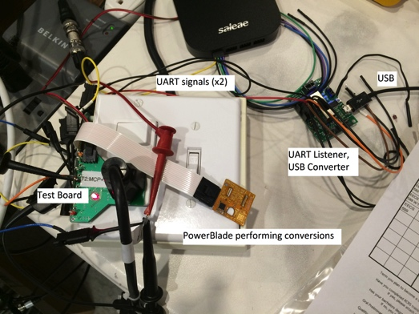For these tests, I connected ISENSE from one of three test boards (seen at the left) to the MSP430 for measurement. The MSP430 then reports its measurements over UART, intended for the BLE radio. The PowerBlade used in this test has no radio, so that signal is interpreted by a UART-to-USB converter and read by a laptop.

For each wattage reading I took 100 MSP430 reported samples, and report the mean below. I also measure VRMS on the oscilloscope using a 100x high-impedance probe.

**Part 1: Amplifiers behave the same**

**Hypothesis Part 1:**

OPA333 and MAX4238 setups both exhibit linearity over the range of 100 W to 500 W, but the VRMS of the signal will level out at the same low value. This will cause the MSP430-reported value to also level out.

If true, the threshold violated by low wattages is not an amplifier voltage or current threshold.

**Results from Part 1:**

Full Range



Low Values Highlighted



**Conclusions from Part 1:**

Although the two amplifiers have very different parameters, VRMS does levels out at a similar value for both. Thus, the parameters of the amplifiers are not having an effect on the signal.

**Part 2: MSP430 is the Culprit**

**Hypothesis Part 2:**

The ideal (function generated) signal will exhibit the same linearity over the same range, but, as a generated signal, the VRMS will not level out below 100 W. Instead, the VRMS will continue to decrease but the MSP430-reported value will still level out.

If true, the MSP430 cannot measure low wattages *in addition* to the results from H1, which, if true, indicate an inability on the hardware side to measure low wattages as well.

**Results from Part 1:**

Full Range



Low Values Highlighted



**Conclusions from Part 2:**

As expected, the MSP430-reported value from the ideal signal matches that from the amplifiers over the linear range. Also as expected, the VRMS of the ideal signal continues decreasing even when the amplifiers level off.

However, the MSP430-reported value continues decreasing past the point where the amplifiers level off. There will be a minimum measure-able wattage in the MSP430, but it is significantly lower than the minimum measure-able wattage from the amplifiers.

**Combined Conclusions from Parts 1 and 2:**

These experiments combined showed that the threshold that is being violated is neither in the amplifiers nor in the MSP430. This points our effort once again toward the inductor.