Foundations of Artificial Intelligence and Logic
Exercise 1

a.
To solve the “Traveling Salesman Problem” (TSP) within 1 second for 1000 different nodes, the Local Search method should be used. This is because there are too many possible permutation in the TSP, therefore a Uniformed Search approach would take way longer than 1 second. Local Search is able to find a good solution within this time.

b.

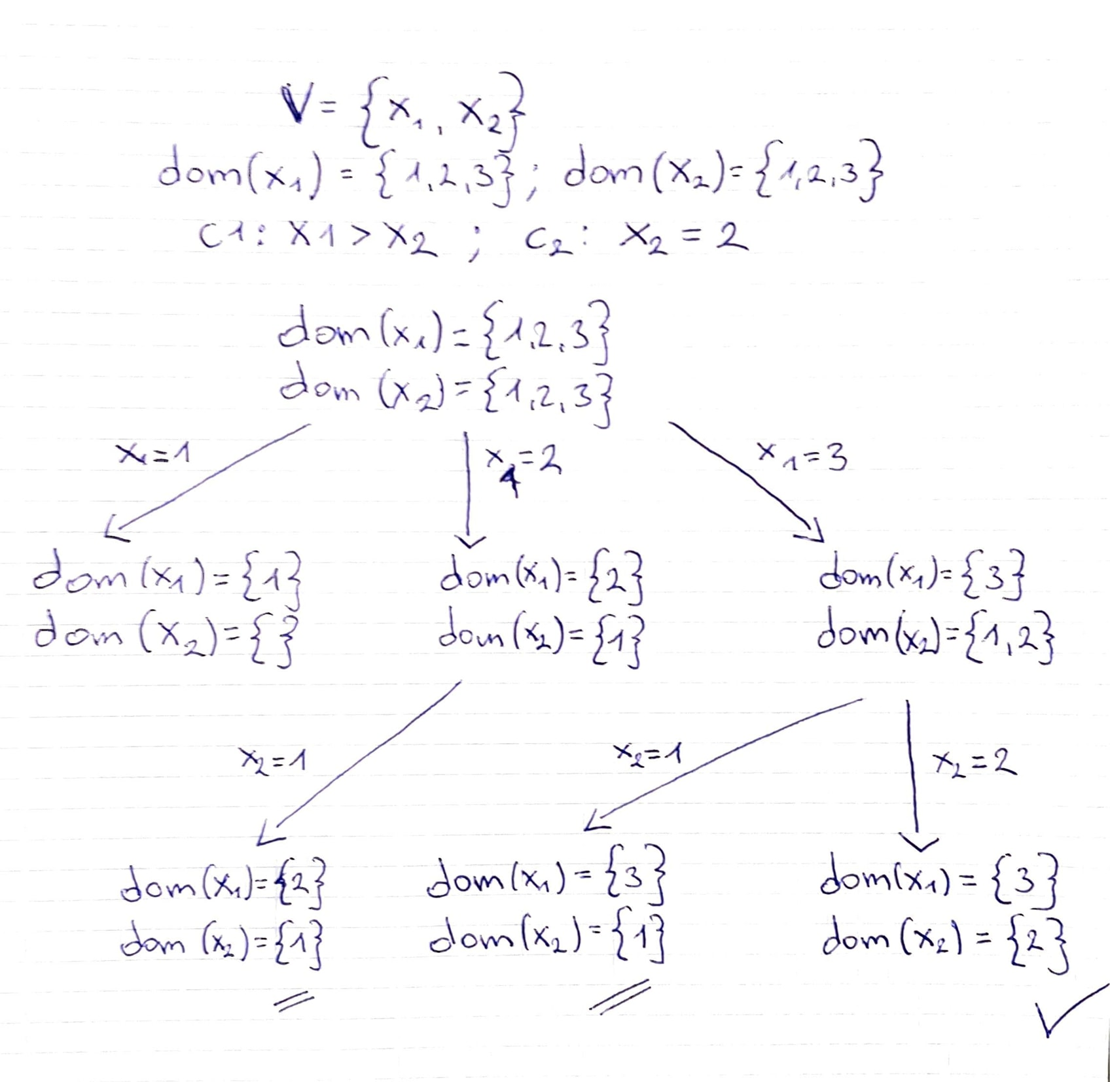

c.
% Task c.
var 0..1: type_city;
var 0..1: type_limo;
var 0..1: type_combi;
var 0..1: type_xdrive;
var 0..1: fuel_41;
var 0..1: fuel_61;
var 0..1: fuel_101;
var 0..1: skibag;
var 0..1: four_wheel;
var 0..1: pdc;
% exactly one type has to be true
constraint type_city + type_limo + type_combi + type_xdrive = 1;
% exactly one fuel type has to be true
constraint fuel_41 + fuel_61 + fuel_101 = 1;
%c1
constraint four_wheel = 1 -> type_xdrive = 1;
%c2
constraint skibag = 1 -> type_city = 0;
%c3
constraint fuel_41 = 1 -> type_city = 1;
%c4
constraint fuel_61 = 1 -> type_xdrive = 0;
%c5
constraint type_city = 1 -> fuel_101 = 0;

