Foundations of Artificial Intelligence and Logic
Exercise 1 - Group BG

a.
To solve the “Traveling Salesman Problem” (TSP) within 1 second for 1000 different nodes, the Local Search method should be used. This is because there are too many possible permutations in the TSP, therefore a Uniformed Search approach would take way longer than 1 second. Local Search is able to find a good solution within this time.

b.

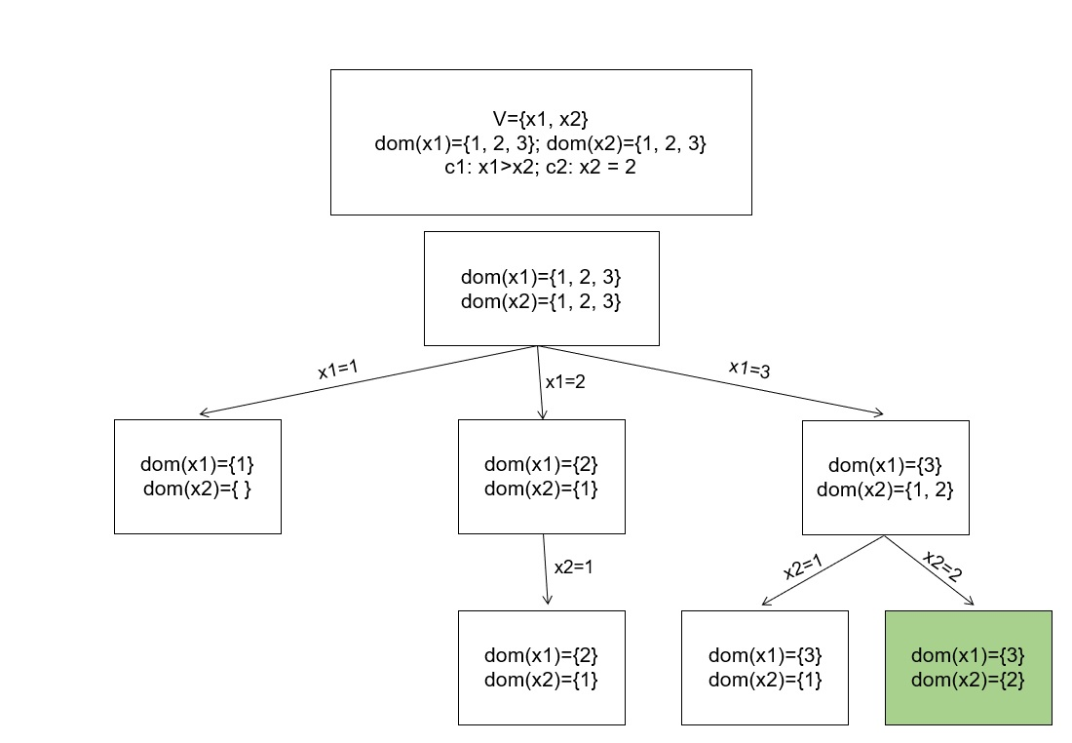

c.
% Task c.
var 0..1: type_city;
var 0..1: type_limo;
var 0..1: type_combi;
var 0..1: type_xdrive;
var 0..1: fuel_4;
var 0..1: fuel_6;
var 0..1: fuel_10;
var 0..1: skibag;
var 0..1: four_wheel;
var 0..1: pdc;

% exactly one type has to be true
constraint type_city + type_limo + type_combi + type_xdrive = 1;

% exactly one fuel type has to be true
constraint fuel_4 + fuel_6 + fuel_10 = 1;

%CKB

%c1
constraint four_wheel = 1 -> type_xdrive = 1;
%c2
constraint skibag = 1 -> type_city = 0;
%c3
constraint fuel_4 = 1 -> type_city = 1;
%c4
constraint fuel_6 = 1 -> type_xdrive = 0;
%c5
constraint type_city = 1 -> fuel_10 = 0;

%CR

constraint four_wheel = 1;
constraint fuel_6 = 1;
constraint type_city = 1;
constraint skibag = 1;
constraint pdc = 1;

solve satisfy;

Output :
WARNING: model inconsistency detected
=====UNSATISFIABLE=====
Finished in 95msec
d.
include "globals.mzn";
int: n = 10;
array[1..n] of var 1..n: connection_point;
constraint all_different(connection_point);
constraint connection_point[1] = 2;
constraint forall(i, j in connection_point where connection_point[i] = 3 /\ connection_point[j] = 5) (connection_point[j] = connection_point[i+1]);

e.
import numpy as np
from geneticalgorithm import geneticalgorithm

# variables[0] type_city;
# variables[1] type_limo;
# variables[2] type_combi;
# variables[3] type_xdrive;

# variables[4] fuel_4;
# variables[5] fuel_6;
# variables[6] fuel_10;

# variables[7] skibag;
# variables[8] four_wheel;
# variables[9] pdc;
def f(variables):
constraints = np.array([False] * 7)

# exactly one type has to be true
constraints[0] = (variables[0] + variables[1] + variables[2] + variables[3] == 1)

# exactly one fuel type has to be true
constraints[1] = (variables[4] + variables[5] + variables[6] == 1)

# %c1
# constraint four_wheel = 1 -> type_xdrive = 1; implication is equivalent to: not(A) or B <==> A -> B
constraints[2] = (not(variables[8]) or variables[3])

# %c2
# constraint skibag = 1 -> type_city = 0;
constraints[3] = (not(variables[7]) or not(variables[0]))

# %c3
# constraint fuel_4 = 1 -> type_city = 1;
constraints[4] = (not(variables[4]) or (variables[0]))

# %c4
# constraint fuel_6 = 1 -> type_xdrive = 0;
constraints[5] = (not(variables[5]) or not(variables[3]))

# %c5
# constraint type_city = 1 -> fuel_10 = 0;
constraints[6] = (not(variables[0]) or not(variables[6]))

return -np.sum(constraints)

task_e_model=geneticalgorithm(function=f,dimension=10,variable_type='bool')
variables = task_e_model.run()

print(task_e_model.best_variable[0], "type_city\n",
task_e_model.best_variable[1], "type_limo\n",
task_e_model.best_variable[2], "type_combi\n",
task_e_model.best_variable[3], "type_xdrive\n",
task_e_model.best_variable[4], "fuel_4\n",
task_e_model.best_variable[5], "fuel_6\n",
task_e_model.best_variable[6], "fuel_10\n",
task_e_model.best_variable[7], "skibag\n",
task_e_model.best_variable[8], "four_wheel\n",
task_e_model.best_variable[9], "pdc")

