David Bunker
Midterm Report

Algorithm:
Using are assignment from homework two, we take the split the individual words into a
separate rdd then do the same with the characters. Using the expected frequencies of letters
in the English language and the character with the highest amount of occurrences we guess
the shift key used in the cipher text. With that key shift the cipher text that amount and
and English word should be found.

Questions:
1) The lambda functions used check the each line contains a string. Each string will be
split into the individual words, and then reduced by key to simplify the amount of data.
With each word split them into characters, map and reduce them into each letter and how many times they occur.

2)The intermediate results can be found in the directories labeled as initial.

Screenshots:
MidTerm Directory
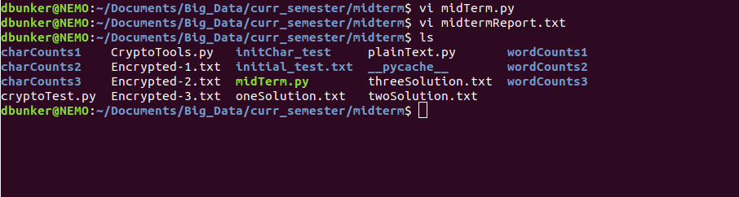
Sample of the plain text

Running of the midterm.py file
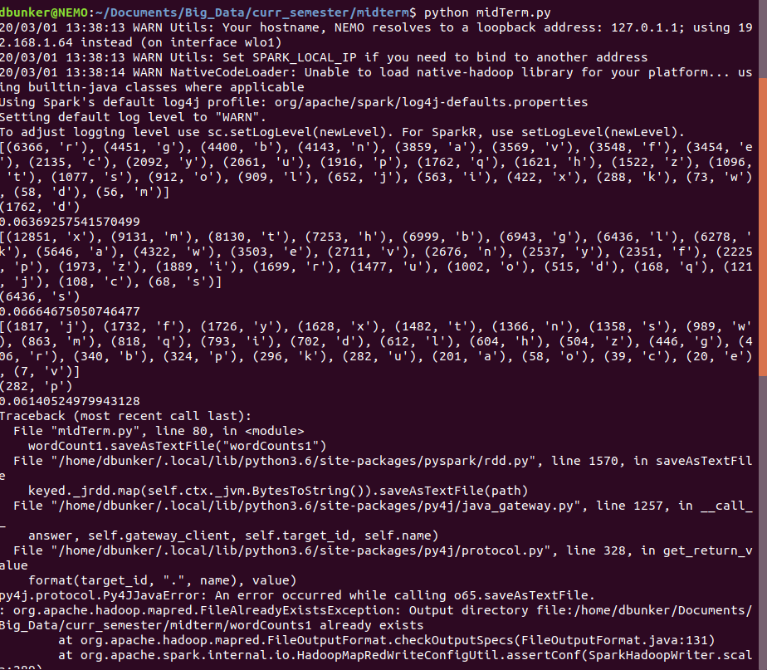
Conclusion:
Unless I royally F’d up the decryption, the files should display an accurate plain text based on the cipher text. Therefor, yes my implementation should give the exact Caesar cipher values.

