ABSTRACT:

**Aim:**

Beta diversity quantifies the similarity of ecological assemblages. Its increase, known as biotic homogenization, can be a consequence of biological invasions. However, species occurrence- (presence/absence) and abundance-based analyses can produce contradictory assessments of the magnitude and direction of changes in beta diversity. Previous work indicates these contradictions should be less frequent in nature than in theory, but a growing number of empirical studies report discrepancies between occurrence- and abundance-based approaches. Understanding if these discrepancies represent a few isolated cases or are systematic across a diversity of ecosystems would allow us to better understand the general patterns, mechanisms, and impacts of biotic homogenization.

**Location:** United States.

**Time period:** 1963-2020.

**Major taxa studied:** Vascular plants.

**Methods:** We used a dataset of more than 70,000 vegetation survey plots to assess differences in biotic homogenization with and without invasion using both occurrence- and abundance-based metrics of beta diversity. We estimated taxonomic biotic homogenization by comparing beta diversity of invaded and uninvaded plots with both classes of metrics, and investigated the characteristics of the non-native species pool that influenced the likelihood these metrics disagree.

**Results:**

In 78% of plot comparisons, occurrence- and abundance-based calculations agreed in direction, and the two metrics were generally well-correlated. Our empirical results are consistent with previous theory. Discrepancies between the metrics were more likely when the same non-native species was at high cover at both plots compared for beta diversity, and when these plots were spatially distant.

**Main conclusions:**

In about 20% of cases, our calculations revealed differences in direction (homogenization vs. differentiation) when comparing occurrence- and abundance-based metrics, indicating that the metrics are not interchangeable, especially when distances between plots are high and invader diversity is low. When data permit, combining the two approaches can offer insights into the role of invasions and extirpations in driving biotic homogenization/differentiation.

**KEYWORDS:** beta diversity, biodiversity, biological invasions, biotic homogenization, Hill numbers, invasive plant species, space-for-time.

INTRODUCTION:

Anthropogenic global change is reshaping species distributions and interactions, prompting ongoing biodiversity loss [(Vitousek *et al.*, 1997; Pecl *et al.*, 2017)](https://www.zotero.org/google-docs/?AELRtp). The impacts of global change are often characterized by changes in the compositional similarity of ecological units (e.g., plots, sites, communities) as some species increase in their distribution and abundance whereas others decline or shift [(Dornelas *et al.*, 2019)](https://www.zotero.org/google-docs/?ioT5gn). A particular concern is that distinct ecological communities are becoming increasingly similar. There is evidence that this "biotic homogenization" is occurring globally and can have adverse effects on ecosystem structure and function [(Olden & Rooney, 2006; Hautier *et al.*, 2018; Daru *et al.*, 2021)](https://www.zotero.org/google-docs/?EAFcjV).

Biotic homogenization can be quantified by beta diversity metrics (i.e., the compositional similarity of ecological communities across the landscape). Though natural ecological processes can alter beta diversity, several global change drivers including biological invasions [(Winter *et al.*, 2009; Petsch, 2016)](https://www.zotero.org/google-docs/?uGosds), urbanization [(Liu *et al.*, 2022)](https://www.zotero.org/google-docs/?GwH8MJ), and climate change [(Magurran *et al.*, 2015)](https://www.zotero.org/google-docs/?MA44pK) have been identified as major agents of biotic homogenization. However, changing ecological conditions can also result in “biotic differentiation” when similarity among ecological units decreases, for example, due to the colonization of different species at different sites, or increased landscape heterogeneity after disturbance [(McKinney, 2008; Blowes *et al.*, 2024)](https://www.zotero.org/google-docs/?XwxSf4). Therefore, accurately quantifying changes in beta diversity is important for predicting global change impacts and quantifying biodiversity loss. Many metrics have been developed to quantify beta diversity (refer to, [Barwell *et al.* 2015; Koleff *et al.* 2003)](https://www.zotero.org/google-docs/?pfbCaW), and can be generally categorized according to whether they are based on occurrence or abundance data [(Anderson *et al.*, 2011)](https://www.zotero.org/google-docs/?OhPsAL).

Occurrence-based metrics are effective indicators of the addition or removal of species from a community. Therefore, they are useful in describing processes of extinction and colonization in meta-communities [(Branco *et al.*, 2020)](https://www.zotero.org/google-docs/?chfdB3), though they may be biased by imperfect detection of species [(Beck *et al.*, 2013)](https://www.zotero.org/google-docs/?xDqxH8). Abundance-based metrics account for the relative rarity of species in their calculation of beta diversity. Abundance-based metrics also account for gains and losses of species but are less responsive to the turnover of rare species. They are, however, sensitive to changes in abundance of the most common species, making them useful when shifts in species dominance are linked to relevant ecosystem functions [(Barwell *et al.*, 2015)](https://www.zotero.org/google-docs/?TmX369). Species abundance is more difficult to measure than occurrence (which is based on presence-absence), so abundance data are less frequently available than species occurrence data, and therefore abundance-based measures of beta diversity are less commonly available [(Pearce & Boyce 2006; Yin & He 2014)](https://www.zotero.org/google-docs/?bRqNMc) .

Although both occurrence- and abundance-based approaches have been used to characterize beta diversity, they can result in very different estimations even when applied to the same ecological units, leading to conflicting conclusions about patterns in biodiversity. An extreme example of this would be a comparison of two plots that contain the same number of individuals and the same number of species but at different levels of abundance between species. Although occurrence-based metrics of beta diversity would quantify the similarity of these two plots as an index value of 1 (100 % similar), abundance metrics would quantify them as substantially less similar (Figure 1). To get a clear and accurate picture of the extent to which biotic homogenization is occurring, we must first understand how frequently occurrence- and abundance-based calculations provide complementary or conflicting inference on patterns in beta diversity.

**How frequently do abundance and occurrence metrics disagree?**

A foundational study by Cassey et al. (2008) used a simulation-based approach to assess the coherence between occurrence- and abundance-based calculations of biotic homogenization/differentiation and detailed the ecological conditions under which these two kinds of metrics are most likely to diverge. Their study found general agreement between occurrence- and abundance-based calculation of biotic homogenization, but in approximately a quarter of the cases, one metric indicated homogenization and the other differentiation (Table 1).

Cassey et al. (2008) suggested that the frequency of disagreement between the metrics should be lower in nature than in theory, but empirical studies that assess biotic homogenization/differentiation among communities simultaneously with both occurrence- and abundance-based calculations of beta diversity provide mixed results. One study in National Parks of the United States showed consistent estimation by occurrence- and abundance-based metrics [(McKinney & Lockwood, 2005)](https://www.zotero.org/google-docs/?uGZYsC) and indicated these metrics can be considered relatively interchangeable [(Olden & Rooney, 2006)](https://www.zotero.org/google-docs/?JA28uH). However, several recent studies report conflicting trends between occurrence- and abundance-based metrics of beta diversity [(La Sorte & McKinney, 2007; Yang *et al.*, 2015; Price *et al.*, 2018; Taylor *et al.*, 2019; Petersen *et al.*, 2021; Liu *et al.*, 2022)](https://www.zotero.org/google-docs/?UhfbBv). Importantly, there is no consistent pattern to these discrepancies. For example, [Taylor *et al.* (2019](https://www.zotero.org/google-docs/?Cfhn6F)) investigated changes in beta diversity of fish assemblages in several river basins with both categories of metrics, and found that in some cases occurrence-based metrics indicated homogenization and abundance-based metrics indicated differentiation, but in other cases the opposite patterns were observed. Moreover, several studies have found that changes in beta diversity were larger when calculated with abundance-based metrics (e.g., [La Sorte & McKinney 2007](https://www.zotero.org/google-docs/?Vj4cyO), [Price *et al.* 2018](https://www.zotero.org/google-docs/?Pyn5ZX)), whereas other studies report a contrasting pattern with greater changes in beta diversity with occurrence-based metrics (e.g., [Liu *et al.* 2022](https://www.zotero.org/google-docs/?ldmJrf)).

Because these comparisons have been restricted to relatively small, localized systems, large-scale, empirical comparisons across a range of environments and ecoregions are lacking. As such, it is difficult to assess whether conflicts in occurrence- vs. abundance-based measures of beta diversity are a rare peculiarity of a few ecological systems, or a general feature of measuring biotic homogenization and a consistent challenge for interpreting global change effects. In this study, we use a new database of plant botanical surveys in the United States, the Standardized Plant Community with Introduced Status database [(SPCIS; Petri *et al.*, 2023)](https://www.zotero.org/google-docs/?Lj1Kgi), to conduct a large-scale, cross-system, empirical synthesis of biotic homogenization due to plant invasions using occurrence- and abundance-based approaches. Across more than 20,000 plots and 800,000 pairwise comparisons, we assessed differences in beta diversity among invaded and paired uninvaded plots to test the predictions of Cassey *et al.,* (2008) about how often—and by how much— occurrence- and abundance-based metrics produce conflicting evidence about patterns of biotic homogenization/differentiation.

**What factors might increase the likelihood of disagreements?**

Directional shifts in homogenization should be consistent between occurrence- and abundance-based metrics when widespread species (those likely to occur across multiple locations) are also generally abundant, and rare species (those less likely to occur at multiple locations) are less abundant [(Cassey *et al.*, 2008)](https://www.zotero.org/google-docs/?ecTxlj), which is a fundamental prediction of occupancy-abundance relationships [(Brown, 1984; Fristoe *et al.*, 2021)](https://www.zotero.org/google-docs/?tbndlL).

Factors that disrupt the macroecological relationship between occupancy and abundance, like disturbance, disease or biological invasions, are likely to increase discrepancies between occurrence- and abundance-based calculations of biotic homogenization [(Cassey *et al.*, 2008)](https://www.zotero.org/google-docs/?o6DuuW). We would expect the situation where occurrence-based metrics indicate differentiation and abundance-based metrics indicate homogenization when a small number of new species arrive at plots and become abundant and when multiple species with low abundance are lost. In the context of plant invasion, the arrival of a new abundant species has a proportionately lower effect on plot richness (i.e., occurrence) compared to dominance (i.e., abundance) and the loss of multiple, low abundance species has a proportionately higher effect on plot richness compared to dominance. We predict (1) the likelihood of this scenario to increase when a single non-native species colonizes both locations and reaches high abundance. We also predict (2) this likelihood to increase with distance between the invaded plots, as the widely observed pattern of distance decay in similarity of communities [(i.e., similarity decreases with increasing distance between ecological units, Morlon *et al.*, 2008)](https://www.zotero.org/google-docs/?UxLEoJ) would make it more likely that plots that are occupied by the same non-native species would differ in the identities of the rare species that are present.

We would expect the situation where occurrence-based metrics indicate homogenization and abundance-based metrics indicate differentiation when few new species arrive at plots at low abundance and few species are lost from plots. In the context of plant invasions, we predict (3) the likelihood of this scenario to increase when the same invader colonizes both plots at low contrasting levels of abundance, and the (4) spatial distance between plots is small (i.e., turnover among native species is low, but their population abundances are more stochastic).

While we use the full SPCIS dataset to compare the frequency with which occurrence- and abundance-based metrics diverge in their predictions of biotic homogenization, we use a subset of the SPCIS dataset to test these specific predictions and identify the biological signatures that are associated with discrepancies between occurrence- and abundance-based calculations of biotic homogenization/differentiation. Using a subset allowed us to isolate potential mechanisms that drive changes in beta diversity in a computationally tractable way. We focus on patterns of cheatgrass invasion (*Bromus tectorum*) in the North American Deserts, representing a case study of the most common non-native species in the dataset and the most well-sampled region.

Both of these analyses focus on differences in beta diversity associated with plant invasions at the taxonomic species level. Our comparisons between occurrence- vs. abundance-based calculations assess general relationship between occurrence-and abundance-based calculations of beta diversity, making our findings applicable to other aspects of beta diversity (e.g. phylogenetic, functional or genetic beta diversity), in other study systems (e.g. aquatic, mammalian, etc.), or those investigating other drivers of biotic homogenization/differentiation (e.g. climate or land-use change) across local, regional and global scales which all use comparable mathematical approaches.

MATERIALS AND METHODS:

**Space-for-time approach**

Here, we compare beta diversity among plots that represent a control state (i.e., non-native plant species absent) and those that represent an altered state (i.e., relative cover of non-native species >5%). Although this dataset does not allow for tracking of beta diversity over time (Olden & Rooney 2006) and is best suited to evaluate changes in beta diversity due to species gains rather than losses, a recent meta-analysis of biotic homogenization studies indicated that these kinds of space-for-time analyses are relatively conservative, often yielding less extreme changes in beta-diversity than change over time approaches [(Petsch *et al.*, 2022)](https://www.zotero.org/google-docs/?xn5s4P). Thus, in this study, we employ this space-for-time approach as a conservative estimate of what we would expect over time with invasions [(Lovell *et al.*, 2023)](https://www.zotero.org/google-docs/?55VmyG), comparing patterns of beta diversity between vegetation survey plots with only native species present and plots that have been invaded by non-native taxa.

**Data preparation:**

We obtained plot data of plant species’ abundance and native status from the SPCIS database [(Petri *et al.*, 2023)](https://www.zotero.org/google-docs/?7BaUjV), a standardized dataset of vegetation surveys for the United States. For each plot in the dataset, we also obtained environmental data from the Invasive Species Habitat Tool (INHABIT; [Engelstad *et al.*, 2022)](https://www.zotero.org/google-docs/?ePZHCY), a web-based decision support tool for modeling invasive plant habitat suitability. For the few plots (2%) that had been surveyed multiple times across years, we subset the dataset to include only the most recent survey.

We matched plots that had 0% non-native species cover (hereafter: uninvaded plots) to corresponding plots that had >5% non-native species cover (hereafter: invaded plots). We matched plots within the U.S. Environmental Protection Agency’s Level IV Ecoregions which “denote areas within which ecosystems (and the type, quality, and quantity of environmental resources) are generally similar” [(Omernik & Griffith 2014](https://www.zotero.org/google-docs/?eY9sjl), the smallest scale ecoregion, of which there are 937 in the conterminous United States), and within original datasets to control for broad-scale spatial, environmental, and methodological differences that affect calculations of beta diversity.

Within these regions, we then matched plots based on five environmental variables that we found to be important predictors of species cover in a preliminary analysis: NDMI (Normalized Difference Moisture Index), total soil Nitrogen at 0.05m depth, minimum temperature of the coldest month (°C), % tree cover, and human modification index [(Theobald, 2013)](https://www.zotero.org/google-docs/?zwINsx). To identify these variables, we first asked whether the presence/absence and cover of 675 common natives was related to each of the INHABIT variables. Models used the linear and quadratic effect of each INHABIT variable individually. For presence/absence models, within each Level IV Ecoregion, we compared presences in that ecoregion against an equal number of absences randomly selected from then the same ecoregion and used level IV ecoregion as a random intercept. For each species, we used 70% of the data (‘training data’) to build models and asked how well each model predicted the remaining 30% of the data (‘semi-independent testing data’). We used binomial Generalized Linear Models (GLM) and selected most informative variables based primarily on the median Area Under the Curve (AUCs) of the fit to the testing dataset. We identified the linear effects of NDMI, % tree cover, total soil N at 0.05m depth, and human modification index as most important. Soil bulk density, pH, and organic carbon had similarly high AUCs to soil N, but were strongly collinear with soil N. Given the extent of the literature around nitrogen and invasion [(e.g., González *et al.*, 2010; Perry *et al.*, 2010)](https://www.zotero.org/google-docs/?EiqqJH), we selected soil N to use in our analyses.

For abundance data, we used beta regression with a logit link function in the

glmmTMB package [(Brooks *et al.*, 2017)](https://www.zotero.org/google-docs/?RdwWEY) and ran the model across all Level IV ecoregions and did not split the data into training subsets. We selected the most informative variables based on the median p-values and deviances explained in the entire dataset. This approach identified the minimum temperature of the coldest month (°C) as the most important. Precipitation between June-August explained slightly less deviance than minimum temperature. Precipitation effects on vegetation are similar to those detected via NDMI, which is directly sensed from the vegetation itself. For parsimony, we chose to use NDMI instead.

Only plots that had complete environmental data were included. We used propensity score matching, a technique for increasing causal inference from statistical models [(Ramsey *et al.*, 2019)](https://www.zotero.org/google-docs/?oEzoVr) to match uninvaded and invaded plots based on 1:1 nearest neighbor matching algorithm with the R package “matchit” [(Ho *et al.*, 2011)](https://www.zotero.org/google-docs/?bnnaNZ). This resulted in a dataset of 20,900 pairwise matches of invaded and uninvaded plots with highly similar environmental conditions (Figure S1) to maximize the likelihood that their composition differences reflected biotic processes rather than environmental filtering. We used these abiotic variables to match uninvaded and invaded plots as a proxy for habitat types rather than using other, common use vegetation classifications, which are defined by the plant communities themselves, to eliminate circularity in our analyses, which focus on plant communities as a response variable.

To assess whether our analyses were sensitive to our matching process, we repeated this procedure, this time matching each invaded plot to the geographically closest uninvaded plot of all plots located within 200 km instead of by environmental similarity. This resulted in 2,792 matched invaded and uninvaded plots (for 169,361 pairwise comparisons of occurrence- and abundance-based calculations of beta diversity). The median distance between paired invaded and uninvaded plots was 49.9 km (mean= 67.5, sd=71.4). This approach yielded comparable results to our environmentally matched plots (Table S1). Given this robustness of our analyses to differences in matching procedures, we proceeded with the environmentally matched plots in our main analyses with the distance-based results viewable in the Supporting Information (Table S1, Figure S2).

**Calculations of beta diversity and change:**

We calculated pairwise beta diversity among all the invaded plots, as well as all the uninvaded plots, within each original dataset in each Level IV ecoregion, based on Hill Numbers [(Chao *et al.*, 2014)](https://www.zotero.org/google-docs/?W4H6iV) using the R package “*hillR*” [(Li, 2018)](https://www.zotero.org/google-docs/?pYUajc). We use Hill numbers to compute abundance-weighted and occurrence-based beta diversity corresponding to two related, and widely used metrics: the Sørensen (occurrence-based) and the Classic Horn (abundance-weighted) index [(Chao *et al.*, 2014)](https://www.zotero.org/google-docs/?15pH8g) for 809,299 pairwise comparisons total. Both metrics range between 0-1 with 0 indicating complete dissimilarity and 1 indicating complete similarity between plots.

To assess differences in beta diversity among invaded and uninvaded plot combinations, our proxy for biotic homogenization, we adapted a homogenization index from [Qian & Guo (2010)](https://www.zotero.org/google-docs/?mSB3PB) where we subtracted the beta diversity estimate for a given native plot pair from the beta diversity of their corresponding invaded counterparts (Figure 1b). For every two uninvaded plots we compared, we used the uninvaded-invaded plot pairings to identify the corresponding two invaded plots found in similar environmental conditions. Our homogenization index compared the beta diversity between two uninvaded plots and two invaded plots while controlling for the magnitude of environmental differences with the formula:

H= 𝛃**invaded**(plotA/plotB) - 𝛃**uninvaded**(plota/plotb)

Where H, or the homogenization index, is the difference in beta diversity ranging from -1 to 1, between any pair of uninvaded (plota & plotb) and their environmentally corresponding pair of invaded (plotA & plotB) plots. Negative values of H indicate that the uninvaded plots are more similar to each other than their corresponding invaded plots are to each other (i.e., differentiation with invasion), whereas positive values of H indicate that uninvaded plots are less similar to each other than their corresponding invaded plots are to each other (i.e., homogenization with invasion).

We quantified the number of pairs that fell into each one of the graphical quadrants (Figure 1b): 1. Homogenizationabn| Homogenizationocc , 2. Homogenizationabn | Differentiationocc , 3. Differentiationabn | Differentiationocc , 4. Differentiationabn | Homogenizationocc, and calculated the mean absolute difference between the two metrics’ estimates.

We calculated the Pearson correlation coefficient and mean and standard deviation of the absolute differences between the occurrence- and abundance-based calculations of each pairwise plot combination. To better understand the frequency that metrics agreed in directionality of homogenization, we then divided the plot with the graphical quadrants in 0.1 x 0.1 grid cells and calculated the percentage of homogenization/differentiation estimates that occurred in each cell (refer to Figure 1c, 2).

We repeated this process for invaded and native plots that were matched based on spatial distance rather than environmental distance, which resulted in 2,952,267 pairwise comparisons of homogenization index estimates for the two indices.

**Identifying factors that affect discrepancies between occurrence- and abundance-based metrics**

To better understand how the distribution of invaders and properties of the ecological communities influence the discrepancies between occurrence- and abundance-based calculations of homogenization, we subset the full database to comparisons in the in the most well sampled Level I Ecoregion [(Omernik & Griffith 2014](https://www.zotero.org/google-docs/?eY9sjl), the largest scale ecoregion, of which there are 12 in the conterminous United States) that included only one non-native species at each plot (40% of invaded plot). We focused this analysis on the impacts of the most common non-native species in the dataset *Bromus tectorum.* For all pairwise comparisons of invaded plots, we assessed whether or not *B. tectorum* was present at both plots or only one in the pair. We did not include pairings where *B. tectorum* was absent in both plots in this analysis. We calculated the haversine distance between each of the invaded plots using the R package “geodist” [(Padgham & Sumner, 2024)](https://www.zotero.org/google-docs/?NAJzDe).

We then randomly subsetted 10% of data rows (plot comparisons) for computational tractability, (n = 26,933).

Response variables like beta diversity (and biotic homogenization) that are derived from pairwise comparisons typically are not analyzed with statistical regression because they inherently violate the assumption of independence that is required for robust hypothesis testing (i.e., each plot contributes to multiple comparisons). However, a novel form of hierarchical linear regression that implements a multi-membership random effect structure can account for this non-independence [(Cafri *et al.*, 2015)](https://www.zotero.org/google-docs/?tzQqRn), allowing for robust parameter estimates.

To evaluate the effect of invader identity on congruence between occurrence- and abundance-based metrics, we fit a Bayesian hierarchical multi-membership model using a categorical, multi-logistic likelihood distribution, with whether or not *B. tectorum* was the invader at both plots in the pair or only one, and log of the distance between plots as interactive predictors of the likelihood a plot pair would fall into one of the four quadrants (1. Homogenizationabn| Homogenizationocc , 2. Homogenizationabn | Differentiationocc , 3. Differentiationabn | Differentiationocc , 4. Differentiationabn | Homogenizationocc).

We implemented the model in the R package “brms” (Burkner, 2018) using the default, weakly informative priors (student t distribution with df=3, mu=0, sigma=2.5 for intercepts and variance parameters and non-informative, uniform priors across the bounding range of the data for the beta parameters). We ran the model on four chains with a warm-up of 3000 iterations per chain, for a total of 4000 sampling iterations across all chains. We assessed model fits with ˆR <1.01, high effective sample sizes, and no divergent transitions.

RESULTS

**How frequently do occurrence- and abundance-based metrics disagree?**

Broadly, occurrence- and abundance-based calculations of differences in beta diversity between corresponding uninvaded and invaded plot pairings agreed in direction (i.e., both methods either indicated homogenization or differentiation) in 77.2% of cases (42.4% homogenization and 34.8% differentiation; Figure 2). The Pearson correlation coefficient between occurrence- and abundance-based calculation of homogenization was 0.71. On a scale of 0-2, the average absolute difference between occurrence- and abundance-based metrics was 0.18 ± 0.147 SD with 4% of the observations having a difference of ≥ 0.5. Differences in beta diversity between invaded and uninvaded plot pairs were small (i.e., no indication of homogenization or differentiation) when calculated with both metrics (<0.1) in just 5% of the cases (Figure 2, origin).

In 8% of the cases, substantive differences (＞0.1) in beta diversity between invaded and uninvaded plot pairs were observed with occurrence-based calculation, but not with the abundance-based calculation (Figure 2, points along the y=0 line). In 12% of cases, there was little difference (＜0.1) in beta diversity between invaded and uninvaded plot pairs with the occurrence-based calculation, but substantial differences with the abundance-based calculation (Figure 2, points along the x=0 line).

**What factors increase the likelihood of disagreements?**

In our case study of the North American Deserts, predicted patterns of agreement between occurrence- and abundance-based calculations were comparable to those in the full database (Figure 3a, orange boxes). We found that whether *B. tectorum* was the present invader in both plots or only present in one plot strongly influenced the likelihood that occurrence- and abundance-based calculations of biotic homogenization/differentiation agreed in direction. Generally, plots with the same invader present tended towards homogenization with both metrics, and those with different invaders at each plot tended towards differentiation (Figure 3a). When *B. tectorum* invaded both plots, the likelihood of differentiation with occurrence-based and homogenization with abundance-based metrics increased by 6% relative to when it was only present in one plot (Figure 3a). This effect was moderated by cover differences between *B. tectorum* in both plots and the distance between them. The likelihood of discrepancies between metrics increased for plots with high *B. tectorum* cover at both plots when they were spatially distant from each other (Figure 3b, 3c).

When *B. tectorum* was at low and mixed cover across both sites (low at one, high at the other), there was a small increase in the likelihood that occurrence-based metrics indicated homogenization and abundance-based indicated differentiation. However, this scenario—where occurrence-based metrics indicated homogenization and abundance- based metrics differentiation—remained the least likely to occur no matter the identity and abundance of the invaders or the spatial distance between plots (Figure 3b).

DISCUSSION:

In this study we compared occurrence- and abundance-based beta diversity in 809,299 contrasts between 20,900 pairs of invaded and uninvaded vegetation plots. To the best of our knowledge, this analysis offers the most extensive empirical comparison of these beta-diversity metrics to date.

A goal of this study was to compare the empirical differences between occurrence- and abundance-based calculations of biotic homogenization/differentiation to the theoretical differences reported in Cassey et al. (2008). We found that the occurrence- and abundance-based calculations were broadly complementary, agreeing in direction (i.e., both methods either indicating homogenization or differentiation) in 77.2% of the cases (Figure 2), and the metrics were moderately well correlated. Yet, in 22.8% of the cases, occurrence- and abundance-based metrics disagreed on the direction of beta diversity differences (i.e., one metric indicating homogenization with the other indicating differentiation). The patterns we observed in our empirical data were similar to the patterns simulated in Cassey et al. (2008, Table 1). This supports the utility of theory for understanding the implications of using these alternative metrics to evaluate beta diversity.

Despite the fact that one out of every five pairwise comparisons in our study produced contradictions between the metrics, the difference in general frequencies of homogenization/differentiation we estimated with each metric was small— we detected homogenization in 51.9% of cases with abundance-based metrics and 55.6 % of cases with occurrence-based metrics (Figure 2). This indicates that although it is not uncommon for these metrics to disagree on *which* plot pairs have become more homogeneous or differentiated, there does not appear to be major systematic bias in metrics (i.e., one does not more frequently detect homogenization than the other). It is also important to note that disagreement between the two metrics was more likely when they both measured smaller effects (Figure 2; i.e., points in the Homogenizationabn | Differentiationocc and Differentiationabn | Homogenizationocc  quadrants were generally closer to the origin than in the quadrants where the metrics agreed), which suggests that in situations where substantial changes in beta diversity occur, the directional effects of homogenization/differentiation are likely to be detected regardless of the metric (i.e., both metrics will agree in direction).

Our case study also shed light onto situations where these metrics may be less interchangeable.

We found that the likelihood that metrics disagreed in direction increased at larger spatial distances. When the same dominant invader was present at high abundance at both plots, it was more likely for occurrence-based metrics to detect differentiation whereas abundance-based metrics detected homogenization (Figure 3). In this scenario, occurrence-based metrics discount the effects of the invader (which increase similarity) and inflate the effects of low abundance native (which could either increase or decrease similarity) by treating the plots as completely even. This effect is compounded at larger spatial distances where native communities themselves are highly dissimilar, and loss of any native species that shared between them would have a proportionally larger impact on their beta diversity calculation than if more species were shared between them (i.e., at smaller distances).

Consequently, the ecological context, scale, and application of biotic homogenization studies should be considered when determining whether to use abundance- or occurrence-based metrics. For example, our results indicate that when assessing general trends in homogenization/differentiation at small spatial scales in species-rich ecosystems, these metrics could be relatively interchangeable, but for understanding processes and magnitude of change at large regional scales (e.g., for applications in conservation or landscape planning), or in environments with low diversity in non-native species pools and where change is (or is expected to be) small, assessments of homogenization may be highly sensitive to which metrics are used.

Additional considerations regarding these metrics come from general discussion about the use of occurrence- and abundance- based data in biogeography. Abundance data are generally more informative [(Barwell *et al.*, 2015)](https://www.zotero.org/google-docs/?ggnnLS), better for assessing the link between the function and composition of ecological communities [(Waldock *et al.*, 2022)](https://www.zotero.org/google-docs/?rhrsAz) and less sensitive to under-sampling [(Beck *et al.*, 2013)](https://www.zotero.org/google-docs/?TMoapO). At the same time, occurrence data are easier to collect and more widely available—especially at large spatial scales—than abundance data [(Engelstad *et al.* 2022; Pearce & Boyce 2006; Yin & He 2014)](https://www.zotero.org/google-docs/?T7Op1T).

We did not find strong evidence that low or contrasting levels of *B. tectorum* invasion substantially increased the likelihood that occurrence-based metrics detected homogenization and abundance-based metrics detected differentiation. This may be related to spatial autocorrelation in abundance, where plots with contrasting levels of invasion frequently occur at larger spatial distances where the turnover of native species present at each outweighs the contribution of invader differences. Our space-for-time approach, while allowing us to address questions about the complementarity of occurrence- and abundance-based metrics at an unprecedented scope, limited our ability to identify how changes in the native community affected the likelihood these metrics disagree. This suggests that the study of biotic homogenization would continue to benefit from more work comparing occurrence- and abundance-based calculations of beta diversity particularly with alternative study designs and especially with repeated sampling that measure change in these metrics over time. Our comparative analysis suggests that not only could these kinds of studies help researchers understand differences in the metrics but also—when used together— they can provide a more complete and accurate picture of beta diversity change. For example, little or no change in beta diversity with occurrence-based metrics might in itself indicate community stability, but a contradictory assessment with an abundance-based metrics would suggest large changes in the abundance of common species, a case in which the function of these communities may be altered. By contrast, little or no change in beta diversity with abundance- based metrics and large changes with occurrence-based ones could suggest that uncommon species are being extirpated from sites or multiple new species are arriving (a potential indicator of future invasion).

In this study, we assessed the differences between occurrence- and abundance-based metrics of biotic homogenization in response to plant invasions. Overall, we found broad congruence in direction between occurrence- and abundance-based metrics, but one in five cases disagreed in direction (homogenization vs. differentiation) when evaluated with occurrence- vs. abundance-based metrics of beta diversity. We found that discrepancies were more likely when a single non-native species was highly abundant at multiple plots, especially those that were far away from each other, suggesting that abundance-based metrics might better capture the impacts of the worst invaders, that are widespread and dominate communities. Harmonizing occurrence- and abundance-based approaches will require continued research to understand additional ecological factors that inflate the differences between occurrence- and abundance-based metrics and whether these differences can be predicted.

Data Availability Statement:

The SPCIS data are available from <https://esajournals.onlinelibrary.wiley.com/doi/10.1002/ecy.3947>, and the code used for data preparation and analysis is currently available on github (https://github.com/dbuona/bioticHogs/tree/main/Analyses/AbnOcc/GEB) and will be publicly archived at UMass Scholarworks (https://scholarworks.umass.edu/) at the time of publication.

REFERENCES

[Anderson, M.J., Crist, T.O., Chase, J.M., Vellend, M., Inouye, B.D., Freestone, A.L., Sanders, N.J., Cornell, H.V., Comita, L.S., Davies, K.F., Harrison, S.P., Kraft, N.J.B., Stegen, J.C. & Swenson, N.G. (2011) Navigating the multiple meanings of β diversity: a roadmap for the practicing ecologist. *Ecology Letters*, **14**, 19–28.](https://www.zotero.org/google-docs/?m2QrKl)

[Barwell, L.J., Isaac, N.J.B. & Kunin, W.E. (2015) Measuring β-diversity with species abundance data. *Journal of Animal Ecology*, **84**, 1112–1122.](https://www.zotero.org/google-docs/?m2QrKl)

[Beck, J., Holloway, J.D. & Schwanghart, W. (2013) Undersampling and the measurement of beta diversity. *Methods in Ecology and Evolution*, **4**, 370–382.](https://www.zotero.org/google-docs/?m2QrKl)

[Blowes, S.A., McGill, B., Brambilla, V., Chow, C.F.Y., Engel, T., Fontrodona-Eslava, A., Martins, I.S., McGlinn, D., Moyes, F., Sagouis, A., Shimadzu, H., van Klink, R., Xu, W.-B., Gotelli, N.J., Magurran, A., Dornelas, M. & Chase, J.M. (2024) Synthesis reveals approximately balanced biotic differentiation and homogenization. *Science Advances*, **10**, eadj9395.](https://www.zotero.org/google-docs/?m2QrKl)

[Branco, C.C.Z., Bispo, P.C., Peres, C.K., Tonetto, A.F., Krupek, R.A., Barfield, M. & Holt, R.D. (2020) Partitioning multiple facets of beta diversity in a tropical stream macroalgal metacommunity. *Journal of Biogeography*, **47**, 1765–1780.](https://www.zotero.org/google-docs/?m2QrKl)

[Brooks, M.E., Kristensen, K., van Benthem, K.J., Magnusson, A., Berg, C.W., Nielsen, A., Skaug, H.J., Maechler, M. & Bolker, B.M. (2017) glmmTMB Balances Speed and Flexibility Among Packagesfor Zero-inflated Generalized Linear Mixed Modeling. *The R Journal*, **9**, 378–400.](https://www.zotero.org/google-docs/?m2QrKl)

[Brown, J.H. (1984) On the Relationship between Abundance and Distribution of Species. *The American Naturalist*, **124**, 255–279.](https://www.zotero.org/google-docs/?m2QrKl)

[Cafri, G., Hedeker, D. & Aarons, G.A. (2015) An introduction and integration of cross-classified, multiple membership, and dynamic group random-effects models. *Psychol Methods*, **20**, 407–421.](https://www.zotero.org/google-docs/?m2QrKl)

[Cassey, P., Lockwood, J.L., Olden, J.D. & Blackburn, T.M. (2008) The varying role of population abundance in structuring indices of biotic homogenization. *Journal of Biogeography*, **35**, 884–892.](https://www.zotero.org/google-docs/?m2QrKl)

[Chao, A., Chiu, C.-H. & Jost, L. (2014) Unifying Species Diversity, Phylogenetic Diversity, Functional Diversity, and Related Similarity and Differentiation Measures Through Hill Numbers. *Annual Review of Ecology, Evolution, and Systematics*, **45**, 297–324.](https://www.zotero.org/google-docs/?m2QrKl)

[Daru, B.H., Davies, T.J., Willis, C.G., Meineke, E.K., Ronk, A., Zobel, M., Pärtel, M., Antonelli, A. & Davis, C.C. (2021) Widespread homogenization of plant communities in the Anthropocene. *Nature Communications*, **12**, 6983.](https://www.zotero.org/google-docs/?m2QrKl)

[Dornelas, M., Gotelli, N.J., Shimadzu, H., Moyes, F., Magurran, A.E. & McGill, B.J. (2019) A balance of winners and losers in the Anthropocene. *Ecology Letters*, **22**, 847–854.](https://www.zotero.org/google-docs/?m2QrKl)

[Engelstad, P., Jarnevich, C.S., Hogan, T., Sofaer, H.R., Pearse, I.S., Sieracki, J.L., Frakes, N., Sullivan, J., Young, N.E., Prevéy, J.S., Belamaric, P. & LaRoe, J. (2022) INHABIT: A web-based decision support tool for invasive plant species habitat visualization and assessment across the contiguous United States. *PLOS ONE*, **17**, e0263056.](https://www.zotero.org/google-docs/?m2QrKl)

[Fristoe, T.S., Chytrý, M., Dawson, W., Essl, F., Heleno, R., Kreft, H., Maurel, N., Pergl, J., Pyšek, P., Seebens, H., Weigelt, P., Vargas, P., Yang, Q., Attorre, F., Bergmeier, E., Bernhardt-Römermann, M., Biurrun, I., Boch, S., Bonari, G., Botta-Dukát, Z., Bruun, H.H., Byun, C., Čarni, A., Carranza, M.L., Catford, J.A., Cerabolini, B.E.L., Chacón-Madrigal, E., Ciccarelli, D., Ćušterevska, R., de Ronde, I., Dengler, J., Golub, V., Haveman, R., Hough-Snee, N., Jandt, U., Jansen, F., Kuzemko, A., Küzmič, F., Lenoir, J., Macanović, A., Marcenò, C., Martin, A.R., Michaletz, S.T., Mori, A.S., Niinemets, Ü., Peterka, T., Pielech, R., Rašomavičius, V., Rūsiņa, S., Dias, A.S., Šibíková, M., Šilc, U., Stanisci, A., Jansen, S., Svenning, J.-C., Swacha, G., van der Plas, F., Vassilev, K. & van Kleunen, M. (2021) Dimensions of invasiveness: Links between local abundance, geographic range size, and habitat breadth in Europe’s alien and native floras. *Proceedings of the National Academy of Sciences*, **118**, e2021173118.](https://www.zotero.org/google-docs/?m2QrKl)

[González, A.L., Kominoski, J.S., Danger, M., Ishida, S., Iwai, N. & Rubach, A. (2010) Can ecological stoichiometry help explain patterns of biological invasions? *Oikos*, **119**, 779–790.](https://www.zotero.org/google-docs/?m2QrKl)

[Hautier, Y., Isbell, F., Borer, E.T., Seabloom, E.W., Harpole, W.S., Lind, E.M., MacDougall, A.S., Stevens, C.J., Adler, P.B., Alberti, J., Bakker, J.D., Brudvig, L.A., Buckley, Y.M., Cadotte, M., Caldeira, M.C., Chaneton, E.J., Chu, C., Daleo, P., Dickman, C.R., Dwyer, J.M., Eskelinen, A., Fay, P.A., Firn, J., Hagenah, N., Hillebrand, H., Iribarne, O., Kirkman, K.P., Knops, J.M.H., La Pierre, K.J., McCulley, R.L., Morgan, J.W., Pärtel, M., Pascual, J., Price, J.N., Prober, S.M., Risch, A.C., Sankaran, M., Schuetz, M., Standish, R.J., Virtanen, R., Wardle, G.M., Yahdjian, L. & Hector, A. (2018) Local loss and spatial homogenization of plant diversity reduce ecosystem multifunctionality. *Nature Ecology & Evolution*, **2**, 50–56.](https://www.zotero.org/google-docs/?m2QrKl)

[Ho, D.E., Imai, K., King, G. & Stuart, E.A. (2011) MatchIt: Nonparametric Preprocessing for Parametric Causal Inference. *Journal of Statistical Software*, **42**, 1–28.](https://www.zotero.org/google-docs/?m2QrKl)

[Koleff, P., Gaston, K.J. & Lennon, J.J. (2003) Measuring beta diversity for presence–absence data. *Journal of Animal Ecology*, **72**, 367–382.](https://www.zotero.org/google-docs/?m2QrKl)

[La Sorte, F.A. & McKinney, M.L. (2007) Compositional changes over space and time along an occurrence–abundance continuum: anthropogenic homogenization of the North American avifauna. *Journal of Biogeography*, **34**, 2159–2167.](https://www.zotero.org/google-docs/?m2QrKl)

[Li, D. (2018) hillR: taxonomic, functional, and phylogenetic diversity and similarity through Hill Numbers. *Journal of Open Source Software*, **3**, 1041.](https://www.zotero.org/google-docs/?m2QrKl)

[Liu, Z., Heino, J., Soininen, J., Zhou, T., Wang, W., Cui, Y., Chen, Y., Li, Z., Zhang, J. & Xie, Z. (2022) Different responses of incidence-weighted and abundance-weighted multiple facets of macroinvertebrate beta diversity to urbanization in a subtropical river system. *Ecological Indicators*, **143**, 109357.](https://www.zotero.org/google-docs/?m2QrKl)

[Lovell, R.S.L., Collins, S., Martin, S.H., Pigot, A.L. & Phillimore, A.B. (2023) Space-for-time substitutions in climate change ecology and evolution. *Biological Reviews*, **98**, 2243–2270.](https://www.zotero.org/google-docs/?m2QrKl)

[Magurran, A.E., Dornelas, M., Moyes, F., Gotelli, N.J. & McGill, B. (2015) Rapid biotic homogenization of marine fish assemblages. *Nature Communications*, **6**, 8405.](https://www.zotero.org/google-docs/?m2QrKl)

[McKinney, M. (2008) Do humans homogenize or differentiate biotas? It depends. *Journal of Biogeography*, **35**, 1960–1961.](https://www.zotero.org/google-docs/?m2QrKl)

[McKinney, M.L. & Lockwood, J.L. (2005) *Community composition and homogenization: evenness and abundance of native and exotic species*. *Species invasions – insights into ecology, evolution and biogeography*, pp. 365–381. Sinauer Press, Sunderland, MA.](https://www.zotero.org/google-docs/?m2QrKl)

[Morlon, H., Chuyong, G., Condit, R., Hubbell, S., Kenfack, D., Thomas, D., Valencia, R. & Green, J.L. (2008) A general framework for the distance–decay of similarity in ecological communities. *Ecology Letters*, **11**, 904–917.](https://www.zotero.org/google-docs/?m2QrKl)

[Olden, J.D. & Rooney, T.P. (2006) On defining and quantifying biotic homogenization. *Global Ecology and Biogeography*, **15**, 113–120.](https://www.zotero.org/google-docs/?m2QrKl)

[Omernik, J.M. & Griffith, G.E. (2014) Ecoregions of the Conterminous United States: Evolution of a Hierarchical Spatial Framework. *Environmental Management*, **54**, 1249–1266.](https://www.zotero.org/google-docs/?m2QrKl)

[Padgham, M. & Sumner, M.D. (2024) geodist: Fast, Dependency-Free Geodesic Distance Calculations.](https://www.zotero.org/google-docs/?m2QrKl)

[PEARCE, J.L. & BOYCE, M.S. (2006) Modelling distribution and abundance with presence-only data. *Journal of Applied Ecology*, **43**, 405–412.](https://www.zotero.org/google-docs/?m2QrKl)

[Pecl, G., Araújo, M., Bell, J., Blanchard, J., Bonebrake, T., Chen, I., Clark, T., Colwell, R., Danielsen, F., Evengård, B., Falconi, L., Ferrier, S., Frusher, S., Garcia, R., Griffis, R., Hobday, A., Janion-Scheepers, C., Jarzyna, M., Jennings, S., Lenoir, J., Linnetved, H., Martin, V., McCormack, P., McDonald, J., Mitchell, N., Mustonen, T., Pandolfi, J., Pettorelli, N., Popova, E., Robinson, S., Scheffers, B., Shaw, J., Sorte, C., Strugnell, J., Sunday, J., Tuanmu, M., Vergés, A., Villanueva, C., Wernberg, T., Wapstra, E. & Williams, S. (2017) Biodiversity redistribution under climate change: Impacts on ecosystems and human well-being. *SCIENCE*, **355**.](https://www.zotero.org/google-docs/?m2QrKl)

[Perry, L.G., Blumenthal, D.M., Monaco, T.A., Paschke, M.W. & Redente, E.F. (2010) Immobilizing nitrogen to control plant invasion. *Oecologia*, **163**, 13–24.](https://www.zotero.org/google-docs/?m2QrKl)

[Petersen, K.N., Freeman, M.C., Kirsch, J.E., McLarney, W.O., Scott, M.C. & Wenger, S.J. (2021) Mixed evidence for biotic homogenization of Southern Appalachian fish communities. *Canadian Journal of Fisheries and Aquatic Sciences*, **78**, 1397–1406.](https://www.zotero.org/google-docs/?m2QrKl)

[Petri, L., Beaury, E.M., Corbin, J., Peach, K., Sofaer, H., Pearse, I.S., Early, R., Barnett, D.T., Ibáñez, I., Peet, R.K., Schafale, M., Wentworth, T.R., Vanderhorst, J.P., Zaya, D.N., Spyreas, G. & Bradley, B.A. (2023) SPCIS: Standardized Plant Community with Introduced Status database. *Ecology*, **104**, e3947.](https://www.zotero.org/google-docs/?m2QrKl)

[Petsch, D.K. (2016) Causes and consequences of biotic homogenization in freshwater ecosystems. *International Review of Hydrobiology*, **101**, 113–122.](https://www.zotero.org/google-docs/?m2QrKl)

[Petsch, D.K., Bertoncin, A.P. dos S., Ortega, J.C.G. & Thomaz, S.M. (2022) Non-native species drive biotic homogenization, but it depends on the realm, beta diversity facet and study design: a meta-analytic systematic review. *Oikos*, **2022**.](https://www.zotero.org/google-docs/?m2QrKl)

[Price, E.P.F., Spyreas, G. & Matthews, J.W. (2018) Biotic homogenization of regional wetland plant communities within short time-scales in the presence of an aggressive invader. *Journal of Ecology*, **106**, 1180–1190.](https://www.zotero.org/google-docs/?m2QrKl)

[Qian, H. & Guo, Q. (2010) Linking biotic homogenization to habitat type, invasiveness and growth form of naturalized alien plants in North America. *Diversity and Distributions*, **16**, 119–125.](https://www.zotero.org/google-docs/?m2QrKl)

[Ramsey, D.S.L., Forsyth, David.M., Wright, E., McKay, M. & Westbrooke, I. (2019) Using propensity scores for causal inference in ecology: Options, considerations, and a case study. *Methods in Ecology and Evolution*, **10**, 320–331.](https://www.zotero.org/google-docs/?m2QrKl)

[Taylor, C.M., Miyazono, S., Cheek, C.A., Edwards, R.J. & Patiño, R. (2019) The spatial scale of homogenisation and differentiation in Chihuahuan Desert fish assemblages. *Freshwater Biology*, **64**, 222–232.](https://www.zotero.org/google-docs/?m2QrKl)

[Theobald, D.M. (2013) A general model to quantify ecological integrity for landscape assessments and US application. *Landscape Ecology*, **28**, 1859–1874.](https://www.zotero.org/google-docs/?m2QrKl)

[Vitousek, P., Mooney, H., Lubchenco, J. & Melillo, J. (1997) Human domination of Earth’s ecosystems. *SCIENCE*, **277**, 494–499.](https://www.zotero.org/google-docs/?m2QrKl)

[Waldock, C., Stuart-Smith, R.D., Albouy, C., Cheung, W.W.L., Edgar, G.J., Mouillot, D., Tjiputra, J. & Pellissier, L. (2022) A quantitative review of abundance-based species distribution models. *Ecography*, **2022**.](https://www.zotero.org/google-docs/?m2QrKl)

[Winter, M., Schweiger, O., Klotz, S., Nentwig, W., Andriopoulos, P., Arianoutsou, M., Basnou, C., Delipetrou, P., Didziulis, V., Hejda, M., Hulme, P., Lambdon, P., Pergl, J., Pysek, P., Roy, D. & Kühn, I. (2009) Plant extinctions and introductions lead to phylogenetic and taxonomic homogenization of the European flora. *PROCEEDINGS OF THE NATIONAL ACADEMY OF SCIENCES OF THE UNITED STATES OF AMERICA*, **106**, 21721–21725.](https://www.zotero.org/google-docs/?m2QrKl)

[Yang, J., La Sorte, F.A., Pyšek, P., Yan, P., Nowak, D. & McBride, J. (2015) The compositional similarity of urban forests among the world’s cities is scale dependent. *Global Ecology and Biogeography*, **24**, 1413–1423.](https://www.zotero.org/google-docs/?m2QrKl)

[Yin, D. & He, F. (2014) A simple method for estimating species abundance from occurrence maps. *Methods in Ecology and Evolution*, **5**, 336–343.](https://www.zotero.org/google-docs/?m2QrKl)

TABLES:

|  |  |  |
| --- | --- | --- |
|  | Theoretical | Empirical |
| Frequency that abundance and occurrence metrics disagree in the direction of homogenization/differentiation | 22.1% | 22.8% |
| Average (±  SD) absolute difference between metrics | 24.4±13.6% | 18.0±14.7% |
| Frequency that absolute differences were >50% | 1% | 4% |
| Pearson correlation coefficient between metrics | 0.62 | 0.71 |

**Table 1: A comparison of the theoretical expectations for the relationship between occurrence- and abundance-based calculations of biotic homogenization from Cassey et al. (2008) with the patterns of homogenization/differentiation calculated in this study for the Standardized Plant Community with Introduction Status (SPCIS) database** [(Petri *et al.* 2023](https://www.zotero.org/google-docs/?sIqk48)).

FIGURES:

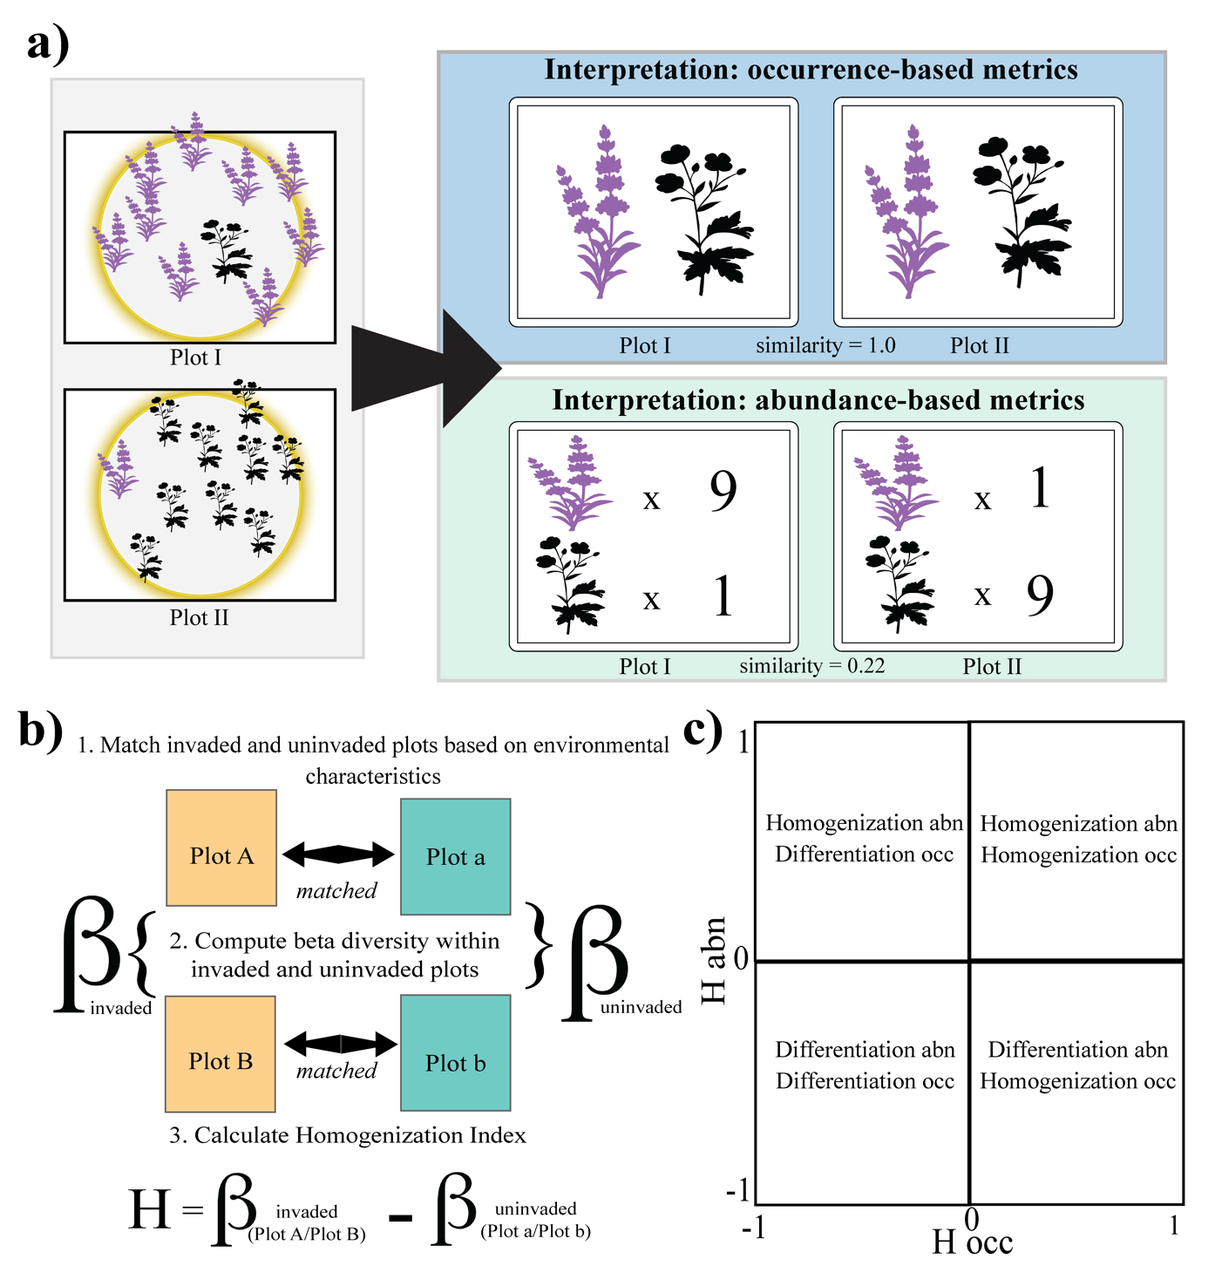

**Figure 1: An example of how occurrence- and abundance-based metrics can generate substantially different estimates of beta diversity, and how our study assesses how frequently this occurs in nature.** Panel a) shows a theoretical example of a pair of vegetation plots where occurrence- and abundance-based calculation of beta diversity would give substantial different estimates of their compositional similarity. Panel b)depicts a conceptual diagram detailing the plot matching procedure for space-for-time calculations of beta diversity differences between corresponding invaded and uninvaded plot pairs, respectively. Panel c) offers guidance for interpreting differences between occurrence- and abundance-based calculations of homogenization. In b) the homogenization Index (H) measures whether invaded plots are more similar to each other than matched uninvaded plots. First, individual invaded and uninvaded plots were matched (i.e, Plot A to Plot a, and Plot B to Plot b) based on environmental similarity. Beta diversity was then calculated among all pairs of invaded and uninvaded plots respectively (i.e., Plot A to Plot B, and Plot a to Plot b), using both a Sørensen (presence/absence-based) and the Classic Horn (abundance-based) index. For each pairwise plot comparison, a homogenization index score (-1 to 1) was calculated by subtracting the beta diversity measures of the pair of uninvaded plots from their environmentally corresponding pair of invaded plots. Estimates of Habn vs. Hocc were then plotted on x,y coordinates as in c), and the percentage of comparisons that fell into each quadrant were tallied.

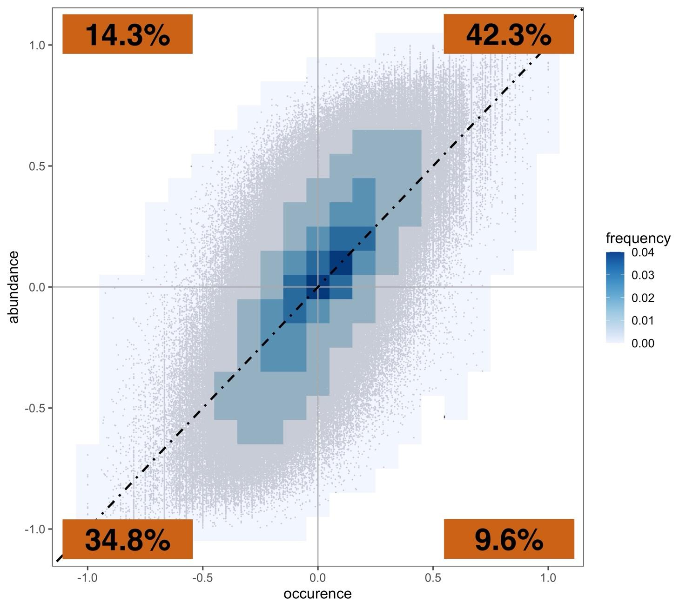

**Figure 2: Frequency of pairwise relationships between occurrence- and abundance-based calculations of change in beta diversity among environmentally corresponding invaded and uninvaded plots of the Standardized Plant Community with Introduction Status (SPCIS) database** [(Petri *et al.* 2023](https://www.zotero.org/google-docs/?v4JySJ))**.** Percentages on the heatmaps describe the number of plot comparisons that fall into each bin. The percentages in the orange boxes on the plots represent the percentage of points that fall into each graphical quadrant.

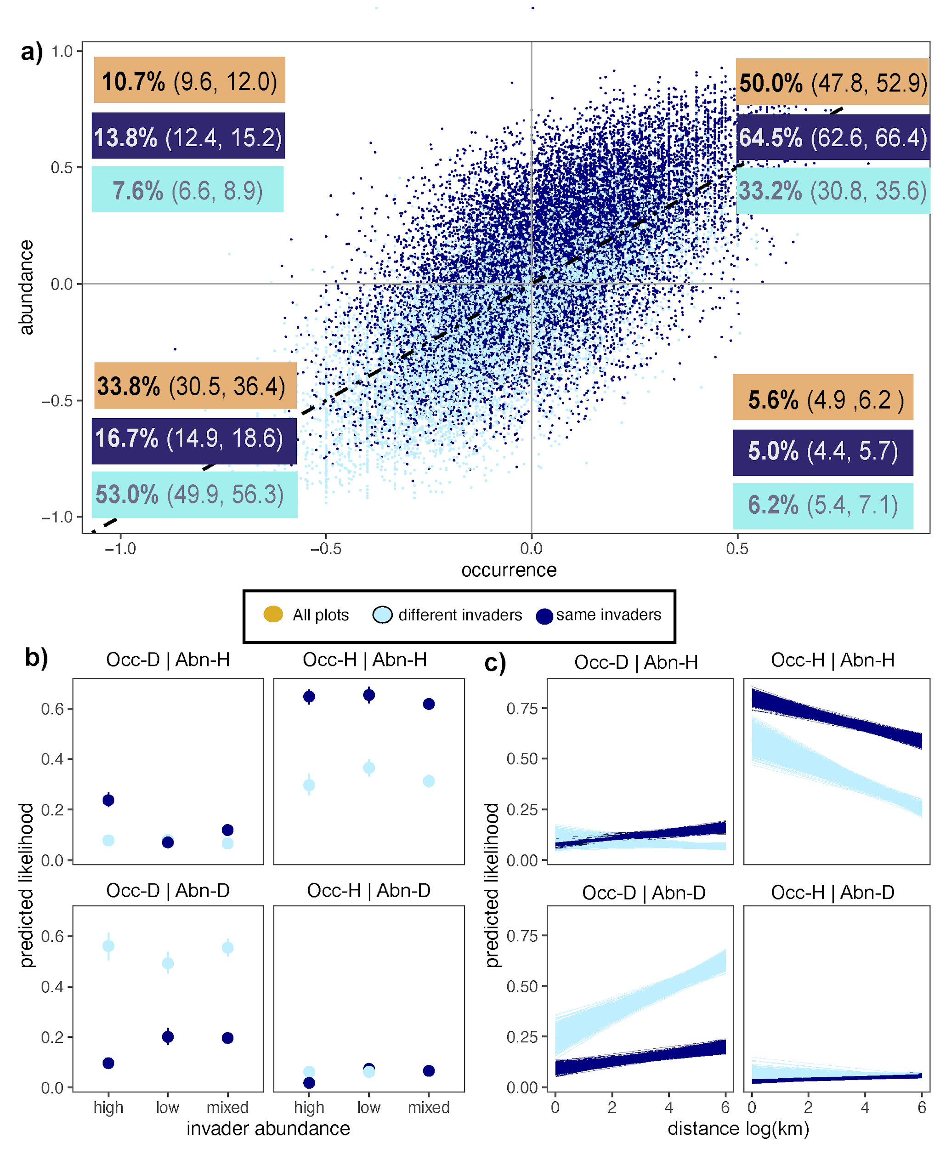

**Figure 3: Frequency of pairwise relationships between occurrence- and abundance-based calculations of biotic homogenization/differentiation among corresponding invaded and uninvaded plots invaded by cheatgrass (Bromus tectorum) in the North American Deserts.** Orange boxes in panel a) represent the predicted likelihood that a point will fall into each of the four graphical quadrants. The light blue box depicts these predictions when *B. tectorum* is only present at one of the invaded plots in the pairwise comparison, and the dark blue boxes portray these estimates when *B. tectorum* invades both plots. Differentiation is more likely when only one of the invaded plots contains *B. tectorum*, and homogenization is more likely when both do. Panel b) depicts likelihood of points occurring in each quadrant depending on whether or not *B. tectorum* is present at both plots or just one, and whether the relative abundance of the invaders are at high (>15%) or low (15% > 5%) relative cover at both plots, or mixed (one high and one low). Points indicate mean posterior estimates and bars 95% uncertainty intervals. Panel c) depicts the likelihood of points occurring in each quadrant depending on whether *B. tectorum* is present at both plots or just one and the distance between the plots. Lines represent 1000 random draws from the posterior distribution for each parameter.

.