TITLE:

Using plant invasions to compare occurrence- and abundance-based calculations of biotic homogenization: are results complementary or contradictory?

RUNNING TITLE:

Comparing metrics of biotic homogenization

ABSTRACT:

**Aim:**

Beta diversity quantifies the distinctiveness of ecological communities across the landscape. Its decline, known as biotic homogenization, is an outcome of anthropogenic global change and thought to be one of many consequences of biological invasions. Quantifying patterns of biotic homogenization is a critical task for promoting biodiversity conservation and management. Species occurrence- (presence/absence) and abundance-based analyses can produce contradictory assessments of the magnitude and direction of changes in beta diversity. Previous work in this area suggests these contradictions should be less frequently observed in nature than in theory, but a growing number of empirical studies report discrepancies between occurrence- and abundance-based approaches. Understanding if these discrepancies are driven by a few isolated cases or are systematic across a diversity of ecosystems is important because it would allow us to better understand the general patterns, mechanisms, and impacts of biotic homogenization.

**Innovation:**

In this study, we used a dataset of more than 70,000 vegetation survey plots across the contiguous United States to assess differences in biotic homogenization when calculated with both occurrence- and abundance-based metrics of beta diversity. We estimated biotic homogenization by comparing beta diversity of invaded plot pairs to environmentally matched uninvaded ones with both classes of metrics.

**Main conclusions:**

In 78% of our plot comparisons, occurrence- and abundance-based calculations agreed in direction, and the two metrics were generally well-correlated. However, 1 in 5 cases we evaluated disagreed in direction, with one metric showing homogenization while the other showed differentiation, indicating that the metrics are not interchangeable. Contrary to previous expectations, we found that these proportions were well aligned with theory. When data permits, combining the two approaches can offer insights into the role of invasions and local extirpations in driving biotic homogenization or its opposite, differentiation.

**KEYWORDS:** beta diversity, biodiversity, biological invasions, biotic homogenization, Hill numbers, invasive plant species, space-for-time

INTRODUCTION:

Anthropogenic global change is reshaping species distributions and interactions, prompting ongoing biodiversity loss [(Vitousek *et al.*, 1997; Pecl *et al.*, 2017)](https://www.zotero.org/google-docs/?AELRtp). The impacts of global change are often characterized by changes in the compositional similarity of ecological units (e.g., plots, sites, communities) as some species increase in their distribution and abundance while others decline [(Dornelas *et al.*, 2019)](https://www.zotero.org/google-docs/?ioT5gn). A particular concern is that distinct ecological communities are becoming increasingly similar. There is evidence that this "biotic homogenization" is occurring globally and can have adverse effects on ecosystem structure and function [(Olden & Rooney, 2006)](https://www.zotero.org/google-docs/?EAFcjV).

Biotic homogenization can be quantified by beta diversity metrics (i.e., the distinctiveness of ecological communities across the landscape). Though natural ecological processes can alter beta diversity, several global change drivers including biological invasions [(Winter *et al.*, 2009; Petsch, 2016)](https://www.zotero.org/google-docs/?uGosds), urbanization [(Liu *et al.*, 2022)](https://www.zotero.org/google-docs/?GwH8MJ), and climate change [(Magurran *et al.*, 2015)](https://www.zotero.org/google-docs/?MA44pK) have been identified as major agents of biotic homogenization. However, the effects of global change on beta diversity can be complex. In some cases, changing ecological conditions can also result in “biotic differentiation” when similarity among ecological units decreases, for example, due to the colonization by different species at different sites, or increased landscape heterogeneity after disturbance [(McKinney, 2008)](https://www.zotero.org/google-docs/?XwxSf4). Therefore, accurately quantifying changes in beta diversity is important for predicting global change impacts and quantifying biodiversity loss. Many metrics have been developed to quantify beta diversity (see, [Barwell *et al.* 2015; Koleff *et al.* 2003)](https://www.zotero.org/google-docs/?pfbCaW), and can be generally categorized according to whether they are based on occurrence or abundance data [(Anderson *et al.*, 2011)](https://www.zotero.org/google-docs/?OhPsAL).

Occurrence-based metrics are effective indicators of the addition or removal of species from a community. Therefore, they are useful in describing the role of rare species and the processes of extinction and colonization in meta-communities [(Branco *et al.*, 2020)](https://www.zotero.org/google-docs/?chfdB3), though they may be biased by imperfect detection of species [(Beck *et al.*, 2013)](https://www.zotero.org/google-docs/?xDqxH8). Abundance-based metrics account for the relative prevalence of species in their calculation of beta diversity. Abundance-based metrics also account for gains and losses of species but are less responsive to the turnover of rare species. They are, however, sensitive to changes in abundance of the most common species, making them useful when shifts in species dominance are linked to relevant ecosystem functions [(Barwell *et al.*, 2015)](https://www.zotero.org/google-docs/?TmX369). Species abundance is more difficult to measure, so abundance data is less frequently available than species occurrence data, and therefore abundance-based measures of beta diversity are less common [(Pearce & Boyce 2006; Yin & He 2014)](https://www.zotero.org/google-docs/?bRqNMc) .

While both occurrence and abundance-based approaches have been used to characterize beta diversity, they can result in very different estimations even when applied to the same ecological units, leading to conflicting conclusions about patterns in biodiversity. An extreme example of this would be a comparison of two plots that contain the same number of individuals and the same number of species but at different levels of abundance between species. While occurrence-based metrics of beta diversity would quantify the similarity of these two plots as an index value of 1 (100 % similar), abundance metrics would quantify them substantially less similar (Figure 1). To get a clear and accurate picture of the extent to which biotic homogenization is occurring, we must first understand how frequent occurrence- and abundance-based calculations provide complementary or conflicting inference on patterns in beta diversity.

There is both a strong foundation of theory [(Rooney *et al.*, 2007; Cassey *et al.*, 2008; Anderson *et al.*, 2011)](https://www.zotero.org/google-docs/?vs0lCC), and a growing empirical literature [(e.g., Petsch *et al.* 2022](https://www.zotero.org/google-docs/?AemR5l)) to provide a starting point for quantifying the differences between occurrence- and abundance-based calculations of beta diversity. Theoretical investigations highlight the potential for conflicts between these two types of beta diversity metrics. Cassey et al. (2008) used a simulation-based approach to assess the coherence between occurrence- and abundance-based calculations of beta diversity, and detailed the ecological conditions under which these two kinds of metrics are most likely to diverge. Their study found general agreement between occurrence- and abundance-based calculation of biotic homogenization, but in approximately a quarter of the cases one metric suggested homogenization and the other differentiation.

There are reasons to believe that these scenarios are relatively uncommon in nature compared to simulated communities. This is because, in many cases, widespread species (those likely to occur across multiple locations) are also generally abundant, whereas rare species (those less likely to occur at multiple locations) are less abundant [(Brown, 1984; Fristoe *et al.*, 2021)](https://www.zotero.org/google-docs/?tbndlL). Therefore, the processes of rare, native species becoming extirpated, or invasive species becoming widespread and abundant are likely to occur in each of the two plots. If changes in beta diversity are mainly driven by these two processes, then both abundance- and occurrence-based calculations of beta-diversity should estimate similar directional trends in beta diversity [(Cassey *et al.*, 2008)](https://www.zotero.org/google-docs/?ecTxlj).

Empirical studies that assess biotic homogenization among communities simultaneously with both occurrence- and abundance-based calculations of beta diversity are scarce and provide mixed results. One study in National Parks of the United States showed consistent estimations of abundance- and occurrence-based beta diversity [(McKinney & Lockwood, 2005)](https://www.zotero.org/google-docs/?uGZYsC) and suggest these metrics can be considered relatively interchangeable [(Olden & Rooney, 2006)](https://www.zotero.org/google-docs/?JA28uH). However, several recent studies report conflicting trends between abundance- and occurrence-based metrics of beta diversity [(La Sorte & McKinney, 2007; Yang *et al.*, 2015; Price *et al.*, 2018; Taylor *et al.*, 2019; Petersen *et al.*, 2021; Liu *et al.*, 2022)](https://www.zotero.org/google-docs/?UhfbBv). Importantly, there is no consistent pattern to these discrepancies. For example, [Taylor *et al.* (2019](https://www.zotero.org/google-docs/?Cfhn6F)) investigated changes in beta diversity of fish assemblages in several river basins with both categories of metrics, and found that in some cases occurrence-based metrics indicated homogenization and abundance-based metrics indicated differentiation, while in others the opposite patterns were observed. Moreover, several studies have found that changes in beta diversity were larger when calculated with abundance-based metrics (e.g., [La Sorte & McKinney 2007](https://www.zotero.org/google-docs/?Vj4cyO), [Price *et al.* 2018](https://www.zotero.org/google-docs/?Pyn5ZX)), while others report a contrasting pattern with greater changes in beta diversity with occurrence-based metrics (e.g., [Liu *et al.* 2022](https://www.zotero.org/google-docs/?ldmJrf)).

Direct comparisons of beta diversity estimates using occurrence- vs. abundance-based metrics are typically restricted to relatively small, localized systems, meaning that large-scale, empirical comparisons across a range of environments and ecoregions are lacking. As such, it is difficult to assess whether conflicts in occurrence- vs. abundance-based measures of beta diversity are a rare peculiarity of a few ecological systems, or a general feature for measuring biotic homogenization and a consistent challenge for interpreting global change effects.

In this study, we use a new database of standardized plant botanical surveys in the United States [(Petri *et al.*, 2023)](https://www.zotero.org/google-docs/?Lj1Kgi) to conduct a large-scale, cross-system, empirical synthesis of biotic homogenization using occurrence and abundance-based approaches. Across more than 23,000 plots and 900,000 pairwise comparisons, we assessed differences in beta diversity among invaded and paired uninvaded plots to quantify how often—and by how much— occurrence and abundance-based metrics produce conflicting evidence about patterns of biotic homogenization/differentiation. We also provide concrete guidelines for how to utilize these two related approaches for estimating beta diversity moving forward.

While we focus here on differences in taxonomic beta diversity associated with plant invasions, the comparisons between occurrence- vs. abundance-based calculations we make should also be relevant to other aspects of beta diversity (e.g. phylogenetic, functional or genetic beta diversity), in other study systems (e.g. aquatic, mammalian, etc.), or those investigating other drivers of biotic homogenization/differentiation (e.g. climate or land-use change).

MATERIALS AND METHODS:

**Space-for-time approach**

Here, we compare beta diversity among plots that represent a control state (i.e., no non-native plant species present) and those that represent an altered state (i.,e., relative cover of non-native species >5%), across space. While this dataset does not allow for tracking of beta diversity over time (Olden & Rooney 2006), a recent meta-analysis of biotic homogenization studies suggested that these kinds of space-for-time analyses are relatively conservative, often registering less extreme changes in beta-diversity than change over time approaches [(Petsch *et al.*, 2022)](https://www.zotero.org/google-docs/?xn5s4P). Thus, in this study, we employ this space-for-time approach [(Lovell *et al.*, 2023)](https://www.zotero.org/google-docs/?55VmyG), comparing patterns of beta diversity between vegetation survey plots with only native species present and plots that have been invaded by non-native taxa.

**Data preparation:**

We obtained plot data of plant species’ abundance and native status from the SPCIS database [(Petri *et al.*, 2023)](https://www.zotero.org/google-docs/?7BaUjV), a standardized dataset of vegetation surveys for the United States. For each plot in the dataset, we also obtained environmental data from INHABIT [(Engelstad *et al.*, 2022)](https://www.zotero.org/google-docs/?ePZHCY), a web-based decision support tool for modeling invasive plant habitat suitability. For the few plots that had been surveyed multiple times across years, we subset the dataset to include only the most recent survey.

We matched plots that had 0% non-native species cover (hereafter: uninvaded plots) to corresponding plots that had >5% non-native species cover (hereafter: invaded plots) based on environmental similarity of uninvaded and invaded plots in order to control for the environmental differences between the invaded and uninvaded plots. We matched plots based on five environmental variables that a preliminary analysis found to be important predictors of non-native species cover: NDMI [Normalized Difference Moisture Index], total soil N at 0.05m depth, minimum temperature of the coldest month [°C], % tree cover, and human modification index. We matched plots within the US EPA’s Level IV Ecoregions [(Omernik & Griffith 2014](https://www.zotero.org/google-docs/?eY9sjl), the smallest scale ecoregion, of which there are 937 in the conterminous United States). Only plots that had complete environmental data were included. We used propensity score matching, a technique for increasing causal inference from statistical models [(Ramsey *et al.*, 2019)](https://www.zotero.org/google-docs/?oEzoVr) to match uninvaded and invaded plots based on 1:1 nearest neighbor matching algorithm with the R package “matchit” [(Ho *et al.*, 2011)](https://www.zotero.org/google-docs/?bnnaNZ). This resulted in a dataset of 22,572 pairwise matches of invaded and uninvaded plots with highly similar environmental conditions (Figure S1) to maximize the likelihood that their composition differences reflect biotic processes rather than environmental filtering.

**Calculations of beta diversity and change:**

We calculated pairwise beta diversity among all invaded and uninvaded plots, respectively, within Level IV ecoregions, based on Hill Numbers [(Chao *et al.*, 2014)](https://www.zotero.org/google-docs/?W4H6iV) using the R package “*hillR*” [(Li, 2018)](https://www.zotero.org/google-docs/?pYUajc). For every plot pair, we computed beta diversity with two widely used metrics; the Sørensen (occurrence-based) and the Classic Horn (abundance-weighted) index (968,388 pairwise comparisons total).

To assess differences in beta diversity among invaded and uninvaded plot combinations, our proxy for biotic homogenization, we adapted a homogenization index from [Qian & Guo (2010)](https://www.zotero.org/google-docs/?mSB3PB) where we subtracted the beta diversity estimate for a given native plot pair combination from the beta diversity of their corresponding invaded counterparts (Figure 2a):

H= 𝛃**invaded**(plotA/plotB) - 𝛃**uninvaded**(plota/plotb)

Where H, or the homogenization index, is the difference in beta diversity ranging from -1 to 1, between any pair of uninvaded (plota & plotb) and their environmentally corresponding pair of invaded (plotA & plotB) plots. Negative values of H indicate that the uninvaded plots are more similar to each other than their corresponding invaded plots are to each other (i.e., differentiation with invasion), while positive values of H indicate that uninvaded plots are less similar to each other than their corresponding invaded plots are to each other (i.e., homogenization with invasion).

We quantified the number of pairs that fell into each one of the graphical quadrants (Figure 2b) : 1. Homogenizationabn| Homogenizationocc , 2. Homogenizationabn | Differentiationocc , 3. Differentiationabn | Differentiationocc , 4. Differentiationabn | Homogenizationocc, and calculated the mean absolute difference between the two metrics’ estimates.

We calculated the Pearson correlation coefficient and mean and standard deviation of the absolute differences between the occurrence- and abundance-based calculations of each pairwise plot combination. To better understand the frequency that metrics agreed in directionality of homogenization, we then divided the plot with the graphical quadrants in 0.1 x 0.1 grid cells and calculated the percentage of homogenization/differentiation estimates that occurred in each cell (see Figure 2b, 3).

Because the SPCIS database combines vegetation surveys from different original datasets using different sampling methods, we also quantified how often the four plot combinations (matched uninvaded and invaded plot pairs) came from the same original data set and plotted this relationship against both absolute differences between metrics and the frequency each category appeared in each graphical quadrant in Figure 3 (see Figure 4a, c).

To gain a broad sense of how patterns of invasion affect the coherence of abundance- and occurrence-based calculations of beta diversity, we also quantified how many plot pairs had the same dominant invaders in each plot and plotted this relationship against both absolute differences between metrics and the frequency each category appeared in each graphical quadrant in Figure 3 (see Figure 4 b, d). It should be noted that due to the complex patterns of non-independence of our data points (i.e., each measure of homogenization was derived from contrasts between four plots) we assess these relationships visually in general terms, rather than attempting to interpret them using statistical hypothesis testing.

RESULTS

Broadly, occurrence- and abundance-based calculations of differences in beta diversity between corresponding uninvaded and invaded plot pairings agreed in direction (i.e., both methods either indicated homogenization or differentiation) in 78.6% of cases (41.3% homogenization and 37.3% differentiation; Figure 3). The Pearson correlation coefficient between occurrence- and abundance-based calculation of homogenization was 0.73. The average absolute difference between metrics was 0.175 ± 0.144 SD with 3% of the observations having a difference of ≥ 0.5. Differences in beta diversity between invaded and uninvaded plot pairs were small with both metrics (<0.1) in just 5% of the cases (Figure 3, origin).

Frequently, while one metric estimated small (＜0.1) differences in beta diversity, the other estimated homogenization or differentiation. In 8% of the cases, substantive differences (＞0.1) in beta diversity between invaded and uninvaded plot pairs were observed with occurrence-based calculation, but not with the abundance-based calculation (Figure 3, points along the x-axis). In 12% of cases, there was little difference (＜0.1) in beta diversity between invaded and uninvaded plot pairs with the occurrence-based calculation, but substantial differences with the abundance-based calculation (Figure 3, points along the y-axis).

82% percent of plot comparisons came from the same dataset, and those that came from multiple datasets did not visibly increase the absolute differences between metrics, nor the frequency that the directionality of abundance- and occurrence metrics conflicted (Figure 4a, c).

Higher differences between abundance- and occurrence-based metrics, and more frequent directional differences between metrics occurred generally when plot comparisons were dominated by the same non-native species (Figure 4b, d).

DISCUSSION:

In this study we compared occurrence and abundance-based beta diversity in 968,388 contrasts between 23,198 pairs of invaded and uninvaded vegetation plots. To the best of our knowledge, this analysis offers the most extensive empirical comparison of these beta-diversity metrics to date.

A goal of this study was to compare the empirical differences of abundance- and occurrence-based calculations of biotic homogenization to the theoretical differences reported in Cassey et al. (2008). We found that the occurrence- and abundance-based calculations were broadly complementary, agreeing in direction (i.e., both methods either indicating homogenization or differentiation) in 78.6% of the cases (Figure 3), and the metrics were moderately-well correlated. Yet, in 21.4% of the cases, abundance- and occurrence-based metrics disagreed on the direction of beta diversity differences (i.e., one metric indicating homogenization with the other indicating differentiation). The patterns we observed in our empirical data were strikingly similar to the patterns simulated in Cassey et al. (2008, Table 1). This supports the utility of theory for understanding the implications of using these alternative methods, but not the prediction that discrepancies between these kinds of metrics should be less common in nature than in mathematical simulations [(Cassey *et al.*, 2008)](https://www.zotero.org/google-docs/?X8A2vM). The fact that increased discrepancies between metrics do not appear to be associated with differences in sampling protocols between datasets (Figure 4a, c) further suggests that the differences we found in our empirical study reflect the biology of the study system rather than any methodological issues.

Even though one out of every five pairwise comparisons in our study produced contradictions between the metrics, the difference in general frequencies of homogenization/differentiation we estimated with each metric was small— we detected homogenization in 49.5% of cases with abundance-based metrics and 54.5 % of cases with occurrence-based metrics (Figure 3). This suggests that while it is not uncommon for these metrics to disagree on *which* plot pairs have become more homogeneous or differentiated, there does not appear to be major systematic bias in metrics (i.e., one does not more frequently detect homogenization than the other). Consequently, the scale and application of biotic homogenization studies should be considered when determining whether to use abundance- or occurrence-based metrics. For example, our results indicate that when assessing general trends in homogenization/differentiation, these metrics could be relatively interchangeable, but for understanding processes and magnitude of change at more local levels (e.g., for applications in conservation or landscape planning) assessments of homogenization may be highly sensitive to which metrics are used.

Additional considerations regarding these metrics come from general discussion about the use of occurrence- and abundance- based data in biogeography. Abundance data are generally more informative [(Barwell *et al.*, 2015)](https://www.zotero.org/google-docs/?ggnnLS), better for assessing the link between the function and composition of ecological communities [(Waldock *et al.*, 2022)](https://www.zotero.org/google-docs/?rhrsAz) and less sensitive to under-sampling [(Beck *et al.*, 2013)](https://www.zotero.org/google-docs/?TMoapO). At the same time, occurrence data are easier to collect and more widely available than abundance data [(Engelstad *et al.* 2022; Pearce & Boyce 2006; Yin & He 2014)](https://www.zotero.org/google-docs/?T7Op1T).

While each metric has its strengths and weaknesses, our comparative analysis suggests that when used together, they can provide a more complete and accurate picture of beta diversity change. For example, little or no change in beta diversity with occurrence- based metrics might in itself indicate community stability, but a contradictory assessment with an abundance-based metrics would suggest large changes in the abundance of common species, a case in which the function of these communities may be altered. By contrast, little or no change in beta diversity with abundance- based metrics and large changes with occurrence-based ones could suggest that uncommon species are being extirpated from sites or multiple new species are arriving (a potential indicator of future invasion).

Abundance- and occurrence-based metrics are most likely to both report homogenization when widespread species are also the most abundant species and report differentiation in systems with multiple invaders and/or when widespread species are more strongly impacted by drivers of change and face declines/extirpation (e.g., Figure 5; quadrants A, C). Discrepancies between occurrence- and abundance-based calculations of biotic homogenization are more likely when native communities are changing rapidly in concert with the arrival of novel species [(Cassey *et al.*, 2008)](https://www.zotero.org/google-docs/?w4CKbJ). The addition of novel species at multiple sites at contrasting abundance levels can lead to homogenization with occurrence-based beta diversity and differentiation with abundance-based metrics (e.g., Figure 5; quadrant D). This is consistent with our findings that conflicts between metrics where occurrence-based metrics showed homogenization and abundance-based metrics differentiation were more frequent when plots had the same dominant invader (Figure 4d). This scenario could arise early in the invasion process, or with the introduction of one or more non-native species that establish but do not become abundant and invasive. It could also arise with the local extinction of one or more rare native species as invaders become more abundant (e.g., [Beaury *et al.* 2023)](https://www.zotero.org/google-docs/?amUntl). In contrast, the decline of widespread, native species due to invasions (e.g., [Powell *et al.*, 2013)](https://www.zotero.org/google-docs/?I6GNgd) that results in local extirpation at only one plot could lead to strong homogenization with abundance-based beta diversity and differentiation with occurrence-based metrics, especially if the invader reaches high abundance in both plots (e.g., Figure 5, quadrant C). This scenario is also more likely when plots share the same dominant invader (Figure 4d) because at high abundances of invasion the impacts on native populations are likely to be similar across plots.

Of course, biotic homogenization is the result of complex patterns of colonizations, population growth, decline and extirpations and many different scenarios of change in community dynamics can converge to the same estimates of homogenization, so the scenarios presented in Figure 5 are certainly not the only ones that can result in complementary and contradictory patterns of homogenization and differentiation. Further, vegetation communities may be invaded by many non native species, and all of these patterns of gain, change and loss may occur simultaneously. Indeed, all of these scenarios (i.e., the addition of rare vs. common non-native species and the reduction of rare vs. common native species) have been observed in invasion ecology [(Powell *et al.*, 2013; Fristoe *et al.*, 2021; Beaury *et al.*, 2023)](https://www.zotero.org/google-docs/?fURqJI) further suggesting that there is no single mechanism by which introduced species alter beta-diversity. Thus, studying the multiple causes of differences between occurrence- and abundance-based calculations offers great potential insight into how ecological communities are shifting in response to global change.

In this study, we assessed the differences between abundance- and occurrence-based metrics of biotic homogenization in relation to plant invasions. Overall we found broad congruence in direction between abundance- and occurrence-based metrics, but 1 in 5 cases disagreed in direction (homogenization vs. differentiation) when evaluated with abundance- vs. occurrence-based metrics of beta diversity. Harmonizing these approaches will require continued research to understand the ecological factors that inflate the differences between abundance- and occurrence-based metrics and whether these differences can be predicted.

References

[Anderson, M.J., Crist, T.O., Chase, J.M., Vellend, M., Inouye, B.D., Freestone, A.L., Sanders, N.J., Cornell, H.V., Comita, L.S., Davies, K.F., Harrison, S.P., Kraft, N.J.B., Stegen, J.C. & Swenson, N.G. (2011) Navigating the multiple meanings of β diversity: a roadmap for the practicing ecologist. *Ecology Letters*, **14**, 19–28.](https://www.zotero.org/google-docs/?m2QrKl)

[Barwell, L.J., Isaac, N.J.B. & Kunin, W.E. (2015) Measuring β-diversity with species abundance data. *Journal of Animal Ecology*, **84**, 1112–1122.](https://www.zotero.org/google-docs/?m2QrKl)

[Beaury, E.M., Sofaer, H.R., Early, R., Pearse, I.S., Blumenthal, D.M., Corbin, J.D., Diez, J., Dukes, J.S., Barnett, D.T., Ibáñez, I., Petri, L., Vilà, M. & Bradley, B.A. (2023) Macroscale analyses suggest invasive plant impacts depend more on the composition of invading plants than on environmental context. *Global Ecology and Biogeography*, **32**, 1964–1976.](https://www.zotero.org/google-docs/?m2QrKl)

[Beck, J., Holloway, J.D. & Schwanghart, W. (2013) Undersampling and the measurement of beta diversity. *Methods in Ecology and Evolution*, **4**, 370–382.](https://www.zotero.org/google-docs/?m2QrKl)

[Branco, C.C.Z., Bispo, P.C., Peres, C.K., Tonetto, A.F., Krupek, R.A., Barfield, M. & Holt, R.D. (2020) Partitioning multiple facets of beta diversity in a tropical stream macroalgal metacommunity. *Journal of Biogeography*, **47**, 1765–1780.](https://www.zotero.org/google-docs/?m2QrKl)

[Brown, J.H. (1984) On the Relationship between Abundance and Distribution of Species. *The American Naturalist*, **124**, 255–279.](https://www.zotero.org/google-docs/?m2QrKl)

[Cassey, P., Lockwood, J.L., Olden, J.D. & Blackburn, T.M. (2008) The varying role of population abundance in structuring indices of biotic homogenization. *Journal of Biogeography*, **35**, 884–892.](https://www.zotero.org/google-docs/?m2QrKl)

[Chao, A., Chiu, C.-H. & Jost, L. (2014) Unifying Species Diversity, Phylogenetic Diversity, Functional Diversity, and Related Similarity and Differentiation Measures Through Hill Numbers. *Annual Review of Ecology, Evolution, and Systematics*, **45**, 297–324.](https://www.zotero.org/google-docs/?m2QrKl)

[Dornelas, M., Gotelli, N.J., Shimadzu, H., Moyes, F., Magurran, A.E. & McGill, B.J. (2019) A balance of winners and losers in the Anthropocene. *Ecology Letters*, **22**, 847–854.](https://www.zotero.org/google-docs/?m2QrKl)

[Engelstad, P., Jarnevich, C.S., Hogan, T., Sofaer, H.R., Pearse, I.S., Sieracki, J.L., Frakes, N., Sullivan, J., Young, N.E., Prevéy, J.S., Belamaric, P. & LaRoe, J. (2022) INHABIT: A web-based decision support tool for invasive plant species habitat visualization and assessment across the contiguous United States. *PLOS ONE*, **17**, e0263056.](https://www.zotero.org/google-docs/?m2QrKl)

[Fristoe, T.S., Chytrý, M., Dawson, W., Essl, F., Heleno, R., Kreft, H., Maurel, N., Pergl, J., Pyšek, P., Seebens, H., Weigelt, P., Vargas, P., Yang, Q., Attorre, F., Bergmeier, E., Bernhardt-Römermann, M., Biurrun, I., Boch, S., Bonari, G., Botta-Dukát, Z., Bruun, H.H., Byun, C., Čarni, A., Carranza, M.L., Catford, J.A., Cerabolini, B.E.L., Chacón-Madrigal, E., Ciccarelli, D., Ćušterevska, R., de Ronde, I., Dengler, J., Golub, V., Haveman, R., Hough-Snee, N., Jandt, U., Jansen, F., Kuzemko, A., Küzmič, F., Lenoir, J., Macanović, A., Marcenò, C., Martin, A.R., Michaletz, S.T., Mori, A.S., Niinemets, Ü., Peterka, T., Pielech, R., Rašomavičius, V., Rūsiņa, S., Dias, A.S., Šibíková, M., Šilc, U., Stanisci, A., Jansen, S., Svenning, J.-C., Swacha, G., van der Plas, F., Vassilev, K. & van Kleunen, M. (2021) Dimensions of invasiveness: Links between local abundance, geographic range size, and habitat breadth in Europe’s alien and native floras. *Proceedings of the National Academy of Sciences*, **118**, e2021173118.](https://www.zotero.org/google-docs/?m2QrKl)

[Ho, D.E., Imai, K., King, G. & Stuart, E.A. (2011) MatchIt: Nonparametric Preprocessing for Parametric Causal Inference. *Journal of Statistical Software*, **42**, 1–28.](https://www.zotero.org/google-docs/?m2QrKl)

[Koleff, P., Gaston, K.J. & Lennon, J.J. (2003) Measuring beta diversity for presence–absence data. *Journal of Animal Ecology*, **72**, 367–382.](https://www.zotero.org/google-docs/?m2QrKl)

[La Sorte, F.A. & McKinney, M.L. (2007) Compositional changes over space and time along an occurrence–abundance continuum: anthropogenic homogenization of the North American avifauna. *Journal of Biogeography*, **34**, 2159–2167.](https://www.zotero.org/google-docs/?m2QrKl)

[Li, D. (2018) hillR: taxonomic, functional, and phylogenetic diversity and similarity through Hill Numbers. *Journal of Open Source Software*, **3**, 1041.](https://www.zotero.org/google-docs/?m2QrKl)

[Liu, Z., Heino, J., Soininen, J., Zhou, T., Wang, W., Cui, Y., Chen, Y., Li, Z., Zhang, J. & Xie, Z. (2022) Different responses of incidence-weighted and abundance-weighted multiple facets of macroinvertebrate beta diversity to urbanization in a subtropical river system. *Ecological Indicators*, **143**, 109357.](https://www.zotero.org/google-docs/?m2QrKl)

[Lovell, R.S.L., Collins, S., Martin, S.H., Pigot, A.L. & Phillimore, A.B. (2023) Space-for-time substitutions in climate change ecology and evolution. *Biological Reviews*, **98**, 2243–2270.](https://www.zotero.org/google-docs/?m2QrKl)

[Magurran, A.E., Dornelas, M., Moyes, F., Gotelli, N.J. & McGill, B. (2015) Rapid biotic homogenization of marine fish assemblages. *Nature Communications*, **6**, 8405.](https://www.zotero.org/google-docs/?m2QrKl)

[McKinney, M. (2008) Do humans homogenize or differentiate biotas? It depends. *Journal of Biogeography*, **35**, 1960–1961.](https://www.zotero.org/google-docs/?m2QrKl)

[McKinney, M.L. & Lockwood, J.L. (2005) *Community composition and homogenization: evenness and abundance of native and exotic species*. *Species invasions – insights into ecology, evolution and biogeography*, pp. 365–381. Sinauer Press, Sunderland, MA.](https://www.zotero.org/google-docs/?m2QrKl)

[Olden, J.D. & Rooney, T.P. (2006) On defining and quantifying biotic homogenization. *Global Ecology and Biogeography*, **15**, 113–120.](https://www.zotero.org/google-docs/?m2QrKl)

[Omernik, J.M. & Griffith, G.E. (2014) Ecoregions of the Conterminous United States: Evolution of a Hierarchical Spatial Framework. *Environmental Management*, **54**, 1249–1266.](https://www.zotero.org/google-docs/?m2QrKl)

[PEARCE, J.L. & BOYCE, M.S. (2006) Modelling distribution and abundance with presence-only data. *Journal of Applied Ecology*, **43**, 405–412.](https://www.zotero.org/google-docs/?m2QrKl)

[Pecl, G., Araújo, M., Bell, J., Blanchard, J., Bonebrake, T., Chen, I., Clark, T., Colwell, R., Danielsen, F., Evengård, B., Falconi, L., Ferrier, S., Frusher, S., Garcia, R., Griffis, R., Hobday, A., Janion-Scheepers, C., Jarzyna, M., Jennings, S., Lenoir, J., Linnetved, H., Martin, V., McCormack, P., McDonald, J., Mitchell, N., Mustonen, T., Pandolfi, J., Pettorelli, N., Popova, E., Robinson, S., Scheffers, B., Shaw, J., Sorte, C., Strugnell, J., Sunday, J., Tuanmu, M., Vergés, A., Villanueva, C., Wernberg, T., Wapstra, E. & Williams, S. (2017) Biodiversity redistribution under climate change: Impacts on ecosystems and human well-being. *SCIENCE*, **355**.](https://www.zotero.org/google-docs/?m2QrKl)

[Petersen, K.N., Freeman, M.C., Kirsch, J.E., McLarney, W.O., Scott, M.C. & Wenger, S.J. (2021) Mixed evidence for biotic homogenization of Southern Appalachian fish communities. *Canadian Journal of Fisheries and Aquatic Sciences*, **78**, 1397–1406.](https://www.zotero.org/google-docs/?m2QrKl)

[Petri, L., Beaury, E.M., Corbin, J., Peach, K., Sofaer, H., Pearse, I.S., Early, R., Barnett, D.T., Ibáñez, I., Peet, R.K., Schafale, M., Wentworth, T.R., Vanderhorst, J.P., Zaya, D.N., Spyreas, G. & Bradley, B.A. (2023) SPCIS: Standardized Plant Community with Introduced Status database. *Ecology*, **104**, e3947.](https://www.zotero.org/google-docs/?m2QrKl)

[Petsch, D.K. (2016) Causes and consequences of biotic homogenization in freshwater ecosystems. *International Review of Hydrobiology*, **101**, 113–122.](https://www.zotero.org/google-docs/?m2QrKl)

[Petsch, D.K., Bertoncin, A.P. dos S., Ortega, J.C.G. & Thomaz, S.M. (2022) Non-native species drive biotic homogenization, but it depends on the realm, beta diversity facet and study design: a meta-analytic systematic review. *Oikos*, **2022**.](https://www.zotero.org/google-docs/?m2QrKl)

[Powell, K.I., Chase, J.M. & Knight, T.M. (2013) Invasive Plants Have Scale-Dependent Effects on Diversity by Altering Species-Area Relationships. *Science*, **339**, 316–318.](https://www.zotero.org/google-docs/?m2QrKl)

[Price, E.P.F., Spyreas, G. & Matthews, J.W. (2018) Biotic homogenization of regional wetland plant communities within short time-scales in the presence of an aggressive invader. *Journal of Ecology*, **106**, 1180–1190.](https://www.zotero.org/google-docs/?m2QrKl)

[Qian, H. & Guo, Q. (2010) Linking biotic homogenization to habitat type, invasiveness and growth form of naturalized alien plants in North America. *Diversity and Distributions*, **16**, 119–125.](https://www.zotero.org/google-docs/?m2QrKl)

[Ramsey, D.S.L., Forsyth, David.M., Wright, E., McKay, M. & Westbrooke, I. (2019) Using propensity scores for causal inference in ecology: Options, considerations, and a case study. *Methods in Ecology and Evolution*, **10**, 320–331.](https://www.zotero.org/google-docs/?m2QrKl)

[Rooney, T.P., Olden, J.D., Leach, M.K. & Rogers, D.A. (2007) Biotic homogenization and conservation prioritization. *Biological Conservation*, **134**, 447–450.](https://www.zotero.org/google-docs/?m2QrKl)

[Taylor, C.M., Miyazono, S., Cheek, C.A., Edwards, R.J. & Patiño, R. (2019) The spatial scale of homogenisation and differentiation in Chihuahuan Desert fish assemblages. *Freshwater Biology*, **64**, 222–232.](https://www.zotero.org/google-docs/?m2QrKl)

[Vitousek, P., Mooney, H., Lubchenco, J. & Melillo, J. (1997) Human domination of Earth’s ecosystems. *SCIENCE*, **277**, 494–499.](https://www.zotero.org/google-docs/?m2QrKl)

[Waldock, C., Stuart-Smith, R.D., Albouy, C., Cheung, W.W.L., Edgar, G.J., Mouillot, D., Tjiputra, J. & Pellissier, L. (2022) A quantitative review of abundance-based species distribution models. *Ecography*, **2022**.](https://www.zotero.org/google-docs/?m2QrKl)

[Winter, M., Schweiger, O., Klotz, S., Nentwig, W., Andriopoulos, P., Arianoutsou, M., Basnou, C., Delipetrou, P., Didziulis, V., Hejda, M., Hulme, P., Lambdon, P., Pergl, J., Pysek, P., Roy, D. & Kühn, I. (2009) Plant extinctions and introductions lead to phylogenetic and taxonomic homogenization of the European flora. *PROCEEDINGS OF THE NATIONAL ACADEMY OF SCIENCES OF THE UNITED STATES OF AMERICA*, **106**, 21721–21725.](https://www.zotero.org/google-docs/?m2QrKl)

[Yang, J., La Sorte, F.A., Pyšek, P., Yan, P., Nowak, D. & McBride, J. (2015) The compositional similarity of urban forests among the world’s cities is scale dependent. *Global Ecology and Biogeography*, **24**, 1413–1423.](https://www.zotero.org/google-docs/?m2QrKl)

[Yin, D. & He, F. (2014) A simple method for estimating species abundance from occurrence maps. *Methods in Ecology and Evolution*, **5**, 336–343.](https://www.zotero.org/google-docs/?m2QrKl)

Data Availability Statement:

The data are available from <https://esajournals.onlinelibrary.wiley.com/doi/10.1002/ecy.3947>, and the code used for data preparation and analysis is currently available on github and will be publicly archived at UMass Scholar works at the time of publication.

TABLES:

|  |  |  |
| --- | --- | --- |
|  | Theoretical | Empirical |
| Frequency that abundance and occurrence metrics disagree in the direction of homogenization/differentiation | 22.1% | 21.4% |
| Average (±  SD) absolute difference between metrics | 24.4±13.6% | 17.5±14.4% |
| Frequency that absolute differences were >50% | 1% | 3% |
| Pearson correlation coefficient between metrics | 0.62 | 0.73 |

**Table 1: A comparison of the theoretical expectations for the relationship between abundance- and occurrence-based calculations of biotic homogenization from Cassey et al. (2008) with the patterns of homogenization/differentiation calculated in this study for the SPCIS database** [(Petri *et al.* 2023](https://www.zotero.org/google-docs/?v4JySJ)).

FIGURES:

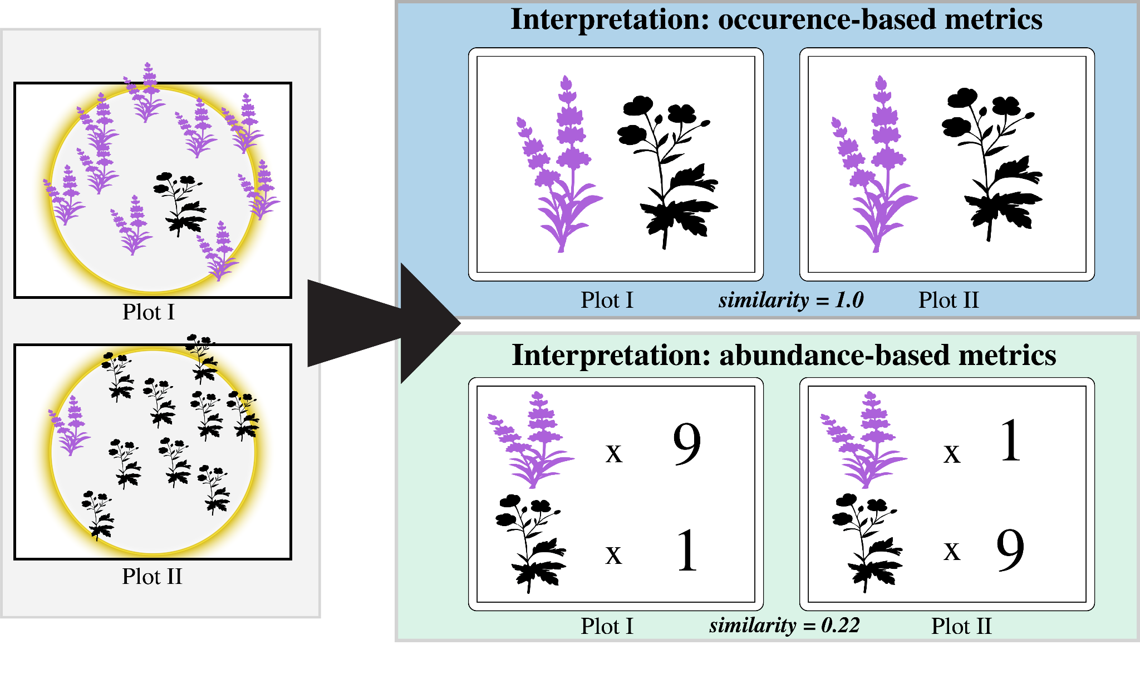

**Figure 1: Occurrence and abundance-based metrics can generate substantially different estimates of beta diversity.**

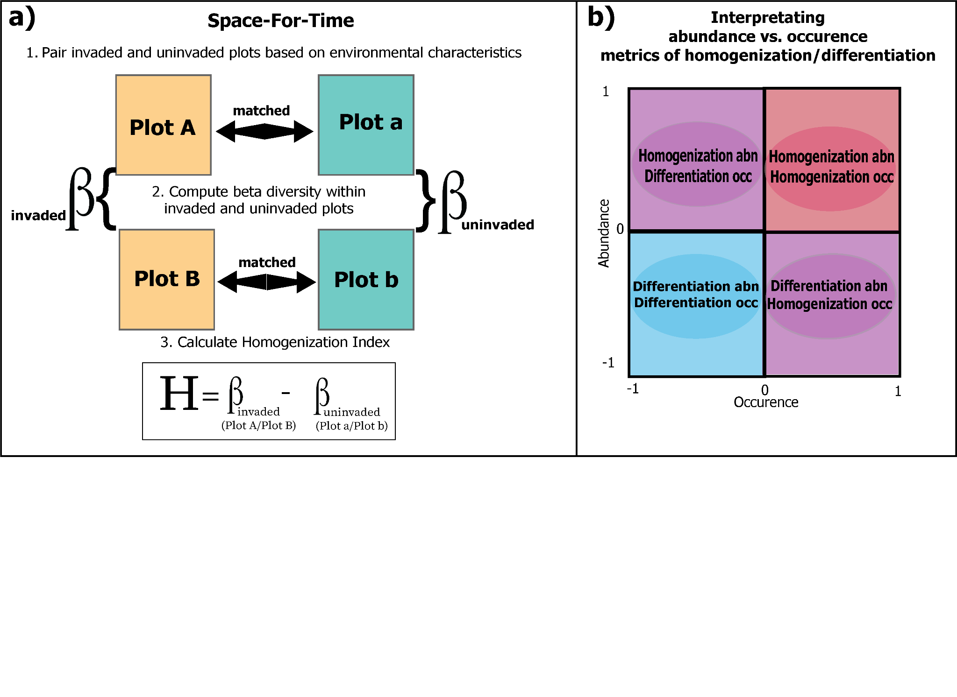

**Figure 2: A conceptual diagram detailing a) the plot matching procedure for space-for-time calculations of beta diversity differences between corresponding invaded and uninvaded plot pairs, respectively, and b) interpreting differences between abundance- and occurrence-based calculations of homogenization.** In a) the homogenization Index (H) measures whether invaded plots are more similar to each other than matched uninvaded plots. First, individual invaded and uninvaded plots were matched (i.e, Plot A to Plot a, and Plot B to Plot b) based on environmental similarity. Beta diversity was then calculated among all pairs of invaded and uninvaded plots respectively (i.e., Plot A to Plot B, and Plot a to Plot b), using both a Sørensen (presence/absence-based) and the Classic Horn (abundance-based) index. For each pairwise plot comparison, a homogenization index score (-1 to 1) was calculated by subtracting the beta diversity measures of the pair of uninvaded plots from their environmentally corresponding pair of invaded plots. Estimates of Habn vs. Hocc were then plotted on x,y coordinates as in b), and the percentage of comparisons that fell into each quadrant were tallied.

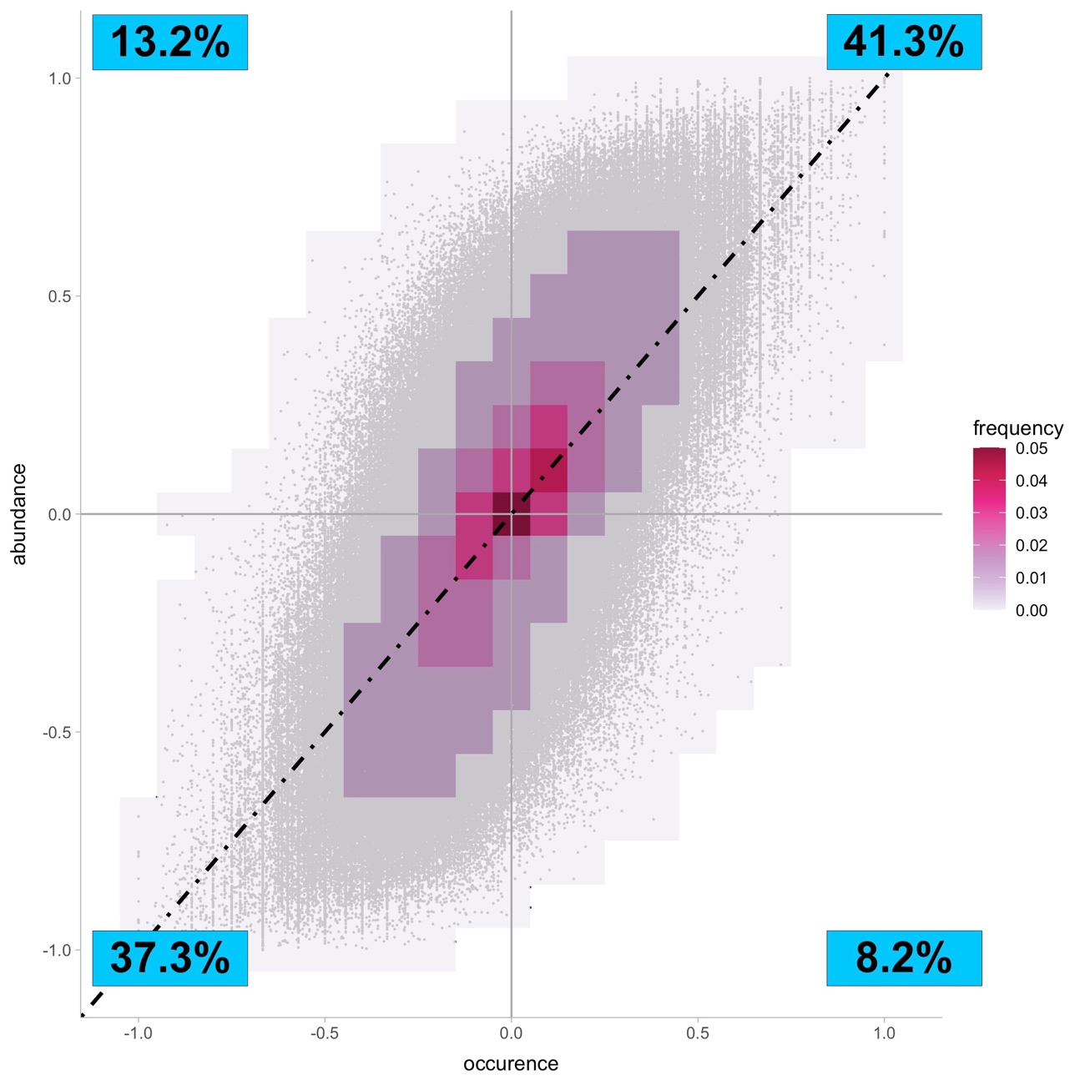

**Figure 3: Frequency of pairwise relationships between occurrence and abundance-based calculations of change in beta diversity among corresponding invaded and uninvaded plots of the SPCIS database.** Percentages on the heatmaps describe the number of plot comparisons that fall into each bin. The percentages in the blue box on the plots represent the percentage of points that fall into each graphical quadrant.

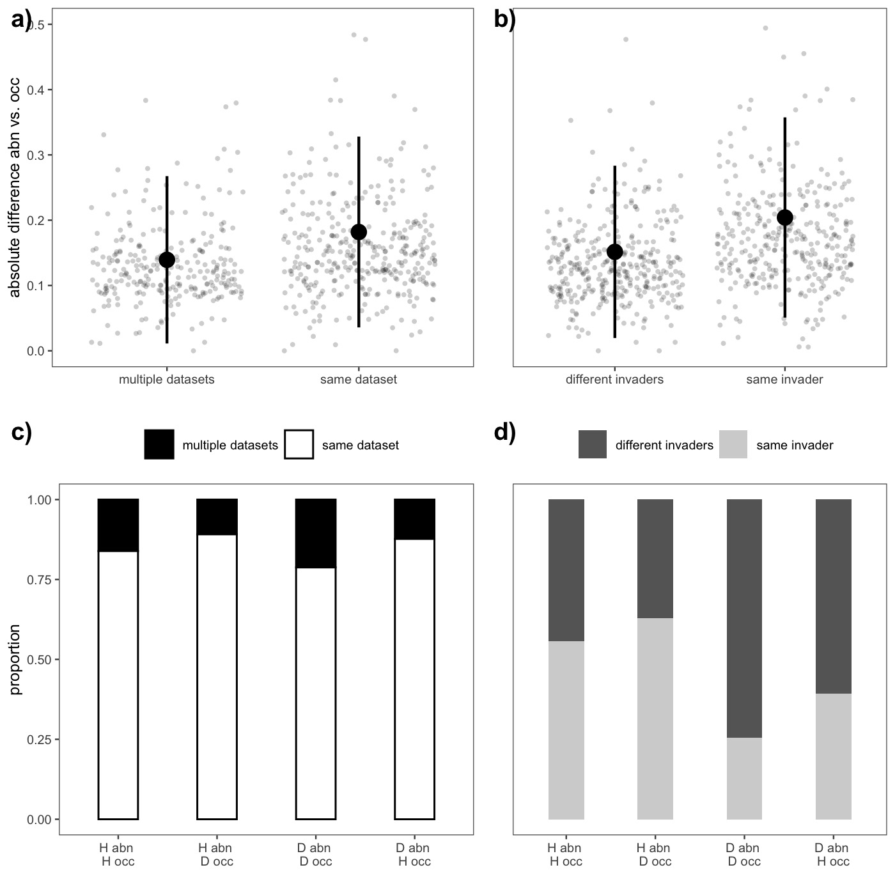

**Figure 4: The relationship between absolution differences in homogenization and directional agreement between abundance- and occurrence-based metrics of beta diversity.** Panel a) contrasts the absolute difference in homogenization index score between abundance- and occurrence-based metrics of beta diversity depending on whether or not the four plots that make up the comparison come from the same data set, and panel b) contrasts this absolute difference between metrics depending on whether or not the plots pairs had the same dominant invader at them. Large points indicate the mean differences in each category and bars represent ± one standard deviation. Grey points represent the mean absolute difference in homogenization index score for each Level IV ecoregion in the dataset and have been jittered to aid with visualization. Panels c) and d) depict the frequency that each category (multiple vs. same dataset and different vs. same invaders, respectively) agree or disagree in the directionality of homogenization vs. differentiation. On the x-axis, H represents homogenization and D represents differentiation.

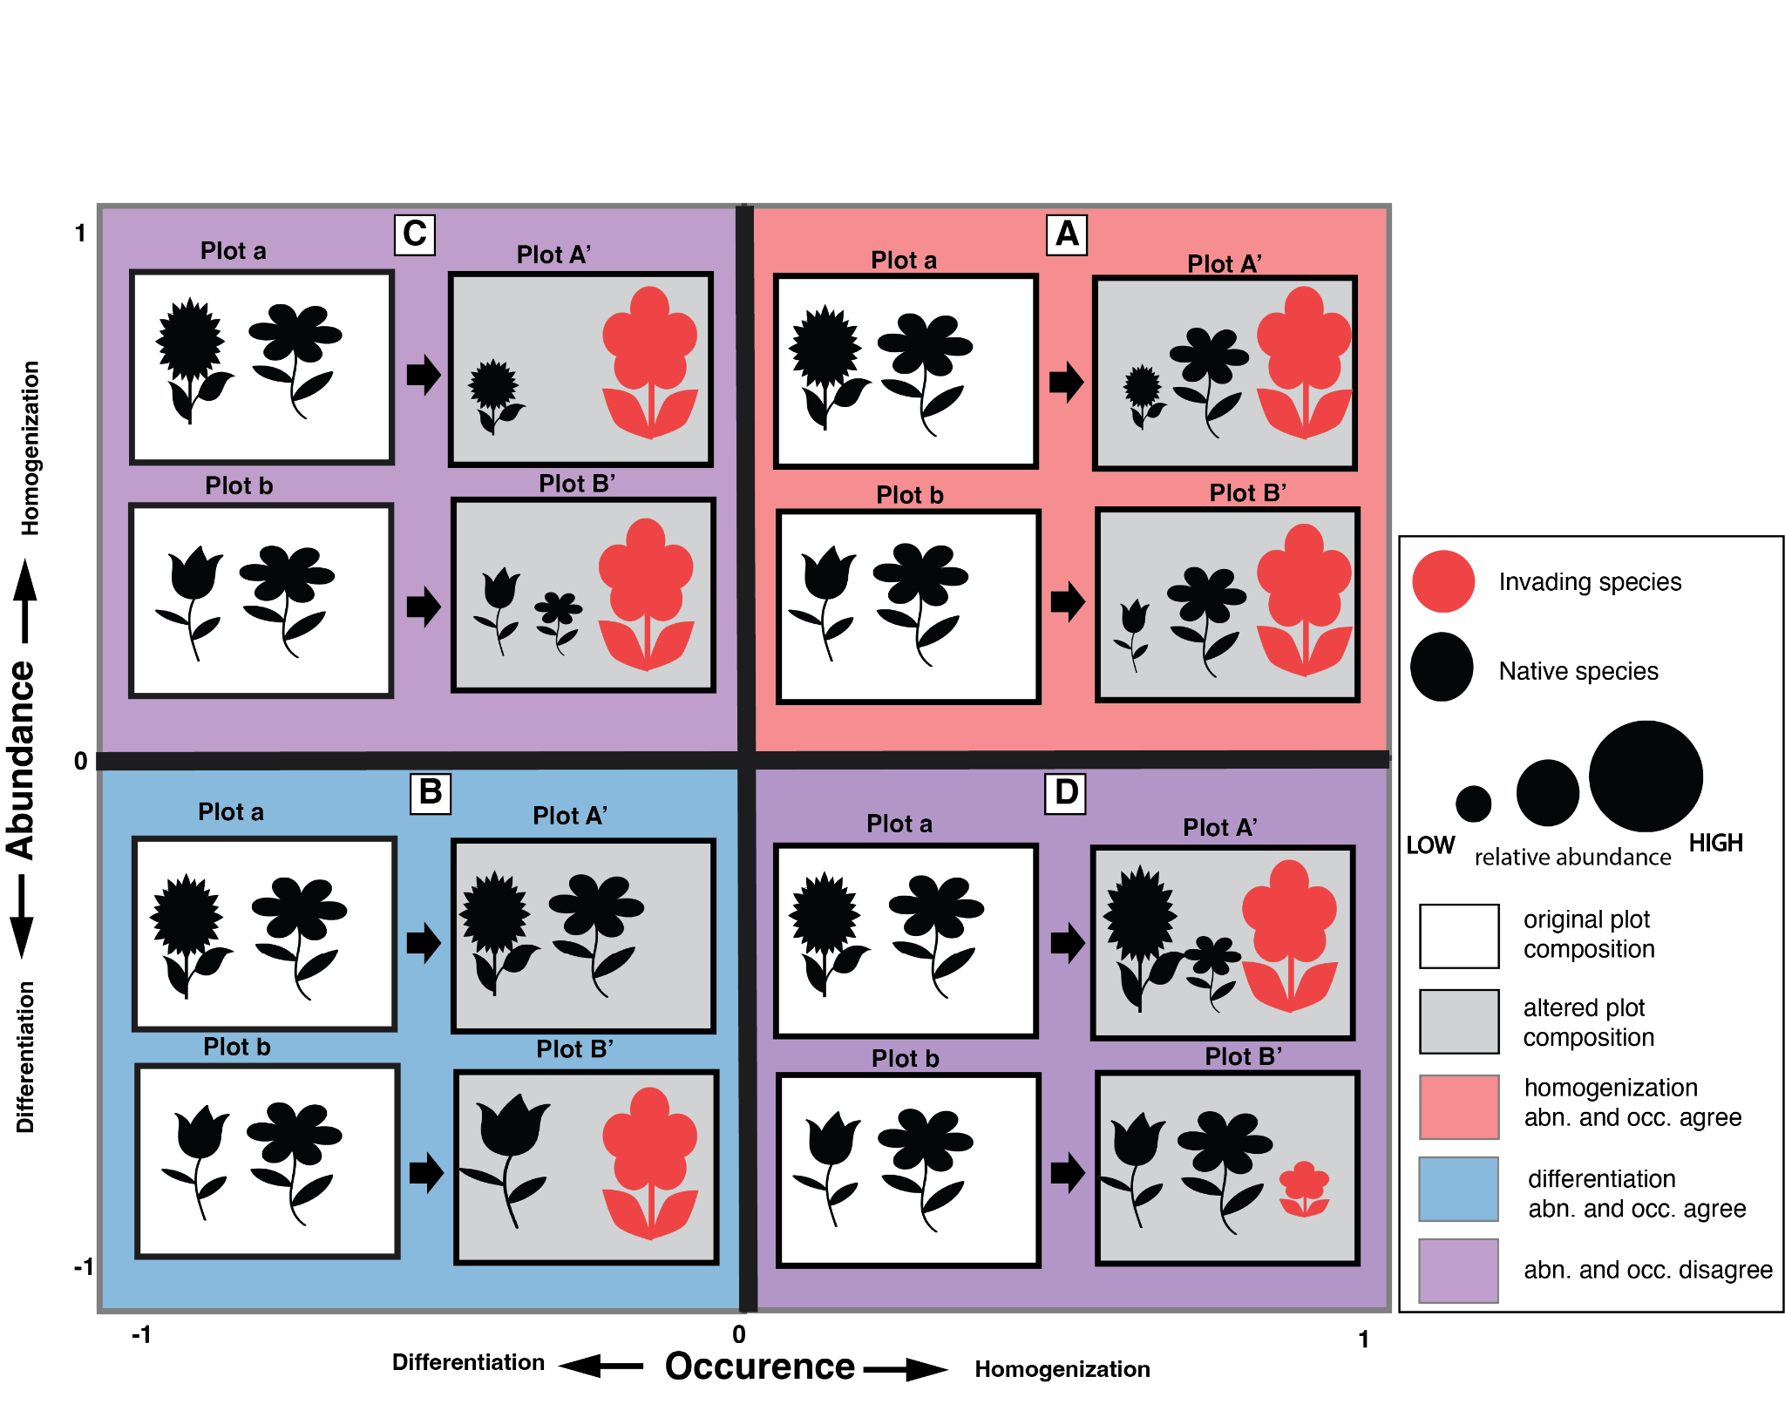

**Figure 5: Scenarios of relationships between occurrence- and abundance-based estimates of beta diversity change. Metrics will either agree (quadrants A, B) or disagree (quadrants C, D) in the direction of change depending on species losses and gains and changes in their abundance after invasion.**  Homogenization according to both metrics (quadrant A) can occur when a new species invades both plots to high abundance and/or when an uncommon species (those not shared between plots) declines or is extirpated. Differentiation according to both metrics (quadrant B) can occur when a new species invades only one plot and/or a common species (those shared between plots) declines, but it is only extirpated from one plot. Estimates of homogenization with abundance-based metrics and differentiation with occurrence-based metrics (quadrant C) can occur when a new species invades both plots at high abundance and uncommon species are extirpated from only one plot. Estimates of homogenization with occurrence-based metrics and differentiation with abundance-based metrics (quadrant D) can occur when a new species invades both plots at contrasting levels of abundance and affects common species abundance across plots, with no extirpations.