Supporting Information for: Using plant invasions to compare occurrence- and abundance-based calculations of biotic homogenization: are results complementary or contradictory?

FIGURES:

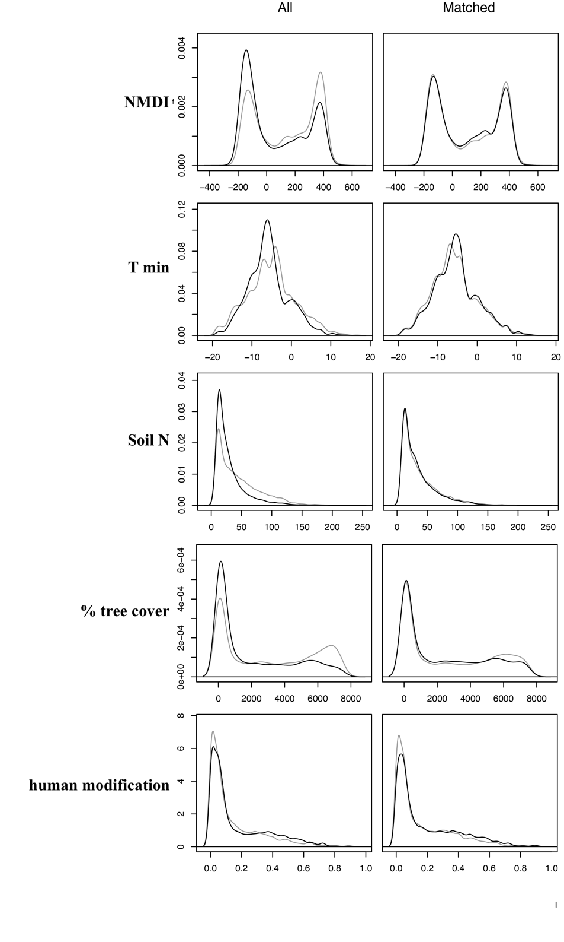

**Figure S1: Results of propensity score matching for univanded and invaded plots.** The left column shows the distribution of environmental variables in uninvaded (gray) and invaded plots (black) for the whole dataset and the right column shows the distributions after matching.