1 **Abstract**

2 1. Temperature and light cues interact to control many biological processes. Experiments give

3 researchers the ability to manipulate these environmental cues independently, and can be

4 designed to robustly quantify their individual and interactive effects on any particular bio-

5 logical activity. Such experiments have produced important insights into the environmental

6 controls on numerous biological processes in both plant and animal taxa across terrestrial and

7 aquatic environments. Testing the interactive effects of multiple environmental cues, how-

8 ever, requires experimental treatments to be fully independent; any unmeasured experimental

9 covariation among treatments can result in incorrect conclusions.

10 2. Using a database of controlled environment experiments on the spring phenology of woody

11 plants as a case study, we highlight how a common experimental set-up, designed to parse

12 the interactive effects of temperature and photoperiod on time to budburst, introduces a

13 latent experimental covariation of these treatments by coupling photo- and thermo- period-

14 icity. Using data simulations, algebraic corrections and a comparative analysis of published

15 experiments, we demonstrate how this unmeasured experimental covariation biases statistical

16 inference regarding the relative contribution of light and temperature cues to phenological

17 variation.

18 3. We identify this experimental covariation in more than 40% of published phenology studies

19 that manipulate photoperiod. Our analyses demonstrate that the coupling of thermo- and

20 photo- periodicity results in the overestimation of the effect of photoperiod, the underesti-

21 mation of forcing effects, and misleading conclusions about their interactions on phenology.

22 This may, in part, explain why the significance of photoperiod cues for spring phenology is

23 currently debated in the literature.

24 4. Accurate forecasting of how varying environmental conditions will impact the dynamics of

25 biological events requires accurately quantifying cues responses. To this end, we present several

26 options for statistical corrections and alternative experimental designs that can provide more

27 robust estimates of the relative effects of temperature and photoperiod on phenology, and

28 many other biological processes controlled by temperature and light.

29 **Keywords:** forcing, full-factorial, growth chamber, light, phenology, photoperiod, temperature,

30 thermoperiod

31

32 **Introduction**

33 Across the tree of life, temperature and light availability shape a number of important biological

34 processes including growth and metabolic rates (MacLean & Gilchrist, 2019), sex determination

35 (Brown *et al.*, 2014), acclimatization to seasonal environments (Hamilton *et al.*, 2016) and the

36 timing of life cycle transitions (i.e., phenology, Forrest & Miller-Rushing, 2010). These biological

37 responses in turn dictate broad-scale ecological processes and patterns ranging from biogeochemical

38 cycling (Piao *et al.*, 2007) to species range limits (Chuine & Beaubien, 2001). Characterizing the

39 specific dynamics of how these environmental factors synergistically affect biological processes across

40 a wide range of taxa has become even more important as anthropogenic global change continues to

41 expose organisms to novel environmental conditions (Pörtner & Farrell, 2008).

42 Because temperature and light availability often co-vary in the field (for example, in most temperate

43 ecosystems, daylength and temperature both increase as the season progresses, Rosenberg, 1974),

44 it can be diﬀicult to disentangle their relative contributions to biological processes. In contrast,

45 experimental manipulations of climate variables in artificial environments can mechanistically char-

46 acterize biological responses to environmental fluctuations (Ettinger *et al.*, 2020; Primack *et al.*,

47 2015). Researchers have used controlled environments of all shapes and sizes to this end (Downs,

48 1980); these efforts have greatly advanced our collective understanding of the fundamental biology

49 of a wide variety of organisms and ability to predict ecological and evolutionary responses to current

50 and future climate change (Stewart *et al.*, 2013).

51 However, controlled environment experiments have their own challenges. Experimentalists must

52 balance biological realism with robust inference, experimental effort with statistical power, and

53 account for the effects of unmanipulated or unmeasured variables (Scheiner & Gurevitch, 2001).

54 Because biological responses to the environment are generally the product of complex interactions

55 between multiple environmental signals (Casal, 2002), seemingly small choices about experimental

56 designs can generate significant differences in outcomes. Experimental treatments are rarely stan-

57 dardized among researchers, even within disciplines (Wolkovich *et al.*, 2022), and these complexities

58 may in part contribute to the many discrepancies between experimental studies and observational

59 data (Poorter *et al.*, 2016). Even with these limitations, controlled environment studies remain

60 a powerful tool to mechanistically assess organismic responses to the environment, provided that

61 the implications of treatment designs are well understood and well matched with the scope of the

62 research question.

63 As technology advances and experiments become more complex, researchers can manipulate more

64 variables and multiple axes of variation (e.g., temperature, amplitude, periodicity, wavelength) at

65 the same time. Yet these efforts may present a tradeoff between biological realism and robust in-

66 ference. Through investigating the literature on experiments with plant phenology, we show that

67 experiments that manipulate both photo- and thermo- periodicity often introduce a latent experi-

68 mental covariation between light and temperature treatments, which may misrepresent the effects

69 of each of these environmental variables and the interaction between them. We begin by briefly

70 detailing how temperature and light treatments are generally applied in phenology experiments and

71 review the minimum experimental elements required to robustly test interactions between two or

72 more environmental variables. We then detail the problem of inference that can arise when manip-

73 ulating the periodicity of both temperature and light in experiments, and demonstrate the extent

74 to which this is an issue through data simulations, a mathematical correction, and a comparative

75 analysis of published experiments. Finally, we conclude by outlining methods that correct for this

76 issue, along with alternative experimental designs that can overcome the problem of periodicity.

77 While our case study deals with phenology of temperate woody plants, it provides insights into a

78 number of other systems with parallel issues. Studies of aquatic algae (Xu *et al.*, 2019), insects (And-

79 uaga *et al.*, 2018), amphibians (Wright & Bruni, 2004) and fish (López‐Olmeda & Sánchez‐Vázquez,

80 2009) have similarly struggled to disentangle the effects of thermo- and photo- periodicity. Thus,

81 we believe the potential problems and solutions we present here are broadly applicable to studies

82 on any other organisms and biological processes that utilize temperature and light signals.

# 83 Case study: Estimating phenological cues from experiments

84 Decades of experimental work in controlled environments have demonstrated that temperature

85 (both cool temperatures in fall/winter and warming temperatures in spring) and photoperiod are

86 the primary phenological cues for plants in the temperate/boreal zones (Ettinger *et al.*, 2020). While

87 exposure to cool winter temperatures (chilling) strongly impacts phenology (Laube *et al.*, 2014), we

88 focus here on warm temperature and light treatments, because controlled chilling treatments with

89 light are uncommon (Wolkovich *et al.*, 2022). Choices about how to apply warm temperature and

90 light treatments, in particular, can compromise inference on their effects, so we focus on these two

91 cues.

92 While a large variety of experimental designs have been used to study plant phenology, generally

93 experiments tend to manipulate two major axes of light and warm temperature variation:

94 1. Intensity: The amount or quality of a variable. Here we define temperature intensity as the

95 amount of heat present in the system (measured in degrees). In the phenology literature this

96 measurement is generally referred to as forcing. We define light intensity as the luminosity or

97 irradiance present in the system (measured in lumens or watts).

98 2. Periodicity: The interval at which the intensity of the variable is applied. Hereafter, we refer

99 to the periodicity of light as photoperiod (often used synonymously with “daylength”) and

100 the periodicity of temperature as thermoperiod.

101 For phenology, photoperiodicity is generally considered the primary light cue for plants (Way &

102 Montgomery, 2015), (though regarding light intensity and phenology see Brelsford & Robson, 2018;

103 Cober *et al.*, 1996). For temperature, conventionally both intensity and periodicity drive pheno-

104 logical activity and several metrics (e.g. growing degree hours, thermal sums, growing degree days)

105 that combine these two axes have been developed (Gu, 2016). The importance of thermo-intensity

106 and periodicity is well supported; under natural conditions diurnal temperature fluctuations in tem-

107 perate regions can be quite large in the spring, and studies have found that diurnal temperature

108 variation strongly influences plant phenology (Burghardt *et al.*, 2016). In fact, even if thermoperi-

109 odicity is not an explicit treatment variable (i.e., manipulated systematically), incorporating it in

110 experiments can be essential for translating experimental results into real world predictions (Chiang

111 *et al.*, 2020).

112 Like many other biological processes, recent advances have demonstrated that plant phenological

113 responses are nonlinear, due largely to interactions between cues (Wolkovich *et al.*, 2022; Fu *et al.*,

114 2015), highlighting the need for experiments designed to evaluate the strength of these interactions.

115 To have the statistical power to partition the individual and interactive effects of two or more

116 variables, an experiment must:

117 1. Have a minimum of two treatment levels of at least two variables.

118 2. Treatment levels must be full factorial (Fig. 1a.). Full factorial designs are both balanced

119 (Fig. 1b.) and orthogonal (Fig. 1c.); meaning that all possible treatment combinations are

120 applied and each treatment is independent of all others (Cheng, 2016).

121 These two critical elements may seem obvious but are conspicuously absent from many published

122 studies. Of the 136 studies contained in a published database of woody plant phenological ex-

123 periments (OSPREE: Observed Spring Phenological Responses in Experimental Environments,

124 Wolkovich *et al.*, 2019), a recent study by Wolkovich *et al.*(2022) found that only 37% of the

125 studies that manipulated more than one variable did so with a design that was both balanced and

126 orthogonal. But even experiments that are designed to be full factorial frequently violate the as-

127 sumption of orthogonality when both photo- and thermo- periodicity are built into experiments.

128 We detail this problem below.

# 129 The problem of periodicity

130 A common approach in phenology experiments that seems to balance prior knowledge about the

131 underlying physiology of phenology, biological realism and experimental inference is to vary pho-

132 toperiodicity, and thermal intensity and periodicity (e.g., Flynn & Wolkovich, 2018; Sanz-Perez

133 *et al.*, 2009; Basler & Körner, 2014). This design could include any number of treatment levels for

134 each variable (e.g., 8, 12, 16...*n* hours of photoperiod and 20/10*◦*C, 22/12*◦*C, 25/15*◦*C...*nday/nnight*

135 day/night temperatures). To consider a simple example, we use a hypothetical experiment with

136 two treatment levels of each variable. Consider a basic experiment that includes, at minimum, a

137 long (16 hours) and short (8 hours) photoperiod treatment and a high (25/15*◦*C day/night) and

138 low (20/10*◦*C day/night) forcing treatment. In this case, the thermoperiodicity is not an explicit

139 treatment (both high and low temperature treatments use a diurnal fluctuation of 10 *◦*C), and is

140 simply incorporated in the design to enhance biological realism. At first glance, this design appears

141 to meet the criteria of a full factorial design, multiple treatment levels that are balanced and or-

142 thogonal, with high/low temperature treatments (mean 20*◦*C and 15*◦*C respectively) and long/short

143 photoperiod treatments applied in all possible combinations.

144 Yet the orthogonality of this design is based on the assumption of a 12 hour thermoperiod. If, rather

145 the thermoperiod is coupled with the photoperiod, the temperature treatment is non-orthogonal

146 because the daily mean temperature of the long/high treatment will be higher than that of the

147 short/high treatment, and the long/low treatment slightly warmer than the short/low. We refer

148 to this experimental set-up as a coupled design (i.e. thermoperiod and photoperiod are coupled

149 with each other). Coupled designs introduce an experimental covariation between photoperiod and

150 forcing treatments. This experimental covariation is clearly illustrated when temperature treatment

151 levels are converted to thermals sums. We calculate thermal sums (also called growing degree hours),

152 by multiplying hourly temperatures above a certain base temperature threshold by the number of

153 hours for which they are applied over a 24 hour period (Parent *et al.*, 2019). For example, given a

154 base temperature of 0*◦*C, a low forcing treatment of 20/10*◦*C day/night accrues 400 thermal units

155 per 24 hours when crossed with the long (16 hour) photoperiod treatment and only 320 thermal units

156 when crossed with the short (8 hour) photoperiod treatment. While this experimental covariation

157 among the photoperiod and temperature treatments is biologically realistic, it makes it statistically

158 impossible to differentiate the independent and interactive effects of temperature and photoperiod

159 on any given biological process.

160 This problem of inference that arises from the experimental covariation of thermo- and photo-

161 periodicity is not limited only to studies seeking to directly compare the effects of photoperiod and

162 forcing; it applies in any study evaluating the influence of photoperiod on biological activity, even if

163 it is the only manipulated cue. Experimentally isolating the effect of photoperiod assumes that all

164 other environmental variables are held constant. Similar to the case described above, the coupling

165 of photoperiod and thermoperiod in an experiment where forcing is intended to be a consistent,

166 background condition (e.g., two or more levels of photoperiod treatments (e.g. 8, 12, and 16 hours),

167 all at a background temperature of 20/10*◦*C day/night) would yield a situation in which longer

168 photoperiod treatments were also receiving more—unmeasured—heating than shorter photoperiod

169 treatments. In this case, some amount of the perceived photoperiod effect is due to the latent,

170 increased forcing, and the experiment will not isolate the true effect of photoperiod.

171 We queried the OSPREE database to identify experiments that applied different day and night

172 temperatures in their studies without designating diurnal temperature variation as an explicit ex-

173 perimental treatment. Of the 51 experiments in the OSPREE database that manipulated pho-

174 toperiod experimentally, up to 43% of them appear to include an experimental covariation with

175 thermoperiod. Of the 18 studies that manipulated both photoperiod and temperature interactively,

176 we found that up to 55% of them appear to have this issue, suggesting that the true interactive

177 effects of these cues on spring phenology is quite poorly characterized. This may be in part why

178 the relative contribution of temperature and photoperiod cues to spring phenology remains a con-

179 tentious debate in the phenology literature (Koerner & Basler, 2010; Chuine *et al.*, 2010; Körner &

180 Basler, 2010).

# 181 Periodicity and inference

182 If the lack of orthogonality introduced to experiments when photoperiod and thermoperiod are

183 coupled is overlooked, regression models will always overestimate the photoperiod effect and un-

184 derestimate the forcing effect (Fig. 2a,b.). This is because forcing is the variable with latent,

185 unmeasured variation. In the case of phenology, this is particularly significant because studies

186 repeatedly suggest that forcing is a more dominant cue than photoperiod for spring phenology

187 (Chuine *et al.*, 2010; Zohner *et al.*, 2016; Gauzere *et al.*, 2019). The influence of this experimental

188 covariation of periodicity on generating incorrect estimations of temperate and photoperiod cue

189 effect-sizes pervades experiments with any number of treatment levels (see Fig. S1 for an example

190 with three treatment levels of forcing and photoperiod), and may be even more diﬀicult to identify

191 as experimental complexity increases.

192 If experiments are designed to quantify the interaction between photoperiod and forcing, here too,

193 the experimental covariation of periodicity will result in an erroneous estimation of the interaction.

194 (Fig. 2c,d.). Our simulation depicts a particularly troublesome case where a true sub-additive

195 interaction is interpreted as a supra-additive one (Fig. 2c,d.), however, other outcomes are possible.

196 Experimental covariation of light and temperature treatments due to coupling thermo- and photo-

197 periodicity will generally result in the incorrect estimation of the interaction term, but the exact

198 nature of this statistical issue depends on the sign and strength of the interaction.

199 We can attempt to estimate how much of a photoperiod effect is due to forcing in experiments where

200 they covary by making several major assumptions. First we assume that forcing and photoperiod

201 effects are additive and linear (i.e., there is no interaction). While this may not be true in nature, it

202 gives us insight into the potential effect of the experimental covariation of periodicity by allowing us

203 to solve algebraically for the separate effects of forcing and photoperiod. We replace the qualitative

204 factor (high/low forcing) by the quantitative effect of forcing (thermal sums) to properly account

205 for the difference in forcing between short and long photoperiods (see Supporting Information:

206 Estimating the effects of experimental periodicity covariance mathematically). Using the data from

207 one experiment that experimentally coupled thermo- and photo-period, Flynn & Wolkovich (2018),

208 we found that 33% of the published photoperiod effect of 4.5 days could be due to forcing.

209 Our algebraic solution cannot be as readily applied in experiments that assume photoperiod and

210 forcing interact. However, we can generally assess the scope of the problem of inference due to

211 experimental covariation of periodicity by comparing studies that used a coupled design to those with

212 alternative approaches. While we are aware of no experiments that explicitly compare the effects

213 of experimentally coupling vs. uncoupling photo- and thermo- periods, we identified two phenology

214 experiments that utilized many overlapping treatment levels and species from the same sampling

215 sites, however in one study, Flynn & Wolkovich (2018), photo- and thermo- period experimentally

216 co-vary, while in the other, Buonaiuto & Wolkovich (2021), photo- and thermo- period were varied

217 independently (see Supporting Information: Modeling Methods for details on treatment similarities

218 and differences between the studies). Comparing the cue estimates from these two studies offers

219 an opportunity to test our theoretical and mathematical predictions, and further understand the

220 uncertainty in cue estimates due to coupled periodicities.

221 We subset each dataset to include only the species shared among the two studies, and re-analyzed

222 the data using Bayesian hierarchical models to compare the difference in the photoperiod, forcing

223 and interaction estimates (see Supporting Information: Modeling Methods). We found that the

224 estimated differences in the mean response to photoperiod and forcing and their interactions among

225 study designs were on the same order as our predictions above for misestimated cue effects due to

226 experimental covariation between light and temperature treatments. We estimated a substantially

227 weaker (less negative) photoperiod effect, and marginally stronger forcing effect for the uncoupled

228 vs. coupled experimental design (Fig. 3). The interaction term we estimated for the uncoupled

229 design was negative, suggesting the interaction between photoperiod and forcing is supra-additive,

230 while the estimated interactive effect from the coupled design was sub-additive (Fig. 3).

231 Unlike in our simulations (Fig. 2), in this comparison we cannot assess what the “true” effects

232 of these variables are. There are almost certainly other factors driving the differences between

233 these experiments. Both were conducted in different years, sampled different individuals from the

234 population, and used different methods for applying chilling pre-treatments (Flynn & Wolkovich,

235 2018; Buonaiuto & Wolkovich, 2021). However, because this comparison is well matched to our

236 predictions and prior knowledge about how temperature and photoperiod are expected to interact-

237 ing in phenology, we argue that the influence of experimental covariation on statistical inference is

238 apparent enough to take seriously.

239

240 **Paths Forward**

241 We have demonstrated that experiments that coupled thermoperiod and photoperiod cannot ro-

242 bustly differentiate the individual or interactive effects of temperature and photoperiod on spring

243 phenology (or any other biological process) due to an unmeasured experimental covariation among

244 temperature and light treatments. Given the paucity of interactive studies in the literature, it is

245 clear that we need more well designed studies to better characterize the effects of these cues. At

246 the same time, there are straight-forward statistical approaches for accounting for this experimental

247 covariation that can be adopted immediately and will rapidly improve scope of inference possible

248 with controlled environment experiments. Below we detail these approaches, and then offer several

249 generalized experimental designs that improve statistical orthogonality of controlled environment

250 experiments, which could be further developed and adjusted to fit the needs of experimentalists

251 across many sub-fields of ecology and evolutionary biology.

## 252 Effect-size inference and statistical corrections:

253 It may be that the experimental design that best balances environmental realism, statistical infer-

254 ence and translatability to observational studies are designs that continue to couple periodicity to

255 mimic natural systems. Fundamentally, simply recognizing the issues that arise when thermo- and

256 photoperiods are experimentally co-varied and accounting for this in interpreting effect-sizes and

257 reporting uncertainty is a powerful start for improving inference from experiments. This awareness

258 can be applied both forward and backward; to future experiments that seek to understand the

259 interactive effects of temperature and photoperiod and to synthesizing and interpreting the near-

260 century’s worth of research in this area that has already been published. The growing awareness of

261 this issue has prompted the development of several simple statistical corrections to deal with this

262 experimental covariation. Some recent studies adjust temperature effect-sizes in their statistical

263 models by daylength treatments (e.g., Ettinger *et al.*, 2020). For example, if a day/night forcing

264 treatment of 25/15*◦*C was applied in conjunction with 8 and 16 hour photoperiod treatment levels,

265 the mean daily temperature of the forcing level can be weighted by hours for which it was applied,

266 in this case resulting in forcing treatments with mean temperatures of 18.3*◦*C and 21.6*◦*C respec-

267 tively. This approach does not remove the covariation between temperature and photoperiod (i.e.,

268 the higher photoperiod treatment is still getting more heat that the lower photoperiod treatment,

269 e.g, Fig. 1b), but this covariation is no longer latent, and can be accounted for in a regression

270 model. This is a simple approach could be adopted by any experimentalist that will substantially

271 increase the utility of such experiments for ecological forecasting.

## 272 Experimental Re-designs:

273 Alternatively, for experimentalists interested in taking on this problem of periodicity head-on in

274 their experiments, there are several experimental design that can either eliminate the problem of

275 experimental covariation of photo- and thermo-period entirely, or more robustly address it at the

276 experimental stage. Below, we provide general details about alternative experimental designs with

277 representative examples in Fig. 4. As in our previous examples, here we depict experiments with

278 two levels of two experimental variables (photoperiod and temperature), but importantly, these

279 generalized scheme can be readily adapted for experiments with any number of treatment levels

280 number of variables, as long as they are full-factorial. Further, these designs could be adapted for

281 any experimental variables for which both intensity and periodicity can be manipulated (e.g. light,

282 humidity, heat or freeze shock etc).

283 1. **Manipulate photoperiod and temperature intensity with no thermoperiodicity**.

284 The simplest way to evaluate the individual and combined effects of temperature and pho-

285 toperiod in experimental settings is to remove thermoperiodicity from studies entirely by

286 maintaining constant day/night temperatures within temperature treatments (Fig. 4a.). This

287 approach allows for the maintenance of statistical orthogonality across treatment combina-

288 tions. The main drawback is that for select biological processes in some organisms, this design

289 sacrifices the realism of diurnal temperature variation, which may make it more diﬀicult to

290 translate estimates from experiments to real-world applications. However, many aspects of

291 physiology and development do not appear to respond explicitly to diurnal temperature vari-

292 ation (e.g., Hellmers, 1966; Warrington *et al.*, 1977; Bhatt *et al.*, 2019), so in many cases this

293 experimental simplification may be worthwhile to improve inference on the overall individual

294 and combined effect of temperature and photoperiod on biological processes.

295 2. **Uncouple thermoperiod and photoperiod**. By varying thermoperiod and photoperiod

296 independently, statistical orthogonality can be maintained across treatments. For example,

297 a study could apply photoperiod treatment levels of 8 vs. 16 hour day/night with a 12

298 hour thermoperiod regime across temperature treatments (Fig. 4b.). While this approach

299 allows for more robust evaluation of cue effects and interactions, uncoupling photoperiod

300 and thermoperiod can require newer and more expensive technologies which many not be

301 widely available. Further, this approach may also introduce new artifacts that occur from

302 the biological rather than statistical interactions between light and temperature (Chew *et al.*,

303 2012). There is evidence that increasing temperatures in the first two hours of daylight can

304 be almost as effective for stimulating shoot elongation as similar temperature increases for

305 the whole photoperiod (Erwin, 1998). With this design, treatments must inherently differ in

306 the amount of time the warmer daytime temperature extends into the dark, nighttime light

307 regime (or vice versa), introducing a new axis of non-orthogonality.

308 3. **Include thermoperiodicity as an explicit experimental treatment**. In many study

309 systems in which both photoperiod and thermoperiod influence biological processes, experi-

310 mentalists often include thermoperiodicity as an explicit experimental treatment with both

311 constant and varying day/night temperatures applied as separate treatment variables (e.g.,

312 Zaslavski *et al.*, 1995). Such experiments are the best way to assess the comparative im-

313 portance of temperature intensity and periodicity, which would provide important insights

314 towards parsing the relative strength of temperature and light cues and their interactions,

315 (Fig. 4c.). However, executing such an experiment with a full-factorial design would sub-

316 stantially increase the size of a study and its experimental effort and, given the availability of

317 the statistical tools and simpler experimental designs we discuss above, may only be worth-

318 while when researchers are explicitly interested in the relative contributions of periodicity and

319 intensity in a particular study system.

320 As we stated above, any of these designs can be implemented for any number of treatment levels,

321 and incorporate additional manipulated variables. This is a particularly important in the context

322 of global change because shifts in the magnitude, and even direction, of climate change will vary

323 spatially, and in some systems, two level studies may struggle to estimate interactions due to under-

324 sampled treatment levels (Collins *et al.*, 2022). Researchers seeking to capture such environmental

325 dynamics could adapt these design to include at least a ”control”, ”increase” and ”decrease” treat-

326 ment levels for experimental variables. Additionally, with increasing numbers of treatments and

327 treatment levels, full-factorial experiments can be implement with a *response surface methodology*,

328 (e.g, Schubert *et al.*, 2009; Begoude *et al.*, 2007); a powerful approach for detecting interactions and

329 non-linearities among variables. Experimentalists should leverage their knowledge of the natural

330 history of their study organisms, historical climate observations and climate change projections to

331 determine the treatment levels that are most appropriate for their study.

332 In correcting one problem, each of these designs introduces another, which may in fact be an intrinsic

333 property of any experimental manipulation. It would be useful for researchers to explicitly test how

334 cue estimates vary among experimental designs, and which design is most useful for predicting

335 biological responses to environmental cues in the field under current and future climate conditions.

336 In the meantime, we hope that this issue is a reminder that, as experimentalists, we must continue to

337 be thoughtful about matching our experimental designs to the goals of a study, and be transparent

338 about uncertainty around our experimental inference.

339 **References**

340 Anduaga, A.M., Nagy, D., Costa, R. & Kyriacou, C.P. (2018) Diapause in drosophila melanogaster

341 – photoperiodicity, cold tolerance and metabolites. *Journal of Insect Physiology* **105**, 46–53.

342 Basler, D. & Körner, C. (2014) Photoperiod and temperature responses of bud swelling and bud

343 burst in four temperate forest tree species. *Tree physiology* **34**, 377–388.

344 Begoude, B.A.D., Lahlali, R., Friel, D., Tondje, P.R. & Jijakli, M.H. (2007) Response surface

345 methodology study of the combined effects of temperature, ph, and aw on the growth rate of

346 trichoderma asperellum. *Journal of Applied Microbiology* **103**, 845–854.

347 Bhatt, A., Bhat, N.R., Suleiman, M.K. & Santo, A. (2019) Effects of storage, mucilage presence,

348 photoperiod, thermoperiod and salinity on germination of farsetia aegyptia turra (brassicaceae)

349 seeds: implications for restoration and seed banks in arabian desert. *Plant Biosystems - An*

350 *International Journal Dealing with all Aspects of Plant Biology* **153**, 280–287.

351 Brelsford, C.C. & Robson, T.M. (2018) Blue light advances bud burst in branches of three deciduous

352 tree species under short-day conditions. *Trees-Structure and Function* **32**, 1157–1164.

353 Brown, E.E., Baumann, H. & Conover, D.O. (2014) Temperature and photoperiod effects on sex

354 determination in a fish. *Journal of Experimental Marine Biology and Ecology* **461**, 39–43.

355 Buonaiuto, D.M. & Wolkovich, E.M. (2021) Differences between flower and leaf phenological re-

356 sponses to environmental variation drive shifts in spring phenological sequences of temperate

357 woody plants. *Journal of Ecology* **109**, 2922–2933.

358 Burghardt, L.T., Runcie, D.E., Wilczek, A.M., Cooper, M.D., Roe, J.L., Welch, S.M. & Schmitt, J.

359 (2016) Fluctuating, warm temperatures decrease the effect of a key floral repressor on flowering

360 time in arabidopsis thaliana. *New Phytologist* **210**, 564–576.

361 Casal, J.J. (2002) Environmental cues affecting development. *Current Opinion in Plant Biology* **5**,

362 37–42.

363 Cheng, C.S. (2016) *Theory of Factorial Design*. Chapman and Hall/CRC.

364 Chew, Y.H., Wilczek, A.M., Williams, M., Welch, S.M., Schmitt, J. & Halliday, K.J. (2012) An

365 augmented arabidopsis phenology model reveals seasonal temperature control of flowering time.

366 *New Phytologist* **194**, 654–665.

367 Chiang, C., Bånkestad, D. & Hoch, G. (2020) Reaching natural growth: The significance of light

368 and temperature fluctuations in plant performance in indoor growth facilities. *Plants* **9**.

369 Chuine, I. & Beaubien, E. (2001) Phenology is a major determinant of tree species range. *Ecology*

370 *Letters* **4**, 500–510.

371 Chuine, I., Morin, X., Bugmann, H., Koerner, C. & Basler, D. (2010) Warming, photoperiods, and

372 tree phenology. *Science* **329**, 277–278.

373 Cober, E., Tanner, J. & Voldeng, H. (1996) Soybean photoperiod-sensitivity loci respond differen-

374 tially to light quality. *Crop Science* **36**, 606–610.

375 Collins, S., Whittaker, H. & Thomas, M.K. (2022) The need for unrealistic experiments in global

376 change biology. *Current Opinion in Microbiology* **68**, 102151.

377 Downs, R.J. (1980) Phytotrons. *Botanical Review* **46**, 447–489.

378 Erwin, J. (1998) Temperature and light effects on stem elongation. *Journal of the Japanses Society*

379 *For Horticultural Science* **67**, 1113–1120, Session of Plant Growth Regulation by Physical and

380 Mechanical Stimuli at the Commemorative Symposium of the 75th Anniversary of Japanese-

381 Society-for-Horticultural-Science, JAPAN, APR 03-04, 1998.

382 Ettinger, A.K., Chamberlain, C.J., Morales-Castilla, I., Buonaiuto, D.M., Flynn, D.F.B., Savas, T.,

383 Samaha, J.A. & Wolkovich, E.M. (2020) Winter temperatures predominate in spring phenological

384 responses to warming. *Nature Climate Change* **10**, 1137–1142.

385 Flynn, D.F.B. & Wolkovich, E.M. (2018) Temperature and photoperiod drive spring phenology

386 across all species in a temperate forest community. *New Phytologist* **219**, 1353–1362.

387 Forrest, J. & Miller-Rushing, A.J. (2010) Toward a synthetic understanding of the role of phenology

388 in ecology and evolution. *Philosophical Transactions of the Royal Society of London B: Biological*

389 *Sciences* **365**, 3101–3112.

390 Fu, Y.S.H., Zhao, H.F., Piao, S.L., Peaucelle, M., Peng, S.S., Zhou, G.Y., Ciais, P., Huang, M.T.,

391 Menzel, A., Uelas, J.P., Song, Y., Vitasse, Y., Zeng, Z.Z. & Janssens, I.A. (2015) Declining global

392 warming effects on the phenology of spring leaf unfolding. *Nature* **526**, 104–107.

393 Gauzere, J., Lucas, C., Ronce, O., Davi, H. & Chuine, I. (2019) Sensitivity analysis of tree phenol-

394 ogy models reveals increasing sensitivity of their predictions to winter chilling temperature and

395 photoperiod with warming climate. *Ecological Modelling* **411**, 108805.

396 Gu, S. (2016) Growing degree hours - a simple, accurate, and precise protocol to approximate

397 growing heat summation for grapevines. *International Journal of Biometeorology* **60**, 1123–1134.

398 Hamilton, J.A., El Kayal, W., Hart, A.T., Runcie, D.E., Arango-Velez, A. & Cooke, J.E. (2016)

399 The joint influence of photoperiod and temperature during growth cessation and development of

400 dormancy in white spruce (Picea glauca). *Tree Physiology* **36**, 1432–1448.

401 Hellmers, H. (1966) Growth response of redwood seedlings to thermoperiodism. *Forest Science* **12**,

402 276–283.

403 Koerner, C. & Basler, D. (2010) Phenology under global warming. *Science* **327**, 1461–1462.

404 Körner, C. & Basler, D. (2010) Response—warming, photoperiods, and tree phenology. *Science*

405 **329**, 278–278.

406 Laube, J., Sparks, T.H., Estrella, N., Höfler, J., Ankerst, D.P. & Menzel, A. (2014) Chilling out-

407 weighs photoperiod in preventing precocious spring development. *Global Change Biology* **20**,

408 170–182.

409 López‐Olmeda, J.F. & Sánchez‐Vázquez, F.J. (2009) Zebrafish temperature selection and synchro-

410 nization of locomotor activity circadian rhythm to ahemeral cycles of light and temperature.

411 *Chronobiology International* **26**, 200–218.

412 MacLean, H.J. & Gilchrist, G.W. (2019) Temperature, photoperiod and life history traits in

413 drosophila subobscura. *bioRxiv* p. 717967.

414 Parent, B., Millet, E.J. & Tardieu, F. (2019) The use of thermal time in plant studies has a sound

415 theoretical basis provided that confounding effects are avoided. *Journal of Experimental Botany*

416 **70**, 2359–2370.

417 Piao, S., Friedlingstein, P., Ciais, P., Viovy, N. & Demarty, J. (2007) Growing season extension and

418 its impact on terrestrial carbon cycle in the northern hemisphere over the past 2 decades. *Global*

419 *Biogeochemical Cycles* **21**.

420 Poorter, H., Fiorani, F., Pieruschka, R., Wojciechowski, T., van der Putten, W.H., Kleyer, M.,

421 Schurr, U. & Postma, J. (2016) Pampered inside, pestered outside? differences and similarities

422 between plants growing in controlled conditions and in the field. *New Phytologist* **212**, 838–855.

423 Pörtner, H.O. & Farrell, A.P. (2008) Physiology and climate change. *Science* **322**, 690–692.

424 Primack, R.B., Laube, J., Gallinat, A.S. & Menzel, A. (2015) From observations to experiments

425 in phenology research: investigating climate change impacts on trees and shrubs using dormant

426 twigs. *Annals of Botany* **116**, 889–897.

427 Rosenberg, N.J. (1974) *Microclimate: the biological environment*. Wiley, New York.

428 Sanz-Perez, V., Castro-Diez, P. & Valladares, F. (2009) Differential and interactive effects of tem-

429 perature and photoperiod on budburst and carbon reserves in two co-occurring Mediterranean

430 oaks. *Plant Biology* **11**, 142–51.

431 Scheiner, S.M. & Gurevitch, J. (2001) *Design and analysis of ecological experiments*. Oxford Uni-

432 versity Press.

433 Schubert, M., Mourad, S., Fink, S. & Schwarze, F. (2009) Ecophysiological responses of the biocon-

434 trol agent trichoderma atroviride (t-15603.1) to combined environmental parameters. *Biological*

435 *Control* **49**, 84–90.

436 Stewart, R.I.A., Dossena, M., Bohan, D.A., Jeppesen, E., Kordas, R.L., Ledger, M.E., Meerhoff,

437 M., Moss, B., Mulder, C., Shurin, J.B., Suttle, B., Thompson, R., Trimmer, M. & Woodward, G.

438 (2013) *Chapter Two - Mesocosm Experiments as a Tool for Ecological Climate-Change Research*,

439 vol. 48, pp. 71–181. Academic Press.

440 Warrington, I., Peet, M., Patterson, D., Bunce, J., Haslemore, R. & Hellmers, H. (1977) Growth

441 and physiological responses of soybean under various thermoperiods. *Functional Plant Biology* **4**,

442 371–380.

443 Way, D.A. & Montgomery, R.A. (2015) Photoperiod constraints on tree phenology, performance

444 and migration in a warming world. *Plant, Cell & Environment* **38**, 1725–1736.

445 Wolkovich, E.M., Chamberlain, C.J., Buonaiuto, D.M., Ettinger, A.K. & Morales-Castilla, I. (2022)

446 Integrating experiments to predict interactive cue effects on spring phenology with warming. *New*

447 *Phytologist* **235**, 1719–1728.

448 Wolkovich, E.M., Ettinger, A.K., Flynn, D., Savas, T., Chamberlain, C., Buonaiuto, D. &

449 Samaha, J. (2019) Observed spring phenology responses in experimental environments (OS-

450 PREE). doi:10.5063/F1CZ35KB.

451 Wright, M.L. & Bruni, N.K. (2004) Influence of the photocycle and thermocycle on rhythms of

452 plasma thyroxine and plasma and ocular melatonin in late metamorphic stages of the bullfrog

453 tadpole, rana catesbeiana. *Comparative Biochemistry and Physiology Part A: Molecular Inte-*

454 *grative Physiology* **139**, 33–40.

455 Xu, D., Song, X., Li, F., Pan, X., Zhu, W. & Zhang, X. (2019) Effects of desiccation, diurnal

456 temperature changes and irradiance on archeospore production of pyropia yezoensis. *Aquaculture*

457 **509**, 167–170.

458 Zaslavski, V.A., Zinovjeva, K.B., Reznik, S.Y. & Umarova, T.Y. (1995) Effect of photoperiod and

459 thermoperiod on the eclosion rhythm of trichogramma evanescens. *Entomologia Experimentalis*

460 *et Applicata* **74**, 99–104.

461 Zohner, C.M., Benito, B.M., Svenning, J.C. & Renner, S.S. (2016) Day length unlikely to constrain

462 climate-driven shifts in leaf-out times of northern woody plants. *Nature Climate Change* **6**, 1120–

463 1123.

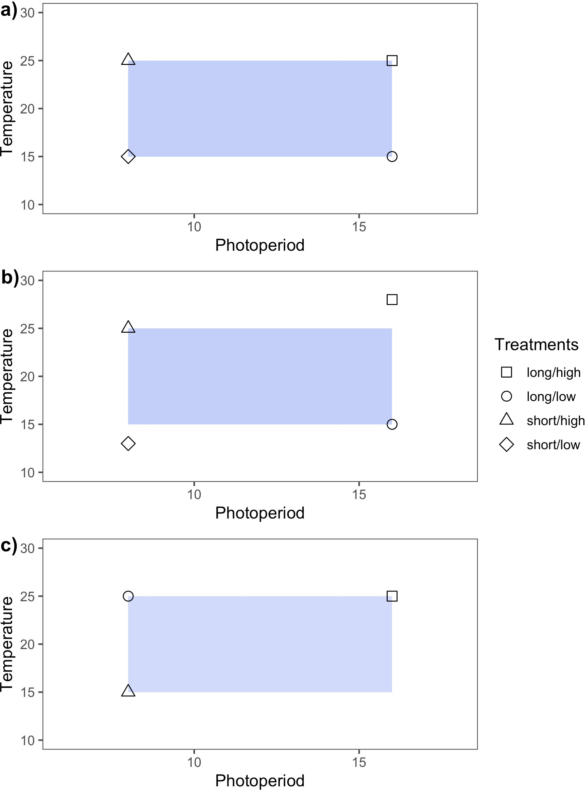

Figure 1: Idealized experimental designs demonstrate three approaches for varying temperature and light treatment levels in controlled environment experiments. Design **a)** is full factorial in that treatments levels are balanced and orthogonal. This design is appropriate for testing interactions between two (or more) variables. In **b)** the design is balanced but not orthogonal. Non-orthogonality in experiments can arise when experimental covariation among the manipulated variables is not accounted for. In **c)**, the experimental design is orthogonal but unbalanced. Lack of balance in experiments often arises due to time, space or resource limitations.

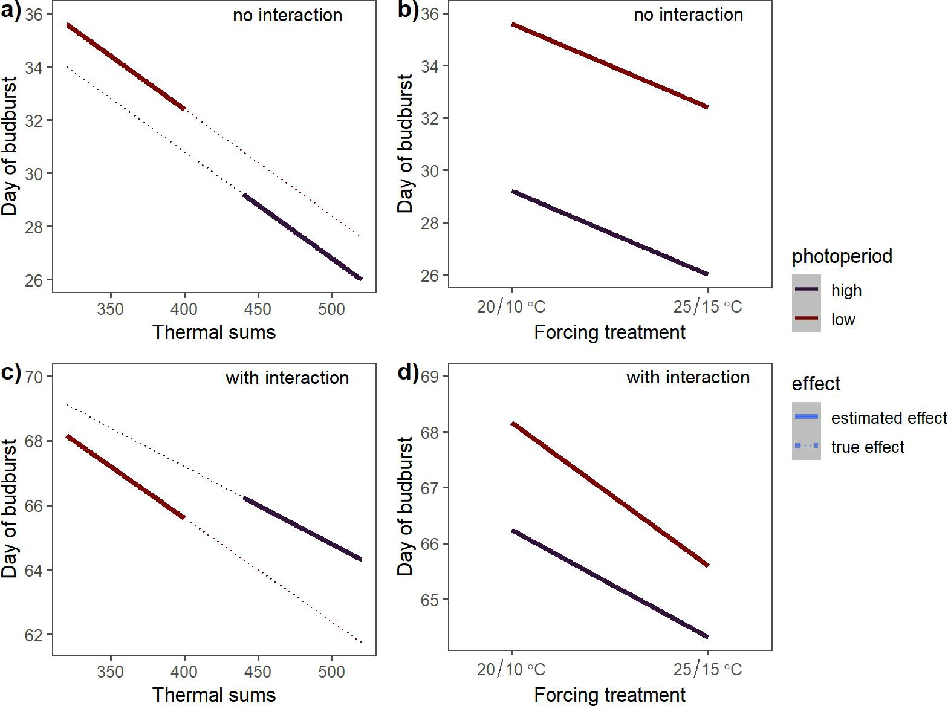

Figure 2: Estimated effects of photoperiod and forcing on spring phenology based on a simulated experiment in which the coupling of photoperiod and thermoperiod introduce an experimental covariation between the temperature and light treatments. The dotted lines in **a)** and **c)** depict the true effects of forcing at each photoperiod level, and the solid lines depict the estimated effects.

**a)** depicts a scenario where forcing and photoperiod effects do not interact, while **c)** includes an interactive effect. **b)** and **d)** depict the estimated effects of forcing and photoperiod if the experimental covariation due to periodicity coupling in **a)** and **c)**, respectively, is unacknowledged.

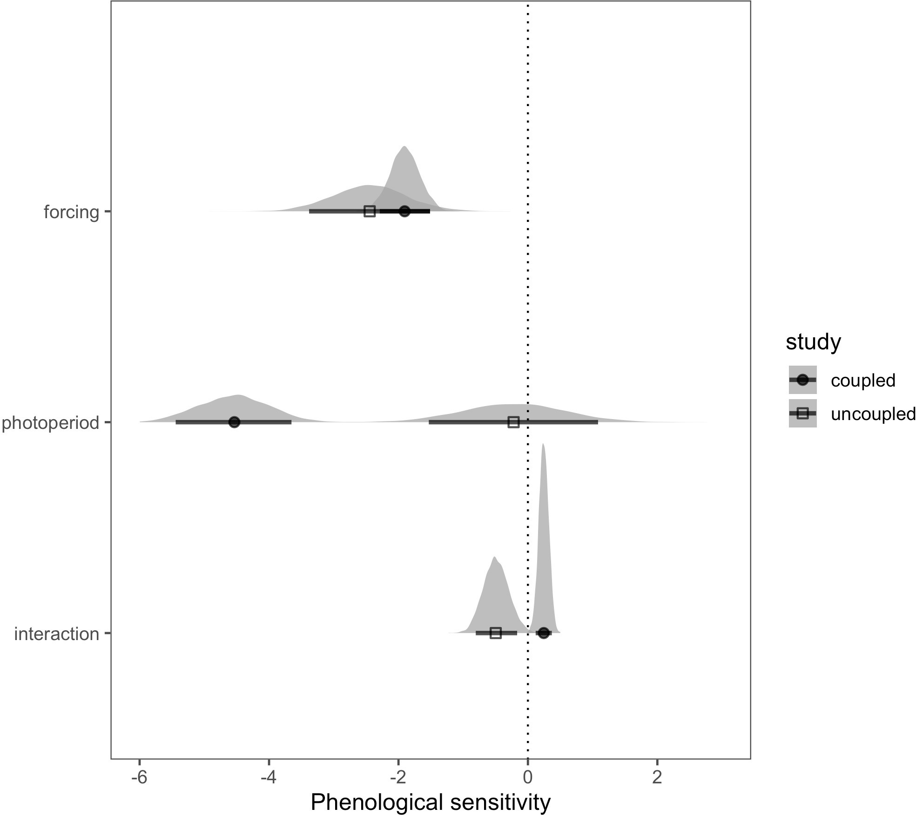

Figure 3: Estimated phenological sensitivity (∆ day of leaf expansion/∆ unit increase in cue level), using alternative methods of varying thermoperiod relative to photoperiod. Points indicate the estimated mean effect and bars the 90% uncertainty intervals. The full posterior distributions for each parameter are also depicted as an additional display of uncertainty. The coupled thermo- photo- period design is from Flynn & Wolkovich (2018) and the uncoupled design is from Buonaiuto & Wolkovich (2021).

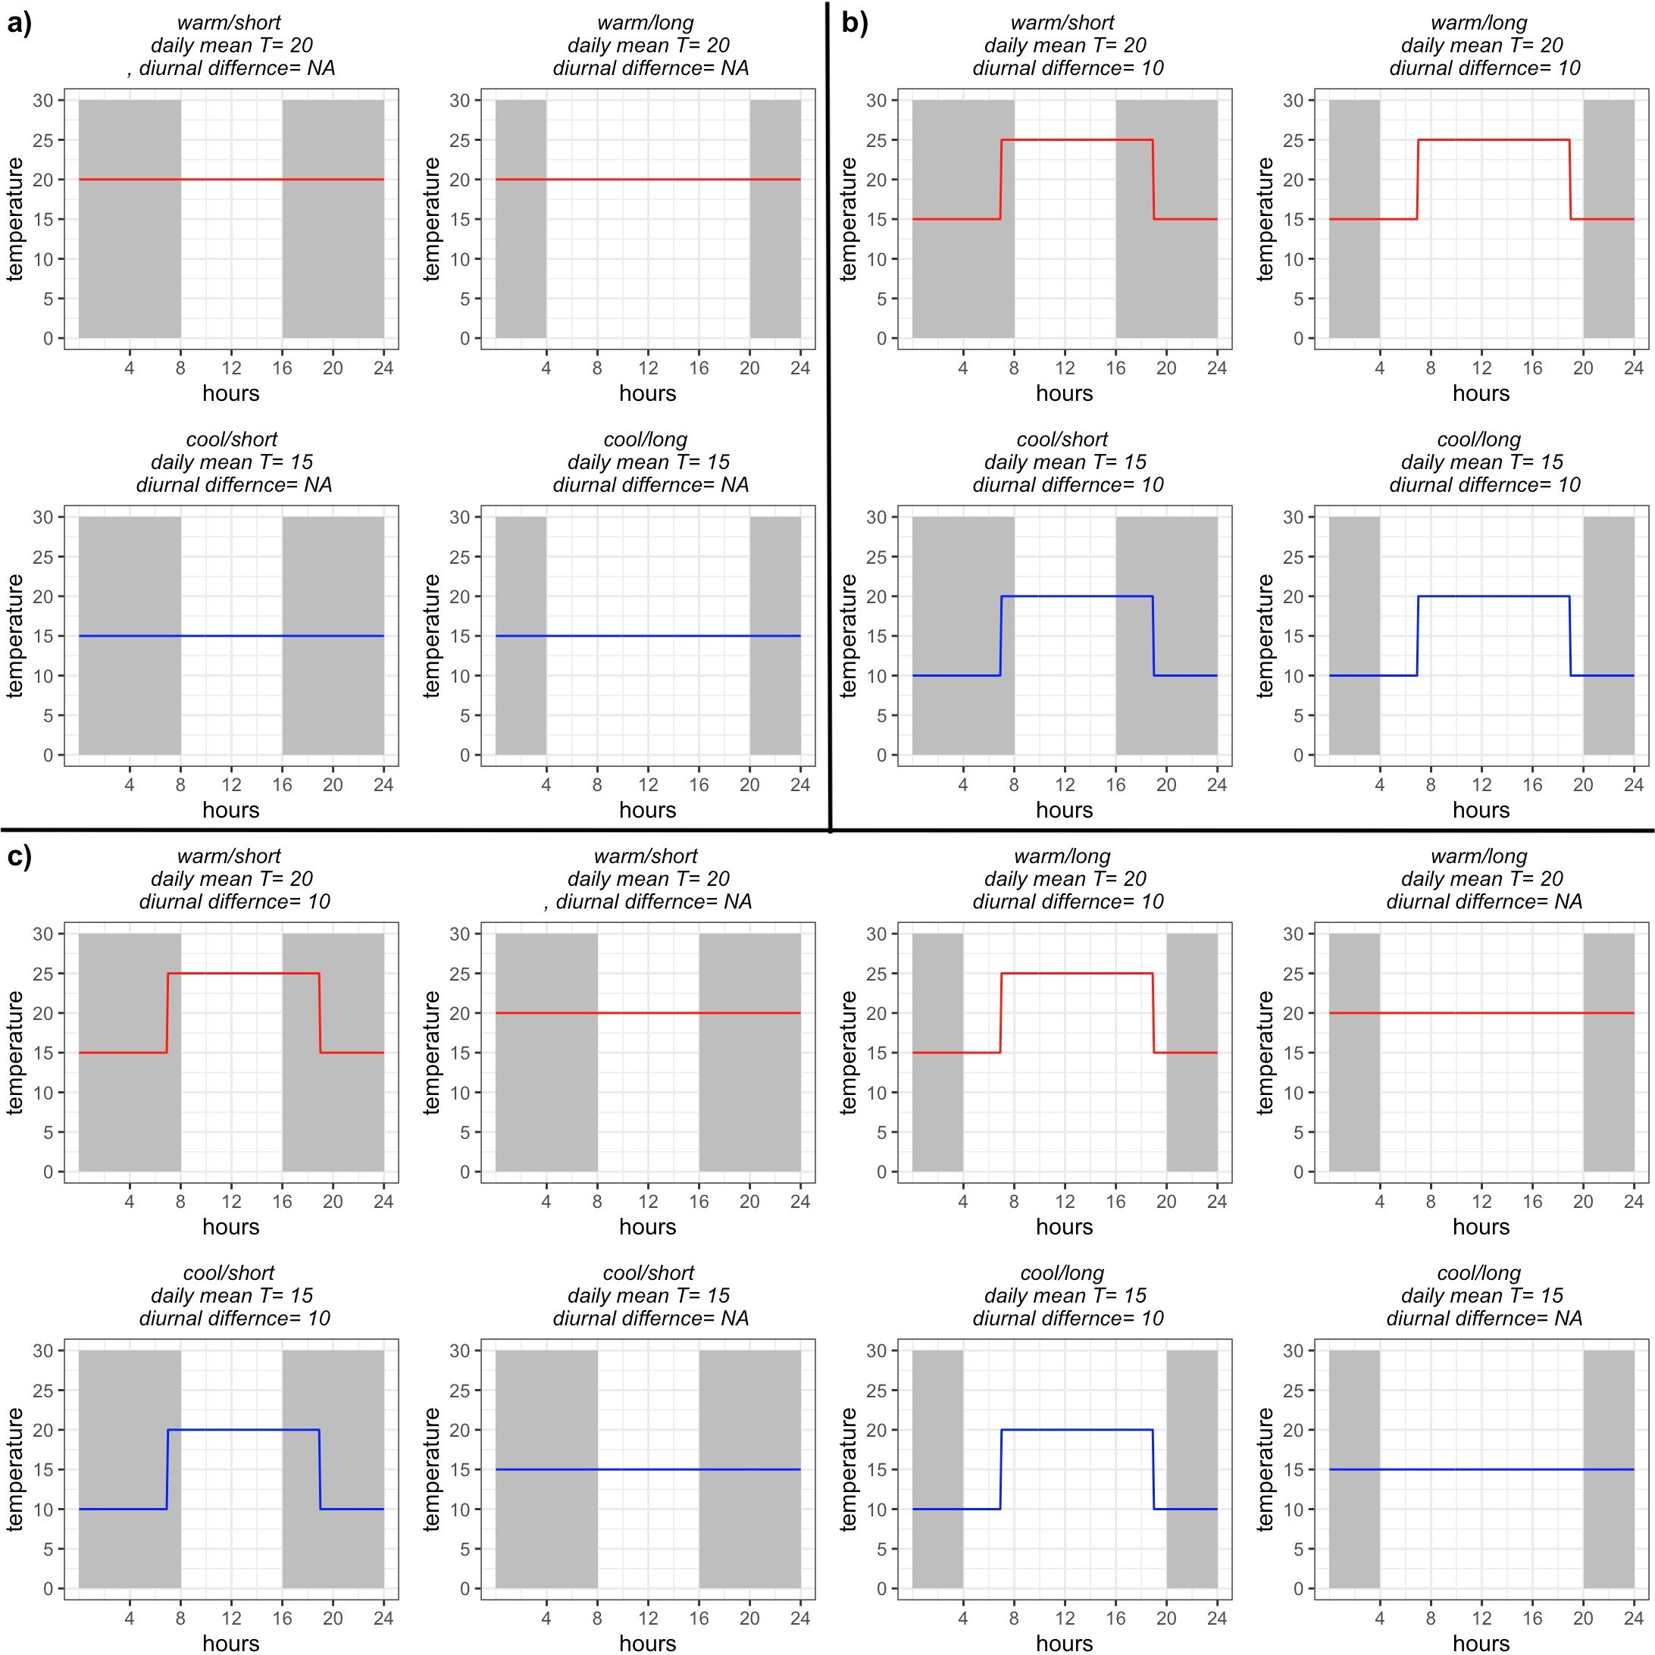

Figure 4: Conceptualized experimental designs to test temperature and daylength interactions on a biological response. Design **a)** manipulates temperature intensity only (no thermoperiodicity). In design **b)**, consistent diurnal temperature fluctuations are maintained but, thermoperiod and pho- toperiod are decoupled and varied independently, maintaining orthogonality in daily temperature treatments. In **c)**, thermoperiod is included as an additional, explicit experimental treatments to evaluate the individual and interactive effect of photoperiod, thermoperiod and temperature.