1 Experimental designs for testing the interactive effects of

2 temperature and light in ecology: the problem of periodicity

3 D.M. Buonaiuto 1*,*2*,a*, M. Donahue3, E.M. Wolkovich1*,*2*,*4

4 *Author aﬀiliations:*

5 1Arnold Arboretum of Harvard University, Boston, Massachusetts, USA. ORCID: 0000-0003-4022-

6 2591

7 2Department of Organismic and Evolutionary Biology, Harvard University, Cambridge, Massachusetts,

8 USA

9 3Hawai’i Institute of Marine Biology, University of Hawai’i at Manoa, Kan‘eohe, HI, USA.

10 4Forest & Conservation Sciences, Faculty of Forestry, University of British Columbia, Vancouver,

11 British Columbia, Canada

12 *a*Corresponding author: 617.823.0687; [dbuonaiuto@g.harvard.edu](mailto:dbuonaiuto@g.harvard.edu)

13

14 **Abstract**

15 1. Temperature and light cues interact to control many biological processes. Experiments give

16 researchers the ability to manipulate these environmental cues independently, and can be de-

17 signed to robustly quantify their individual and interactive effects on any particular biological

18 activity. Testing the interactive effects of multiple environmental cues requires experimen-

19 tal treatments to be fully independent, and any unmeasured experimental covariation among

20 treatments can result in incorrect conclusions.

21 2. Using a database of controlled environment experiments on the spring phenology of woody

22 plants as a case study, we highlight how a common experimental set-up, designed to parse

23 the interactive effects of temperature and photoperiod on time to budburst, introduces a

24 latent experimental covariation of these treatments by coupling photo- and thermo- period-

25 icity. Using data simulations, algebraic corrections and a comparative analysis of published

26 experiments, we demonstrate how this unmeasured experimental covariation biases statistical

27 inference regarding the relative contribution of light and temperature cues to phenological

28 variation.

29 3. We identify this experimental covariation in more than 40% of published phenology studies

30 that manipulate photoperiod. Our analyses demonstrate that the coupling of thermo- and

31 photo- periodicity results in the overestimation of the effect of photoperiod, the underesti-

32 mation of forcing effects, and misleading conclusions about their interactions on phenology.

33 This may, in part, explain why the significance of photoperiod cues for spring phenology is

34 currently debated in the literature.

35 4. Accurate forecasting of how varying environmental conditions will impact the dynamics of

36 biological events requires accurately quantifying cues responses. To this end, we present several

37 alternative experimental designs that can provide more robust estimates of the relative effects

38 of temperature and photoperiod on phenology, and many other biological processes controlled

39 by temperature and light.

40 **Keywords:** forcing, full-factorial, growth chamber, light, phenology, photoperiod, temperature,

41 thermoperiod

42

43 2948 words, four figures

44 **Introduction**

45 Across the tree of life, temperature and light availability shape a number of important biological

46 processes including growth and metabolic rates (MacLean & Gilchrist, 2019), sex determination

47 (Brown *et al.*, 2014), acclimatization to seasonal environments (Hamilton *et al.*, 2016) and the

48 timing of life cycle transitions (i.e., phenology, Forrest & Miller-Rushing, 2010). These biological

49 responses in turn dictate broad-scale ecological processes and patterns ranging from biogeochemical

50 cycling (Piao *et al.*, 2007) to species range limits (Chuine & Beaubien, 2001). Characterizing the

51 specific dynamics of how these environmental factors synergistically affect biological processes across

52 a wide range of taxa has become even more important as anthropogenic global change continues to

53 expose organisms to novel environmental conditions (Pörtner & Farrell, 2008).

54 Because temperature and light availability often co-vary in the field (for example, in most temperate

55 ecosystems, daylength and temperature both increase as the season progresses, Rosenberg, 1974),

56 it can be diﬀicult to disentangle their relative contributions to biological processes. In contrast,

57 experimental manipulations of climate variables in artificial environments can mechanistically char-

58 acterize biological responses to environmental fluctuations (Ettinger *et al.*, 2020; Primack *et al.*,

59 2015). Researchers have used controlled environments of all shapes and sizes to this end (Downs,

60 1980); these efforts have greatly advanced our collective understanding of the fundamental biology

61 of a wide variety of organisms and ability to predict ecological and evolutionary responses to current

62 and future climate change (Stewart *et al.*, 2013).

63 However, controlled environment experiments have their own challenges. Experimentalists must

64 balance biological realism with statistical inference, experimental effort with statistical power, and

65 account for the effects of unmanipulated or unmeasured variables (Scheiner & Gurevitch, 2001).

66 Because biological responses to the environment are generally the product of complex interactions

67 between multiple environmental signals (Casal, 2002), seemingly small choices about experimen-

68 tal designs can generate significant differences in outcomes. Experimental treatments are rarely

69 standardized among researchers, even within disciplines (Wolkovich *et al.*, in Review.), and these

70 complexities may in part contribute to the many discrepancies between experimental studies and

71 observation data (Poorter *et al.*, 2016). Even with these limitations, controlled environment stud-

72 ies remain a powerful tool for mechanistically assessing organismic responses to the environment,

73 provided that the implications of treatment designs are well understood and well matched with the

74 scope of the research question.

75 As technology advances and experiments become more complex, researchers can manipulate more

76 variables and multiple axes of variation (e.g., temperature, amplitude, periodicity, wavelength) at

77 the same time. Yet these efforts may present a tradeoff between biological realism and statistical

78 inference. Through investigating the literature on experiments with plant phenology, we show that

79 experiments that manipulate both photo- and thermo- periodicity often introduce a latent experi-

80 mental covariation between light and temperature treatments, which may misrepresent the effects

81 of each of these environmental variables and the interaction between them. We begin by briefly

82 detailing how temperature and light treatments are generally applied in phenology experiments and

83 review the minimum experimental elements required to robustly test interactions between two or

84 more environmental variables. We then detail the problem of inference that can arise when manip-

85 ulating the periodicity of both temperature and light in experiments, and demonstrate the extent

86 to which this is an issue through data simulations, a mathematical correction, and a comparative

87 analysis of published experiments. Finally, we conclude by outlining several experimental designs

88 that can overcome the problem of periodicity. While, our example deals with phenology of temper-

89 ate woody plants, the issues and solutions we present below are broadly applicable to studies on

90 any other organisms and biological processes that utilize temperature and light signals.

# 91 Estimating phenological cues from experiments

92 Decades of experimental work in controlled environments have demonstrated that temperature

93 (both cool temperatures in fall/winter and warming temperatures in spring) and photoperiod are

94 the primary phenological cues for plants in the temperate/boreal zones (Ettinger *et al.*, 2020). While

95 exposure to cool winter temperatures (chilling) strongly impacts phenology (Laube *et al.*, 2014), we

96 focus here on warm temperature and light treatments, because controlled chilling treatments with

97 light are uncommon (Wolkovich *et al.*, in Review.). Choices about how to apply warm temperature

98 and light treatments, in particular, can compromise inference on their effects, so we focus on these

99 two cues.

100 While a large variety of experimental designs have been used to study plant phenology, generally

101 experiments tend to manipulate two major axes of light and warm temperature variation:

102 1. Intensity: The amount or quality of a variable. Here we define temperature intensity as the

103 amount of heat present in the system (measured in degrees). In the phenology literature this

104 measurement is generally referred to as forcing. We define light intensity as the luminosity or

105 irradiance present in the system (measured in lumens or watts).

106 2. Periodicity: The interval at which the intensity of the variable is applied. Hereafter, we refer

107 to the periodicity of light as photoperiod (often used synonomously with “daylength”) and

108 the periodicity of temperature as thermoperiod.

109 For phenology, photoperiodicity is generally considered the primary light cue for plants (Way &

110 Montgomery, 2015), (though regarding light intensity and phenology see Brelsford & Robson, 2018;

111 Cober *et al.*, 1996). For temperature, conventionally both intensity and periodicity drive pheno-

112 logical activity and several metrics (e.g. growing degree hours, thermal sums, growing degree days)

113 that combine these two axes have been developed (Gu, 2016). The importance of thermo-intensity

114 and periodicity is well supported; under natural conditions diurnal temperature fluctuations in tem-

115 perate regions can be quite large in the spring, and studies have found that diurnal temperature

116 variation strongly influences plant phenology (Burghardt *et al.*, 2016). In fact, even if thermoperi-

117 odicity is not an explicit treatment variable (i.e., manipulated systematically), incorporating it in

118 experiments can be essential for translating experimental results into real world predictions (Chiang

119 *et al.*, 2020).

120 Like many other biological processes, recent advances have demonstrated that plant phenological

121 responses are nonlinear, due largely to interactions between cues (Wolkovich *et al.*, in Review.;

122 Fu *et al.*, 2015), highlighting the need for experiments designed to evaluate the strength of these

123 interactions. To have the statistical power to partition the individual and interactive effects of two

124 or more variables, an experiment must:

125 1. Have at minimum of two treatment levels of at least two variables.

126 2. Treatment levels must be full factorial (Fig. 1a.). Full factorial designs are both balanced

127 (Fig. 1b.) and orthogonal (Fig. 1c.); meaning that all possible treatment combinations are

128 applied and each treatment is independent of all others (Cheng, 2016).

129 These two critical elements may seem obvious but are conspicuously absent from many published

130 studies. Using a recently published database of woody plant phenological experiments, OSPREE:

131 Observed Spring Phenological Responses in Experimental Environments (Wolkovich *et al.*, 2019),

132 we found that out of 152 controlled environment experiments (across 93 studies) only 18 manipu-

133 lated both light and forcing cues with a design that was both balanced and orthogonal. But even

134 experiments that are designed to be full factorial frequently violate the assumption of orthogonality

135 when both photo- and thermo- periodicity are built into experiments. We detail this problem below.

# 136 The problem of periodicity

137 A common approach in phenology experiments that seems to balance prior knowledge about the

138 underlying physiology of phenology, biological realism and experimental inference is to vary pho-

139 toperiodicity, and thermal intensity and periodicity (e.g., Flynn & Wolkovich, 2018; Sanz-Perez

140 *et al.*, 2009; Basler & Körner, 2014). For example, a basic experiment might include a long (16

141 hours) and short (8 hours) photoperiod treatment and a high (25/15*◦*C day/night) and low (20/10*◦*C

142 day/night) forcing treatment. In this case, the thermoperiodicity is not an explicit treatment (both

143 high and low temperature treatments use a diurnal fluctuation of 10 *◦*C), and is simply incorporated

144 in the design to enhance biological realism. At first glance, this design appears to meet the criteria

145 of a full factorial design, multiple treatment levels that are balanced and orthogonal, with high/low

146 temperature treatments (mean 20*◦*C and 15*◦*C respectively) and long/short photoperiod treatments

147 applied in all possible combinations.

148 Yet the orthogonality of this design is based on the assumption of a 12 hour thermoperiod. If, rather

149 the thermoperiod is coupled with the photoperiod, the temperature treatment is non-orthogonal

150 because the daily mean temperature of the long/high treatment will be higher than that of the

151 short/high treatment, and the long/low treatment slightly warmer than the short/low. We refer

152 to this experimental set-up as a coupled design (i.e. thermoperiod and photoperiod are coupled

153 with each other). Coupled designs introduce an experimental covariation between photoperiod and

154 forcing treatments. This experimental covariation is clearly illustrated when temperature treatment

155 levels are converted to thermals sums. We calculate thermal sums (also called growing degree hours),

156 by multiplying hourly temperatures above a certain base temperature threshold by the number of

157 hours for which they are applied over a 24 hour period (Parent *et al.*, 2019). For example, given a

158 base temperature of 0*◦*C, a low forcing treatment of 20/10*◦*C day/night accrues 400 thermal units

159 per 24 hours when crossed with the long (16 hour) photoperiod treatment and only 320 thermal units

160 when crossed with the short (8 hour) photoperiod treatment. While this experimental covariation

161 among the photoperiod and temperature treatments is biologically realistic, it makes it statistically

162 impossible to differentiate the independent and interactive effects of temperature and photoperiod

163 on any given biological process.

164 This problem of inference that arises from the experimental covariation of thermo- and photo-

165 periodicity is not limited only to studies seeking to directly compare the effects of photoperiod

166 and forcing; it applies in any study evaluating the influence of photoperiod on biological activity,

167 even if it is the only manipulated cue. Experimentally isolating the effect of photoperiod assumes

168 that all other environmental variables are held constant. Similar to the case described above, the

169 coupling of photoperiod and thermoperiod in an experiment where forcing is supposed to be a

170 consistent, background condition (e.g., two levels of photoperiod treatments of 8 and 16 hours,

171 both at a background temperature of 20/10*◦*C day/night) would yield a situation in which longer

172 photoperiod treatments were also receiving more—unmeasured—heating than shorter photoperiod

173 treatments. In this case, some amount of the perceived photoperiod effect is due to the latent,

174 increased forcing, and the experment will not isolate the true effect of photoperiod.

175 Of the 51 experiments in the OSPREE database that manipulated photoperiod experimentally,

176 up to 43% of them appear to include an experimental covariation with thermoperiod. Of the 18

177 studies that manipulated both photoperiod and temperature interactively, we found that up to

178 55% of them appear to have this issue, suggesting that the true interactive effects of these cues on

179 spring phenology is quite poorly characterized. This may be in part why the relative contribution

180 of temperature and photoperiod cues to spring phenology remains a contentious debate in the

181 phenology literature (Koerner & Basler, 2010; Chuine *et al.*, 2010; Körner & Basler, 2010).

# 182 Periodicity and inference

183 If the lack of orthogonality introduced to experiments when photoperiod and thermoperiod are

184 coupled is overlooked, regression models will always overestimate the photoperiod effect and un-

185 derestimate the forcing effect on spring phenology (Fig. 2a,b.). This is because forcing is the

186 variable with latent, unmeasured variation. In the case of phenology, this is particularly significant

187 because studies repeatedly suggest that forcing is a more dominant cue than photoperiod for spring

188 phenology (Chuine *et al.*, 2010; Zohner *et al.*, 2016; Gauzere *et al.*, 2019).

189 If experiments are designed to quantify the interaction between photoperiod and forcing, here too,

190 the experimental covariation of periodicity will result in an erroneous estimation of the interaction.

191 (Fig. 2c,d.). Our simulation depicts a particularly troublesome case where a true sub-additive

192 interaction is interpreted as a supra-additive one (Fig. 2c,d.), however, this must not always be the

193 case. Experimental covariation of light and temperature treatments due to coupling thermo- and

194 photo- periodicity will generally result in the incorrect estimation of the interaction term, but the

195 exact nature of this statistical issue depends on the sign and strength of the interaction.

196 We can attempt to estimate how much of a photoperiod effect is due to forcing in experiments where

197 they covary by making several major assumptions. Our major assumptions are that forcing and

198 photoperiod effects are additive and linear (i.e., there is no interaction). While this may not be true

199 in nature, it gives us insight into the potential effect of the experimental covariation of periodcity

200 by allowing us to solve algebraically for the separate effects of forcing and photoperiod. We replace

201 the qualitative factor (high/low forcing) by the quantitative effect of forcing (thermal sums) to

202 properly account for the difference in forcing between short and long photoperiods (see Supporting

203 Information: Estimating the effects of experimental periodicity covariance mathmatically). Using

204 the data from one experiment that experimentally coupled thermo- and photo-period, Flynn &

205 Wolkovich (2018), we found that 33% of the published photoperiod effect of 4.5 days could be due

206 to forcing.

207 Our algebraic solution cannot be as readily applied in experiments that assume photoperiod and

208 forcing interact. However, we can generally assess the scope of the problem of inference due to

209 experimental covariation of periodicity by comparing studies that used a coupled design to those with

210 alternative approaches. While we are aware of no experiments that explicitly compare the effects

211 of experimentally coupling vs. uncoupling photo- and thermo- periods, two phenology experiments

212 in our lab utilized many overlapping treatment levels and species from the same sampling sites,

213 however in one study, Flynn & Wolkovich (2018), photo- and thermo- period experimentally co-

214 vary, while in the other, Buonaiuto & Wolkovich (2021), photo- and thermo- period were varied

215 independently. Comparing the cue estimates from these two studies offers an opportunity to test our

216 theoretical and mathematical predictions, and further understand the uncertainty in cue estimates

217 due to coupled periodicities.

218 We subset each dataset to include only the species shared among the two studies, and re-analyzed

219 the data using Bayesian hierarchical models to compare the difference in the photoperiod, forcing

220 and interaction estimates (see Supporting Information: Modeling Methods). We found that the

221 estimated differences in the mean response to photoperiod and forcing and their interactions among

222 study designs were on the same order as our predictions. We estimated a substantially weaker (less

223 negative) photoperiod effect, and marginally stronger forcing effect for the uncoupled vs. coupled

224 experimental design (Fig. 3). The interaction term we estimated for the uncoupled design was

225 negative, suggesting the interaction between photoperiod and forcing is supra-additive, while the

226 estimated interactive effect from the coupled design was sub-additive (Fig. 3).

227 Unlike in our simulations (Fig. 2), in this comparison we cannot assess what the “true” effects

228 of these variables are. There are almost certainly other factors driving the differences between

229 these experiments. Both were conducted in different years, sampled different individuals from the

230 population, and used different methods for applying chilling pre-treatments (Flynn & Wolkovich,

231 2018; Buonaiuto & Wolkovich, 2021). However, because this comparison is well matched to our

232 predictions and prior knowledge about how temperature and photoperiod are expected to interact-

233 ing in phenology, we argue that the influence of experimental covariation on statistical inference is

234 apparent enough to take seriously.

235

236 **Paths Forward**

237 We have systematically demonstrated that experiments that couple thermoperiod and photoperiod

238 cannot robustly differentiate the individual or interactive effects of temperature and photoperiod on

239 spring phenology (or any other biological process) due to an unmeasured experimental covariation

240 among temperature and light treatments. Given the paucity of interactive studies in the literature,

241 it is clear that we need more well designed studies to better characterize the effects of these cues.

242 Below we offer several generalized experimental designs that improve statistical orthogonality of

243 controlled environment experiments, which could be further developed and adjusted to fit the needs

244 of experimentalists across many sub-fields of ecology and evolutionary biology.

245 1. **Manipulate photoperiod and temperature intesity with no thermoperiodicity**. This

246 approach allows for the maintenance of statistical orthogonality across treatment combinations

247 (4a.). The main drawback is that this design sacrifices the biological realism of diurnal tem-

248 perature variation, which may make it more diﬀicult to translate estimates from experiments

249 to real world applications.

250 2. **Compensitory diurnal temperature fluctions**. There are almost unlimited pairs of in-

251 tegers that can reduce to the same mean (e.g. (24 + 26)*/*2 = (30 + 20)*/*2 = 25) and the

252 non-orthogonality of the mean daily temperature (or thermal sums) that arises in a coupled

253 photo-thermo- period design could be corrected for by proportionately increasing the diurnal

254 temperature fluctuation of the short photoperiod treatment relative to the long treatments

255 (4b.). However, if the differences between day and night temperature has a meaningful bi-

256 ological effect, this introduces another confounding, non-orthogonal factor for interpreting

257 temperature and photoperiod effects. For example, the influence of day-time warming of phe-

258 nology can be as much as three times stronger than proportionate night-time warming (Rossi

259 & Isabel, 2017; Meng *et al.*, 2020).

260 3. **Uncouple thermoperiod and photoperiod**. By varying thermoperiod and photoperiod

261 independently (4c.), statistical orthogonality can be maintained across treatments. However,

262 this approach may also introduce new artifacts that occur from the biological rather than

263 statistical interactions between light and temperature (Chew *et al.*, 2012). For example, there

264 is evidence that increasing temperatures in the first two hours of daylight can be almost as

265 effective for stimulating shoot elongation as similar temperature increases for the whole pho-

266 toperiod (Erwin, 1998). With this design, treatments must inherently differ in the amount

267 of time the warmer daytime temperature extends into the dark nighttime light regime, intro-

268 ducing a new axis of non-orthogonality.

269 In correcting one problem, each of these designs introduces another, which may in fact be an intrinsic

270 property of any experimental manipulation. It may also be that the experimental design that best

271 balances environmental realism, statistical inference and translatability to observational studies are

272 designs that continue to couple periodicity to mimic natural systems. Moving forward, researchers

273 using this design need to be aware of its non-orthogonality, and carefully consider how to present

274 the uncertainty around their effect estimates. It would be useful for researchers to explicitly test

275 how cue estimates vary among experimental designs, and which design is most useful for predicting

276 phenology in the field under current and future climate conditions. In the meantime, we hope that

277 this issue is a reminder that, as experimentalists, we must continue to be thoughtful about matching

278 our experimental designs to the goals of a study, and be transparent about uncertainty around our

279 experimental inference.

# 280 Conflict of Interest Statement:

281 The authors declare no conflict of interest.

282 **Author contributions**

283 DMB, MD and EMW conceived of the manuscript; MD and EMW developed the algebraic solution;

284 DMB performed the comparative analysis of the published studies; DMB led the writing of the

285 manuscript. All authors contributed to writing and gave approval for the submission.

286 **Data Availability**

287 Data from the Flynn & Wolkovich (2018) study is available at the Harvard Forest Data Archieve

288 (https://harvardforest1.fas.harvard.edu/exist/apps/datasets/showData.html?id=HF314) and from

289 the Buonaiuto & Wolkovich (2021) study available at Knowledge Network for Biocomplexity

290 (https://knb.ecoinformatics.org/view/doi:10.5063/PG1Q4B). The R code used to analyse the data

291 is available on github.

292 **References**

293 Basler, D. & Körner, C. (2014) Photoperiod and temperature responses of bud swelling and bud

294 burst in four temperate forest tree species. *Tree physiology* **34**, 377–388.

295 Brelsford, C.C. & Robson, T.M. (2018) Blue light advances bud burst in branches of three deciduous

296 tree species under short-day conditions. *Trees-Structure and Function* **32**, 1157–1164.

297 Brown, E.E., Baumann, H. & Conover, D.O. (2014) Temperature and photoperiod effects on sex

298 determination in a fish. *Journal of Experimental Marine Biology and Ecology* **461**, 39–43.

299 Buonaiuto, D.M. & Wolkovich, E.M. (2021) Differences between flower and leaf phenological re-

300 sponses to environmental variation drive shifts in spring phenological sequences of temperate

301 woody plants. *Journal of Ecology* **109**, 2922–2933.

302 Burghardt, L.T., Runcie, D.E., Wilczek, A.M., Cooper, M.D., Roe, J.L., Welch, S.M. & Schmitt, J.

303 (2016) Fluctuating, warm temperatures decrease the effect of a key floral repressor on flowering

304 time in arabidopsis thaliana. *New Phytologist* **210**, 564–576.

305 Casal, J.J. (2002) Environmental cues affecting development. *Current Opinion in Plant Biology* **5**,

306 37–42.

307 Cheng, C.S. (2016) *Theory of Factorial Design*. Chapman and Hall/CRC.

308 Chew, Y.H., Wilczek, A.M., Williams, M., Welch, S.M., Schmitt, J. & Halliday, K.J. (2012) An

309 augmented arabidopsis phenology model reveals seasonal temperature control of flowering time.

310 *New Phytologist* **194**, 654–665.

311 Chiang, C., Bånkestad, D. & Hoch, G. (2020) Reaching natural growth: The significance of light

312 and temperature fluctuations in plant performance in indoor growth facilities. *Plants* **9**.

313 Chuine, I. & Beaubien, E. (2001) Phenology is a major determinant of tree species range. *Ecology*

314 *Letters* **4**, 500–510.

315 Chuine, I., Morin, X., Bugmann, H., Koerner, C. & Basler, D. (2010) Warming, photoperiods, and

316 tree phenology. *Science* **329**, 277–278.

317 Cober, E., Tanner, J. & Voldeng, H. (1996) Soybean photoperiod-sensitivity loci respond differen-

318 tially to light quality. *Crop Science* **36**, 606–610.

319 Downs, R.J. (1980) Phytotrons. *Botanical Review* **46**, 447–489.

320 Erwin, J. (1998) Temperature and light effects on stem elongation. *Journal of the Japanses Society*

321 *For Horticultural Science* **67**, 1113–1120, Session of Plant Growth Regulation by Physical and

322 Mechanical Stimuli at the Commemorative Symposium of the 75th Anniversary of Japanese-

323 Society-for-Horticultural-Science, JAPAN, APR 03-04, 1998.

324 Ettinger, A.K., Chamberlain, C.J., Morales-Castilla, I., Buonaiuto, D.M., Flynn, D.F.B., Savas, T.,

325 Samaha, J.A. & Wolkovich, E.M. (2020) Winter temperatures predominate in spring phenological

326 responses to warming. *Nature Climate Change* **10**, 1137–1142.

327 Flynn, D.F.B. & Wolkovich, E.M. (2018) Temperature and photoperiod drive spring phenology

328 across all species in a temperate forest community. *New Phytologist* **219**, 1353–1362.

329 Forrest, J. & Miller-Rushing, A.J. (2010) Toward a synthetic understanding of the role of phenology

330 in ecology and evolution. *Philosophical Transactions of the Royal Society of London B: Biological*

331 *Sciences* **365**, 3101–3112.

332 Fu, Y.S.H., Zhao, H.F., Piao, S.L., Peaucelle, M., Peng, S.S., Zhou, G.Y., Ciais, P., Huang, M.T.,

333 Menzel, A., Uelas, J.P., Song, Y., Vitasse, Y., Zeng, Z.Z. & Janssens, I.A. (2015) Declining global

334 warming effects on the phenology of spring leaf unfolding. *Nature* **526**, 104–107.

335 Gauzere, J., Lucas, C., Ronce, O., Davi, H. & Chuine, I. (2019) Sensitivity analysis of tree phenol-

336 ogy models reveals increasing sensitivity of their predictions to winter chilling temperature and

337 photoperiod with warming climate. *Ecological Modelling* **411**, 108805.

338 Gu, S. (2016) Growing degree hours - a simple, accurate, and precise protocol to approximate

339 growing heat summation for grapevines. *International Journal of Biometeorology* **60**, 1123–1134.

340 Hamilton, J.A., El Kayal, W., Hart, A.T., Runcie, D.E., Arango-Velez, A. & Cooke, J.E. (2016)

341 The joint influence of photoperiod and temperature during growth cessation and development of

342 dormancy in white spruce (Picea glauca). *Tree Physiology* **36**, 1432–1448.

343 Koerner, C. & Basler, D. (2010) Phenology under global warming. *Science* **327**, 1461–1462.

344 Körner, C. & Basler, D. (2010) Response—warming, photoperiods, and tree phenology. *Science*

345 **329**, 278–278.

346 Laube, J., Sparks, T.H., Estrella, N., Höfler, J., Ankerst, D.P. & Menzel, A. (2014) Chilling out-

347 weighs photoperiod in preventing precocious spring development. *Global Change Biology* **20**,

348 170–182.

349 MacLean, H.J. & Gilchrist, G.W. (2019) Temperature, photoperiod and life history traits in

350 drosophila subobscura. *bioRxiv* p. 717967.

351 Meng, L., Zhou, Y., Li, X., Asrar, G.R., Mao, J., Wanamaker, A.D. & Wang, Y. (2020) Diver-

352 gent responses of spring phenology to daytime and nighttime warming. *Agricultural and Forest*

353 *Meteorology* **281**, 107832.

354 Parent, B., Millet, E.J. & Tardieu, F. (2019) The use of thermal time in plant studies has a sound

355 theoretical basis provided that confounding effects are avoided. *Journal of Experimental Botany*

356 **70**, 2359–2370.

357 Piao, S., Friedlingstein, P., Ciais, P., Viovy, N. & Demarty, J. (2007) Growing season extension and

358 its impact on terrestrial carbon cycle in the northern hemisphere over the past 2 decades. *Global*

359 *Biogeochemical Cycles* **21**.

360 Poorter, H., Fiorani, F., Pieruschka, R., Wojciechowski, T., van der Putten, W.H., Kleyer, M.,

361 Schurr, U. & Postma, J. (2016) Pampered inside, pestered outside? differences and similarities

362 between plants growing in controlled conditions and in the field. *New Phytologist* **212**, 838–855.

363 Pörtner, H.O. & Farrell, A.P. (2008) Physiology and climate change. *Science* **322**, 690–692.

364 Primack, R.B., Laube, J., Gallinat, A.S. & Menzel, A. (2015) From observations to experiments

365 in phenology research: investigating climate change impacts on trees and shrubs using dormant

366 twigs. *Annals of Botany* **116**, 889–897.

367 Rosenberg, N.J. (1974) *Microclimate: the biological environment*. Wiley, New York.

368 Rossi, S. & Isabel, N. (2017) Bud break responds more strongly to daytime than night-time tem-

369 perature under asymmetric experimental warming. *Global Change Biology* **23**, 446–454.

370 Sanz-Perez, V., Castro-Diez, P. & Valladares, F. (2009) Differential and interactive effects of tem-

371 perature and photoperiod on budburst and carbon reserves in two co-occurring Mediterranean

372 oaks. *Plant Biology* **11**, 142–51.

373 Scheiner, S.M. & Gurevitch, J. (2001) *Design and analysis of ecological experiments*. Oxford Uni-

374 versity Press.

375 Stewart, R.I.A., Dossena, M., Bohan, D.A., Jeppesen, E., Kordas, R.L., Ledger, M.E., Meerhoff,

376 M., Moss, B., Mulder, C., Shurin, J.B., Suttle, B., Thompson, R., Trimmer, M. & Woodward, G.

377 (2013) *Chapter Two - Mesocosm Experiments as a Tool for Ecological Climate-Change Research*,

378 vol. 48, pp. 71–181. Academic Press.

379 Way, D.A. & Montgomery, R.A. (2015) Photoperiod constraints on tree phenology, performance

380 and migration in a warming world. *Plant, Cell & Environment* **38**, 1725–1736.

381 Wolkovich, E., Chamberlin, C., Buonaiuto, D., Ettinger, A. & Morales-Castilla, I. (in Review.)

382 Integrating experiments to predict interactive cue effects on spring phenology with warming .

383 Wolkovich, E.M., Ettinger, A.K., Flynn, D., Savas, T., Chamberlain, C., Buonaiuto, D. &

384 Samaha, J. (2019) Observed spring phenology responses in experimental environments (OS-

385 PREE). doi:10.5063/F1CZ35KB.

386 Zohner, C.M., Benito, B.M., Svenning, J.C. & Renner, S.S. (2016) Day length unlikely to constrain

387 climate-driven shifts in leaf-out times of northern woody plants. *Nature Climate Change* **6**, 1120–

388 1123.

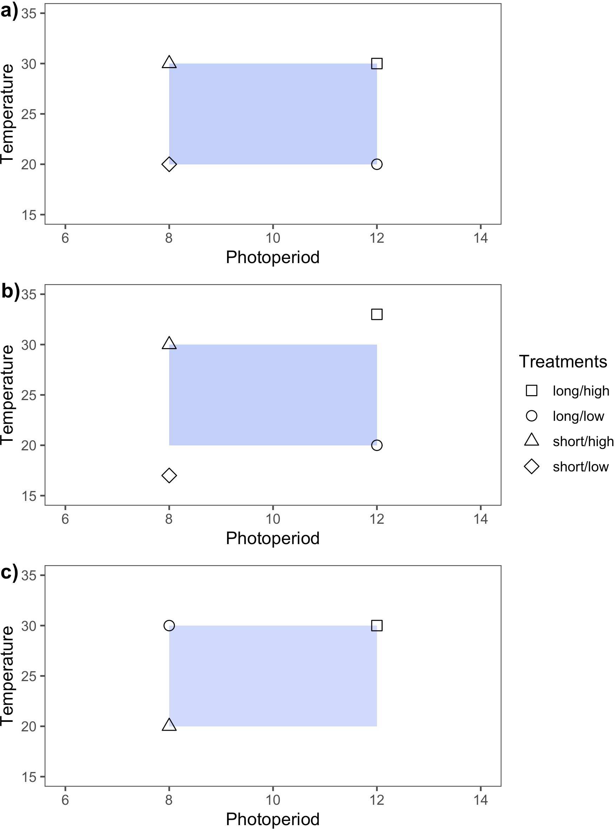

Figure 1: Idealized experimental designs demonstrate three approaches for varying temperature and light treatment levels in controlled environment experiments. Design **a)** is full factorial in that treatments levels are balanced and orthogonal. This design is appropriate for testing interactions between two or more variables. In **b)** the design is balanced but not orthogonal. Non-orthogonality in experiments can arise when experimental covariation among the manipulated variables is not accounted for. In **c)**, the experimental design is orthogonal but unbalanced. Lack of balance in experiments often arises due to time, space or resource limitations.

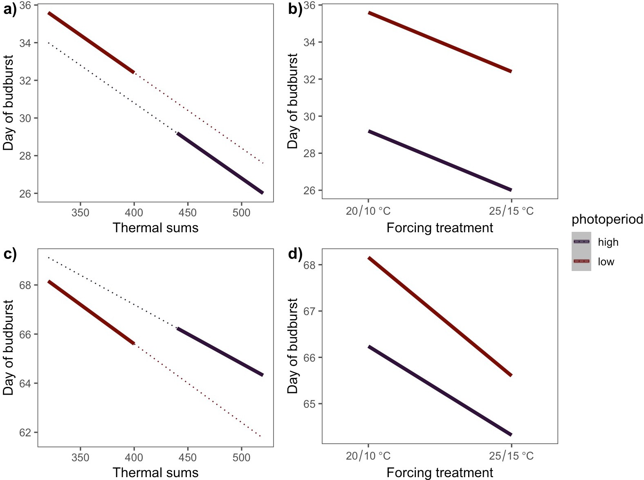

Figure 2: Estimated effects of photoperiod and forcing on spring phenology based on a simulated experiment in which the coupling of photoperiod and thermoperiod introduce an experimental covariation between the temperature and light treatments. The dotted lines in **a)** and **c)** depict the true effects of forcing at each photoperiod level, and the solid lines depict the estimated effects.

**a)** depicts a scenario where forcing and photoperiod effects do not interact, while **c)** includes an interactive effect. **b)** and **d)** depict the estimated effects of forcing and photoperiod if the experimental covariation due to periodicity coupling in **a)** and **c)**, respectively, is unacknowledged.

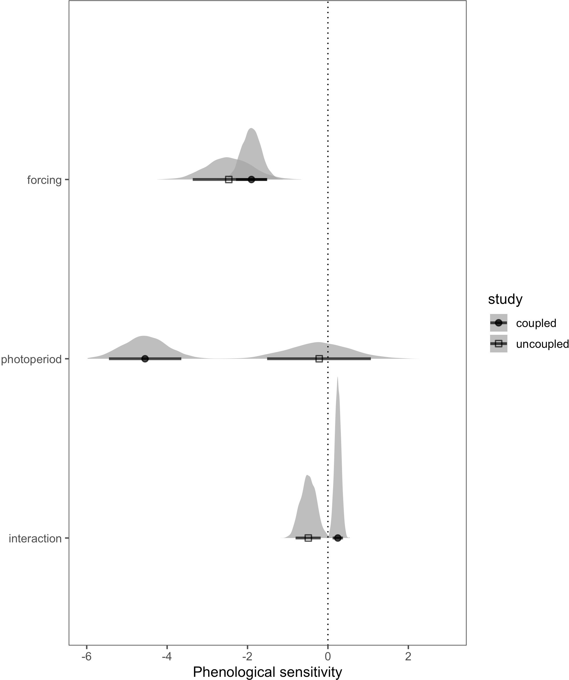

Figure 3: Estimated phenological sensitivity, (∆ day of leaf expansion/∆ unit increase in cue level) using alternative methods of varying thermoperiod relative to photoperiod. Points indicate the estimated mean effect and bars the 90% uncertainty intervals. The full posterior distributions for each parameter are also depicted as an additional display of uncertainty. The coupled thermo- photo- period design is from Flynn & Wolkovich (2018) and the uncoupled design is from Buonaiuto & Wolkovich (2021).

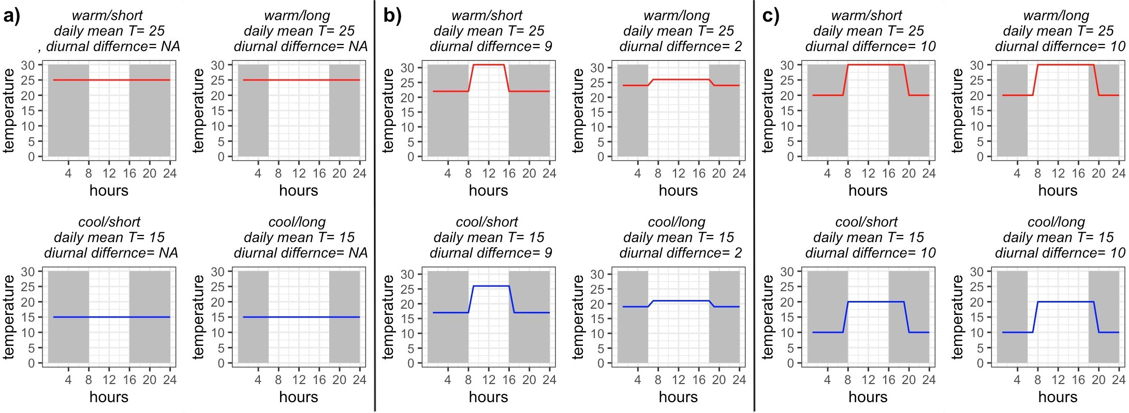

Figure 4: Conceptualized experimental designs to test temperature and daylength interactions on a biological response. Design **a)** manipulates temperature intensity only (no thermoperiodicity). In **b)**, photo- and thermo- periods are coupled, but the orthogonality of daily temperature treatments is maintained by proportionately varying the diurnal temperature fluctuations across photoperiod treatments. In design **c)**, consistent diurnal temperature fluctuations are maintained but, ther- moperiod and photoperiod are decoupled and varied independently, maintaining orthogonality in daily temperature treatments.