Differences between flower and leaf phenological responses to environmental variation drive shifts in spring phenological sequences of temperate woody plants
D.M. Buonaiuto ^{1,2,a}, E.M. Wolkovich

Author affiliations:
³
¹Arnold Arboretum of Harvard University, Boston, Massachusetts, USA. ORCID: 0000-0003- 4022-2591
²Department of Organismic and Evolutionary Biology, Harvard University, Cambridge, Mas- sachusetts, USA
³Forest & Conservation Sciences, Faculty of Forestry, University of British Columbia, Van- couver, British Columbia, Canada
ªCorresponding author: 617.823.0687; dbuonaiuto@g.harvard.edu
1 Abstract

2 The relative timing of growth and reproduction is an important driver of plant fitness. For
3 deciduous woody species in temperate regions leaves and flowers both appear in the early
4 spring, but the order and duration of these phenological events vary among species, popula-
5 tions, and individuals. Researchers have long hypothesized that this variation in flower-leaf
6 sequences (FLSs) may be important—affecting the reproduction, recruitment and survival of
7 individuals. Further, FLSs appear to be shifting with climate change; thus anticipating the
8 extent of these shifts may influence projections of how climate change may impact species’
9 performance and reshape forest communities. Predicting FLS shifts requires an improved
10 understanding of how environmental variation dictates FLS patterns. To address this, we
11 compared the phenological responses of flowers and developing leaves for 10 temperate woody
12 species to varying levels of temperature and photoperiod in a lab experiment. Our experi-
13 mental design allowed us to test competing hypotheses for how environmental cues determine
14 FLS variation—specifically whether forcing (warm temperatures) alone drives variation or
15 differential sensitivity to chilling (cool temperatures generally in the fall and winter) and/or
16 photoperiod matter. Within species, we found that flower and leaf phenology responded
17 with differential sensitivity to environmental cues, with differences in their response to chill-
18 ing being the dominant driver of FLS variation. These differences between flowering and leaf
19 responses were consistent across species, but because species differ the order of phenologi-
20 cal events in their FLSs (flowering-first vs. leafing-first), differences between flower and leaf
21 phenology will have contrasting impacts on FLS variation across species. Because climate
22 change will amplify variability in chilling across time and space, our findings suggest that
23 FLS shifts may be large, but are likely to vary substantially among populations and species.
24 Simple projections of FLS shifts with climate change, based on our results, showed large
25 shifts in wind-pollinated species that flower before leafing, with flower-leaf interphases sub-
26 stantially shortened. This shorter interphase would reduce the time period for efficient pollen
27 transfer, and thus raises the possibility that wind-pollinated taxa especially may experience
28 reproductive declines due to FLS shifts in the decades to come.

29 Keywords: chilling, climate change, deciduous forests, flower-leaf sequences, forcing, hyster-
30 anthy, phenology, wind-pollination

31

32 Introduction

33 Among the most widely documented biological effects of anthropogenic climate change are
34 shifts in plant phenology, the timing of life cycle events (Parmesan & Yohe, 2003; Menzel
35 et al., 2006; Cleland et al., 2007). While phenology is generally advancing with climate
36 change, the strength of these phenological shifts can vary substantially among specific phe-
37 nological phases (Augspurger & Zaya, 2020). These differences alter the timing of phases
38 relative to each other, changing the duration between events that make up phenological se-
39 quences (Ettinger et al., 2018). Phenological sequences are a major driver of plant fitness
40 that impact plant life history, resource allocation, demography and ecosystem processes (Post
41 et al., 2008). Thus, shifting sequences with climate change will likely impact many of these
42 processes. The effects of these shifts, however, depend both on their direction—whether dis-
43 tinct phases are shifting closer together or farther apart—and magnitude—how much they
44 are shifting relative to each other.

45

46 For deciduous woody plants, the relative timing of flower and leaf phenology, or flower-leaf
47 sequences (FLSs), may be particularly consequential to fitness in temperate regions where
48 flowering prior to leaf development is common (Rathcke & Lacey, 1985). There are several
49 hypotheses regarding the function of FLS variation (see Gougherty & Gougherty, 2018), and
50 it is likely that the adaptive significance of FLSs vary among species, and may co-vary with
51 other plant traits.

52

53 The flowering-first FLS is strongly correlated with wind-pollination (Buonaiuto et al., 2021;
54 Friedman & Barrett, 2009) and models of pollen movement show that for wind-pollinated
55 species, flowering-first increases pollen dispersal distances and significantly reduces the amount
56 of pollen intercepted by non-reproductive structures (Di-Giovanni et al., 1989; Tauber, 1967;
57 Whitehead, 1969). Flowering-first is also prevalent in some biotically-pollinated taxa, but
58 its function is less clear. Some authors suggest that flowering-first impacts floral visibility
59 to pollinators (Janzen, 1967; Bukovac et al., 2017; Forrest & Thomson, 2009) or modifies
60 hydraulic demand (Gougherty & Gougherty, 2018; Franklin, 2016), while others suggest that
61 in biotically-pollinated taxa there is no unique function to the sequence and flowering-first a
62 by-product of selection for early flowering in general (Primack, 1987).

63

64 Phenological observations over the last several decades indicate that, like other phenological
65 sequences, FLSs are shifting with climate change (Ma et al., 2020). For several species, the
66 time between flowering and leafing appears to be increasing, but the strength of this trend
67 varies among species and the direction of FLS shifts are not consistent across populations
68 (Buonaiuto et al., 2021; Ma et al., 2020). These changes could affect the important functions
69 of FLSs, potentially putting some species at greater risk for fitness declines, while benefiting
70 others.

71

72 The impact on FLS shifts with climate change on the fitness of woody plants depends on 1)
73 the function of FLSs for that species and 2) the direction and magnitude of the shift. For
74 example, in wind-pollinated species that rely on a substantial flower-leaf interphase for effec-
75 tive pollen transport, decreasing FLS interphases with climate change may drive a reduction
76 in pollination success as more pollen is intercepted by vegetation. Conversely, pollination
77 efficiency could improve for species with lengthening FLS interphases. However, a propor-
78 tionate FLS shift in biotically-pollinated taxa may have different fitness implications because
79 of the contrasting function of FLS variation in these species.

80

81 While several recent analyses have examined the function of FLS variation (e.g. Buonaiuto
82 et al., 2021; Gougherty & Gougherty, 2018), the factors that influence the magnitude and
83 direction of FLS shifts are less well studied (but see Ma et al., 2020). Predicting FLS shifts
84 requires identifying the proximate mechanisms that drive and constrain FLS variation, and
85 how these mechanisms differ among species.

86

87 Decades of research suggest that cool winter temperatures (chilling), warm spring tempera-
88 tures (forcing), and day-length (photoperiod) are the primary drivers of both reproductive
89 and vegetative phenology for woody plants in temperate regions (K¨orner & Basler, 2010;
90 Flynn & Wolkovich, 2018). However, observed FLS shifts indicate that there must be dif-
91 ferences in how these cues influence the phenology of flowers and leaves (Buonaiuto et al.,
92 2021).

93 It is also likely that FLS variation is mediated by other internal mechanisms like developmen-
94 tal construction (Diggle, 1995), or other physical constraints like inflorescence architecture
95 or bud type (Pope et al., 2013). For example, FLS variation in species with separate buds
96 (buds containing either embryonic leaves or flowers) may be less constrained than species
97 with mixed buds (buds containing both embryonic leaves and flowers together). Other fac-
98 tors like growth form (tree vs. shrub) or colonization-competition tradeoffs that have been
99 shown to influence the phenological sensitivity of specific phenophases (Basler & K¨orner,
100 2012; Donnelly & Yu, 2021) may also influence the sensitivity of phenological sequences to
101 climate.

102
103 While FLS variation in woody plants is no doubt the product of interactions between species-
104 specific biology and complex environmental inputs, identifying the differences in how flower
105 and leaf phenology responds to environmental change is a necessary step for predicting the
106 direction, magnitude and—ultimately—fitness impacts of FLS shifts with climate change.
107 Studies that have attempted to identify the differences between reproductive and vegeta-
108 tive phenology in woody plants (mostly focused on crop species) have yielded two common
109 explanations which we present below.

110 Hypotheses for FLS variation

111 One hypothesis suggests that reproductive and vegetative buds utilize the same underlying
112 environmental cues, but have different threshold responses to forcing, with whichever bud
113 type bursts later—leaves or flowers—having a higher thermal requirement (that is, they need
114 a greater sum of warm temperature to trigger the phenological event, Guo et al., 2014; Cos-
115 mulescu & Calusaru, 2020; Cosmulescu & Ionescu, 2018). Under this hypothesis, which we
116 call the forcing hierarchy hypothesis (FHH), leaf and flower buds share the same suite of cues
117 and develop similarly to non-forcing cues (i.e., chilling and photoperiod), but differ in the
118 thermal requirement for budburst.

119

120 In contrast, an alternative hypothesis suggests that flower and leaf buds differ in the strength
121 of their phenological responses to multiple environmental cues (Citadin et al., 2001; Gariglio
122 et al., 2006; Aslamarz et al., 2009; Mehlenbacher, 1991). Under this hypothesis, which we
123 call the differential sensitivity hypothesis (DSH), each bud type relies more or less on certain
124 cues, generating FLS variability.

125

126 While observational studies of phenology in the field are commonly used to evaluate the
127 relationship between environmental conditions and phenology (Cleland et al., 2007), under
128 current and recent climatic conditions, the FHH and DSH may produce similar phenological
129 patterns, making it difficult to evaluate these hypotheses with such methods. However, ex-
130 periments designed to isolate all three environmental cues have the potential to disentangle
131 the two hypotheses. Studies aiming to differentiate these hypotheses can look for two dif-
132 ferent signatures. The key signature of the FHH is that the sensitivity to forcing (∆ day of
133 phenological event/ ∆◦C) of the second phase in the phenological sequence is always greater
134 than that of the first phase with sensitivity differences being inversely proportional to the
135 difference in thermal requirement among bud types (2x in our simulations; Fig. 1 a.). By
136 contrast, the signature of the DSH is that sensitivity estimates of flower and leaf buds to
137 chilling and/or photoperiod will diverge (Fig. 1 b.), but there is no characteristic pattern
138 as to the strength or direction of this divergence (e.g., leaves may require longer or shorter
139 photoperiods than flowers, or more or less chilling).

140

141 The clarity of these signatures from each hypothesis, however, may be obscured in certain
142 situations. First, a species’ buds could be both differentially sensitive to photoperiod or chill-
143 ing (supporting the DSH) and also respond to forcing in a forcing hierarchy (that is, both
144 hypotheses can operate at once, see Fig. 1 c.). Second, the differential sensitivity framework
145 can generate the signature of the FHH when other cues are at high levels due to interactions
146 between the chilling or photoperiod response and the thermal requirement, which make forc-
147 ing the dominant phenological cue once other cue requirements have been met (see Fig. 1
148 b., chill x force interaction). When this happens the FHH would effectively be a special case
149 of the DSH.

150

151 While these two hypothesized mechanisms may produce similar phenology patterns under
152 current conditions, differentiating them is important, as they have substantially different im-
153 plications regarding the potential for FLS shifts with climate change. The FHH suggests that
154 FLS variation is largely a product of climate variation during the interphase. If spring tem-
155 peratures increase with climate change, the second phenophase of the FLS will be accelerated
156 relative to the first and FLS interphases will decrease, but given the relative auto-correlation
157 of spring temperatures (Di Cecco & Gouhier, 2018), these shifts should be muted. If FLSs are
158 structured by a forcing hierarchy, the direction of FLS shifts are relatively straight forward
159 to predict, and it is less likely that shifts will be large enough in magnitude to significantly
160 affect woody plant fitness.

161

162 Climate change would also drive FLS shifts under the DSH, but the trajectory of these shifts
163 are more complicated to predict. The DSH suggests that there could be strongly localized
164 or regional effects of climate change on FLSs. Shifts in FLS variation will depend on the
165 direction and rate of change in cues at given locations and the species-specific differential
166 sensitivity of reproductive and vegetative phenology to cue combinations. This hypothesis
167 allows for larger magnitude shift in FLSs, on a scale that could impact pollen transport
168 or the physiological functioning of woody plants. Further, the DSH also suggests that the
169 magnitude of shifts may be highly divergent both among species in a community, and among
170 populations of the same species, which could impact gene flow, population structure and
171 demography.

172

173 In this study we tested the FHH and DSH hypotheses in 10 temperate shrub and tree species.
174 Using a full-factorial growth-chamber experiment we manipulated chilling, forcing and pho-
175 toperiod cues for flower and leaf buds. We then leveraged these data to examine how FLSs
176 may shift with climate change.

177
178 Materials and Methods

179 Growth chamber study

180 We sampled plant material from Harvard Forest in Petersham, MA, USA (42.5314◦N, 72.1900◦W)
181 on 25 October 2017, just as most individuals dropped their leaves, to capture the period
182 immediately after most plants in the area entered endo-dormancy but before they could ac-
183 cumulate significant chilling in the field. We collected branch cuttings from 7-13 individuals
184 of 12 woody plant species (4-12 cuttings per individual for a total of 48-56 per species), con-
185 sisting of a mix of deciduous shrubs, understory and canopy trees commonly found in mesic
186 hardwood forests of the eastern United States. The use of branch cuttings to study woody
187 plant phenology in artificial environments is common (Ettinger et al., 2020), and these meth-
188 ods have been shown to match whole-plant phenological patterns (Vitasse & Basler, 2014;
189 Primack et al., 2015). We selected species displaying variation of the three major FLS pat-
190 terns; species for which flowers appear before leaves (flowering-first; Acer rubrum, Betula
191 alleghaniensis, Comptonia peregrina, and Corylus cornuta), species for which flowers appear
192 with their leaves (concurrent; Acer pensylvanicum, Acer saccharum, Ilex mucronata, Prunus
193 pensylvanica, Vaccinium corymbosum), and species for which flowers appear after leaf devel-
194 opment (leafing-first; Ilex verticillata, Prunus virginiana, Viburnum acerifolium). Because
195 we expected that other characteristics such as pollination syndrome, bud type, and growth
196 habit were likely to impact FLS sensitivity, we made sure that the species we chose exhibited
197 variation in these traits as well (see Tab. S1 for details and full species list). We included
198 several congenerics in our study, explicitly choosing species with different FLS patterns to
199 mitigate phylogenetic non-independence in our trait of interest (FLS) (Revell, 2010).

200

201 We transported all cuttings to the Arnold Arboretum in Boston, MA (USA) where they were
202 re-cut in water to prevent callousing and minimize embolism and placed in 500 ml Erlen-
203 meyer flasks with distilled water.

204

205 We randomly assigned cuttings to a fully crossed set of eight experimental treatments; two
206 levels of chilling (30 vs 60 days at 4◦C), two levels of temperature (24◦C:18◦C (day/night)
207 warm vs 18◦C:12◦C (day/night) cool) and two levels of photoperiod (12 vs 8 hours). We
208 alternated day/night temperature periodicity on a 12 hour schedule to reduce co-variation
209 with photo-periodicity. We re-cut all twigs and changed the water every 7-10 days and ro-
210 tated all treatments between growth chambers every two weeks to minimize chamber effects.
211 We made phenological observations every 2-3 days using a modified BBCH scale for woody
212 plants (Finn et al., 2007) for three months following release from chilling conditions. In
213 this period we assessed three phenological phases: leaf budburst (BBCH phase 07), leafout
214 (BBCH phase 15) and first flower open (BBCH 60). While leaf budburst is the first stage
215 of vegetative expansion and therefore most directly comparable to first flowering, we also
216 included leafout in our observations because several of the functional hypotheses for FLS
217 variation are predicated on developing leaves be sufficiently large enough to impact canopy
218 structure, which would only happen at later stages of leaf development.

219

220 At the conclusion of this period we assessed all individuals that did not undergo budburst
221 and excluded 56 dead twigs from our analyses.

222 Data analysis

223 To assess the phenological sensitivity of each phase, we fit mixed-effects hierarchical models
224 with chilling, forcing, photoperiod and all two-way interactions as the fixed effects and species
225 as a grouping factor on both the slopes and the intercepts. We chose a Bayesian hierarchical
226 approach in order to identify systematic trends across species’ responses while accounting
227 for sample size, variance, and the unique effect of each species. We modeled the effects of
228 environmental parameters on flower opening, leaf budburst and leafout separately. We also
229 fit a model with FLS interphase (day of budburst - day of flowering) as a response variable
230 to compare these estimates with field observations. Two species, Betula allegheniensis and
231 Acer saccharum, produced no flowers in our trial, likely because flowering branches were out
232 of reach during our field sampling, so we excluded them from our analysis. In total, our
233 analyses included 464 twigs from 10 species.

234

235 The models we fit appear below:

236

237 y[i] ∼ N (αsp[i] +βforcingsp[i] +βchillingsp[i] +βphotoperiodsp[i] +βforcingxchillingsp[i] +βforcingxphotoperiodsp[i] +
238 βchillingxphotoperiod , σ2)
sp[i] y

239

240 Where y_{[i]} is either the day of the experiment of leaf budburst, day of first flower opening,

241 day of leafout or FLS interphase length, and σ² the error. We modeled the intercept (α) and
y
242 each slope (β) parameter at the species level using the formula:

243

244 α_{x} or β_{x} ∼ N (µ_{x}, σ²)
sp sp x
245

246 To test the hypothesis that the FHH is a special case of the DSH that occurs when other
247 cue (i.e., chilling and photoperiod) requirements are met, we re-ran our leaf budburst and
248 flowering models on a subset of our data which included both levels of the forcing treatment
249 but only the high photoperiod and chilling treatment levels. This model included forcing as
250 the only main effect but, like our main models written above, included species as a grouping
251 factor on the slopes and intercept.
252

253 We fit all models using the R package “brms” (Bu¨rkner, 2018). We ran each model on four
254 chains with 4000 iterations and a 3000 iteration warm up for a total of 4000 posterior draws
255 for each parameter. In all models we used weakly informative priors and increasing the priors
256 5-fold did not affect the model results. We assessed model performance through ensuring Rˆs
257 were between 1 and 1.01 and bulk and tail effective sample sizes were high (1800-2800 for
258 most parameters, but as low as 800-900 for some). We present 50% credible intervals in
259 figures because they are the most computationally stable (Gelman et al., 2013), but provide
260 other intervals in the Supporting Information (Tab. S3, Tab. S4, Tab. S5). All of our
261 estimates of phenological sensitivity (∆ day of phenological event/ ∆ environmental cue) are
262 scaled by treatment level (chilling: ∆ 30 days, forcing: ∆ 6◦C, photoperiod: ∆ 4 hours; thus,
263 for example, when we report a forcing effect of -19 days it means a change of -19 days given
264 a 6◦C temperature difference).

265

266 Climate change scenarios

267 To apply our model results to general climate change scenarios we chose environmental treat-
268 ments in the experiment to broadly reflect historic and future conditions at our sampling site.
269 Our low forcing treatment approximated average spring temperature (March/April) at the
270 site while our high temperature treatment reflects a 6 ◦C increase. Average field chilling
271 (calculated from 15 October - 15 April, measured in Chill Hours, Weinberger, 1950) at Har-
272 vard Forest is 1170.7, approximately 63% of the difference between our low and high chilling
273 treatment (Tab. S2). Thus, our low chilling treatment represents a feasible estimate for
274 a decrease in chilling with climate change and our high chilling treatment approximates a
275 reasonable increase (Luedeling, 2012). Our low photoperiod treatment (8 hours of daylight)
276 is well below the photoperiod experienced at Harvard Forest, but given that the photoperiod
277 effects are expected to be small (Laube et al., 2014), we chose more extreme values in order
278 to robustly estimate an effect (i.e., increasing statistical power). For this reason, our climate
279 change scenarios for FLS variation are based on our high photoperiod treatment alone.

280

281 We used our flower, leafout and leaf budburst models to project for each species in our study:

282 1. FLSs under average environmental conditions (low forcing, 45 days of chilling)

283 2. FLS shifts with spring warming only (high forcing, 45 days of chilling)

284 3. FLS shifts with warming and increased chilling (high forcing, 60 days of chilling)

285 4. FLS shifts with warming and decreased chilling (high forcing, 30 days of chilling)

286 To validate our predictions, we compared our FLS interphase model estimates of “average”
287 condition FLS interphases to long term phenological records from Harvard Forest (O’Keefe,
288 2015) for five species common to both datasets (Fig. S1), and found them comparable.

289

290 Given the variable dynamics of shifts in environmental forcing and chilling with climate
291 change over time and space (Luedeling et al., 2011), these scenarios should not be treated
292 as absolute predictions of the magnitude of FLS shifts with climate change. Instead, we
293 provide these scenarios to identify general trends in how FLSs could shift with warming and
294 demonstrate that the range of possibilities vary based on characteristics of plant species and
295 the specific climate dynamics.

296

297 Finally, we characterized FLS shifts for three broad FLS groups (flowering-first, concurrent,
298 leafing-first) by extracting all sampling posterior estimates from our main models using the
299 R package tidybayes (Kay, 2020), and grouping them by FLS pattern. We also include the
300 species-specific estimates on which these grouped estimates are based in Fig. S3.

301

302 Results

303 Growth chamber study

304 Flowering, leaf budburst and leafout advanced with higher forcing and longer chilling dura-
305 tion (flowering: chilling effect: -21.2 days, forcing effect: -19.0 days, leaf budburst: chilling
306 effect: -30.4 days, forcing effect: -17.8 days, leafout: chilling effect: -39.7 days, forcing ef-
307 fect: -32.6 days; Fig. 2, Fig. S2, Tab. S3, Tab. S4—all sensitivity estimates are scaled by
308 treatments; see “Data analysis” section above), but increases in both of these cues together
309 offset these advances (flowering: force x chill effect: 7.0 days, leaf budburst: force x chill
310 effect: 12.4 days, leafout: force x chill effect: 21.4 days; Fig. 2, Fig. S2, Tab. S3, Tab. S4).
311 Leaf and flower phenologies diverged in their responses to photoperiod, with flower phenol-
312 ogy advancing at longer photoperiod and leaf phenology remaining unaffected (leafout) with
313 photoperiod changes, or delaying (budburst) at longer photoperiods when the other two cues
314 were at low levels (Fig. 2, Fig. S2, Tab. S3, Tab. S4). As seen in the interactions between
315 photoperiod and chilling and photoperiod and forcing, increasing chilling or forcing with
316 longer photoperiod advanced the phenology of all three phases. For flowering, leaf budburst
317 and leafout, chilling and forcing were the dominant cues, while photoperiod produced a more
318 muted phenological response (Fig. 2, Fig. S2, Tab. S3, Tab. S4).

319

320 While leaf and flower phenological responses to environmental cues were qualitatively sim-
321 ilar, the strength of their responses to each cue differed substantially. Leaf budburst and
322 leafout responded more strongly to chilling than flowering (budburst: 1.4x, leafout: 1.9x),
323 and had stronger responses to all cue interactions (leaf budburst: forcing x chilling: 1.8x,
324 photoperiod x chilling: 5.8x, photoperiod x forcing: 2.2x, leafout: forcing x chilling: 3.1x,
325 photoperiod x chilling: 2.4x, photoperiod x forcing: 1x; Fig. 2, Fig. S2, Tab. S3, Tab. S4).
326 Across all species, both leaf budburst and flowering displayed a similar magnitude advance
327 with increased forcing, while leafout responded comparatively much stronger (Fig. 2, Fig.
328 S2, Tab. S3, Tab. S4).

329

330 Our results did not show the characteristic sensitivity pattern of the FHH across most species
331 in our experiment (Fig. 2, Fig. S2, see Fig. 1,a.,b.), though there was significant variation
332 among species in the relative strength of their response to forcing between flowering and leaf
333 budburst. However, when we re-ran our flowering and leaf budburst models on the subset of
334 data which included phenological observations at only high levels of chilling and photoperiod,
335 we found the the sensitivity to forcing for 9/10 species followed the predicted pattern of the
336 FHH, with the second phases of the FLS showing stronger sensitivity to forcing than the first
337 phases (Fig. 3, Tab. S5).

338

339 Climate change scenarios

340 Our models project that flowering, budburst and leafout will advance in our generalized fu-
341 ture scenarios. FLS shifts depended strongly on how forcing levels change relative to chilling
342 exposure (Fig. 4). Given the significant differences in sensitivity to chilling between flowering
343 and leafing phenology we found in our experiment, our scenarios showed that FLS interphases
344 will be more strongly influenced by changes in chilling duration than increased forcing alone.

345

346 The direction and magnitude of shifts in FLS interphases varied among species, varying espe-
347 cially by whether or not they displayed a flowering-first FLS. Under some warming scenarios,
348 flower-leafout interphases were strongly reduced in a number of taxa, and flower-budburst
349 interphases for some species effectively disappeared or the order of phenophases in the FLS
350 switched (Fig. 4, Fig. S3). Several species, Acer rubrum, Ilex verticillata, Prunus pensyl-
351 vanica, Prunus virginiana, and Viburnum acerifolium, had FLSs that were relatively robust
352 to changing environments. For other species, Acer pensylvanicum, Vaccinium corymbosum
353 and Ilex mucronata, which typically begin to produce leaves shortly before flowers open, the
354 magnitudes of projected FLS shifts were moderate. The two species with the most signifi-
355 cant FLS shifts in both direction and magnitude across treatment combinations and climate
356 change scenarios were the flowering-first, wind-pollinated shrubs Comptonia peregrina and
357 Corylus cornuta (Fig. S3). In all of our climate change scenarios, the FLS interphase was
358 dramatically reduced in these taxa.

359

360 Discussion

361 Our experiment supports the hypothesis that flower-leaf sequences are structured by differ-
362 ential sensitivity (DSH) to the environment between flower and leaf phenology. Specifically,
363 differences in the chilling response among flowering and leaf phenology was the strongest
364 driver of FLS variation. We also found that under high chilling and long photoperiods, the
365 FLSs of most species followed the predicted sensitivity pattern of the FHH, supporting the
366 hypothesis that the FHH is likely a special case of the DSH that occurs when other phe-
367 nological cues are met for both vegetative and flowering phenology. Together, these results
368 explain why the two FLS hypotheses have been difficult to distinguish, and suggest that cli-
369 mate change has the potential to significantly disrupt FLSs as global warming alters historic
370 chilling patterns across the temperate zone (Morin et al., 2009).
371 Reconciling the differential sensitivity and the forcing hierarchy hy-

372 potheses

373 The relationship we found between the FHH and the DSH in our experiment offers a path
374 forward for reconciling previous studies that have favored one hypothesis over the other.
375 Support for the FHH is most often associated with observational studies (e.g. Cosmulescu
376 & Calusaru, 2020; Guo et al., 2014). By contrast, experimental studies which manipulate
377 chilling levels beyond historically observed minima in the field tend to support the DSH (e.g.
378 Aslamarz et al., 2009; Gariglio et al., 2006). This pattern can be explained by the FHH being
379 a special case of the DSH, if historic climate regimes make detection of the DSH in the field
380 difficult.

381

382 Under historic climate regimes, seasonal chilling requirements were usually met (Gauzere
383 et al., 2019; Chuine et al., 2016), making it difficult to detect any effect of chilling in ob-
384 servational studies, let alone differences in flower versus leaf responses. It would take larger
385 reductions in chilling to reveal the signature of the DSH, which at present, rarely occurs
386 in the field, but can be induced in artificial environments, which explains the discrepancy
387 between these two methods. These dynamics are consistent with findings in other phenolog-
388 ical studies that suggest simple growing degree models (which underlie the FHH) accurately
389 predict phenology under current climate, but under-perform under climate change scenarios
390 when shifts in chilling accumulation become more pronounced (Linkosalo et al., 2008; Chuine
391 et al., 2016). Our findings suggest that as climate continues to change, differential sensitivity
392 to the environment between flower and leaf phenology should become more apparent in field
393 observations, and that the magnitude of interannual FLS variation is likely to extend beyond
394 historically observed reaction norms.

395
396 Population-level implications of the DSH with climate change

397 Predicted shifts in chilling are highly variable across both time and space—because chilling
398 only accumulates at intermediately low temperatures, warming may increase chilling at some
399 locations while decreasing it in others (Man et al., 2017; Zhang et al., 2007). Layered onto
400 these variable shifts in chilling, spring warming from climate change also differs by location
401 (Karmalkar & Bradley, 2017; Loarie et al., 2009), suggesting that forcing may increase more
402 rapidly in some places than others. These shifts in both chilling and forcing suggest that the
403 direction and magnitude of FLS shifts is likely to vary substantially among populations based
404 on the specific cue combinations at a given locality (Chmielewski et al., 2012). Long-term
405 phenology records show there was already substantial intra-specific variation in FLSs at the
406 population level (Buonaiuto et al., 2021) and our findings suggest that these population-level
407 differences may be further amplified by climate change. In this way, all the three generic FLS
408 climate change scenarios depicted in Fig. 4 should not be considered alternatives to each
409 other, but could occur contemporaneously across a species’ range.

410

411 This increased population-level heterogeneity in FLSs that our models project has the po-
412 tential to influence patterns of pollen dispersal across the landscape (Borycka et al., 2017;
413 Pace et al., 2018). For example, in wind-pollinated species advancing canopy closure relative
414 to flowering can impede long-distance pollen transport (Milleron et al., 2012), which may
415 in turn alter patterns of gene flow across a landscape. In biotically-pollinated species FLS
416 shifts may interact with other drivers of global change such as phenological mismatches with
417 pollinators (Burkle et al., 2013) or flowering asynchrony among populations (Cresti et al.,
418 2013; Zohner et al., 2018) to impact gene flow, but more research is needed to determine if
419 and how FLS variation affects the foraging behavior of pollinators. Our findings regarding
420 FLS shifts should be integrated with projections of pollinator movement or prevailing wind
421 directions (Kling & Ackerly, 2020) to better understand how FLS variation may contribute
422 to population structure in the long term.

423

424 While changes in chilling and forcing from climate change may increase FLS variation, the
425 climate change implications of strong differential sensitivity to photoperiod among flower
426 and leaf phenology are more difficult to predict. Climate change does not directly impact
427 photoperiod, but may alter the photoperiods plants experience as they approach their tem-
428 perature optima for phenological activity. However, in most temperate regions, temperature
429 would have to drive phenological shifts by a minimum of several weeks before the experienced
430 photoperiod of plants would change substantially. Because these dynamics are more extreme
431 than most studies suggest (Thackeray et al., 2016) and the photoperiod effect we observed on
432 our study was relatively weak, we modeled climate change scenarios with a constant photope-
433 riod in our FLS scenarios. Such an approach may be useful at temperate and some boreal
434 latitudes, but may not work at high latitudes, where photoperiod changes more rapidly over
435 the season and thus temperature-driven phenological shifts may significantly alter the expe-
436 rienced photoperiod of plants. Our results suggest that such shifts could mute or amplify the
437 FLS shifts, which may be particularly important as species shift their distribution poleward
438 with climate change and begin to encounter novel photoperiod regimes (Way & Montgomery,
439 2015).

440

441 Species-level implications of the DSH with climate change

442 The impact of FLS shifts with climate change rely on both the function of FLS variation
443 and the magnitude of FLS shifts. Just as previous analyses suggest that the function of FLS
444 variation may differ among species (Buonaiuto et al., 2021; Gougherty & Gougherty, 2018),
445 our study highlights that the direction and magnitude of FLS shifts with climate change are
446 also species-specific. We found that FLSs of some species were very sensitive to changing
447 climate conditions, while other remain fairly resilient (Fig. 4, Fig. S3).

448

449 The different FLS response patterns we observed across species may correlate with suite of
450 interrelated anatomical, physiological and phenological traits. Just as pollination syndrome
451 appears to be a major driver of differences in the function of FLSs in woody plants (Buon-
452 aiuto et al., 2021), we also found significant differences in the magnitude and direction of
453 FLS shifts between biotically and wind-pollinated species.

454

455 The species that maintained FLS structure across our climate change scenarios were biotically-
456 pollinated. They also generally shared a strongly leafing-first FLS, with a fairly long FLS
457 interphase (Fig 4). As expected, these species tended to have mixed buds so there may be
458 strong physical constraints on their FLSs. Our models suggest that the FLSs of a subset
459 of biotically-pollinated taxa, those classified with “concurrent”, are expected to shift under
460 some scenarios (see Fig 4), but it is unclear if these FLS shifts would be large enough in
461 magnitude to impact plant performance.

462

463 By contrast, the species that were most sensitive to FLS shifts were monoecious, flowering-
464 first, wind-pollinated shrubs (Fig 4, Fig S3). This result supports other evidence that the
465 reproductive phenology of wind-pollinated species may be more sensitive to climate change
466 compared to biotically pollinated taxa (Ziello et al., 2012). In all scenarios, our projections
467 suggest that the flower-leaf interphase will decrease for these species. Given this period is
468 considered critical for successful pollination in these taxa (Whitehead, 1969), this pattern
469 suggests that these species, and flowering-first, wind-pollinated taxa in general, may face
470 particular risk for reproductive performance reductions with climate change.

471

472 However, there are several caveats to this prediction. The function of FLS variation in wind-
473 pollinated species suggests that leaves must create a substantial barrier to pollen movement.
474 In our study, we observed both leaf budburst, a stage that is unlikely to contribute much
475 to canopy structure, and leafout, a stage more likely to impact airflow though the canopy.
476 It is unclear at what point in leaf development wind-pollination becomes impaired, so the
477 effective duration of the FLS interphase that impacts wind pollination may be somewhere
478 in between the two interphases we measured (flower-leaf budburst and flower-leafout) or be-
479 yond the interphases used in our projections. Secondly, in growth chamber experiments such
480 as ours, it is difficult to evaluate the full duration of phenological episodes (Primack et al.,
481 2015). Shifts in the duration of flowering or period of leaf expansion could compensate for,
482 or exacerbate the shifts in FLSs we observed.

483

484 Finally, many wind-pollinated species are monoecious or dioecious (Ackerman, 2000) and in
485 several families (e.g. Betulaceae, Juglandaceace), male flowers occur in separate buds, while
486 female flowers occur in mixed buds (Pope et al., 2013). This suggest that the phenology of
487 female flowers may be more tightly constrained by leaf phenology and if this is the case, even
488 increases in the FLS interphases for flowering-first wind-pollinated taxa such as those ob-
489 served in the field (e.g. Ma et al., 2020) could adversely affect wind-pollination by disrupting
490 floral synchrony of male and female flowers (Alizoti et al., 2010; Mutke et al., 2005; Elkassaby
491 & Davidson, 1991).

492

493 While much of the public interest around phenology and pollination in the context of global
494 change has centered around trophic mismatches between pollinator and floral phenology
495 (Memmott et al., 2007), our study identified the possibility that the effects of FLS shifts
496 with climate change may be particularly important for wind-pollinated woody plants. The
497 direction and magnitude of FLS shifts we observed in these taxa, coupled with the hypothe-
498 sized function of a flowering-first FLS in wind-pollinated species, suggests that FLS variation
499 in this functional group should be explored in greater detail in the future. More research is
500 needed to identify species’ traits that may correlate with the potential for FLS shifts, but
501 flowering-first, wind-pollinated species may be particular sensitive to FLS shifts. Our results
502 suggest that species in this functional group should be considered a research priority for the
503 study of spring phenological sequences in deciduous woody plants.

504

505 Acknowledgements:

506 We thank C. de Keyzer for generously helping to collect and prepare plant materials for the
507 experiment. We also thank R. Lee for help with monitoring and maintaining the experiment.

508

509 Author Contributions:

510 DMB and EMW conceived of the experiment; DMB collected the data and performed the
511 statistical analyses, DMB and EMW wrote the manuscript. All authors contributed critically
512 to the drafts and gave final approval for publication.

513

514 Data Availability Statement:

515 Data and code will be available on KNB (https://knb.ecoinformatics.org/) upon publication.
516 References

517 Ackerman, J.D. (2000) Abiotic pollen and pollination: ecological, functional, and evolution-
518 ary perspectives. Plant Systematics and Evolution 222, 167–185.

519 Alizoti, P.G., Kilimis, K. & Gallios, P. (2010) Temporal and spatial variation of flowering
520 among Pinus nigra Arn. clones under changing climatic conditions. Forest Ecology and
521 Management 259, 786–797, Conference on Adaptation of Forests and Forest Management
522 to Changing Climate with Emphasis on Forest Health, Umea, Sweden, AUG 25-28, 2008.

523 Aslamarz, A.A., Vahdati, K., Rahemi, M. & Hassani, D. (2009) Estimation of chilling and
524 heat requirements of some persian walnut cultivars and genotypes. HortScience 44, 697–
525 701.

526 Augspurger, C.K. & Zaya, D.N. (2020) Concordance of long-term shifts with climate warming
527 varies among phenological events and herbaceous species. Ecological Monographs n/a,
528 e01421.

529 Basler, D. & K¨orner, C. (2012) Photoperiod sensitivity of bud burst in 14 temperate forest
530 tree species. Agricultural and Forest Meteorology 165, 73–81.

531 Borycka, K., Ortyl, B. & Kasprzyk, I. (2017) Temporal variations and spatial differentiation in
532 the black alder and silver birch pollination pattern-the impact of local climate or something
533 more? Agricultural and Forest Meteorology 247, 65–78.

534 Bukovac, Z., Shrestha, M., Garcia, J.E., Burd, M., Dorin, A. & Dyer, A.G. (2017) Why
535 background colour matters to bees and flowers. Journal of Comparative Physiology A 203,
536 369–380.

537 Buonaiuto, D.M., Morales-Castilla, I. & Wolkovich, E.M. (2021) Reconciling competing hy-
538 potheses regarding flower–leaf sequences in temperate forests for fundamental and global
539 change biology. New Phytologist 229, 1206–1214.
540 Burkle, L.A., Marlin, J.C. & Knight, T.M. (2013) Plant-pollinator interactions over 120
541 years: loss of species, co-occurrence, and function. Science 339, 1611–1615.

542 Bu¨rkner, P.C. (2018) Advanced bayesian multilevel modeling with the r package brms. R
543 Journal 10, 395–411.

544 Chmielewski, F.M., Blu¨mel, K. & P´alesov´a, I. (2012) Climate change and shifts in dormancy
545 release for deciduous fruit crops in germany. Climate Research 54, 209–219.

546 Chuine, I., Bonhomme, M., Legave, J.M., Garc´ıa de Cort´azar-Atauri, I., Charrier, G., La-
547 cointe, A. & Am´eglio, T. (2016) Can phenological models predict tree phenology accurately
548 in the future? the unrevealed hurdle of endodormancy break. Global Change Biology 22,
549 3444–3460.

550 Citadin, I., Raseira, M.C.B., Herter, F.G. & da Silva, J.B. (2001) Heat requirement for
551 blooming and leafing in peach. HortScience HortSci 36, 305–307.

552 Cleland, E.E., Chuine, I., Menzel, A., Mooney, H.A. & Schwartz, M.D. (2007) Shifting plant
553 phenology in response to global change. Trends in Ecology Evolution 22, 357 – 365.

554 Cosmulescu, S. & Calusaru, F.G. (2020) Influence of temperature on blackthorn (prunus
555 spinosa l.) phenophases in spring season. Journal of Agricultural Meteorology 76, –.

556 Cosmulescu, S. & Ionescu, M. (2018) Phenological calendar in some walnut genotypes grown
557 in romania and its correlations with air temperature. International Journal of Biometeo-
558 rology 62.

559 Cresti, M., Aroca, R., Khanduri, V.P., Sharma, C.M., Kumar, K.S. & Ghildiyal, S.K. (2013)
560 Annual variation in flowering phenology, pollination, mating system, and pollen yield in
561 two natural populations of schima wallichii (dc.) korth. The Scientific World Journal 2013,
562 350157.
563 Di Cecco, G.J. & Gouhier, T.C. (2018) Increased spatial and temporal autocorrelation of
564 temperature under climate change. Scientific Reports 8, 14850.

565 Di-Giovanni, F., Beckett, P.M. & Flenley, J.R. (1989) Modelling of dispersion and deposition
566 of tree pollen within a forest canopy. Grana 28, 129–139.

567 Diggle, P.K. (1995) Architectural effects and the interpretation of patterns of fruit and seed
568 development 26, 531–552.

569 Donnelly, A. & Yu, R. (2021) Temperate deciduous shrub phenology: the overlooked forest
570 layer. International journal of biometeorology 65, 343–355.

571 Elkassaby, Y. & Davidson, R. (1991) Impact of pollination environment manipulation on the
572 apparent outcrossing rate in a Douglas Fir seed orchard. Heredity 66, 55–59.

573 Ettinger, A., Gee, S. & Wolkovich, E. (2018) Phenological sequences: how early season events
574 define those that follow. American Journal of Botany 105.

575 Ettinger, A.K., Chamberlain, C.J., Morales-Castilla, I., Buonaiuto, D.M., Flynn, D.F.B.,
576 Savas, T., Samaha, J.A. & Wolkovich, E.M. (2020) Winter temperatures predominate in
577 spring phenological responses to warming. Nature Climate Change 10, 1137–1142.

578 Finn, G.A., Straszewski, A.E. & Peterson, V. (2007) A general growth stage key for describing
579 trees and woody plants. Annals of Applied Biology 151, 127–131.

580 Flynn, D.F.B. & Wolkovich, E.M. (2018) Temperature and photoperiod drive spring phenol-
581 ogy across all species in a temperate forest community. New Phytologist 219, 1353–1362.

582 Forrest, J. & Thomson, J.D. (2009) Background complexity affects colour preference in bum-
583 blebees. Naturwissenschaften 96, 921–925.

584 Franklin, D.C. (2016) Flowering while leafess in the seasonal tropics need not be cued by
585 leaf drop: evidence from the woody genus brachychiton (malvaceae). Plant Ecology and
586 Evolution 149, 272–279.

587 Friedman, J. & Barrett, S.C.H. (2009) Wind of change: new insights on the ecology and
588 evolution of pollination and mating in wind-pollinated plants. Annals of Botany 103,
589 1515–1527.

590 Gariglio, N., Gonz´alez Rossia, D.E., Mendow, M., Reig, C. & Agusti, M. (2006) Effect of
591 artificial chilling on the depth of endodormancy and vegetative and flower budbreak of
592 peach and nectarine cultivars using excised shoots. Scientia Horticulturae 108, 371–377.

593 Gauzere, J., Lucas, C., Ronce, O., Davi, H. & Chuine, I. (2019) Sensitivity analysis of
594 tree phenology models reveals increasing sensitivity of their predictions to winter chilling
595 temperature and photoperiod with warming climate. Ecological Modelling 411, 108805.

596 Gellman, A. & Hill, J. (2007) Data Analysis Using Regression and Multilevel/Hierarchical
597 Models. Cambridge University Press.

598 Gelman, A., Carlin, J., Stern, H., Dunson, D., Vehtari, A. & Rubin, D. (2013) Bayesian Data
599 Analysis. Chapman and Hall/CRC.

600 Gougherty, A.V. & Gougherty, S.W. (2018) Sequence of flower and leaf emergence in decid- 601 uous trees is linked to ecological traits, phylogenetics, and climate. New Phytologist 220, 602 121–131.

603 Guo, L., Luedeling, E., Dai, J. & Xu, J. (2014) Differences in heat requirements of flower 604 and leaf buds make hysteranthous trees bloom before leaf unfolding. Plant Diversity and 605 Resources 36, 245–253.

606 Janzen, D.H. (1967) Synchronization of sexual reproduction of trees within the dry season
607 in central america. Evolution 21, 620–637.
608 Karmalkar, A.V. & Bradley, R.S. (2017) Consequences of global warming of 1.5 ◦c and 2 ◦c 609 for regional temperature and precipitation changes in the contiguous united states. PLOS 610 ONE 12, e0168697–.

611 Kay, M. (2020) tidybayes: Tidy Data and Geoms for Bayesian Models. R package version
612 2.1.1.

613 Kling, M.M. & Ackerly, D.D. (2020) Global wind patterns and the vulnerability of wind-
614 dispersed species to climate change. Nature Climate Change 10, 868–875.

615 K¨orner, C. & Basler, D. (2010) Phenology under global warming. Science 327, 1461–1462.

616 Laube, J., Sparks, T.H., Estrella, N., H¨ofler, J., Ankerst, D.P. & Menzel, A. (2014) Chilling 617 outweighs photoperiod in preventing precocious spring development. Global Change Biology 618 20, 170–182.

619 Linkosalo, T., Lappalainen, H.K. & Hari, P. (2008) A comparison of phenological models of 620 leaf bud burst and flowering of boreal trees using independent observations. Tree Physiology 621 28, 1873–1882.

622 Loarie, S.R., Duffy, P.B., Hamilton, H., Asner, G.P., Field, C.B. & Ackerly, D.D. (2009) The
623 velocity of climate change. Nature 462, 1052–1055.

624 Luedeling, E. (2012) Climate change impacts on winter chill for temperate fruit and nut
625 production: A review. Scientia Horticulturae 144, 218–229.

626 Luedeling, E., Girvetz, E.H., Semenov, M.A. & Brown, P.H. (2011) Climate change affects
627 winter chill for temperate fruit and nut trees. PLOS ONE 6, e20155–.

628 Ma, Q., Huang, J.G., Ha¨nninen, H., Li, X. & Berninger, F. (2020) Climate warming prolongs 629 the time interval between leaf-out and flowering in temperate trees: Effects of chilling, 630 forcing and photoperiod. Journal of Ecology n/a.
631 Man, R., Lu, P. & Dang, Q.L. (2017) Insufficient chilling effects vary among boreal tree
632 species and chilling duration. Frontiers in Plant Science 8, 1354.

633 Mehlenbacher, S.A. (1991) Chilling requirements of hazelnut cultivars. Scientia Horticulturae
634 47, 271–282.

635 Memmott, J., Craze, P.G., Waser, N.M. & Price, M.V. (2007) Global warming and the
636 disruption of plant–pollinator interactions. Ecology Letters 10, 710–717.

637 Menzel, A., Sparks, T.H., Estrella, N., Koch, E., Aasa, A., Ahas, R., Alm-Kuebler, K., 638 Bissolli, P., Braslavska, O., Briede, A., Chmielewski, F.M., Crepinsek, Z., Curnel, Y., 639 Dahl, A., Defila, C., Donnelly, A., Filella, Y., Jatcza, K., Mage, F., Mestre, A., Nordli, O., 640 Penuelas, J., Pirinen, P., Remisova, V., Scheifinger, H., Striz, M., Susnik, A., Van Vliet, 641 A.J.H., Wielgolaski, F.E., Zach, S. & Zust, A. (2006) European phenological response to 642 climate change matches the warming pattern. Global Change Biology 12, 1969–1976.

643 Milleron, M., Lopez de Heredia, U., Lorenzo, Z., Perea, R., Dounavi, A., Alonso, J., Gil, 644 L. & Nanos, N. (2012) Effect of canopy closure on pollen dispersal in a wind-pollinated 645 species (Fagus sylvatica L.). Plant Ecology 213, 1715–1728.

646 Morin, X., Lechowicz, M.J., Augspurger, C.K., O’Keefe, J., Viner, D. & Chuine, I. (2009) 647 Leaf phenology in 22 north american tree species during the 21st century. Global Change 648 Biology 15, 961–975.

649 Mutke, S., Gordo, J. & Gil, L. (2005) Variability of mediterranean stone pine cone production:
650 Yield loss as response to climate change. Agricultural and Forest Meteorology 132, 263–272.

651 O’Keefe, J. (2015) Phenology of Woody Species at Harvard Forest since 1990. Harvard Forest
652 Data Archive: HF003., Petersham, MA, USA.

653 Pace, L., Boccacci, L., Casilli, M., Di Carlo, P. & Fattorini, S. (2018) Correlations between
654 weather conditions and airborne pollen concentration and diversity in a mediterranean
655 high-altitude site disclose unexpected temporal patterns. Aerobiologia 34, 75–87.

656 Parmesan, C. & Yohe, G. (2003) A globally coherent fingerprint of climate change impacts
657 across natural systems. Nature 421, 37 EP –.

658 Pope, K.S., Dose, V., Da Silva, D., Brown, P.H., Leslie, C.A. & DeJong, T.M. (2013) Detect- 659 ing nonlinear response of spring phenology to climate change by bayesian analysis. Global 660 Change Biology 19, 1518–1525.

661 Post, E.S., Pedersen, C., Wilmers, C.C. & Forchhammer, M.C. (2008) Phenological sequences
662 reveal aggregate life history response to climatic warming. Ecology 89, 363–370.

663 Primack, R.B. (1987) Relationships among flowers, fruits, and seeds. Annual Review of Ecol-
664 ogy and Systematics 18, 409–430.

665 Primack, R.B., Laube, J., Gallinat, A.S. & Menzel, A. (2015) From observations to exper- 666 iments in phenology research: investigating climate change impacts on trees and shrubs 667 using dormant twigs. Annals of Botany 116, 889–897.

668 Rathcke, B. & Lacey, E.P. (1985) Phenological patterns of terrestrial plants. Annual Review
669 of Ecology and Systematics 16, 179–214.

670 Revell, L.J. (2010) Phylogenetic signal and linear regression on species data. Methods in
671 Ecology and Evolution 1, 319–329.

672 Tauber, H. (1967) Investigations of the mode of pollen transfer in forested areas. Review of
673 Palaeobotany and Palynology 3, 277–288.

674 Thackeray, S.J., Henrys, P.A., Hemming, D., Bell, J.R., Botham, M.S., Burthe, S., Helaouet, 675 P., Johns, D.G., Jones, I.D., Leech, D.I., Mackay, E.B., Massimino, D., Atkinson, S., Bacon, 676 P.J., Brereton, T.M., Carvalho, L., Clutton-Brock, T.H., Duck, C., Edwards, M., Elliott,
677 J.M., Hall, S.J.G., Harrington, R., Pearce-Higgins, J.W., Høye, T.T., Kruuk, L.E.B., 678 Pemberton, J.M., Sparks, T.H., Thompson, P.M., White, I., Winfield, I.J. & Wanless, 679 S. (2016) Phenological sensitivity to climate across taxa and trophic levels. Nature 535, 680 241–245.

681 Vitasse, Y. & Basler, D. (2014) Is the use of cuttings a good proxy to explore phenological 682 responses of temperate forests in warming and photoperiod experiments? Tree Physiology 683 .

684 Way, D.A. & Montgomery, R.A. (2015) Photoperiod constraints on tree phenology, perfor-
685 mance and migration in a warming world. Plant, Cell & Environment 38, 1725–1736.

686 Weinberger, J.H. (1950) Chilling requirements of peach varieties. id - 19511602967. Proceed-
687 ings. American Society for Horticultural Science 56, 122–28.

688 Whitehead, D.R. (1969) Wind pollination in the angiosperms: Evolutionary and environ-
689 mental considerations. Evolution 23, 28–35.

690 Zhang, X., Tarpley, D. & Sullivan, J.T. (2007) Diverse responses of vegetation phenology to
691 a warming climate. Geophysical Research Letters 34.

692 Ziello, C., B¨ock, A., Estrella, N., Ankerst, D. & Menzel, A. (2012) First flowering of wind- 693 pollinated species with the greatest phenological advances in europe. Ecography 35, 1017– 694 1023.

695 Zohner, C.M., Mo, L. & Renner, S.S. (2018) Global warming reduces leaf-out and flowering
696 synchrony among individuals. eLife 7, e40214.

697 Zohner, C.M., Mo, L., Renner, S.S., Svenning, J.C., Vitasse, Y., Benito, B.M., Ordonez, A., 698 Baumgarten, F., Bastin, J.F., Sebald, V., Reich, P.B., Liang, J., Nabuurs, G.J., de Miguel, 699 S., Alberti, G., Ant´on-Fern´andez, C., Balazy, R., Br¨andli, U.B., Chen, H.Y.H., Chisholm, 700 C., Cienciala, E., Dayanandan, S., Fayle, T.M., Frizzera, L., Gianelle, D., Jagodzinski,
701 A.M., Jaroszewicz, B., Jucker, T., Kepfer-Rojas, S., Khan, M.L., Kim, H.S., Korjus, H.,
702 Johannsen, V.K., Laarmann, D., Lang, M., Zawila-Niedzwiecki, T., Niklaus, P.A., Paque- 703 tte, A., Pretzsch, H., Saikia, P., Schall, P., Sˇebenˇ, V., Svoboda, M., Tikhonova, E., Viana, 704 H., Zhang, C., Zhao, X. & Crowther, T.W. (2020) Late-spring frost risk between 1959 705 and 2017 decreased in north america but increased in europe and asia. Proceedings of the 706 National Academy of Sciences 117, 12192–12200.

707 Figures
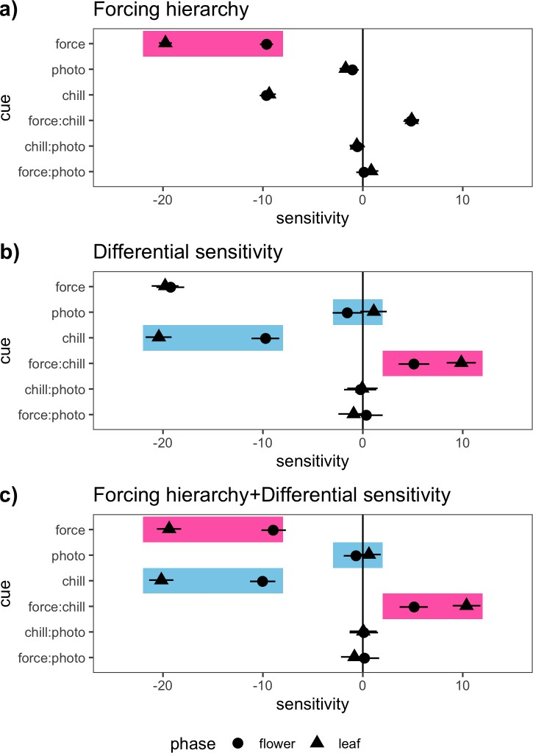

Figure 1: Characteristic sensitivity (∆ day of phenological event/ ∆ environmental cue) patterns of the phenological response to changing cue levels for the two major flower-leaf sequence hypotheses. a) displays a signature pattern of the forcing hierarchy hypothesis (FHH, pink boxes)—with the second phenophase in the sequence (in this case leafing) having a higher sensitivity to forcing than the first. b) Highlights a typical sensitivity pattern produced by the differential sensitivity hypothesis (DSH). c) Depicts a scenario where both the FHH and the DSH contribute to flower-leaf sequence variation. Here the characteristic forcing sensitivity of the FHH is still apparent but the differential sensitivity to chilling and photoperiod is seen as well (blue boxes). All plots above are based on simulations (see Supporting Information: Methods). Shapes indicate mean estimates and lines depict 95% credible intervals from Bayesian hierarchical models with advances in phenology shown as negative numbers, and delays in phenology as positive numbers.

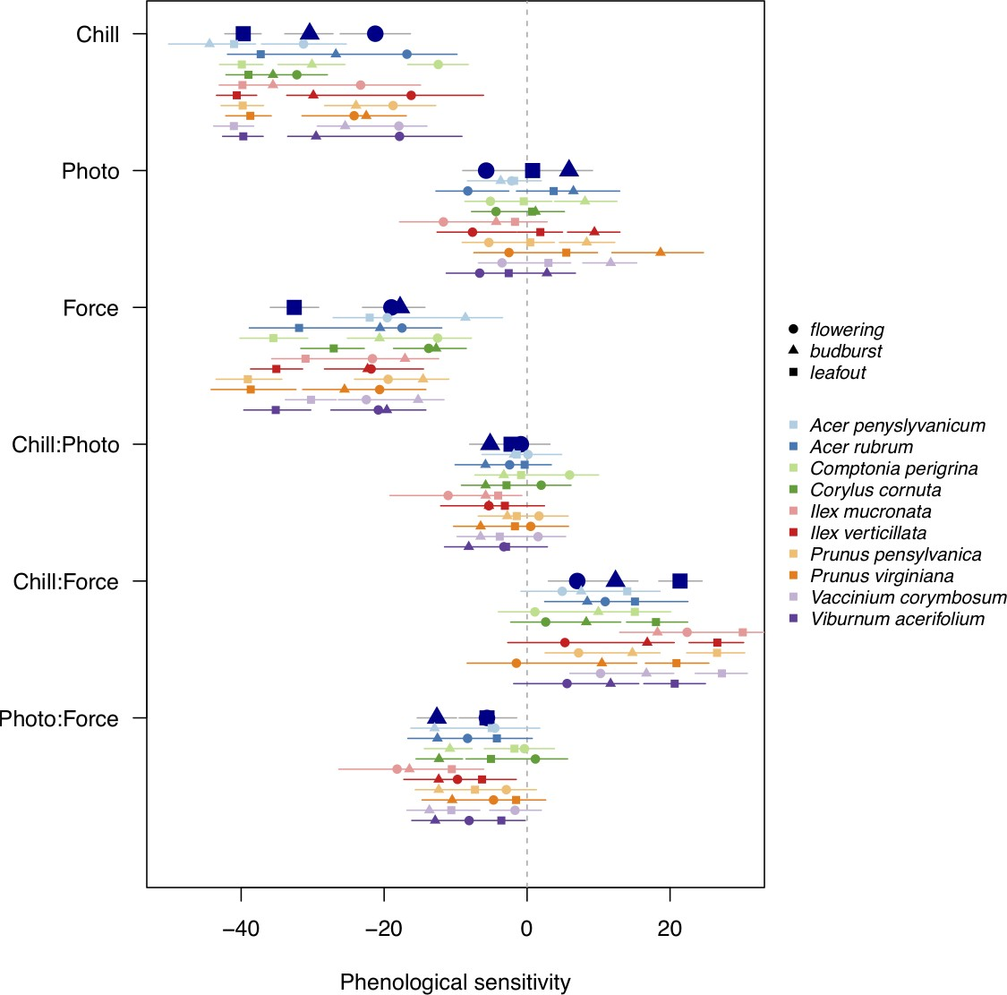
Figure 2: Effects of forcing temperature, chilling duration, and photoperiod on the leaf budburst (triangles), leafout (squares) and flowering (circles) phenology of 10 temperate woody plant species collected from Harvard Forest (Petersham, MA, USA). Shapes indicate mean estimates and lines depict 50% credible intervals (See Tab. S3, Tab. S4 for other intervals) from Bayesian hierarchical models with advances in phenology shown as negative numbers, and delays in phenology as positive numbers. Flower and leaf phenology differs in sensitivity (∆ day of phenological event/ ∆ environmental cue; 30 days chilling/6 ◦C forcing/4 hours photoperiod) to these environmental cues. See Fig. S2 for an alternative presentation of these results that depicts the difference between the mean estimates of each phase (shapes).

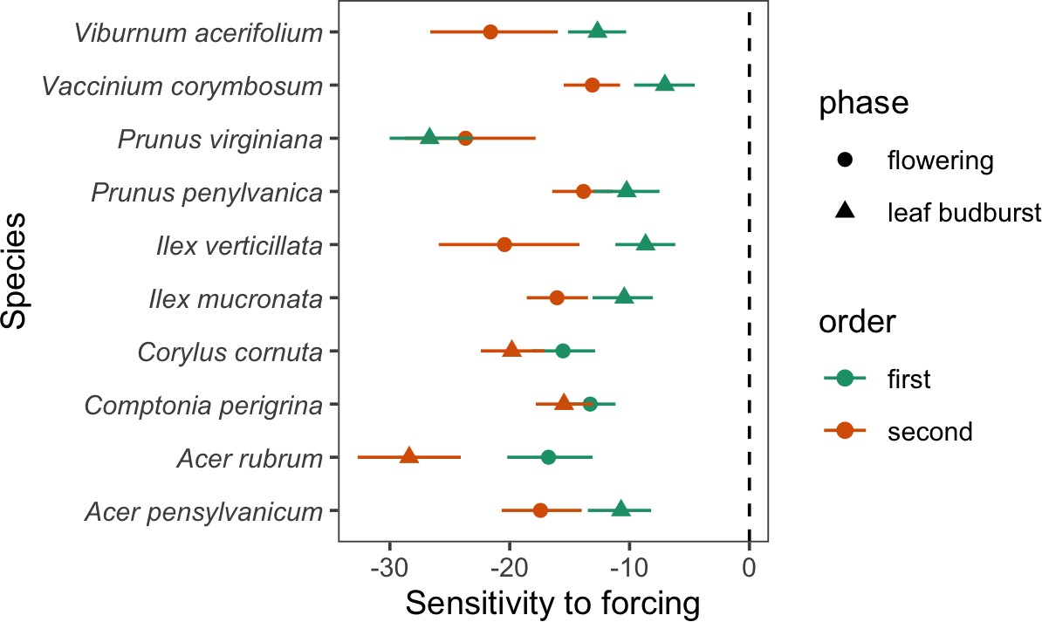

Figure 3: Phenological sensitivity (∆ days of phenological event/ ∆ 6◦C) to forcing temperatures of leaf budburst (triangles) and flowering (circles) phenology from 10 temperate deciduous woody plants at long (12 hour) photoperiod and long chilling du- ration treatments (60 days at 4◦C). Shapes indicate mean estimates and lines depict 50% credible intervals (See Tab. S5 for other intervals) from Bayesian hierarchical models with advances in phenology shown as negative numbers. When photoperiod and chilling are high, most species follows the predicted pattern of the forcing hierar- chy hypothesis (FHH), with the second phenophase of the sequence consistently more sensitive to forcing than the first. This result suggests that the FHH should be con- sidered a special case of the differential sensitivity hypothesis (DSH) that occurs when the chilling and photoperiod requirements are met for both tissue types.
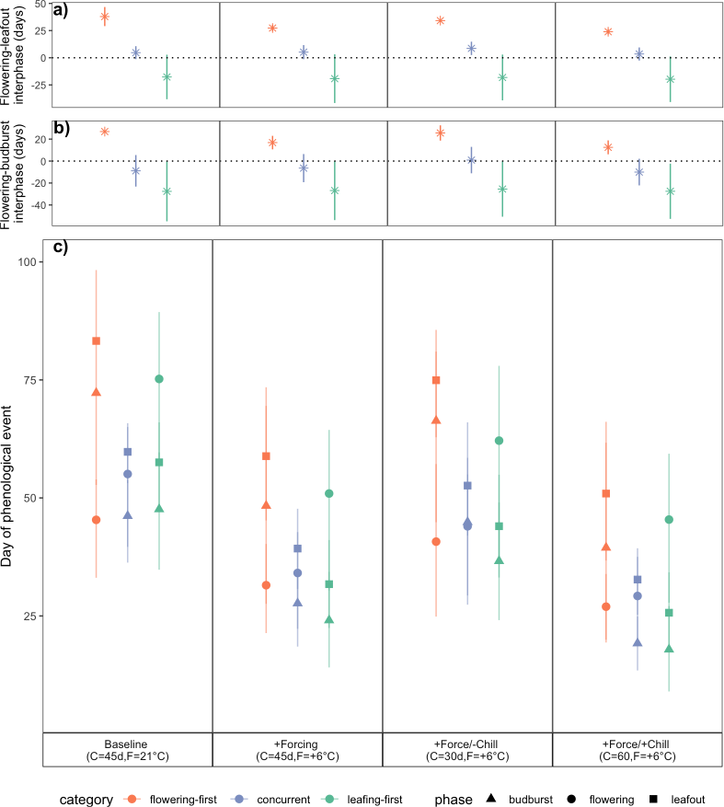

Figure 4: Projected shifts in flower-leaf sequences under current environmental con- ditions (Baseline) and three climate change scenarios (increase forcing, increase forc- ing/decrease chilling, increase forcing/increase chilling) predict that FLS shifts differ among the three major FLS types, and will be strongest is flowering-first species. Pan- els a) and b) show the mean time between flowering and vegetative phenological events (shapes) with 50% credible intervals (lines). Panel c) shows the predicted event day for each phase. Predictions are based on species-level posterior estimates grouped by FLS category (flowering-first, concurrent, leafing-first) from Bayesian hierarchical models comparing flowering (circles), leaf budburst (triangles) and leafout (squares) phenolog- ical responses to variable chilling duration and forcing temperatures. Shapes represent the mean estimates and lines represent the 50% credible intervals.

