1 Ecological drivers of ﬂower-leaf sequences: aridity and pollination
2 success select for ﬂowering-ﬁrst in the American Plums

3 D.M. Buonaiuto ^{1,2,3,a}, T.J. Davies ^{4,5}, S. Collins ⁴ & E.M. Wolkovich

4 Author aﬃliations:
5 1Department of Environmental Conservation, University of Massachusetts, Amherst, Massachusetts, USA.
6 ORCID: 0000-0003-4022-2591
7 2Arnold Arboretum of Harvard University, Boston, Massachusetts, USA.
8 3Department of Organismic and Evolutionary Biology, Harvard University, Cambridge, Massachusetts, USA
9 4Forest & Conservation Sciences, Faculty of Forestry, University of British Columbia, Vancouver, British
10 Columbia, Canada
11 5 Department of Botany, University of British Columbia, Vancouver, British Columbia, Canada
12 aCorresponding author: 617.823.0687; dbuonaiuto@umass.edu

13
14 Summary

15 • Across temperate forests around the globe, many tree species produce ﬂowers before their leaves emerge.
16 This ﬂower-leaf phenological sequence, known as hysteranthy, is generally described as an adaptation
17 for wind-pollination. However, this explanation does not address why hysteranthy is also common in
18 biotically-pollinated taxa.

19 • In this study, we quantiﬁed ﬂower-leaf sequence variation in the American plums (Prunus, subspp.
20 Prunus sect. Prunocerasus ), a clade of insect-pollinated tree and shrubs, using herbaria specimens
21 and Bayesian hierarchical modeling. We tested two common, but rarely interrogated hypotheses—
22 that hysteranthy confers aridity tolerance and/or pollinator visibility—by modeling the associations
23 between hysteranthy and related traits. To better understand how these phenology-trait associations
24 were sensitive to taxonomic scale and ﬂower-leaf sequence classiﬁcation, we extended these analyses to
25 include all Prunus species in North America.

26 • Our ﬁndings across these two taxonomic levels support the hypotheses that hysteranthy may both help
27 temporally partition hydraulic demand to reduce water stress, and increase pollinator visibility and
28 reduce selective pressure on inﬂorescence size.

29 • These results provide foundational insights into the evolution of ﬂower-leaf sequences in the genus
30 Prunus, with implications for understanding these patterns in biotically-pollinated plants in general.
31 Teasing out these hypotheses further will require both inquiries in other clades and mechanistic exper-
32 iments.

33 Keywords: Deciduous forests, Flower-leaf sequences, Hysteranthy, Phenology, Plant hydraulics, Pollination,
34 Phylogeny
35 Introduction

36 Woody perennials are among a subset of plant types with the unique ability to seasonally begin reproduction
37 prior to vegetative growth. This ﬂowering-ﬁrst phenological sequence, known as hysteranthy, proteranthy or
38 precocious ﬂowering, is apparent in temperate deciduous forests around the globe (Rathcke & Lacey, 1985).
39 A number of studies suggest that this ﬂower-leaf sequence is under selection, and that hysteranthy can confer
40 performance advantages (Guo et al., 2014; Gougherty & Gougherty, 2018; Buonaiuto et al., 2021), but the
41 importance of variation in ﬂower-leaf sequences for maintaining ﬁtness may vary across functional types, taxa
42 and biomes.

43 The most common, and well-tested explanation for the evolution of hysteranthy in temperate forests is that it
44 is adaptive for wind-pollination, as leaﬂess canopies increase wind speeds for pollen transport and reduce the
45 likelihood of pollen interception by vegetation (Whitehead, 1969; Niklas, 1985). However, this explanation
46 does not address the widespread prevalence of hysteranthy in biotically-pollinated taxa found in temperate
47 regions. This number is not trivial; a recent analysis found that approximately 20% of the hysteranthy species
48 in Eastern Temperate Forests of North America are biotically-pollinated (Buonaiuto et al., 2021).

49 Alternative hypotheses have been put forward to explain the advantage of hysteranthy in biotically-pollinated
50 species, but they have not been widely evaluated in the literature. Below, we brieﬂy review these hypotheses
51 and their predictions, and then test their predictions using the American plums (Prunus subspp. Prunus
52 sect. Prunocerasus ), a widespread clade with high variability in ﬂower-leaf sequences, as a case-study. Our
53 study both clariﬁes the hypothesized function of ﬂower-leaf sequence variation in the genus Prunus and lays
54 the ground work for understanding the origins of ﬂower-leaf sequence variation in biotically-pollinated taxa
55 more generally.

56 Hypotheses of hysteranthous ﬂowering in biotically-pollinated taxa

57 Water limitation hypothesis: In the dry-deciduous tropics of South and Central America, hysteranthy is
58 common (Rathcke & Lacey, 1985; Franklin, 2016), and is regarded as an important adaptation to alleviate
59 water stress by partitioning the hydraulic demand of ﬂowers and leaves across the season (Borchert, 1983;
60 Reich & Borchert, 1984; Franklin, 2016; Gougherty & Gougherty, 2018). Under this hypothesis, the function of
61 hysteranthous ﬂowering in temperate regions parallels that in the dry tropics—partitioning hydraulic demand
62 across the season to allow hysteranthous species to tolerate increased aridity. While temperate forests are
63 rarely water-limited in the early season during which ﬂowering and leaﬁng occur (Polgar & Primack, 2011),
64 there is still considerable variation in water availability in space and time within temperate regions of the
65 globe. With this hypothesis, we would expect to ﬁnd hysteranthous taxa in locations that are, on average,
66 drier than their non-hysteranthous relatives.

67 Insect visibility hypothesis: Hysteranthous ﬂowers are visually conspicuous in the landscape. Thus, as in
68 wind-pollinated taxa, hysteranthy in biotically-pollinated taxa may be an adaptation for pollination eﬃciency
69 as ﬂowering-ﬁrst species are easier for insect pollinators to locate (Janzen, 1967). A challenge to evaluating this
70 hypothesis is that correlated selection between ﬂower-leaf sequences and pollinator visibility could have either
71 a positive or negative relationship depending on the pollination environment. In one scenario, hysteranthy
72 may be associated with smaller ﬂoral displays: because ﬂowers are not obscured by leaves, they are easier
73 to see and there is weaker selection for increasing ﬂoral display size. In an alternative scenario, hysteranthy
74 could be associated with larger ﬂoral displays, especially in environments where plants are more often pollen-
75 limited and selection may favor both hysteranthy and increased ﬂoral display size to augment ﬂoral attraction
76 to visual pollinators.

77 In contrast to these functional hypotheses, hysteranthous ﬂowering could simply be a by-product of selection
78 for early ﬂowering. Species that ﬂower before their leaves inherently ﬂower early in the season. For example,
79 fruit development or dispersal constraints may drive early ﬂowering (Primack, 1987), and because spring
80 ﬂower phenology is less constrained by prior phenological events than leaf phenology (Ettinger et al., 2018;
81 Savage, 2019), this selection for early ﬂowering could incidentally produce the hysteranthous phenological
82 sequence. Here, there is no speciﬁc adaptive advantage to hysteranthy; selection is not operating on the
83 relative timing of ﬂower and leaf emergence, but rather the absolute ﬂowering time alone. Rejection of the
84 above functional hypotheses might provide support to this null explanation.

85 A signiﬁcant challenge for robust testing of hysteranthy hypotheses is that most characterizations of ﬂower-
86 leaf phenological sequences are based on expert-opinion verbal descriptions (e.g. “ﬂowers before leaves” or
87 “ﬂower before/with leaves”), which make comparisons across taxa, time and space diﬃcult and sensitive
88 to observer bias (see; Buonaiuto et al., 2021). This problem can be overcome by adopting standardized
89 quantitative measures of plant phenology for observational studies and applying them to historical data
90 records. Herbarium records are an excellent source of data that can be leveraged for quantitative phenological
91 measurements (Willis et al., 2017), but have not been used widely to investigate variability of ﬂower-leaf
92 sequences.

93 The American plums are powerful model clade to investigate of drivers of hysteranthous ﬂowering in biotically-
94 pollinated species. The species that make up this group are distributed across the temperate zone of North
95 America and, like the genus Prunus more generally show pronounced inter-speciﬁc variation in ﬂower-leaf
96 sequences. Usefully, species in this clade are well represented in herbaria records (Fig. 1a), making them a
97 tractable group to measure and assess variation in ﬂower-leaf sequences.

98 To interrogate the functional hypotheses for hysteranthous ﬂowering described above, we used herbaria records
99 to quantify variation in ﬂower-leaf sequences of the American plums. Then we combined environmental
100 attributes, biological traits and phylogenetic data in statistical models designed to evaluate whether the
101 observed associations between ﬂower-leaf sequences and morphological and environmental traits match the
102 predicted associations of the hysteranthy hypotheses. Finally, we compared our ﬁndings in this clade to
103 patterns observed in larger genus Prunus to test whether these phenology-trait associations were sensitive to
104 taxonomic scale and ﬂower-leaf sequence classiﬁcation.
105 Materials and Methods

106 Quantifying ﬂower-leaf sequence variation

107 We obtained digital herbarium specimens of the American plums from the Consortium of Midwest Herbaria
108 (CMH) Database (of Midwest Herbaria, 2023). Specimen collection dates ranged from 1844-2020, with the
109 majority collected between 1950-2000. To quantify ﬂower-leaf sequence variation in this group we randomly
110 sampled 200 specimens for each species and scored the phenological development of ﬂowers and leaves; we
111 used a modiﬁed BBCH scale for woody plants that is designed to evaluate vegetative and reproductive
112 phenological progress using a standardized quantitative index (Finn et al., 2007). For species with less than
113 200 specimens in the collection, we included all available specimens. In total, we evaluated the phenology
114 of 2521 specimens, but only specimens with visible ﬂowers were included in this analysis. We also removed
115 specimens with ﬂowering dates that were major outliers from the observed ﬂowering period of each species.
116 We removed outliers visually, and by excluding observations that were beyond three standard deviations of
117 the median ﬂowering time for each species (n=9). Our ﬁnal analyses included 1000 specimens (see Tab. S1
118 for number of observations/species). We reconstructed the phylogenetic relationships among species in this
119 group based on the tree topology in Shaw & Small (2004). We inferred branch lengths following the method
120 of Grafen & Hamilton (1989) in which node heights are estimated in proportion to number of subtending
121 taxa using the R package “ape” (E. Paradis and K. Schliep, 2019).

122 To quantify ﬂower-leaf sequence variation, we ﬁt an ordinal, hierarchical, Bayesian phylogenetic mixed model
123 (de Villemeruil P. & Nakagawa, 2014) to assess the likelihood an individual would be at any given vegetative
124 BBCH phase while ﬂowering. Our model predicted leaf stage (y_{i}, ordinal, with six categories) as a function of
125 species and additional phylogenetic eﬀects. Because hysteranthy co-varies with ﬂowering time (i.e., ﬂowering
126 ﬁrst species will generally ﬂower earlier than other species, on average), and collection dates are not evenly
127 distributed across the ﬂowering season (see Fig. S1), we included day of year of observation as an additional
128 predictor. Additionally, because it is possible that climate change has aﬀected the interval between ﬂowering
129 and leafout over the course of our time series, we included the year of collection of each specimen as a
130 co-variate. Following previous conventions for modeling the possible eﬀects of climate change on spring
131 phenology, we parameterized year as hinge variable, using 1980 as a break point (Stocker et al., 2013;
132 Buonaiuto et al., 2021; Kharouba et al., 2018).

133 The model is written below:

134

 2 if z_{i} ∈ (0, c₂)
 1 if z_{i} < 0
y =  3 if z_{i} ∈ (c₂, c₃)
i
4 if z_{i} ∈ (c₃, c₄)
 5 if z_{i} ∈ (c₄, c₅)
 6 if z_{i} > c₅

135

136
zi = α + αphylo + αsp + βday of year[sp] ∗ Xday of year + βyear ∗ Xyear + ϵi

137 ϵ_{i} ∼ logistic(0, 1)

138

139 where y_{i} is the ordinal outcome (leaf stage; as 1,2,...6 categories). c_{2...5} are the estimated cutpoints between
140 leaf stages on the logit scale and year is (the year the specimen was collected − 1980). z_{i} is the linear
141 component of the underlying latent variable model.

142 α describes an intercept for each category [1,2,...6], while slope (β_{day} _{of} _{year} and β_{year}) is constant across
143 cutpoints, but β_{day} _{of} _{year} varies among species.

144 The inﬂuence of the phylogeny (α_{phylo}) was modeled as:

145

α_{phylo} ∼ N (0, COR[σ^{2,3,4}
phylo
² ])

146 The α for species eﬀects independent of the phylogeny was modeled as:

147

α_{sp} ∼ N (0, σ² )
species

148 We used our model to predict the likelihood each species would be observed at a given vegetative BBCH stage
149 during ﬂowering for each day of the ﬂowering period of each species by extracting 1000 random draws from
150 the posterior distribution. For each day of the ﬂowering season, we summed the predicted likelihood that
151 species would be at BBCH 0 (“bud closed”), BBCH 07/09 (“bud break”) or BBCH 11 (“start of leaf unfolding)
152 vs. BBCH 15 (“leaf unfolding”), BBCH 17(“most leaves unfolded”), BBCH 19 (“leaf expansion complete”) to
153 quantify the likelihood that a species would be hysteranthous or non-hysteranthy respectively, for each day of
154 the season. We chose the BBCH 11/BBCH 15 boundary to deﬁne hysteranthous ﬂowering because this is the
155 earliest point in development when most leaves are unfurled enough to visually obscure ﬂowers and transpire.
156 We used these estimates to develop a ﬂower-leaf sequence index by summing the likelihood of hysteranthy
157 vs. non-hysteranthy across the full ﬂowering period of each species, with 0 being never hysteranthous and 1
158 being always hysteranthous. To evaluate the sensitivity of our model to choice of cutoﬀ, we also calculated

159 a hysteranthy index using an alternative cutoﬀ at the BBCH 09/BBCH 11 which did not alter the species’
160 ranks on the index (see Tab. S2).

161 To better understand how within-season dynamics aﬀected our inference, we also reﬁt our model excluding
162 day of year as a predictor. This version of the model did not substantially alter the species’ ranks on the index
163 or our inference about the relationships between ﬂower-leaf sequence variation and the trait representing the
164 main hysteranthy hypotheses (Tab. S2, Tab. S3).

165 Evaluating hysteranthy hypotheses

166 To test the hypotheses of hysteranthy, we ﬁrst recorded petal length measurements directly from herbarium
167 specimens. For these morphological measurements, we sampled 321 specimens and measured the petal length
168 of up to 10 randomly selected petals per specimen (n=2757) using ImageJ image processing software (see
169 Tab. S2, for n/species).

170 To assess aridity tolerance, we computed the average Palmer Modiﬁed Drought Index score (hereafter: PDSI)
171 obtained from the for Environmental Information (2017), for every Prunocerasus specimen in the database
172 (n=2305, see Tab. S2, for n/species). PDSI is a standardized index that integrates temperature and pre-
173 cipitation data to estimate relative dryness in time and space (Heim, 2002). For any specimens that lacked
174 accurate geo-location information, we extracted PDSI values at the county centroid of the herbaria specimen.

175 Because our all of our measurements were made on diﬀerent individuals—with diﬀerent sample sizes—we
176 used two diﬀerent modeling approaches to test the relationship between ﬂower-leaf sequence index scores,
177 aridity tolerance and ﬂoral displays.

178 First we computed species-levels means of PDSI and petal length and used a beta regression to evaluate the
179 relationship between ﬂower-leaf sequences, PDSI, petal length and their interaction. We standardized the
180 units of all predictors through z-scoring (Gellman & Hill, 2007) to make their eﬀect size estimates directly
181 comparable within the following model structure:

182

183 y_{i} = (µ, µ(1 − µ)/(1 + ϕ)

184

185 where µ and ϕ are the two shape parameters of the beta regression. Due to the limited sample size of this
186 analysis (13 species), we only modeled the eﬀect of our predictors on the mean parameter µ and ﬁt a grand
187 intercept for the precision parameter ϕ as:

188

189

190
µ = α + βPDSI ∗ XP D¯SI + βpetal length ∗ Xpetal ¯length + βPDSIxpetal length ∗ XP D¯SI_{x}petal ¯length)

191 ϕ = α

192

193 We chose this model structure because it allowed us to assess the additive and interactive eﬀects of PDSI
194 and petal size on ﬂower-leaf sequences. However, by using means trait values as predictors, we could not
195 incorporate within-species variation in these trait/environmental predictors or account for their phylogenetic
196 structure. To understand how these factors aﬀected our inferences about the relationship between ﬂower-leaf
197 sequences and traits, we ﬁt two additional models to estimate relationship between ﬂower-leaf sequences index
198 values and PDSI, and between ﬂower-leaf sequences index values and petal size separately which included
199 the intra-speciﬁc variation and phylogenetic structure of each of these traits (see Supporting Information:
200 Extended Methods for details).

201 Hysteranthy in the larger genus Prunus

202 To better understand how the patterns we identiﬁed in the American Plums clade scaled across coarser
203 taxonomic resolution, we also evaluated the relationship between hysteranthous ﬂowering and hypothesis-
204 related traits for additional Prunus species native to, or established in, North America (n=32). For this
205 analysis, we obtained categorical descriptions of ﬂower-leaf sequences and mean estimates of the number of
206 ﬂowers per inﬂorescence as a proxy for ﬂoral investment from the Flora of North America (Rohrer, 1993+).
207 We extracted PDSI values for all herbaria observation of those species in the Consortium of Midwest Herbaria
208 database (n=23,272) as described above.

209 To account for the inﬂuence of evolutionary relationships among species, we reconstructed the phylogenetic
210 relationships in the genus based on the tree topology in Chin et al. (2014). As above, we computed branch
211 lengths with the R package “ape” (E. Paradis and K. Schliep, 2019).

212

213
As above, we standardized the units of all predictors through z-scoring (Gellman & Hill, 2007). The model structure is:
 1 if z_{i} < 0

y =  2 if z_{i} ∈ (0, c₂)
i
3 if z_{i} ∈ (c₂, c₃)
 4 if z_{i} > c₃

214 zi = α+αphylo+βPDSI∗XPDSI +βﬂoral investment∗Xﬂowers/inﬂorescence+βPDSI_{x}ﬂoral investment∗XPDSI_{x}ﬂowers/inﬂorescence+
215 ϵ_{i}

216

ϵ_{i} ∼ logistic(0, 1)

217 where y_{i} is the ordinal outcome of ﬂower-leaf sequence category ( “ﬂowers after leaves”, “ﬂowers with leaves”,
218 “ﬂowers before/with leaves” and“ﬂowers before leaves”) and c_{2...3} are the estimated cutpoints between cate-

219 gories on the logit scale. As above, z_{i} is the linear component of the underlying latent variable model. α
220 describes a grand intercept, and we modeled the inﬂuence of phylogeny (α_{phylo}) as above. Note that this
221 model includes four ordinal categories while our model of the American Plums clade included six, due to the
222 underlying structure of the data.

223 Model runs

224 We ﬁt models in the R package “brms” (Bu¨rkner, 2018) using weakly informative priors, and four chains. For
225 the our models aimed at“Quantifying ﬂower-leaf sequence variation” and“Evaluating hysteranthy hypotheses”
226 in The American plums, we ran the models with a warm-up of 3000 iterations, and 4000, and 5000 sampling
227 iterations respectively, for a total of 4000 and 8000 sampling iterations across all chains. For the “Hysteranthy
228 in the larger genus Prunus” model, we used a warm up of 6,000 iterations and 8,000 sampling iterations for
229 a total of 8000 sampling iterations to maximize the eﬀective sampling size. Model ﬁts was assessed with Rˆ
230 <1.01, high eﬀective sample sizes, and no divergent transitions. We provide mean estimates with uncertainty
231 intervals in-text, and 50 and 89% intervals for all ﬁgures and tables.

232 Results

233 Quantifying ﬂower leaf sequences in the American plums

234 We found substantial inter-speciﬁc diﬀerences in ﬂower-leaf sequences within the American plums (Fig.
235 1b,2a). Several species (P. mexicana, P. umbellata, P. angustifolia, P. maritima and P. gracilis) were
236 most likely to be hysteranthous for all—or most—of their ﬂower period, while for others, (P. americana, P.
237 munsoniana, P. alleghaniensis, P. nigra, P. hortulana, P. texana and P. rivularis ), hysteranthous ﬂowering
238 was only likely in the early part of their ﬂowering session. One species, P. subcordata, was unlikely to be
239 hysteranthous at any point in its ﬂowering period (Fig. 2a). These relative ranking of species’ hysteranthy
240 likelihoods were consistent with our alternative method for constructing the hysteranthy index (Tab. S2, Fig.
241 S2).

242 Across all species of American Plums, day of year of had a strong association with the being more like to be
243 in ﬂowering during an early vegetative phenological stage (Fig. 2b). Year of observation did not substantially
244 impact this likelihood of hysteranthy for this taxonomic group (Fig. 2b).

245 Associations between hysteranthy and environmental and morphological traits

246 In the American plums, predominately hysteranthous species were more likely to have smaller ﬂower and be
247 found in drier localities that species with more overlap between ﬂowers and leaves (i.e., increased likelihood of
248 hysteranthy was negatively associated with PDSI and petal length without a substantial interaction between
249 them, Fig. 3a, b). Parameter estimates from this model were β_{PDSI} : −0.47, UI₈₉[−0.96, 0.01], β_{petal} _{length} :
250 −0.14, UI₈₉[−0.54, 0.24] β_{PDSI}xpetal length : −0.14, UI₈₉[−0.91, 0.65].

251 These estimates were comparable to those in which we model each predictor separately and account for
252 phylogeny (Fig. S3), and using the hysteranthy index derived from models that did not include day of year
253 as a predictor (Tab. S3). The direction and magnitude of the estimated eﬀects support the predictors of the
254 water-limitation hypothesis and marginally support the predictors of the insect-visibility hypothesis.

255 In the larger genus Prunus, hysteranthous species were more likely to have smaller inﬂorescences and be
256 found in drier locations, and species with species from dry locations that also have smaller inﬂorescences are
257 the mostly likely to be hysteranthous (i.e., there was a negative association between hysteranthy and PDSI
258 and number of ﬂowers per inﬂorescence, as well as a substantial negative interaction between them, Fig.
259 4a, b). Paremeter estimates from this model were β_{PDSI} : −8.0, UI₈₉[−16.6, −2.44], β_{flowers/inflorescence} :
260 −15.5, UI₈₉[−31.46, −5.56] and β_{PDSIxflowers/inflorescence} : −13.06, UI₈₉[−28.53, −2.93]. The direction and
261 magnitude of the estimated eﬀects support the predictors of both the water-limitation hypothesis and the
262 insect-visibility hypothesis.

263 The estimated eﬀects of ﬂoral traits and their interactions with PDSI were stronger in the larger genus Prunus
264 than in the American Plums clade. This is not surprising given that all species in the American plums clade
265 have solitary ﬂowers, making the variation in ﬂoral display size highly constrained. By contrast, Prunus
266 species included in our secondary analysis include those with solitary ﬂowers and species with as many as 100
267 ﬂowers per inﬂorescence, representing substantially more variation in both ﬂoral investment and in hydraulic
268 demand. This suggests that the correlated selection between ﬂower-leaf sequences and the ﬂoral traits may
269 be more pronounced at coarser taxonomic resolutions, when underlying trait variation is greater.

270 Discussion

271 Using North American Prunus species as a case study, our analyses indicate that ﬂower-leaf sequences
272 are under selection. Our study shows that variation in these patterns across species may reﬂect adaptive
273 tradeoﬀs between a) the timing of investment in reproduction relative to the timing of resumption of carbon
274 gain through leafout, and b) other aspects of plant performance like environmental tolerance and pollinator
275 attraction strategies that we investigated in this study. We show that hysteranthous ﬂowering is associated
276 with increased aridity and smaller ﬂower displays in both the American plums, and more broadly across
277 Prunus species native to, or established in North America. The relationships between hysteranthy and
278 aridity, and hysteranthy and ﬂoral display size support the predictions of the water limitation hypothesis and
279 the insect visibility hypothesis.

280 Our models estimated a strong relationship between aridity and ﬂower-leaf sequences at both taxonomic
281 scales we studied, but the relationship between ﬂoral display size and ﬂower-leaf sequences predicted by the
282 insect visibility was better supported at the coarser taxonomic scale of the full genus Prunus than in the
283 American Plums clade. While this suggests that associated selection between ﬂower-leaf sequences and polli-
284 nator traits has more strongly inﬂuenced inﬂorescence architecture than the morphology of individual ﬂowers,
285 our estimates at both scales agreed in directionality (i.e., hysteranthy associated with smaller ﬂoral displays).
286 Under the current insect visibility hypothesis, ﬂoral display size could either be positively or negatively as-
287 sociated with hysteranthy depending on the pollination environment. The association between hysteranthy
288 and smaller ﬂower displays we found supports the prediction that increased visibility of hysteranthous ﬂowers
289 reduces selection pressure on ﬂower display size. This results ﬁt with other comparative anatomy studies in
290 plants that report hysteranthous species have smaller inﬂorescences than non-hysteranthous relatives (Gu-
291 natilleke & Gunatilleke, 1984), and studies about pollinator foraging behavior that suggest the presence of
292 leaves substantially alter the visual perception of pollinators (Rivest et al., 2017; Forrest & Thomson, 2009),
293 providing further evidence to reﬁne the predictions of this hypothesis.

294 Our support for both the water limitation hypothesis and insect visibility hypothesis, and the strong positive
295 interactions terms between PDSI and ﬂoral investment we observed in the larger genus Prunus highlights
296 that these hypotheses are not mutually exclusive, and could be related. Selection on ﬂoral size represents
297 a classic evolutionary tradeoﬀ where larger ﬂoral displays may generally be more eﬀective for attracting
298 pollinators but demand more resources, including water, to maintain turgor and reproductive function than
299 smaller ones (Galen et al., 1999; Lambrecht & Dawson, 2007). With this trade-oﬀ, reproductive displays are
300 often small in harsher environments (Lambrecht, 2013; Teixido et al., 2016), and hysteranthy could represent
301 a compensatory mechanism that both reduces hydraulic demand while increasing pollination eﬃciency in
302 these environments.

303 Despite this evidence that hysteranthy can reduced hydraulic demand in dry environments, hysteranthous
304 species in the American plum clade are not found in extremely arid locations (PDSI values typically range
305 from -4 to 4, however the values that we observed in our analyses were more restricted, ranging from -0.5
306 to 0.2). This contrasts with hysteranthous species in the dry tropics where this phenological pattern allows
307 them to tolerate more extreme aridity (Franklin, 2016). But the ﬂower-leaf sequences of the hysteranthous
308 species in our study were markedly diﬀerent from patterns of hysteranthy in these dry-tropics where the water
309 limitation hypothesis was initially proposed. While ﬂowering can precede leafout by as much several weeks
310 for species in the American plums, the process of fruit development, which is also water intensive, occurs
311 when leaves are present. By contrast, in the dry tropics hysteranthous ﬂowering is initiated at the time of
312 leaf drop (Borchert, 1983; Franklin, 2016); thus, the full reproductive cycle occurs in the leaﬂess period. The
313 comparatively small window of leaﬂess reproductive development in our temperate clade, may in part, explain
314 why the association we observed between hysteranthy and aridity in our study was relatively weak with high
315 residual variance. Our results suggest that hysteranthy may allow temperate species to occupy marginally
316 drier environments than non-hysteranthous species, but may not facilitate species’ persistence under extreme
317 aridity.
318 Inter-and intra-speciﬁc variation in ﬂower-leaf sequences

319 We developed a novel approach to assessing ﬂower-leaf sequences that scales from quantitative, individual-
320 level observations to species-level characterizations that were based on empirical likelihood estimates. With
321 this approach, we were able to—for the ﬁrst time—quantitatively assess intermediate cases of hysteranthy
322 (such as those that are typically described as “ﬂowers before/with leaves”). Previous studies of hysteranthous
323 ﬂowering have either excluded these cases from their analyses (e.g.; Gougherty & Gougherty, 2018) or binned
324 them with the well deﬁned cases (e.g.; Buonaiuto et al., 2021). We found that many of American plum
325 species expressed this intermediate ﬂower-leaf sequence, and our classiﬁcations broadly matched previous
326 species-level analyses in this group by Shaw & Small (2004). By estimating the likelihood of hysteranthy
327 across the growing season with Bayesian methods, our approach identiﬁed substantial diﬀerences in ﬂower-
328 leaf sequences among these intermediate cases (Fig. 1b), which allowed us to assess the trait associations
329 with this phenotype.

330 Our quantitative analysis of the American plums clade revealed that ﬂower-leaf sequences—often described
331 as a species-level trait—are highly variable within species (Fig. 2a). For almost all members of the clade,
332 hysteranthy was strongly predicted by the day of the observation (“day of year” in our model,Fig. 2b). In
333 many cases there was high likelihood that individuals of a species may be observed at diﬀerent vegetative
334 stages during ﬂowering (Fig. 2a, Fig. S2). This variation could either suggest high levels of local adaptation in
335 ﬂower-leaf sequences or, alternatively, high levels of plasticity through which ﬂower-leaf sequences respond to
336 interannual variation in environmental conditions. Because our study was based on herbaria records collected
337 on diﬀerent individuals across space and time without repeat sampling, we were not able to robustly how
338 much ﬂower-leaf sequences vary within vs. among species. However this would be an important next step
339 for understanding how the environment and species interactions have shaped these phenological patterns.

340 Interestingly, while there is substantial evidence that both ﬂowering and leaf phenology have advanced over
341 the last several decades in response to anthropogenic climate change (Menzel et al., 2006; Cleland et al., 2007;
342 Augspurger & Zaya, 2020), we did not observe changes in ﬂower-leaf sequences patterns over that time scale
343 in our dataset (Fig. 2b). This supports a recent ﬁnding that despite changes in both ﬂowering and leafout,
344 the time interval between them has remained relatively stable (Guo et al., 2023), but does not preclude that
345 possibility that these the sequences will eventually be disrupted as climate change continues to become more
346 extreme in the future (Buonaiuto & Wolkovich, 2021).

347 Future directions

348 We focused on a well-studied, and economically important clade of morphologically similar species. Our
349 case-study provides a road map for evaluating the role of hysteranthy more generally in temperate biotically-
350 pollinated plant taxa (other groups with high interspeciﬁc ﬂower-leaf sequence variation include Magnolia,
351 Rhododendron, Acer and Cornus), and more broadly across taxa and biomes.
352 Combining the observational approach with novel experiments could further advance our collective under-
353 standing of the adaptive signiﬁcance of ﬂower-leaf sequences. To test the water-limitation hypothesis, re-
354 searchers could plant sister-taxa with contrasting ﬂower-leaf sequences in common environments across a
355 gradient of aridity, and evaluate their performance. To test the insect visibility hypothesis, researchers
356 should also consider hysteranthy—and phenology in general—in the more general framework of tradeoﬀs in
357 pollination biology. The tradeoﬀ between phenology and pollination investment should not only consider
358 ﬂower size, but also the number of ﬂowers, nectar and pollen reward investment, volatiles between related
359 hysteranthous and non-hysteranthous taxa. Findings that hysteranthous species invest fewer resources into
360 these other pollinator attraction traits than non-hysteranthous relatives would support the insect visibil-
361 ity hypothesis. For a simple experiment to test the pollinator visibility hypothesis, researchers could force
362 hysteranthy/non-hysteranthy phenotypes for the same genotype using environmental cues, and systematically
363 release pollinators to observe their preferences, search times and foraging behavior. If pollinators are more
364 readily drawn to the hysteranthous individuals, it would suggest that hysteranthy may be an adaptive trait
365 for pollinator attraction.

366 With a better mechanistic understanding of the relationship between ﬂower-leaf sequences and ecological
367 performance in hand, researchers could then use experiments to assess how diﬀerences in ﬂoral and leaf
368 physiological responses to temperature variation shape ﬂower-leaf sequences. The measurement and modeling
369 approaches we developed in our observational study can be readily implemented to analyze data from such
370 experimental settings, presenting an important opportunity to unite observations of broad ecological patterns
371 with targeted experimental manipulations to better understand both the evolutionary past and ecological
372 future of ﬂower-leaf sequences.

373 Competing Interests:

374 The authors declare no conﬂict of interest.

375 Author contributions

376 DMB, and EMW conceived of the manuscript; DMB and SC collected the data; DMB led the statistical
377 analyses with TJD and EMW; DMB led the writing of the manuscript. All authors contributed to writing
378 and gave approval for the submission.
379 Data Availability

380 The phenology and trait data collected for this study will be made available and archived at KNB: The
381 Knowledge Network for Biocomplexity (https://knb.ecoinformatics.org/) at the time of publication.

382 References

383 Augspurger CK , Zaya DN. 2020. Concordance of long-term shifts with climate warming varies among
384 phenological events and herbaceous species. Ecological Monographs, n/a: e01421.

385 Borchert R. 1983. Phenology and control of ﬂowering in tropical trees. Biotropica, 15: 81–89.

386 Buonaiuto DM, Morales-Castilla I , Wolkovich EM. 2021. Reconciling competing hypotheses regarding
387 ﬂower–leaf sequences in temperate forests for fundamental and global change biology. New Phytologist,
388 229: 1206–1214.

389 Buonaiuto DM , Wolkovich EM. 2021. Diﬀerences between ﬂower and leaf phenological responses to envi-
390 ronmental variation drive shifts in spring phenological sequences of temperate woody plants. Journal of
391 Ecology, 109: 2922–2933.

392 Bu¨rkner PC. 2018. Advanced bayesian multilevel modeling with the r package brms. R Journal, 10: 395–411.

393 Chin SW, Shaw J, Haberle R, Wen J , Potter D. 2014. Diversiﬁcation of almonds, peaches, plums and
394 cherries –molecular systematics and biogeographic history of prunus (rosaceae). Molecular Phylogenetics
395 and Evolution, 76: 34–48.

396 Cleland EE, Chuine I, Menzel A, Mooney HA , Schwartz MD. 2007. Shifting plant phenology in response
397 to global change. Trends in Ecology Evolution, 22: 357 – 365.

398 E. Paradis and K. Schliep. 2019. ape 5.0: an environment for modern phylogenetics and evolutionary analyses
399 in R. Bioinformatics, 35: 526–528.

400 for Environmental Information NC. 2017. Lbdp-v2. Tech. rep., National Oceanic and Atmospheric Admin-
401 istration.

402 Ettinger A, Gee S , Wolkovich E. 2018. Phenological sequences: how early season events deﬁne those that
403 follow. American Journal of Botany, 105.

404 Finn GA, Straszewski AE , Peterson V. 2007. A general growth stage key for describing trees and woody
405 plants. Annals of Applied Biology, 151: 127–131.

406 Forrest J , Thomson JD. 2009. Background complexity aﬀects colour preference in bumblebees. Naturwis-
407 senschaften, 96: 921–925.
408 Franklin DC. 2016. Flowering while leafess in the seasonal tropics need not be cued by leaf drop: evidence
409 from the woody genus brachychiton (malvaceae). Plant Ecology and Evolution, 149: 272–279.

410 Galen C, Sherry R , Carroll A. 1999. Are ﬂowers physiological sinks or faucets? costs and correlates of water
411 use by ﬂowers of polemonium viscosum. OECOLOGIA, 118: 461–470.

412 Gellman A , Hill J. 2007. Data Analysis Using Regression and Multilevel/Hierarchical Models. Cambridge
413 University Press.

414 Gougherty AV , Gougherty SW. 2018. Sequence of ﬂower and leaf emergence in deciduous trees is linked to
415 ecological traits, phylogenetics, and climate. New Phytologist, 220: 121–131.

416 Grafen A , Hamilton WD. 1989. The phylogenetic regression. Philosophical Transactions of the Royal Society
417 of London. B, Biological Sciences, 326: 119–157.

418 Gunatilleke CVS , Gunatilleke IAUN. 1984. Some observations on the reproductive biology of three species
419 of cornus (cornaceae). Journal of the Arnold Arboretum, 65: 419–427.

420 Guo L, Liu X, Alatalo JM, Wang C, Xu J, Yu H, Chen J, Yu Q, Peng C, Dai J et al . 2023. Climatic
421 drivers and ecological implications of variation in the time interval between leaf-out and ﬂowering. Current
422 Biology, 33: 3338–3349.e3.

423 Guo L, Luedeling E, Dai J , Xu J. 2014. Diﬀerences in heat requirements of ﬂower and leaf buds make
424 hysteranthous trees bloom before leaf unfolding. Plant Diversity and Resources, 36: 245–253.

425 Heim RR. 2002. A review of twentieth-century drought indices used in the united states. Bulletin of the
426 American Meteorological Society, 83: 1149–1166.

427 Janzen DH. 1967. Synchronization of sexual reproduction of trees within the dry season in central america.
428 Evolution, 21: 620–637.

429 Kharouba HM, Ehrl´en J, Gelman A, Bolmgren K, Allen JM, Travers SE , Wolkovich EM. 2018. Global
430 shifts in the phenological synchrony of species interactions over recent decades. Proceedings of the National
431 Academy of Sciences, 115: 5211.

432 Lambrecht SC. 2013. Floral water costs and size variation in the highly selﬁng leptosiphon bicolor (polemo-
433 niaceae). International Journal of Plant Sciences, 174: 74–84.

434 Lambrecht SC , Dawson TE. 2007. Correlated variation of ﬂoral and leaf traits along a moisture availability
435 gradient. Oecologia, 151: 574–583.

436 Menzel A, Sparks TH, Estrella N, Koch E, Aasa A, Ahas R, Alm-Kuebler K, Bissolli P, Braslavska O, Briede
437 A et al . 2006. European phenological response to climate change matches the warming pattern. Global
438 Change Biology, 12: 1969–1976.

439 of Midwest Herbaria C. 2023. Consortium of midwest herbaria.
440 Niklas KJ. 1985. The aerodynamics of wind pollination. The Botanical Review, 51: 328–386.

441 Polgar C , Primack R. 2011. Leaf-out phenology of temperate woody plants: From trees to ecosystems. New
442 Phytologist, 191: 926–41.

443 Primack RB. 1987. Relationships among ﬂowers, fruits, and seeds. Annual Review of Ecology and Systematics,
444 18: 409–430.

445 Rathcke B , Lacey EP. 1985. Phenological patterns of terrestrial plants. Annual Review of Ecology and
446 Systematics, 16: 179–214.

447 Reich P , Borchert R. 1984. Water-stress and tree phenology in a tropical dry forest in the lowlands of
448 costa-rica. Journal of Ecology, 72: 61–74.

449 Rivest SA, Austen EJ , Forrest JRK. 2017. Foliage aﬀects colour preference in bumblebees (bombus impa-
450 tiens): a test in a three-dimensional artiﬁcial environment. Evolutionary Ecology, 31: 435–446.

451 Rohrer J. 1993+. Prunus. In: Flora of North America North of Mexico (ed. of North America Editorial Com-
452 mittee F.). New York and Oxford.

453 Savage JA. 2019. A temporal shift in resource allocation facilitates ﬂowering before leaf out and spring vessel
454 maturation in precocious species. American Journal of Botany, 106: 113–122.

455 Shaw J , Small RL. 2004. Addressing the ”hardest puzzle in american pomology:” phylogeny of prunus sect.
456 prunocerasus (rosaceae) based on seven noncoding chloroplast dna regions. Am J Bot, 91: 985–996.

457 Stocker T, Qin D, Plattner GK, Tignor M, Allen S, Boschung J, Nauels A, Xia Y, Bex V , Midgley P.
458 2013. Climate Change 2013: The Physical Science Basis. Contribution of Working Group I to the Fifth
459 Assessment Report of the Intergovernmental Panel on Climate Change. IPCC, Cambridge, United Kingdom
460 and New York, NY.

461 Teixido AL, Barrio M , Valladares F. 2016. Size matters: Understanding the conﬂict faced by large ﬂowers
462 in mediterranean environments. The Botanical Review, 82: 204–228.

463 de Villemeruil P. , Nakagawa S. 2014. Modern Phylogenetic Comparative Methods and Their Application in
464 Evolutionary Biology, Springer, New York, chap. General quantitative genetic methods for comparative
465 biology, pp. pp. 287–303.

466 Whitehead DR. 1969. Wind pollination in the angiosperms: Evolutionary and environmental considerations.
467 Evolution, 23: 28–35.

468 Willis CG, Ellwood ER, Primack RB, Davis CC, Pearson KD, Gallinat AS, Yost JM, Nelson G, Mazer SJ,
469 Rossington NL et al . 2017. Old plants, new tricks: Phenological research using herbarium specimens.
470 Trends in Ecology & Evolution, 32: 531–546.
471 Figures

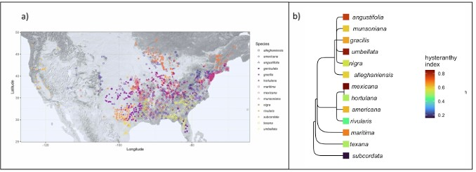

Figure 1: Geographic distribution and taxonomic relationships among the American plums. a) Maps the local- ities of all the herbaria records used in this study. b) Depicts phylogenetic relationships among the American plums and the likelihood they each species is hysteranthous across its full ﬂowering period, represented by a hysteranthy index where 0 is never hysteranthous and 1 is always hysteranthous. These designations are based on ordinal phylogenetic mixed models. Tree topology is from Shaw & Small (2004)
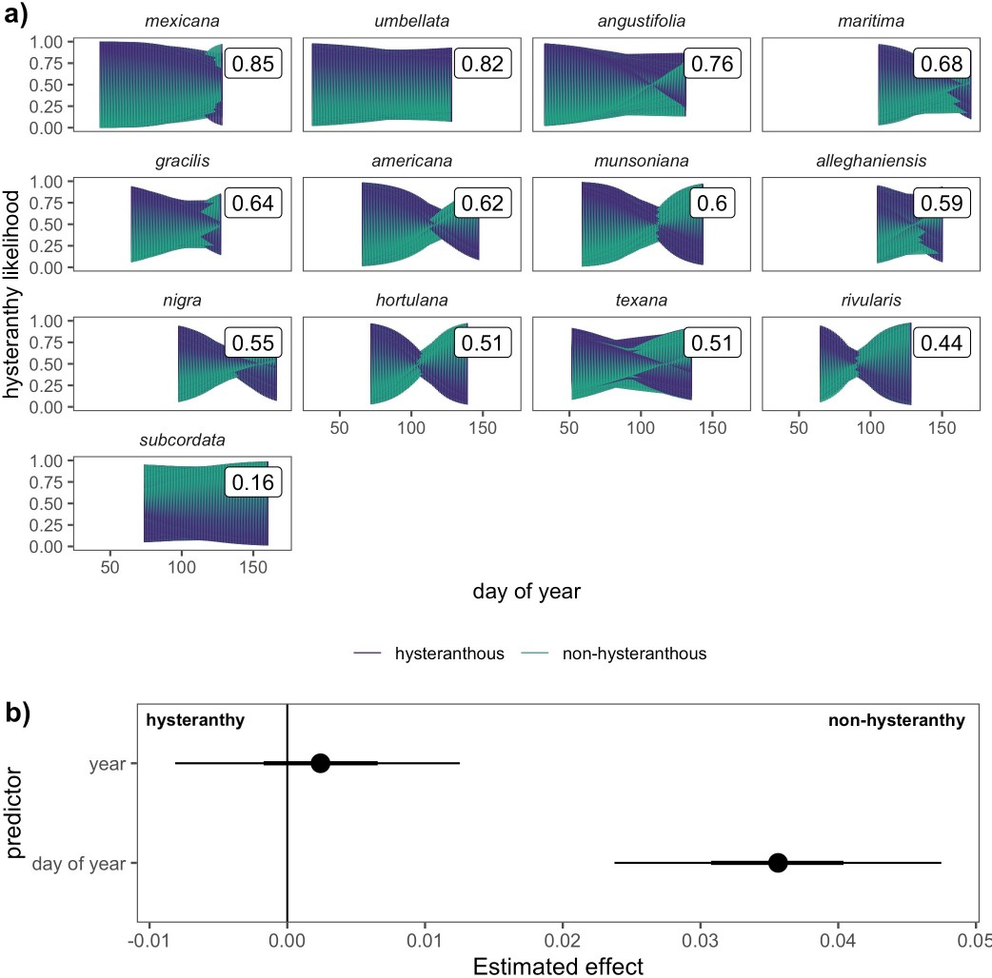

Figure 2: Predicted likelihood of hysteranthy across the ﬂowering period of 13 American plum species and the temporal predictors that drive these patterns. Panel a) depicts the predicted likelihood that each species would express hysteranthy on each day of their ﬂowering season based on 1000 draws from the posterior distribution of Bayesian hierarchical models. The colored shapes represent how the likelihood changes over time and the boxed numerical values represent the average likelihood a species would express hysteranthy, summed across the full ﬂowering period.Panel b) depicts the inﬂuence of among season (year of sample) and within season (day of year of sample) trends on the likelihood species would express hysteranthy. Points are the mean eﬀect size estimates, while thick and thin bars represent the 50 and 89% uncertainty intervals respectively.

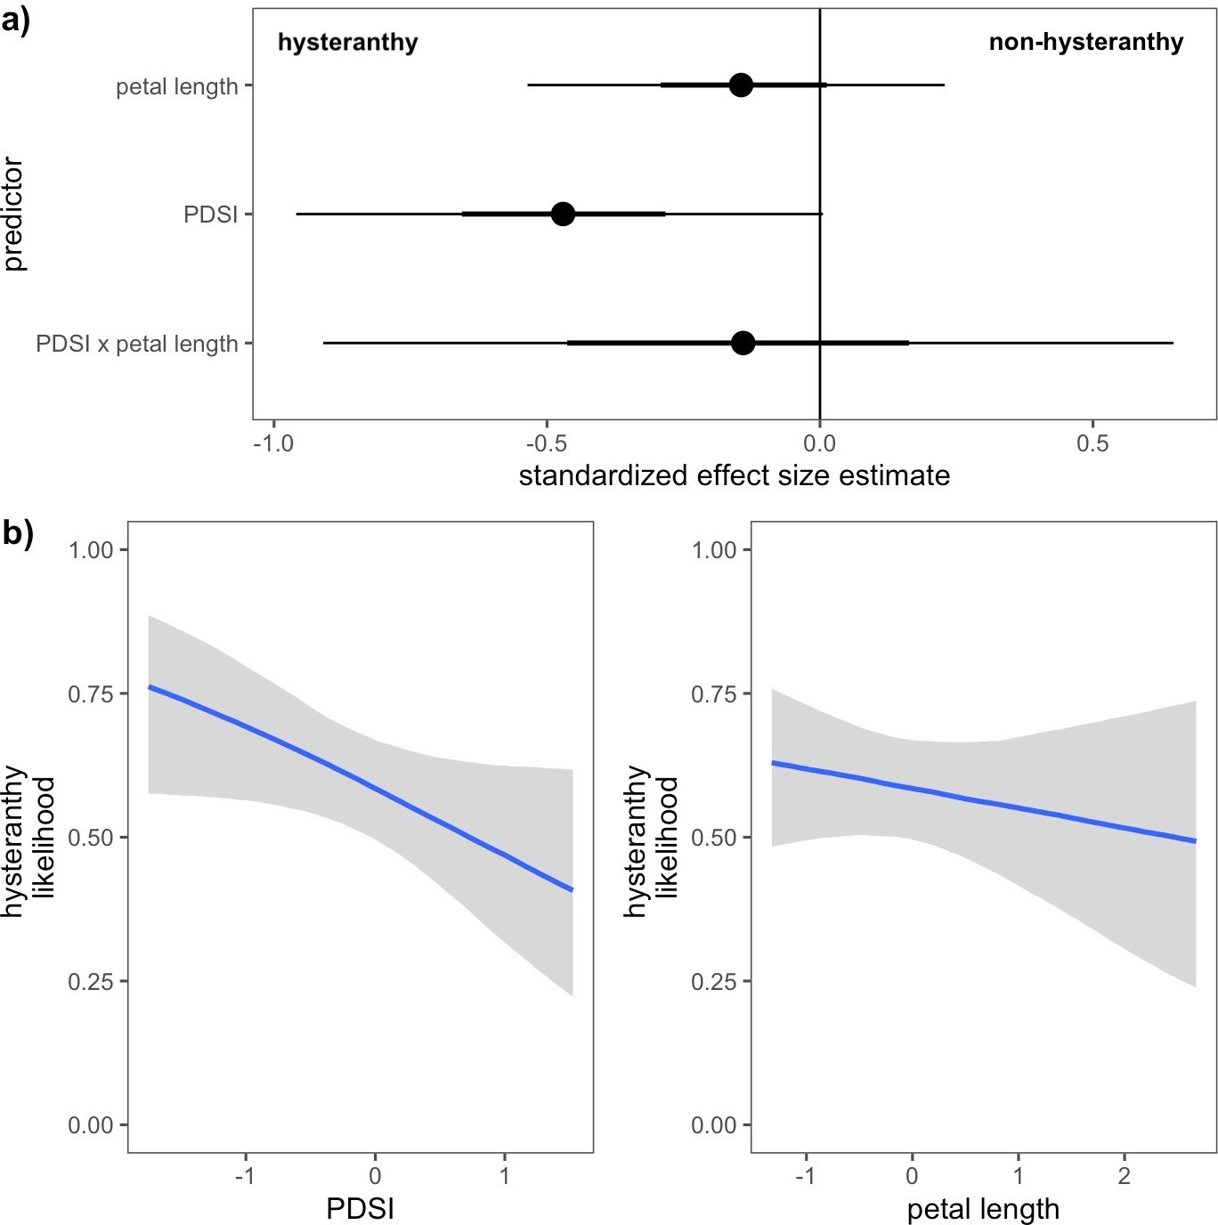

Figure 3: Relationships between hysteranthy and environmental and biological traits for the 13 species of the American Plums. Panel a) shows the estimated eﬀects of each predictor and their interaction the likelihood hysteranthy. Points indicate the mean eﬀects and the thick and thin bars represent the 50 and 89% uncertainty intervals. Panel b) depicts the conditional eﬀects of each predictor on hysteranthy likelihood. Blue lines indicate the mean estimate and grey ﬁll the 89% uncertainty intervals. Predictor values (x-axis) have been z-scored to make standardized comparisons

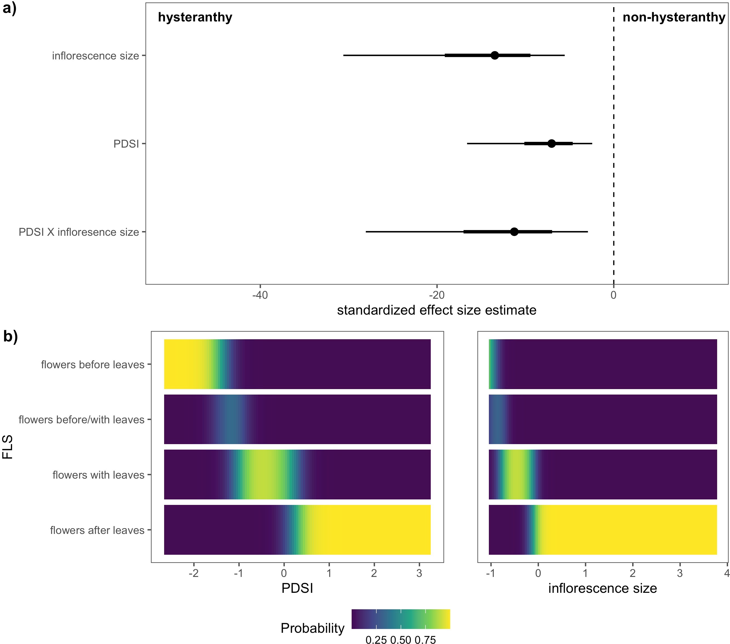

Figure 4: Relationships between the likelihood of hysteranthy and environmental and biological traits for 32 species of the genus Prunus native to, or established in North America. Panel a) shows the estimated eﬀect size of each predictor. Points indicate the mean estimate for each predictor, and thick and thin bars the 50% and 89% uncertainty intervals respectively. Panel b) depicts the likelihood for each ﬂower-leaf sequence stage (y-axis) at any given values of PDSI or number of ﬂowers/inﬂorescence (inﬂorescence size). Predictor values (x-axis) have been z-scored to make standardized comparisons.

