1 Flower-leaf phenological sequences in the American Plums (Prunus
2 sect. Prunocerasus) reﬂect adaption to aridity

3

4 August 18, 2022

5 Introduction

6 Woody perennials have a unique ability among plants to seasonally begin reproduction prior to vegetative
7 growth. This ﬂowering-ﬁrst phenological sequence known as hysteranthy, proteranthy or precocious ﬂowering
8 is particularly common in temperate forests around the globe (Rathcke & Lacey, 1985). A number of
9 studies suggest that this ﬂower-leaf sequences (FLSs) are under selection, and that hysteranthy has functional
10 signiﬁcance (Gougherty & Gougherty, 2018; Buonaiuto et al., 2021; Guo et al., 2014).

11 The most common, and well-tested explanation for the evolution of hysteranthy in temperate forests is
12 that it is adaptive for wind-pollination, as leaﬂess canopies increase wind speeds for pollen transport and
13 reduce the likelihood of pollen interception on vegetation (Whitehead, 1969; Niklas, 1985). However, this
14 hypothesis fails to address the prevalence of hysteranthous taxa that are biotically-pollinated. Approximately
15 30% of woody plant species of Eastern temperate forests of North America ﬂower before leaﬁng out, and of
16 these, approximately 20% are biotically pollinated (Buonaiuto et al., 2021). Despite the pervasiveness of this
17 phenological syndrome, direct tests of the function of hysteranthy in biotically pollinated taxa are rare for
18 temperate forest species.

19 Yet looking to other biomes in which hysteranthous ﬂowering is also common oﬀers important insights regard-
20 ing the function of hysteranthy in temperate, biotically-pollinated taxa. In the dry-deciduous tropics of South
21 and Central America, ﬂowering during the leaﬂess period is also common (Rathcke & Lacey, 1985; Franklin,
22 2016). In these ecosystems, ﬂowering is associated with a recovery in plant water status due to leaf drop
23 (Borchert, 1983; Reich & Borchert, 1984). By temporally separating leaf and ﬂower activity, woody plants can
24 partition their hydraulic demand across the season, alleviating water stress (Gougherty & Gougherty, 2018;
25 Franklin, 2016). These physiological observations suggest that hysteranthous ﬂowering may be an adaptation
26 to arid environments.

27 It is unclear whether this hydraulic demand hypothesis (also refered to as the water dynamic hypothesis
28 (Gougherty & Gougherty, 2018) or water limitation hypothesis (Buonaiuto et al., 2021)) is relevant in the
29 temperate zone where forests are rarely water-limited in the early season during which ﬂowering and leaﬁng
30 occur (Polgar & Primack, 2011).Yet the hypothesis yields several predictions to evaluate whether hysteranthy
31 serves to increase aridity tolerance in temperate ﬂora:

32 1. Hysteranthous taxa should be found in dryer habitats compared to closely related, non-hysteranthous
33 species.

34 2. Hysteranthy may be linked to other reproductive traits associated with dry environments such as
35 reduced ﬂower and fruit size (Herrera, 2009; Liu et al., 2013).

36 With mounting evidence anthropogenic climate change is both driving shifts in ﬂower-leaf sequences (Ma
37 et al., 2020) and changing geographic patterns of water availability (Overpeck & Udall, 2020), understanding
38 the functional signiﬁcance of hysteranthy is vital to forecasting the demography and performance of forest
39 communities in an era of global climate change. However, there are two major methodological challenges to
40 testing the hydraulic demand hypothesis:
41 First, characteristics like aridity tolerance, are the emergent product of a suite of biological traits (Sˇ´ımov´a
42 et al., 2017). Thus, when analyzing selective drivers of any particular trait at large taxonomic scales, un-
43 measured trait diﬀerences may obscure the estimated eﬀects of the trait of interest, biasing results. This is a
44 common problem in trait-based ecology, and one of the most promising solutions for understanding the func-
45 tional signiﬁcance of hysteranthy in woody plants is through character deconstruction (Terribile et al., 2009);
46 comparing ﬂower-leaf sequences variation for only a subset of taxa of shared phylogenetic and morphological
47 character.

48 A second challenge for robust testing of hysteranthy hypotheses is that most characterizations of ﬂower-leaf
49 phenological sequences are based on expert-opinion verbal descriptions (e.g. “ﬂowers before leaves” or “ﬂower
50 before/with leaves”), which make comparisons across taxa, time and space diﬃcult and sensitive to observer
51 bias (see; Buonaiuto et al., 2021). This problem can be overcome by adopting standardized quantitative
52 measures of plant phenology for observational studies and applying them to historic data records. Herbarium
53 records are an excellent source of data that can be leveraged for quantitative phenological measurements
54 (Willis et al., 2017), but have not be used widely to investigate variability of ﬂower-leaf sequences variation
55 among and within species.

56 In this study,we used herbaria records to to quantify ﬂower-leaf sequence patterns in the American plums,
57 (subspecies prunus, sect. prunocerasus. We then evaluated the association between hysteranthy and several
58 ecological and morphological traits to test the predictions of the hydraulic demand hypothesis of hysteranthy.
59 Our ﬁndings both clarify the hypothesized function of ﬂower-leaf sequence variation in biotically-pollinated
60 taxa, and oﬀer insights into how ﬂower-leaf sequences may impact species distributions as climate continues
61 to change.

62 Methods

63 0.1 Study system

64 The genus Prunus comprises approximately 200 species distributed across the globe (Chin et al., 2014),
65 Within the genus, The American plums (Prunus subspp. prunus sect. prunocerasus) oﬀer potential for a
66 higher resolution investigation of drivers of hysteranthous ﬂowering. The 16 species that make up the section
67 are distributed across North America and, like the genus Prunus at large, show pronounced inter-speciﬁc
68 variation in ﬂower-leaf sequences. While within the larger genus species can be separated into three distinct
69 morphological clades by inﬂorescence architecture (solitary, corymbose or racemose) all members of the section
70 share solitary inﬂorescences (Shaw & Small, 2004) allowing for reﬁned character deconstruction. Species in
71 this section are well represented in herbaria records (Fig. 1), making them a tractable group to measure and
72 assess variation in ﬂower-leaf sequences as well as other ecological and morphological characteristics related
73 to the hydraulic demand hypothesis.
74 0.2 Quantifying ﬂower-leaf sequence variation

75 We obtained digital herbarium specimens for all member of the section Prunocerasus from the Consortium
76 of Midwest Herbaria Database. To quantify the ﬂower-leaf sequence sequence variation within and across
77 species we randomly sample 200 specimens for each species and scored the phenological development of ﬂower
78 and leaves using a modiﬁed BBCH scale for woody plants (Finn et al., 2007). In total, we evaluated the
79 phenology of 2521 specimens, but only specimens with visible ﬂower were included in this analysis (n=1009).
80 We reconstructed the phylogenetic relationships among species in this group based on the tree topology in
81 Shaw & Small (2004). Following the methods of Grafen & Hamilton (1989) we computed branch lengths for
82 this phylogeny by assigning each node a height and computing the distance between upper and lower nodes
83 using the R package “ape” ().

84 Need to write this part more professionally. To compute a phylogentic signal for ﬂower-leaf sequence variation,
85 we calculated the mean of the log(vegetative BBCH observed during ﬂowering) for each species and calculated
86 Bloomberg’s K using the function phylosig ().

87 To quantify FLS variation, we ﬁt an ordinal, hierarchical, Bayesian, phylogenetic mixed model (de Villemeruil
88 P. Nakagawa, 2014) to assess the likelihood an individual would be at any given vegetative BBCH phase
89 while ﬂowering. Because we expect that hysteranthy is more likely to occur earlier in the ﬂowering period
90 and species diﬀer in their ﬂowering periods, we included the day of the observation as a varying slope, main
91 eﬀect in the model and species and phylogeny as random eﬀects. The model is written below:
92

93 logit(P (Y ≤ j)) = β[j]sp[i] + β[j]sp[i] + βdayofyear[sp[i]] ∗ X1 + ϵi
94

ϵ_{i} ∼ N (0, σ²)
y

95 where Y is the ordinal outcome (leaf stage) and j is the number of categories (1,2,...6). P (Y ≤ j)) is the
96 probability of Y less than of equal to a category j=1,...j-1. In this varying slope and intercept model, β_{[j]}
97 describes an intercept for each category [1,2,...6], while slope $beta_{dayofyear[sp[i]]} is constant across categories.

The inﬂuence of the phylogeny α_{phylo} was modeled as follows:
α_{sp} ∼ N (µ_{α}, COR[σ² ])
phylo

THe α for species eﬀects independent of the phylogeny was modeled as follows:
α_{sp} ∼ N (µ_{α}, σ² )
species

98 We ﬁt the model in the R package “brms” (Bu¨rkner, 2018) using weakly informative priors, and ran the
99 model on four chains with a warmup of 3,000 iterations and 4,000 sampling iterations for a total of 4,000
100 sampling iterations. Model ﬁt was assessed with Rhats <1.01 and high eﬀective sample sizes and no divergent
101 transitions.

102 Because the day of observation strongly inﬂuenced the BBCH stage likelihood, quantifying ﬂower-leaf se-
103 quences among species was intractable without accounting for this temporal trend. To address this issues,
104 we used our model to predict the likelihood each species would be observed at a given vegetative BBCH
105 stage during ﬂowering at the 0%, 25% 50% and 75% quantiles of their ﬂowering period. We then developed
106 a ﬂower-leaf sequence index, by assigning a numerical score to each species per seasonal quantile, and sum-
107 ming over the full ﬂowering season. In each seasonal quantile, species received a 1 if more that 50% of their
108 probability distribution occurred at BBCH 0 and BBCH 09 and a 0 if not. These values were summed across
109 the season generating an index from 0 (never hysteranthous) to 4 (hysteranthous through late season (Q75)),
110 where 1= hysteranthous at start of season, 2= hysteranthous through early season (Q25) and 3 = hysteran-
111 thous through mid season (Q50). We also used two alternative indexing schemes (>25% of the probability
112 distribution occured at BBCH 0 and >40% of the probability distribution occurred at BBCH 0 and BBCH
113 09).

114 0.3 Evaluating the hydralic demand hypothesis

115 To test the predictions of the hydralic demand hypothesis of hysteranthy we obtained data on petal length,
116 fruit diameter and directly from herbarium specimens and characterized the aridity of the sites specimens
117 were collected from using the Palmer Modiﬁed Drought Index (PDSI).

118 For our morphological measurements, we sampled an additional 321 specimens measured the petal length of
119 up to 10 randomly selected petals per specimen (n=2757) using ImageJ image processing software. We also
120 used ImageJ to measure the diameter of fruits on an additional 316 specimens, measuring up to 5 fruit per
121 specimen (n=224). We computed the average Palmer Modiﬁed Drought Index score from 1900-2017 for every
122 Prunocerasus specimen in the database (n=2305) from the North America Drought Atlas (Cook & Krusic,
123 2004).

124 We than used Bayesian phylogenetic mixed models to test the relationship between ﬂower-leaf sequence index
125 scores and each of the variables. In these models, we included species and phylogeny as the random eﬀect.
126 For our PDSI model, we did not include phylogeny as a random eﬀect as PDSI is a environmental trait rather
127 than a biological one. Question for Jonathan: Does this check out?

128 The model structure is written below:

yi = αind/sp[i] + αphylo[i] + βhyst.index ∗ Xhyst.index + ϵi ϵ_{i} ∼ N (0, σ²)
y
129 The eﬀect of the phylogeny was model as above.

130 Like above, we ﬁt these models in the R package “brms” (Bu¨rkner, 2018) using weakly informative priors,
131 and ran the model on four chains with a warmup of 3,500 iterations and 4,500 sampling iterations for a total
132 of 4,000 sampling iterations. Model ﬁt was assessed with Rhats <1.01 and high eﬀective sample sizes and no
133 divergent transitions. We also ran each model using our two alternative FLS indexing approaches to make
134 sure our particular indexing approach was not inﬂuencing our results. Though these alternative classiﬁcation
135 scheme did change the hysteranthy index score for some species (Fig. S1), they changes did not substantially
136 impact the interence from our models (see Tab. S1 for comparisons).

137 Results

138 Quantifying ﬂower leaf sequences in the American plums

139 We found substantial inter-speciﬁc diﬀerences in ﬂower-leaf sequences within the American plums (Fig. 2, S1).
140 The phylogenetic signal was relatively weak (Phylogenetic signal K : 0.28), and ﬂower-leaf sequences patterns
141 were strongly dependent on the day of observations, with observations later in the the ﬂowering season of
142 each species decreasing the likely hood of ﬁnding ﬂowers open during early vegetative BBCH phases (β_{doy}
143 0.03, CI₅₀ [0.02,0.03] ). Based on our ﬂower leaf sequence index, two species (P. umbellata,P. mexicana) were
144 likely to be hysteranthous regardless of the time of observation and three species (P. rivularis,P. subcordata,
145 and P. texana) were always most likely to ﬂower after level expansion began (Fig. 3). All other species
146 displayed intermediate phenotypes with ﬁve species mostly likely to hysteranthous at the start of the season
147 (P. alleghaniensis,P. americana,P. hortulana,P. munsoniana and P. nigra), one species through early season
148 (P gracilis) and two species through mid season (P. angustifolia, P. maritima) (Fig 3).

149 Evaluating the Hydraulic Demand hypothesis

150 We found a negative association between ﬂower-leaf sequence index and mean pdsi (β: -0.03 ,CI₅₀[-0.05, 0.02]
151 ,Fig. 4a.), suggesting that species that displayed hysteranthous ﬂowering later into their ﬂowering season
152 were found in dryer locations.

153 We found a negative association between ﬂower-leaf sequence index and both petal length and fruit diameter
154 (-.21, CI₅₀”[-0.38 -0.04],-1.40, CI₅₀[-1.97 -0.82] respectively), though the relationship between FLS index and
155 fruit size was much stronger (Fig. 4b.,c.).

156 Discussion

157 Our analyses suggest that within the American plums, hysteranthous taxa occur in more arid environments
158 and are associated with drought-tolerant reproductive traits like reduced ﬂower and fruit size. These associ-
159 ations support the hydraulic demand hypothesis of hysteranthous ﬂowering. These results indicate that even
160 though water limitation less common during the ﬂowering season in temperate trees, the temporal segregation
161 of ﬂowering and leaf phenology can impact whole plant-water status later in the season.

162 Studies that have compared the transpiration rates among ﬂowers and leaves that occur simultaneously
163 provide insights to the potential importance of this seasonal partitioning for maintaining water status. These
164 studies report ﬂoral transpiration rates of ﬂowers can range from 20%-60% of that of leaves under comparable
165 conditions (Whiley et al., 1988; Roddy & Dawson, 2012). This additional hydraulic demand can drive loss of
166 stomatal conductance and decrease photosynthetic rates (Galen et al., 1999). A recent study Liu et al. (2017)
167 comparing hydraulic properties of ﬂowers and leaves in two hysteranthous tree species (Magnolia spp), found
168 that sap ﬂow to ﬂowers (a measure of water movement) was 22-55% that of leaves. When considering species
169 in or study speciﬁcally, the xylem conductivity of spring ﬂoral branches of Prunus americana is reported
170 to be 20% of summer foliage branches (McMann et al., 2022). Taken together, magnitude of water loss
171 through ﬂoral organs in these physiological measurements demonstrate an underlying mechanism for the
172 macro-ecological patterns we observed in our data.

173 Our ﬁnding that smaller ﬂowers were associated with extended hysteranthy in the Amerian plums may be
174 surprising when viewed in the context of a classic ecological tradeoﬀ. It is well established that larger ﬂowers
175 demand more resources to maintain turgor and reproductive function than smaller ones(Galen et al., 1999;
176 Lambrecht & Dawson, 2007), therefore one might expect that hysteranthous ﬂowering serves to compensate
177 for maintaining larger ﬂowers and in dry environments. The fact that we observed a negative association
178 between the degree of hysternathy and ﬂower size suggests rather, that hysteranthy might be part of a suite
179 of traits that operate to increase the aridity tolerance of a species.
180 The negative relationship between hysteranthy and ﬂower size we observed is also expected when considered
181 in the context of resource allocation. A negative trade-oﬀ for the beneﬁts gained by hysteranthous ﬂowering
182 is that hysteranthous woody plants much begin their reproductive investment from stored carbon alone; at
183 the time of their annual cycle when their stored reserved are likely at their lowest (). The association between
184 smaller ﬂower and hysteranthous ﬂowering has been observed in other clades (), though to our knowledge
185 has not been investigated on the context of hydraulic costs or aridity tolerance. It it, however, clear that
186 hysteranthous species have evolved specialized mechanisms for mobilizing water and carbohydrates early in
187 the season to accommodate this resource partitioning strategy (). Sum up this paragraph.

188 Of course, selection on both phenology and ﬂoral traits is driven by a number of other factors than just plant
189 hydraulics and resource allocation. The support we found for the hydraic demand hypothesis does not rule
190 out other eco-evo drivers shaping the ﬂower-leaf sequences of insect-pollinated. In fact, the relationship we
191 observed between hysteranthy with ﬂowering and fruit size could also be evidence for alternative hypotheses
192 for FLS.

193 Pollinator attraction is major selective force on both ﬂoral phenology and morphology () and it has been
194 alternatively suggested that hysteranthous ﬂowering is an adaptation to increase the visibility of ﬂowers to
195 visually-foraging pollinators (). To our knowledge this hypothesis has not bee widely tested though there
196 is evidence that background contrast does impact pollinators ability to locate ﬂowers (). This hypothesis
197 and the hydraulic demand hypothesis that we tested may be related, with loss of pollinator visibility that is
198 associated with accompany the reduction in ﬂower size () due to aridity compensated for by hysteranthous
199 ﬂowering. While we cannot make this mechanistic link from our analysis, our ﬁndings that hysteranthy is
200 associated with aridity and reduced ﬂower size set up intriguing follow up work to elucidate the ecological
201 and evolutionary links between ﬂoral morphology and function, aridity and hysteranthous ﬂowering.

202 In this study we intentionally chose to analyze a small, and morphologically restricted taxonomic clade
203 in order to reduce the impact of unmeasured biological variation on our traits of interest. Our ﬁndings
204 compliment and clarify previous analyses performed at large taxonomic scales which suggested that aridity
205 may be a more important driver in biotically pollinated taxa than wind pollinated ones (). It was interesting
206 we found a relatively weak inﬂuence of phylogeny at our restricted scale, while it appears to be quite strong
207 at larger ones (). Jonathan is there something interesting we can say about this in a line or two?

208 To compliment the work that has been done at both very ﬁne and course taxonomic resolution, it would be
209 useful to explore the drivers of hysteranthy at an intermediate scale to better understand if the associations
210 we observed in the American plums emerged at the genus or family level, or in other clades with strong
211 intra-generic ﬂower-leaf sequence variation like Rhododendron, Magnolia, Acer, Cornus.

212 Flower-leaf sequences patterns can vary substantially on an interannual basis with populations and even
213 individuals (). It has been suggested that this variation is a product of diﬀerential sensitivity to temperature
214 and light cues between ﬂowers and leaves (), but if water limitation drives the evolution of hysteranthous
215 ﬂowering at the species level, it is possible that water availability may inﬂuence the plasticity of ﬂower-leaf
216 sequence on a seasonal timescale. Executing experimental or observational studies about this (say better)
217 is an important step of for understanding the signiﬁcance to the water dynamics hypothesis and for predict
218 how woody plant phenological sequences may shift with climate change as local patterns of both temperature
219 and water availability continue to change in the coming decades.

220 References

221 Borchert, R. (1983) Phenology and control of ﬂowering in tropical trees. Biotropica 15, 81–89.
222 Buonaiuto, D.M., Morales-Castilla, I. & Wolkovich, E.M. (2021) Reconciling competing hypotheses regarding
223 ﬂower–leaf sequences in temperate forests for fundamental and global change biology. New Phytologist 229,
224 1206–1214.

225 Bu¨rkner, P.C. (2018) Advanced bayesian multilevel modeling with the r package brms. R Journal 10, 395–411.

226 Chin, S.W., Shaw, J., Haberle, R., Wen, J. & Potter, D. (2014) Diversiﬁcation of almonds, peaches, plums and
227 cherries –molecular systematics and biogeographic history of prunus (rosaceae). Molecular Phylogenetics
228 and Evolution 76, 34–48.

229 Cook, E. & Krusic, P. (2004) The North American Drought Atlas.

230 de Villemeruil P. Nakagawa, S. (2014) Modern Phylogenetic Comparative Methods and Their Application in
231 Evolutionary Biology, chap. General quantitative genetic methods for comparative biology, pp. pp. 287–303.
232 Springer, New York.

233 Finn, G.A., Straszewski, A.E. & Peterson, V. (2007) A general growth stage key for describing trees and
234 woody plants. Annals of Applied Biology 151, 127–131.

235 Franklin, D.C. (2016) Flowering while leafess in the seasonal tropics need not be cued by leaf drop: evidence
236 from the woody genus brachychiton (malvaceae). Plant Ecology and Evolution 149, 272–279.

237 Galen, C., Sherry, R. & Carroll, A. (1999) Are ﬂowers physiological sinks or faucets? costs and correlates of
238 water use by ﬂowers of polemonium viscosum. OECOLOGIA 118, 461–470.

239 Gougherty, A.V. & Gougherty, S.W. (2018) Sequence of ﬂower and leaf emergence in deciduous trees is linked
240 to ecological traits, phylogenetics, and climate. New Phytologist 220, 121–131.

241 Grafen, A. & Hamilton, W.D. (1989) The phylogenetic regression. Philosophical Transactions of the Royal
242 Society of London. B, Biological Sciences 326, 119–157.

243 Guo, L., Luedeling, E., Dai, J. & Xu, J. (2014) Diﬀerences in heat requirements of ﬂower and leaf buds make
244 hysteranthous trees bloom before leaf unfolding. Plant Diversity and Resources 36, 245–253.

245 Herrera, J. (2009) Visibility vs. biomass in ﬂowers: exploring corolla allocation in mediterranean ento-
246 mophilous plants. Annals of Botany 103, 1119–1127.

247 Lambrecht, S.C. & Dawson, T.E. (2007) Correlated variation of ﬂoral and leaf traits along a moisture avail-
248 ability gradient. Oecologia 151, 574–583.

249 Liu, H., Xu, Q.Y., Lundgren, M.R. & Ye, Q. (2017) Diﬀerent water relations between ﬂowering and leaf
250 periods: a case study in ﬂower-before-leaf-emergence <i>magnolia</i> species. Functional Plant Biology
251 44, 1098–1110.

252 Liu, J., Bai, Y., Lamb, E.G., Simpson, D., Liu, G., Wei, Y., Wang, D., McKenney, D.W. & Papadopol, P.
253 (2013) Patterns of cross-continental variation in tree seed mass in the canadian boreal forest. PLOS ONE
254 8, e61060–.

255 Ma, Q., Huang, J.G., Ha¨nninen, H., Li, X. & Berninger, F. (2020) Climate warming prolongs the time interval
256 between leaf-out and ﬂowering in temperate trees: Eﬀects of chilling, forcing and photoperiod. Journal of
257 Ecology n/a.

258 McMann, N., Peichel, A. & Savage, J.A. (2022) Early spring ﬂowers rely on xylem hydration but are not
259 limited by stem xylem conductivity. New Phytologist 233, 838–850.
260 Niklas, K.J. (1985) The aerodynamics of wind pollination. The Botanical Review 51, 328–386.

261 Overpeck, J.T. & Udall, B. (2020) Climate change and the aridiﬁcation of north america. Proceedings of the
262 National Academy of Sciences 117, 11856–11858.

263 Polgar, C. & Primack, R. (2011) Leaf-out phenology of temperate woody plants: From trees to ecosystems.
264 New Phytologist 191, 926–41.

265 Rathcke, B. & Lacey, E.P. (1985) Phenological patterns of terrestrial plants. Annual Review of Ecology and
266 Systematics 16, 179–214.

267 Reich, P. & Borchert, R. (1984) Water-stress and tree phenology in a tropical dry forest in the lowlands of
268 costa-rica. Journal of Ecology 72, 61–74.

269 Roddy, A.B. & Dawson, T.E. (2012) Determining the water dynamics of ﬂowering using miniature sap ﬂow
270 sensors. 951, pp. 47–53, International Society for Horticultural Science (ISHS), Leuven, Belgium.

271 Shaw, J. & Small, R.L. (2004) Addressing the ”hardest puzzle in american pomology:” phylogeny of prunus
272 sect. prunocerasus (rosaceae) based on seven noncoding chloroplast dna regions. Am J Bot 91, 985–996.
273 Sˇ´ımov´a, I., Rueda, M. & Hawkins, B.A. (2017) Stress from cold and drought as drivers of functional trait
274 spectra in north american angiosperm tree assemblages. Ecology and evolution 7, 7548–7559.
275 Terribile, L.C., Diniz-Filho, J.F., Rodr´ıguez, M.A´. & Rangel, T.F.L.V.B. (2009) Richness patterns, species
276 distributions and the principle of extreme deconstruction. Global Ecology and Biogeography 18, 123–136.

277 Whiley, A., Chapman, K. & Saranah, J. (1988) Water loss by ﬂoral structures of avocado (<i>persea amer-
278 icana</i> cv. fuerte) during ﬂowering. Australian Journal of Agricultural Research 39, 457–467.

279 Whitehead, D.R. (1969) Wind pollination in the angiosperms: Evolutionary and environmental considera-
280 tions. Evolution 23, 28–35.

281 Willis, C.G., Ellwood, E.R., Primack, R.B., Davis, C.C., Pearson, K.D., Gallinat, A.S., Yost, J.M., Nelson,
282 G., Mazer, S.J., Rossington, N.L., Sparks, T.H. & Soltis, P.S. (2017) Old plants, new tricks: Phenological
283 research using herbarium specimens. Trends in Ecology & Evolution 32, 531–546.
284 Figures

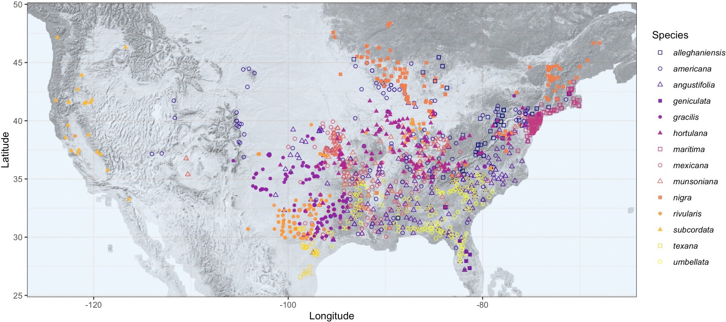

Figure 1: This is a map of all the herbaria records of our focal clade.

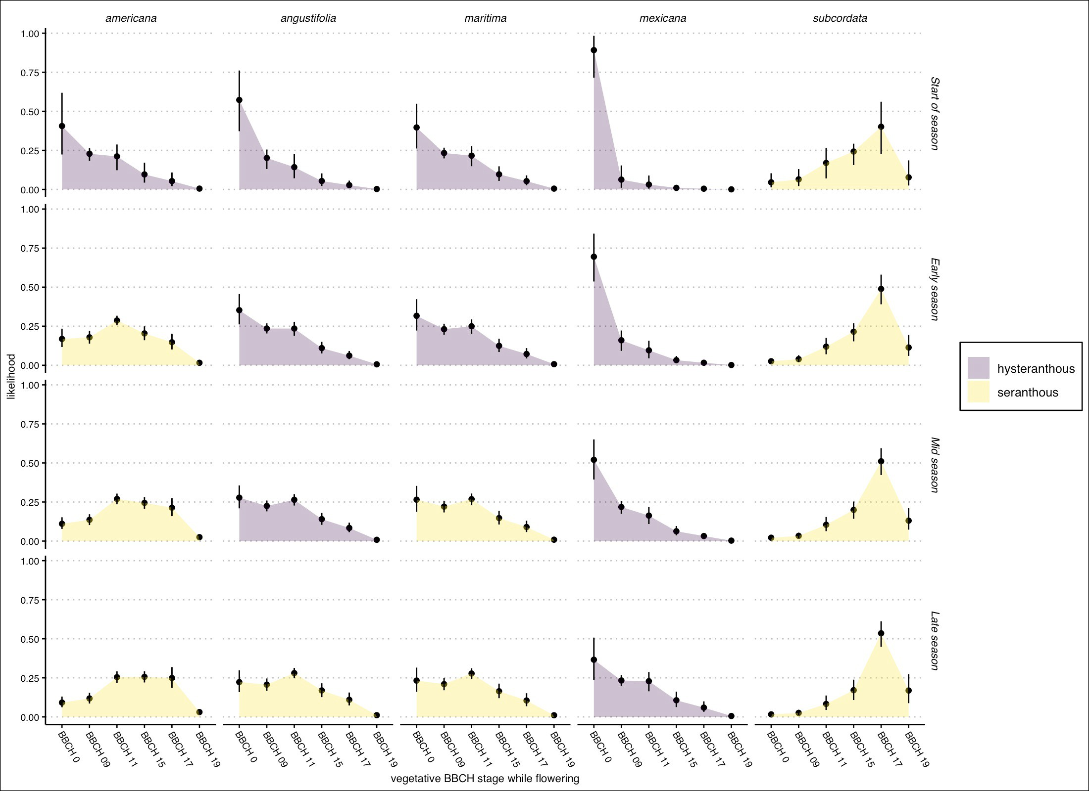

Figure 2: Estimated likelihood that a species would be at any given vegetative BBCH phase while ﬂowering for ﬁve example species in the American plums. Points are the mean likelihood and bar the 95% uncertaintly intervals. Colors represent hysteranthy classiﬁcation at each point in the season. See Fig. S1 for all species and alternative cutoﬀs.

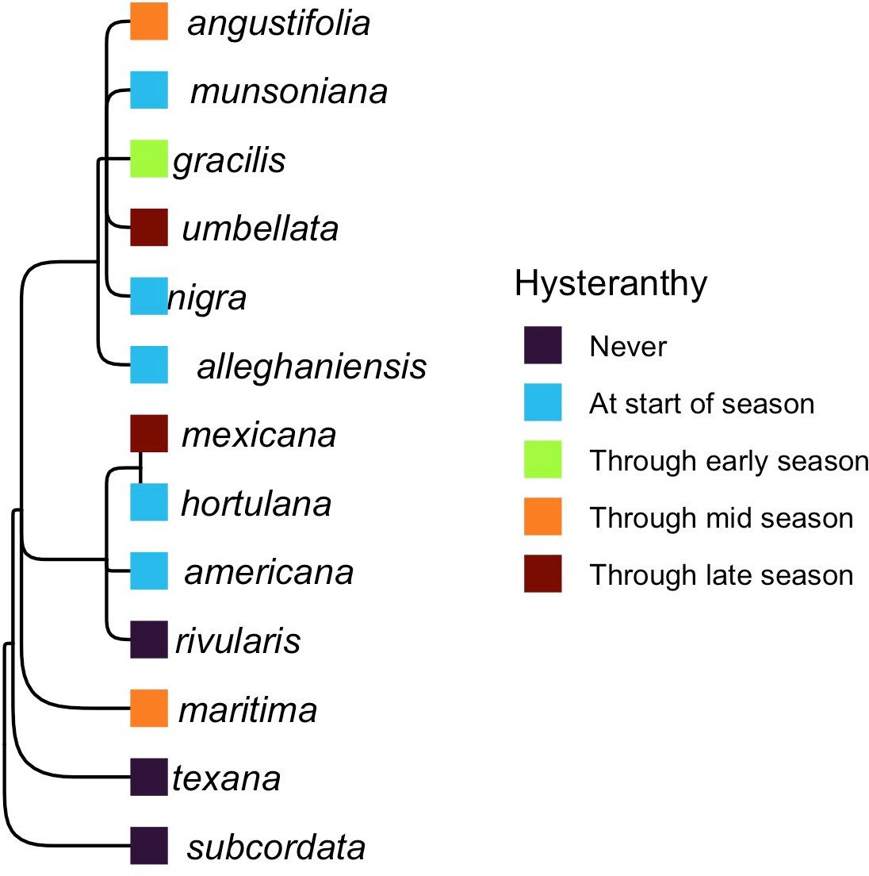

Figure 3: Phylogenetic relationships amoung the American plums and the duration of their ﬂowering perion they are hysterathous. These categorizations are based on ordinal phylogenetics mixed models. Tree topology is from Shaw.

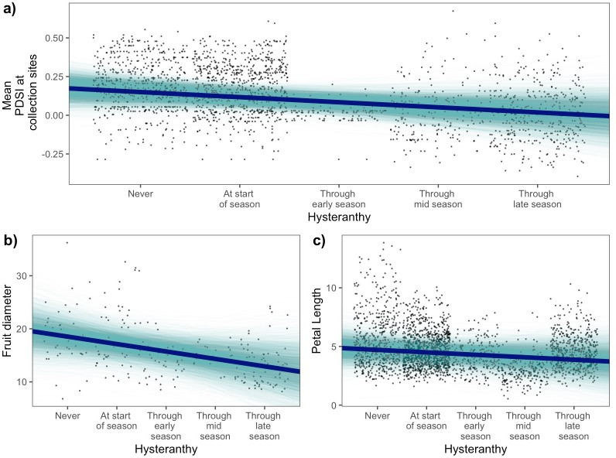

Figure 4: Relationships between the duration of hysteranthy across the ﬂowering period and environmental and biological traits based on Bayesian phylogenetic mixed models.

