Differences in flower and leaf bud environmental responses drive shifts in spring phenological sequences of temperate woody plants

1 Abstract

2 The relative timing of growth and reproduction is an important driver of plant fitness. For deciduous
3 woody species in temperate regions leaves and flowers both appear in the early spring, but the order
4 and duration of these phenological events vary among species, populations, and individuals. This
5 observed variation in flower-leaf sequences (FLSs) suggests that the relative timing of these events
6 may be important—affecting the reproduction, recruitment and survival of individuals. Further,
7 FLSs appear to be shifting with climate change, and anticipating the extent of these shifts is key to
8 projecting how climate change may impact species’ performance and reshape forest communities.
9 Predicting FLS shifts, however, requires an improved understanding of how the environment dic-
10 tates FLS patterns. To address this, we compared the phenological responses of flower and leaf buds
11 for 10 temperate woody species to varying levels of temperature and light in a lab experiment. Our
12 experimental design allowed us to test competing hypotheses for how environmental cues determine
13 FLS variation—specifically whether forcing (warm temperatures) alone drives variation or differen-
14 tial sensitivity to chilling (cool temperatures generally in the fall and winter) and/or photoperiod
15 matter. We found that flower and leaf buds respond with differential sensitivity to environmental
16 cues, with differences in their response to chilling being the dominant driver of FLS variation. Be-
17 cause climate change will amplify variability in chilling across time and space, these findings suggest
18 that FLS shifts may be large, but are likely to vary substantially among populations and species.
19 In our study, FLS shifts were largest in wind-pollinated species that flower before leafing, raising
20 the possibility that, more generally, wind-pollinated taxa may experience reproductive declines due
21 to FLS shifts in the decades to come.

22

23 Keywords: chilling, climate change, deciduous forests, differential sensitivity, flower-leaf sequences,
24 forcing, hysteranthy, phenology

25

26 Introduction

27 Among the most widely documented biological effects of anthropogenic climate change are shifts
28 in plant phenology, the timing of life cycle events (Parmesan & Yohe, 2003; Menzel et al., 2006;
29 Cleland et al., 2007). While phenology is generally advancing with climate change, the strength
30 of these phenological shifts can vary substantially among specific phenological phases (Augspurger
31 & Zaya, 2020). These differences alter the timing of phases relative to each other, changing the
32 duration between events that make up phenological sequences (Ettinger et al., 2018). Phenological
33 sequences are a major driver of plant fitness that impacts plant life history, resource allocation,
34 demography and ecosystem processes (Post et al., 2008). Thus, shifting sequences with climate
35 change will likely impact many of these processes. The effects of these shifts, however, depend
36 both on their direction—whether distinct phases are shifting closer together or farther apart—and
37 magnitude—how much they are shifting relative to each other.

38

39 Among deciduous woody plants, the relative timing of flower and leaf phenology, or flower-leaf se-
40 quences (FLSs), may be particularly consequential to fitness in temperate regions where flowering
41 prior to leaf development is common (Rathcke & Lacey, 1985; Gougherty & Gougherty, 2018). Flow-
42 ering before leafing may be a critical adaptation for pollination efficiency in wind-pollinated taxa,
43 with the leafless canopy minimizing obstacles for air flow and pollen transfer (Whitehead, 1969). In
44 insect-pollinated taxa, flowering-first may increase the visibility of flowers to pollinators (Janzen,
45 1967; Savage, 2019) or alleviate hydraulic demand in dry conditions (Gougherty & Gougherty, 2018;
46 Franklin, 2016).

47

48 Phenological observations over the last several decades indicate that, like other phenological se-
49 quences, FLSs are shifting due to anthropogenic climate change (Buonaiuto et al., 2020). For
50 several species, the time between flowering and leafing appears to be increasing, but the strength of
51 this trend varies among species and the direction of FLS shifts are not consistent across populations
52 (Buonaiuto et al., 2020). These changes could affect the important functions of FLSs, potentially
53 putting some species at greater risk for fitness declines, while benefiting others.

54

55 For example, species with decreasing FLS interphases with climate change may see a reduction
56 in pollination success as more pollen is intercepted by vegetation, or flowers are obscured by de-
57 veloping leaves. Conversely, pollination efficiency could improve for species with lengthening FLS
58 interphases. A change in the FLS interphase of just a few days would likely have little impact on
59 these processes, but if shifts were on the order of weeks, the impact on the pollination biology of
60 a species could be significant. For example, because canopy structure influences the speed and di-
61 rection of air flow (Niklas, 1985; Jackson & Lyford, 1999), decreasing FLS interphases could reduce
62 pollen dispersal distances for wind-pollinated taxa (Milleron et al., 2012), which would ultimately
63 impact population structure and gene flow across a landscape.

64

65 Predicting FLS shifts requires identifying the proximate mechanisms that drive FLS variation.
66 Decades of research suggest that cool winter temperatures (chilling), warm spring temperatures
67 (forcing), and day-length (photoperiod) are the primary drivers of both reproductive and vegetative
68 phenology for woody plants in temperate regions (K¨orner & Basler, 2010; Flynn & Wolkovich, 2018).
69 However, observed FLS shifts indicate that there must be differences in how these cues influence the
70 phenology of flowers and leaves (Buonaiuto et al., 2020). Identifying these differences is a necessary
71 step for predicting the direction, magnitude and—ultimately—fitness impacts of FLS shifts with
72 climate change.
73 Hypotheses for FLS variation

74 Studies that have attempted to identify the differences between reproductive and vegetative phe-
75 nology in woody plants (mostly focused on crop species) have yielded two common explanations:

76 One hypothesis suggests that reproductive and vegetative buds utilize the same underlying envi-
77 ronmental cues, but have different threshold responses to forcing, with whichever bud type bursts
78 later—leaves or flowers—having a higher thermal requirement (that is, they need a greater sum of
79 warm temperature to trigger the phenological event, Guo et al., 2014; Cosmulescu & Calusaru, 2020;
80 Cosmulescu & Ionescu, 2018). Under this hypothesis, which we call the forcing hierarchy hypothesis
81 (FHH), leaf and flower buds share the same suite of cues and develop similarly to non-forcing cues
82 (i.e., chilling and photoperiod), but differ in the thermal requirement for budburst.

83

84 In contrast, an alternative hypothesis suggests that flower and leaf buds differ in the strength of
85 their phenological responses to multiple environmental cues (Citadin et al., 2001; Gariglio et al.,
86 2006; Aslamarz et al., 2009; Mehlenbacher, 1991). Under this hypothesis, which we call the differ-
87 ential sensitivity hypothesis (DSH), each bud type relies more or less on certain cues, generating
88 FLS variability.

89

90 While observational studies of phenology in the field are commonly used to evaluate the relationship
91 between environmental conditions and phenology (Cleland et al., 2007), under current and recent
92 climatic conditions, the FHH and DSH may produce similar phenological patterns, making it dif-
93 ficult to evaluate these hypotheses with such methods. However, experiments designed to isolate
94 all three environmental cues have the potential to disentangle the two hypotheses. Studies aiming
95 to differentiate these hypotheses can look for two different signatures. The key signature of the
96 FHH is that the sensitivity to forcing (∆ day of phenological event/ ∆◦C) of the second phase in
97 the phenological sequence is always greater than that of the first phase with sensitivity differences
98 being inversely proportional to the difference in thermal requirement among bud types (2x in our
99 simulations; Fig. 1 a.). By contrast, the signature of the DSH is that sensitivity estimates of flower
100 and leaf buds to chilling and/or photoperiod will diverge (Fig. 1 c.), but there is no characteristic
101 pattern as to the strength or direction of this divergence (e.g., leaves may require longer or shorter
102 photoperiods than flowers, or more or less chilling).

103

104 The clarity of these signatures from each hypothesis, however, may be obscured in certain situations.
105 First, a species’ buds could be both differentially sensitive to photoperiod or chilling (supporting
106 the DSH) and also respond to forcing in a forcing hierarchy (that is, both hypotheses can operate
107 at once, see Fig. 1 b.). Second, the differential sensitivity framework can generate the signature of
108 the FHH when other cues are at high levels due to interactions between the chilling or photoperiod
109 response and the thermal requirement, which make forcing the dominant phenological cue once
110 other cue requirements have been met (see Fig. 1 c., chill x force interaction). When this happens
111 the FHH would effectively be a special case of the DSH.

112

113 While these two hypothesized mechanisms may produce similar phenology patterns under current
114 conditions, differentiating them is important, as they have substantially different implications re-
115 garding the potential for FLS shifts with climate change. The FHH suggests that FLS variation is
116 largely a product of climate variation during the interphase. If spring temperatures increase with
117 climate change, the second phenophase of the FLS with be accelerated relative to the first and FLS
118 interphases will decrease, but given the relative auto-correlation of spring temperatures (Di Cecco
119 & Gouhier, 2018), these shifts should be muted. If FLSs are structured by a forcing hierarchy, the
120 direction of FLS shifts are relatively straight forward to predict, and it is less likely that shifts will
121 be large enough in magnitude to significantly affect woody plant fitness.

122

123 Climate change would also drive FLS shifts under the DSH, but the trajectory of these shifts are
124 more complicated to predict. The DSH suggests that there could be strongly localized effects of
125 climate change on FLSs. Shifts in FLS variation will depend on the direction and rate of change in
126 cues at given locations and the species-specific differential sensitivity of reproductive and vegetative
127 phenology to cue combinations. This hypothesis allows for larger magnitude shift in FLSs, on a
128 scale that could impact pollen transport or the physiological functioning of woody plants. Further,
129 the DSH also suggests that the magnitude of shifts may be highly divergent both among species in
130 a community, and among populations of the same species which could impact gene flow, population
131 structure and demography.

132

133 In this study we tested the FHH and DSH hypotheses in 10 temperate shrub and tree species. Using
134 a full-factorial growth-chamber experiment we manipulated chilling, forcing and photoperiod cues
135 for flower and leaf buds. We then leveraged these data to examine how FLSs may shift with climate
136 change.

137

138 Materials and Methods

139 Growth chamber study

140 We sampled plant material from Harvard Forest in Petersham, MA, USA (42.5314◦N, 72.1900◦W)
141 on 25 October 2017, immediately after most plants in the area entered dormancy but before they
142 could accumulate significant chilling in the field. We collected branch cuttings from 7-13 indi-
143 viduals of 12 woody plant species (4-12 cuttings per individual for a total of 48-56 per species),
144 consisting of a mix of deciduous shrubs, understory and canopy trees commonly found in mesic
145 hardwood forests of the eastern United States. We selected species displaying variation of the three
146 major FLS patterns; species for which flowers appear before leaves (flowering-first; Acer rubrum,
147 Betula alleghaniensis, Comptonia peregrina, and Corylus cornuta), species for which flowers ap-
148 pear with their leaves (concurrent; Acer pensylvanicum, Acer saccharum, Ilex mucronata, Prunus
149 pensylvanica, Vaccinium corymbosum), and species for which flowers appear after leaf development
150 (leafing-first; Ilex verticillata, Prunus virginiana, Viburnum acerifolium), These species also vary in
151 other important functional traits including pollination syndrome, bud type, and growth habit (see
152 tab. S1 for details and full species list).
153 We transported all cuttings to the Arnold Arboretum in Boston, MA (USA) where they were re-cut
154 in water to prevent callousing and cavitation and placed in 500 ml Erlenmeyer flasks with distilled
155 water.

156

157 We randomly assigned cuttings to a fully crossed set of eight experimental treatments; two levels of
158 chilling (4 vs 8 weeks at 4◦C), two levels of temperature (24◦C:18◦C (day/night) warm vs 18◦C:12◦C
159 (day/night) cool) and two levels of photoperiod (12 vs 8 hours). We alternated day/night temper-
160 ature periodicity on a 12 hour schedule to reduce co-variation with photo-periodicity. We re-cut all
161 twigs and changed the water every 7-10 days and rotated all treatments between growth chambers
162 every two weeks to minimize chamber effects. We made phenological observations every 2-3 days
163 using a modified BBCH scale for woody plants (Finn et al., 2007) for three months following release
164 from chilling conditions. In this period we assessed two phenological phases: budburst (BBCH phase
165 07) and first flower open (BBCH 60). At the conclusion of this period we assessed all individuals
166 that did not undergo budburst and excluded 56 dead twigs from our analyses.

167 Data analysis

168 To assess the phenological sensitivity of each phase, we fit mixed-effects hierarchical models with
169 chilling, forcing, photoperiod and all two-way interactions as the fixed effects and species as a group-
170 ing factor on both the slopes and the intercepts. We chose a Bayesian hierarchical approach in order
171 to identify systematic trends across species’ responses while accounting for sample size, variance,
172 and the unique effect of each species. We also used z-scoring to standardized the units of each en-
173 vironmental predictor to allow for appropriate comparisons between them (Gellman & Hill, 2007).
174 We modeled the effects of environmental parameters on flower opening and leaf budburst separately.
175 We also fit a model with FLS interphase (day of budburst - day of flowering) as a response variable
176 to compare these estimates with field observations. Two species, Betula allegheniensis and Acer
177 saccharum, produced no flowers in our trial, so we excluded them from our analysis. In total, our
178 analyses included 464 twigs from 10 species.

179
180 The models we fit appear below:

181

182 y[i] ∼ N (αsp[i] +βforcingsp[i] +βchillingsp[i] +βphotoperiodsp[i] +βforcingxchillingsp[i] +βforcingxphotoperiodsp[i] +
183 βchillingxphotoperiod , σ2)
sp[i] y

184

185 Where y[i] is either the day of the experiment of leaf budburst, day of first flower opening or FLS
186 interphase length, and σ² the error. We modeled the intercept (α) and each slope (β) parameter at
y
187 the species level using the formula:

188

189 α_{x} or β_{x} ∼ N (µ_{x}, σ²)
sp sp x
190

191 To test the hypothesis that the FHH is a special case of the DSH that occurs when other cue (i.e.,
192 chilling and photoperiod) requirements are met, we re-ran our models on a subset of our data which
193 included both levels of the forcing treatment but only the high photoperiod and chilling treatment
194 levels. This model included forcing as the only main effect but, like our main models written above,
195 included species as a grouping factor on the slopes and intercept.

196

197 We fit all models using the R package “brms” (Bu¨rkner, 2018). We ran each model on four chains
198 with 4000 iterations and a 3000 iteration warm up for a total of 4000 posterior draws for each
199 parameter. In all models we used weakly informative priors and increasing the priors 5-fold did not
200 affect the model results. We assessed model performance through ensuring Rˆs were between 1 and
201 1.01 and bulk and tail effective sample sizes were high (1800-2800 for most parameters, but as low
202 as 800-900 for some). We present 50% credible intervals in figures generally because they are the
203 most computationally stable (Gelman et al., 2013) but provide other intervals in the Supporting
204 Information (Tab. S3,Tab. S4, Tab. S5.

205
206 Climate change scenarios

207 To apply our model results to general climate change scenarios we chose environmental treatments
208 in the experiment to broadly reflect historic and future conditions at our sampling site. Our low
209 forcing treatment approximated average spring temperature (March/April) at the site while our
210 high temperature treatment reflects a 5 ◦C increase. Average field chilling (calculated from 15
211 October - 15 April, measured in Chill Hours, Weinberger, 1950) at Harvard Forest is 1170.7, ap-
212 proximately 63% of the difference between our low and high chilling treatment (Tab. S2). Thus, our
213 low chilling treatment represents a feasible estimate for a decrease in chilling with climate change
214 and our high chilling treatment approximates a reasonable increase (Luedeling, 2012). Our low
215 photoperiod treatment (8 hours of daylight) is well below the photoperiod experienced at Harvard
216 Forest, but given that the photoperiod effects are expected to be small (Laube et al., 2014), we
217 chose more extreme values in order to robustly estimate an effect (i.e., increasing statistical power).
218 For this reason, our climate change scenarios for FLS variation are based on our high photoperiod
219 treatment alone.

220

221 We used our flower and budburst models to project for each species in our study:

222 1. FLSs under average environmental conditions (low forcing, 6.5 weeks of chilling treatment)

223 2. FLS shifts with spring warming only (high forcing, 6.5 weeks of chilling treatment)

224 3. FLS shifts with warming and increased chilling (high forcing, 8 weeks of chilling treatment)

225 4. FLS shifts with warming and decreased chilling (high forcing, 4 weeks of chilling treatment)

226 To validate our predictions, we compared our FLS interphase model estimates of “average” con-
227 dition FLS interphases to long term phenological records from Harvard Forest (O’Keefe, 2015) for
228 five species common to both datasets (Fig. S1), and found them comparable.

229

230 Given the variable dynamics of shifts in environmental forcing and chilling with climate change
231 over time and space (Luedeling et al., 2011), these scenarios should not be treated as absolute
232 predictions of the magnitude of FLS shifts with climate change. Instead, we provide these sce-
233 narios to identify general trends in how FLSs could shift with warming and demonstrate that the
234 range of possibilities vary based on characteristics of plant species and the specific climate dynamics.

235

236 Finally, we characterized FLS shifts for three broad FLS groups (flowering-first, concurrent, leafing-
237 first) by extracting all sampling posterior estimates from our main models using the R package
238 tidybayes (Kay, 2020), and grouping them by FLS pattern. We also include the species-specific
239 estimates on which these grouped estimates are based in Fig. S2.

240

241 Results

242 Growth chamber study

243 Both flower and leaf phenology advanced with higher forcing and longer chilling duration (flowers:
244 chilling effect: -21.2, forcing effect: -19.0, leaves: chilling effect: -30.4, forcing effect: -17.8; Fig.
245 2, Tab. S3, Tab. S4—all standardized units; see “Data analysis” section above), but increases in
246 both of these cues together offset these advances (flowers: force x chill effect: 7.0, leaves: force x
247 chill effect: 12.4; Fig. 2, Tab. S3, Tab. S4). Leaf and flower buds diverged in their responses
248 to increasing photoperiod, with flower phenology advancing and leaf phenology delaying when the
249 other two cues were at low levels (Fig. 2, Tab. S3, Tab. S4). As seen in the interactions between
250 photoperiod and chilling and photoperiod and forcing, increasing chilling or forcing with longer
251 photoperiod advanced the phenology of both bud types. For both bud types, chilling and forcing
252 were the dominant cues, while increasing photoperiod produced a more muted phenological response
253 (Fig. 2, Tab. S3, Tab. S4).

254

255 While leaf and flower bud phenological responses to environmental cues were qualitatively similar,
256 the strength of their responses to each cue differed substantially. Leaf buds responded more strongly
257 to chilling than flower buds (1.4x), and had a stronger response to all cue interactions (forcing x
258 chilling: 1.8x, photoperiod x chilling: 5.8x, photoperiod x forcing: 2.2x; Fig. 2, Tab. S3, Tab. S4).
259 Across all species both bud types displayed a similar magnitude advance with increased forcing
260 (Fig. 2, Tab. S3, Tab. S4).

261

262 Our results did not showed the characteristic sensitivity pattern of the FHH across most species in
263 our experiment (Fig. 2, see Fig. 1,a.,b.), though there was significant variation among species in
264 the strength of their response to forcing between bud types. However, when we re-ran our models
265 on the subset of data which included phenological observations at only high levels of chilling and
266 photoperiod, we found the the sensitivity to forcing for 9/10 species followed the predicted pattern
267 of the FHH, with the second phases of the FLS showing stronger sensitivity to forcing than the first
268 phases (Fig. 3, Tab. S5).

269

270 Climate change scenarios

271 Our models project that both flower and leaf phenology will advance in our generalized future
272 scenarios. FLS shifts depended strongly on how forcing levels change relative to chilling exposure
273 (Fig. 4). Given the significant differences in sensitivity to chilling between flowering and leafing
274 phenology we found in our experiment, our scenarios showed that FLS interphases will be more
275 strongly influenced by changes in chilling duration than increased forcing alone.

276

277 The direction and magnitude of shifts in FLS interphases varied among species, varying especially by
278 whether or not they displayed a flowering-first FLS. Under some warming scenarios, our model pre-
279 dicted that FLS interphases for some species may effectively disappear or the order of phenophases
280 in the FLS may switch (Fig. 4, Fig. S2). Several species, Acer rubrum, Ilex verticillata, Prunus
281 pensylvanica, Prunus virginiana, and Viburnum acerifolium, had FLSs that were relatively robust
282 to changing environments. For other species, Acer pensylvanicum, Vaccinium corymbosum and Ilex
283 mucronata, which typically begin to produce leaves shortly before flowers open, the magnitudes
284 of projected FLS shifts were moderate. The two species with the most significant FLS shifts in
285 both direction and magnitude across treatment combinations and climate change scenarios were
286 Comptonia peregrina and Corylus cornuta (Fig. S2). In all of our climate change scenarios, the
287 FLS interphase was dramatically reduced in these taxa.

288

289 Discussion

290 Our experiment supports the hypothesis that flower-leaf sequences are structured by differential
291 sensitivity (DSH) to the environment between flower and leaf buds. Specifically, differences in
292 the chilling response among bud types was the strongest driver of FLS variation. We also found
293 that under high chilling and long photoperiods, the FLSs of most species followed the predicted
294 sensitivity pattern of the FHH, supporting the hypothesis that the FHH is likely a special case of
295 the DSH that occurs when other phenological cues are met for both bud types. Together, these
296 results explain why the two FLS hypotheses have been difficult to distinguish, and suggest that
297 climate change has the potential to significantly disrupt FLSs as global warming alters historic
298 chilling patterns across the temperate zone (Morin et al., 2009).

299 Reconciling the differential sensitivity and the forcing hierarchy hypotheses

300 The relationship we found between the FHH and the DSH in our experiment offers a path forward
301 for reconciling previous studies that have favored one hypothesis over the other. Support for the
302 FHH is most often associated with observational studies (e.g. Cosmulescu & Calusaru, 2020; Guo
303 et al., 2014). By contrast, experimental studies which manipulate chilling levels beyond historically
304 observed minima in the field tend to support the DSH (e.g. Aslamarz et al., 2009; Gariglio et al.,
305 2006). This pattern can be explained by the FHH being a special case of the DSH, if historic climate
306 regimes make detection of the DSH in the field difficult.
307

308 Under historic climate regimes, seasonal chilling requirements were usually met (Gauzere et al.,
309 2019; Chuine et al., 2016), making it difficult to detect any effect of chilling in observational studies,
310 let alone differences in flower versus leaf buds. It would take larger reductions in chilling to reveal
311 the signature of the DSH, which at present, rarely occurs in the field, but can be induced in artificial
312 environments which explains the discrepancy between these two methods. These dynamics are con-
313 sistent with findings in other phenological studies that suggest simple growing degree models (which
314 underlie the FHH) accurately predict phenology under current climate, but under-perform under
315 climate change scenarios when shifts in chilling accumulation become more pronounced (Linkosalo
316 et al., 2008; Chuine et al., 2016). Our findings suggest that as climate continues to change, differen-
317 tial sensitivity to the environment between flower and leaf phenology should become more apparent
318 in field observations, and that the magnitude of interannual FLS variation is likely to extend beyond
319 historically observed reaction norms.

320

321 Population-level implications of the DSH with climate change

322 Predicted shifts in chilling are highly variable across both time and space—because chilling only
323 accumulates at intermediately low temperatures warming may increase chilling at some locations
324 while decreasing it in others (Man et al., 2017; Zhang et al., 2007). Layered onto these variable
325 shifts in chilling, spring warming from climate change also differs by location (Karmalkar & Bradley,
326 2017; Loarie et al., 2009), suggesting that forcing may increase more rapidly in some places than
327 others. These shifts in both chilling and forcing suggest that the direction and magnitude of FLS
328 shifts is likely to vary substantially among populations based on the specific cue combinations at
329 a given locality (Chmielewski et al., 2012). Long-term phenology records show there was already
330 substantial intra-specific variation in FLSs at the population level (Buonaiuto et al., 2020) and our
331 findings suggest that these population-level differences may be further amplified by climate change.
332 In this way, all the three generic FLS climate change scenarios depicted in Fig. 4 should not be
333 considered alternatives to each other, but could occur contemporaneously across a species’ range.
334

335 This increased population-level heterogeneity in FLSs that our models project has the potential
336 to influence patterns of pollen dispersal across the landscape (Borycka et al., 2017; Pace et al.,
337 2018). For example, advancing canopy closure relative to flowering can impede long-distance pollen
338 transport (Milleron et al., 2012), which may in turn alter patterns of gene flow across a landscape.
339 Our findings regarding FLS shifts should be integrated with projections of pollinator movement or
340 prevailing wind directions (Kling & Ackerly, 2020) to better understand how FLS variation may
341 contribute to population structure in the long term.

342

343 While changes in chilling and forcing from climate change may increase FLS variation, the climate
344 change implications of strong differential sensitivity to photoperiod among bud types are more
345 difficult to predict. Climate change does not directly impact photoperiod, but may alter the pho-
346 toperiods plants experience as they approach their temperature optima for phenological activity.
347 However, in most temperate regions, temperature would have to drive phenological shifts by a min-
348 imum of several weeks before the experienced photoperiod of plants would change substantially.
349 Because these dynamics are more extreme than most studies suggest (Thackeray et al., 2016), we
350 modeled climate change scenarios with a constant photoperiod in our FLS scenarios. Such an ap-
351 proach may be useful at temperate and some boreal latitudes, but may not work at high latitudes,
352 where photoperiod changes more rapidly over the season and thus temperature-driven phenological
353 shifts may significantly alter the experienced photoperiod of plants. Our results suggest that such
354 shifts could mute or amplify the FLS shifts, which may be particularly important as species shift
355 their distribution poleward with climate change and begin to encounter novel photoperiod regimes
356 (Way & Montgomery, 2015).

357
358 Species-level implications of the DSH with climate change

359 Our study highlights that the direction and magnitude of FLS shifts with climate change are species-
360 specific. Not only is it likely that the function of FLS variation differs among species (Buonaiuto
361 et al., 2020), but we found that FLSs of some species were very sensitive to changing climate con-
362 ditions, while other remain fairly resilient (Fig. 4, Fig. S2).

363

364 These differences suggest that FLS shifts will impact some species more than others and successful
365 forest conservation and management programs may require identifying the species that are most
366 vulnerable to extreme FLS shifts. To aid this effort, there is a strong need for generalizing principles
367 to identify species with potential for consequential FLS shifts with climate change. While our one
368 study does not begin to represent the taxonomic diversity of a temperate forest, several patterns
369 in the FLS responses of our multi-species experiment may serve as starting point for further inquiry.

370

371 The different FLS response patterns we observed across species may correlate with suite of interre-
372 lated anatomical, physiological and phenological traits. The species that maintained FLS structure
373 across our climate change scenarios generally shared a strongly leafing-first FLS, with a fairly long
374 FLS interphase (Fig 4). These species tended to have mixed buds (leaf and flower primordia to-
375 gether in one bud) so there may be strong physical constraints on their FLSs. By contrast, the
376 species that were most sensitive to FLS shifts were monoecious, flowering-first, wind-pollinated
377 shrubs (Fig 4, Fig S2). This result supports other evidence that the reproductive phenology of
378 wind-pollinated species may be more sensitive to climate change compared to biotically pollinated
379 taxa (Ziello et al., 2012). Given the hypothesized function of FLSs in wind-pollinated species, the
380 significant reductions in FLS interphases we observed suggest that these species, and flowering-first,
381 wind-pollinated taxa in general, may face particular risk for reproductive performance reductions.

382

383 While much of the public interest around phenology and pollination in the context of global change
384 has centered around trophic mismatches between pollinator and floral phenology (Memmott et al.,
385 2007), which is of little relevance to abiotically pollinated taxa, our study identified the possibility
386 that the effects of FLS shifts with climate change may be particularly important for wind-pollinated
387 woody plants. The direction and magnitude of FLS shifts we observed in these taxa, coupled with
388 the hypothesized function of a flowering-first FLS in wind-pollinated species, suggests that FLS vari-
389 ation in this functional group should be explored in greater detail in the future. More research is
390 needed to identify species’ traits that may correlate with the potential for FLS shifts, but flowering-
391 first, wind-pollinated species may be particular sensitive to FLS shifts. Our results suggest that
392 species in this functional group should be considered a research priority for the study of spring
393 phenological sequences in deciduous woody plants.

394

395 References

396 Aslamarz, A.A., Vahdati, K., Rahemi, M. & Hassani, D. (2009) Estimation of chilling and heat
397 requirements of some persian walnut cultivars and genotypes. HortScience 44, 697–701.

398 Augspurger, C.K. & Zaya, D.N. (2020) Concordance of long-term shifts with climate warming varies
399 among phenological events and herbaceous species. Ecological Monographs n/a, e01421.

400 Borycka, K., Ortyl, B. & Kasprzyk, I. (2017) Temporal variations and spatial differentiation in the
401 black alder and silver birch pollination pattern-the impact of local climate or something more?
402 Agricultural and Forest Meteorology 247, 65–78.

403 Buonaiuto, D.M., Morales-Castilla, I. & Wolkovich, E.M. (2020) Reconciling competing hypotheses
404 regarding flower–leaf sequences in temperate forests for fundamental and global change biology.
405 New Phytologist n/a.

406 Bu¨rkner, P.C. (2018) Advanced bayesian multilevel modeling with the r package brms. R Journal
407 10, 395–411.

408 Chmielewski, F.M., Blu¨mel, K. & P´alesov´a, I. (2012) Climate change and shifts in dormancy release
409 for deciduous fruit crops in germany. Climate Research 54, 209–219.
410 Chuine, I., Bonhomme, M., Legave, J.M., Garc´ıa de Cort´azar-Atauri, I., Charrier, G., Lacointe, A.
411 & Am´eglio, T. (2016) Can phenological models predict tree phenology accurately in the future?
412 the unrevealed hurdle of endodormancy break. Global Change Biology 22, 3444–3460.

413 Citadin, I., Raseira, M.C.B., Herter, F.G. & da Silva, J.B. (2001) Heat requirement for blooming
414 and leafing in peach. HortScience HortSci 36, 305–307.

415 Cleland, E.E., Chuine, I., Menzel, A., Mooney, H.A. & Schwartz, M.D. (2007) Shifting plant phe-
416 nology in response to global change. Trends in Ecology Evolution 22, 357 – 365.

417 Cosmulescu, S. & Calusaru, F.G. (2020) Influence of temperature on blackthorn (prunus spinosa l.)
418 phenophases in spring season. Journal of Agricultural Meteorology 76, –.

419 Cosmulescu, S. & Ionescu, M. (2018) Phenological calendar in some walnut genotypes grown in
420 romania and its correlations with air temperature. International Journal of Biometeorology 62.

421 Di Cecco, G.J. & Gouhier, T.C. (2018) Increased spatial and temporal autocorrelation of tempera-
422 ture under climate change. Scientific Reports 8, 14850.

423 Ettinger, A., Gee, S. & Wolkovich, E. (2018) Phenological sequences: how early season events define
424 those that follow. American Journal of Botany 105.

425 Finn, G.A., Straszewski, A.E. & Peterson, V. (2007) A general growth stage key for describing trees
426 and woody plants. Annals of Applied Biology 151, 127–131.

427 Flynn, D.F.B. & Wolkovich, E.M. (2018) Temperature and photoperiod drive spring phenology
428 across all species in a temperate forest community. New Phytologist 219, 1353–1362.

429 Franklin, D.C. (2016) Flowering while leafess in the seasonal tropics need not be cued by leaf drop:
430 evidence from the woody genus brachychiton (malvaceae). Plant Ecology and Evolution 149,
431 272–279.

432 Gariglio, N., Gonz´alez Rossia, D.E., Mendow, M., Reig, C. & Agusti, M. (2006) Effect of artificial
433 chilling on the depth of endodormancy and vegetative and flower budbreak of peach and nectarine
434 cultivars using excised shoots. Scientia Horticulturae 108, 371–377.
435 Gauzere, J., Lucas, C., Ronce, O., Davi, H. & Chuine, I. (2019) Sensitivity analysis of tree phenol-
436 ogy models reveals increasing sensitivity of their predictions to winter chilling temperature and
437 photoperiod with warming climate. Ecological Modelling 411, 108805.

438 Gellman, A. & Hill, J. (2007) Data Analysis Using Regression and Multilevel/Hierarchical Models.
439 Cambridge University Press.

440 Gelman, A., Carlin, J., Stern, H., Dunson, D., Vehtari, A. & Rubin, D. (2013) Bayesian Data
441 Analysis. Chapman and Hall/CRC.

442 Gougherty, A.V. & Gougherty, S.W. (2018) Sequence of flower and leaf emergence in deciduous
443 trees is linked to ecological traits, phylogenetics, and climate. New Phytologist 220, 121–131.

444 Guo, L., Luedeling, E., Dai, J. & Xu, J. (2014) Differences in heat requirements of flower and leaf
445 buds make hysteranthous trees bloom before leaf unfolding. Plant Diversity and Resources 36,
446 245–253.

447 Jackson, S.T. & Lyford, M.E. (1999) Pollen dispersal models in quaternary plant ecology: Assump-
448 tions, parameters, and prescriptions. The Botanical Review 65, 39–75.

449 Janzen, D.H. (1967) Synchronization of sexual reproduction of trees within the dry season in central
450 america. Evolution 21, 620–637.

451 Karmalkar, A.V. & Bradley, R.S. (2017) Consequences of global warming of 1.5 ◦c and 2 ◦c for
452 regional temperature and precipitation changes in the contiguous united states. PLOS ONE 12,
453 e0168697–.

454 Kay, M. (2020) tidybayes: Tidy Data and Geoms for Bayesian Models. R package version 2.1.1.

455 Kling, M.M. & Ackerly, D.D. (2020) Global wind patterns and the vulnerability of wind-dispersed
456 species to climate change. Nature Climate Change 10, 868–875.

457 K¨orner, C. & Basler, D. (2010) Phenology under global warming. Science 327, 1461–1462.
458 Laube, J., Sparks, T.H., Estrella, N., H¨ofler, J., Ankerst, D.P. & Menzel, A. (2014) Chilling out-
459 weighs photoperiod in preventing precocious spring development. Global Change Biology 20,
460 170–182.

461 Linkosalo, T., Lappalainen, H.K. & Hari, P. (2008) A comparison of phenological models of leaf
462 bud burst and flowering of boreal trees using independent observations. Tree Physiology 28,
463 1873–1882.

464 Loarie, S.R., Duffy, P.B., Hamilton, H., Asner, G.P., Field, C.B. & Ackerly, D.D. (2009) The velocity
465 of climate change. Nature 462, 1052–1055.

466 Luedeling, E. (2012) Climate change impacts on winter chill for temperate fruit and nut production:
467 A review. Scientia Horticulturae 144, 218–229.

468 Luedeling, E., Girvetz, E.H., Semenov, M.A. & Brown, P.H. (2011) Climate change affects winter
469 chill for temperate fruit and nut trees. PLOS ONE 6, e20155–.

470 Man, R., Lu, P. & Dang, Q.L. (2017) Insufficient chilling effects vary among boreal tree species and
471 chilling duration. Frontiers in Plant Science 8, 1354.

472 Mehlenbacher, S.A. (1991) Chilling requirements of hazelnut cultivars. Scientia Horticulturae 47,
473 271–282.

474 Memmott, J., Craze, P.G., Waser, N.M. & Price, M.V. (2007) Global warming and the disruption
475 of plant–pollinator interactions. Ecology Letters 10, 710–717.

476 Menzel, A., Sparks, T.H., Estrella, N., Koch, E., Aasa, A., Ahas, R., Alm-Kuebler, K., Bissolli, P.,
477 Braslavska, O., Briede, A., Chmielewski, F.M., Crepinsek, Z., Curnel, Y., Dahl, A., Defila, C.,
478 Donnelly, A., Filella, Y., Jatcza, K., Mage, F., Mestre, A., Nordli, O., Penuelas, J., Pirinen, P.,
479 Remisova, V., Scheifinger, H., Striz, M., Susnik, A., Van Vliet, A.J.H., Wielgolaski, F.E., Zach,
480 S. & Zust, A. (2006) European phenological response to climate change matches the warming
481 pattern. Global Change Biology 12, 1969–1976.

482 Milleron, M., Lopez de Heredia, U., Lorenzo, Z., Perea, R., Dounavi, A., Alonso, J., Gil, L. &
483 Nanos, N. (2012) Effect of canopy closure on pollen dispersal in a wind-pollinated species (Fagus
484 sylvatica L.). Plant Ecology 213, 1715–1728.

485 Morin, X., Lechowicz, M.J., Augspurger, C.K., O’Keefe, J., Viner, D. & Chuine, I. (2009) Leaf
486 phenology in 22 north american tree species during the 21st century. Global Change Biology 15,
487 961–975.

488 Niklas, K.J. (1985) The aerodynamics of wind pollination. The Botanical Review 51, 328–386.

489 O’Keefe, J. (2015) Phenology of Woody Species at Harvard Forest since 1990. Harvard Forest Data
490 Archive: HF003., Petersham, MA, USA.

491 Pace, L., Boccacci, L., Casilli, M., Di Carlo, P. & Fattorini, S. (2018) Correlations between weather
492 conditions and airborne pollen concentration and diversity in a mediterranean high-altitude site
493 disclose unexpected temporal patterns. Aerobiologia 34, 75–87.

494 Parmesan, C. & Yohe, G. (2003) A globally coherent fingerprint of climate change impacts across
495 natural systems. Nature 421, 37 EP –.

496 Post, E.S., Pedersen, C., Wilmers, C.C. & Forchhammer, M.C. (2008) Phenological sequences reveal
497 aggregate life history response to climatic warming. Ecology 89, 363–370.

498 Rathcke, B. & Lacey, E.P. (1985) Phenological patterns of terrestrial plants. Annual Review of
499 Ecology and Systematics 16, 179–214.

500 Savage, J.A. (2019) A temporal shift in resource allocation facilitates flowering before leaf out and
501 spring vessel maturation in precocious species. American Journal of Botany 106, 113–122.

502 Thackeray, S.J., Henrys, P.A., Hemming, D., Bell, J.R., Botham, M.S., Burthe, S., Helaouet, P.,
503 Johns, D.G., Jones, I.D., Leech, D.I., Mackay, E.B., Massimino, D., Atkinson, S., Bacon, P.J.,
504 Brereton, T.M., Carvalho, L., Clutton-Brock, T.H., Duck, C., Edwards, M., Elliott, J.M., Hall,
505 S.J.G., Harrington, R., Pearce-Higgins, J.W., Høye, T.T., Kruuk, L.E.B., Pemberton, J.M.,
506 Sparks, T.H., Thompson, P.M., White, I., Winfield, I.J. & Wanless, S. (2016) Phenological sen-
507 sitivity to climate across taxa and trophic levels. Nature 535, 241–245.
508 Way, D.A. & Montgomery, R.A. (2015) Photoperiod constraints on tree phenology, performance
509 and migration in a warming world. Plant, Cell & Environment 38, 1725–1736.

510 Weinberger, J.H. (1950) Chilling requirements of peach varieties. id - 19511602967. Proceedings.
511 American Society for Horticultural Science 56, 122–28.

512 Whitehead, D.R. (1969) Wind pollination in the angiosperms: Evolutionary and environmental
513 considerations. Evolution 23, 28–35.

514 Zhang, X., Tarpley, D. & Sullivan, J.T. (2007) Diverse responses of vegetation phenology to a
515 warming climate. Geophysical Research Letters 34.

516 Ziello, C., B¨ock, A., Estrella, N., Ankerst, D. & Menzel, A. (2012) First flowering of wind-pollinated
517 species with the greatest phenological advances in europe. Ecography 35, 1017–1023.

518 Figures
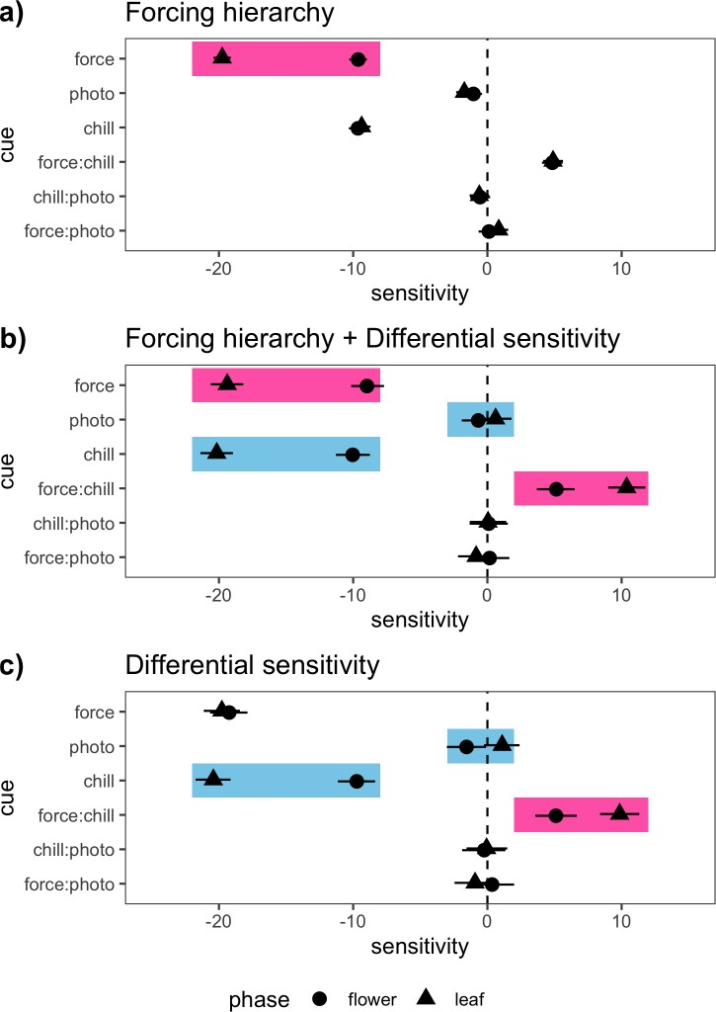

Figure 1: Characteristic sensitivity (∆ day of phenological event/ ∆ environmental cue) pat- terns of the phenological response to changing cue levels for the two major flower-leaf sequence hypotheses. a) displays a signature pattern of the forcing hierarchy hypothesis (FHH, pink boxes)—with the second phenophase in the sequence (in this case leafing) having a higher sen- sitivity to forcing than the first. b) depicts a scenario where both the FHH and the differential sensitivity hypothesis (DSH) contribute to flower-leaf sequence variation. Here the characteris- tic forcing sensitivity of the FHH is still apparent but the differential sensitivity to chilling and photoperiod is seen as well (blue boxes). c) highlights a typical sensitivity pattern produced by the DSH without the FHH. All plots above are based on simulations (see Supporting In- formation: Methods). Shapes indicate mean estimates and lines depict 95% credible intervals from Bayesian hierarchical models with advances in phenology shown as negative numbers, and delays in phenology as positive numbers.

Chill

Light

Force

flower leaf

Chill:Light

Chill:Force
Acer penyslyvanicum Acer rubrum Comptonia perigrina Corylus cornuta
Ilex mucronata Ilex verticillata
Prunus pensylvanica Prunus virginiana Vaccinium corymbosum Viburnum acerifolium

Light:Force

−40 −20 0 20

Phenological sensitivity

Figure 2: Effects of forcing temperature, chilling duration, and photoperiod on the leaf (circles) and flower (triangles) phenology of 10 temperate woody plant species collected from Harvard Forest (Petersham, MA, USA). Shapes indicate mean estimates and lines depict 50% credible intervals (See Tab. S3, Tab. S4 for other intervals) from Bayesian hierarchical models with advances in phenology shown as negative numbers, and delays in phenology as positive numbers. Flower and leaf phenology differs in sensitivity (∆ day of phenological event/ ∆ environmental cue) to these environmental cues.

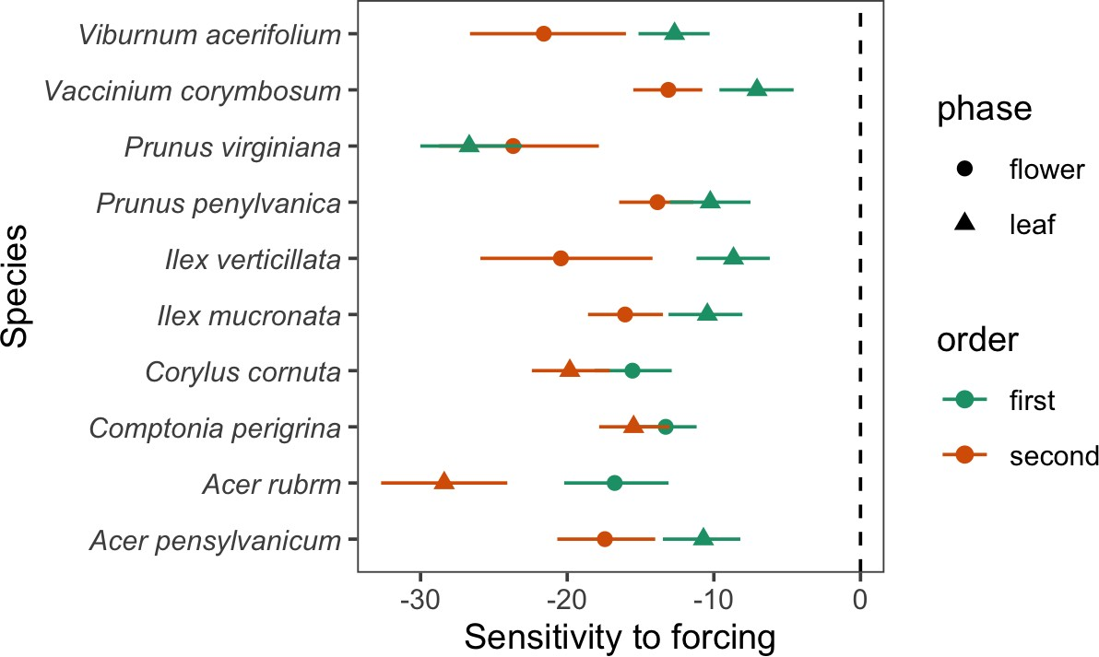

Figure 3: Phenological sensitivity (∆ phenological event/ ∆ C◦) to forcing temperatures of leaf (circles) and flower (triangles) phenology from 10 temperate deciduous woody plants at long (12 hour) photoperiod and long chilling duration treatments (8 weeks at 4◦C). Shapes indicate mean estimates and lines depict 50% credible intervals (See Tab. S5 for other intervals) from Bayesian hierarchical models with advances in phenology shown as negative numbers. When photoperiod and chilling are high, most species follows the predicted pattern of the forcing hierarchy hypothesis (FHH), with the second phenophase of the sequence consistently more sensitive to forcing than the first. This result suggests that the FHH should be considered a special case of the differential sensitivity hypothesis (DSH) that occurs when the chilling and photoperiod requirements are met for both tissue types.

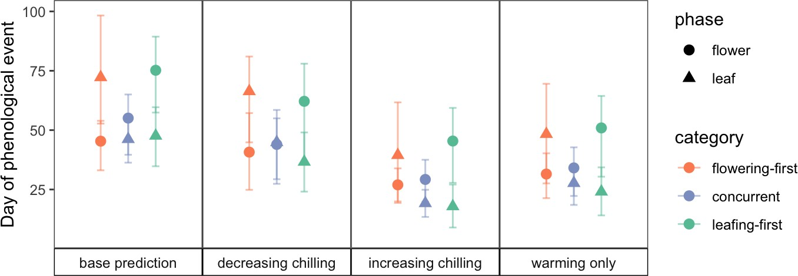

Figure 4: Projected shifts in flower-leaf sequences under current environmental conditions (base prediction) and three climate change scenarios predict that FLS differ among the three major FLS types and will be strongest is flowering-first species. Predictions are based on species- level posterior estimates grouped by FLS category (flowering-first, concurrent, leafing-first) from Bayesian hierarchical models comparing flower (circles) and leaf (triangles) phenological responses to variable chilling duration and forcing temperatures. Shapes represent the mean estimates and lines represent the 50% credible intervals.

