1 Ecological drivers of ﬂower-leaf sequences: aridity and proxies for

2 pollinator attraction select for ﬂowering-ﬁrst in the American Plums

3 D.M. Buonaiuto 1*,*2*,*3*,a*, T.J. Davies 4*,*5, S. Collins 4 & E.M. Wolkovich2*,*3*,*4

4 *Author aﬃliations:*

5 1Department of Environmental Conservation, University of Massachusetts, Amherst, Massachusetts, USA.

6 ORCID: 0000-0003-4022-2591

7 2Arnold Arboretum of Harvard University, Boston, Massachusetts, USA.

8 3Department of Organismic and Evolutionary Biology, Harvard University, Cambridge, Massachusetts, USA

9 4Forest & Conservation Sciences, Faculty of Forestry, University of British Columbia, Vancouver, British

10 Columbia, Canada

11 5 Department of Botany, University of British Columbia, Vancouver, British Columbia, Canada

12 *a*Corresponding author: 617.823.0687; [dbuonaiuto@umass.edu](mailto:dbuonaiuto@umass.edu)

13

14 Word Count: Introduction 945, Materials and Methods: 1735, Results: 503, Discussion:1647, **Total: 4830**

15 Figures: 4

16

17 **Summary**

18 • Across temperate forests many tree species produce ﬂowers before their leaves emerge. This ﬂower-

19 leaf phenological sequence, known as hysteranthy, is generally described as an adaptation for wind-

20 pollination. However, this explanation does not address why hysteranthy is also common in biotically-

21 pollinated taxa.

22 • We quantiﬁed ﬂower-leaf sequence variation in the American plums (*Prunus*, subspp. *Prunus* sect.

23 *Prunocerasus* ), a clade of insect-pollinated trees, using herbaria specimens and Bayesian hierarchical

24 modeling. We tested two common, but rarely interrogated hypotheses—that hysteranthy confers aridity

25 tolerance and/or pollinator visibility—by modeling the associations between hysteranthy and related

26 traits. To understand how these phenology-trait associations were sensitive to taxonomic scale and

27 ﬂower-leaf sequence classiﬁcation, we then extended these analyses to all *Prunus* species in North

28 America.

29 • Our ﬁndings across two taxonomic levels support the hypotheses that hysteranthy may help temporally

30 partition hydraulic demand to reduce water stress, and increase pollinator visibility—thereby reducing

31 selective pressure on inﬂorescence size.

32 • Our results provide foundational insights into the evolution of ﬂower-leaf sequences in the genus *Prunus*,

33 with implications for understanding these patterns in biotically-pollinated plants in general. Our ap-

34 proach suggests a path to advance these hypotheses to other clades, but teasing out drivers fully will

35 require new experiments.

36 Keywords: Deciduous forests, Flower-leaf sequences, Hysteranthy, Phenology, Plant hydraulics, Pollination,

37 Phylogeny

38 **Introduction**

39 Woody perennials are among a subset of plant types with the unique ability to seasonally begin reproduction

40 prior to vegetative growth. This ﬂowering-ﬁrst phenological sequence, known as hysteranthy, proteranthy or

41 precocious ﬂowering, is apparent in temperate deciduous forests around the globe (Rathcke & Lacey, 1985).

42 A number of studies suggest that this ﬂower-leaf sequence is under selection, and that hysteranthy can confer

43 performance advantages (Guo *et al.*, 2014; Gougherty & Gougherty, 2018; Buonaiuto *et al.*, 2021), but the

44 importance of variation in ﬂower-leaf sequences for maintaining ﬁtness may vary across functional types, taxa

45 and biomes.

46 The most common, and well-tested explanation for the evolution of hysteranthy in temperate forests is that it

47 is adaptive for wind-pollination, as leaﬂess canopies increase wind speeds for pollen transport and reduce the

48 likelihood of pollen interception by vegetation (Whitehead, 1969; Niklas, 1985). However, this explanation

49 does not address the widespread prevalence of hysteranthy in biotically-pollinated taxa found in temperate

50 regions. This number is not trivial; a recent analysis found that approximately 20% of the hysteranthy species

51 in Eastern Temperate Forests of North America are biotically-pollinated (Buonaiuto *et al.*, 2021).

52 Alternative hypotheses have been put forward to explain the advantage of hysteranthy in biotically-pollinated

53 species, but they have not been widely evaluated in the literature. Below, we brieﬂy review these hypotheses,

54 then test their predictions using the American plums (*Prunus* subspp. *Prunus* sect. *Prunocerasus* )—a

55 widespread clade with high variability in ﬂower-leaf sequences—as a case-study. Our study both clariﬁes

56 the hypothesized function of ﬂower-leaf sequence variation in the genus *Prunus* and lays the groundwork for

57 understanding the origins of ﬂower-leaf sequence variation in biotically-pollinated taxa more generally.

## 58 Hypotheses of hysteranthous ﬂowering in biotically-pollinated taxa

59 Water limitation hypothesis: In the dry-deciduous tropics of South and Central America, hysteranthy is

60 common (Rathcke & Lacey, 1985; Franklin, 2016), and is regarded as an important adaptation to alleviate

61 water stress by partitioning the hydraulic demand of ﬂowers and leaves across the season (Borchert, 1983;

62 Reich & Borchert, 1984; Franklin, 2016; Gougherty & Gougherty, 2018). Under this hypothesis, the function

63 of hysteranthous ﬂowering in temperate regions parallels that in the dry tropics. While temperate forests are

64 rarely water-limited in the early season during which ﬂowering and leaﬁng occur (Polgar & Primack, 2011),

65 there is still considerable variation in water availability in space and time within temperate regions of the

66 globe. With this hypothesis, we would expect to ﬁnd hysteranthous taxa in locations that are, on average,

67 drier than where their non-hysteranthous relatives are found.

68 Insect visibility hypothesis: Hysteranthous ﬂowers are visually conspicuous in the landscape. Thus, as in

69 wind-pollinated taxa, hysteranthy in biotically-pollinated taxa may be an adaptation for pollination eﬃciency

70 as ﬂowering-ﬁrst species are easier for insect pollinators to locate (Janzen, 1967). A challenge to evaluating this

71 hypothesis is that correlated selection between ﬂower-leaf sequences and pollinator visibility could have either

72 a positive or negative relationship depending on the pollination environment. In one scenario, hysteranthy

73 may be associated with smaller ﬂoral displays: because ﬂowers are not obscured by leaves, they are easier

74 to see and there is weaker selection for increasing ﬂoral display size. In an alternative scenario, hysteranthy

75 could be associated with larger ﬂoral displays, especially in environments where plants are more often pollen-

76 limited and selection may favor both hysteranthy and increased ﬂoral display size to augment ﬂoral attraction

77 to visual pollinators.

78 In contrast to these functional hypotheses, hysteranthous ﬂowering could simply be a by-product of selection

79 for early ﬂowering. Species that ﬂower before their leaves inherently ﬂower early in the season. For example,

80 fruit development or dispersal constraints may drive early ﬂowering (Primack, 1987), and because spring

81 ﬂower phenology is less constrained by prior phenological events than leaf phenology (Ettinger *et al.*, 2018;

82 Savage, 2019), this selection for early ﬂowering could incidentally produce the hysteranthous phenological

83 sequence. Here, there is no speciﬁc adaptive advantage to hysteranthy; selection is not operating on the

84 relative timing of ﬂower and leaf emergence, but rather the absolute ﬂowering time alone. Rejection of the

85 above functional hypotheses might provide support to this null explanation.

86 A signiﬁcant challenge for robust testing of hypotheses for hysteranthy is that most characterizations of ﬂower-

87 leaf phenological sequences are based on expert-opinion verbal descriptions (e.g. “ﬂowers before leaves” or

88 “ﬂower before/with leaves”), which make comparisons across taxa, time and space diﬃcult and sensitive

89 to observer bias (see Buonaiuto *et al.*, 2021). This problem can be overcome by adopting standardized

90 quantitative measures of plant phenology for observational studies and applying them to historical data

91 records. Herbarium records are an excellent source of data that can be leveraged for quantitative phenological

92 measurements (Willis *et al.*, 2017), but have not been widely used to investigate variability of ﬂower-leaf

93 sequences.

94 The American plums are a useful model clade to investigate drivers of hysteranthous ﬂowering in biotically-

95 pollinated species. The species that make up this group are distributed across the temperate zone of North

96 America and, like the genus *Prunus*, generally show pronounced inter-speciﬁc variation in ﬂower-leaf se-

97 quences. Usefully, species in this clade are well represented in herbaria records (Fig. 1a), making them a

98 tractable group to measure and assess variation in ﬂower-leaf sequences.

99 To interrogate the functional hypotheses for hysteranthous ﬂowering described above, we used herbaria records

100 to quantify variation in ﬂower-leaf sequences of the American plums. Then we combined environmental

101 attributes, biological traits and phylogenetic data in statistical models designed to evaluate whether the

102 observed associations between ﬂower-leaf sequences and morphological and environmental traits match the

103 predicted associations of the hysteranthy hypotheses. Finally, we compared our ﬁndings in this clade to

104 patterns observed in the larger genus *Prunus* to test whether these phenology-trait associations were sensitive

105 to taxonomic scale and ﬂower-leaf sequence classiﬁcation.

# 106 Materials and Methods

## 107 Quantifying ﬂower-leaf sequence variation

108 We obtained digital herbarium specimens of the American plums from the Consortium of Midwest Herbaria

109 (CMH) Database (of Midwest Herbaria, 2023). Specimen collection dates ranged from 1844-2020, with the

110 majority collected between 1950-2000. To quantify ﬂower-leaf sequence variation in this group we randomly

111 sampled 200 specimens for each species and scored the phenological development of ﬂowers and leaves; we

112 used a modiﬁed BBCH scale for woody plants designed to evaluate vegetative and reproductive phenological

113 progress through a standardized quantitative index (Finn *et al.*, 2007). For species with less than 200

114 specimens in the collection, we included all available specimens. In total, we evaluated the phenology of 2521

115 specimens, but only specimens with visible ﬂowers were included in this analysis. We also removed specimens

116 with ﬂowering dates that were major outliers from the observed ﬂowering period of each species. We removed

117 outliers visually, and by excluding observations that were beyond three standard deviations of the median

118 ﬂowering time for each species (*n*=9). Our ﬁnal analyses included 1000 specimens (see Tab. S1 for number

119 of observations/species).

120 We reconstructed the phylogenetic relationships among species in this group based on the tree topology in

121 Shaw & Small (2004). We inferred branch lengths following the method of Grafen & Hamilton (1989) in

122 which node heights are estimated in proportion to number of subtending taxa using the R package “ape” (E.

123 Paradis and K. Schliep, 2019).

124 To quantify ﬂower-leaf sequence variation, we ﬁt an ordinal, hierarchical, Bayesian phylogenetic mixed model

125 (de Villemeruil P. & Nakagawa, 2014) designed to assess the likelihood an individual would be at any given

126 vegetative BBCH phase while ﬂowering. Our model predicted leaf stage (*yi*, ordinal, with six categories

127 representing stage from 1 for “buds closed” and 6 for “leaf expansion complete”) as a function of species and

128 additional phylogenetic eﬀects. Because hysteranthy co-varies with ﬂowering time (i.e., ﬂowering ﬁrst species

129 will generally ﬂower earlier than other species, on average), and collection dates were not evenly distributed

130 across the ﬂowering season (see Fig. S1), we included day of year of observation as an additional predictor.

131 Additionally, because climate change could aﬀect the interval between ﬂowering and leafout over the course

132 of our time series, we included the year of collection of each specimen as a covariate. Following previous

133 conventions for modeling the possible eﬀects of climate change on spring phenology, we parameterized *year*

134 as a hinge variable, using 1980 as a break point (Stocker *et al.*, 2013; Buonaiuto *et al.*, 2021).

135 The model is written below:

136

 2 *if zi ∈* (0*, c*2)

 1 *if zi <* 0

*y* =  3 *if zi ∈* (*c*2*, c*3)

*i*

4 *if zi ∈* (*c*3*, c*4)

 5 *if zi ∈* (*c*4*, c*5)

 6 *if zi > c*5

137

138

*zi* = *α* + *αphylo* + *αsp* + *β*day of year[sp] *∗ X*day of year + *βyear ∗ Xyear* + *ϵi*

139 *ϵi ∼ logistic*(0*,* 1)

140

141 where *yi* is the ordinal outcome (leaf stage; as 1,2,...6 categories). *c*2*...*5 are the estimated cutpoints between

142 leaf stages on the logit scale and *Xyear* is the year the specimen was collected *−* 1980. *zi* is the linear

143 component of the underlying latent variable model.

144 *α* describes an intercept for each category [1,2,...6] and slopes (*β*day of year and *βyear*) are constant across

145 cutpoints. *β*day of year also varies among *species* while *βyear* is a pooled estimate across species.

146 The inﬂuence of the phylogeny (*αphylo*) was modeled as:

147

*αphylo ∼* normal(0*, COR*[*σ*2 ])

*phylo*

148 The *α* for species eﬀects independent of the phylogeny was modeled as:

149

*αsp ∼* normal(0*, σ*2 )

*species*

150 We used our model to predict the probability that each species would be observed at a given vegetative

151 BBCH stage during ﬂowering for each day of the ﬂowering period of each species by extracting 1000 random

152 draws from the posterior distribution. Next, for each day of the ﬂowering season, we summed the predicted

153 likelihood that species would be at BBCH 0 (“bud closed”), BBCH 07/09 (“bud break”) or BBCH 11 (“start

154 of leaf unfolding) vs. BBCH 15 (“leaf unfolding”), BBCH 17(“most leaves unfolded”), BBCH 19 (“leaf ex-

155 pansion complete”)—this allowed us to quantify the likelihood that a species would be hysteranthous or

156 non-hysteranthous respectively for each day of the season. We chose the BBCH 11/BBCH 15 boundary to

157 deﬁne hysteranthous ﬂowering because this is the earliest point in development when most leaves are unfurled

158 enough to visually obscure ﬂowers and transpire. Finally, we used these estimates to develop a ﬂower-leaf

159 sequence index: for this, we summed the likelihood of hysteranthy vs. non-hysteranthy across the full ﬂower-

160 ing period of each species, with 0 being never hysteranthous and 1 being always hysteranthous. To evaluate

161 the sensitivity of our model to choice of cutoﬀ, we also calculated a hysteranthy index using an alternative

162 cutoﬀ at the BBCH 09/BBCH 11, which did not alter the species’ ranks on the index (see Tab. S2).

163 To better understand how within-season dynamics aﬀected our inference, we also reﬁt our model excluding

164 *day of year* as a predictor. This version of the model did not substantially alter the species’ ranks on the index

165 or our inference about the relationships between ﬂower-leaf sequence variation and the trait representing the

166 main hysteranthy hypotheses (Tab. S2, Tab. S3).

## 167 Evaluating hysteranthy hypotheses

168 To test the hypotheses of hysteranthy, we ﬁrst recorded petal length measurements directly from herbarium

169 specimens. For these morphological measurements, we sampled 321 specimens and measured the petal length

170 of up to 10 randomly selected petals per specimen (*n*=2757) using ImageJ image processing software (see

171 Tab. S2, for sample sizes per species).

172 To assess aridity tolerance, we computed the average Palmer Modiﬁed Drought Index score from June-August

173 (hereafter: PDSI), obtained from Gille *et al.* (2017) for every *Prunocerasus* specimen in the database (*n*=2305,

174 see Tab. S2, for *n* per species). PDSI is a unitless, standardized drought index that integrates temperature

175 and precipitation data to estimate relative dryness in time and space (Heim, 2002). Negative PDSI values

176 indicate more arid conditions and positive values wetter conditions. For any specimens that lacked accurate

177 geo-location information, we extracted PDSI values at the county centroid of the herbaria specimen.

178 Because all of our measurements were made on diﬀerent individuals—with diﬀerent sample sizes—we used

179 two diﬀerent modeling approaches to test the relationship between ﬂower-leaf sequence index scores, aridity

180 tolerance and ﬂoral displays.

181 First we computed species-level means of PDSI and petal length and used a beta regression to evaluate the

182 relationship between ﬂower-leaf sequences, PDSI, petal length and their interaction. We standardized the

183 units of all predictors through *z*-scoring (Gellman & Hill, 2007) to make their eﬀect size estimates directly

184 comparable within the following model structure:

185

186 *yi* = (*µ, µ*(1 *− µ*)*/*(1 + *ϕ*)

187

188 where *µ* and *ϕ* are the two shape parameters of the beta regression. Due to the limited sample size of this

189 analysis (13 species), we only modeled the eﬀect of our predictors on the mean parameter, *µ*, and ﬁt a grand

190 intercept for the precision parameter *ϕ*. We modeled the *µ* parameter as:

191

192

193

*µ* = *α* + *βPDSI ∗ XPDSI* + *β*petal length *∗ X*petal length + *βPDSIx*petal length *∗* (*XPDSI* )(*X*petal length)

194 Both ﬂower and leaf phenology are sensitive to temperature cues (Buonaiuto & Wolkovich, 2021; Guo *et al.*,

195 2023), and to test whether broad temperature diﬀerences between species’ ranges oﬀered an alternative

196 explanation of hysteranthy variation, we additionally obtained monthly temperature data from 1900-2014

197 from Matsuura (2023). We then re-ﬁt our model using mean spring temperature (February-April) as a

198 predictor in place of PDSI.

199 We chose this model structure because it allowed us to assess the additive and interactive eﬀects of PDSI and

200 petal size on ﬂower-leaf sequences. However, by using mean trait values as predictors, we could not incorporate

201 within-species variation in these trait/environmental predictors or account for their phylogenetic structure.

202 To understand how these factors aﬀected our inferences about the relationship between ﬂower-leaf sequences

203 and traits, we ﬁt two additional models to estimate the relationship between ﬂower-leaf sequences index

204 values and PDSI, and between ﬂower-leaf sequences index values and petal size separately which included

205 the intra-speciﬁc variation and phylogenetic structure of each of these traits (see Supporting Information:

206 Extended Methods for details). This alternative modeling approach produced similar results for phenology-

207 trait relationships to our main model.

208 **Hysteranthy in the larger genus *Prunus***

209 To better understand how the patterns we identiﬁed in the American Plums clade scaled across a coarser

210 taxonomic resolution, we also evaluated the relationship between hysteranthous ﬂowering and hypothesis-

211 related traits for additional *Prunus* species native to, or established in, North America (*n*=32). For this

212 analysis, we obtained categorical descriptions of ﬂower-leaf sequences and mean estimates of the number of

213 ﬂowers per inﬂorescence as a proxy for ﬂoral investment from the Flora of North America (Rohrer, 1993+).

214 We extracted PDSI values for all herbaria observations of those species in the Consortium of Midwest Herbaria

215 database (*n*=23,272) as described above.

216 To account for the inﬂuence of evolutionary relationships among species, we reconstructed the phylogenetic

217 relationships in the genus based on the tree topology in Chin *et al.* (2014). As above, we computed branch

218 lengths with the R package “ape” (E. Paradis and K. Schliep, 2019).

219

220

As above, we standardized the units of all predictors through *z*-scoring (Gellman & Hill, 2007). The model structure is:

 1 *if zi <* 0

*y* =  2 *if zi ∈* (0*, c*2)

*i*

3 *if zi ∈* (*c*2*, c*3)

 4 *if zi > c*3

221 *zi* = *α*+*αphylo*+*βPDSI∗XPDSI* +*β*ﬂoral investment*∗X*ﬂowers/inﬂorescence+*βPDSIx*ﬂoral investment(*XPDSI* )(*X*ﬂowers/inﬂorescence)+

222 *ϵi*

223

*ϵi ∼ logistic*(0*,* 1)

224 where *yi* is the ordinal outcome of ﬂower-leaf sequence category ( “ﬂowers after leaves”=1, “ﬂowers with

225 leaves”=2, “ﬂowers before/with leaves”=3 and “ﬂowers before leaves”=4) and *c*2*...*3 are the estimated cutpoints

226 between categories on the logit scale. *zi* is the linear component of the underlying latent variable model. *α*

227 describes a grand intercept, and we modeled the inﬂuence of phylogeny (*αphylo*) as above. Note that this

228 model includes four ordinal categories, while our model of the American Plums clade included six, due to the

229 diﬀerent underlying structures of the two datasets.

230 **Model runs**

231 We ﬁt all models in the R package “brms” (Bu¨rkner, 2018) using weakly informative priors, and four chains.

232 For the models aimed at“Quantifying ﬂower-leaf sequence variation” and“Evaluating hysteranthy hypotheses”

233 in the American plums, we ran the models with a warm-up of 3000 iterations, and 4000, and 5000 sampling

234 iterations respectively, for a total of 4000 and 8000 sampling iterations across all chains. For the “Hysteranthy

235 in the larger genus *Prunus*” model, we used a warm up of 6,000 iterations and 8,000 sampling iterations for

236 a total of 8000 sampling iterations to maximize the eﬀective sampling size. Model ﬁts were assessed with *R*ˆ

237 *<*1.01, high eﬀective sample sizes, and no divergent transitions. We provide mean estimates with uncertainty

238 intervals in-text, and 50% and 89% intervals for all ﬁgures and tables.

239 **Results**

## 240 Quantifying ﬂower leaf sequences in the American plums

241 We found substantial inter-speciﬁc diﬀerences in ﬂower-leaf sequences within the American plums (Fig. 1b,

242 Fig. 2a). Several species (*P. mexicana*, *P. umbellata*, *P. angustifolia*, *P. maritima* and *P. gracilis*) were

243 most likely to be hysteranthous for all—or most—of their ﬂower period, while for others, (*P. americana*, *P.*

244 *munsoniana*, *P. alleghaniensis*, *P. nigra*, *P. hortulana*, *P. texana* and *P. rivularis* ), hysteranthous ﬂowering

245 was only likely in the early part of their ﬂowering session. One species, *P. subcordata*, was unlikely to be

246 hysteranthous at any point in its ﬂowering period (Fig. 2a). These relative rankings of species’ hysteranthy

247 likelihoods were consistent with our alternative method for constructing the hysteranthy index (Tab. S2, Fig.

248 S2).

249 Across all species of American Plums, day of year increased the likelihood of ﬂowering during a later vegetative

250 phenological stage (Fig. 2b). Year of observation did not substantially impact the likelihood of hysteranthy

251 for this taxonomic group (Fig. 2b).

## 252 Associations between hysteranthy and environmental and morphological traits

253 In the American plums, predominately hysteranthous species had marginally smaller ﬂowers and occurred in

254 historically drier localities than species with more overlap between ﬂowers and leaves (i.e., increased likelihood

255 of hysteranthy was negatively associated with PDSI and petal length without a substantial interaction between

256 them, Fig. 3a; parameter estimates from this model were *βPDSI* : *−*0*.*47*, UI*89[*−*0*.*96*,* 0*.*01], *β*petal length :

257 *−*0*.*14*, UI*89[*−*0*.*54*,* 0*.*24] *βPDSI* petal length : *−*0*.*14*, UI*89[*−*0*.*91*,* 0*.*65]; Bayesian *R*2: 0.33). These estimates

*x*

258 were comparable to estimates from models where we treated each predictor separately and accounted for

259 phylogeny (Fig. S3), and where we used the hysteranthy index derived from models that did not include day

260 of year as a predictor (Tab. S3). The direction and magnitude of the estimated eﬀects support the predictions

261 of the water-limitation hypothesis and weakly support the predictions of the insect-visibility hypothesis.

262 While predominately hysteranthous species tended to be found in regions with warmer spring temperatures,

263 this relationship was weak and uncertain (Tab. S4, *β*spring temperature: -0.26, UI89[*−*0*.*36*,* 0*.*86]) and the model

264 with spring temperature as a climate predictor explained considerably less variation (Bayesian *R*2: 0.20) in

265 hysteranthy than the model with PDSI.

266 In the larger genus *Prunus*, hysteranthous species had smaller inﬂorescences and were found in drier locations

267 (Fig. 4a, b; i.e., there was a negative association between hysteranthy and PDSI and number of ﬂowers

268 per inﬂorescence, as well as a substantial negative interaction between them, parameter estimates from

269 this model were *βPDSI* : *−*8*.*0*, UI*89[*−*16*.*6*, −*2*.*44], *βflowers/inflorescence* : *−*15*.*5*, UI*89[*−*31*.*46*, −*5*.*56] and

270 *βPDSIxflowers/inflorescence* : *−*13*.*06*, UI*89[*−*28*.*53*, −*2*.*93]). The direction and magnitude of the estimated

271 eﬀects support the predictions of both the water-limitation hypothesis and the insect-visibility hypothesis.

272 The estimated eﬀects of ﬂoral traits and their interactions with PDSI were stronger in the larger genus *Prunus*

273 than in the American plums clade. This is not surprising given that all species in the American plums clade

274 have solitary ﬂowers, making the variation in ﬂoral display size highly constrained. By contrast, *Prunus*

275 species included in our secondary analysis include those with solitary ﬂowers and species with as many as 100

276 ﬂowers per inﬂorescence—substantially more variation in both ﬂoral investment and in hydraulic demand.

277 This suggests that the correlated selection between ﬂower-leaf sequences and these ﬂoral traits may be more

278 pronounced at coarser taxonomic resolutions, where we sample a greater breadth of ecological strategies along

279 both axes.

280 **Discussion**

281 Using North American *Prunus* species as a case study, our results indicate that ﬂower-leaf sequences are likely

282 under selection. We show that variation in ﬂower-leaf sequences across species may reﬂect adaptive tradeoﬀs

283 between a) the timing of investment in reproduction relative to the timing of resumption of carbon acquisition

284 through leafout, and b) other aspects of plant performance, such as environmental tolerance and pollinator

285 attraction strategies that we investigated in this study. We show that hysteranthous ﬂowering is associated

286 with historic aridity (PDSI) and smaller ﬂower displays in both the American plums, and more broadly

287 across *Prunus* species native to, or established in, North America. The relationships between hysteranthy

288 and aridity, and hysteranthy and ﬂoral display size support the predictions of the water limitation hypothesis

289 and the insect visibility hypothesis.

290 Our models estimated a strong relationship between ﬂower-leaf sequences and aridity (PDSI) at both taxo-

291 nomic scales we studied. For the Americans plums, aridity was a better predictor of hysteranthy then average

292 spring temperature, suggesting inter-speciﬁc diﬀerences in ﬂower-leaf sequences do not simply reﬂect a phe-

293 nological response to temperature cues. The relationship between ﬂoral display size and ﬂower-leaf sequences

294 predicted by the insect visibility was better supported at the coarser taxonomic scale of the full genus *Prunus*

295 than in the American plums clade. While species in the American plum clade have solitary ﬂowers, they are

296 still clustered on branches, so it is unlikely the unit of attraction that pollinators are responding to is the

297 individual ﬂower, which may explain why the relationships between hysteranthy and petal size we observed

298 were weak (Fig. 3b). The inﬂorescences of the larger genus *Prunus*, are probably a better proxy for diﬀer-

299 ences in units of attraction, which may explain their stronger association with ﬂower-leaf sequences variation

300 among species (Fig 4). This contrast may suggest that associated selection between ﬂower-leaf sequences and

301 pollinator traits has more strongly inﬂuenced inﬂorescence architecture than the morphology of individual

302 ﬂowers though our estimates at both scales agreed in directionality (i.e., hysteranthy associated with smaller

303 ﬂoral displays).

304 Under the insect visibility hypothesis, ﬂoral display size could either be positively or negatively associated

305 with hysteranthy depending on the pollination environment. The association between hysteranthy and smaller

306 ﬂower displays that we found supports the prediction that increased visibility of hysteranthous ﬂowers reduces

307 selection pressure on ﬂower display size. These results ﬁt with other comparative anatomy studies in plants

308 that report hysteranthous species typically have smaller inﬂorescences than non-hysteranthous relatives (Gu-

309 natilleke & Gunatilleke, 1984), and studies on pollinator foraging behavior that suggest the presence of leaves

310 substantially alters the visual perception of pollinators (Rivest *et al.*, 2017; Forrest & Thomson, 2009).

311 Our support for both the water limitation hypothesis and insect visibility hypothesis (especially in the larger

312 genus *Prunus*), and the strong positive interactions between PDSI and ﬂoral investment that we observed in

313 the larger genus *Prunus*, highlight that these hypotheses are not mutually exclusive, and could be related.

314 Selection on ﬂoral size represents a classic evolutionary tradeoﬀ where larger ﬂoral displays may generally be

315 more eﬀective for attracting pollinators but demand more resources, including water, to maintain turgor and

316 reproductive function than smaller ones (Galen *et al.*, 1999; Lambrecht & Dawson, 2007). With this trade-oﬀ,

317 reproductive displays are often small in harsher environments (Lambrecht, 2013; Teixido *et al.*, 2016), and

318 hysteranthy could represent a compensatory mechanism that both reduces hydraulic demand while increasing

319 pollination eﬃciency in these environments. Studies that have compared the transpiration rates among ﬂowers

320 and leaves provide insights to the potential importance of hysteranthy as a means of partitioning hydraulic

321 demand across the season and maintaining water status. Measurements of water movement (transpiration

322 rates, sap ﬂow, hydraulic conductivity) to ﬂowers range from 20%-60% of that of leaves under comparable

323 conditions (Whiley *et al.*, 1988; Roddy & Dawson, 2012; Liu *et al.*, 2017; McMann *et al.*, 2022). This level

324 of additional hydraulic demand can drive loss of stomatal conductance and decrease photosynthetic rates

325 (Galen *et al.*, 1999).

326 The PDSI records that we incorporated in this study—spanning over two millennia—oﬀer additional insights

327 into why the water limitation hypothesis may still be relevant to temperate forest regions that are typically

328 well saturated in the spring. These records reveal that the southeastern United States (the region in which

329 much of our data originates) was once much drier than it has been in contemporary times (Cook *et al.*, 2010,

330 Fig S4), suggesting that the spatial patterns of hysteranthy we see in the American plums may represent a

331 lagged-correlation with historical climate conditions.

332 Despite this evidence that hysteranthy can reduce hydraulic demand in dry environments, hysteranthous

333 species in the American plum clade are not found—even historically—in extremely arid locations (PDSI

334 values typically range from -4 to 4, although the values that we observed in our analyses were more restricted,

335 ranging from -0.5 to 0.2). This contrasts with hysteranthous species in the dry tropics where this phenological

336 pattern appears to allow them to tolerate more extreme aridity (Franklin, 2016). But the ﬂower-leaf sequences

337 of the hysteranthous species in our study were markedly diﬀerent from patterns of hysteranthy in these dry-

338 tropics where the water limitation hypothesis was initially proposed. While ﬂowering can precede leafout

339 by as much several weeks for species in the American plums, the process of fruit development, which is also

340 water intensive, occurs when leaves are present. By contrast, in the dry tropics hysteranthous ﬂowering is

341 initiated at the time of leaf drop (Borchert, 1983; Franklin, 2016); thus, the full reproductive cycle occurs in

342 the leaﬂess period. The comparatively small window of leaﬂess reproductive development in our temperate

343 clade suggests that hysteranthy may allow temperate species to occupy marginally drier environments than

344 non-hysteranthous species, but may not facilitate species’ persistence under extreme aridity.

## 345 Inter-and intra-speciﬁc variation in ﬂower-leaf sequences

346 We developed a novel approach to assessing ﬂower-leaf sequences that scales from quantitative, individual-

347 level observations to species-level characterizations. With this approach, we were able to—for the ﬁrst

348 time—quantitatively assess intermediate cases of hysteranthy (such as those that are typically described as

349 “ﬂowers before/with leaves”). Previous studies of hysteranthous ﬂowering have either excluded these cases

350 from their analyses (e.g.; Gougherty & Gougherty, 2018) or binned them with the well deﬁned cases (e.g.;

351 Buonaiuto *et al.*, 2021). We found that many American plum species expressed this intermediate ﬂower-leaf

352 sequence. Further, while our classiﬁcations broadly matched previous species-level analyses in this group by

353 Shaw & Small (2004), our approach identiﬁed substantial diﬀerences in ﬂower-leaf sequences among these

354 intermediate cases (Fig. 1b), which allowed us to assess the trait associations with this phenotype.

355 Our quantitative analysis of the American plums clade revealed that ﬂower-leaf sequences—often described

356 as a species-level trait—are highly variable within species (Fig. 2a). For almost all members of the clade,

357 hysteranthy was strongly predicted by the day of the observation (“day of year” in our model, Fig. 2b). In

358 many cases there was a high likelihood that individuals of a species may be observed at diﬀerent vegetative

359 stages during ﬂowering (Fig. 2a, Fig. S2). The variation we observed here could either suggest high levels

360 of local adaptation in ﬂower-leaf sequences or, alternatively, high levels of plasticity through which ﬂower-

361 leaf sequences respond to interannual variation in environmental conditions. Because our study was based on

362 herbaria records collected on diﬀerent individuals across space and time without repeat sampling, we could not

363 robustly estimate how much ﬂower-leaf sequences vary within vs. among species, and within individuals over

364 time. Parsing in the inﬂuence of multiple climate drivers across multiple scales of ecological and evolutionary

365 time would be an important next step for understanding how the environment and species interactions have

366 shaped these phenological patterns.

367 Interestingly, while there is substantial evidence that both ﬂowering and leaf phenology have advanced over

368 the last several decades in response to anthropogenic climate change (Menzel *et al.*, 2006; Cleland *et al.*,

369 2007; Augspurger & Zaya, 2020), we did not observe changes in ﬂower-leaf sequences over that time scale

370 in our dataset (Fig. 2b). This supports a recent ﬁnding that despite changes in both ﬂowering and leafout,

371 the time interval between them has remained relatively stable (Guo *et al.*, 2023), but does not preclude that

372 possibility that these the sequences will eventually be disrupted as climate change continues to become more

373 extreme in the future (Buonaiuto & Wolkovich, 2021).

374 **Future directions**

375 We focused on a well-studied, and economically important clade of morphologically similar species. Our

376 case-study provides a road map for evaluating the role of hysteranthy more generally in temperate biotically-

377 pollinated plant taxa (other groups with high interspeciﬁc ﬂower-leaf sequence variation include *Magnolia*,

378 *Rhododendron*, *Acer* and *Cornus*), and more broadly across taxa and biomes.

379 Combining the observational approach with novel experiments could further advance our collective under-

380 standing of the adaptive signiﬁcance of ﬂower-leaf sequences. To test the water-limitation hypothesis, re-

381 searchers could plant sister-taxa with contrasting ﬂower-leaf sequences in common environments across a

382 gradient of aridity, and evaluate their performance. To test the insect visibility hypothesis, researchers

383 should consider hysteranthy—and phenology in general—in the broader framework of tradeoﬀs in pollination

384 biology. The tradeoﬀ between phenology and pollination investment could not only consider ﬂower size, but

385 also the number of ﬂowers, nectar and pollen reward investment, volatiles between related hysteranthous and

386 non-hysteranthous taxa. Findings that hysteranthous species invest fewer resources into these other pollinator

387 attraction traits than non-hysteranthous relatives would support the insect visibility hypothesis. For a simple

388 experiment to test the pollinator visibility hypothesis, researchers could force hysteranthy/non-hysteranthy

389 phenotypes for the same genotype using environmental cues and systematically release pollinators to ob-

390 serve their preferences, search times and foraging behavior. If pollinators are more readily drawn to the

391 hysteranthous individuals, it would support hysteranthy as an adaptive trait for pollinator attraction.

392 With a better mechanistic understanding of the relationship between ﬂower-leaf sequences and ecological

393 performance, researchers could then use experiments to assess how diﬀerences in ﬂoral and leaf physiological

394 responses to temperature variation shape ﬂower-leaf sequences. The measurement and modeling approaches

395 we developed in our observational study can be readily implemented to analyze data from such experimental

396 settings, presenting an important opportunity to unite observations of broad ecological patterns with targeted

397 experimental manipulations to better understand both the evolutionary past and ecological future of ﬂower-

398 leaf sequences.

# 399 Competing Interests:

400 The authors declare no conﬂict of interest.

# 401 Author contributions

402 DMB, and EMW conceived of the manuscript; DMB and SC collected the data; DMB led the statistical

403 analyses with TJD and EMW; DMB led the writing of the manuscript. All authors contributed to writing

404 and gave approval for the submission.

405 **Data Availability**

406 The phenology and trait data collected for this study will be made available and archived at KNB: The

407 Knowledge Network for Biocomplexity (https://knb.ecoinformatics.org/) at the time of publication.

408 **References**

409 **Augspurger CK , Zaya DN. 2020**. Concordance of long-term shifts with climate warming varies among

410 phenological events and herbaceous species. *Ecological Monographs*, **n/a**: e01421.

411 **Borchert R. 1983**. Phenology and control of ﬂowering in tropical trees. *Biotropica*, **15**: 81–89.

412 **Buonaiuto DM, Morales-Castilla I , Wolkovich EM. 2021**. Reconciling competing hypotheses regarding

413 ﬂower–leaf sequences in temperate forests for fundamental and global change biology. *New Phytologist*,

414 **229**: 1206–1214.

415 **Buonaiuto DM , Wolkovich EM. 2021**. Diﬀerences between ﬂower and leaf phenological responses to envi-

416 ronmental variation drive shifts in spring phenological sequences of temperate woody plants. *Journal of*

417 *Ecology*, **109**: 2922–2933.

418 **Bu¨rkner PC. 2018**. Advanced bayesian multilevel modeling with the r package brms. *R Journal*, **10**: 395–411.

419 **Chin SW, Shaw J, Haberle R, Wen J , Potter D. 2014**. Diversiﬁcation of almonds, peaches, plums and

420 cherries –molecular systematics and biogeographic history of prunus (rosaceae). *Molecular Phylogenetics*

421 *and Evolution*, **76**: 34–48.

422 **Cleland EE, Chuine I, Menzel A, Mooney HA , Schwartz MD. 2007**. Shifting plant phenology in response

423 to global change. *Trends in Ecology Evolution*, **22**: 357 – 365.

424 **Cook ER, Seager R, Heim Jr RR, Vose RS, Herweijer C , Woodhouse C. 2010**. Megadroughts in north

425 america: placing ipcc projections of hydroclimatic change in a long-term palaeoclimate context. *Journal*

426 *of Quaternary Science*, **25**: 48–61.

427 **E. Paradis and K. Schliep. 2019**. ape 5.0: an environment for modern phylogenetics and evolutionary analyses

428 in R. *Bioinformatics*, **35**: 526–528.

429 **Ettinger A, Gee S , Wolkovich E. 2018**. Phenological sequences: how early season events deﬁne those that

430 follow. *American Journal of Botany*, **105**.

431 **Finn GA, Straszewski AE , Peterson V. 2007**. A general growth stage key for describing trees and woody

432 plants. *Annals of Applied Biology*, **151**: 127–131.

433 **Forrest J , Thomson JD. 2009**. Background complexity aﬀects colour preference in bumblebees. *Naturwis-*

434 *senschaften*, **96**: 921–925.

435 **Franklin DC. 2016**. Flowering while leafess in the seasonal tropics need not be cued by leaf drop: evidence

436 from the woody genus brachychiton (malvaceae). *Plant Ecology and Evolution*, **149**: 272–279.

437 **Galen C, Sherry R , Carroll A. 1999**. Are ﬂowers physiological sinks or faucets? costs and correlates of water

438 use by ﬂowers of polemonium viscosum. *OECOLOGIA*, **118**: 461–470.

439 **Gellman A , Hill J**. 2007. *Data Analysis Using Regression and Multilevel/Hierarchical Models*. Cambridge

440 University Press.

441 **Gille E, Wahl E, Vose R , Cook E**. 2017. Noaa/wds paleoclimatology - living blended drought atlas (lbda)

442 version 2 - recalibrated reconstruction of united states summer pmdi over the last 2000 years.

443 **Gougherty AV , Gougherty SW. 2018**. Sequence of ﬂower and leaf emergence in deciduous trees is linked to

444 ecological traits, phylogenetics, and climate. *New Phytologist*, **220**: 121–131.

445 **Grafen A , Hamilton WD. 1989**. The phylogenetic regression. *Philosophical Transactions of the Royal Society*

446 *of London. B, Biological Sciences*, **326**: 119–157.

447 **Gunatilleke CVS , Gunatilleke IAUN. 1984**. Some observations on the reproductive biology of three species

448 of cornus (cornaceae). *Journal of the Arnold Arboretum*, **65**: 419–427.

449 **Guo L, Liu X, Alatalo JM, Wang C, Xu J, Yu H, Chen J, Yu Q, Peng C, Dai J *et al* . 2023**. Climatic

450 drivers and ecological implications of variation in the time interval between leaf-out and ﬂowering. *Current*

451 *Biology*, **33**: 3338–3349.e3.

452 **Guo L, Luedeling E, Dai J , Xu J. 2014**. Diﬀerences in heat requirements of ﬂower and leaf buds make

453 hysteranthous trees bloom before leaf unfolding. *Plant Diversity and Resources*, **36**: 245–253.

454 **Heim RR. 2002**. A review of twentieth-century drought indices used in the united states. *Bulletin of the*

455 *American Meteorological Society*, **83**: 1149–1166.

456 **Janzen DH. 1967**. Synchronization of sexual reproduction of trees within the dry season in central america.

457 *Evolution*, **21**: 620–637.

458 **Lambrecht SC. 2013**. Floral water costs and size variation in the highly selﬁng leptosiphon bicolor (polemo-

459 niaceae). *International Journal of Plant Sciences*, **174**: 74–84.

460 **Lambrecht SC , Dawson TE. 2007**. Correlated variation of ﬂoral and leaf traits along a moisture availability

461 gradient. *Oecologia*, **151**: 574–583.

462 **Liu H, Xu QY, Lundgren MR , Ye Q. 2017**. Diﬀerent water relations between ﬂowering and leaf periods: a case

463 study in ﬂower-before-leaf-emergence *<*i*>*magnolia*<*/i*>* species. *Functional Plant Biology*, **44**: 1098–1110.

464 **Matsuura K**. 2023. The climate data guide: Global (land) precipitation and temperature: Willmott mat-

465 suura, university of delaware.”. retrieved from: *https://climatedataguide.ucar.edu/climate-data/global-land-*

466 *precipitation-and-temperature-willmott-matsuura-university-delaware*. on 2024-02-14

467 **McMann N, Peichel A , Savage JA. 2022**. Early spring ﬂowers rely on xylem hydration but are not limited

468 by stem xylem conductivity. *New Phytologist*, **233**: 838–850.

### 469 Menzel A, Sparks TH, Estrella N, Koch E, Aasa A, Ahas R, Alm-Kuebler K, Bissolli P, Braslavska O, Briede

470 **A *et al* . 2006**. European phenological response to climate change matches the warming pattern. *Global*

471 *Change Biology*, **12**: 1969–1976.

472 **of Midwest Herbaria C**. 2023. Consortium of midwest herbaria.

473 **Niklas KJ. 1985**. The aerodynamics of wind pollination. *The Botanical Review*, **51**: 328–386.

474 **Polgar C , Primack R. 2011**. Leaf-out phenology of temperate woody plants: From trees to ecosystems. *New*

475 *Phytologist*, **191**: 926–41.

476 **Primack RB. 1987**. Relationships among ﬂowers, fruits, and seeds. *Annual Review of Ecology and Systematics*,

477 **18**: 409–430.

478 **Rathcke B , Lacey EP. 1985**. Phenological patterns of terrestrial plants. *Annual Review of Ecology and*

479 *Systematics*, **16**: 179–214.

480 **Reich P , Borchert R. 1984**. Water-stress and tree phenology in a tropical dry forest in the lowlands of

481 costa-rica. *Journal of Ecology*, **72**: 61–74.

482 **Rivest SA, Austen EJ , Forrest JRK. 2017**. Foliage aﬀects colour preference in bumblebees (bombus impa-

483 tiens): a test in a three-dimensional artiﬁcial environment. *Evolutionary Ecology*, **31**: 435–446.

484 **Roddy AB , Dawson TE**. 2012. Determining the water dynamics of ﬂowering using miniature sap ﬂow sensors.

485 International Society for Horticultural Science (ISHS), Leuven, Belgium, 951, pp. 47–53.

486 **Rohrer J**. 1993+. Prunus. In: *Flora of North America North of Mexico* (ed. of North America Editorial Com-

487 mittee F.). New York and Oxford.

488 **Savage JA. 2019**. A temporal shift in resource allocation facilitates ﬂowering before leaf out and spring vessel

489 maturation in precocious species. *American Journal of Botany*, **106**: 113–122.

490 **Shaw J , Small RL. 2004**. Addressing the ”hardest puzzle in american pomology:” phylogeny of prunus sect.

491 prunocerasus (rosaceae) based on seven noncoding chloroplast dna regions. *Am J Bot*, **91**: 985–996.

### 492 Stocker T, Qin D, Plattner GK, Tignor M, Allen S, Boschung J, Nauels A, Xia Y, Bex V , Midgley P.

493 2013. *Climate Change 2013: The Physical Science Basis. Contribution of Working Group I to the Fifth*

494 *Assessment Report of the Intergovernmental Panel on Climate Change*. IPCC, Cambridge, United Kingdom

495 and New York, NY.

496 **Teixido AL, Barrio M , Valladares F. 2016**. Size matters: Understanding the conﬂict faced by large ﬂowers

497 in mediterranean environments. *The Botanical Review*, **82**: 204–228.

498 **de Villemeruil P. , Nakagawa S**. 2014. *Modern Phylogenetic Comparative Methods and Their Application in*

499 *Evolutionary Biology*, Springer, New York, chap. General quantitative genetic methods for comparative

500 biology, pp. pp. 287–303.

501 **Whiley A, Chapman K , Saranah J. 1988**. Water loss by ﬂoral structures of avocado (*<*i*>*persea ameri-

502 cana*<*/i*>* cv. fuerte) during ﬂowering. *Australian Journal of Agricultural Research*, **39**: 457–467.

503 **Whitehead DR. 1969**. Wind pollination in the angiosperms: Evolutionary and environmental considerations.

504 *Evolution*, **23**: 28–35.

### 505 Willis CG, Ellwood ER, Primack RB, Davis CC, Pearson KD, Gallinat AS, Yost JM, Nelson G, Mazer SJ,

506 **Rossington NL *et al* . 2017**. Old plants, new tricks: Phenological research using herbarium specimens.

507 *Trends in Ecology & Evolution*, **32**: 531–546.

508 **Figures**

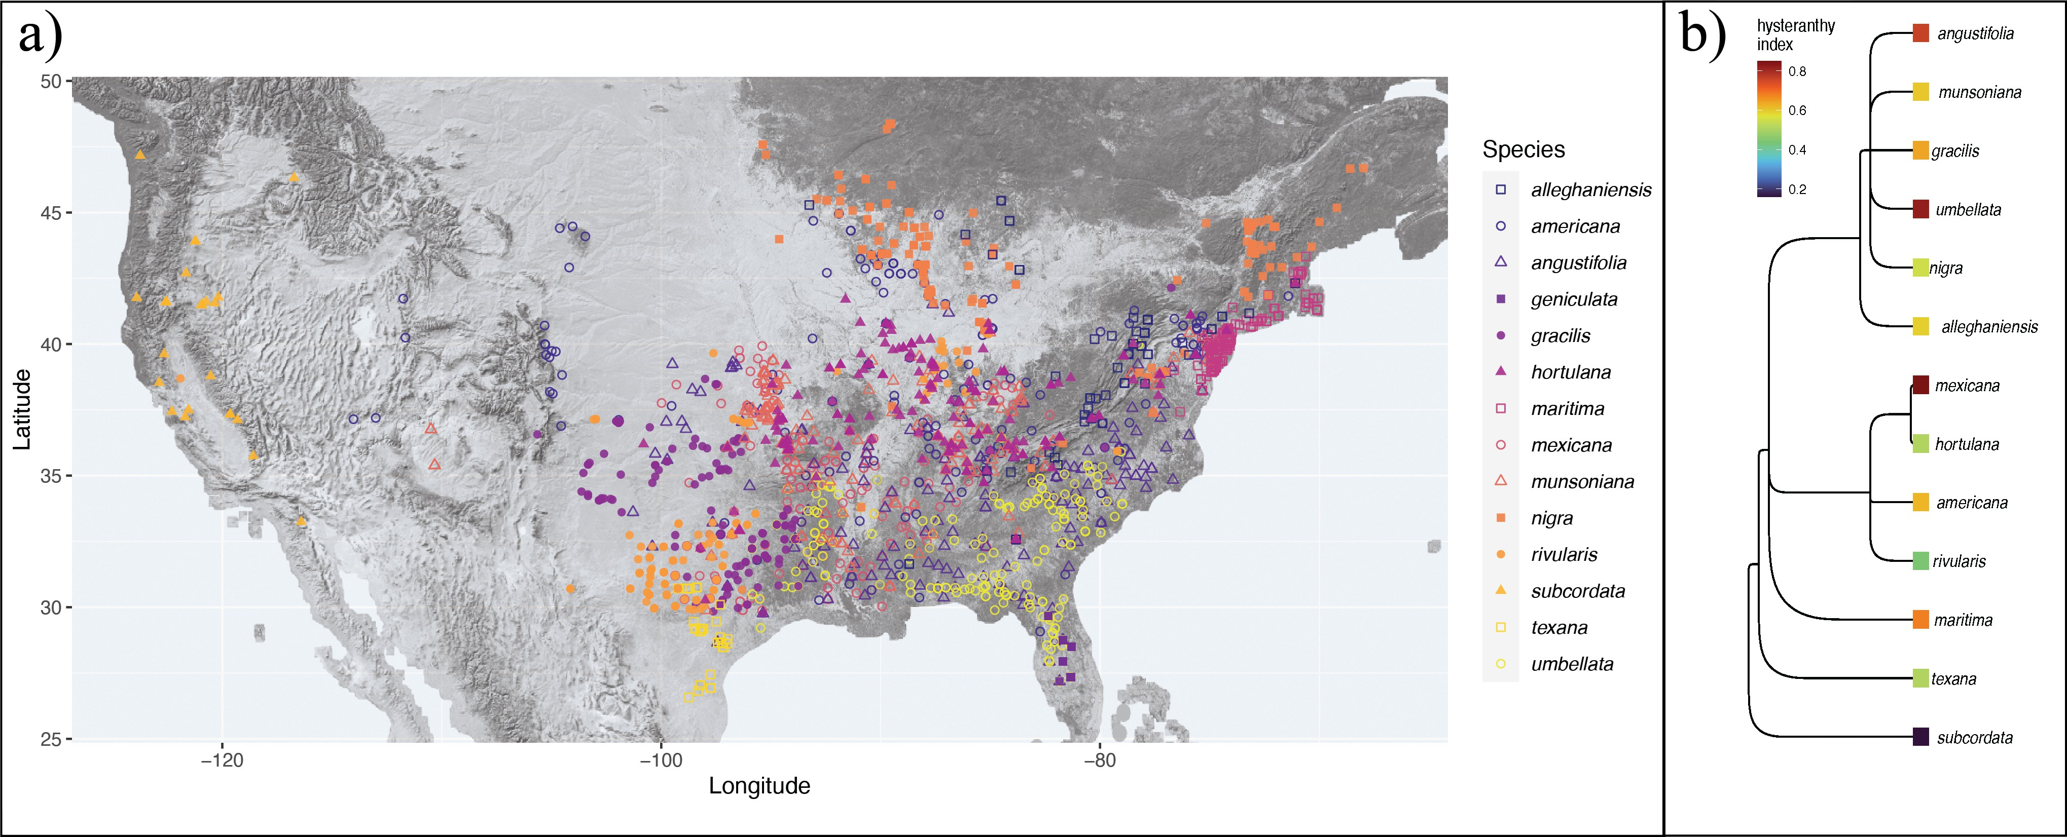

Figure 1: Geographic distribution and taxonomic relationships among the American plums. a) Maps the local- ities of all the herbaria records used in this study. b) Depicts phylogenetic relationships among the American plums and the likelihood they each species is hysteranthous across its full ﬂowering period, represented by a hysteranthy index where 0 is never hysteranthous and 1 is always hysteranthous. These designations are based on ordinal phylogenetic mixed models. Tree topology is from Shaw & Small (2004)

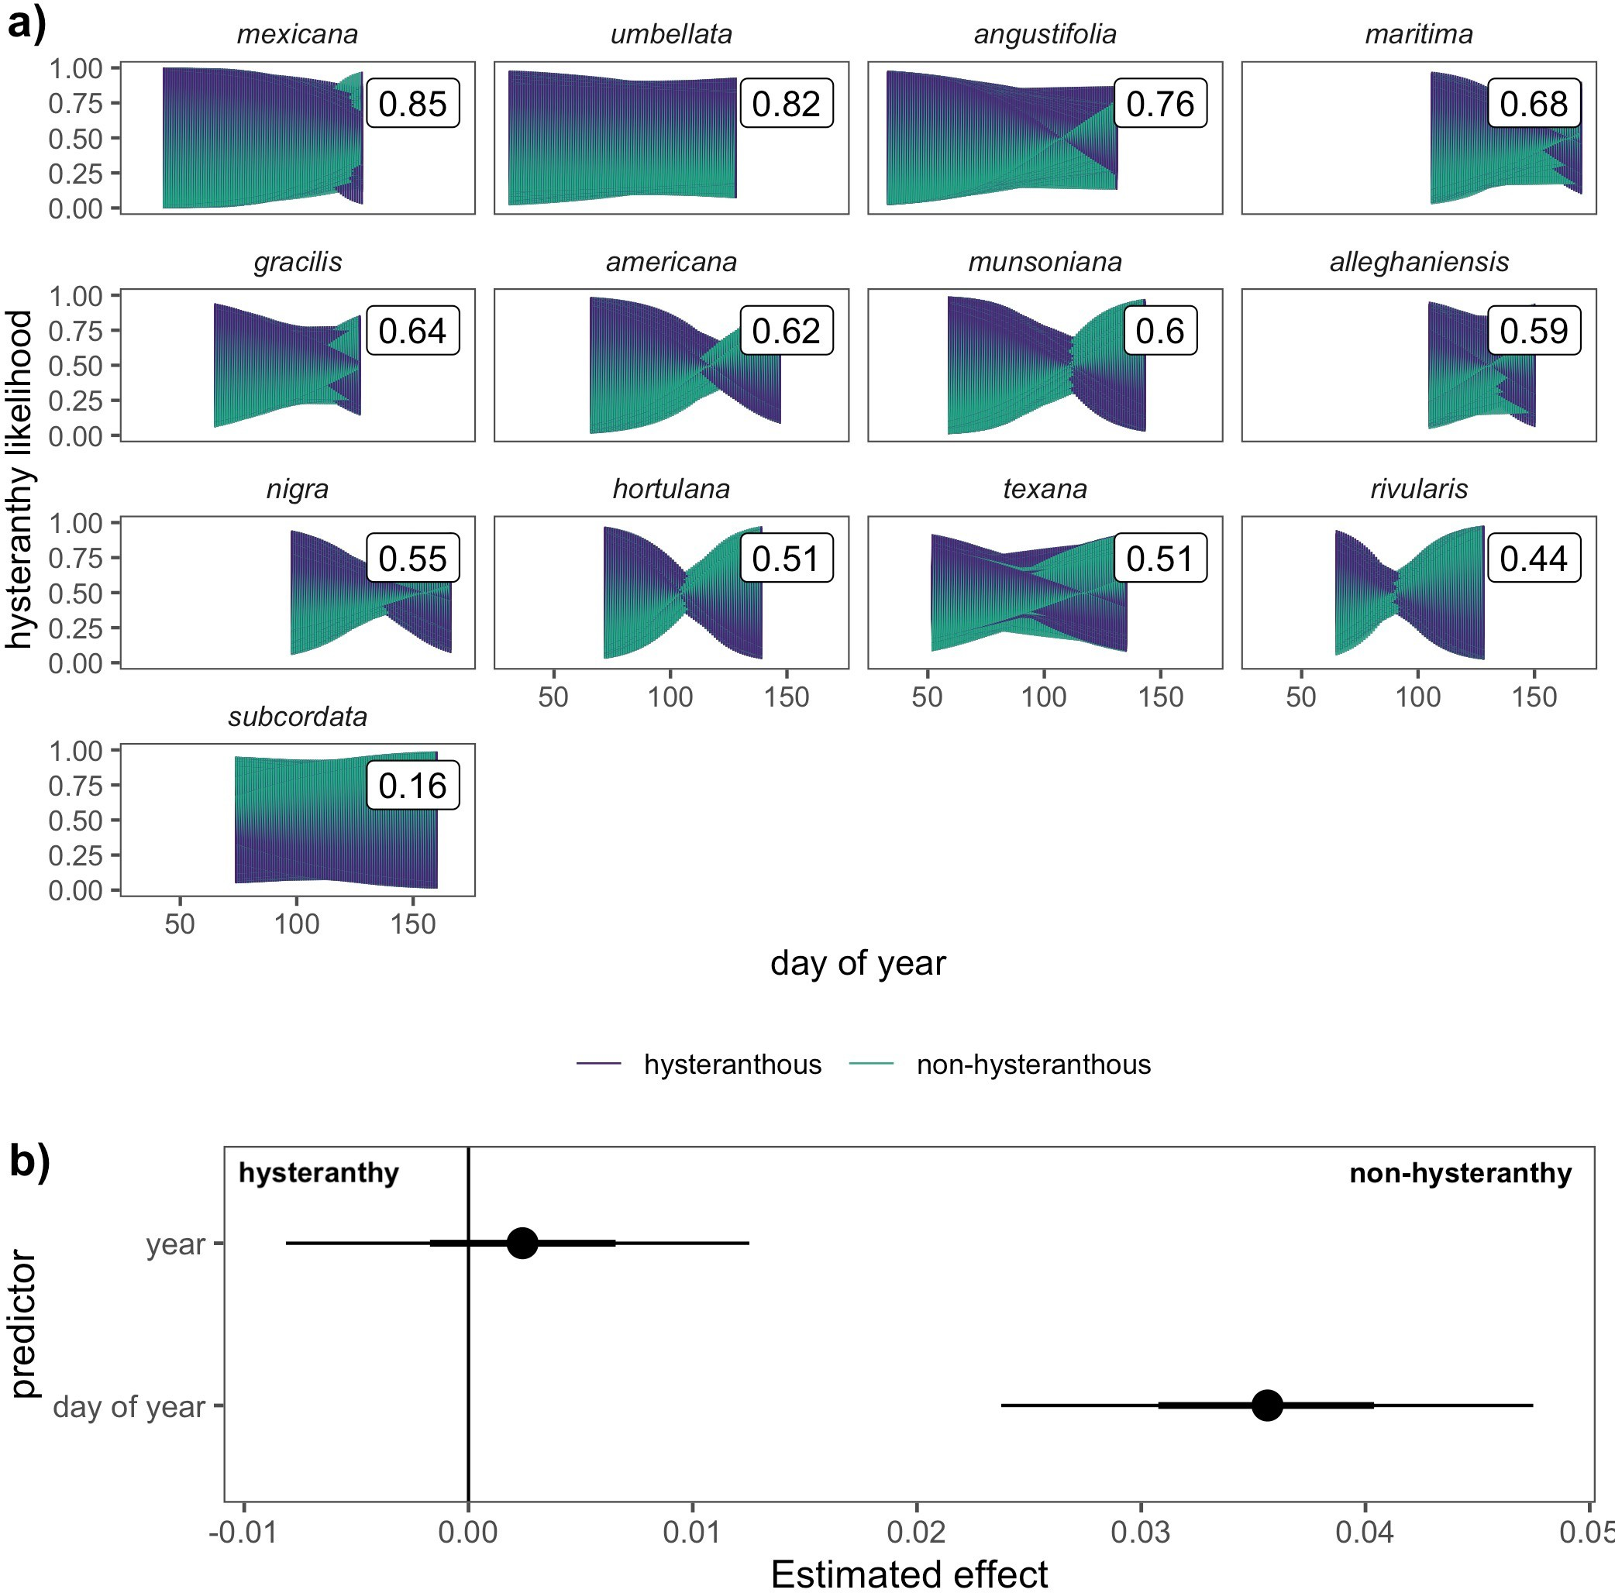

Figure 2: Predicted likelihood of hysteranthy across the ﬂowering period of 13 American plum species and the temporal predictors that drive these patterns. Panel a) depicts the predicted likelihood that each species would express hysteranthy on each day of their ﬂowering season based on 1000 draws from the posterior distribution of Bayesian hierarchical models. The colored shapes represent how the likelihood changes over time and the boxed numerical values represent the average likelihood a species would express hysteranthy, summed across the full ﬂowering period. Panel b) depicts the inﬂuence of among season (year of sample) and within season (day of year of sample) trends on the likelihood species would express hysteranthy. Points are the mean eﬀect size estimates, while thick and thin bars represent the 50% and 89% uncertainty intervals respectively.

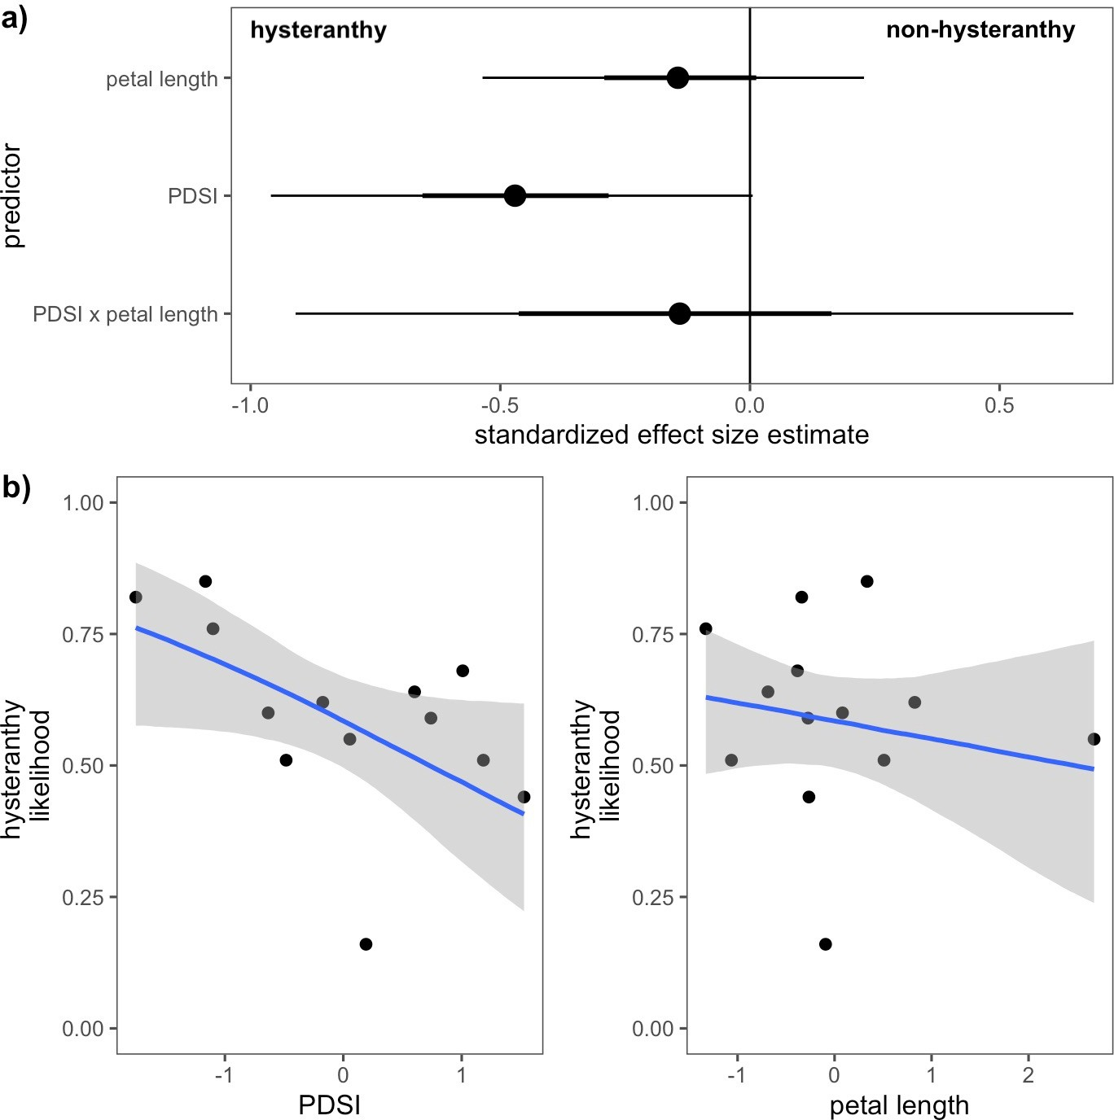

Figure 3: Relationships between hysteranthy and environmental and biological traits for the 13 species of the American Plums. Panel a) shows the estimated eﬀects of each predictor and their interaction on the likelihood hysteranthy. Points indicate the mean eﬀects and the thick and thin bars represent the 50% and 89% uncertainty intervals, respectively. Panel b) depicts the conditional eﬀects of each predictor on hysteranthy likelihood. Blue lines indicate the mean estimate and grey ﬁll the 89% uncertainty intervals. Predictor values (*x*-axis) are in standardized units (*z*-scored) to allow direct comparisons between predictors.

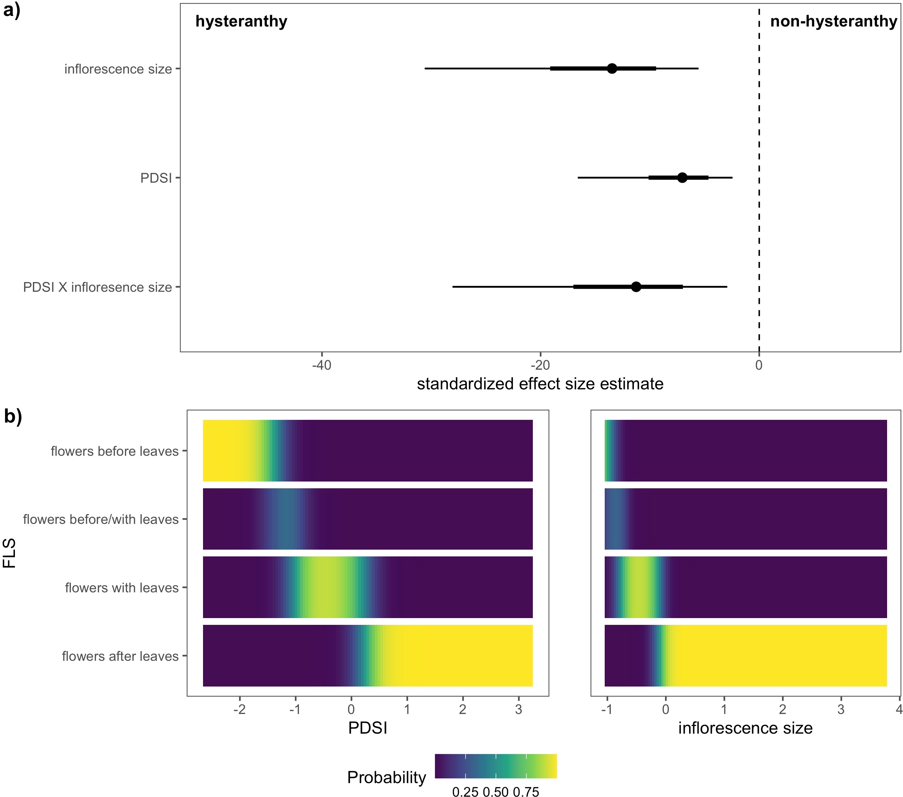

Figure 4: Relationships between the likelihood of hysteranthy and environmental and biological traits for 32 species of the genus *Prunus* native to, or established in North America. Panel a) shows the estimated eﬀect size of each predictor. Points indicate the mean estimate for each predictor, and thick and thin bars the 50% and 89% uncertainty intervals, respectively. Panel b) depicts the likelihood for each ﬂower-leaf sequence stage (*y*-axis) at any given values of PDSI or number of ﬂowers/inﬂorescence (inﬂorescence size). Predictor values (*x*-axis) have been *z*-scored to allow direct comparisons between predictors.