1 Aridity and pollination success contribute to ﬂowering-ﬁrst

2 phenological sequences in a major North American temperate tree

3 clade

4 D.M. Buonaiuto 1*,*2*,*3*,a*, T.J. Davies 4*,*5, S. Collins 4, E.M. Wolkovich2*,*3*,*4

5 *Author aﬃliations:*

6 1Department of Environmental Conservation, University of Massachusetts, Amherst, Massachusetts, USA.

7 ORCID: 0000-0003-4022-2591

8 2Arnold Arboretum of Harvard University, Boston, Massachusetts, USA.

9 3Department of Organismic and Evolutionary Biology, Harvard University, Cambridge, Massachusetts, USA

10 4Forest & Conservation Sciences, Faculty of Forestry, University of British Columbia, Vancouver, British

11 Columbia, Canada

12 5 Department of Botany, University of British Columbia, Vancouver, British Columbia, Canada

13 *a*Corresponding author: 617.823.0687; [dbuonaiuto@umass.edu](mailto:dbuonaiuto@umass.edu)

14

15 **Summary**

16 A large number of woody plant species in temperate forests produce ﬂowers before their leaves emerge each

17 spring. This ﬂower-leaf phenological sequence, known as hysteranthy, proteranthy or precocious ﬂowering is

18 generally described as an adaptation to facilitate wind-pollination—which does not explain why it has also

19 evolved to be common in biotically-pollinated taxa in these regions.

20 In this study, we quantiﬁed the inter- and intraspeciﬁc variation in ﬂower-leaf sequences in the American

21 plums (*Prunus*, subspp. *Prunus* sect. *Prunocerasus* ), a clade of insect-pollinated trees and shrubs, using

22 a large database of digitized herbaria specimens and Bayesian hierarchical modeling. We leveraged these

23 observations to test common hypotheses for the evolution and function of hysteranthy by modeling the

24 associations between hysteranthy and environmental and biological traits related to these hypotheses. To

25 better understand how these phenology-trait associations were sensitive to taxonomic scale and ﬂower-leaf

26 sequence classiﬁcation, we then repeated these analyses for the more inclusive genus *Prunus* with trait and

27 phenology descriptions from published guidebooks.

28 We found that in both the American plums and larger genus *Prunus*, hysteranthy was associated with

29 aridity and reduced ﬂoral display size. These ﬁndings support the assertion that hysteranthy may function

30 to temporally partition hydraulic demand between ﬂowers and leaves and reduce water stress, or increase

31 pollinator visibility and reduce selective pressure on increased ﬂower size.

32 Our study provides critical insights into the evolution of ﬂower-leaf sequences in biotically pollinated species

33 and function of ﬂower-leaf sequences. Our ﬁndings that hysteranthous ﬂowering is linked to both aridity tol-

34 erance and pollination success highlights the importance of phenological sequences in global change research

35 as climate shifts continue to disrupt pollinator services and impact environmental variability.

36

37 Keywords: Deciduous forests, Flower-leaf sequences, Hysteranthy, Phenology, Pollination syndrome, Phy-

38 logeny

39 **Introduction**

40 Woody perennials have a unique ability among plants to seasonally begin reproduction prior to vegetative

41 growth. This ﬂowering-ﬁrst phenological sequence, known as hysteranthy, proteranthy or precocious ﬂowering,

42 is particularly common in temperate deciduous forests around the globe (Rathcke & Lacey, 1985). A number

43 of studies suggest that this ﬂower-leaf sequence (FLSs) is under selection, and that hysteranthy has functional

44 signiﬁcance, but the importance of variation in FLSs for maintaining ﬁtness (Gougherty & Gougherty, 2018;

45 Buonaiuto *et al.*, 2021; Guo *et al.*, 2014) may vary across functional types and evolutionary clades within

46 the temperate forest biome. With mounting evidence that anthropogenic climate change is driving shifts in

47 ﬂower-leaf sequences (Ma *et al.*, 2020), expanding our understanding of the adaptive beneﬁt of hysteranthy

48 may be important to forecasting the demography and performance of forest communities.

49 The most common, and well-tested explanation for the evolution of hysteranthy in temperate forests is that it

50 is adaptive for wind-pollination, as leaﬂess canopies increase wind speeds for pollen transport and reduce the

51 likelihood of pollen interception by vegetation (Whitehead, 1969; Niklas, 1985). However, this explanation

52 does not address the widespread prevalence of hysteranthy in biotically-pollinated taxa found in temperate

53 regions. This number is not trivial; a recent analysis found that approximately 20% of the hysteranthy species

54 in the moist, Eastern Temperate Forests of North America are biotically pollinated (Buonaiuto *et al.*, 2021).

55 Several alternative hypotheses have been put forward to explain the advantage of hysteranthy in biotically-

56 pollinated species, but they have not been widely evaluated in the literature. Below, we brieﬂy review these

57 hypotheses and their predictions, and then test these predictions using the American plums (*Prunus* subspp.

58 *prunus* sect. *prunocerasus* ), a widespread clade with high variability in ﬂower-leaf sequences, as a case-study.

59 Our treatment here both clariﬁes the hypothesized function of ﬂower-leaf sequence variation in biotically-

60 pollinated taxa, and oﬀers insights into how shifting ﬂower-leaf sequences may impact species demography

61 and distributions as climate continues to change.

## 62 Hypotheses of Hysteranthous ﬂowering in biotically pollinated taxa

63 Water limitation hypothesis: In the dry-deciduous tropics of South and Central America, hysteranthy is

64 common (Rathcke & Lacey, 1985; Franklin, 2016), and is regarded as an important adaptation to alleviate

65 water stress by partitioning the hydraulic demand of ﬂowers and leaves across the season (Gougherty &

66 Gougherty, 2018; Franklin, 2016; Borchert, 1983; Reich & Borchert, 1984). Under this hypothesis, the function

67 of hysteranthous ﬂowering in temperate regions parallels that in the dry tropics—partitioning hydraulic

68 demand across the season to allow hysteranthous species to tolerate increased aridity. While temperate forests

69 are rarely water-limited in the early season during which ﬂowering and leaﬁng occur (Polgar & Primack, 2011),

70 there is still considerable variation in water availability in space and time within temperate regions of the

71 globe. With this hypothesis, we would expect to ﬁnd hysteranthous taxa in locations that are, on average,

72 drier than their non-hysteranthous relatives.

73 Insect-visibility hypothesis: Hysteranthous ﬂowers are visually conspicuous in the landscape. Thus, as in

74 wind-pollinated taxa, hysteranthy in biotically pollinated taxa may be an adaptation for pollination eﬃciency

75 as ﬂowering-ﬁrst species are easier for insects pollinators to locate (Janzen, 1967). This hypothesis predicts

76 that hysteranthy should be associated with smaller ﬂoral displays, because ﬂowers are not obscured by leaves,

77 they are easier to see, and there is weaker selection for increasing ﬂoral display size.

78 Fruit maturaturion hypothesis: There are several aspects of reproductive development that suggest hysteran-

79 thy is a by-product of developmental constraints related to fruit maturation. Hysteranthy may be common

80 in large fruited species that require lots of time to mature their fruits, or in small, early fruiting species that

81 have evolved dispersal syndromes (wind dispersal, non-dormant seeds) that require dispersal early in the

82 season (Primack, 1987). In either case, we should expect fruit size to associate with hysteranthy, although

83 the sign of the correlation diﬀers.

84 Alternative to these functional hypotheses is the assertion that hysteranthous ﬂowering is simply a by-product

85 of selection for early ﬂowering. Species that ﬂower before their leaves inherently ﬂower early in the season.

86 Spring ﬂower phenology is less constrained by prior phenological events than leaf phenology (Savage, 2019;

87 Ettinger *et al.*, 2018), which could allow selection to drive ﬂowering into the early season, producing the

88 hysteranthous phenological sequence. Here, there is no speciﬁc adaptive advantage to hysteranthy; selection

89 is not operating on the relative timing of ﬂower and leaf emergence, but rather the absolute ﬂowering time

90 alone. Rejection of the above hypotheses might provide support to this null explanation.

91 A signiﬁcant challenge for robust testing of hysteranthy hypotheses is that most characterizations of ﬂower-leaf

92 phenological sequences are based on expert-opinion verbal descriptions (e.g. “ﬂowers before leaves” or “ﬂower

93 before/with leaves”), which make comparisons across taxa, time and space diﬃcult and sensitive to observer

94 bias (see; Buonaiuto *et al.*, 2021). This problem can be overcome by adopting standardized quantitative

95 measures of plant phenology for observational studies and applying them to historic data records. Herbarium

96 records are an excellent source of data that can be leveraged for quantitative phenological measurements

97 (Willis *et al.*, 2017), but have not been used widely to investigate variability of ﬂower-leaf sequences variation

98 among and within species.

99 The American plums oﬀer potential for a high resolution investigation of drivers of hysteranthous ﬂowering

100 in taxa that are not easily explained by the dominant wind-pollination hypothesis. The 16 species that make

101 up the section are distributed across the temperate zone of North America and, like the genus *Prunus* at

102 large, are all insect-pollinated, yet show pronounced inter-speciﬁc variation in ﬂower-leaf sequences. Usefully,

103 species in this section are well represented in herbaria records (Fig. 1a), making them a tractable group to

104 measure and assess variation in ﬂower-leaf sequences.

105 To interrogate the functional hypotheses for hysteranthous ﬂowering described above, we used herbaria records

106 to to quantify both within- and across- species level variation in ﬂower-leaf sequences of the American plums.

107 Then we combined environmental attributes, biological traits and phylogenetic data in statistical models to

108 evaluate whether the observed associations between ﬂower-leaf sequence variation and morphological and

109 environmental traits match the predicted associations of the hysteranthy hypotheses. Finally, we compared

110 our ﬁndings in this clade to patterns observed in larger genus *Prunus* to better understand whether these

111 phenology-trait associations were sensitive to taxonomic scale and ﬂower-leaf sequence classiﬁcation.

# 112 Materials and Methods

## 113 Quantifying ﬂower-leaf sequence variation

114 We obtained digital herbarium specimens for all members of the section *Prunocerasus* from the Consortium

115 of Midwest Herbaria (CMH) Database (CMH, 2023). To quantify ﬂower-leaf sequence variation within and

116 across species we randomly sampled 200 specimens for each species and scored the phenological development of

117 ﬂowers and leaves using a modiﬁed BBCH scale for woody plants (Finn *et al.*, 2007). In total, we evaluated

118 the phenology of 2521 specimens, but only specimens with visible ﬂowers were included in this analysis

119 (n=1009). We reconstructed the phylogenetic relationships among species in this group based on the tree

120 topology in Shaw & Small (2004). We inferred branch lengths following the method of Grafen & Hamilton

121 (1989) in which node heights are estimated in proportion to number of subtending taxa using the R package

122 “ape” (E. Paradis and K. Schliep, 2019).

123 To quantify FLS variation, we ﬁt an ordinal, hierarchical, Bayesian phylogenetic mixed model (de Villemeruil

124 P. Nakagawa, 2014) to assess the likelihood an individual would be at any given vegetative BBCH phase

125 while ﬂowering. Our model predicted leaf stage (*Y* , ordinal, with up to *j* categories) as a function of species

126 and additional phylogenetic eﬀects. Because hysteranthy co-varies with ﬂowering time (i.e., ﬂowering ﬁrst

127 species will generally ﬂower earlier than other species, on average) we included day of observation as an

128 additional predictor. The model is written below:

129

130

131

*logit*(*P* (*Y ≤ j*)) = *α*[*j*]*phylo* + *α*[*j*]*sp* + *βdayofyear*[*sp*] *∗ Xdayofyear* + *ϵ*

*ϵ ∼ N* (0*, σ*2)

*y*

132 where *Y* is the ordinal outcome (leaf stage) and *j* is the number of categories (1,2,...6). *P* (*Y ≤ j*)) is the

133 probability of *Y* less than or equal to a category *j* = 1*...j −* 1. *α*[*j*] describes an intercept for each category

134 [1,2,...6], while slope *β*day of year[*sp*] is constant across categories, but varies among *species*.

The inﬂuence of the phylogeny *αphylo* was modeled as follows:

*αsp ∼ N* (*µα, COR*[*σ*2 ])

*phylo*

The *α* for species eﬀects independent of the phylogeny was modeled as follows:

*αsp ∼ N* (*µα, σ*2 )

*species*

135 We used our model to predict the likelihood each species would be observed at a given vegetative BBCH stage

136 during ﬂowering at the 0%, 25% 50% and 75% quantiles of their ﬂowering period. We then developed a ﬂower-

137 leaf sequence index, by assigning a numerical score to each species per seasonal quantile, and summing over

138 the full ﬂowering season. In each seasonal quantile, species received a “1” if more than 50% of their probability

139 distribution occurred at the two earliest stages of vegetative phenology—BBCH 0 (“bud development”) and

140 BBCH 09 (“bud break”)—and a “0” if not. We summed these values across the season, generating an index

141 from 0 (never hysteranthous) to 4 (hysteranthous through late season (Q75)), where 1= hysteranthous at

142 start of season, 2= hysteranthous through early season (Q25) and 3 = hysteranthous through mid season

143 (Q50). We also used two alternative indexing schemes (*>*25% of the probability distribution occurred at

144 BBCH 0 and *>*40% of the probability distribution occurred at BBCH 0 and BBCH 09) to make sure our

145 result were robust across multiple cutoﬀs.

## 146 Evaluating hysteranthy hypotheses

147 To test the hypotheses of hysteranthy, we obtained data on petal length and fruit diameter directly from

148 herbarium specimens. To assess aridity tolerance, we computed the average Palmer Modiﬁed Drought Index

149 score from 1900-2017 for every *Prunocerasus* specimen in the database (n=2305) from the North America

150 Drought Atlas (Cook & Krusic, 2004). For any specimens that lacked accurate geo-location information, we

151 extracted PDSI values at the county centroid of the herbaria specimen.

152 For our morphological measurements, we sampled an additional 321 specimens and measured the petal length

153 of up to 10 randomly selected petals per specimen (n=2757) using ImageJ image processing software. We

154 also used ImageJ to measure the diameter of fruits on an additional 316 specimens, measuring up to 5 fruit

155 per specimen (n=224).

156 We then used Bayesian phylogenetic mixed models to test the relationship between ﬂower-leaf sequence index

157 scores and each of the variables. In these models, we modeled species and phylogeny as above.

158 The model structure is written below:

159

160

*ytrait* = *αsp* + *αphylo* + *βhyst.index ∗ Xhyst.index* + *ϵi*

*ϵi ∼ N* (0*, σ*2)

*y*

161 where *ytrait* is observed trait values (PDSI, petal length or fruit diameter), and the slope *β*hyst.index describes

162 the relationship between extended hysteranthy (higher hysteranthy index value) and the trait of interest. *αsp*

163 and *αphylo* describe the species and phylogenetic eﬀects respectively. We also ran each model using our two

164 alternative FLS indexing approaches to make sure our results were robust to choice of index. Though these

165 alternative classiﬁcation schemes did change the hysteranthy index score for some species (Fig. S1), they did

166 not substantially impact the inference from our models (see Tab. S1 for comparisons).

167 **Hysteranthy in the larger genus *Prunus***

168 To better understand how the patterns we identiﬁed in *Pruncerasus* scaled across coarser taxonomic resolution

169 and ﬂower-leaf sequence classiﬁcation we also evaluated the relationship between hysteranthous ﬂowering and

170 hypothesis-related traits in all *Prunus* species native to, or established in North America. For this analysis,

171 we obtained categorical descriptions of ﬂower-leaf sequences and mean estimates of fruit diameter and number

172 of ﬂowers per inﬂorescence as a proxy for ﬂoral investment from the Flora of North America (Rohrer, 1993+).

173 We extracted PDSI values for all herbaria observation of those species in the Consortium of Midwest Herbaria

174 database (n=23,272) as described above.

175 To account for the inﬂuence of evolutionary relationships among species, we reconstructed the phylogenetic

176 relationships in the genus based on the tree topology in Chin *et al.*(2014). As above, we computed branch

177 lengths with the R package “ape” (E. Paradis and K. Schliep, 2019).

178 We standardized the units of all predictors to make their eﬀect size estimates for the following model structure

179 directly comparable to each other:

180 *logit*(*P* (*Y ≤ j*)) = *α*[*j*]*phylo* + *βPDSI*[*sp*] *∗ XP DSI* + *βfruitdiamter ∗ Xfruitdiameter* + +*βfloralinvestment ∗*

|  |  |
| --- | --- |
| 181 | *Xflowersperinflorescence* + *ϵ* |
| 182 |  |
|  | *ϵ ∼ N* (0*, σ*2)  *y* |
| 183 | where *Y* is the ordinal outcome of ﬂower-leaf sequence category (“ﬂowers before leaves”,“ﬂowers before/with |
| 184 | leaves”, “ﬂowers with leaves” and “ﬂowers after leaves”) and *j* is the number of categories (1,2,...4). *P* (*Y ≤ j*)) |
| 185 | is the probability of *Y* less than or equal to a category *j* = 1*, ...j−*1. We modeled the inﬂuence of the phylogeny |
| 186 | (*αphylo*) as above. |
| 187 | **0.1 Model runs** |
| 188 | We ﬁt models in the R package “brms” (Bu¨rkner, 2018) using weakly informative priors, and four chains. For |
| 189 | the “Quantifying ﬂower-leaf sequence variation” and “Evaluating hysteranthy hypotheses” we ran the models |
| 190 | with a warm-up of 3000, and 3500 iterations, and 4000, and 4500 sampling iterations respectively, for a total |
| 191 | of 4000 sampling iterations across all chains. For the “Hysteranthy in the larger genus *Prunus*” model, we |
| 192 | used a warm up of 6,000 iterations and 8,000 sampling iterations for a total of 8,000 sampling iterations to |
| 193 | maximize the eﬀective sampling size. Model ﬁts was assessed with Rhats *<*1.01, high eﬀective sample sizes |

194 and no divergent transitions.

195 **Results**

## 196 Quantifying ﬂower leaf sequences in the American plums

197 We found substantial inter-speciﬁc diﬀerences in ﬂower-leaf sequences within the American plums (Fig. 2,

198 S1). Flower-leaf sequence patterns were strongly dependent on the day of observation, with observations

199 later in the the ﬂowering season of each species decreasing the likelihood of ﬁnding ﬂowers open during

200 early vegetative BBCH phases (*βdoy* 0.03, *CI*50 [0.02,0.03]). Based on our ﬂower leaf sequence index, two

201 species (*P. umbellata*, *P. mexicana*) were likely to be hysteranthous regardless of the time of observation

202 and three species (*P. rivularis*, *P. subcordata*, and *P. texana*) were always most likely to ﬂower after leaves

203 developed (Fig. 1b). All other species displayed intermediate phenotypes, with ﬁve species mostly likely to

204 hysteranthous at the start of the season (*P. alleghaniensis*, P. americana, *P. hortulana*, *P. munsoniana* and

205 P. nigra), one species through early season (*P gracilis*) and two species through mid season (*P. angustifolia*,

206 *P. maritima*) (Fig 1b).

## 207 Associations between hysteranthy and environmental and morphological traits

208 In the American plums clade, aridity (lower average PDSI) was associated with higher ﬂower-leaf sequence

209 index scores (*β*: -0.03, *CI*50[-0.05, 0.02], Fig. 3a), suggesting that species that displayed hysteranthous

210 ﬂowering later into their ﬂowering season are found in dryer locations.

211 Shorter petal and smaller fruit diameters were also associated with higher ﬂower-leaf sequence index scores

212 (*β*: -.21, *CI*50[-0.38 -0.04] and *β*:-1.40, *CI*50[-1.97 -0.82] respectively, Fig. 3b,c). This suggests that smaller

213 fruits and ﬂowers are associated with increased hysteranthy.

214 At the genus level, there was a positive association between increasing PDSI and inﬂorescence size and

215 increasing overlap between ﬂowers and leaves (i.e., decreasing hysteranthy; *β*: 2.50, *CI*50[1.17, 3.371] and

216 *β* 6.41,*CI*50[3.86, 8.05] respectively, Fig. 4a), again suggesting that hysteranthy is associated with drier

217 locations and smaller ﬂoral displays (Fig. 4b). However, hysteranthy was associated with larger fruits (*β*:

218 -1.24, *CI*50[-1.95,-0.21], 4b)] though there was high uncertainty around these estimates in our model.

219 **Discussion**

220 Our study provides foundational insights into the evolution of ﬂower-leaf sequences in biotically pollinated

221 plants. We show that hysteranthous ﬂowering can be linked to both aridity tolerance and pollination success

222 through the predictions of the water limitation and insect visibility hypotheses, highlighting the urgency for

223 advancing our understanding phenological sequences as human-caused global change continues to disrupt

224 pollinator services and impact environmental variability.

## 225 Hysteranthy hypotheses

226 Using North American *Prunus* species as a case study, our analyses indicate that ﬂower-leaf sequences are

227 under selection by biological and environmental drivers, and that variation in these patterns across species

228 may reﬂect adaptive tradeoﬀs. We found that hysteranthous ﬂowering is associated with smaller ﬂoral displays

229 and increased aridity in both the American plums, and more broadly across *Prunus* native or established

230 in North America. While we did not ﬁnd support for the fruit maturation hypotheses, the relationships

231 between hysteranthy and aridity, and hysteranthy and ﬂoral display size support the predictions of the water

232 limitation hypothesis and the insect visibility hypothesis, respectively.

233 Our support for both the water limitation hypothesis and insect visibility hypothesis highlights that these

234 hypotheses are not mutually exclusive, and could be related. Selection on ﬂoral size represents a classic

235 evolutionary tradeoﬀ where larger ﬂoral displays may generally be more eﬀective for attracting pollinators

236 but demand more resources, including water, to maintain turgor and reproductive function than smaller

237 ones (Galen *et al.*, 1999; Lambrecht & Dawson, 2007). With this trade-oﬀ, reproductive displays are often

238 small in harsher environments (Teixido *et al.*, 2016; Lambrecht, 2013), and hysteranthy could represent a

239 compensatory mechanism that both reduces hydraulic demand while increasing pollination eﬃciency in these

240 environments.

241 Studies that have compared the transpiration rates among ﬂowers and leaves provide insights to the potential

242 importance of this seasonal partitioning for maintaining water status. Measurements of water movement

243 (transpiration rates, sap ﬂow, hydraulic conductivity) to ﬂowers range from 20%-60% of that of leaves under

244 comparable conditions (Whiley *et al.*, 1988; Roddy & Dawson, 2012; Liu *et al.*, 2017; McMann *et al.*, 2022).

245 This level of additional hydraulic demand can drive loss of stomatal conductance and decrease photosynthetic

246 rates (Galen *et al.*, 1999).

247 Despite this evidence that hysteranthy can reduced hydraulic demand in dry environments, hysteranthous

248 species in the American plum clade are not found in extremely arid locations (mean PDSI values only ranged

249 from -.48 to 0.2 for species classiﬁed as hysteranthous through mid-season or through late season, while

250 PDSI can range from -10 to 10). This contrasts with hysteranthous species in the dry tropics where this

251 phenological syndrome allows them to tolerate more extreme aridity (Franklin, 2016). But the ﬂower-leaf

252 sequences of the hysteranthous species in our study were markedly diﬀerent from patterns of hysteranthy in

253 these dry-tropics where the water limitation hypothesis was initially proposed. While ﬂowering can precede

254 leafout by as much several weeks for species in the American plums, the process of fruit development, which is

255 also water intensive, occurs when leaves are present. By contrast, in the dry tropics hysteranthous ﬂowering

256 is initiated at the time of leaf drop (Borchert, 1983; Franklin, 2016). Thus, the full reproductive cycle

257 occurs in the leaﬂess period. The comparatively small window of leaﬂess reproductive development in our

258 temperate clade, may in part, explain why the association we observed between hysteranthy and aridity in

259 our study was relatively weak with high residual variance. Our results suggest that hysteranthy may allow

260 temperate species to occupy marginally drier environments than non-hysteranthous species, but may not

261 facilitate species’ persistence under extreme aridity.

## 262 Inter-and intra-speciﬁc variation in ﬂower-leaf sequences

263 We developed a novel approach to assessing ﬂower-leaf sequences that scales from quantitative, individual-level

264 observations to species-level characterizations that were based on empirical likelihood estimates. With this

265 approach, we were able to—for the ﬁrst time—quantitatively assess intermediate cases of hysteranthy (such as

266 those that are typically described as “ﬂowers before/with leaves”). Previous studies of hysteranthous ﬂowering

267 have either excluded these cases from their analyses (e.g.; Gougherty & Gougherty, 2018) or binned them

268 with the well deﬁned cases (e.g.; Buonaiuto *et al.*, 2021). We found that eight of the thirteen American plum

269 species expressed this intermediate ﬂower-leaf sequence, and our classiﬁcations broadly matched previous

270 species-level analyses in this group by Shaw & Small (2004). By estimating the likelihood of hysteranthy

271 across the growing season with Bayesian methods, our approach identiﬁed substantial diﬀerences in ﬂower-leaf

272 sequences among these intermediate cases (Fig. 2, Fig. S1), which allowed us to assess the trait associations

273 with this phenotype.

274 Our quantitative analysis of the American plums clade revealed that ﬂower-leaf sequences—often described

275 as a species-level trait—are highly variable within species (Fig. 2, Fig. S1). For all members of the clade,

276 the day of phenological observation was a strong predictor of the likelihood that ﬂowers would be visible

277 before the emergence of leaves. In many cases there was high likelihood that individuals of a species may

278 be observed at diﬀerent vegetative stages during ﬂowering (Fig. 3, S1). This variation could either suggest

279 high levels of local adaptation in ﬂower-leaf sequences or, alternatively, high levels of plasticity through

280 which ﬂower-leaf sequences respond to interannual variation in environmental conditions. For example—in a

281 given population—ﬂower-leaf sequences may respond to interannual variation in precipitation with increased

282 temporal separation between ﬂowers and leaves in drier years. While our data did not have the temporal

283 resolution to address this question, the high levels of within-species variation we observed raise important

284 questions about environmental drivers of ﬂower-leaf sequences operating on both the macro-evolutionary scale

285 we investigated here and on individual physiological responses to environmental change.

286 Additionally, by scoring these individual, quantitative observations as ordinal response categories with our

287 hysteranthy index, we were able to contrast our ﬁndings to those derived from categorical, species-level char-

288 acterizations based on expert opinion. The coherence between our individual based observational approach

289 for the American plum clade and the top-down, categorical classiﬁcation across *Prunus* is an encouraging

290 demonstration that the expert opinion-based data can still oﬀer useful insights into the drivers of hysterant-

291 hous ﬂowering when higher-resolution data is not available.

292 **Future directions**

293 In this study, we focused on a well-studied, and economically important clade of morphologically similar

294 species, that allowed us to control for unmeasured biological variation. Our case-study provides a road

295 map for evaluating the role of hysteranthy in temperate biotically pollinated plant taxa (groups with high

296 interspeciﬁc ﬂower-leaf sequence include *Magnolia*, *Rhododendron*, *Acer* and *Cornus*), and more broadly

297 across taxa and biomes.

298 Combining the observational approach with novel experiments could further advance our collective under-

299 standing of the adaptive signiﬁcance of ﬂower-leaf sequences. To test the water-limitation hypothesis, re-

300 searchers could plant sister-taxa with contrasting ﬂower-leaf sequences in common environments across a

301 gradient of aridity, and evaluate their performance. To test the insect visibility hypothesis, researchers should

302 also consider hysteranthy—and phenology in general—in the more general framework of tradeoﬀs in pollina-

303 tion biology. The trade oﬀ between phenology and pollination investment should not only consider ﬂower size,

304 but also the number of ﬂowers, nectar and pollen reward investment, volatiles between related hysteranthous

305 and non-hysteranthous taxa. The expectation here is that hysteranthous species would invest fewer resources

306 into these other pollinator attraction traits than non-hysteranthous relatives. For a simple experiment to test

307 the pollinator visibility hypothesis, researchers could force hysteranthy/non-hysteranthy phenotypes for the

308 same genotype using environmental cues, and systematically release pollinators to observe their preferences,

309 search times and foraging behavior. If pollinators are more readily drawn to the hysteranthous individuals,

310 it would suggest that hysteranthy may be an adaptive trait for pollinator attraction.

311 With a better mechanistic understanding of the relationship between ﬂower-leaf sequences and ecological

312 performance in hand, researchers could then use experiments to assess how diﬀerences in ﬂoral and leaf

313 physiological responses to temperature variation may alter the adaptive beneﬁts of ﬂower-leaf sequences with

314 climate change. The measurement and modeling approaches we developed in our observational study can be

315 readily implemented to analyze data from such experimental settings, presenting an important opportunity to

316 unite observations of broad ecological patterns with targeted experimental manipulations to better understand

317 both the evolutionary past and ecological future of ﬂower-leaf sequences.

# 318 Competitng Interests:

319 The authors declare no conﬂict of interest.

# 320 Author contributions

321 DMB, and EMW conceived of the manuscript; DMB and SC collected the data; DMB led the statistical

322 analyses with TJD and EMW; DMB led the writing of the manuscript. All authors contributed to writing

323 and gave approval for the submission.

324 **Data Availability**

325 The phenology and trait data collected for this study will be made available and archived at KNB: The

326 Knowledge Network for Biocomplexity (https://knb.ecoinformatics.org/) at the time of publication.

327 **References**

328 (2023) Consortium of midwest herbaria.

329 Borchert, R. (1983) Phenology and control of ﬂowering in tropical trees. *Biotropica* **15**, 81–89.

330 Buonaiuto, D.M., Morales-Castilla, I. & Wolkovich, E.M. (2021) Reconciling competing hypotheses regarding

331 ﬂower–leaf sequences in temperate forests for fundamental and global change biology. *New Phytologist* **229**,

332 1206–1214.

333 Bu¨rkner, P.C. (2018) Advanced bayesian multilevel modeling with the r package brms. *R Journal* **10**, 395–411.

334 Chin, S.W., Shaw, J., Haberle, R., Wen, J. & Potter, D. (2014) Diversiﬁcation of almonds, peaches, plums and

335 cherries –molecular systematics and biogeographic history of prunus (rosaceae). *Molecular Phylogenetics*

336 *and Evolution* **76**, 34–48.

337 Cook, E. & Krusic, P. (2004) *The North American Drought Atlas*.

338 de Villemeruil P. Nakagawa, S. (2014) *Modern Phylogenetic Comparative Methods and Their Application in*

339 *Evolutionary Biology*, chap. General quantitative genetic methods for comparative biology, pp. pp. 287–303.

340 Springer, New York.

341 E. Paradis and K. Schliep (2019) ape 5.0: an environment for modern phylogenetics and evolutionary analyses

342 in R. *Bioinformatics* **35**, 526–528.

343 Ettinger, A., Gee, S. & Wolkovich, E. (2018) Phenological sequences: how early season events deﬁne those

344 that follow. *American Journal of Botany* **105**.

345 Finn, G.A., Straszewski, A.E. & Peterson, V. (2007) A general growth stage key for describing trees and

346 woody plants. *Annals of Applied Biology* **151**, 127–131.

347 Franklin, D.C. (2016) Flowering while leafess in the seasonal tropics need not be cued by leaf drop: evidence

348 from the woody genus brachychiton (malvaceae). *Plant Ecology and Evolution* **149**, 272–279.

349 Galen, C., Sherry, R. & Carroll, A. (1999) Are ﬂowers physiological sinks or faucets? costs and correlates of

350 water use by ﬂowers of polemonium viscosum. *OECOLOGIA* **118**, 461–470.

351 Gougherty, A.V. & Gougherty, S.W. (2018) Sequence of ﬂower and leaf emergence in deciduous trees is linked

352 to ecological traits, phylogenetics, and climate. *New Phytologist* **220**, 121–131.

353 Grafen, A. & Hamilton, W.D. (1989) The phylogenetic regression. *Philosophical Transactions of the Royal*

354 *Society of London. B, Biological Sciences* **326**, 119–157.

355 Guo, L., Luedeling, E., Dai, J. & Xu, J. (2014) Diﬀerences in heat requirements of ﬂower and leaf buds make

356 hysteranthous trees bloom before leaf unfolding. *Plant Diversity and Resources* **36**, 245–253.

357 Janzen, D.H. (1967) Synchronization of sexual reproduction of trees within the dry season in central america.

358 *Evolution* **21**, 620–637.

359 Lambrecht, S.C. (2013) Floral water costs and size variation in the highly selﬁng leptosiphon bicolor (pole-

360 moniaceae). *International Journal of Plant Sciences* **174**, 74–84.

361 Lambrecht, S.C. & Dawson, T.E. (2007) Correlated variation of ﬂoral and leaf traits along a moisture avail-

362 ability gradient. *Oecologia* **151**, 574–583.

363 Liu, H., Xu, Q.Y., Lundgren, M.R. & Ye, Q. (2017) Diﬀerent water relations between ﬂowering and leaf

364 periods: a case study in ﬂower-before-leaf-emergence *<*i*>*magnolia*<*/i*>* species. *Functional Plant Biology*

365 **44**, 1098–1110.

366 Ma, Q., Huang, J.G., H¨anninen, H., Li, X. & Berninger, F. (2020) Climate warming prolongs the time interval

367 between leaf-out and ﬂowering in temperate trees: Eﬀects of chilling, forcing and photoperiod. *Journal of*

368 *Ecology* **n/a**.

369 McMann, N., Peichel, A. & Savage, J.A. (2022) Early spring ﬂowers rely on xylem hydration but are not

370 limited by stem xylem conductivity. *New Phytologist* **233**, 838–850.

371 Niklas, K.J. (1985) The aerodynamics of wind pollination. *The Botanical Review* **51**, 328–386.

372 Polgar, C. & Primack, R. (2011) Leaf-out phenology of temperate woody plants: From trees to ecosystems.

373 *New Phytologist* **191**, 926–41.

374 Primack, R.B. (1987) Relationships among ﬂowers, fruits, and seeds. *Annual Review of Ecology and System-*

375 *atics* **18**, 409–430.

376 Rathcke, B. & Lacey, E.P. (1985) Phenological patterns of terrestrial plants. *Annual Review of Ecology and*

377 *Systematics* **16**, 179–214.

378 Reich, P. & Borchert, R. (1984) Water-stress and tree phenology in a tropical dry forest in the lowlands of

379 costa-rica. *Journal of Ecology* **72**, 61–74.

380 Roddy, A.B. & Dawson, T.E. (2012) Determining the water dynamics of ﬂowering using miniature sap ﬂow

381 sensors. 951, pp. 47–53, International Society for Horticultural Science (ISHS), Leuven, Belgium.

382 Rohrer, J. (1993+) Prunus. *Flora of North America North of Mexico* (ed. F. of North America Editorial Com-

383 mittee), New York and Oxford.

384 Savage, J.A. (2019) A temporal shift in resource allocation facilitates ﬂowering before leaf out and spring

385 vessel maturation in precocious species. *American Journal of Botany* **106**, 113–122.

386 Shaw, J. & Small, R.L. (2004) Addressing the ”hardest puzzle in american pomology:” phylogeny of prunus

387 sect. prunocerasus (rosaceae) based on seven noncoding chloroplast dna regions. *Am J Bot* **91**, 985–996.

388 Teixido, A.L., Barrio, M. & Valladares, F. (2016) Size matters: Understanding the conﬂict faced by large

389 ﬂowers in mediterranean environments. *The Botanical Review* **82**, 204–228.

390 Whiley, A., Chapman, K. & Saranah, J. (1988) Water loss by ﬂoral structures of avocado (*<*i*>*persea amer-

391 icana*<*/i*>* cv. fuerte) during ﬂowering. *Australian Journal of Agricultural Research* **39**, 457–467.

392 Whitehead, D.R. (1969) Wind pollination in the angiosperms: Evolutionary and environmental considera-

393 tions. *Evolution* **23**, 28–35.

394 Willis, C.G., Ellwood, E.R., Primack, R.B., Davis, C.C., Pearson, K.D., Gallinat, A.S., Yost, J.M., Nelson,

395 G., Mazer, S.J., Rossington, N.L., Sparks, T.H. & Soltis, P.S. (2017) Old plants, new tricks: Phenological

396 research using herbarium specimens. *Trends in Ecology & Evolution* **32**, 531–546.

397 **Figures**

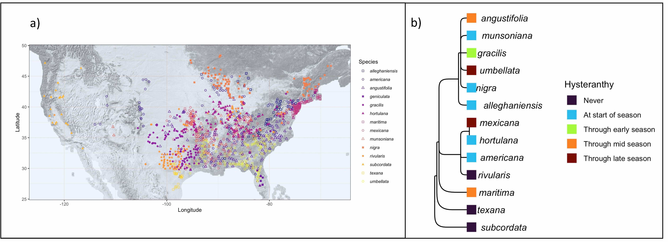

Figure 1: Geographic distribution and taxonomic relationships among the American plums. a) Maps the localities of all the herbaria records used in this study. b) Depicts phylogenetic relationships among the American plums and the duration of their ﬂowering period they are hysteranthous. These categorizations are based on ordinal phylogenetic mixed models. Tree topology is from Shaw & Small (2004)

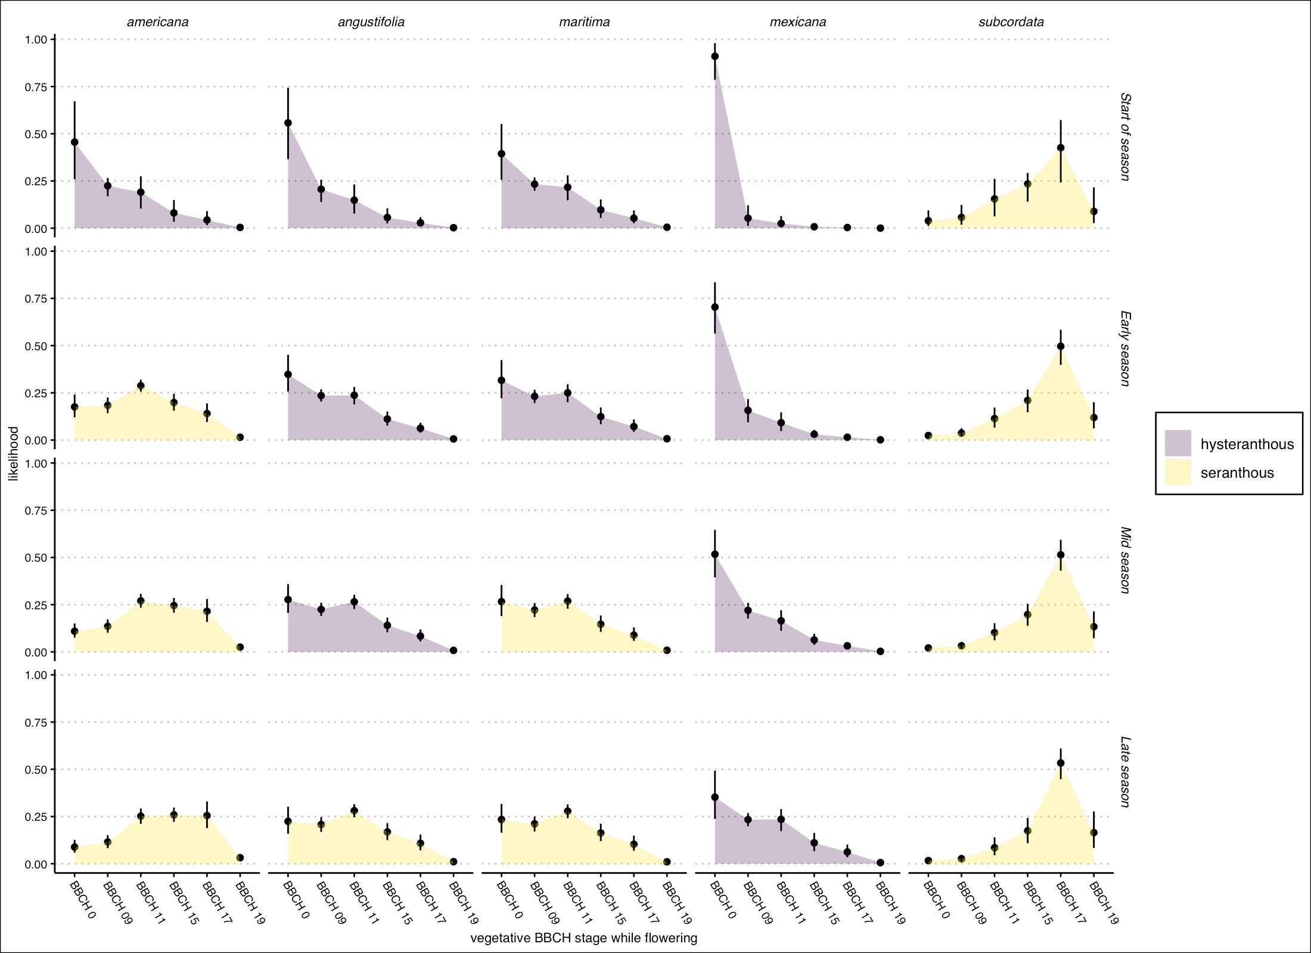

Figure 2: Predicted likelihood that a species would be in ﬂower during each vegetative BBCH phase for ﬁve example species in the American plums. Points are the mean likelihood and bar the 95% uncertainty intervals. Species were classiﬁed as hysteranthous if greater than 50% probability ﬂowering occurred in BBCH 0 and BBCH 09 (colors) for each part of the ﬂowering season. See Fig. S1 for all species and alternative hysteranthy classiﬁcation schemes.

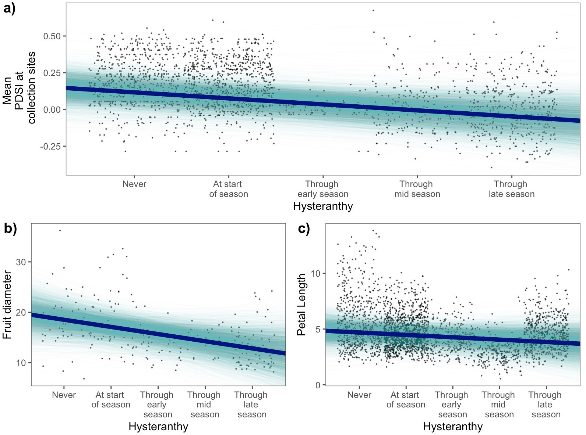

Figure 3: Relationships between the duration of hysteranthy across the ﬂowering period and environmental and biological traits based on Bayesian phylogenetic mixed models. a) b) and c) dipict the relationships between the duration of hysteranthy and mean PDSI, fruit diameter, and petal length respectively. Solid lines indicate the mean posterior estimate and shaded areas 4000 draws from the posterior distrubtion as a display of uncertainty.

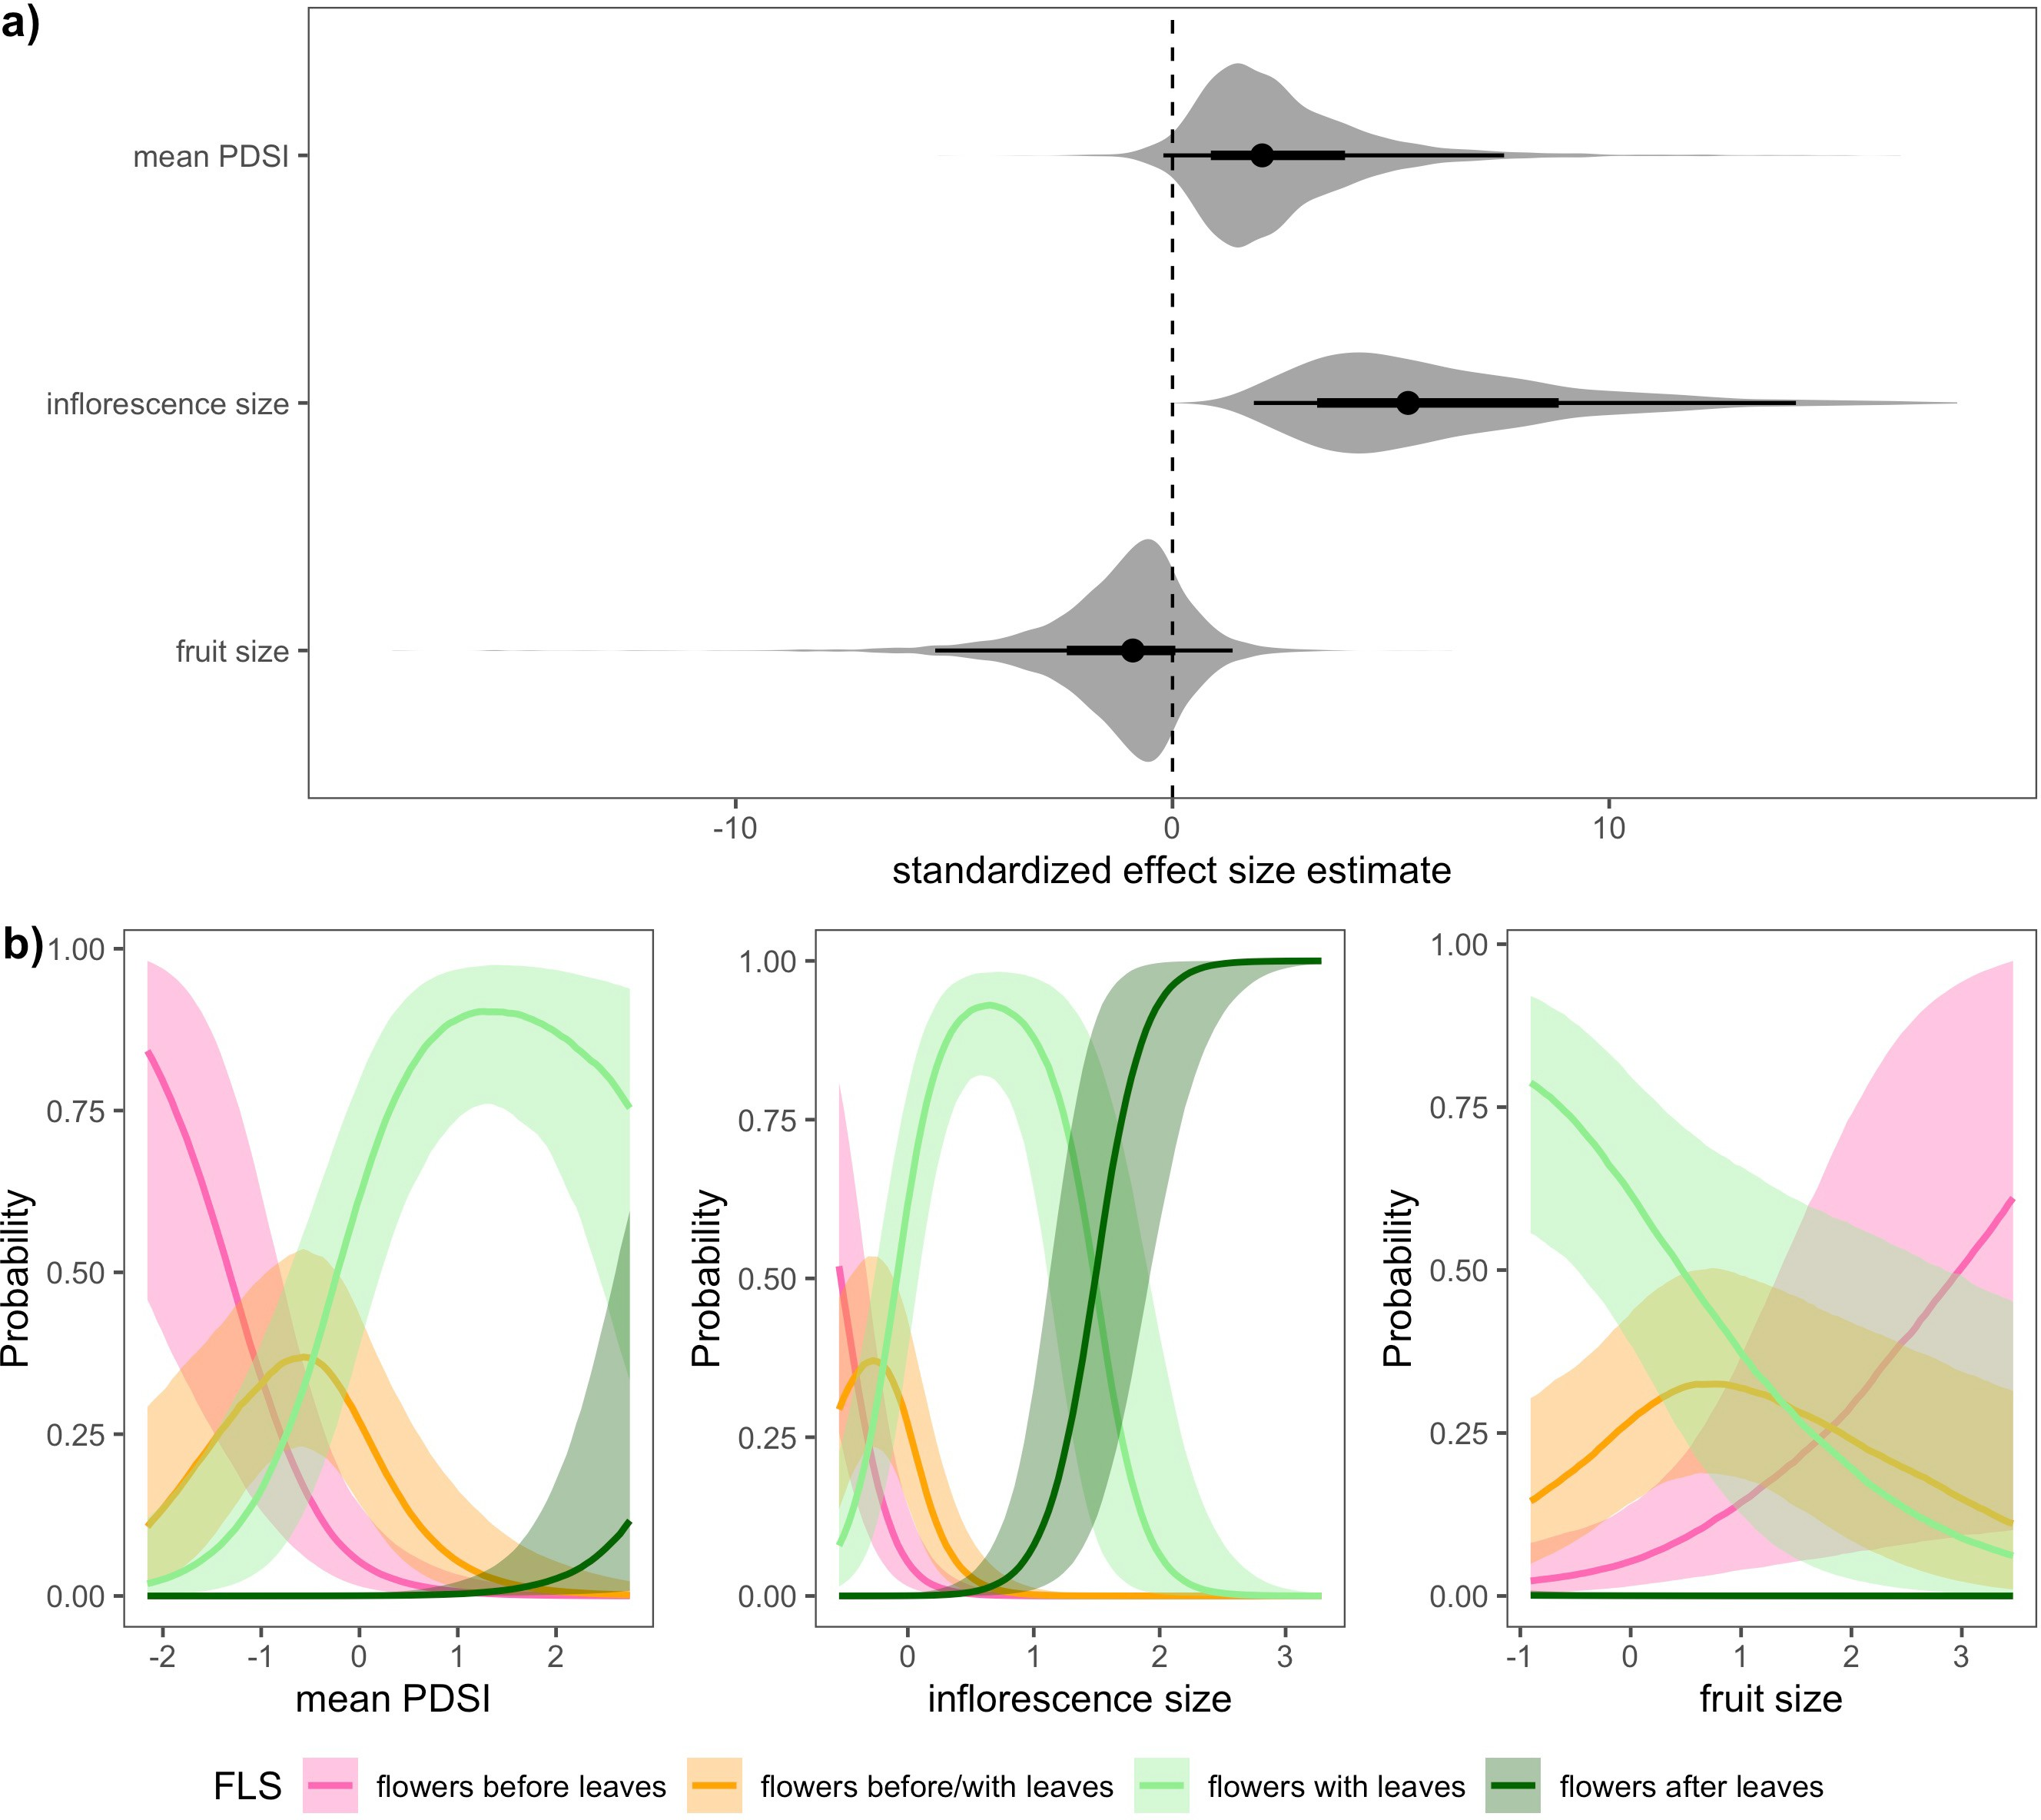

Figure 4: Relationships between the likelihood of hysteranthy and environmental and biological traits in the genus Prunus based on Bayesian phylogenetic mixed models. Panel a) shows the estimated eﬀect size of each predictor with negative values indicating an increased likelihood of hysteranthy. Points indicate the mean posterior estimate for each predictor, and thick and thin bars the 50% and 97.5% uncertaintly intervals respectively. We also show the full posterior distribution as an aditional meaure of uncertainty, Panel b), c) and d) show the marginal eﬀect of mean PDSI, inﬂorescence size and fruit size respectively, on the likelihood that of each FLS category. Solid lines indicate the mean likelihood and shaded areas the 50% uncertainty intervals.