1 Ecological drivers of ﬂower-leaf sequences: aridity and pollination

2 success select for ﬂowering-ﬁrst in the American Plums

3 D.M. Buonaiuto 1*,*2*,*3*,a*, T.J. Davies 4*,*5, S. Collins 4 & E.M. Wolkovich2*,*3*,*4

4 *Author aﬃliations:*

5 1Department of Environmental Conservation, University of Massachusetts, Amherst, Massachusetts, USA.

6 ORCID: 0000-0003-4022-2591

7 2Arnold Arboretum of Harvard University, Boston, Massachusetts, USA.

8 3Department of Organismic and Evolutionary Biology, Harvard University, Cambridge, Massachusetts, USA

9 4Forest & Conservation Sciences, Faculty of Forestry, University of British Columbia, Vancouver, British

10 Columbia, Canada

11 5 Department of Botany, University of British Columbia, Vancouver, British Columbia, Canada

12 *a*Corresponding author: 617.823.0687; [dbuonaiuto@umass.edu](mailto:dbuonaiuto@umass.edu)

13

14 **Summary**

15 • Across temperate forests many tree species produce ﬂowers before their leaves emerge. This ﬂower-

16 leaf phenological sequence, known as hysteranthy, is generally described as an adaptation for wind-

17 pollination. However, this explanation does not address why hysteranthy is also common in biotically-

18 pollinated taxa.

19 • We quantiﬁed ﬂower-leaf sequence variation in the American plums (*Prunus*, subspp. *Prunus* sect.

20 *Prunocerasus* ), a clade of insect-pollinated trees, using herbaria specimens and Bayesian hierarchical

21 modeling. We tested two common, but rarely interrogated hypotheses—that hysteranthy confers aridity

22 tolerance and/or pollinator visibility—by modeling the associations between hysteranthy and related

23 traits. To understand how these phenology-trait associations were sensitive to taxonomic scale and

24 ﬂower-leaf sequence classiﬁcation, we then extended these analyses to all *Prunus* species in North

25 America.

26 • Our ﬁndings across two taxonomic levels support the hypotheses that hysteranthy may help temporally

27 partition hydraulic demand to reduce water stress, and increase pollinator visibility and thereby reduce

28 selective pressure on inﬂorescence size.

29 • Our results provide foundational insights into the evolution of ﬂower-leaf sequences in the genus *Prunus*,

30 with implications for understanding these patterns in biotically-pollinated plants in general. Our ap-

31 proach suggests a path to advance these hypotheses to other clades, but teasing out drivers fully will

32 require new experiments.

33 Keywords: Deciduous forests, Flower-leaf sequences, Hysteranthy, Phenology, Plant hydraulics, Pollination,

34 Phylogeny

35 **Introduction**

36 Woody perennials are among a subset of plant types with the unique ability to seasonally begin reproduction

37 prior to vegetative growth. This ﬂowering-ﬁrst phenological sequence, known as hysteranthy, proteranthy or

38 precocious ﬂowering, is apparent in temperate deciduous forests around the globe (Rathcke & Lacey, 1985).

39 A number of studies suggest that this ﬂower-leaf sequence is under selection, and that hysteranthy can confer

40 performance advantages (Guo *et al.*, 2014; Gougherty & Gougherty, 2018; Buonaiuto *et al.*, 2021), but the

41 importance of variation in ﬂower-leaf sequences for maintaining ﬁtness may vary across functional types, taxa

42 and biomes.

43 The most common, and well-tested explanation for the evolution of hysteranthy in temperate forests is that it

44 is adaptive for wind-pollination, as leaﬂess canopies increase wind speeds for pollen transport and reduce the

45 likelihood of pollen interception by vegetation (Whitehead, 1969; Niklas, 1985). However, this explanation

46 does not address the widespread prevalence of hysteranthy in biotically-pollinated taxa found in temperate

47 regions. This number is not trivial; a recent analysis found that approximately 20% of the hysteranthy species

48 in Eastern Temperate Forests of North America are biotically-pollinated (Buonaiuto *et al.*, 2021).

49 Alternative hypotheses have been put forward to explain the advantage of hysteranthy in biotically-pollinated

50 species, but they have not been widely evaluated in the literature. Below, we brieﬂy review these hypotheses

51 and their predictions, then test their predictions using the American plums (*Prunus* subspp. *Prunus* sect.

52 *Prunocerasus* )—a widespread clade with high variability in ﬂower-leaf sequences, as a case-study. Our study

53 both clariﬁes the hypothesized function of ﬂower-leaf sequence variation in the genus *Prunus* and lays the

54 groundwork for understanding the origins of ﬂower-leaf sequence variation in biotically-pollinated taxa more

55 generally.

## 56 Hypotheses of hysteranthous ﬂowering in biotically-pollinated taxa

57 Water limitation hypothesis: In the dry-deciduous tropics of South and Central America, hysteranthy is

58 common (Rathcke & Lacey, 1985; Franklin, 2016), and is regarded as an important adaptation to alleviate

59 water stress by partitioning the hydraulic demand of ﬂowers and leaves across the season (Borchert, 1983;

60 Reich & Borchert, 1984; Franklin, 2016; Gougherty & Gougherty, 2018). Under this hypothesis, the function

61 of hysteranthous ﬂowering in temperate regions parallels that in the dry tropics. While temperate forests are

62 rarely water-limited in the early season during which ﬂowering and leaﬁng occur (Polgar & Primack, 2011),

63 there is still considerable variation in water availability in space and time within temperate regions of the

64 globe. With this hypothesis, we would expect to ﬁnd hysteranthous taxa in locations that are, on average,

65 drier than their non-hysteranthous relatives.

66 Insect visibility hypothesis: Hysteranthous ﬂowers are visually conspicuous in the landscape. Thus, as in

67 wind-pollinated taxa, hysteranthy in biotically-pollinated taxa may be an adaptation for pollination eﬃciency

68 as ﬂowering-ﬁrst species are easier for insect pollinators to locate (Janzen, 1967). A challenge to evaluating this

69 hypothesis is that correlated selection between ﬂower-leaf sequences and pollinator visibility could have either

70 a positive or negative relationship depending on the pollination environment. In one scenario, hysteranthy

71 may be associated with smaller ﬂoral displays: because ﬂowers are not obscured by leaves, they are easier

72 to see and there is weaker selection for increasing ﬂoral display size. In an alternative scenario, hysteranthy

73 could be associated with larger ﬂoral displays, especially in environments where plants are more often pollen-

74 limited and selection may favor both hysteranthy and increased ﬂoral display size to augment ﬂoral attraction

75 to visual pollinators.

76 In contrast to these functional hypotheses, hysteranthous ﬂowering could simply be a by-product of selection

77 for early ﬂowering. Species that ﬂower before their leaves inherently ﬂower early in the season. For example,

78 fruit development or dispersal constraints may drive early ﬂowering (Primack, 1987), and because spring

79 ﬂower phenology is less constrained by prior phenological events than leaf phenology (Ettinger *et al.*, 2018;

80 Savage, 2019), this selection for early ﬂowering could incidentally produce the hysteranthous phenological

81 sequence. Here, there is no speciﬁc adaptive advantage to hysteranthy; selection is not operating on the

82 relative timing of ﬂower and leaf emergence, but rather the absolute ﬂowering time alone. Rejection of the

83 above functional hypotheses might provide support to this null explanation.

84 A signiﬁcant challenge for robust testing of hysteranthy hypotheses is that most characterizations of ﬂower-

85 leaf phenological sequences are based on expert-opinion verbal descriptions (e.g. “ﬂowers before leaves” or

86 “ﬂower before/with leaves”), which make comparisons across taxa, time and space diﬃcult and sensitive

87 to observer bias (see Buonaiuto *et al.*, 2021). This problem can be overcome by adopting standardized

88 quantitative measures of plant phenology for observational studies and applying them to historical data

89 records. Herbarium records are an excellent source of data that can be leveraged for quantitative phenological

90 measurements (Willis *et al.*, 2017), but have not been widely used to investigate variability of ﬂower-leaf

91 sequences.

92 The American plums are useful model clade to investigate drivers of hysteranthous ﬂowering in biotically-

93 pollinated species. The species that make up this group are distributed across the temperate zone of North

94 America and, like the genus *Prunus* more generally show pronounced inter-speciﬁc variation in ﬂower-leaf

95 sequences. Usefully, species in this clade are well represented in herbaria records (Fig. 1a), making them a

96 tractable group to measure and assess variation in ﬂower-leaf sequences.

97 To interrogate the functional hypotheses for hysteranthous ﬂowering described above, we used herbaria records

98 to quantify variation in ﬂower-leaf sequences of the American plums. Then we combined environmental

99 attributes, biological traits and phylogenetic data in statistical models designed to evaluate whether the

100 observed associations between ﬂower-leaf sequences and morphological and environmental traits match the

101 predicted associations of the hysteranthy hypotheses. Finally, we compared our ﬁndings in this clade to

102 patterns observed in larger genus *Prunus* to test whether these phenology-trait associations were sensitive to

103 taxonomic scale and ﬂower-leaf sequence classiﬁcation.

# 104 Materials and Methods

## 105 Quantifying ﬂower-leaf sequence variation

106 We obtained digital herbarium specimens of the American plums from the Consortium of Midwest Herbaria

107 (CMH) Database (of Midwest Herbaria, 2023). Specimen collection dates ranged from 1844-2020, with the

108 majority collected between 1950-2000. To quantify ﬂower-leaf sequence variation in this group we randomly

109 sampled 200 specimens for each species and scored the phenological development of ﬂowers and leaves; we

110 used a modiﬁed BBCH scale for woody plants designed to evaluate vegetative and reproductive phenological

111 progress through a standardized quantitative index (Finn *et al.*, 2007). For species with less than 200

112 specimens in the collection, we included all available specimens. In total, we evaluated the phenology of 2521

113 specimens, but only specimens with visible ﬂowers were included in this analysis. We also removed specimens

114 with ﬂowering dates that were major outliers from the observed ﬂowering period of each species. We removed

115 outliers visually, and by excluding observations that were beyond three standard deviations of the median

116 ﬂowering time for each species (*n*=9). Our ﬁnal analyses included 1000 specimens (see Tab. S1 for number

117 of observations/species).

118 We reconstructed the phylogenetic relationships among species in this group based on the tree topology in

119 Shaw & Small (2004). We inferred branch lengths following the method of Grafen & Hamilton (1989) in

120 which node heights are estimated in proportion to number of subtending taxa using the R package “ape” (E.

121 Paradis and K. Schliep, 2019).

122 To quantify ﬂower-leaf sequence variation, we ﬁt an ordinal, hierarchical, Bayesian phylogenetic mixed model

123 (de Villemeruil P. & Nakagawa, 2014) designed to assess the likelihood an individual would be at any given

124 vegetative BBCH phase while ﬂowering. Our model predicted leaf stage (*yi*, ordinal, with six categories

125 representing stage from 1 for “buds closed” and 6 for “leaf expansion complete”) as a function of species and

126 additional phylogenetic eﬀects. Because hysteranthy co-varies with ﬂowering time (i.e., ﬂowering ﬁrst species

127 will generally ﬂower earlier than other species, on average), and collection dates were not evenly distributed

128 across the ﬂowering season (see Fig. S1), we included day of year of observation as an additional predictor.

129 Additionally, because climate change could aﬀect the interval between ﬂowering and leafout over the course

130 of our time series, we included the year of collection of each specimen as a covariate. Following previous

131 conventions for modeling the possible eﬀects of climate change on spring phenology, we parameterized *year*

132 as a hinge variable, using 1980 as a break point (Stocker *et al.*, 2013; Buonaiuto *et al.*, 2021).

133 The model is written below:

134

 2 *if zi ∈* (0*, c*2)

 1 *if zi <* 0

*y* =  3 *if zi ∈* (*c*2*, c*3)

*i*

4 *if zi ∈* (*c*3*, c*4)

 5 *if zi ∈* (*c*4*, c*5)

 6 *if zi > c*5

135

136

*zi* = *α* + *αphylo* + *αsp* + *β*day of year[sp] *∗ X*day of year + *βyear ∗ Xyear* + *ϵi*

137 *ϵi ∼ logistic*(0*,* 1)

138

139 where *yi* is the ordinal outcome (leaf stage; as 1,2,...6 categories). *c*2*...*5 are the estimated cutpoints between

140 leaf stages on the logit scale and *year* is: (the year the specimen was collected *−* 1980). *zi* is the linear

141 component of the underlying latent variable model.

142 *α* describes an intercept for each category [1,2,...6] and slopes (*β*day of year and *βyear*) are constant across

143 cutpoints. *β*day of year also varies among *species* while *βyear* is a pooled estimate across species.

144 The inﬂuence of the phylogeny (*αphylo*) was modeled as:

145

*αphylo ∼* normal(0*, COR*[*σ*2 ])

*phylo*

146 The *α* for species eﬀects independent of the phylogeny was modeled as:

147

*αsp ∼* normal(0*, σ*2 )

*species*

148 We used our model to predict the probability that each species would be observed at a given vegetative

149 BBCH stage during ﬂowering for each day of the ﬂowering period of each species by extracting 1000 ran-

150 dom draws from the posterior distribution. Next, for each day of the ﬂowering season, we summed the

151 predicted likelihood that species would be at BBCH 0 (“bud closed”), BBCH 07/09 (“bud break”) or BBCH

152 11 (“start of leaf unfolding) vs. BBCH 15 (“leaf unfolding”), BBCH 17(“most leaves unfolded”), BBCH 19

153 (“leaf expansion complete”)—this allowed us to quantify the likelihood that a species would be hysteranthous

154 or non-hysteranthy respectively for each day of the season. We chose the BBCH 11/BBCH 15 boundary to

155 deﬁne hysteranthous ﬂowering because this is the earliest point in development when most leaves are unfurled

156 enough to visually obscure ﬂowers and transpire. Finally, we used these estimates to develop a ﬂower-leaf

157 sequence index: for this, we summed the likelihood of hysteranthy vs. non-hysteranthy across the full ﬂower-

158 ing period of each species, with 0 being never hysteranthous and 1 being always hysteranthous. To evaluate

159 the sensitivity of our model to choice of cutoﬀ, we also calculated a hysteranthy index using an alternative

160 cutoﬀ at the BBCH 09/BBCH 11, which did not alter the species’ ranks on the index (see Tab. S2).

161 To better understand how within-season dynamics aﬀected our inference, we also reﬁt our model excluding

162 *day of year* as a predictor. This version of the model did not substantially alter the species’ ranks on the index

163 or our inference about the relationships between ﬂower-leaf sequence variation and the trait representing the

164 main hysteranthy hypotheses (Tab. S2, Tab. S3).

## 165 Evaluating hysteranthy hypotheses

166 To test the hypotheses of hysteranthy, we ﬁrst recorded petal length measurements directly from herbarium

167 specimens. For these morphological measurements, we sampled 321 specimens and measured the petal length

168 of up to 10 randomly selected petals per specimen (*n*=2757) using ImageJ image processing software (see

169 Tab. S2, for *n* per species).

170 To assess aridity tolerance, we computed the average Palmer Modiﬁed Drought Index score (hereafter:

171 PDSI), obtained from for Environmental Information (2017) for every *Prunocerasus* specimen in the database

172 (*n*=2305, see Tab. S2, for *n* per species). PDSI is a standardized index that integrates temperature and

173 precipitation data to estimate relative dryness in time and space (Heim, 2002). For any specimens that lacked

174 accurate geo-location information, we extracted PDSI values at the county centroid of the herbaria specimen.

175 Because all of our measurements were made on diﬀerent individuals—with diﬀerent sample sizes—we used

176 two diﬀerent modeling approaches to test the relationship between ﬂower-leaf sequence index scores, aridity

177 tolerance and ﬂoral displays.

178 First we computed species-level means of PDSI and petal length and used a beta regression to evaluate the

179 relationship between ﬂower-leaf sequences, PDSI, petal length and their interaction. We standardized the

180 units of all predictors through *z*-scoring (Gellman & Hill, 2007) to make their eﬀect size estimates directly

181 comparable within the following model structure:

182

183 *yi* = (*µ, µ*(1 *− µ*)*/*(1 + *ϕ*)

184

185 where *µ* and *ϕ* are the two shape parameters of the beta regression. Due to the limited sample size of this

186 analysis (13 species), we only modeled the eﬀect of our predictors on the mean parameter *µ* and ﬁt a grand

187 intercept for the precision parameter *ϕ*.We modeled the *µ* parameter as:

188

189

190

*µ* = *α* + *βPDSI ∗ XPDSI* + *β*petal length *∗ X*petal length + *βPDSIx*petal length *∗* (*XPDSI* )(*X*petal length)

191 We chose this model structure because it allowed us to assess the additive and interactive eﬀects of PDSI and

192 petal size on ﬂower-leaf sequences. However, by using mean trait values as predictors, we could not incorporate

193 within-species variation in these trait/environmental predictors or account for their phylogenetic structure.

194 To understand how these factors aﬀected our inferences about the relationship between ﬂower-leaf sequences

195 and traits, we ﬁt two additional models to estimate relationship between ﬂower-leaf sequences index values

196 and PDSI, and between ﬂower-leaf sequences index values and petal size separately which included the intra-

197 speciﬁc variation and phylogenetic structure of each of these traits (see Supporting Information: Extended

198 Methods for details). This alternative modeling approach produced similar results about the phenology-trait

199 relationships investigated in our main model.

200 **Hysteranthy in the larger genus *Prunus***

201 To better understand how the patterns we identiﬁed in the American Plums clade scaled across coarser

202 taxonomic resolution, we also evaluated the relationship between hysteranthous ﬂowering and hypothesis-

203 related traits for additional *Prunus* species native to, or established in, North America (*n*=32). For this

204 analysis, we obtained categorical descriptions of ﬂower-leaf sequences and mean estimates of the number of

205 ﬂowers per inﬂorescence as a proxy for ﬂoral investment from the Flora of North America (Rohrer, 1993+).

206 We extracted PDSI values for all herbaria observations of those species in the Consortium of Midwest Herbaria

207 database (*n*=23,272) as described above.

208 To account for the inﬂuence of evolutionary relationships among species, we reconstructed the phylogenetic

209 relationships in the genus based on the tree topology in Chin *et al.* (2014). As above, we computed branch

210 lengths with the R package “ape” (E. Paradis and K. Schliep, 2019).

211

212

As above, we standardized the units of all predictors through *z*-scoring (Gellman & Hill, 2007). The model structure is:

 1 *if zi <* 0

*y* =  2 *if zi ∈* (0*, c*2)

*i*

3 *if zi ∈* (*c*2*, c*3)

 4 *if zi > c*3

213 *zi* = *α*+*αphylo*+*βPDSI∗XPDSI* +*β*ﬂoral investment*∗X*ﬂowers/inﬂorescence+*βPDSIx*ﬂoral investment(*XPDSI* )(*X*ﬂowers/inﬂorescence)+

214 *ϵi*

215

*ϵi ∼ logistic*(0*,* 1)

216 where *yi* is the ordinal outcome of ﬂower-leaf sequence category ( “ﬂowers after leaves”=1, “ﬂowers with

217 leaves”=2, “ﬂowers before/with leaves”=3 and “ﬂowers before leaves”=4) and *c*2*...*3 are the estimated cutpoints

218 between categories on the logit scale. *zi* is the linear component of the underlying latent variable model. *α*

219 describes a grand intercept, and we modeled the inﬂuence of phylogeny (*αphylo*) as above. Note that this

220 model includes four ordinal categories while our model of the American Plums clade included six, due to the

221 diﬀerent underlying structures of the two datasets.

222 **Model runs**

223 We ﬁt all models in the R package “brms” (Bu¨rkner, 2018) using weakly informative priors, and four chains.

224 For the models aimed at“Quantifying ﬂower-leaf sequence variation” and“Evaluating hysteranthy hypotheses”

225 in the American plums, we ran the models with a warm-up of 3000 iterations, and 4000, and 5000 sampling

226 iterations respectively, for a total of 4000 and 8000 sampling iterations across all chains. For the “Hysteranthy

227 in the larger genus *Prunus*” model, we used a warm up of 6,000 iterations and 8,000 sampling iterations for

228 a total of 8000 sampling iterations to maximize the eﬀective sampling size. Model ﬁts were assessed with *R*ˆ

229 *<*1.01, high eﬀective sample sizes, and no divergent transitions. We provide mean estimates with uncertainty

230 intervals in-text, and 50% and 89% intervals for all ﬁgures and tables.

231 **Results**

## 232 Quantifying ﬂower leaf sequences in the American plums

233 We found substantial inter-speciﬁc diﬀerences in ﬂower-leaf sequences within the American plums (Fig.

234 1b,2a). Several species (*P. mexicana*, *P. umbellata*, *P. angustifolia*, *P. maritima* and *P. gracilis*) were

235 most likely to be hysteranthous for all—or most—of their ﬂower period, while for others, (*P. americana*, *P.*

236 *munsoniana*, *P. alleghaniensis*, *P. nigra*, *P. hortulana*, *P. texana* and *P. rivularis* ), hysteranthous ﬂowering

237 was only likely in the early part of their ﬂowering session. One species, *P. subcordata*, was unlikely to be

238 hysteranthous at any point in its ﬂowering period (Fig. 2a). These relative ranking of species’ hysteranthy

239 likelihoods were consistent with our alternative method for constructing the hysteranthy index (Tab. S2, Fig.

240 S2).

241 Across all species of American Plums, day of year increased the likelihood of ﬂowering during a later vegetative

242 phenological stage (Fig. 2b). Year of observation did not substantially impact the likelihood of hysteranthy

243 for this taxonomic group (Fig. 2b).

## 244 Associations between hysteranthy and environmental and morphological traits

245 In the American plums, predominately hysteranthous species had smaller ﬂowers and occured in drier local-

246 ities than species with more overlap between ﬂowers and leaves (i.e., increased likelihood of hysteranthy

247 was negatively associated with PDSI and petal length without a substantial interaction between them,

248 Fig. 3a, b; parameter estimates from this model were *βPDSI* : *−*0*.*47*, UI*89[*−*0*.*96*,* 0*.*01], *β*petal length :

249 *−*0*.*14*, UI*89[*−*0*.*54*,* 0*.*24] *βPDSIx*petal length : *−*0*.*14*, UI*89[*−*0*.*91*,* 0*.*65]). These estimates were comparable to

250 estimates from models where we treated each predictor separately and accounted for phylogeny (Fig. S3),

251 and where we used the hysteranthy index derived from models that did not include day of year as a predictor

252 (Tab. S3). The direction and magnitude of the estimated eﬀects support the predictors of the water-limitation

253 hypothesis and marginally support the predictors of the insect-visibility hypothesis.

254 In the larger genus *Prunus*, hysteranthous species had smaller inﬂorescences and were found in drier loca-

255 tions (i.e., there was a negative association between hysteranthy and PDSI and number of ﬂowers per inﬂo-

256 rescence, as well as a substantial negative interaction between them, Fig. 4a, b; parameter estimates from

257 this model were *βPDSI* : *−*8*.*0*, UI*89[*−*16*.*6*, −*2*.*44], *βflowers/inflorescence* : *−*15*.*5*, UI*89[*−*31*.*46*, −*5*.*56] and

258 *βPDSIxflowers/inflorescence* : *−*13*.*06*, UI*89[*−*28*.*53*, −*2*.*93]). The direction and magnitude of the estimated

259 eﬀects support the predictors of both the water-limitation hypothesis and the insect-visibility hypothesis.

260 The estimated eﬀects of ﬂoral traits and their interactions with PDSI were stronger in the larger genus *Prunus*

261 than in the American plums clade. This is not surprising given that all species in the American plums clade

262 have solitary ﬂowers, making the variation in ﬂoral display size highly constrained. By contrast, *Prunus*

263 species included in our secondary analysis include those with solitary ﬂowers and species with as many as 100

264 ﬂowers per inﬂorescence—substantially more variation in both ﬂoral investment and in hydraulic demand.

265 This suggests that the correlated selection between ﬂower-leaf sequences and these ﬂoral traits may be more

266 pronounced at coarser taxonomic resolutions, where underlying trait variation is greater.

267 **Discussion**

268 Using North American *Prunus* species as a case study, our analyses indicate that ﬂower-leaf sequences are

269 likely under selection. We show that variation in ﬂower-leaf sequences across species may reﬂect adaptive

270 tradeoﬀs between a) the timing of investment in reproduction relative to the timing of resumption of carbon

271 acquisition through leafout, and b) other aspects of plant performance, such as environmental tolerance and

272 pollinator attraction strategies that we investigated in this study. We show that hysteranthous ﬂowering is

273 associated with increased aridity and smaller ﬂower displays in both the American plums, and more broadly

274 across *Prunus* species native to, or established in North America. The relationships between hysteranthy

275 and aridity, and hysteranthy and ﬂoral display size support the predictions of the water limitation hypothesis

276 and the insect visibility hypothesis.

277 Our models estimated a strong relationship between aridity and ﬂower-leaf sequences at both taxonomic

278 scales we studied, but the relationship between ﬂoral display size and ﬂower-leaf sequences predicted by the

279 insect visibility was better supported at the coarser taxonomic scale of the full genus *Prunus* than in the

280 American Plums clade. This contrast may suggest that associated selection between ﬂower-leaf sequences and

281 pollinator traits has more strongly inﬂuenced inﬂorescence architecture than the morphology of individual

282 ﬂowers, our estimates at both scales agreed in directionality (i.e., hysteranthy associated with smaller ﬂoral

283 displays).

284 Under the insect visibility hypothesis, ﬂoral display size could either be positively or negatively associated

285 with hysteranthy depending on the pollination environment. The association between hysteranthy and smaller

286 ﬂower displays we found supports the prediction that increased visibility of hysteranthous ﬂowers reduces

287 selection pressure on ﬂower display size. These results ﬁt with other comparative anatomy studies in plants

288 that report hysteranthous species typically have smaller inﬂorescences than non-hysteranthous relatives (Gu-

289 natilleke & Gunatilleke, 1984), and studies on pollinator foraging behavior that suggest the presence of leaves

290 substantially alters the visual perception of pollinators (Rivest *et al.*, 2017; Forrest & Thomson, 2009).

291 Our support for both the water limitation hypothesis and insect visibility hypothesis, and the strong positive

292 interactions between PDSI and ﬂoral investment that we observed in the larger genus *Prunus* highlight that

293 these hypotheses are not mutually exclusive, and could be related. Selection on ﬂoral size represents a classic

294 evolutionary tradeoﬀ where larger ﬂoral displays may generally be more eﬀective for attracting pollinators

295 but demand more resources, including water, to maintain turgor and reproductive function than smaller

296 ones (Galen *et al.*, 1999; Lambrecht & Dawson, 2007). With this trade-oﬀ, reproductive displays are often

297 small in harsher environments (Lambrecht, 2013; Teixido *et al.*, 2016), and hysteranthy could represent a

298 compensatory mechanism that both reduces hydraulic demand while increasing pollination eﬃciency in these

299 environments.

300 Despite this evidence that hysteranthy can reduce hydraulic demand in dry environments, hysteranthous

301 species in the American plum clade are not found in extremely arid locations (PDSI values typically range

302 from -4 to 4, although the values that we observed in our analyses were more restricted, ranging from -

303 0.5 to 0.2). This contrasts with hysteranthous species in the dry tropics where this phenological pattern

304 appears to allow them to tolerate more extreme aridity (Franklin, 2016). But the ﬂower-leaf sequences of

305 the hysteranthous species in our study were markedly diﬀerent from patterns of hysteranthy in these dry-

306 tropics where the water limitation hypothesis was initially proposed. While ﬂowering can precede leafout

307 by as much several weeks for species in the American plums, the process of fruit development, which is also

308 water intensive, occurs when leaves are present. By contrast, in the dry tropics hysteranthous ﬂowering is

309 initiated at the time of leaf drop (Borchert, 1983; Franklin, 2016); thus, the full reproductive cycle occurs in

310 the leaﬂess period. The comparatively small window of leaﬂess reproductive development in our temperate

311 clade may, in part, explain why the association we observed between hysteranthy and aridity was relatively

312 weak and variable. Our results suggest that hysteranthy may allow temperate species to occupy marginally

313 drier environments than non-hysteranthous species, but may not facilitate species’ persistence under extreme

314 aridity.

## 315 Inter-and intra-speciﬁc variation in ﬂower-leaf sequences

316 We developed a novel approach to assessing ﬂower-leaf sequences that scales from quantitative, individual-

317 level observations to species-level characterizations. With this approach, we were able to—for the ﬁrst

318 time—quantitatively assess intermediate cases of hysteranthy (such as those that are typically described as

319 “ﬂowers before/with leaves”). Previous studies of hysteranthous ﬂowering have either excluded these cases

320 from their analyses (e.g.; Gougherty & Gougherty, 2018) or binned them with the well deﬁned cases (e.g.;

321 Buonaiuto *et al.*, 2021). We found that many American plum species expressed this intermediate ﬂower-leaf

322 sequence. Further, while our classiﬁcations broadly matched previous species-level analyses in this group by

323 Shaw & Small (2004), our approach identiﬁed substantial diﬀerences in ﬂower-leaf sequences among these

324 intermediate cases (Fig. 1b), which allowed us to assess the trait associations with this phenotype.

325 Our quantitative analysis of the American plums clade revealed that ﬂower-leaf sequences—often described

326 as a species-level trait—are highly variable within species (Fig. 2a). For almost all members of the clade,

327 hysteranthy was strongly predicted by the day of the observation (“day of year” in our model, Fig. 2b). In

328 many cases there was a high likelihood that individuals of a species may be observed at diﬀerent vegetative

329 stages during ﬂowering (Fig. 2a, Fig. S2). This variation could either suggest high levels of local adaptation in

330 ﬂower-leaf sequences or, alternatively, high levels of plasticity through which ﬂower-leaf sequences respond to

331 interannual variation in environmental conditions. Because our study was based on herbaria records collected

332 on diﬀerent individuals across space and time without repeat sampling, we could not robustly estimate how

333 much ﬂower-leaf sequences vary within vs. among species. However, this would be an important next step

334 for understanding how the environment and species interactions have shaped these phenological patterns.

335 Interestingly, while there is substantial evidence that both ﬂowering and leaf phenology have advanced over

336 the last several decades in response to anthropogenic climate change (Menzel *et al.*, 2006; Cleland *et al.*,

337 2007; Augspurger & Zaya, 2020), we did not observe changes in ﬂower-leaf sequences over that time scale

338 in our dataset (Fig. 2b). This supports a recent ﬁnding that despite changes in both ﬂowering and leafout,

339 the time interval between them has remained relatively stable (Guo *et al.*, 2023), but does not preclude that

340 possibility that these the sequences will eventually be disrupted as climate change continues to become more

341 extreme in the future (Buonaiuto & Wolkovich, 2021).

342 **Future directions**

343 We focused on a well-studied, and economically important clade of morphologically similar species. Our

344 case-study provides a road map for evaluating the role of hysteranthy more generally in temperate biotically-

345 pollinated plant taxa (other groups with high interspeciﬁc ﬂower-leaf sequence variation include *Magnolia*,

346 *Rhododendron*, *Acer* and *Cornus*), and more broadly across taxa and biomes.

347 Combining the observational approach with novel experiments could further advance our collective under-

348 standing of the adaptive signiﬁcance of ﬂower-leaf sequences. To test the water-limitation hypothesis, re-

349 searchers could plant sister-taxa with contrasting ﬂower-leaf sequences in common environments across a

350 gradient of aridity, and evaluate their performance. To test the insect visibility hypothesis, researchers

351 should consider hysteranthy—and phenology in general—in the broader framework of tradeoﬀs in pollination

352 biology. The tradeoﬀ between phenology and pollination investment could not only consider ﬂower size, but

353 also the number of ﬂowers, nectar and pollen reward investment, volatiles between related hysteranthous and

354 non-hysteranthous taxa. Findings that hysteranthous species invest fewer resources into these other pollinator

355 attraction traits than non-hysteranthous relatives would support the insect visibility hypothesis. For a simple

356 experiment to test the pollinator visibility hypothesis, researchers could force hysteranthy/non-hysteranthy

357 phenotypes for the same genotype using environmental cues, and systematically release pollinators to ob-

358 serve their preferences, search times and foraging behavior. If pollinators are more readily drawn to the

359 hysteranthous individuals, it would support hysteranthy as an adaptive trait for pollinator attraction.

360 With a better mechanistic understanding of the relationship between ﬂower-leaf sequences and ecological

361 performance, researchers could then use experiments to assess how diﬀerences in ﬂoral and leaf physiological

362 responses to temperature variation shape ﬂower-leaf sequences. The measurement and modeling approaches

363 we developed in our observational study can be readily implemented to analyze data from such experimental

364 settings, presenting an important opportunity to unite observations of broad ecological patterns with targeted

365 experimental manipulations to better understand both the evolutionary past and ecological future of ﬂower-

366 leaf sequences.

# 367 Competing Interests:

368 The authors declare no conﬂict of interest.

# 369 Author contributions

370 DMB, and EMW conceived of the manuscript; DMB and SC collected the data; DMB led the statistical

371 analyses with TJD and EMW; DMB led the writing of the manuscript. All authors contributed to writing

372 and gave approval for the submission.

373 **Data Availability**

374 The phenology and trait data collected for this study will be made available and archived at KNB: The

375 Knowledge Network for Biocomplexity (https://knb.ecoinformatics.org/) at the time of publication.

376 **References**

377 **Augspurger CK , Zaya DN. 2020**. Concordance of long-term shifts with climate warming varies among

378 phenological events and herbaceous species. *Ecological Monographs*, **n/a**: e01421.

379 **Borchert R. 1983**. Phenology and control of ﬂowering in tropical trees. *Biotropica*, **15**: 81–89.

380 **Buonaiuto DM, Morales-Castilla I , Wolkovich EM. 2021**. Reconciling competing hypotheses regarding

381 ﬂower–leaf sequences in temperate forests for fundamental and global change biology. *New Phytologist*,

382 **229**: 1206–1214.

383 **Buonaiuto DM , Wolkovich EM. 2021**. Diﬀerences between ﬂower and leaf phenological responses to envi-

384 ronmental variation drive shifts in spring phenological sequences of temperate woody plants. *Journal of*

385 *Ecology*, **109**: 2922–2933.

386 **Bu¨rkner PC. 2018**. Advanced bayesian multilevel modeling with the r package brms. *R Journal*, **10**: 395–411.

387 **Chin SW, Shaw J, Haberle R, Wen J , Potter D. 2014**. Diversiﬁcation of almonds, peaches, plums and

388 cherries –molecular systematics and biogeographic history of prunus (rosaceae). *Molecular Phylogenetics*

389 *and Evolution*, **76**: 34–48.

390 **Cleland EE, Chuine I, Menzel A, Mooney HA , Schwartz MD. 2007**. Shifting plant phenology in response

391 to global change. *Trends in Ecology Evolution*, **22**: 357 – 365.

392 **E. Paradis and K. Schliep. 2019**. ape 5.0: an environment for modern phylogenetics and evolutionary analyses

393 in R. *Bioinformatics*, **35**: 526–528.

394 **for Environmental Information NC**. 2017. Lbdp-v2. Tech. rep., National Oceanic and Atmospheric Admin-

395 istration.

396 **Ettinger A, Gee S , Wolkovich E. 2018**. Phenological sequences: how early season events deﬁne those that

397 follow. *American Journal of Botany*, **105**.

398 **Finn GA, Straszewski AE , Peterson V. 2007**. A general growth stage key for describing trees and woody

399 plants. *Annals of Applied Biology*, **151**: 127–131.

400 **Forrest J , Thomson JD. 2009**. Background complexity aﬀects colour preference in bumblebees. *Naturwis-*

401 *senschaften*, **96**: 921–925.

402 **Franklin DC. 2016**. Flowering while leafess in the seasonal tropics need not be cued by leaf drop: evidence

403 from the woody genus brachychiton (malvaceae). *Plant Ecology and Evolution*, **149**: 272–279.

404 **Galen C, Sherry R , Carroll A. 1999**. Are ﬂowers physiological sinks or faucets? costs and correlates of water

405 use by ﬂowers of polemonium viscosum. *OECOLOGIA*, **118**: 461–470.

406 **Gellman A , Hill J**. 2007. *Data Analysis Using Regression and Multilevel/Hierarchical Models*. Cambridge

407 University Press.

408 **Gougherty AV , Gougherty SW. 2018**. Sequence of ﬂower and leaf emergence in deciduous trees is linked to

409 ecological traits, phylogenetics, and climate. *New Phytologist*, **220**: 121–131.

410 **Grafen A , Hamilton WD. 1989**. The phylogenetic regression. *Philosophical Transactions of the Royal Society*

411 *of London. B, Biological Sciences*, **326**: 119–157.

412 **Gunatilleke CVS , Gunatilleke IAUN. 1984**. Some observations on the reproductive biology of three species

413 of cornus (cornaceae). *Journal of the Arnold Arboretum*, **65**: 419–427.

414 **Guo L, Liu X, Alatalo JM, Wang C, Xu J, Yu H, Chen J, Yu Q, Peng C, Dai J *et al* . 2023**. Climatic

415 drivers and ecological implications of variation in the time interval between leaf-out and ﬂowering. *Current*

416 *Biology*, **33**: 3338–3349.e3.

417 **Guo L, Luedeling E, Dai J , Xu J. 2014**. Diﬀerences in heat requirements of ﬂower and leaf buds make

418 hysteranthous trees bloom before leaf unfolding. *Plant Diversity and Resources*, **36**: 245–253.

419 **Heim RR. 2002**. A review of twentieth-century drought indices used in the united states. *Bulletin of the*

420 *American Meteorological Society*, **83**: 1149–1166.

421 **Janzen DH. 1967**. Synchronization of sexual reproduction of trees within the dry season in central america.

422 *Evolution*, **21**: 620–637.

### 423 Kharouba HM, Ehrl´en J, Gelman A, Bolmgren K, Allen JM, Travers SE , Wolkovich EM. 2018. Global

424 shifts in the phenological synchrony of species interactions over recent decades. *Proceedings of the National*

425 *Academy of Sciences*, **115**: 5211.

426 **Lambrecht SC. 2013**. Floral water costs and size variation in the highly selﬁng leptosiphon bicolor (polemo-

427 niaceae). *International Journal of Plant Sciences*, **174**: 74–84.

428 **Lambrecht SC , Dawson TE. 2007**. Correlated variation of ﬂoral and leaf traits along a moisture availability

429 gradient. *Oecologia*, **151**: 574–583.

### 430 Menzel A, Sparks TH, Estrella N, Koch E, Aasa A, Ahas R, Alm-Kuebler K, Bissolli P, Braslavska O, Briede

431 **A *et al* . 2006**. European phenological response to climate change matches the warming pattern. *Global*

432 *Change Biology*, **12**: 1969–1976.

433 **of Midwest Herbaria C**. 2023. Consortium of midwest herbaria.

434 **Niklas KJ. 1985**. The aerodynamics of wind pollination. *The Botanical Review*, **51**: 328–386.

435 **Polgar C , Primack R. 2011**. Leaf-out phenology of temperate woody plants: From trees to ecosystems. *New*

436 *Phytologist*, **191**: 926–41.

437 **Primack RB. 1987**. Relationships among ﬂowers, fruits, and seeds. *Annual Review of Ecology and Systematics*,

438 **18**: 409–430.

439 **Rathcke B , Lacey EP. 1985**. Phenological patterns of terrestrial plants. *Annual Review of Ecology and*

440 *Systematics*, **16**: 179–214.

441 **Reich P , Borchert R. 1984**. Water-stress and tree phenology in a tropical dry forest in the lowlands of

442 costa-rica. *Journal of Ecology*, **72**: 61–74.

443 **Rivest SA, Austen EJ , Forrest JRK. 2017**. Foliage aﬀects colour preference in bumblebees (bombus impa-

444 tiens): a test in a three-dimensional artiﬁcial environment. *Evolutionary Ecology*, **31**: 435–446.

445 **Rohrer J**. 1993+. Prunus. In: *Flora of North America North of Mexico* (ed. of North America Editorial Com-

446 mittee F.). New York and Oxford.

447 **Savage JA. 2019**. A temporal shift in resource allocation facilitates ﬂowering before leaf out and spring vessel

448 maturation in precocious species. *American Journal of Botany*, **106**: 113–122.

449 **Shaw J , Small RL. 2004**. Addressing the ”hardest puzzle in american pomology:” phylogeny of prunus sect.

450 prunocerasus (rosaceae) based on seven noncoding chloroplast dna regions. *Am J Bot*, **91**: 985–996.

### 451 Stocker T, Qin D, Plattner GK, Tignor M, Allen S, Boschung J, Nauels A, Xia Y, Bex V , Midgley P.

452 2013. *Climate Change 2013: The Physical Science Basis. Contribution of Working Group I to the Fifth*

453 *Assessment Report of the Intergovernmental Panel on Climate Change*. IPCC, Cambridge, United Kingdom

454 and New York, NY.

455 **Teixido AL, Barrio M , Valladares F. 2016**. Size matters: Understanding the conﬂict faced by large ﬂowers

456 in mediterranean environments. *The Botanical Review*, **82**: 204–228.

457 **de Villemeruil P. , Nakagawa S**. 2014. *Modern Phylogenetic Comparative Methods and Their Application in*

458 *Evolutionary Biology*, Springer, New York, chap. General quantitative genetic methods for comparative

459 biology, pp. pp. 287–303.

460 **Whitehead DR. 1969**. Wind pollination in the angiosperms: Evolutionary and environmental considerations.

461 *Evolution*, **23**: 28–35.

### 462 Willis CG, Ellwood ER, Primack RB, Davis CC, Pearson KD, Gallinat AS, Yost JM, Nelson G, Mazer SJ,

463 **Rossington NL *et al* . 2017**. Old plants, new tricks: Phenological research using herbarium specimens.

464 *Trends in Ecology & Evolution*, **32**: 531–546.

465 **Figures**

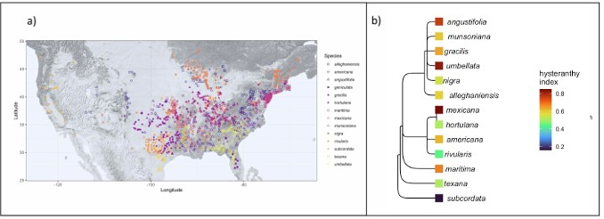

Figure 1: Geographic distribution and taxonomic relationships among the American plums. a) Maps the local- ities of all the herbaria records used in this study. b) Depicts phylogenetic relationships among the American plums and the likelihood they each species is hysteranthous across its full ﬂowering period, represented by a hysteranthy index where 0 is never hysteranthous and 1 is always hysteranthous. These designations are based on ordinal phylogenetic mixed models. Tree topology is from Shaw & Small (2004)

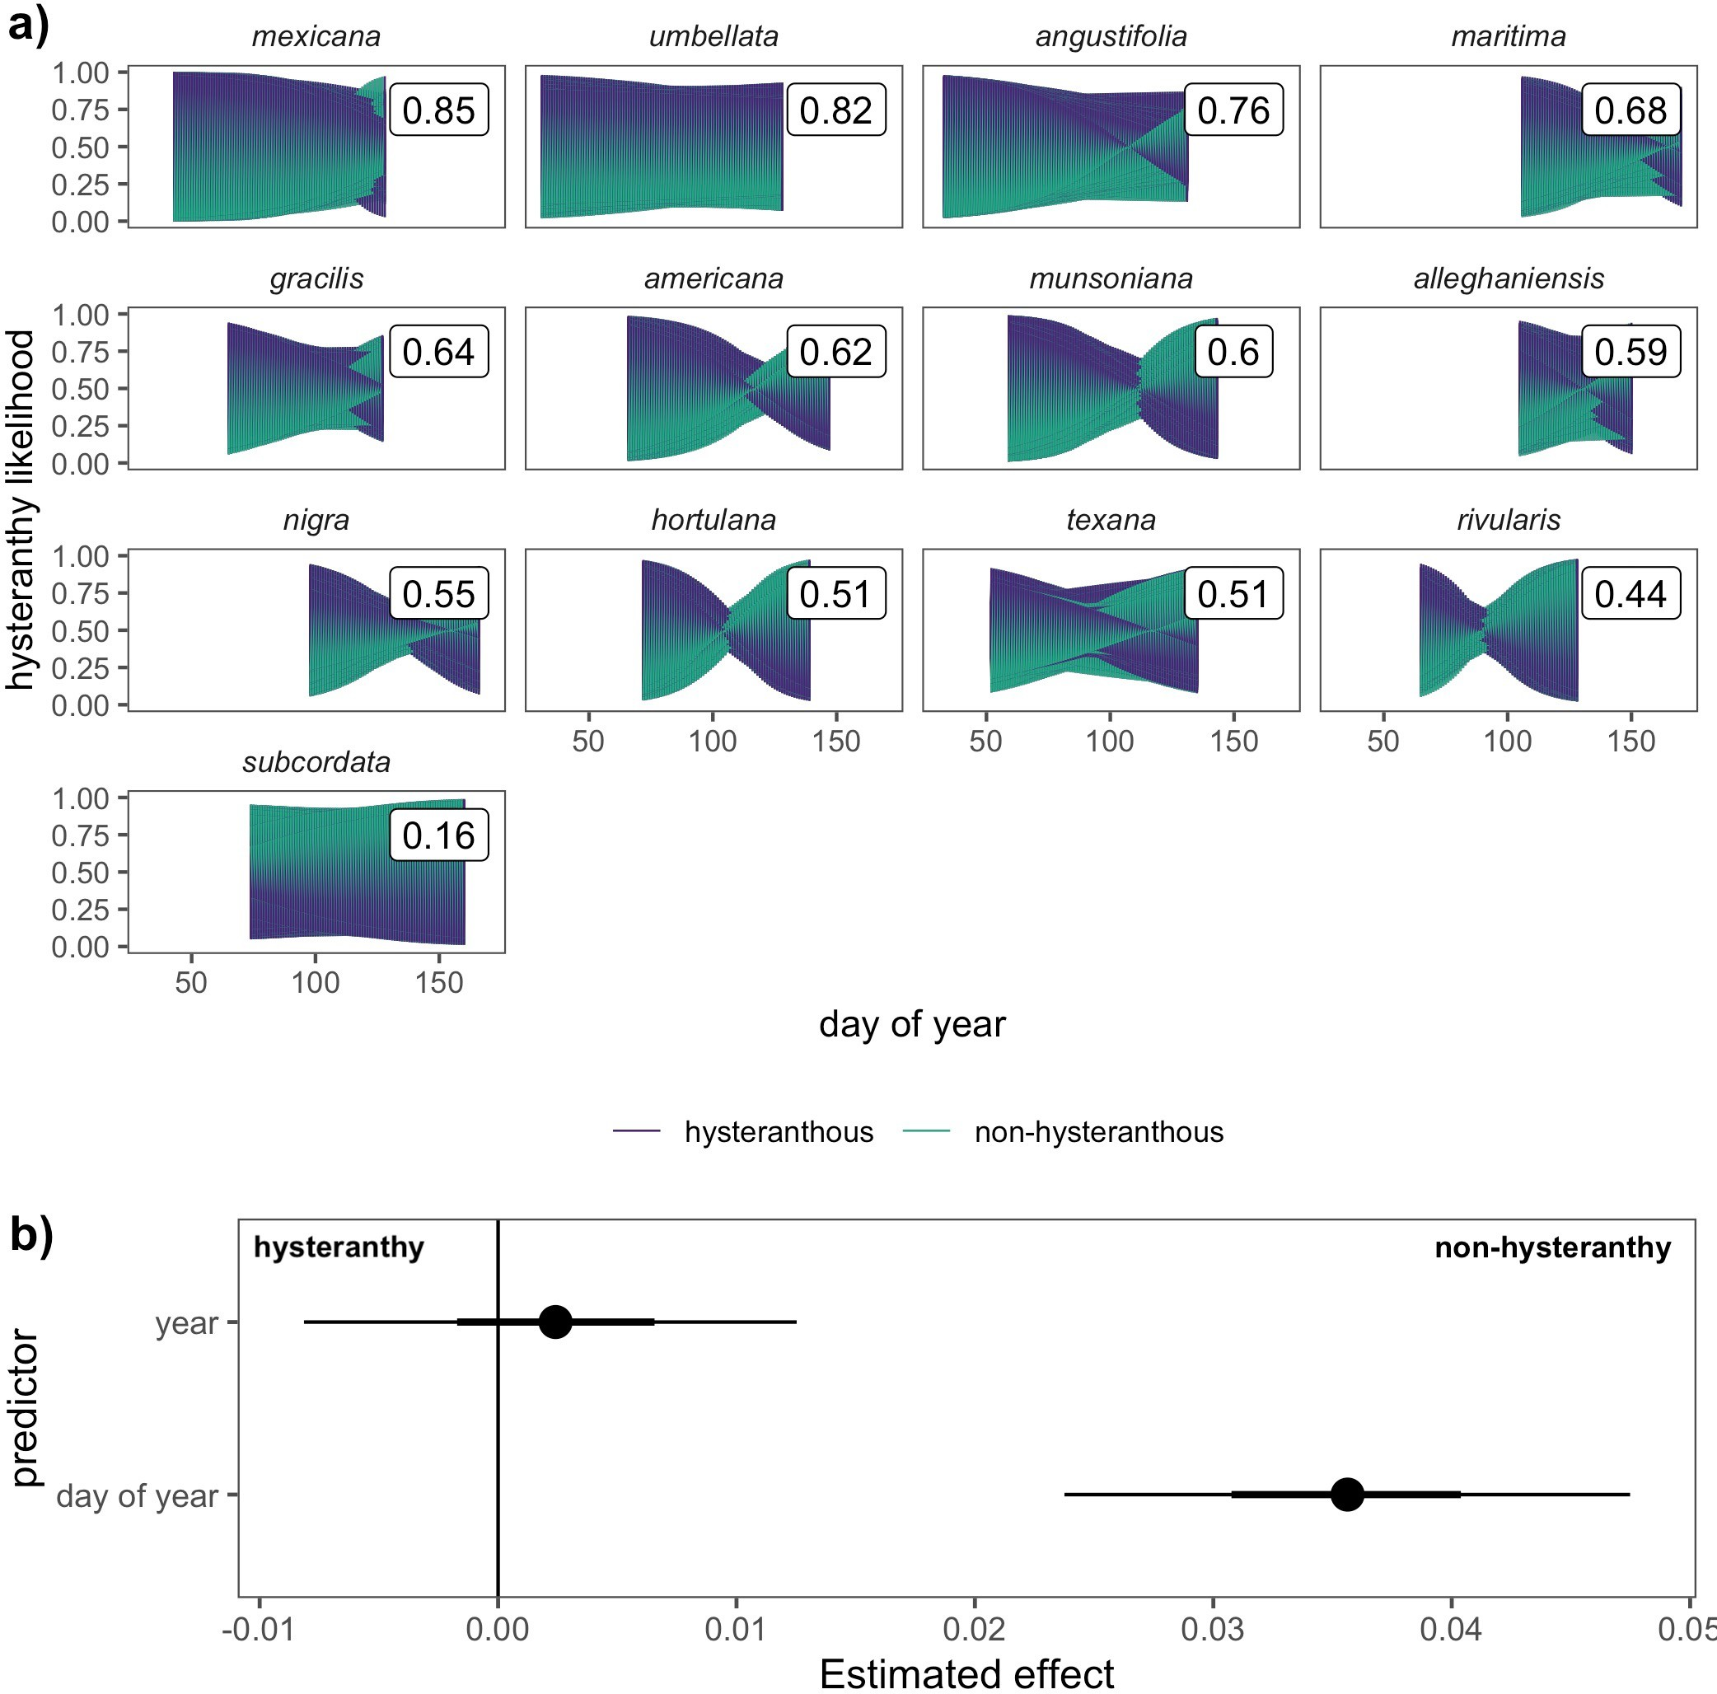

Figure 2: Predicted likelihood of hysteranthy across the ﬂowering period of 13 American plum species and the temporal predictors that drive these patterns. Panel a) depicts the predicted likelihood that each species would express hysteranthy on each day of their ﬂowering season based on 1000 draws from the posterior distribution of Bayesian hierarchical models. The colored shapes represent how the likelihood changes over time and the boxed numerical values represent the average likelihood a species would express hysteranthy, summed across the full ﬂowering period. Panel b) depicts the inﬂuence of among season (year of sample) and within season (day of year of sample) trends on the likelihood species would express hysteranthy. Points are the mean eﬀect size estimates, while thick and thin bars represent the 50% and 89% uncertainty intervals respectively.

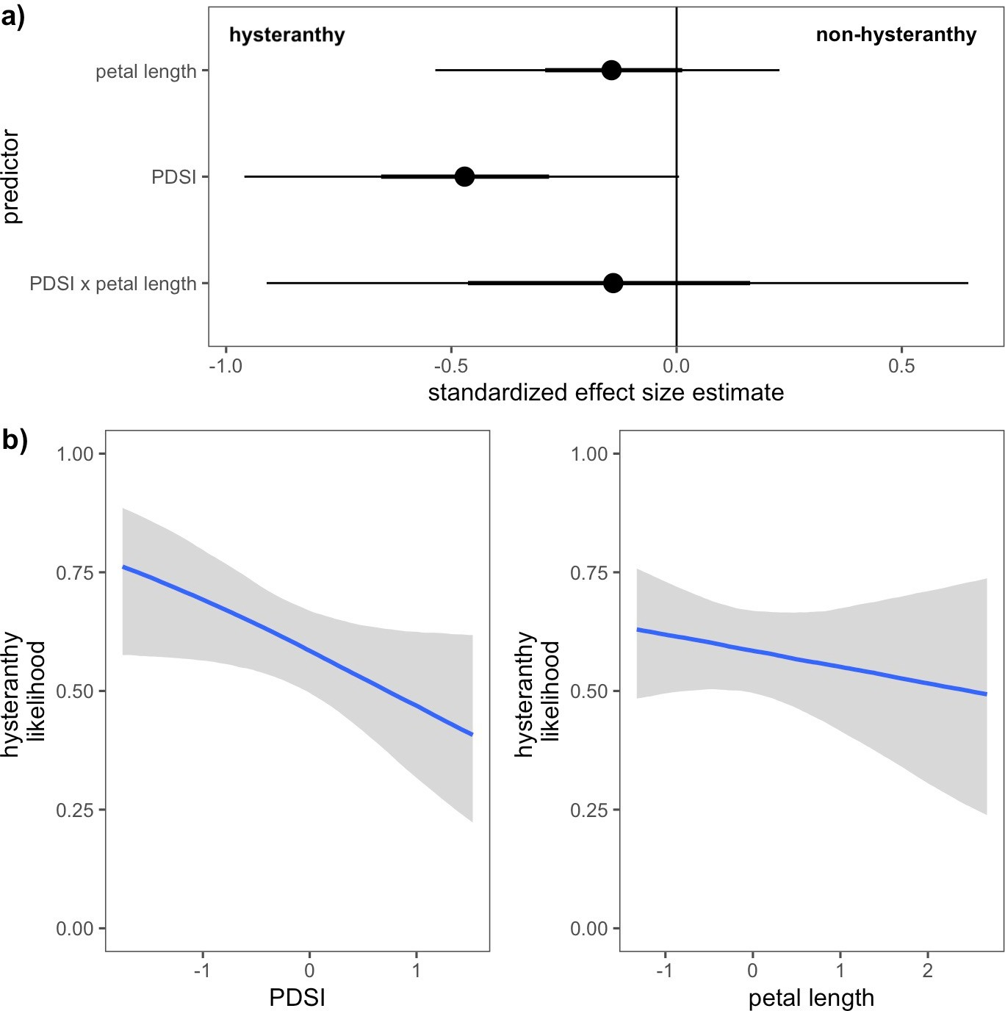

Figure 3: Relationships between hysteranthy and environmental and biological traits for the 13 species of the American Plums. Panel a) shows the estimated eﬀects of each predictor and their interaction on the likelihood hysteranthy. Points indicate the mean eﬀects and the thick and thin bars represent the 50% and 89% uncertainty intervals, respectively. Panel b) depicts the conditional eﬀects of each predictor on hysteranthy likelihood. Blue lines indicate the mean estimate and grey ﬁll the 89% uncertainty intervals. Predictor values (*x*-axis) have been *z*-scored to allow direct comparisons between predictors.

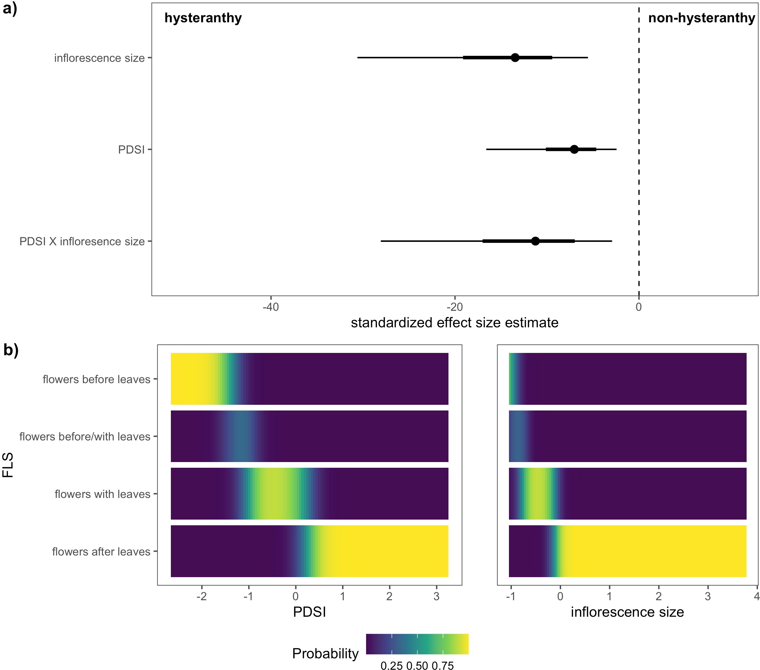

Figure 4: Relationships between the likelihood of hysteranthy and environmental and biological traits for 32 species of the genus *Prunus* native to, or established in North America. Panel a) shows the estimated eﬀect size of each predictor. Points indicate the mean estimate for each predictor, and thick and thin bars the 50% and 89% uncertainty intervals, respectively. Panel b) depicts the likelihood for each ﬂower-leaf sequence stage (*y*-axis) at any given values of PDSI or number of ﬂowers/inﬂorescence (inﬂorescence size). Predictor values (*x*-axis) have been *z*-scored to allow direct comparisons between predictors.