1 Ecological drivers of ﬂower-leaf sequences: aridity and pollination

2 success select for ﬂowering-ﬁrst in insect-pollinated temperate trees

3 D.M. Buonaiuto 1*,*2*,*3*,a*, T.J. Davies 4*,*5, S. Collins 4 & E.M. Wolkovich2*,*3*,*4

4 *Author aﬃliations:*

5 1Department of Environmental Conservation, University of Massachusetts, Amherst, Massachusetts, USA.

6 ORCID: 0000-0003-4022-2591

7 2Arnold Arboretum of Harvard University, Boston, Massachusetts, USA.

8 3Department of Organismic and Evolutionary Biology, Harvard University, Cambridge, Massachusetts, USA

9 4Forest & Conservation Sciences, Faculty of Forestry, University of British Columbia, Vancouver, British

10 Columbia, Canada

11 5 Department of Botany, University of British Columbia, Vancouver, British Columbia, Canada

12 *a*Corresponding author: 617.823.0687; [dbuonaiuto@umass.edu](mailto:dbuonaiuto@umass.edu)

13

14 **Summary**

Many trees in temperate forests produce ﬂowers before their leaves emerge. This ﬂower-leaf phenological sequence, known as hysteranthy, is generally described as an adaptation for wind-pollination—which does not explain why it is also common in biotically-pollinated taxa.

In this study, we quantiﬁed ﬂower-leaf sequence variation in the American plums (*Prunus*, subspp. *Prunus* sect. *Prunocerasus* ), a clade of insect-pollinated species, using herbaria specimens and Bayesian hierarchical modeling. With these observations, we tested common hypotheses for the evolution of hysteranthy by modeling the associations between hysteranthy and related traits. To better understand how these phenology-trait associations were sensitive to taxonomic scale and ﬂower-leaf sequence classiﬁcation, we extended these analyses to the more inclusive genus *Prunus*.

In both groups hysteranthy was associated with aridity and smaller ﬂoral displays. These ﬁndings indicate that hysteranthy may function to temporally partition hydraulic demand and reduce water stress, or increase pollinator visibility and reduce selective pressure on ﬂower size. Our study provides insights into the function of ﬂower-leaf sequences in biotically-pollinated species.

Our ﬁndings that hysteranthy is linked to aridity tolerance and pollination success highlights the importance of phenological sequences in global change research as climate shifts continue to disrupt pollinator services and impact environmental variability.

31

32 Keywords: Deciduous forests, Flower-leaf sequences, Hysteranthy, Phenology, Plant hydraulics, Pollination,

33 Phylogeny

34 **Introduction**

35 Woody perennials have a unique ability among plants to seasonally begin reproduction prior to vegetative

36 growth. This ﬂowering-ﬁrst phenological sequence, known as hysteranthy, proteranthy or precocious ﬂowering,

37 is particularly common in temperate deciduous forests around the globe (Rathcke & Lacey, 1985). A number

38 of studies suggest that this ﬂower-leaf sequence is under selection, and that hysteranthy has functional

39 signiﬁcance (Gougherty & Gougherty, 2018; Buonaiuto *et al.*, 2021; Guo *et al.*, 2014), but the importance of

40 variation in ﬂower-leaf sequences for maintaining ﬁtness may vary across functional types and evolutionary

41 clades within the temperate forest biome. With mounting evidence that anthropogenic climate change is

42 driving shifts in ﬂower-leaf sequences (Ma *et al.*, 2021; Wang *et al.*, 2022), expanding our understanding of

43 the adaptive beneﬁt of hysteranthy may be important to forecasting the demography and performance of

44 forest communities.

45 The most common, and well-tested explanation for the evolution of hysteranthy in temperate forests is that it

46 is adaptive for wind-pollination, as leaﬂess canopies increase wind speeds for pollen transport and reduce the

47 likelihood of pollen interception by vegetation (Whitehead, 1969; Niklas, 1985). However, this explanation

48 does not address the widespread prevalence of hysteranthy in biotically-pollinated taxa found in temperate

49 regions. This number is not trivial; a recent analysis found that approximately 20% of the hysteranthy species

50 in Eastern Temperate Forests of North America are biotically-pollinated (Buonaiuto *et al.*, 2021).

51 Several alternative hypotheses have been put forward to explain the advantage of hysteranthy in biotically-

52 pollinated species, but they have not been widely evaluated in the literature. Below, we brieﬂy review these

53 hypotheses and their predictions, and then test these predictions using the American plums (*Prunus* subspp.

54 *Prunus* sect. *Prunocerasus* ), a widespread clade with high variability in ﬂower-leaf sequences, as a case-study.

55 Our treatment here both clariﬁes the hypothesized function of ﬂower-leaf sequence variation in biotically-

56 pollinated taxa, and oﬀers insights into how shifting ﬂower-leaf sequences may impact species demography

57 and distributions as climate continues to change.

## 58 Hypotheses of hysteranthous ﬂowering in biotically-pollinated taxa

59 Water limitation hypothesis: In the dry-deciduous tropics of South and Central America, hysteranthy is

60 common (Rathcke & Lacey, 1985; Franklin, 2016), and is regarded as an important adaptation to alleviate

61 water stress by partitioning the hydraulic demand of ﬂowers and leaves across the season (Gougherty &

62 Gougherty, 2018; Franklin, 2016; Borchert, 1983; Reich & Borchert, 1984). Under this hypothesis, the function

63 of hysteranthous ﬂowering in temperate regions parallels that in the dry tropics—partitioning hydraulic

64 demand across the season to allow hysteranthous species to tolerate increased aridity. While temperate forests

65 are rarely water-limited in the early season during which ﬂowering and leaﬁng occur (Polgar & Primack, 2011),

66 there is still considerable variation in water availability in space and time within temperate regions of the

67 globe. With this hypothesis, we would expect to ﬁnd hysteranthous taxa in locations that are, on average,

68 drier than their non-hysteranthous relatives.

69 Insect visibility hypothesis: Hysteranthous ﬂowers are visually conspicuous in the landscape. Thus, as in

70 wind-pollinated taxa, hysteranthy in biotically-pollinated taxa may be an adaptation for pollination eﬃciency

71 as ﬂowering-ﬁrst species are easier for insect pollinators to locate (Janzen, 1967). This hypothesis predicts

72 that hysteranthy should be associated with smaller ﬂoral displays, because ﬂowers are not obscured by leaves,

73 they are easier to see, and there is weaker selection for increasing ﬂoral display size.

74 Fruit maturaturion hypothesis: There are several aspects of reproductive development that suggest hysteran-

75 thy is a by-product of developmental constraints related to fruit maturation. Hysteranthy may be common

76 in large fruited species that require lots of time to mature their fruits, or in small, early fruiting species that

77 have evolved dispersal syndromes (wind dispersal, non-dormant seeds) that require dispersal early in the

78 season (Primack, 1987). In either case, we should expect fruit size to associate with hysteranthy, although

79 the sign of the correlation diﬀers.

80 Alternative to these functional hypotheses is the assertion that hysteranthous ﬂowering is simply a by-product

81 of selection for early ﬂowering. Species that ﬂower before their leaves inherently ﬂower early in the season.

82 Spring ﬂower phenology is less constrained by prior phenological events than leaf phenology (Savage, 2019;

83 Ettinger *et al.*, 2018), which could allow selection to drive ﬂowering into the early season, producing the

84 hysteranthous phenological sequence. Here, there is no speciﬁc adaptive advantage to hysteranthy; selection

85 is not operating on the relative timing of ﬂower and leaf emergence, but rather the absolute ﬂowering time

86 alone. Rejection of the above hypotheses might provide support to this null explanation.

87 A signiﬁcant challenge for robust testing of hysteranthy hypotheses is that most characterizations of ﬂower-leaf

88 phenological sequences are based on expert-opinion verbal descriptions (e.g. “ﬂowers before leaves” or “ﬂower

89 before/with leaves”), which make comparisons across taxa, time and space diﬃcult and sensitive to observer

90 bias (see; Buonaiuto *et al.*, 2021). This problem can be overcome by adopting standardized quantitative

91 measures of plant phenology for observational studies and applying them to historic data records. Herbarium

92 records are an excellent source of data that can be leveraged for quantitative phenological measurements

93 (Willis *et al.*, 2017), but have not been used widely to investigate variability of ﬂower-leaf sequences among

94 and within species.

95 The American plums oﬀer potential for a high resolution investigation of drivers of hysteranthous ﬂowering

96 in taxa that are not easily explained by the dominant wind-pollination hypothesis. The 16 species that make

97 up the section are distributed across the temperate zone of North America and, like the genus *Prunus* at

98 large, are all insect-pollinated, yet show pronounced inter-speciﬁc variation in ﬂower-leaf sequences. Usefully,

99 species in this section are well represented in herbaria records (Fig. 1a), making them a tractable group to

100 measure and assess variation in ﬂower-leaf sequences.

101 To interrogate the functional hypotheses for hysteranthous ﬂowering described above, we used herbaria records

102 to to quantify both within- and across- species level variation in ﬂower-leaf sequences of the American plums.

103 Then we combined environmental attributes, biological traits and phylogenetic data in statistical models to

104 evaluate whether the observed associations between ﬂower-leaf sequence variation and morphological and

105 environmental traits match the predicted associations of the hysteranthy hypotheses. Finally, we compared

106 our ﬁndings in this clade to patterns observed in larger genus *Prunus* to better understand whether these

107 phenology-trait associations were sensitive to taxonomic scale and ﬂower-leaf sequence classiﬁcation.

# 108 Materials and Methods

## 109 Quantifying ﬂower-leaf sequence variation

110 We obtained digital herbarium specimens for all members of the section *Prunocerasus* from the Consortium

111 of Midwest Herbaria (CMH) Database (Consortium of Midwest Herbaria, 2023). To quantify ﬂower-leaf

112 sequence variation within and across species we randomly sampled 200 specimens for each species and scored

113 the phenological development of ﬂowers and leaves using a modiﬁed BBCH scale for woody plants (Finn *et al.*,

114 2007). In total, we evaluated the phenology of 2521 specimens, but only specimens with visible ﬂowers were

115 included in this analysis (n=1009). We reconstructed the phylogenetic relationships among species in this

116 group based on the tree topology in Shaw & Small (2004). We inferred branch lengths following the method

117 of Grafen & Hamilton (1989) in which node heights are estimated in proportion to number of subtending

118 taxa using the R package “ape” (E. Paradis and K. Schliep, 2019).

119 To quantify ﬂower-leaf sequence variation, we ﬁt an ordinal, hierarchical, Bayesian phylogenetic mixed model

120 (de Villemeruil P. Nakagawa, 2014) to assess the likelihood an individual would be at any given vegetative

121 BBCH phase while ﬂowering. Our model predicted leaf stage (*yi*, ordinal, with six categories) as a function of

122 species and additional phylogenetic eﬀects. Because hysteranthy co-varies with ﬂowering time (i.e., ﬂowering

123 ﬁrst species will generally ﬂower earlier than other species, on average) we included day of observation as an

124 additional predictor. The model is written below:

125

 1 *if zi <* 0

 2 *if zi ∈* (0*, c*2)

y =  3 *if zi ∈* (*c*2*, c*3)

*i*

4 *if zi ∈* (*c*3*, c*4)

 5 *if zi ∈* (*c*4*, c*5)

 6 *if zi > c*5

126

127

*zi* = *α* + *αphylo* + *αsp* + *β*day of year[sp] *∗ X*day of year + *ϵi*

128 *ϵi ∼ logistic*(0*,* 1)

129

130 where *yi* is the ordinal outcome (leaf stage; as 1,2,...6 categories). *c*2*...*5 are the estimated cutpoints between

131 leaf stages on the logit scale. *zi* is the linear component of the underlying latent variable model. *α* describes

132 an intercept for each category [1,2,...6], while slope (*β*day of year) is constant across cutpoints, but varies among

133 *species*.

The inﬂuence of the phylogeny (*αphylo*) was modeled as:

*αphylo ∼ N* (0*, COR*[*σ*2 ])

*phylo*

The *α* for species eﬀects independent of the phylogeny was modeled as:

*αsp ∼ N* (0*, σ*2 )

*species*

134 We used our model to predict the likelihood each species would be observed at a given vegetative BBCH stage

135 during ﬂowering at the 0%, 25% 50% and 75% quantiles of their ﬂowering period. We then developed a ﬂower-

136 leaf sequence index, by assigning a numerical score to each species per seasonal quantile, and summing over

137 the full ﬂowering season. In each seasonal quantile, species received a “1” if more than 50% of their probability

138 distribution occurred at the two earliest stages of vegetative phenology—BBCH 0 (“bud development”) and

139 BBCH 09 (“bud break”)—and a “0” if not. We summed these values across the season, generating an index

140 from 0 (never hysteranthous) to 4 (hysteranthous through late season (Q75)), where 1= hysteranthous at

141 start of season, 2= hysteranthous through early season (Q25) and 3 = hysteranthous through mid season

142 (Q50). We also used two alternative indexing schemes (*>*25% of the probability distribution occurred at

143 BBCH 0 and *>*40% of the probability distribution occurred at BBCH 0 and BBCH 09) to make sure our

144 result were robust across multiple cutoﬀs.

## 145 Evaluating hysteranthy hypotheses

146 To test the hypotheses of hysteranthy, we obtained data on petal length and fruit diameter directly from

147 herbarium specimens. To assess aridity tolerance, we computed the average Palmer Modiﬁed Drought In-

148 dex score from 1900-2017, obtained from the National Centers for Environmental Information (2017), for

149 every *Prunocerasus* specimen in the database(n=2305). For any specimens that lacked accurate geo-location

150 information, we extracted PDSI values at the county centroid of the herbaria specimen.

151 For our morphological measurements, we sampled an additional 321 specimens and measured the petal length

152 of up to 10 randomly selected petals per specimen (n=2757) using ImageJ image processing software. We

153 also used ImageJ to measure the diameter of fruits on an additional 316 specimens, measuring up to 5 fruit

154 per specimen (n=224).

155 We then used Bayesian phylogenetic mixed models to test the relationship between ﬂower-leaf sequence index

156 scores and each of the variables. In these models, we modeled species and phylogeny as above.

|  |  |
| --- | --- |
| 157 | The model structure is: |
| 158 | *ytrait* = *α* + *αsp* + *αphylo* + *βhyst.index ∗ Xhyst.index* + *ϵ* |
| 159 |  |
|  | *ϵ ∼ N* (0*, σ*2)  *y* |
| 160 | where *ytrait* is observed trait values (PDSI, petal length or fruit diameter), and the slope *β*hyst.index describes |
| 161 | the relationship between extended hysteranthy (higher hysteranthy index value) and the trait of interest. *α* |
| 162 | describes a grand intercept, and *αsp* and *αphylo* describe the species and phylogenetic eﬀects respectively. |
| 163 | We also ran each model using our two alternative ﬂower-leaf sequence indexing approaches to make sure |
| 164 | our results were robust to choice of index. Though these alternative classiﬁcation schemes did change the |
| 165 | hysteranthy index score for some species (Fig. S1), they did not substantially impact the inference from our |
| 166 | models (see Tab. S1 for comparisons). |
| 167 | **Hysteranthy in the larger genus *Prunus*** |
| 168 | To better understand how the patterns we identiﬁed in *Pruncerasus* scaled to a larger more inclusive group and |
| 169 | across coarser taxonomic resolution and ﬂower-leaf sequence classiﬁcation we also evaluated the relationship |
| 170 | between hysteranthous ﬂowering and hypothesis-related traits in all *Prunus* species native to, or established |
| 171 | in, North America. For this analysis, we obtained categorical descriptions of ﬂower-leaf sequences and mean |
| 172 | estimates of fruit diameter and number of ﬂowers per inﬂorescence as a proxy for ﬂoral investment from the |
| 173 | Flora of North America (Rohrer, 1993+). We extracted PDSI values for all herbaria observation of those |
| 174 | species in the Consortium of Midwest Herbaria database (n=23,272) as described above. |
| 175 | To account for the inﬂuence of evolutionary relationships among species, we reconstructed the phylogenetic |
| 176 | relationships in the genus based on the tree topology in Chin *et al.*(2014). As above, we computed branch |
| 177 | lengths with the R package “ape” (E. Paradis and K. Schliep, 2019). |
| 178 | We standardized the units of all predictors through z-scoring (Gellman & Hill, 2007) to make their eﬀect size |
| 179 | estimates for the following model structure directly comparable to each other: |

*i*

|  |  |  |  |  |
| --- | --- | --- | --- | --- |
|  |  | 1 | *if* | *zi <* 0 |
| y  180 z*i*  181 | =  2  3   4  = *α* + *α* | | *if*  *if if*  *phylo* | *zi ∈* (0*, c*2)  *zi ∈* (*c*2*, c*3)  *zi > c*3  + *βPDSI ∗ X* |
| *ϵi* | *∼ log* | *istic*(0*,* | | 1)) |



*PDSI* + *β*fruit diameter *∗ X*fruit diameter + *β*ﬂoral investment *∗ Xflowers/inflorescence* + *ϵi*

182 where *yi* is the ordinal outcome of ﬂower-leaf sequence category (“ﬂowers before leaves”, “ﬂowers before/with

183 leaves”, “ﬂowers with leaves” and “ﬂowers after leaves”) and *c*2*...*3 are the estimated cutpoints between cat-

184 egories on the logit scale. As above, *zi* is the linear component of the underlying latent variable model. *α*

185 describes a grand intercept, and we modeled the inﬂuence of phylogeny (*αphylo*) as above.

186 **Model runs**

187 We ﬁt models in the R package “brms” (Bu¨rkner, 2018) using weakly informative priors, and four chains. For

188 the “Quantifying ﬂower-leaf sequence variation” and “Evaluating hysteranthy hypotheses” we ran the models

189 with a warm-up of 3000, and 3500 iterations, and 4000, and 4500 sampling iterations respectively, for a total

190 of 4000 sampling iterations across all chains. For the “Hysteranthy in the larger genus *Prunus*” model, we

191 used a warm up of 6,000 iterations and 8,000 sampling iterations for a total of 8,000 sampling iterations to

192 maximize the eﬀective sampling size. Model ﬁts was assessed with *R*ˆ *<*1.01, high eﬀective sample sizes and

193 no divergent transitions. We provide mean estimates and 50% uncertainty intervals in the text with alternate

194 intervals in ﬁgures and the Supporting Information.

195 **Results**

## 196 Quantifying ﬂower leaf sequences in the American plums

197 We found substantial inter-speciﬁc diﬀerences in ﬂower-leaf sequences within the American plums (Fig. 2,

198 S1). Flower-leaf sequence patterns were strongly dependent on the day of observation, with observations

199 later in the the ﬂowering season of each species decreasing the likelihood of ﬁnding ﬂowers open during early

200 vegetative BBCH phases (*βdoy* 0.03, *CI*50 [0.02,0.04]). Based on our ﬂower leaf sequence index, two species

201 (*P. umbellata*, *P. mexicana*) were likely to be hysteranthous regardless of the time of observation and ﬁve

202 species (*P. alleghaniensis*, *P. nigra*, *P. rivularis*, *P. subcordata*, and *P. texana*) were always most likely to

203 ﬂower after leaves developed (Fig. 1b). All other species displayed intermediate phenotypes, with four species

204 mostly likely to hysteranthous at the start of the season (*P. americana*, *P. hortulana*, *P. munsoniana* and *P.*

205 *gracilis*), one species through early season (*P. maritima*) and one species through mid season (*P. angustifolia*)

206 (Fig 1b).

## 207 Associations between hysteranthy and environmental and morphological traits

208 In the American plums clade, aridity (lower average PDSI) was associated with higher ﬂower-leaf sequence

209 index scores (*β*: -0.04, *CI*50[-0.06, -0.03], Fig. 3a), suggesting that species that displayed hysteranthous

210 ﬂowering later into their ﬂowering season are found in drier locations.

211 Shorter petal and smaller fruit diameters were also associated with higher ﬂower-leaf sequence index scores

212 (*β*: -.21, *CI*50[-0.38 -0.05] and *β*:-1.41, *CI*50[-2.00 -0.84] respectively, Fig. 3b,c). This suggests that smaller

213 fruits and ﬂowers are associated with increased hysteranthy.

214 At the genus level, there was a positive association between increasing PDSI and inﬂorescence size and

215 increasing overlap between ﬂowers and leaves (i.e., decreasing hysteranthy; *β*: 2.50, *CI*50[1.17, 3.371] and

216 *β* 6.41, *CI*50[3.86, 8.05] per standardized unit, respectively, Fig. 4a), again suggesting that hysteranthy is

217 associated with drier locations and smaller ﬂoral displays (Fig. 4b). However, hysteranthy was associated

218 with larger fruits (*β*: -1.24, *CI*50[-1.95, -0.21], 4b) though there was high uncertainty around these estimates.

219 **Discussion**

220 Our study provides foundational insights into the evolution of ﬂower-leaf sequences in biotically-pollinated

221 plants. We show that hysteranthous ﬂowering can be linked to both aridity tolerance and pollination success

222 through the predictions of the water limitation and insect visibility hypotheses, highlighting the urgency for

223 advancing our understanding of phenological sequences as human-caused global change continues to disrupt

224 pollinator services and impact environmental variability.

## 225 Hysteranthy hypotheses

226 Using North American *Prunus* species as a case study, our analyses indicate that ﬂower-leaf sequences are

227 under selection by biological and environmental drivers, and that variation in these patterns across species

228 may reﬂect adaptive tradeoﬀs. We found that hysteranthous ﬂowering is associated with smaller ﬂoral displays

229 and increased aridity in both the American plums, and more broadly across *Prunus* native or established in

230 North America. While we did not ﬁnd consistent support for the fruit maturation hypothesis, the relationships

231 between hysteranthy and aridity, and hysteranthy and ﬂoral display size support the predictions of the water

232 limitation hypothesis and the insect visibility hypothesis, respectively.

233 Our support for both the water limitation hypothesis and insect visibility hypothesis highlights that these

234 hypotheses are not mutually exclusive, and could be related. Selection on ﬂoral size represents a classic

235 evolutionary tradeoﬀ where larger ﬂoral displays may generally be more eﬀective for attracting pollinators

236 but demand more resources, including water, to maintain turgor and reproductive function than smaller

237 ones (Galen *et al.*, 1999; Lambrecht & Dawson, 2007). With this trade-oﬀ, reproductive displays are often

238 small in harsher environments (Teixido *et al.*, 2016; Lambrecht, 2013), and hysteranthy could represent a

239 compensatory mechanism that both reduces hydraulic demand while increasing pollination eﬃciency in these

240 environments.

241 Studies that have compared the transpiration rates among ﬂowers and leaves provide insights to the potential

242 importance of this seasonal partitioning for maintaining water status. Measurements of water movement

243 (transpiration rates, sap ﬂow, hydraulic conductivity) to ﬂowers range from 20%-60% of that of leaves under

244 comparable conditions (Whiley *et al.*, 1988; Roddy & Dawson, 2012; Liu *et al.*, 2017; McMann *et al.*, 2022).

245 This level of additional hydraulic demand can drive loss of stomatal conductance and decrease photosynthetic

246 rates (Galen *et al.*, 1999).

247 Despite this evidence that hysteranthy can reduced hydraulic demand in dry environments, hysteranthous

248 species in the American plum clade are not found in extremely arid locations (PDSI values typically range

249 from -4 to 4, however our analyses found mean values ranging from -0.5 to 0.2 for species classiﬁed as

250 hysteranthous through mid-season or through late season). This contrasts with hysteranthous species in

251 the dry tropics where this phenological syndrome allows them to tolerate more extreme aridity (Franklin,

252 2016). But the ﬂower-leaf sequences of the hysteranthous species in our study were markedly diﬀerent from

253 patterns of hysteranthy in these dry-tropics where the water limitation hypothesis was initially proposed.

254 While ﬂowering can precede leafout by as much several weeks for species in the American plums, the process

255 of fruit development, which is also water intensive, occurs when leaves are present. By contrast, in the

256 dry tropics hysteranthous ﬂowering is initiated at the time of leaf drop (Borchert, 1983; Franklin, 2016);

257 thus, the full reproductive cycle occurs in the leaﬂess period. The comparatively small window of leaﬂess

258 reproductive development in our temperate clade, may in part, explain why the association we observed

259 between hysteranthy and aridity in our study was relatively weak with high residual variance. Our results

260 suggest that hysteranthy may allow temperate species to occupy marginally drier environments than non-

261 hysteranthous species, but may not facilitate species’ persistence under extreme aridity.

## 262 Inter-and intra-speciﬁc variation in ﬂower-leaf sequences

263 We developed a novel approach to assessing ﬂower-leaf sequences that scales from quantitative, individual-level

264 observations to species-level characterizations that were based on empirical likelihood estimates. With this

265 approach, we were able to—for the ﬁrst time—quantitatively assess intermediate cases of hysteranthy (such as

266 those that are typically described as “ﬂowers before/with leaves”). Previous studies of hysteranthous ﬂowering

267 have either excluded these cases from their analyses (e.g.; Gougherty & Gougherty, 2018) or binned them

268 with the well deﬁned cases (e.g.; Buonaiuto *et al.*, 2021). We found that eight of the thirteen American plum

269 species expressed this intermediate ﬂower-leaf sequence, and our classiﬁcations broadly matched previous

270 species-level analyses in this group by Shaw & Small (2004). By estimating the likelihood of hysteranthy

271 across the growing season with Bayesian methods, our approach identiﬁed substantial diﬀerences in ﬂower-leaf

272 sequences among these intermediate cases (Fig. 2, Fig. S1), which allowed us to assess the trait associations

273 with this phenotype.

274 Our quantitative analysis of the American plums clade revealed that ﬂower-leaf sequences—often described

275 as a species-level trait—are highly variable within species (Fig. 2, Fig. S1). For all members of the clade,

276 the day of phenological observation was a strong predictor of the likelihood that ﬂowers would be visible

277 before the emergence of leaves. In many cases there was high likelihood that individuals of a species may

278 be observed at diﬀerent vegetative stages during ﬂowering (Fig. 2, S1). This variation could either suggest

279 high levels of local adaptation in ﬂower-leaf sequences or, alternatively, high levels of plasticity through

280 which ﬂower-leaf sequences respond to interannual variation in environmental conditions. For example—in a

281 given population—ﬂower-leaf sequences may respond to interannual variation in precipitation with increased

282 temporal separation between ﬂowers and leaves in drier years. While our data did not have the temporal

283 resolution to address this question, the high levels of within-species variation we observed raise important

284 questions about environmental drivers of ﬂower-leaf sequences operating on both the macro-evolutionary scale

285 we investigated here and on individual physiological responses to environmental change.

286 Additionally, by scoring these individual, quantitative observations as ordinal response categories with our

287 hysteranthy index, we were able to contrast our ﬁndings to those derived from categorical, species-level char-

288 acterizations based on expert opinion. The coherence between our individual based observational approach

289 for the American plum clade and the top-down, categorical classiﬁcation across *Prunus* is an encouraging

290 demonstration that the expert opinion-based data can still oﬀer useful insights into the drivers of hysterant-

291 hous ﬂowering when higher-resolution data is not available.

292 **Future directions**

293 In this study, we focused on a well-studied, and economically important clade of morphologically similar

294 species, that allowed us to control for unmeasured biological variation. Our case-study provides a road map

295 for evaluating the role of hysteranthy in temperate biotically-pollinated plant taxa (other groups with high

296 interspeciﬁc ﬂower-leaf sequence variation include *Magnolia*, *Rhododendron*, *Acer* and *Cornus*), and more

297 broadly across taxa and biomes.

298 Combining the observational approach with novel experiments could further advance our collective under-

299 standing of the adaptive signiﬁcance of ﬂower-leaf sequences. To test the water-limitation hypothesis, re-

300 searchers could plant sister-taxa with contrasting ﬂower-leaf sequences in common environments across a

301 gradient of aridity, and evaluate their performance. To test the insect visibility hypothesis, researchers

302 should also consider hysteranthy—and phenology in general—in the more general framework of tradeoﬀs in

303 pollination biology. The tradeoﬀ between phenology and pollination investment should not only consider

304 ﬂower size, but also the number of ﬂowers, nectar and pollen reward investment, volatiles between related

305 hysteranthous and non-hysteranthous taxa. Findings that hysteranthous species invest fewer resources into

306 these other pollinator attraction traits than non-hysteranthous relatives would support the insect visibil-

307 ity hypothesis. For a simple experiment to test the pollinator visibility hypothesis, researchers could force

308 hysteranthy/non-hysteranthy phenotypes for the same genotype using environmental cues, and systematically

309 release pollinators to observe their preferences, search times and foraging behavior. If pollinators are more

310 readily drawn to the hysteranthous individuals, it would suggest that hysteranthy may be an adaptive trait

311 for pollinator attraction.

312 With a better mechanistic understanding of the relationship between ﬂower-leaf sequences and ecological

313 performance in hand, researchers could then use experiments to assess how diﬀerences in ﬂoral and leaf

314 physiological responses to temperature variation may alter the adaptive beneﬁts of ﬂower-leaf sequences with

315 climate change. The measurement and modeling approaches we developed in our observational study can be

316 readily implemented to analyze data from such experimental settings, presenting an important opportunity to

317 unite observations of broad ecological patterns with targeted experimental manipulations to better understand

318 both the evolutionary past and ecological future of ﬂower-leaf sequences.

# 319 Competing Interests:

320 The authors declare no conﬂict of interest.

# 321 Author contributions

322 DMB, and EMW conceived of the manuscript; DMB and SC collected the data; DMB led the statistical

323 analyses with TJD and EMW; DMB led the writing of the manuscript. All authors contributed to writing

324 and gave approval for the submission.

325 **Data Availability**

326 The phenology and trait data collected for this study will be made available and archived at KNB: The

327 Knowledge Network for Biocomplexity (https://knb.ecoinformatics.org/) at the time of publication.

328 **References**

329 **Borchert R. 1983**. Phenology and control of ﬂowering in tropical trees. *Biotropica*, **15**: 81–89.

330 **Buonaiuto DM, Morales-Castilla I , Wolkovich EM. 2021**. Reconciling competing hypotheses regarding

331 ﬂower–leaf sequences in temperate forests for fundamental and global change biology. *New Phytologist*,

332 **229**: 1206–1214.

333 **Bu¨rkner PC. 2018**. Advanced bayesian multilevel modeling with the r package brms. *R Journal*, **10**: 395–411.

334 **Chin SW, Shaw J, Haberle R, Wen J , Potter D. 2014**. Diversiﬁcation of almonds, peaches, plums and

335 cherries –molecular systematics and biogeographic history of prunus (rosaceae). *Molecular Phylogenetics*

336 *and Evolution*, **76**: 34–48.

337 **Consortium of Midwest Herbaria C**. 2023. Consortium of midwest herbaria.

338 **E. Paradis and K. Schliep. 2019**. ape 5.0: an environment for modern phylogenetics and evolutionary analyses

339 in R. *Bioinformatics*, **35**: 526–528.

340 **Ettinger A, Gee S , Wolkovich E. 2018**. Phenological sequences: how early season events deﬁne those that

341 follow. *American Journal of Botany*, **105**.

342 **Finn GA, Straszewski AE , Peterson V. 2007**. A general growth stage key for describing trees and woody

343 plants. *Annals of Applied Biology*, **151**: 127–131.

344 **Franklin DC. 2016**. Flowering while leafess in the seasonal tropics need not be cued by leaf drop: evidence

345 from the woody genus brachychiton (malvaceae). *Plant Ecology and Evolution*, **149**: 272–279.

346 **Galen C, Sherry R , Carroll A. 1999**. Are ﬂowers physiological sinks or faucets? costs and correlates of water

347 use by ﬂowers of polemonium viscosum. *OECOLOGIA*, **118**: 461–470.

348 **Gellman A , Hill J**. 2007. *Data Analysis Using Regression and Multilevel/Hierarchical Models*. Cambridge

349 University Press.

350 **Gougherty AV , Gougherty SW. 2018**. Sequence of ﬂower and leaf emergence in deciduous trees is linked to

351 ecological traits, phylogenetics, and climate. *New Phytologist*, **220**: 121–131.

352 **Grafen A , Hamilton WD. 1989**. The phylogenetic regression. *Philosophical Transactions of the Royal Society*

353 *of London. B, Biological Sciences*, **326**: 119–157.

354 **Guo L, Luedeling E, Dai J , Xu J. 2014**. Diﬀerences in heat requirements of ﬂower and leaf buds make

355 hysteranthous trees bloom before leaf unfolding. *Plant Diversity and Resources*, **36**: 245–253.

356 **Janzen DH. 1967**. Synchronization of sexual reproduction of trees within the dry season in central america.

357 *Evolution*, **21**: 620–637.

358 **Lambrecht SC. 2013**. Floral water costs and size variation in the highly selﬁng leptosiphon bicolor (polemo-

359 niaceae). *International Journal of Plant Sciences*, **174**: 74–84.

360 **Lambrecht SC , Dawson TE. 2007**. Correlated variation of ﬂoral and leaf traits along a moisture availability

361 gradient. *Oecologia*, **151**: 574–583.

362 **Liu H, Xu QY, Lundgren MR , Ye Q. 2017**. Diﬀerent water relations between ﬂowering and leaf periods: a case

363 study in ﬂower-before-leaf-emergence *<*i*>*magnolia*<*/i*>* species. *Functional Plant Biology*, **44**: 1098–1110.

364 **Ma Q, Huang JG, H¨anninen H, Li X , Berninger F. 2021**. Climate warming prolongs the time interval

365 between leaf-out and ﬂowering in temperate trees: Eﬀects of chilling, forcing and photoperiod. *Journal of*

366 *Ecology*, **109**: 1319–1330.

367 **McMann N, Peichel A , Savage JA. 2022**. Early spring ﬂowers rely on xylem hydration but are not limited

368 by stem xylem conductivity. *New Phytologist*, **233**: 838–850.

369 **National Centers for Environmental Information**. 2017. Lbdp-v2. National Oceanic and Atmospheric Ad-

370 ministration.

371 **Niklas KJ. 1985**. The aerodynamics of wind pollination. *The Botanical Review*, **51**: 328–386.

372 **Polgar C , Primack R. 2011**. Leaf-out phenology of temperate woody plants: From trees to ecosystems. *New*

373 *Phytologist*, **191**: 926–41.

374 **Primack RB. 1987**. Relationships among ﬂowers, fruits, and seeds. *Annual Review of Ecology and Systematics*,

375 **18**: 409–430.

376 **Rathcke B , Lacey EP. 1985**. Phenological patterns of terrestrial plants. *Annual Review of Ecology and*

377 *Systematics*, **16**: 179–214.

378 **Reich P , Borchert R. 1984**. Water-stress and tree phenology in a tropical dry forest in the lowlands of

379 costa-rica. *Journal of Ecology*, **72**: 61–74.

380 **Roddy AB , Dawson TE**. 2012. Determining the water dynamics of ﬂowering using miniature sap ﬂow sensors.

381 International Society for Horticultural Science (ISHS), Leuven, Belgium, 951, pp. 47–53.

382 **Rohrer J**. 1993+. Prunus. In: *Flora of North America North of Mexico* (ed. of North America Editorial Com-

383 mittee F.). New York and Oxford.

384 **Savage JA. 2019**. A temporal shift in resource allocation facilitates ﬂowering before leaf out and spring vessel

385 maturation in precocious species. *American Journal of Botany*, **106**: 113–122.

386 **Shaw J , Small RL. 2004**. Addressing the ”hardest puzzle in american pomology:” phylogeny of prunus sect.

387 prunocerasus (rosaceae) based on seven noncoding chloroplast dna regions. *Am J Bot*, **91**: 985–996.

388 **Teixido AL, Barrio M , Valladares F. 2016**. Size matters: Understanding the conﬂict faced by large ﬂowers

389 in mediterranean environments. *The Botanical Review*, **82**: 204–228.

390 **de Villemeruil P. Nakagawa S**. 2014. *Modern Phylogenetic Comparative Methods and Their Application in*

391 *Evolutionary Biology*, Springer, New York, chap. General quantitative genetic methods for comparative

392 biology, pp. pp. 287–303.

393 **Wang S, Wu Z, Gong Y, Wang S, Zhang W, Zhang S, De Boeck HJ , Fu YH. 2022**. Climate warming shifts

394 the time interval between ﬂowering and leaf unfolding depending on the warming period. *Science China*

395 *Life Sciences*, **65**: 2316–2324.

396 **Whiley A, Chapman K , Saranah J. 1988**. Water loss by ﬂoral structures of avocado (*<*i*>*persea ameri-

397 cana*<*/i*>* cv. fuerte) during ﬂowering. *Australian Journal of Agricultural Research*, **39**: 457–467.

398 **Whitehead DR. 1969**. Wind pollination in the angiosperms: Evolutionary and environmental considerations.

399 *Evolution*, **23**: 28–35.

400 **Willis CG, Ellwood ER, Primack RB, Davis CC, Pearson KD, Gallinat AS, Yost JM, Nelson G, Mazer SJ,**

401 **Rossington NL *et al* . 2017**. Old plants, new tricks: Phenological research using herbarium specimens.

402 *Trends in Ecology & Evolution*, **32**: 531–546.

403 **Figures**

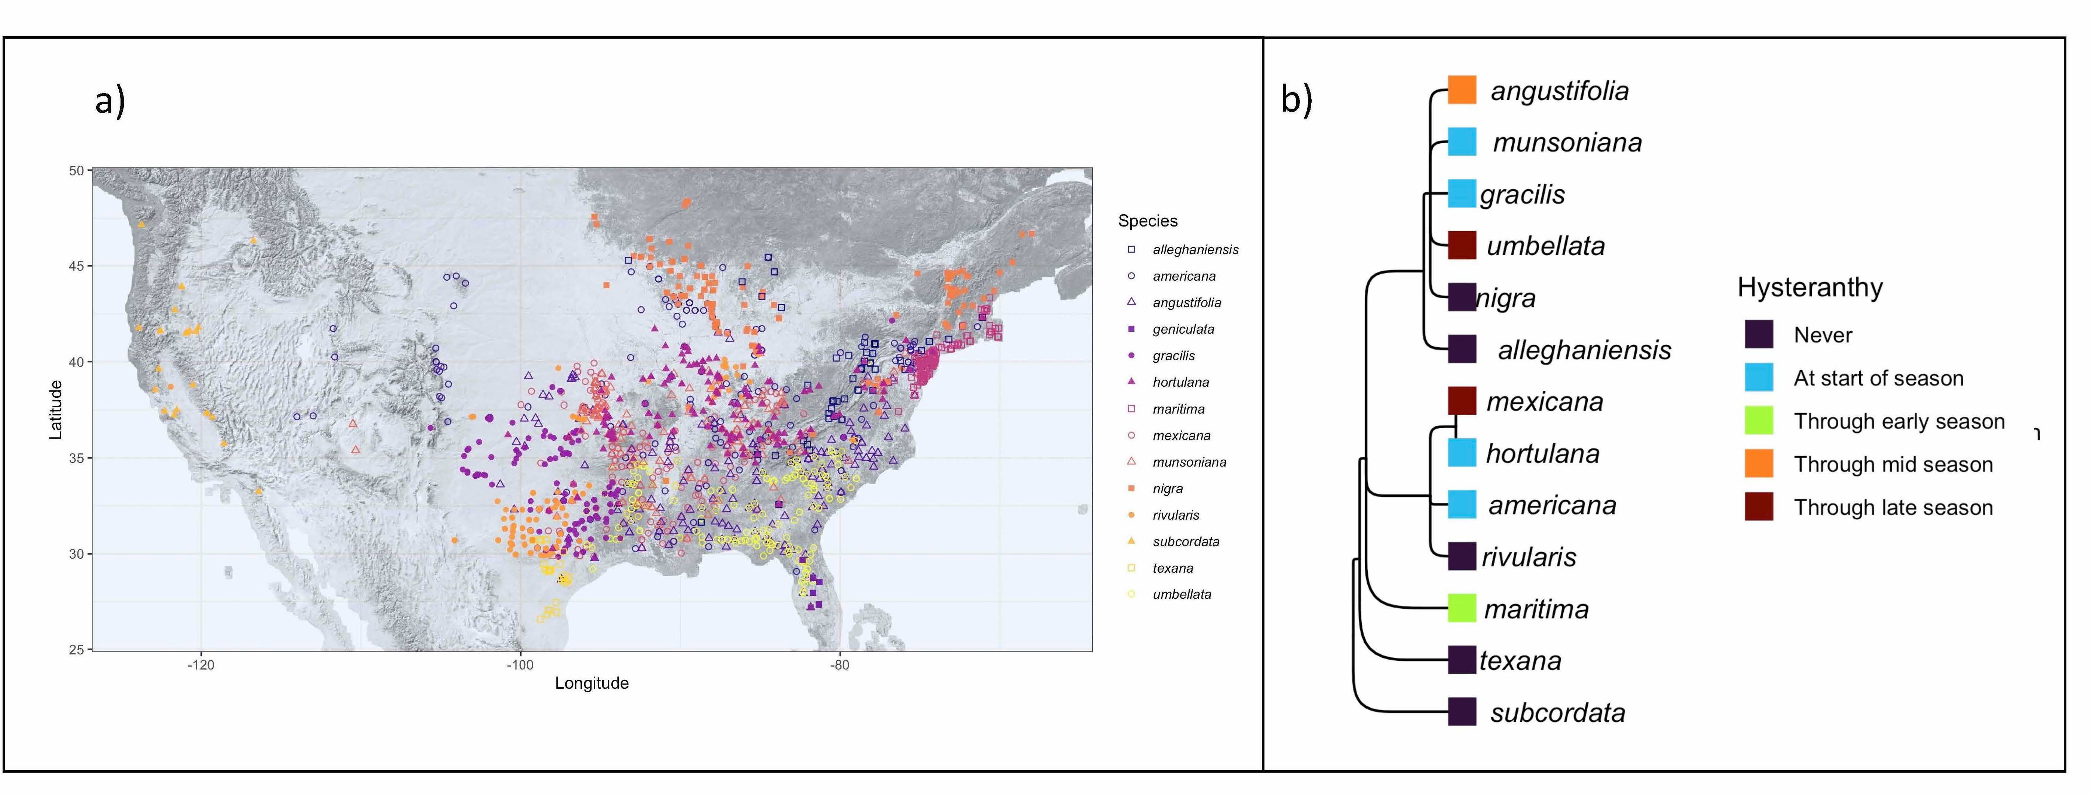

Figure 1: Geographic distribution and taxonomic relationships among the American plums. a) Maps the localities of all the herbaria records used in this study. b) Depicts phylogenetic relationships among the American plums and the duration of their ﬂowering period they are hysteranthous. These categorizations are based on ordinal phylogenetic mixed models. Tree topology is from Shaw & Small (2004)

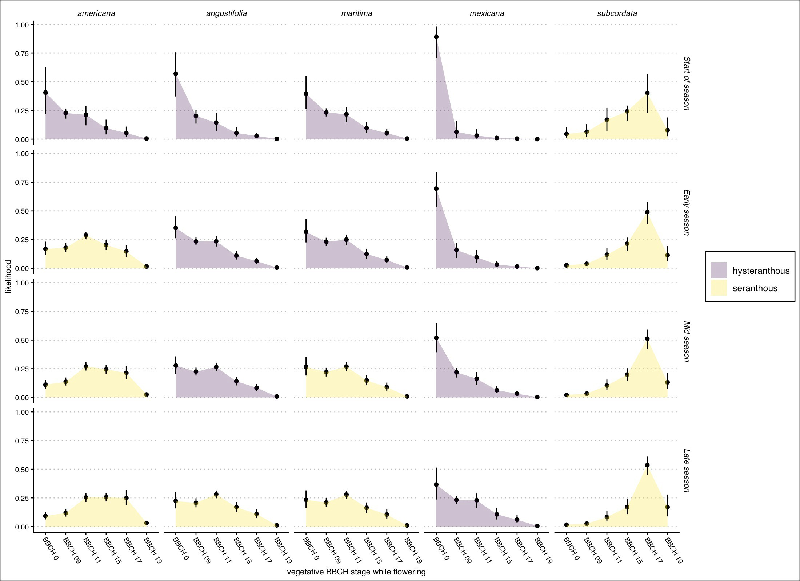

Figure 2: Predicted likelihood that a species would be in ﬂower during each vegetative BBCH phase for ﬁve example species in the American plums. Points are the mean likelihood while bars represent 95% uncertainty intervals. Species were classiﬁed as hysteranthous if greater than 50% probability ﬂowering occurred in BBCH 0 and BBCH 09 (colors) for each part of the ﬂowering season. See Fig. S1 for all species and alternative hysteranthy classiﬁcation schemes.

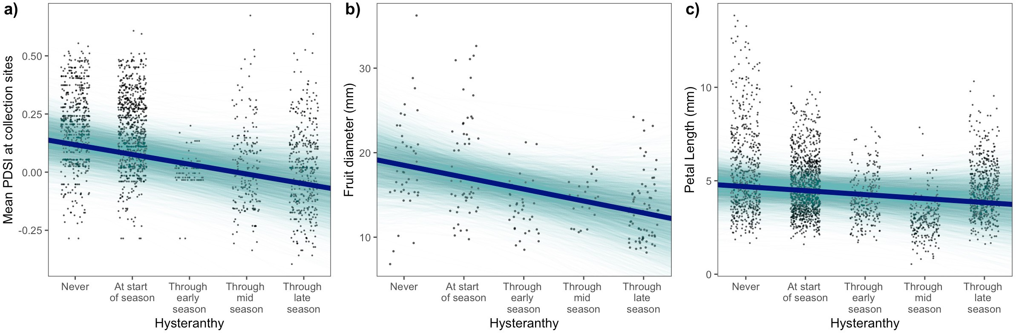

Figure 3: Relationships between the duration of hysteranthy across the ﬂowering period and environmental and biological traits based on Bayesian phylogenetic mixed models. a) b) and c) depict the relationships between the duration of hysteranthy and mean PDSI, fruit diameter, and petal length respectively. Solid lines indicate the mean posterior estimate and shaded areas 4000 draws from the posterior distrubtion as a display of uncertainty. The points are jittered along the x-axis only for visibility.

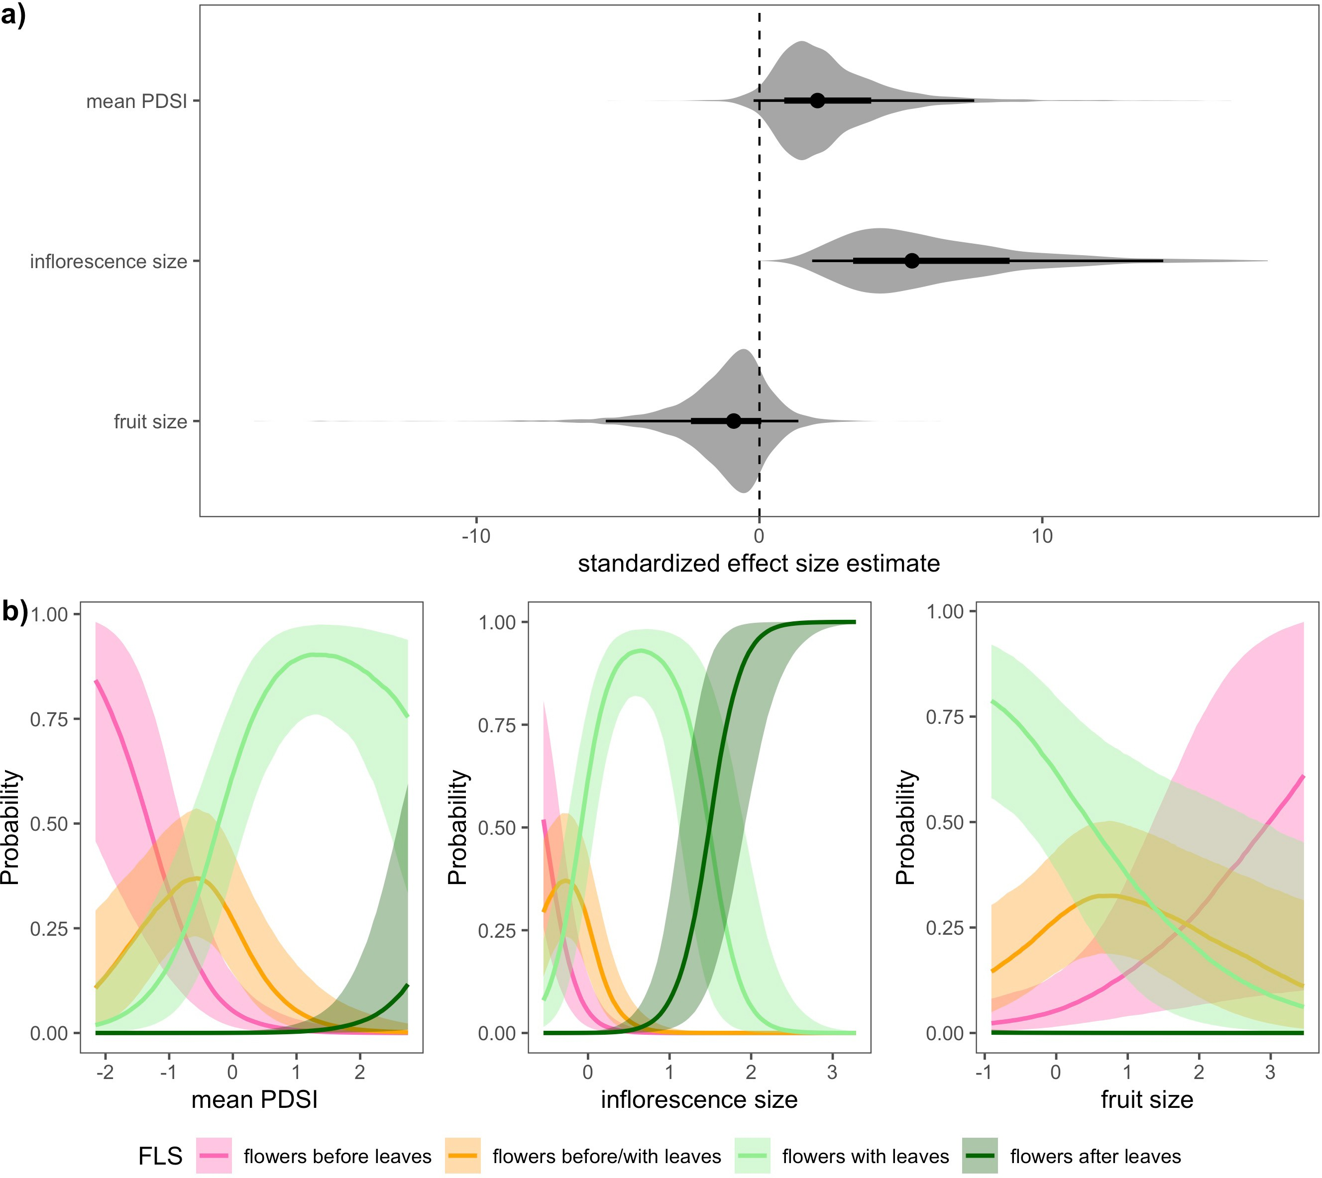

Figure 4: Relationships between the likelihood of hysteranthy and environmental and biological traits in the genus *Prunus* based on Bayesian phylogenetic mixed models. Panel a) shows the estimated eﬀect size of each predictor with negative values indicating an increased likelihood of hysteranthy. Points indicate the mean posterior estimate for each predictor, and thick and thin bars the 50% and 97.5% uncertainty intervals respectively. We also show the full posterior distribution as an additional more of uncertainty, Panel b), c) and d) show the marginal eﬀect of mean PDSI, inﬂorescence size and fruit size respectively, on the likelihood that of each ﬂower-leaf sequence category. Solid lines indicate the mean likelihood and shaded areas the 50% uncertainty intervals.