1 Seedling competition with an invasive woodland herb is mediated by
2 cold stratiﬁcation

3 D.M. Buonaiuto ^{1,2,3a}, E.M. Wolkovich

4 Author aﬃliations:
5 1Department of Environmental Conservation, University of Massachusetts, Amherst, Massachusetts, USA.
6 ORCID: 0000-0003-4022-2591
7 2Arnold Arboretum of Harvard University, Boston, Massachusetts, USA.
8 3Department of Organismic and Evolutionary Biology, Harvard University, Cambridge, Massachusetts, USA
9 4Forest & Conservation Sciences, Faculty of Forestry, University of British Columbia, Vancouver, British
10 Columbia, Canada
11 aCorresponding author: 617.823.0687; dbuonaiuto@umass.edu

12

13 Abstract

14 1. Invasive plants are often characterized by rapid germination and precocious phenology. Theory sug-
15 gests that early germination may provide invaders with competitive advantage over slower germinating
16 natives, but the relative contribution of rapid germination vs. other intrinsic competitive traits to the
17 success of invaders is poorly understood. Depending on the relationship between germination and com-
18 petition, shifts in germination phenology due to climate change may increase the dominance of invaders
19 or buﬀer communities against their impacts.

20 2. We investigated the link between temperature variation, germination phenology and competitive inter-
21 actions with a sequence of controlled environment experiments. First, we evaluated the relationships
22 between temperature variation and germination phenology for two North American herbaceous species,
23 the invasive Hesperis matronalis and native Cryptotaenia canadensis. We then leveraged temperature-
24 response diﬀerences to manipulate the relative germination phenology of these taxa and quantiﬁed the
25 eﬀects of their phenological diﬀerences on competition.

26 3. Seeds of the invasive H. matronalis germinated rapidly, reaching 50% germination in under ten days
27 in all treatment combinations.C. candensis did not reach 50% germination with less than seven weeks
28 of cold stratiﬁcation. However, with more than 10 weeks of cold stratiﬁcation and low (20/10^{2,3,4}
◦C) in-
29 cubation temperatures, the germination phenology of C. canadensis was well matched to that of H.
30 matronalis. When grown together in competition, we found that precocious germination phenology
31 doubled the competitive impact of H. matronalis relative to its other intrinsic competitive traits. Phe-
32 nological advances of just two-three days relative to C. canadensis were enough to secure competitive
33 dominance at the seedling stage.

34 4. Synthesis and applications. This study revealed that the mechanistic link between the germination
35 phenology and competitive success of an invasive plant can be strongly mediated by climate sensitivity
36 diﬀerences between introduced and native species. Climate change will likely exacerbate these diﬀer-
37 ences, especially in regions where warming reduces the cold stratiﬁcation. Our ﬁndings suggest that
38 phenological diversity in native plant communities is an important property of invasion resistance. The
39 relationship between environmental variation, germination dynamics and competition provide a path
40 forward for forecasting climate change impacts on seasonal community assembly, and highlights the
41 need to incorporate phenological diversity in restoration.

42 Keywords: competition, climate change, germination, invasion, phenology, priority eﬀects, stratiﬁcation
43 Introduction

44 A central tenet of community assembly theory is that the order of arrival of species mediates inter-speciﬁc
45 interactions and can dictate the trajectory of community structure (Fukami, 2015). These historical contin-
46 gencies, known as priority eﬀects, alter the structure and function of communities, driving communities to
47 long-term alternate stable states (Fukami & Nakajima, 2011). Yet in many ecosystems, plant communities
48 must re-assemble each year after a period of dormancy. In these communities, priority eﬀects are the prod-
49 ucts of phenology, the timing of seasonal life cycle events, rather than the timing of the arrival of propagules,
50 which occurs prior to the dormant season in many cases (Rudolf, 2019; Howe & Smallwood, 1982; Baskin &
51 Baskin, 1988a).

52 Invasive plants are often characterized by rapid germination and precocious phenology under a wide variety
53 of environmental conditions (Gioria et al., 2018; Gioria & Pyˇsek, 2017; Wolkovich & Cleland, 2011; Smith,
54 2013). By contrast, native plants tend to exhibit more constrained germination cues (Marushia et al., 2010;
55 Wainwright & Cleland, 2013; Van Clef & Stiles, 2001). In many temperate systems, seeds of native plants are
56 dispersed with deep physiological dormancy, requiring prolonged exposure to speciﬁc environmental condi-
57 tions, such as cold stratiﬁcation (cool temperatures of 0-10◦ C), to break dormancy and stimulate germination
58 (ten Brink et al., 2013; Cavieres & Sierra-Almeida, 2017; Bradford & Nonogaki, 2007).

59 These diﬀerences in germination physiology can yield strong diﬀerences in the relative germination phenology
60 of invasive and native plants, with invaders germinating well before their native competitors (Gioria &
61 Pyˇsek, 2017). This diﬀerence in relative germination timing among species, which we refer to as phenological
62 advantage, can contribute signiﬁcantly to the competitive abilities, and ultimately invasion success, of invasive
63 plants. By allowing them to begin drawing down seasonal resources and modifying their environment before
64 their native competitors emerge (Kardol et al., 2013), invaders gain a competitive advantage through a
65 seasonal priority eﬀect (Wainwright et al., 2011).

66 Despite the growing interest in seasonal priority eﬀects, it has been diﬃcult to quantify their overall contri-
67 bution to the competitive success of invaders. Germination is notoriously diﬃcult to monitor in the ﬁeld, and
68 rapid phenology often co-varies with other competitive traits (Dickson et al., 2012; Milbau et al., 2003; Hao
69 et al., 2009). Because of these diﬃculties, many experiments vary phenological advantage by sowing com-
70 peting seeds at diﬀerent time intervals (Young et al., 2017). While these experiments have provided strong
71 evidence that phenological advantage—on the order of just days to weeks—can yield substantial priority
72 eﬀects (Weidlich et al., 2020), their experimental set-up is diﬃcult to translate into natural communities in
73 which priority eﬀects are mediated by climate, and diﬃcult to use for forecasting. Understanding the role that
74 phenological advantage plays in mediating the dynamics of interspeciﬁc competition is critical for predicting
75 and managing the structure and function of plant communities in the face of anthropogenic climate change.

76 Due to interspeciﬁc diﬀerences in responses to environmental variation, sustained alterations to environmental
77 conditions are already shifting community-wide patterns of germination (Walck et al., 2011). If patterns of
78 germination are indeed tightly linked to the competitive dynamics of communities, then phenological re-
79 organization is likely to shift the strength of species’ interactions, change patterns of invasion, and strongly
80 inﬂuence biological ﬁltering of plant communities.

81 In this study, we generated contrasting levels of phenological advantage among two woodland herbaceous
82 species (the North American invasive Hesperis matronalis and native Cryptotaenia canadensis ) by leveraging
83 their diﬀerences in germination timing in response to environmental variation. First, we performed a series of
84 germination assays in controlled environments under varying temperature regimes to estimate a realistic range
85 of climate-driven variation in phenological advantage. We then used competition trials under contrasting
86 environmental conditions to indirectly manipulate the phenological advantage between these two taxa and
87 quantify the contribution of seasonal priority eﬀects to their competitive dynamics. By linking climate
88 variation, phenological advantage, and seasonal priority eﬀects, our study has important implications for how
89 anthropogenic climate change will alter phenological assembly and, in turn, plant community interactions in
90 the decades to come.

91 Materials and Methods

92 Focal species

93 For this study, we focused on a pair of woodland herbaceous species. Dames Rocket (Hesperis matronalis ) is
94 a herbaceous biennial/perennial species in the Brasicaeceae family, originally from Eurasia, and introduced
95 to North America in the 19th century (Francis et al., 2009). It can rapidly invade meadows, forest edges
96 and woodlands, forming thick stands and excluding native vegetation (Francis et al., 2009). It is currently
97 listed as a noxious or invasive weed is several states and provinces in the United States and Canada (Susko &
98 Hussein, 2008). Honewort (Cryptotania canadensis ) is a herbaceous perennial in the Apiaceae family, native
99 to forests and woodlands of eastern North America (Hawkins et al., 2007). The habitat overlap of these two
100 species suggests that they may compete in nature. While their habitat requirements may be similar, the two
101 species display a substantially diﬀerent germination niche, making them a suitable model for our study. C.
102 canadensis seeds are classiﬁed with deep physiological dormancy and require a substantial period of cold moist
103 stratiﬁcation to release dormancy and initiate germination (Baskin & Baskin, 1988b). While some reports
104 suggests that cold stratiﬁcation enhances germination in H. matronalis at low incubation temperatures,
105 several studies have demonstrated that fresh and after-ripened (dry-stored) seeds of H. matronalis are capable
106 of rapid and complete germination at a wide range of temperatures (Susko & Hussein, 2008).

107 Experiment I: Germination Assays

108 To investigate the relationship between environmental variation and relative germination timing among
109 species, we obtained seeds of C. canadensis from Prairie Moon Nursery (Winona, MN) and seeds of H.
110 matronalis from American Meadows (Shelburne, VT). We performed germination assays in the growth fa-
111 cilities of the Arnold Arboretum in Boston, Massachusetts, USA (42.3074◦ N, 71.1208◦ W). We assigned
112 seeds to a fully-crossed set of twenty experimental treatments; 10 levels of of cold stratiﬁcation duration
113 (0,2,4,5,6,7,8,9,11,13 weeks at 4◦C) and two levels of incubation temperature (warm— 25◦C:15◦C (day/night),
114 cool— 20◦C:10◦C (day/night)).

115 Prior to applying experimental treatments we performed a “ﬂoat test” in which all seeds were placed in
116 distilled water, and unﬁlled seeds (ﬂoating) were removed from the experiment (Baskin & Baskin, 2014).
117 We imbibed the remaining seeds in distilled water for 24 hours and then placed 20 seeds for each species/
118 treatment combination in petri dishes on moist pool-ﬁlter sand, with three replicates per treatment. For the
119 cold stratiﬁcation treatments, we wrapped petri dishes in aluminum foil to prevent light exposure and placed
120 them in a growth chamber at 4◦C. After each stratiﬁcation interval, we transferred the petri dishes to their
121 assigned incubation chamber for 25 days, moistening the germination substrate as necessary to maintain
122 maximum saturation of the medium without ﬂooding the seeds. We checked for new germinates every two
123 days, deﬁning a seed as germinated when its radical or cotyledon tissue was visible (Baskin & Baskin, 2014).
124 We assessed the viability of any seeds that did not germinate in the 25 day incubation period by performing
125 a “crush test” in which we applied pressure to the intact seed to evaluate its condition (Baskin & Baskin,
126 2014). We excluded any seeds deemed unviable from all subsequent analyses. Due to the staggering of our
127 stratiﬁcation treatments the experiment took place between 27 August - 12 December 2018.

128 Experiment II: Competition Trials

129 To quantify the contribution of seasonal priority eﬀects to interspeciﬁc competition dynamics we performed
130 competition trials under controlled conditions in a research greenhouse at the Arnold Arboretum from October
131 2020 - February 2021. We planted seeds of C. canadensis and H. matronalis into 8.9 cm square pots, employing
132 a response surface design where we varied both the overall density of seeds and proportion of each species in
133 each pot (Inouye, 2001). High and low density treatments consisted of 14 and 8 seeds respectively. Proportion
134 treatments were 100:0%, 25:75%, 50:50%, 75:25%, 0:100% (C. canadensis:H. matronalis). Each density by
135 proportion treatment was replicated six times.

136 We randomly assigned half of the pots to low (45 days) and high (72 days) cold stratiﬁcation treatments in
137 dark growth chambers at 4◦C. We staggered the start of the treatments, so that at the conclusion of the
138 cold stratiﬁcation, all pots were transferred to a heated greenhouse maintained at 15-25◦C with 14 hours of
139 supplemental light. Germination was observed daily from 24 December 2020 - 13 January 2021 and every two
140 days from 15 January 2021 - 01 February 2021. The locations of each pot in the greenhouse were randomly
141 reassigned every three days to minimize any blocking eﬀects on germination or growth.

142 After 35 days we added 1 tsp per gallon of water of Peters 20-10-20 liquid feed fertilizer to all pots. After 62
143 days, we harvested the above-ground biomass from all pots, dried it for 48 hours at 60◦C, and recorded the
144 dry weight of each species/pot.

145 Statistical analysis

146 Germination Assays

147 To assess interspeciﬁc diﬀerences in the relationship between germination rate and temperature variability,
148 we ﬁt a Bayesian mixed-eﬀect accelerated failure time model (AFT, Onofri et al., 2010) using a Weibull
149 distribution for the likelihood function. We included weeks of stratiﬁcation and incubation temperature and
150 their interaction with species as ﬁxed eﬀects. The model written below is modiﬁed from Onofri et al. (2010).

151 t₅₀ = t₀ϕ

152 where t₅₀ is time to 50% germination and corresponds to the germination times of a references seed lot
153 (t₀) multiplied by and “acceleration factor” (ϕ). The acceleration factor is a product of the experimental
154 treatments of our study through the equation:

155 ϕ = exp(βspXsp + βstratXstrat + βincXinc + βstratXspeciesXstrat ∗ Xsp + βincXspeciesXinc ∗ Xsp)
156 where X_{sp}, X_{strat} and X_{inc} are the species, stratiﬁcation and incubation treatment levels in our experiment,
157 and β_{sp}, β_{strat}, β_{inc}, β_{stratXspecies} and β_{incXspecies} are the estimated eﬀects on ϕ for adding an additional
158 week or stratiﬁcation or degree of incubation for each species respectively.

159 The AFT modeling framework let us robustly compare germination timing (t50, time to 50% germination)
160 even among treatments with diﬀerent ﬁnal germination percentages by accounting for viable seeds that did
161 not germinate during our incubation window (Soltani et al., 2015; Onofri et al., 2010). One drawback of
162 this approach is that this class of models assumes that all viable seeds will eventually germinate, which we
163 would not expect in nature. For this reason, we considered any estimated t50 values greater than 40 days to
164 indicate that seeds would not reach 50% germination under those conditions.

165 Competition trials

166 We quantiﬁed phenological advantage between species by subtracting the mean germination time of H.
167 matronalis from that of C. canadensis in each pot. This allowed us to evaluate the eﬀect phenological
168 advantage with a regression design (Cottingham et al., 2005), with advantage values ranging from -1.3 to 9.5
169 (C. candensis mean germination time 1.3 days earlier to 9.5 days later than H. matronalis ).

170 For each pot, we calculated the relative growth rate diﬀerence (RGRD) among species using the equation
171 below, modiﬁed from Connolly & Wayne (2005).

172

YCc YHm
173 RGRD = ln( yCc ) − ln( yHm )
174

175 where Y_{Hm} and Y_{Cc} are the ﬁnal biomass of the species at the end of the experiment and y_{Hm} and y_{Cc} are
176 the initial biomass of the seeds planted at the outset of the experiment. For this calculation we obtained
177 estimates of seed mass for our focal species from the Kew Gardens Seed Information Database (Kew, 2022).

178 We then modeled the eﬀect of seedling density of C. canadensis, H. matronalis and phenological advantage
179 using on RGRD. The model is written below:

180

181 RGRD_{i} = N (α + β_{Hm}n_{Hm} + β_{Cc}n_{Cc} + β_{pri}MGT, σ² )
RGRD

182

183 where β_{Hm} and β_{Cc} are known as the species inﬂuence parameters—representing the intrinsic competitive
184 ability of each species—or the estimated eﬀect of increasing the seedling density of each species by one
185 individual on the RGRD (Connolly & Wayne, 2005), and β_{pri} is the priority eﬀect, or the eﬀect of increasing
186 the diﬀerence in mean germination time between H.matronalis and C. canadensis by one day. n_{Hm} and
187 n_{Cc} are the number of germinated individuals of H. matronalis and C. canadensis respectively. In this
188 formulation, α is an un-interpretable intercept (Connolly & Wayne, 2005).

189 To assess whether the rapid germination phenology of H. matronalis modiﬁed the germination niche of C.
190 canadnesis we performed two additional Bayesian regression analyses. We assessed the inﬂuence of planting
191 type (single species vs. mixed competition) on the likelihood of C. canadensis germination using a Bernoulli
192 likelihood distribution and the mean germination time of C. canadensis using a Gaussian likelihood distri-
193 bution. In both models we included stratiﬁcation treatment as a ﬁxed-eﬀect co-variate.
194 Model Implementation

We ﬁt all models using the R package “brms” (Bu¨rkner, 2018). We ran the model on four chains with 4000 iterations and a 3000 iteration warm-up for a total of 4000 posterior draws for each parameter, using weakly informative priors. We validated model performance by obtaining Rˆ values between 1 and 1.01, high eﬀective
sample sizes and no divergent transitions. For all models we report the mean posterior estimate along with 90% uncertainty intervals (I₉₀).

195 Results

196 Germination advantage

197 H. matronalis reached 50% germination in under ten days for all environmental treatments, always exceeding
198 75% germination regardless of environmental conditions (Fig. 1, Tab. S1). Increasing cold stratiﬁcation
199 duration and incubation temperature only marginally enhanced the germination rate of this species (Fig.
200 1). By contrast, increasing incubation temperature had a delaying eﬀect on the germination rate of C.
201 canadensis, suggesting that the mean 20◦C temperature of our warm incubation treatment is supra-optimal
202 for the species (Fig. 1). Without suﬃcient cold stratiﬁcation (<7 weeks for low incubation and <10 weeks
203 for high incubation temperatures), seeds of C. canadensis did not reach 50% germination during the duration
204 of our experiment (Fig. 1, Tab. S1). However, under high levels of cold stratiﬁcation germination rates of
205 C.canadensis began to converge on those of H. matronialis, and at levels of stratiﬁcation >10 weeks and low
206 incubation, the germination rate and fraction of C.canadensis was well matched to that of H. matronalis
207 (Fig. 1, Tab. S1).

208 Germination priority eﬀects

209 In the absence of phenological advantage, the inﬂuence of adding one seedling of H. matronalis to a pot
210 community was almost 4X less than adding one C. canadensis seedling on the pot-level RGRD (represented
211 by the species’ inﬂuence parameters β_{Hm}, β_{Cc}—H. matronalis (β_{Hm}): 0.13, I₉₀: 0.08,0.17, C. canadensis
212 (β_{Cc}): -0.40, I₉₀: -0.46, -0.35 ). Each day increase in the phenological advantage of H. matronalis had
213 approximately the same inﬂuence on shifting the community biomass composition towards H. matronalis as
214 adding an individual of that species to the community (seasonal priority eﬀect (β_{pri}): 0.15, I₉₀: 0.09, 0.20,
215 Fig. 2, Tab. S2). Together, these results suggest that H. matronalis will come to dominate the community
216 biomass composition unless C. canadensis is at high relative abundance or the phenological advantage of H.
217 matronalis is small.

218 Priority eﬀects and germination niche modiﬁcation

219 We observed no evidence that the rapid germination of H. matronalis adversely modiﬁed the germination
220 niche of C. canadensis. Neither the likelihood of germination nor the mean germination time of C. canadensis
221 were suppressed when the species grew in mixed-species competition vs. single-species pots (Fig. 3). Rather,
222 at low stratiﬁcation levels, the presence of rapidly germinating H. matronalis might have positively aﬀected
223 the germination fraction of C. canadensis, (C. canadensis germination percentage is higher in competition
224 pots under low stratiﬁcation, Fig. 3a), though there is high uncertainty in this comparison.

225 Discussion

226 Environmental drivers of seasonal priority eﬀects

227 Our experimental results advance the understanding of the role of seasonal priority eﬀects on competition by
228 identifying a natural mechanism, species’ diﬀerential sensitivity to temperature, that can generate seasonal
229 priority eﬀects. In the absence of phenological advantage, the intrinsic competitive abilities of each species
230 suggest that the native species, C. canadensis, is the stronger competitor (Fig. 2). However, the inﬂuence of
231 one day of phenological advantage for H. matronalis virtually doubled its inﬂuence on the ﬁnal community
232 composition, suggesting that seasonal priority eﬀects play a major role in the competitive success of H.
233 matronalis (Fig. 2). Our results indicate that C. canadensis can compete with the invasive H. matronalis
234 at high relative abundance levels and/or when phenological advantage is low, joining a growing body of
235 experiments demonstrating that relative germination phenology can function as a seasonal priority eﬀect,
236 enhancing the performance of the earliest germinating species at the expense of later germinants (Koerner
237 et al., 2008; Dickson et al., 2012; Ross & Harper, 1972).

238 The role of seasonal priority eﬀects in plant competition has been primarily demonstrated in experiments in
239 which the planting of competing seeds is staggered at increasing intervals (Young et al., 2017; Weidlich et al.,
240 2020). In our experiment, variation in phenological advantage was a product of interspeciﬁc diﬀerences in
241 germination responses to cold stratiﬁcation, suggesting that seasonal priority eﬀects can strongly inﬂuence
242 seedling competition even in environments were germination phenology is under strong temperature control.
243 While it is possible that H. matronalis interacts diﬀerently with other species, the results of our pair-wise
244 competition trial suggests that seasonal priority eﬀects, manifested through rapid germination phenology
245 and propagule pressure, are mechanistically related to the competitive dominance, and—ultimately—invasion
246 success of H. matronalis.

247 Our competition trials did not suggest any evidence that the rapid germination phenology of H. matronalis
248 impacted the germination niche of C. canadensis (Fig. 3). This indicates that the mechanism underlying the
249 seasonal priority eﬀect of H. matronalis is likely niche preemption (Gioria et al., 2018).

250 Seasonal priority eﬀects and anthropogenic climate change

251 The implications of our study for the role of climate variability in mediating seasonal priority eﬀects is two-
252 fold. First, our results suggest that interannual climate variability should generate both among- and within-
253 season variation in competition strength among species, potentially driving species coexistence via the storage
254 eﬀect (Chesson, 2003). Second, the key role we observed of climate in generating germination advantage and
255 therefore seasonal priority eﬀects suggests that sustained alteration to historic patterns of climate variability,
256 like those driven by anthropogenic climate change, are likely to alter the dynamics of competing seedlings.
257 Changing patterns of phenological assembly have downstream eﬀects on the structure and function of plant
258 communities.

259 In our study, the phenological advantage of H. matronalis was maximized under lower stratiﬁcation treat-
260 ments and warmer incubation temperatures. This suggests that the warming temperatures associated with
261 anthropogenic climate change may increase the magnitude of seasonal priority eﬀects, largely due to the
262 delay of germination in more climate-sensitive native species like C. canadensis. Interestingly, the diﬀerence
263 in phenological advantage among our focal species was much higher in our germination assays than in our
264 competition trials even at comparable levels of stratiﬁcation. There are likely several explanations for these
265 diﬀerences.

266 First, we used diﬀerent metrics of germination speed, time to 50% germination (t50) and mean germination
267 time in each experiment. While the metrics are related and often confused, there are important diﬀerences
268 between them that make one or the other more appropriate for the two types of experiments we ran (see
269 Supporting Information: “Measures of germination speed”). Second, the incubation temperatures in our
270 greenhouse competition trials were more variable than in our growth chamber germination assays. The lower
271 germination fractions we observed in C. canadensis under greenhouse conditions suggest that the temperature
272 range was likely supra-optimal for this species, and the lower germination fraction increased the diﬀerence
273 between t50 estimates and mean germination time measurements. Finally, we conducted germination assays
274 and competition trials in diﬀerent growth media (ﬁlter sand vs. potting soil), which have diﬀerent moisture
275 retention and light transmissible capacities. Germination media can aﬀect germination rates (Baskin &
276 Baskin, 2014), which may further explain diﬀerences among our two experiments.
277 Despite these diﬀerences, in both experiments increasing cold stratiﬁcation advanced the germination phe-
278 nology of C. canadensis and weakly that of H. matronalis, resulting in weaker phenological advantage for H.
279 matronalis at higher stratiﬁcation levels. (Fig. 1, Fig. S1) suggesting that the relationships between cold
280 stratiﬁcation and germination phenology we observed were robust.

281 Climate change may also increase the risk of precocious phenology (Inouye, 2000). In our experiment, there
282 was no cost to germinating too early. It is generally accepted that optimum germination phenology is driven
283 by a trade-oﬀ between maximizing the length of the growing season and the risk of exposure to damaging
284 environmental episodes when germinating too early (Augspurger & Salk, 2017). In dry grassland ecosystems,
285 the precocious germination of invasives has a substantial cost if water availability is too low (Wainwright
286 et al., 2011). In temperate forest ecosystems, the primary risk of early phenology is damage from late season
287 frost (Kollas et al., 2014) and climate change is also altering the timing and frequency of frost events (?).
288 Understanding how climate change will reshape this tradeoﬀ between seasonal priority eﬀects and frost risk
289 is a critical next step for understanding plant community interactions in an era of global change.

290 While we found that seasonal priority eﬀects impacted competition among seedlings, our experiment was
291 not able to quantify the role of seasonal priority eﬀects in inﬂuencing the long-term, among-year dynamics
292 of these perennial species. Many studies suggest that these short term priority eﬀects many be transient,
293 though several studies that used staggered planting methods at similar scale to the phenological advantage we
294 observed in our trials saw the inﬂuence of these initial priority eﬀects on community composition maintained
295 several seasons later (Vaughn & Young, 2015; Young et al., 2017; Torrez et al., 2017). In perennial com-
296 munities, these long terms dynamics are even more diﬃcult to assess. Many perennial herbs, C. canadensis
297 included, rely heavily on vegetative reproduction (Hawkins et al., 2005), and competition between ramets,
298 and between ramets and seedlings, may also impact species interactions in the long-term. Understanding how
299 phenological diﬀerences across life stages of long-lived perennial plants aﬀects competition is an important
300 need for predicting how communities may be impacted by interannual environmental variation and climate
301 change.

302 Because we found that seasonal priority eﬀects mediated competition for early ontological stages (germina-
303 tion, seedling), our ﬁndings may be most relevant to global change biology in the context of native plant
304 establishment; whether colonizing new areas due to range shifts, recovering from novel disturbances or eco-
305 logical restoration. In fact, there has been a growing call to increase phenological diversity in restoration
306 planning (Hess et al., 2019). Studies have found that including early active species in plantings can suppress
307 the abundance of invaders in both grassland (Cleland et al., 2013) and forest ecosystems (Schuster et al.,
308 2020). At the same time, restoration mixes tend to lack species which ﬁll the early season phenological
309 niche (Havens & Vitt, 2016). The results of our study suggest that minimizing the priority eﬀect conferred
310 to invasive species due to rapid germination and early phenology by including species with similar, early
311 phenological traits could be a powerful tool for managing plant invasions and restoring native ecosystems in
312 an era of global change.

313 Conclusion

314 By leveraging the diﬀerential germination sensitivities to environmental cues of two competing species to ma-
315 nipulate phenological advantage between them, we were able to quantify the contribution of seasonal priority
316 eﬀects gained through rapid phenology on the competitive ability of the invasive species H. matronalis. We
317 found that priority eﬀects were approximately as strong as the intrinsic competitive traits of H. matronalis
318 in inﬂuencing its competitive dominance over the native forest herb Cryptotaenia canadensis, suggesting sea-
319 sonal priority eﬀects mechanistically increase the invasion success of H. matronalis. Variation in germination
320 phenology was strongly mediated by diﬀerences in how species respond to temperature cues, suggesting that
321 sustained climate change will alter patterns of phenological advantage, potentially strengthening the seasonal
322 priority eﬀects of invaders as climate warms. Our ﬁndings highlight the important role of phenological diver-
323 sity in the invasion resistance of native plant communities, implying that measures of phenological diversity
324 should be incorporated into plant community assessments and ecological restoration.

325 Author Contributions

326 DMB and EMW conceived of this manuscript; DMB designed and executed the experiments, collected the
327 data and performed the analyses; DMB led the writing of the manuscript. All authors contributed critically
328 to drafts and gave ﬁnal approval for submission.

329 Acknowledgements

330 Special thanks to K.J Woodruﬀ, L. Toomey and the rest of the Arnold Arboretum research greenhouses staﬀ
331 for helping to manage the growth facilities as well as maintain and repeat these experiments throughout lab
332 closures, quarantines and all other Covid19-related challenges.
333 Conﬂict of Interest

334 The authors declare no conﬂict of interest.

335 Statement on Inclusion

336 This paper includes authors from multiple countries, including one based in the country where the study was
337 carried out and region in which the study organisms are found.

338 Data Availability

339 Data from the germination assays and competition trials, and associated modeling code will be made available
340 at the time of publication at KNB (https://knb.ecoinformatics.org/).

341 References

342 Augspurger, C.K. & Salk, C.F. (2017) Constraints of cold and shade on the phenology of spring ephemeral
343 herb species. Journal of Ecology 105, 246–254.
344 Baskin, C. & Baskin, J. (2014) Seeds: Ecology,Biogeography, and Evolution of Dormancy and Germination.
345 Elsevier Inc.
346 Baskin, C.C. & Baskin, J.M. (1988a) Germination ecophysiology of herbaceous plant species in a temperate
347 region. American Journal of Botany 75, 286–305.

348 Baskin, J.M. & Baskin, C.C. (1988b) The ecological life cycle of cryptotaenia canadensis (l.) dc. (umbelliferae),
349 a woodland herb with monocarpic ramets. The American Midland Naturalist 119, 165–173.
350 Bradford, K.J.K.J.. & Nonogaki, H. (2007) Seed development, dormancy, and germination. Blackwell Pub.,
351 Oxford, OX, UK; Ames, Iowa, USA.
352 Bu¨rkner, P.C. (2018) Advanced bayesian multilevel modeling with the r package brms. R Journal 10, 395–411.
353 Cavieres, L. & Sierra-Almeida, A. (2017) Assessing the importance of cold-stratiﬁcation for seed germination
354 in alpine plant species of the high-andes of central chile. Perspectives in Plant Ecology, Evolution and
355 Systematics 30.
356 Chesson, P. (2003) Quantifying and testing coexistence mechanisms arising from recruitment ﬂuctuations.
357 Theoretical Population Biology 64, 345–357.
358 Cleland, E.E., Larios, L. & Suding, K.N. (2013) Strengthening invasion ﬁlters to reassemble native plant
359 communities: Soil resources and phenological overlap. Restoration Ecology 21, 390–398.
360 Connolly, J. & Wayne, P. (2005) Assessing determinants of community biomass composition in two-species
361 plant competition studies. Oecologia 142, 450–457.
362 Cottingham, K.L., Lennon, J.T. & Brown, B.L. (2005) Knowing when to draw the line: designing more
363 informative ecological experiments. Frontiers in Ecology and the Environment 3, 145–152.
364 Dickson, T.L., Hopwood, J.L. & Wilsey, B.J. (2012) Do priority eﬀects beneﬁt invasive plants more than
365 native plants? an experiment with six grassland species. Biological Invasions 14, 2617–2624.
366 Francis, A., Cavers, P.B. & Warwick, S.I. (2009) The biology of canadian weeds. 140. hesperis matronalis l.
367 Canadian Journal of Plant Science 89, 191–206.
368 Fukami, T. (2015) Historical contingency in community assembly: Integrating niches, species pools, and
369 priority eﬀects. Annual Review of Ecology, Evolution, and Systematics 46, 1–23.
370 Fukami, T. & Nakajima, M. (2011) Community assembly: alternative stable states or alternative transient
371 states? Ecology Letters 14, 973–984.
372 Gioria, M. & Pyˇsek, P. (2017) Early bird catches the worm: germination as a critical step in plant invasion.
373 Biological Invasions 19, 1055–1080.
374 Gioria, M., Pyˇsek, P. & Osborne, B.A. (2018) Timing is everything: does early and late germination favor
375 invasions by herbaceous alien plants? Journal of Plant Ecology 11, 4–16.
376 Hao, J.H., Qiang, S., Liu, Q.Q. & Cao, F. (2009) Reproductive traits associated with invasiveness in conyza
377 sumatrensis. Journal of Systematics and Evolution 47, 245–254.
378 Havens, K. & Vitt, P. (2016) The importance of phenological diversity in seed mixes for pollinator restoration.
379 Natural Areas Journal 36, 531–537.
380 Hawkins, T.S., Baskin, J.M. & Baskin, C.C. (2005) Life cycles and biomass allocation in seed- and ramet-
381 derived plants of cryptotaenia canadensis (apiaceae), a monocarpic species of eastern north america. Cana-
382 dian Journal of Botany 83, 518–528.
383 Hawkins, T.S., Baskin, J.M. & Baskin, C.C. (2007) Seed morphology, germination phenology, and capacity
384 to form a seed bank in six herbaceous layer apiaceae species of the eastern deciduous forest. Castanea 72,
385 8–14.
386 Hess, M.C.M., Mesl´eard, F. & Buisson, E. (2019) Priority eﬀects: Emerging principles for invasive plant
387 species management. Ecological Engineering 127, 48–57.
388 Howe, H.F. & Smallwood, J. (1982) Ecology of seed dispersal 13, 201–228.
389 Inouye, B. (2001) Response surface experimental designs for investigating interspeciﬁc competition. Ecology
390 82, 2696–2706.
391 Inouye, D.W. (2000) The ecological and evolutionary signiﬁcance of frost in the context of climate change.
392 Ecology Letters 3, 457–463.
393 Kardol, P., Souza, L. & Classen, A.T. (2013) Resource availability mediates the importance of priority eﬀects
394 in plant community assembly and ecosystem function. Oikos 122, 84–94.
395 Kew, R.B.G. (2022) Seed information database (sid). version 7.1.
396 Koerner, C., Stoecklin, J., Reuther-Thiebaud, L. & Pelaez-Riedl, S. (2008) Small diﬀerences in arrival time
397 inﬂuence composition and productivity of plant communities. New Phytologist 177, 698–705.
398 Kollas, C., Ko¨rner, C. & Randin, C.F. (2014) Spring frost and growing season length co-control the cold
399 range limits of broad-leaved trees. Journal of Biogeography 41, 773–783.
400 Marushia, R.G., Cadotte, M.W. & Holt, J.S. (2010) Phenology as a basis for management of exotic annual
401 plants in desert invasions. Journal of Applied Ecology 47, 1290–1299.
402 Milbau, A., Nijs, I., Van Peer, L., Reheul, D. & De Cauwer, B. (2003) Disentangling invasiveness and
403 invasibility during invasion in synthesized grassland communities. New Phytologist 159, 657–667.
404 Onofri, A., Gresta, F. & Tei, F. (2010) A new method for the analysis of germination and emergence data of
405 weed species. Weed Research 50, 187–198.
406 Ross, M.A. & Harper, J.L. (1972) Occupation of biological space during seedling establishment 60, 77–88.
407 Rudolf, V.H.W. (2019) The role of seasonal timing and phenological shifts for species coexistence. Ecology
408 Letters 22, 1324–1338.
409 Schuster, M.J., Wragg, P.D., Williams, L.J., Butler, E.E., Stefanski, A. & Reich, P.B. (2020) Phenology
410 matters: Extended spring and autumn canopy cover increases biotic resistance of forests to invasion by
411 common buckthorn (rhamnus cathartica). Forest Ecology and Management 464, 118067.
412 Smith, L.M. (2013) Extended leaf phenology in deciduous forest invaders: mechanisms of impact on native
413 communities. Journal of Vegetation Science 24, 979–987.
414 Soltani, E., Ghaderi-Far, F., Baskin, C.C. & Baskin, J.M. (2015) Problems with using mean germination
415 time to calculate rate of seed germination. Australian Journal of Botany 63, 631–635.
416 Susko, D.J. & Hussein, Y. (2008) Factors aﬀecting germination and emergence of dame’s rocket (hesperis
417 matronalis). Weed Science 56, 389–393.
418 ten Brink, D.J., Hendriksma, H.P. & Bruun, H.H. (2013) Habitat specialization through germination cueing:
419 a comparative study of herbs from forests and open habitats. Annals of Botany 111, 283–292.
420 Torrez, V., Mergeay, J., Meester, L.D., Honnay, O., Helsen, K. & Standish, R. (2017) Diﬀerential eﬀects
421 of dominant and subordinate plant species on the establishment success of target species in a grassland
422 restoration experiment. Applied vegetation science 20, 363–375.
423 Van Clef, M. & Stiles, E.W. (2001) Seed longevity in three pairs of native and non-native congeners: Assessing
424 invasive potential. Northeastern Naturalist 8, 301–310.
425 Vaughn, K.J. & Young, T.P. (2015) Short-term priority over exotic annuals increases the initial density and
426 longer-term cover of native perennial grasses. Ecological Applications 25, 791–799.
427 Wainwright, C.E. & Cleland, E.E. (2013) Exotic species display greater germination plasticity and higher
428 germination rates than native species across multiple cues. Biological Invasions 15, 2253–2264.
429 Wainwright, C.E., Wolkovich, E.M. & Cleland, E.E. (2011) Seasonal priority eﬀects: implications for invasion
430 and restoration in a semi-arid system. Journal of Applied Ecology 49, 234–241.
431 Walck, J.L., Hidayati, S.N., Dixon, K.W., Thompson, K. & Poschlod, P. (2011) Climate change and plant
432 regeneration from seed. Global Change Biology 17, 2145–2161.
433 Weidlich, E.W.A., Nelson, C.R., Maron, J.L., Callaway, R.M., Delory, B.M. & Temperton, V.M. (2020)
434 Priority eﬀects and ecological restoration. Restoration Ecology n/a, e13317.
435 Wolkovich, E.M. & Cleland, E.E. (2011) The phenology of plant invasions: a community ecology perspective.
436 Frontiers in Ecology and the Environment 9, 287–294.
437 Young, T.P., Stuble, K.L., Balachowski, J.A. & Werner, C.M. (2017) Using priority eﬀects to manipulate
438 competitive relationships in restoration. Restoration Ecology 25, S114–S123.

439 Figures
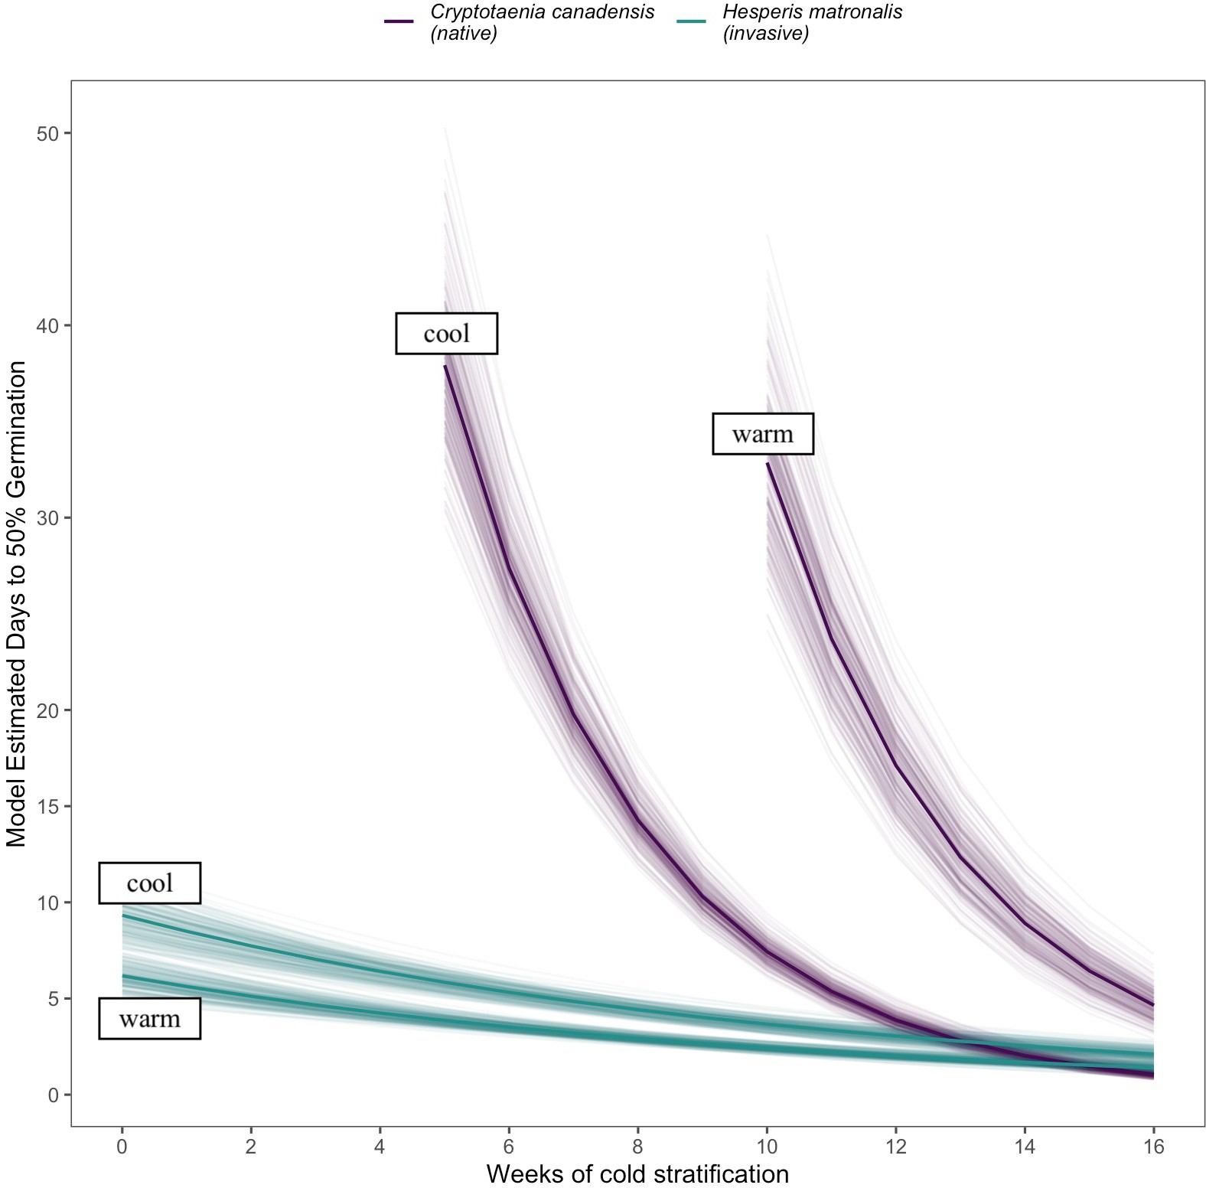

Figure 1: The eﬀects of weeks of cold stratiﬁcation at 4◦ C on the time to 50% germination of Cryptotaenia canadensis and Hesperis matronalis under warm (20/10◦ C day/night) and cool (25/15◦ C day/night) incu- bation conditions, estimated with accelerated failure time model. We show here only stratiﬁcation treatment levels which allowed both species to reach 50% germination in less that 40 days. The solid lines depict the mean estimate, while lighter lines depict uncertainty.

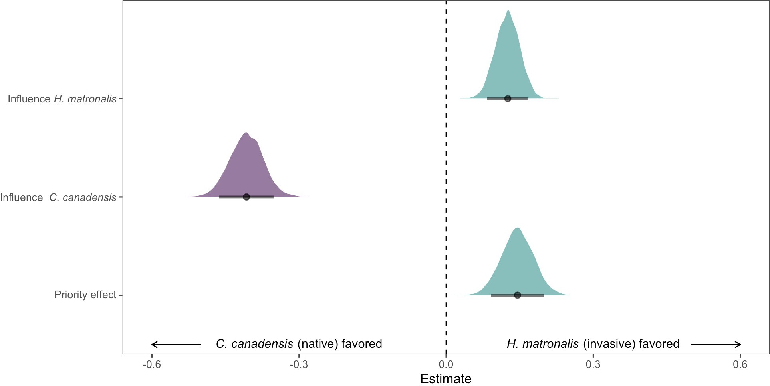

Figure 2: Estimated eﬀects of species’ abundance (intrinsic competitive ability parameters) and phenological advantage (seasonal priority eﬀects) on the relative growth rate diﬀerence between H. matronalis and C. canadensis. Negative parameter estimates indicate the community biomass composition shifts to favor C. candensis while positive estimate towards dominance by H. matronalis. The points indicate the mean estimated eﬀect of each parameter and bars the 90% uncertainty intervals. The full posterior distribution for each parameter is also depicted as an additional measure of uncertainty.

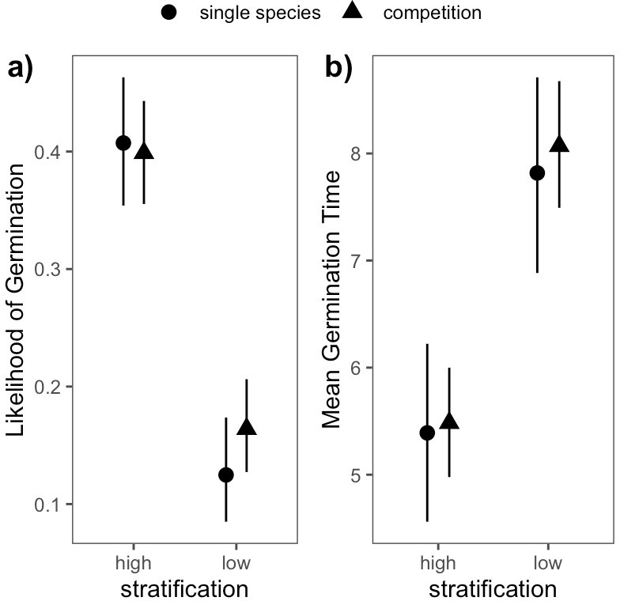

Figure 3: Estimated eﬀects of single and mixed species competition on the germination dynamics of Cryp- totania canadensis under 6 (low) and 10 weeks (high) of cold stratiﬁcation at 4◦C. Panel a) depicts diﬀerences germination likelihood and b) shows the estimated mean germination time in single species vs. competition pot. Points represent the mean estimates under each planting type and bars represent 90% uncertainty in- tervals.

