1 Phenological responses to climate mediate seedling competition with

2 an invasive woodland herb

3 D.M. Buonaiuto 1*,*2*,*3*a*, E.M. Wolkovich2*,*3*,*4

4 *Author aﬃliations:*

5 1Department of Environmental Conservation, University of Massachusetts, Amherst, Massachusetts, USA.

6 ORCID: 0000-0003-4022-2591

7 2Arnold Arboretum of Harvard University, Boston, Massachusetts, USA.

8 3Department of Organismic and Evolutionary Biology, Harvard University, Cambridge, Massachusetts, USA

9 4Forest & Conservation Sciences, Faculty of Forestry, University of British Columbia, Vancouver, British

10 Columbia, Canada

11 *a*Corresponding author: 617.823.0687; [dbuonaiuto@umass.edu](mailto:dbuonaiuto@umass.edu)

12

13 **Abstract**

14 1. Invasive plants are often characterized by rapid germination and precocious phenology. Theory sug-

15 gests that early germination may provide invaders with competitive advantage over slower germinating

16 natives, but the relative contribution of rapid germination vs. other intrinsic competitive traits to the

17 success of invaders is poorly understood. Depending on the relationship between germination and com-

18 petition, shifts in germination phenology due to climate change may increase the dominance of invaders

19 or buﬀer communities against their impacts.

20 2. We investigated the link between temperature variation, germination phenology and competitive inter-

21 actions with a sequence of controlled environment experiments. First, we evaluated the relationships

22 between temperature variation and germination phenology for two North American herbaceous species,

23 the invasive *Hesperis matronalis* and native *Cryptotaenia canadensis*. We then leveraged temperature-

24 response diﬀerences to manipulate the relative germination phenology of these taxa and quantiﬁed the

25 eﬀects of their phenological diﬀerences on competition.

26 3. Seeds of the invasive *H. matronalis* germinated rapidly, reaching 50% germination in under ten days

27 in all treatment combinations.*C. candensis* did not reach 50% germination with less than seven weeks

28 of cold stratiﬁcation. However, with more than 10 weeks of cold stratiﬁcation and low (20/10*◦*C)

29 incubation temperatures, the germination phenology of *C. canadensis* was well matched to that of

30 *H. matronalis*. When grown together, we found that precocious germination phenology doubled the

31 competitive impact of *H. matronalis* relative to its other intrinsic competitive traits. Phenological

32 advantage of just two-three days relative to *C. canadensis* was enough to secure competitive dominance

33 at the seedling stage.

34 4. *Synthesis.* This study revealed that the mechanistic link between the germination phenology and com-

35 petitive success of an invasive plant can be strongly mediated by climate sensitivity diﬀerences between

36 introduced and native species. Climate change will likely exacerbate these diﬀerences, especially in

37 regions where warming reduces the cold stratiﬁcation. Our ﬁndings suggest that phenological diversity

38 in native plant communities is an important property of invasion resistance. The relationship between

39 environmental variation, germination dynamics and competition provide a path forward for forecast-

40 ing climate change impacts on seasonal community assembly, and highlights the need to incorporate

41 phenological diversity in restorations.

42 Keywords: competition, climate change, germination, invasion, phenology, priority eﬀects, stratiﬁcation

43 **Introduction**

44 A central tenet of community assembly theory is that the order of arrival of species mediates inter-speciﬁc

45 interactions and can dictate the trajectory of community structure (Fukami, 2015). These historical contin-

46 gencies, known as priority eﬀects, alter the structure and function of communities, driving communities to

47 long-term alternate stable states (Fukami & Nakajima, 2011). Yet in many ecosystems, plant communities

48 must re-assemble each year after a period of dormancy. In these communities, priority eﬀects are the prod-

49 ucts of phenology, the timing of seasonal life cycle events, rather than the timing of the arrival of propagules,

50 which occurs prior to the dormant season in many cases (Rudolf, 2019; Howe & Smallwood, 1982; Baskin &

51 Baskin, 1988a).

52 Invasive plants are often characterized by rapid germination and precocious phenology under a wide variety

53 of environmental conditions (Gioria *et al.*, 2018; Gioria & Pyˇsek, 2017; Wolkovich & Cleland, 2011; Smith,

54 2013). By contrast, native plants tend to exhibit more constrained germination cues (Marushia *et al.*, 2010;

55 Wainwright & Cleland, 2013; Van Clef & Stiles, 2001). In many temperate systems, seeds of native plants are

56 dispersed with deep physiological dormancy, requiring prolonged exposure to speciﬁc environmental condi-

57 tions, such as cold stratiﬁcation (cool temperatures of 0-10*◦* C), to break dormancy and stimulate germination

58 (ten Brink *et al.*, 2013; Cavieres & Sierra-Almeida, 2017; Bradford & Nonogaki, 2007).

59 These diﬀerences in germination physiology can yield strong diﬀerences in the relative germination phenology

60 of invasive and native plants, with invaders germinating well before their native competitors (Gioria &

61 Pyˇsek, 2017). This diﬀerence in relative germination timing among species, which we refer to as **phenological**

62 **advantage**, can contribute signiﬁcantly to the competitive abilities, and ultimately invasion success, of invasive

63 plants. By allowing them to begin drawing down seasonal resources and modifying their environment before

64 their native competitors emerge (Kardol *et al.*, 2013), invaders gain a competitive advantage through a

65 **seasonal priority eﬀect** (Wainwright *et al.*, 2011).

66 Despite the growing interest in seasonal priority eﬀects, it has been diﬃcult to quantify their overall contri-

67 bution to the competitive success of invaders. Germination is notoriously diﬃcult to monitor in the ﬁeld, and

68 rapid phenology often co-varies with other competitive traits (Dickson *et al.*, 2012; Milbau *et al.*, 2003; Hao

69 *et al.*, 2009). Because of these diﬃculties, many experiments vary phenological advantage by sowing com-

70 peting seeds at diﬀerent time intervals (Young *et al.*, 2017). While these experiments have provided strong

71 evidence that phenological advantage—on the order of just days to weeks—can yield substantial priority

72 eﬀects (Weidlich *et al.*, 2020), their experimental set-up is diﬃcult to translate into natural communities in

73 which priority eﬀects are mediated by climate, and diﬃcult to use for forecasting. Understanding the role that

74 phenological advantage plays in mediating the dynamics of interspeciﬁc competition is critical for predicting

75 and managing the structure and function of plant communities in the face of anthropogenic climate change.

76 Due to interspeciﬁc diﬀerences in responses to environmental variation, sustained alterations to environmental

77 conditions are already shifting community-wide patterns of germination (Walck *et al.*, 2011). If patterns of

78 germination are indeed tightly linked to the competitive dynamics of communities, then phenological re-

79 organization is likely to shift the strength of species’ interactions, change patterns of invasion, and strongly

80 inﬂuence biological ﬁltering of plant communities.

81 In this study, we generated contrasting levels of phenological advantage among two woodland herbaceous

82 species (the North American invasive *Hesperis matronalis* and native *Cryptotaenia canadensis* ) by leveraging

83 their diﬀerences in germination timing in response to environmental variation. First, we performed a series of

84 germination assays in controlled environments under varying temperature regimes to estimate a realistic range

85 of climate-driven variation in phenological advantage. We then used competition trials under contrasting

86 environmental conditions to indirectly manipulate the phenological advantage between these two taxa and

87 quantify the contribution of seasonal priority eﬀects to their competitive dynamics. By linking climate

88 variation, phenological advantage, and seasonal priority eﬀects, our study has important implications for how

89 anthropogenic climate change will alter phenological assembly and, in turn, plant community interactions in

90 the decades to come.

# 91 Materials and Methods

92 **Focal species**

93 For this study, we focused on a pair of woodland herbaceous species. Dames Rocket (*Hesperis matronalis* ) is

94 a herbaceous biennial/perennial species in the *Brasicaeceae* family, originally from Eurasia, and introduced

95 to North America in the 19th century (Francis *et al.*, 2009). It can rapidly invade meadows, forest edges

96 and woodlands, forming thick stands and excluding native vegetation (Francis *et al.*, 2009). It is currently

97 listed as a noxious or invasive weed is several states and provinces in the United States and Canada (Susko &

98 Hussein, 2008). Honewort (*Cryptotania canadensis* ) is a herbaceous perennial in the *Apiaceae* family, native

99 to forests and woodlands of eastern North America (Hawkins *et al.*, 2007). The habitat overlap of these two

100 species suggests that they may compete in nature. While their habitat requirements may be similar, the two

101 species display a substantially diﬀerent germination niche, making them a suitable model for our study. *C.*

102 *canadensis* seeds are classiﬁed with deep physiological dormancy and require a substantial period of cold moist

103 stratiﬁcation to release dormancy and initiate germination (Baskin & Baskin, 1988b). While some reports

104 suggests that cold stratiﬁcation enhances germination in *H. matronalis* at low incubation temperatures,

105 several studies have demonstrated that fresh and after-ripened (dry-stored) seeds of *H. matronalis* are capable

106 of rapid and complete germination at a wide range of temperatures (Susko & Hussein, 2008).

## 107 Experiment I: Germination Assays

108 To investigate the relationship between environmental variation and relative germination timing among

109 species, we obtained seeds of *C. canadensis* from Prairie Moon Nursery (Winona, MN) and seeds of *H.*

110 *matronalis* from American Meadows (Shelburne, VT). We performed germination assays in the growth fa-

111 cilities of the Arnold Arboretum in Boston, Massachusetts, USA (42.3074*◦* N, 71.1208*◦* W). We assigned

112 seeds to a fully-crossed set of twenty experimental treatments; 10 levels of of cold stratiﬁcation duration

113 (0,2,4,5,6,7,8,9,11,13 weeks at 4*◦*C) and two levels of incubation temperature (warm— 25*◦*C:15*◦*C (day/night),

114 cool— 20*◦*C:10*◦*C (day/night)).

115 Prior to applying experimental treatments we performed a “ﬂoat test” in which all seeds were placed in

116 distilled water, and unﬁlled seeds (ﬂoating) were removed from the experiment (Baskin & Baskin, 2014).

117 We imbibed the remaining seeds in distilled water for 24 hours and then placed 20 seeds for each species/

118 treatment combination in petri dishes on moist pool-ﬁlter sand, with three replicates per treatment. For the

119 cold stratiﬁcation treatments, we wrapped petri dishes in aluminum foil to prevent light exposure and placed

120 them in a growth chamber at 4*◦*C. After each stratiﬁcation interval, we transferred the petri dishes to their

121 assigned incubation chamber for 25 days, moistening the germination substrate as necessary to maintain

122 maximum saturation of the medium without ﬂooding the seeds. We checked for new germinates every two

123 days, deﬁning a seed as germinated when its radical or cotyledon tissue was visible (Baskin & Baskin, 2014).

124 We assessed the viability of any seeds that did not germinate in the 25 day incubation period by performing

125 a “crush test” in which we applied pressure to the intact seed to evaluate its condition (Baskin & Baskin,

126 2014). We excluded any seeds deemed unviable from all subsequent analyses. Due to the staggering of our

127 stratiﬁcation treatments the experiment took place between 27 August - 12 December 2018.

## 128 Experiment II: Competition Trials

129 To quantify the contribution of seasonal priority eﬀects to interspeciﬁc competition dynamics we performed

130 competition trials under controlled conditions in a research greenhouse at the Arnold Arboretum from October

131 2020 - February 2021. We planted seeds of *C. canadensis* and *H. matronalis* into 8.9 cm square pots, employing

132 a response surface design where we varied both the overall density of seeds and proportion of each species in

133 each pot (Inouye, 2001). High and low density treatments consisted of 14 and 8 seeds respectively. Proportion

134 treatments were 100:0%, 25:75%, 50:50%, 75:25%, 0:100% (*C. canadensis*:*H. matronalis*). Each density by

135 proportion treatment was replicated six times.

136 We randomly assigned half of the pots to low (45 days) and high (72 days) cold stratiﬁcation treatments in

137 dark growth chambers at 4*◦*C. We staggered the start of the treatments, so that at the conclusion of the

138 cold stratiﬁcation, all pots were transferred to a heated greenhouse maintained at 15-25*◦*C with 14 hours of

139 supplemental light. Germination was observed daily from 24 December 2020 - 13 January 2021 and every two

140 days from 15 January 2021 - 01 February 2021. The locations of each pot in the greenhouse were randomly

141 reassigned every three days to minimize any blocking eﬀects on germination or growth.

142 After 35 days we added 1 tsp per gallon of water of Peters 20-10-20 liquid feed fertilizer to all pots. After 62

143 days, we harvested the above-ground biomass from all pots, dried it for 48 hours at 60*◦*C, and recorded the

144 dry weight of each species/pot.

## 145 Statistical analysis

146 **Germination Assays**

147 To assess interspeciﬁc diﬀerences in the relationship between germination rate and temperature variability,

148 we ﬁt a Bayesian mixed-eﬀect accelerated failure time model (AFT, Onofri *et al.*, 2010) using a Weibull

149 distribution for the likelihood function. We included weeks of stratiﬁcation and incubation temperature and

150 their interaction with species as ﬁxed eﬀects. The model written below is modiﬁed from Onofri *et al.* (2010).

151 *t*50 = *t*0*ϕ*

152 where *t*50 is time to 50% germination and corresponds to the germination times of a references seed lot

153 (*t*0) multiplied by and “acceleration factor” (*ϕ*). The acceleration factor is a product of the experimental

154 treatments of our study through the equation:

155 *ϕ* = *exp*(*βspXsp* + *βstratXstrat* + *βincXinc* + *βstratXspeciesXstrat ∗ Xsp* + *βincXspeciesXinc ∗ Xsp*)

156 where *Xsp*, *Xstrat* and *Xinc* are the species, stratiﬁcation and incubation treatment levels in our experiment,

157 and *βsp*, *βstrat*, *βinc*, *βstratXspecies* and *βincXspecies* are the estimated eﬀects on *ϕ* for adding an additional

158 week or stratiﬁcation or degree of incubation for each species respectively.

159 The AFT modeling framework let us robustly compare germination timing (t50, time to 50% germination)

160 even among treatments with diﬀerent ﬁnal germination percentages by accounting for viable seeds that did

161 not germinate during our incubation window (Soltani *et al.*, 2015; Onofri *et al.*, 2010). One drawback of

162 this approach is that this class of models assumes that all viable seeds will eventually germinate, which we

163 would not expect in nature. For this reason, we considered any estimated t50 values greater than 40 days to

164 indicate that seeds would not reach 50% germination under those conditions.

165 **Competition trials**

166 We quantiﬁed phenological advantage between species by subtracting the mean germination time of *H.*

167 *matronalis* from that of *C. canadensis* in each pot. This allowed us to evaluate the eﬀect phenological

168 advantage with a regression design (Cottingham *et al.*, 2005), with advantage values ranging from -1.3 to 9.5

169 (*C. candensis* mean germination time 1.3 days earlier to 9.5 days later than *H. matronalis* ).

170 For each pot, we calculated the relative growth rate diﬀerence (RGRD) among species using the equation

171 below, modiﬁed from Connolly & Wayne (2005).

172

*YCc YHm*

173 RGRD = *ln*( *yCc* ) *− ln*( *yHm* )

174

175 where *YHm* and *YCc* are the ﬁnal biomass of the species at the end of the experiment and *yHm* and *yCc* are

176 the initial biomass of the seeds planted at the outset of the experiment. For this calculation we obtained

177 estimates of seed mass for our focal species from the Kew Gardens Seed Information Database (Kew, 2022).

178 We then modeled the eﬀect of seedling density of *C. canadensis*, *H. matronalis* and phenological advantage

179 using on RGRD. The model is written below:

180

181 *RGRDi* = *N* (*α* + *βHmnHm* + *βCcnCc* + *βpriMGT, σ*2 )

*RGRD*

182

183 where *βHm* and *βCc* are known as the species inﬂuence parameters—representing the intrinsic competitive

184 ability of each species—or the estimated eﬀect of increasing the seedling density of each species by one

185 individual on the RGRD (Connolly & Wayne, 2005). *nHm* and *nCc* are the number of germinated individuals

186 of *H. matronalis* and *C. canadensis* respectively. The relationship between the species inﬂuence parameters

187 and *nHm* and *nCc* indicate that these parameter estimates are dependent on both the number of seeds planted

188 (i.e. the seed bank in each pot) and the percentage of those seeds that germinated. This formulation allows

189 our model to partition the eﬀects of interspeciﬁc diﬀerences in germination phenology from the eﬀects of

190 interspeciﬁc diﬀerences in germination fraction under each environmental treatment. *βpri* is the priority

191 eﬀect, or the eﬀect of increasing the diﬀerence in mean germination time between *H.matronalis* and C.

192 canadensis by one day. In this formulation, *α* is an un-interpretable intercept (Connolly & Wayne, 2005).

## 193 Model Implementation

We ﬁt all models using the R package “brms” (Bu¨rkner, 2018). We ran the model on four chains with 4000 iterations and a 3000 iteration warm-up for a total of 4000 posterior draws for each parameter, using weakly informative priors. We validated model performance by obtaining *R*ˆ values between 1 and 1.01, high eﬀective

sample sizes and no divergent transitions. For all models we report the mean posterior estimate along with 90% uncertainty intervals (I90)*.*

194 **Results**

## 195 Germination advantage

196 *H. matronalis* reached 50% germination in under ten days for all environmental treatments, always exceeding

197 75% germination regardless of environmental conditions (Fig. 1, 2, Tab. S1). Increasing cold stratiﬁcation

198 duration and incubation temperature only marginally enhanced the germination rate of this species (Fig.

199 2). By contrast, increasing incubation temperature had a delaying eﬀect on the germination rate of *C.*

200 *canadensis*, suggesting that the mean 20*◦*C temperature of our warm incubation treatment is supra-optimal

201 for the species (Fig. 2). Without suﬃcient cold stratiﬁcation (*<*7 weeks for low incubation and *<*10 weeks

202 for high incubation temperatures), seeds of *C. canadensis* did not reach 50% germination during the duration

203 of our experiment (Fig. 1, 2, Tab. S1). However, under high levels of cold stratiﬁcation germination rates

204 of *C.canadensis* began to converge on those of *H. matronialis*, and at levels of stratiﬁcation *>*10 weeks and

205 low incubation, the germination rate and fraction of *C.canadensis* was well matched to that of *H. matronalis*

206 (Fig. 1, 2, Tab. S1).

## 207 Germination priority eﬀects

208 In the absence of phenological advantage, the inﬂuence of adding one seedling of *H. matronalis* to a pot

209 community was almost 4X less than adding one *C. canadensis* seedling on the pot-level RGRD (represented

210 by the species’ inﬂuence parameters—*H. matronalis* (*βHm*): 0.13, *I*90: *0.08,0.17*, *C. canadensis* (*βCc*): -0.40,

211 *I*90: *-0.46, -0.35* ). Each day increase in the phenological advantage of *H. matronalis* had approximately the

212 same inﬂuence on shifting the community biomass composition towards *H. matronalis* as adding an individual

213 of that species to the community (seasonal priority eﬀect (*βpri*): 0.15, *I*90: *0.09, 0.20*, Fig. 3, Tab. S2).

214 Together, these results suggest that *H. matronalis* will come to dominate the community biomass composition

215 unless *C. canadensis* is at high relative abundance or the phenological advantage of *H. matronalis* is small.

216 **Discussion**

## 217 Environmental drivers of seasonal priority eﬀects

218 Our experimental results advance the understanding of the role of seasonal priority eﬀects on competition by

219 identifying a natural mechanism, species’ diﬀerential sensitivity to temperature, that can generate seasonal

220 priority eﬀects. In the absence of phenological advantage, the intrinsic competitive abilities of each species

221 suggest that the native species, *C. canadensis*, is the stronger competitor (Fig. 3). However, the inﬂuence of

222 one day of phenological advantage for *H. matronalis* virtually doubled its inﬂuence on the ﬁnal community

223 composition, suggesting that seasonal priority eﬀects play a major role in the competitive success of *H.*

224 *matronalis* (Fig. 3). Our results indicate that *C. canadensis* can compete with the invasive *H. matronalis*

225 at high relative abundance levels and/or when phenological advantage is low, joining a growing body of

226 experiments demonstrating that relative germination phenology can function as a seasonal priority eﬀect,

227 enhancing the performance of the earliest germinating species at the expense of later germinants (Koerner

228 *et al.*, 2008; Dickson *et al.*, 2012; Ross & Harper, 1972).

229 The role of seasonal priority eﬀects in plant competition has been primarily demonstrated in experiments in

230 which the planting of competing seeds is staggered at increasing intervals (Young *et al.*, 2017; Weidlich *et al.*,

231 2020). In our experiment, variation in phenological advantage was a product of interspeciﬁc diﬀerences in

232 germination responses to cold stratiﬁcation, suggesting that seasonal priority eﬀects can strongly inﬂuence

233 seedling competition even in environments were germination phenology is under strong temperature control.

234 While it is possible that *H. matronalis* interacts diﬀerently with other species, the results of our pair-wise

235 competition trial suggests that seasonal priority eﬀects, manifested through rapid germination phenology

236 and propagule pressure, are mechanistically related to the competitive dominance, and—ultimately—invasion

237 success of *H. matronalis*.

## 238 Seasonal priority eﬀects and anthropogenic climate change

239 The implications of our study for the role of climate variability in mediating seasonal priority eﬀects is two-

240 fold. First, our results suggest that interannual climate variability should generate both among- and within-

241 season variation in competition strength among species, potentially driving species coexistence via the storage

242 eﬀect (Chesson, 2003). Second, the key role we observed of climate in generating germination advantage and

243 therefore seasonal priority eﬀects suggests that sustained alteration to historic patterns of climate variability,

244 like those driven by anthropogenic climate change, are likely to alter the dynamics of competing seedlings.

245 Changing patterns of phenological assembly have downstream eﬀects on the structure and function of plant

246 communities.

247 In our study, the phenological advantage of *H. matronalis* was maximized under lower stratiﬁcation treat-

248 ments and warmer incubation temperatures. This suggests that the warming temperatures associated with

249 anthropogenic climate change may increase the magnitude of seasonal priority eﬀects, largely due to the

250 delay of germination in more climate-sensitive native species like *C. canadensis*. Interestingly, the diﬀerence

251 in phenological advantage among our focal species was much higher in our germination assays than in our

252 competition trials even at comparable levels of stratiﬁcation. There are likely several explanations for these

253 diﬀerences.

254 First, we used diﬀerent metrics of germination speed, time to 50% germination (t50) and mean germination

255 time in each experiment. While the metrics are related and often confused, there are important diﬀerences

256 between them that make one or the other more appropriate for the two types of experiments we ran (see

257 Supporting Information: “Measures of germination speed”). Second, the incubation temperatures in our

258 greenhouse competition trials were more variable than in our growth chamber germination assays. The lower

259 germination fractions we observed in *C. canadensis* under greenhouse conditions suggest that the temperature

260 range was likely supra-optimal for this species, and the lower germination fraction increased the diﬀerence

261 between t50 estimates and mean germination time measurements. Finally, we conducted germination assays

262 and competition trials in diﬀerent growth media (ﬁlter sand vs. potting soil), which have diﬀerent moisture

263 retention and light transmissible capacities. Germination media can aﬀect germination rates (Baskin &

264 Baskin, 2014), which may further explain diﬀerences among our two experiments.

265 Despite these diﬀerences, in both experiments increasing cold stratiﬁcation advanced the germination phe-

266 nology of *C. canadensis* and weakly that of *H. matronalis*, resulting in weaker phenological advantage for *H.*

267 *matronalis* at higher stratiﬁcation levels. (Fig. 2, Fig. S1) suggesting that the relationships between cold

268 stratiﬁcation and germination phenology we observed were robust.

269 Climate change may also increase the risk of precocious phenology (Inouye, 2000). In our experiment, there

270 was no cost to germinating too early. It is generally accepted that optimum germination phenology is driven

271 by a trade-oﬀ between maximizing the length of the growing season and the risk of exposure to damaging

272 environmental episodes when germinating too early (Augspurger & Salk, 2017). In dry grassland ecosystems,

273 the precocious germination of invasives has a substantial cost if water availability is too low (Wainwright

274 *et al.*, 2011). In temperate forest ecosystems, the primary risk of early phenology is damage from late season

275 frost (Kollas *et al.*, 2014) and climate change is also altering the timing and frequency of frost events (Ma

276 *et al.*, 2019). Understanding how climate change will reshape this tradeoﬀ between seasonal priority eﬀects

277 and frost risk is a critical next step for understanding plant community interactions in an era of global change.

278 While we found that seasonal priority eﬀects impacted competition among seedlings, our experiment was

279 not able to quantify the role of seasonal priority eﬀects in inﬂuencing the long-term, among-year dynamics

280 of these perennial species. Many studies suggest that these short term priority eﬀects many be transient,

281 though several studies that used staggered planting methods at similar scale to the phenological advantage we

282 observed in our trials saw the inﬂuence of these initial priority eﬀects on community composition maintained

283 several seasons later (Vaughn & Young, 2015; Young *et al.*, 2017; Torrez *et al.*, 2017). In perennial com-

284 munities, these long terms dynamics are even more diﬃcult to assess. Many perennial herbs, *C. canadensis*

285 included, rely heavily on vegetative reproduction (Hawkins *et al.*, 2005), and competition between ramets,

286 and between ramets and seedlings, may also impact species interactions in the long-term. Understanding how

287 phenological diﬀerences across life stages of long-lived perennial plants aﬀects competition is an important

288 need for predicting how communities may be impacted by interannual environmental variation and climate

289 change.

290 Because we found that seasonal priority eﬀects mediated competition for early ontological stages (germina-

291 tion, seedling), our ﬁndings may be most relevant to global change biology in the context of native plant

292 establishment; whether colonizing new areas due to range shifts, recovering from novel disturbances or eco-

293 logical restoration. In fact, there has been a growing call to increase phenological diversity in restoration

294 planning (Hess *et al.*, 2019). Studies have found that including early active species in plantings can suppress

295 the abundance of invaders in both grassland (Cleland *et al.*, 2013) and forest ecosystems (Schuster *et al.*,

296 2020). At the same time, restoration mixes tend to lack species which ﬁll the early season phenological

297 niche (Havens & Vitt, 2016). The results of our study suggest that minimizing the priority eﬀect conferred

298 to invasive species due to rapid germination and early phenology by including species with similar, early

299 phenological traits could be a powerful tool for managing plant invasions and restoring native ecosystems in

300 an era of global change.

301 **Conclusion**

302 By leveraging the diﬀerential germination sensitivities to environmental cues of two competing species to ma-

303 nipulate phenological advantage between them, we were able to quantify the contribution of seasonal priority

304 eﬀects gained through rapid phenology on the competitive ability of the invasive species *H. matronalis*. We

305 found that priority eﬀects were approximately as strong as the intrinsic competitive traits of *H. matronalis*

306 in inﬂuencing its competitive dominance over the native forest herb *Cryptotaenia canadensis*, suggesting sea-

307 sonal priority eﬀects mechanistically increase the invasion success of *H. matronalis*. Variation in germination

308 phenology was strongly mediated by diﬀerences in how species respond to temperature cues, suggesting that

309 sustained climate change will alter patterns of phenological advantage, potentially strengthening the seasonal

310 priority eﬀects of invaders as climate warms. Our ﬁndings highlight the important role of phenological diver-

311 sity in the invasion resistance of native plant communities, implying that measures of phenological diversity

312 should be incorporated into plant community assessments and ecological restoration.

# 313 Author Contributions

314 DMB and EMW conceived of this manuscript; DMB designed and executed the experiments, collected the

315 data and performed the analyses; DMB led the writing of the manuscript. All authors contributed critically

316 to drafts and gave ﬁnal approval for submission.

317 **Acknowledgements**

318 Special thanks to K.J Woodruﬀ, L. Toomey and the rest of the Arnold Arboretum research greenhouses staﬀ

319 for helping to manage the growth facilities as well as maintain and repeat these experiments throughout lab

320 closures, quarantines and all other Covid19-related challenges.

321 **Conﬂict of Interest**

322 The authors declare no conﬂict of interest.

323 **Data Availability**

324 Data from the germination assays and competition trials, and associated modeling code will be made available

325 at the time of publication at KNB (https://knb.ecoinformatics.org/).

326 **References**

327 Augspurger, C.K. & Salk, C.F. (2017) Constraints of cold and shade on the phenology of spring ephemeral

328 herb species. *Journal of Ecology* **105**, 246–254.

329 Baskin, C. & Baskin, J. (2014) *Seeds: Ecology,Biogeography, and Evolution of Dormancy and Germination*.

330 Elsevier Inc.

331 Baskin, C.C. & Baskin, J.M. (1988a) Germination ecophysiology of herbaceous plant species in a temperate

332 region. *American Journal of Botany* **75**, 286–305.

333 Baskin, J.M. & Baskin, C.C. (1988b) The ecological life cycle of cryptotaenia canadensis (l.) dc. (umbelliferae),

334 a woodland herb with monocarpic ramets. *The American Midland Naturalist* **119**, 165–173.

335 Bradford, K.J.K.J.. & Nonogaki, H. (2007) *Seed development, dormancy, and germination*. Blackwell Pub.,

336 Oxford, OX, UK; Ames, Iowa, USA.

337 Bu¨rkner, P.C. (2018) Advanced bayesian multilevel modeling with the r package brms. *R Journal* **10**, 395–411.

338 Cavieres, L. & Sierra-Almeida, A. (2017) Assessing the importance of cold-stratiﬁcation for seed germination

339 in alpine plant species of the high-andes of central chile. *Perspectives in Plant Ecology, Evolution and*

340 *Systematics* **30**.

341 Chesson, P. (2003) Quantifying and testing coexistence mechanisms arising from recruitment ﬂuctuations.

342 *Theoretical Population Biology* **64**, 345–357.

343 Cleland, E.E., Larios, L. & Suding, K.N. (2013) Strengthening invasion ﬁlters to reassemble native plant

344 communities: Soil resources and phenological overlap. *Restoration Ecology* **21**, 390–398.

345 Connolly, J. & Wayne, P. (2005) Assessing determinants of community biomass composition in two-species

346 plant competition studies. *Oecologia* **142**, 450–457.

347 Cottingham, K.L., Lennon, J.T. & Brown, B.L. (2005) Knowing when to draw the line: designing more

348 informative ecological experiments. *Frontiers in Ecology and the Environment* **3**, 145–152.

349 Dickson, T.L., Hopwood, J.L. & Wilsey, B.J. (2012) Do priority eﬀects beneﬁt invasive plants more than

350 native plants? an experiment with six grassland species. *Biological Invasions* **14**, 2617–2624.

351 Francis, A., Cavers, P.B. & Warwick, S.I. (2009) The biology of canadian weeds. 140. hesperis matronalis l.

352 *Canadian Journal of Plant Science* **89**, 191–206.

353 Fukami, T. (2015) Historical contingency in community assembly: Integrating niches, species pools, and

354 priority eﬀects. *Annual Review of Ecology, Evolution, and Systematics* **46**, 1–23.

355 Fukami, T. & Nakajima, M. (2011) Community assembly: alternative stable states or alternative transient

356 states? *Ecology Letters* **14**, 973–984.

357 Gioria, M. & Pyˇsek, P. (2017) Early bird catches the worm: germination as a critical step in plant invasion.

358 *Biological Invasions* **19**, 1055–1080.

359 Gioria, M., Pyˇsek, P. & Osborne, B.A. (2018) Timing is everything: does early and late germination favor

360 invasions by herbaceous alien plants? *Journal of Plant Ecology* **11**, 4–16.

361 Hao, J.H., Qiang, S., Liu, Q.Q. & Cao, F. (2009) Reproductive traits associated with invasiveness in conyza

362 sumatrensis. *Journal of Systematics and Evolution* **47**, 245–254.

363 Havens, K. & Vitt, P. (2016) The importance of phenological diversity in seed mixes for pollinator restoration.

364 *Natural Areas Journal* **36**, 531–537.

365 Hawkins, T.S., Baskin, J.M. & Baskin, C.C. (2005) Life cycles and biomass allocation in seed- and ramet-

366 derived plants of cryptotaenia canadensis (apiaceae), a monocarpic species of eastern north america. *Cana-*

367 *dian Journal of Botany* **83**, 518–528.

368 Hawkins, T.S., Baskin, J.M. & Baskin, C.C. (2007) Seed morphology, germination phenology, and capacity

369 to form a seed bank in six herbaceous layer apiaceae species of the eastern deciduous forest. *Castanea* **72**,

370 8–14.

371 Hess, M.C.M., Mesl´eard, F. & Buisson, E. (2019) Priority eﬀects: Emerging principles for invasive plant

372 species management. *Ecological Engineering* **127**, 48–57.

373 Howe, H.F. & Smallwood, J. (1982) Ecology of seed dispersal **13**, 201–228.

374 Inouye, B. (2001) Response surface experimental designs for investigating interspeciﬁc competition. *Ecology*

375 **82**, 2696–2706.

376 Inouye, D.W. (2000) The ecological and evolutionary signiﬁcance of frost in the context of climate change.

377 *Ecology Letters* **3**, 457–463.

378 Kardol, P., Souza, L. & Classen, A.T. (2013) Resource availability mediates the importance of priority eﬀects

379 in plant community assembly and ecosystem function. *Oikos* **122**, 84–94.

380 Kew, R.B.G. (2022) Seed information database (sid). version 7.1.

381 Koerner, C., Stoecklin, J., Reuther-Thiebaud, L. & Pelaez-Riedl, S. (2008) Small diﬀerences in arrival time

382 inﬂuence composition and productivity of plant communities. *New Phytologist* **177**, 698–705.

383 Kollas, C., Ko¨rner, C. & Randin, C.F. (2014) Spring frost and growing season length co-control the cold

384 range limits of broad-leaved trees. *Journal of Biogeography* **41**, 773–783.

385 Ma, Q., Huang, J.G., Ha¨nninen, H. & Berninger, F. (2019) Divergent trends in the risk of spring frost damage

386 to trees in europe with recent warming. *Global Change Biology* **25**, 351–360.

387 Marushia, R.G., Cadotte, M.W. & Holt, J.S. (2010) Phenology as a basis for management of exotic annual

388 plants in desert invasions. *Journal of Applied Ecology* **47**, 1290–1299.

389 Milbau, A., Nijs, I., Van Peer, L., Reheul, D. & De Cauwer, B. (2003) Disentangling invasiveness and

390 invasibility during invasion in synthesized grassland communities. *New Phytologist* **159**, 657–667.

391 Onofri, A., Gresta, F. & Tei, F. (2010) A new method for the analysis of germination and emergence data of

392 weed species. *Weed Research* **50**, 187–198.

393 Ross, M.A. & Harper, J.L. (1972) Occupation of biological space during seedling establishment **60**, 77–88.

394 Rudolf, V.H.W. (2019) The role of seasonal timing and phenological shifts for species coexistence. *Ecology*

395 *Letters* **22**, 1324–1338.

396 Schuster, M.J., Wragg, P.D., Williams, L.J., Butler, E.E., Stefanski, A. & Reich, P.B. (2020) Phenology

397 matters: Extended spring and autumn canopy cover increases biotic resistance of forests to invasion by

398 common buckthorn (rhamnus cathartica). *Forest Ecology and Management* **464**, 118067.

399 Smith, L.M. (2013) Extended leaf phenology in deciduous forest invaders: mechanisms of impact on native

400 communities. *Journal of Vegetation Science* **24**, 979–987.

401 Soltani, E., Ghaderi-Far, F., Baskin, C.C. & Baskin, J.M. (2015) Problems with using mean germination

402 time to calculate rate of seed germination. *Australian Journal of Botany* **63**, 631–635.

403 Susko, D.J. & Hussein, Y. (2008) Factors aﬀecting germination and emergence of dame’s rocket (hesperis

404 matronalis). *Weed Science* **56**, 389–393.

405 ten Brink, D.J., Hendriksma, H.P. & Bruun, H.H. (2013) Habitat specialization through germination cueing:

406 a comparative study of herbs from forests and open habitats. *Annals of Botany* **111**, 283–292.

407 Torrez, V., Mergeay, J., Meester, L.D., Honnay, O., Helsen, K. & Standish, R. (2017) Diﬀerential eﬀects

408 of dominant and subordinate plant species on the establishment success of target species in a grassland

409 restoration experiment. *Applied vegetation science* **20**, 363–375.

410 Van Clef, M. & Stiles, E.W. (2001) Seed longevity in three pairs of native and non-native congeners: Assessing

411 invasive potential. *Northeastern Naturalist* **8**, 301–310.

412 Vaughn, K.J. & Young, T.P. (2015) Short-term priority over exotic annuals increases the initial density and

413 longer-term cover of native perennial grasses. *Ecological Applications* **25**, 791–799.

414 Wainwright, C.E. & Cleland, E.E. (2013) Exotic species display greater germination plasticity and higher

415 germination rates than native species across multiple cues. *Biological Invasions* **15**, 2253–2264.

416 Wainwright, C.E., Wolkovich, E.M. & Cleland, E.E. (2011) Seasonal priority eﬀects: implications for invasion

417 and restoration in a semi-arid system. *Journal of Applied Ecology* **49**, 234–241.

418 Walck, J.L., Hidayati, S.N., Dixon, K.W., Thompson, K. & Poschlod, P. (2011) Climate change and plant

419 regeneration from seed. *Global Change Biology* **17**, 2145–2161.

420 Weidlich, E.W.A., Nelson, C.R., Maron, J.L., Callaway, R.M., Delory, B.M. & Temperton, V.M. (2020)

421 Priority eﬀects and ecological restoration. *Restoration Ecology* **n/a**, e13317.

422 Wolkovich, E.M. & Cleland, E.E. (2011) The phenology of plant invasions: a community ecology perspective.

423 *Frontiers in Ecology and the Environment* **9**, 287–294.

424 Young, T.P., Stuble, K.L., Balachowski, J.A. & Werner, C.M. (2017) Using priority eﬀects to manipulate

425 competitive relationships in restoration. *Restoration Ecology* **25**, S114–S123.

426 **Figures**

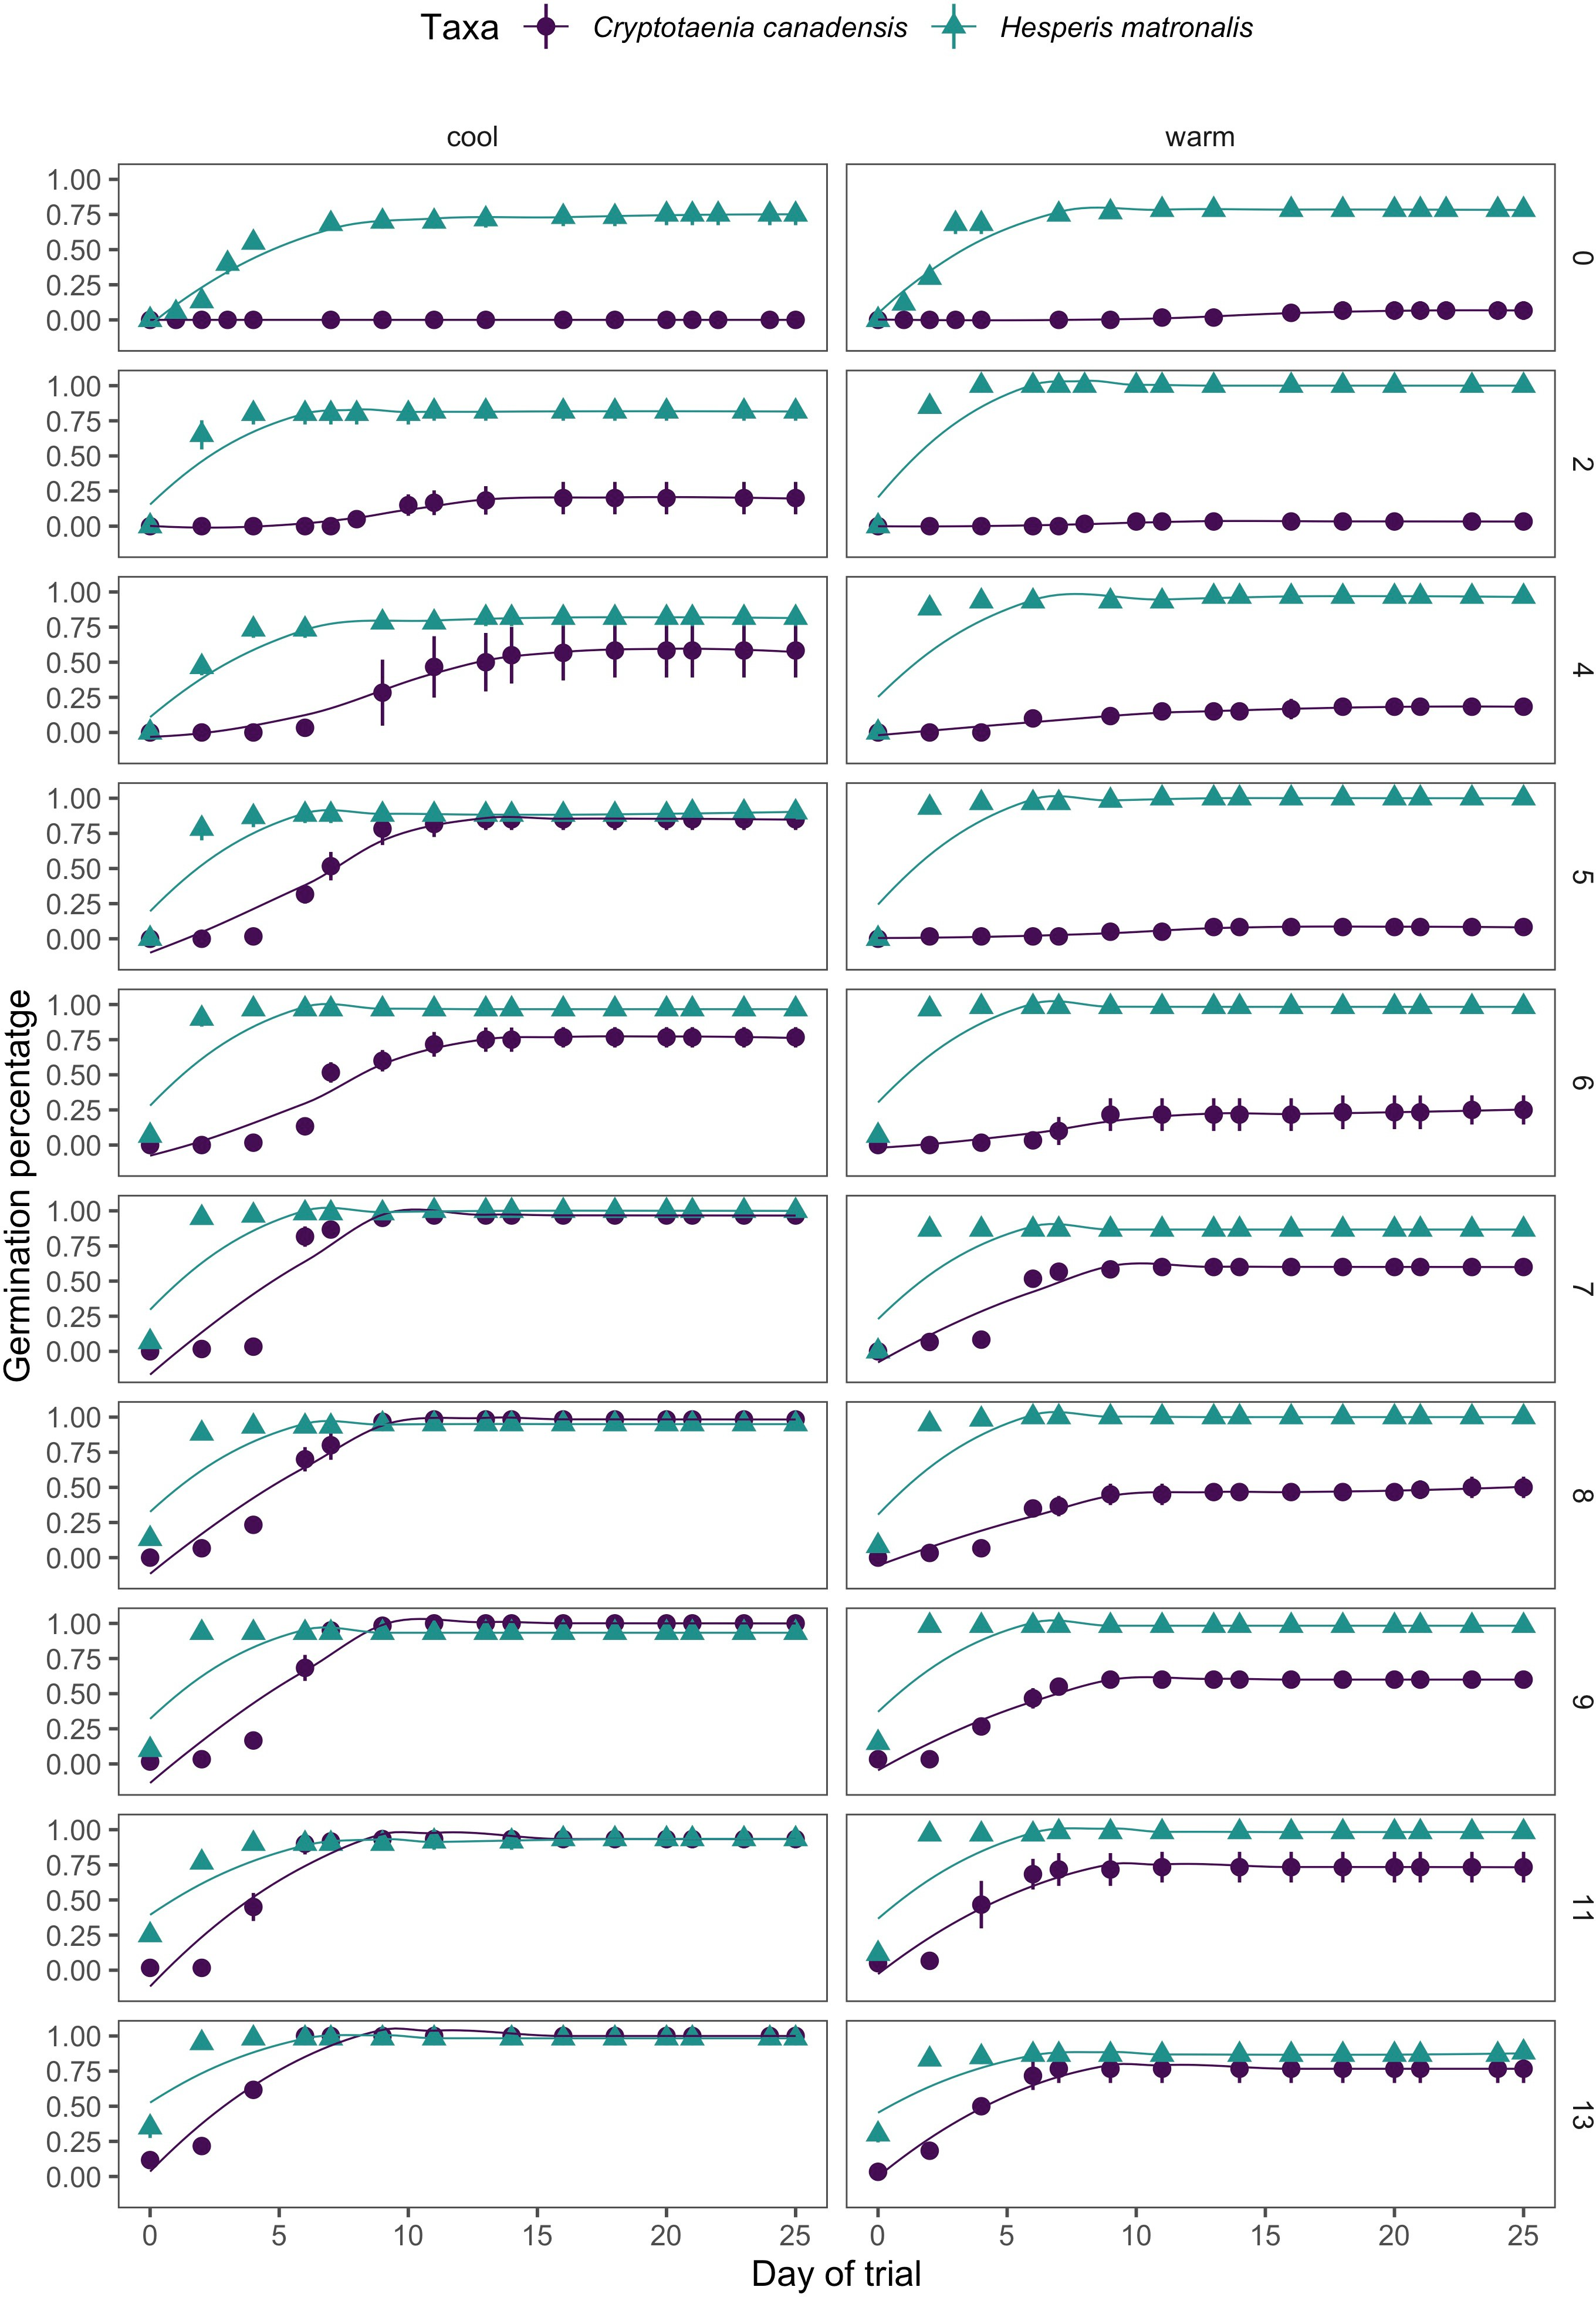

Figure 1: Cumulative germination rates of *H. matronalis* and C.canadensis under cool (20/10*◦* C day/night) and warm (25/15*◦* C day/night) incubation temperatures for each stratiﬁcation treatment (number of weeks at 4*◦* C, right axis) in our germination assays. Points depict the mean cumulative germination at each

observation time, and vertical bars depict the standard error across replicates. Lines represents a generalized 20

trend for cumulative germination, ﬁt with a loess function.

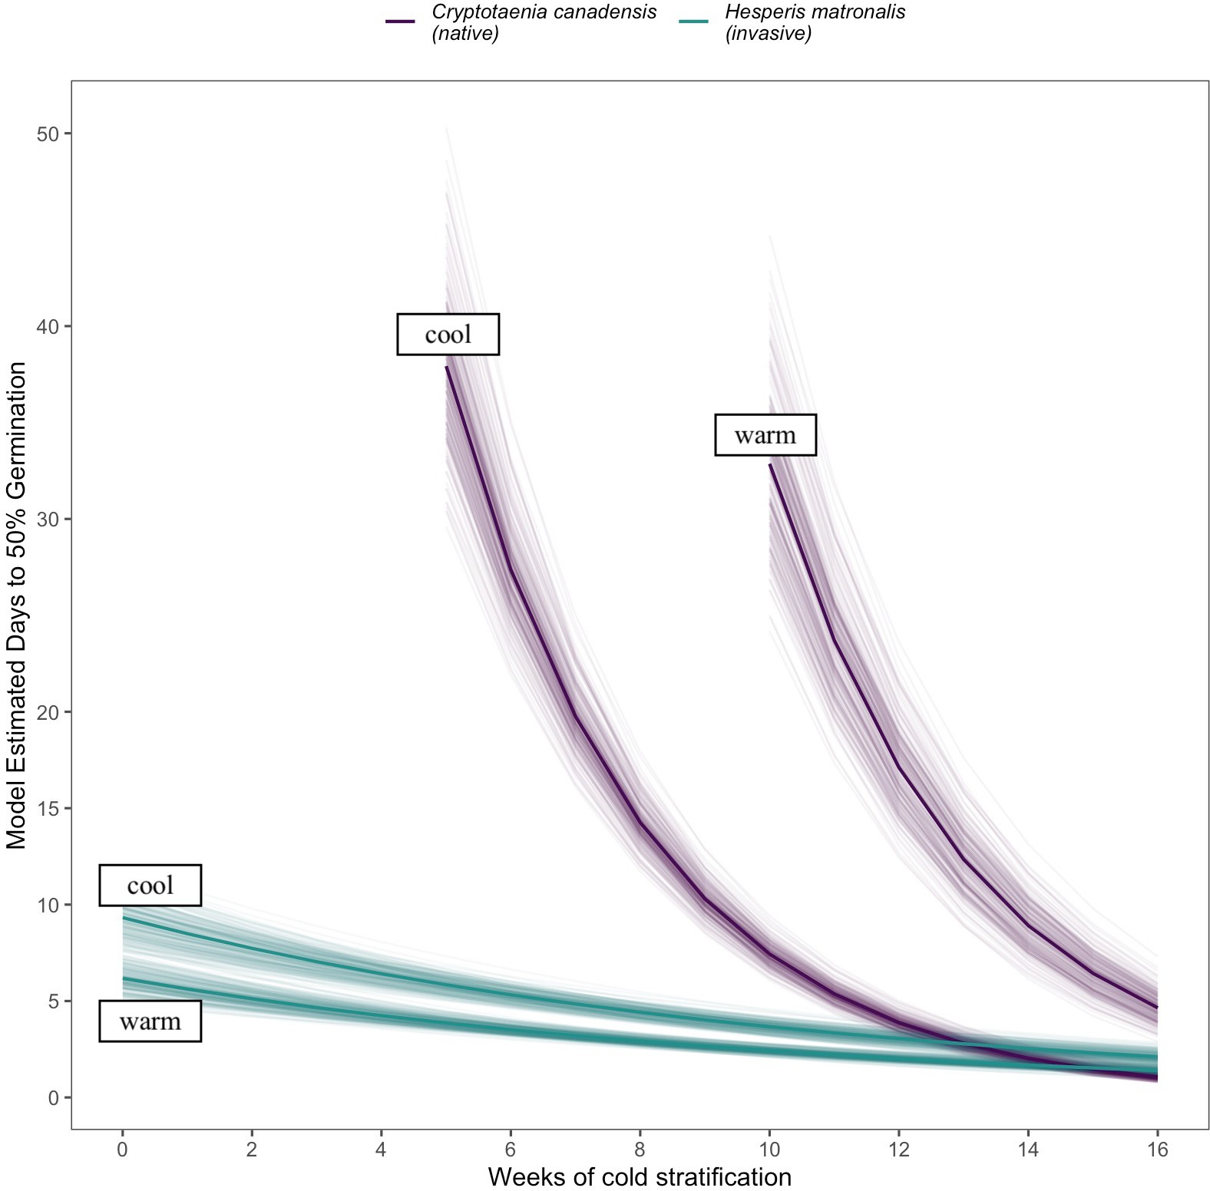

Figure 2: The eﬀects of weeks of cold stratiﬁcation at 4*◦* C on the time to 50% germination of *Cryptotaenia canadensis* and *Hesperis matronalis* under warm (20/10*◦* C day/night) and cool (25/15*◦* C day/night) incu- bation conditions, estimated with accelerated failure time model. We show here only stratiﬁcation treatment levels which allowed both species to reach 50% germination in less that 40 days. The solid lines depict the mean estimate, while lighter lines depict uncertainty.

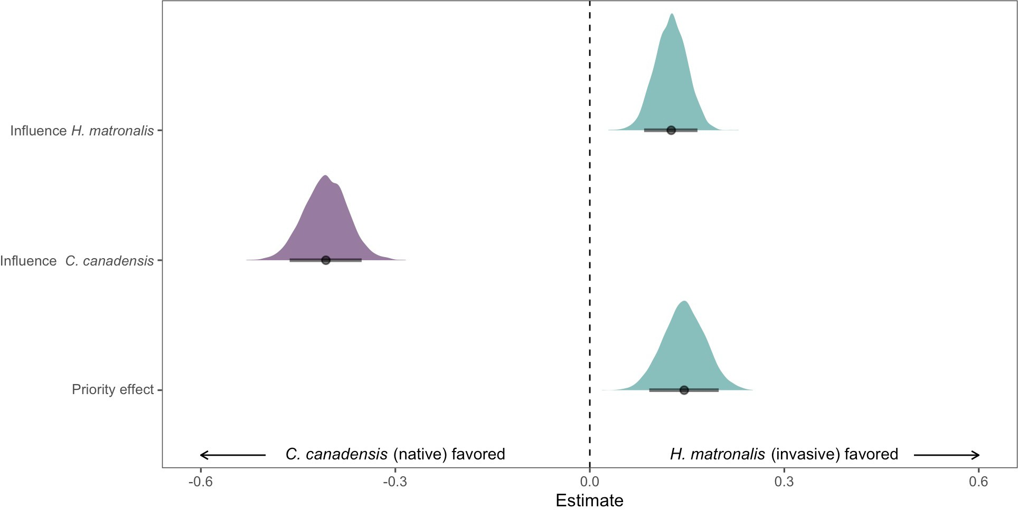

Figure 3: Estimated eﬀects of species’ abundance (intrinsic competitive ability parameters) and phenological advantage (seasonal priority eﬀects) on the relative growth rate diﬀerence between *H. matronalis* and *C. canadensis*. Negative parameter estimates indicate the community biomass composition shifts to favor *C. candensis* while positive estimate towards dominance by *H. matronalis*. The points indicate the mean estimated eﬀect of each parameter and bars the 90% uncertainty intervals. The full posterior distribution for each parameter is also depicted as an additional measure of uncertainty.