Web Programming Languages

The early development of the World Wide Web (WWW) was characterized by static HTML pages. Static web pages allowed people to share information on the Internet and hyperlinks could be followed to locate relevant material of interest. Because HTML pages were easy to create, the amount of information on the Internet quickly grew; however, it soon became clear that HTML alone would not be sufficient for the type of applications that people wished to deploy. A sampling of such applications include:

- extremely large web sites
- web sites whose data changes frequently
- interaction with surfers such as message boards
- customization of a web page based on the user
- processing of orders

The obvious solution to these problems was to extend the HTML standard and incorporate programming languages on both the client and server components of the WWW so that greater interactivity could be facilitated. In so doing, data could be sent from the browser to the server for processing. HTML pages could then be constructed "on the fly" by programs executing on the server with full access to all server resources, especially database resources.

One way the HTML standard was improved was the ability to create forms on web pages. Here is a small example of an HTML form:

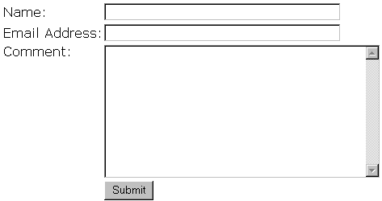

Here is the HTML code to create the above form:

<form method="post" action="formproc.pl">
Name:<input type='text' name='txtName' size='40'><br>
Email Address:<input type='text' name='txtEmailAddress' size='40'><br>
Comment:<textarea name='txtComments' rows='15' cols='40'></textarea><br>
<input type='submit' name='cmdSubmit' value='Submit'>
</form>

The HTML form is constructed with the form tag and in this case the form tag contains two attributes. The method attribute specifies how form data will be sent to the server. If it is set to get, the data is appended to the URL. If the method is set to post, as it is above, the form data is sent back to the server within a message body. The action attribute specifies the URL that will receive the form data for processing. Below that we see two input tags. In this case the input tag has the attribute type set to text. This creates a text box control in the form. The name attribute will allow the controls to be identified by our code. On the above form we have text boxes named txtName and txtEmailAddress. The size attribute specifies the width of the text box control. The next control on our form is the textarea element. A textarea is a text box that can be used to enter a large amount of text. The attributes specified with our textarea control include name, set to txtComments, rows, and cols. The last control on our form is an input element of type submit. The submit type makes a submit button that will initiate the process of sending the form data to the URL specified in the action attribute of the form. It includes a name attribute set to cmdSubmit and a value attribute that determines the text displayed on the button. While many more form controls are available such as list boxes and option buttons, the given controls will be sufficient for the demonstration of many web programming language concepts.

Server Side Programming

On the server, Common Gateway Interface (CGI) quickly became the predominant standard way to interface with external programs. With CGI the server recognizes that files in specific directories, often cgi-bin, or files with specified extensions should not be merely read and sent like an HTML file, but instead should be executed. CGI operates as the "gateway" that sends information to and receives information from the file to be executed. In general this is done by directing data to the CGI program through environment variables and standard in and sending web page data back through standard out. The following is a diagram that demonstrates the CGI process:

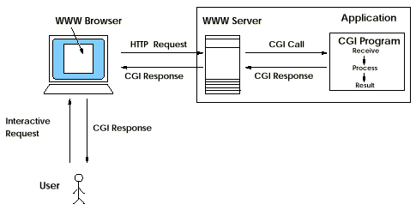

One type of information sent to the CGI program is information about the http request passed in environment variables. The remote users IP address and browser software/version are two examples of http request information. Form data sent using the "get" method is available through an environment variable and data sent using "post" is available through standard in. One of the more tedious tasks in writing CGI programs is handling the data sent from forms. The data directed to the CGI program consists of the name of each form element, followed by an equals sign, followed by the text value of that form element. The data from each form element is then separated by ampersand symbols. For example, the submission of our example form above could produce:
txtName=John+Doe&txtEmailAddress=john%40yahoo.com&txtComments=Nice+web+site.&cmdSubmit=Submit

The data is URL encoded, that is certain characters are changed into a percent followed by their hexadecimal ASCII value while spaces are changed into plus symbols. Many programming languages have library functions or object wrappers that simplify the process of parsing the incoming data and sending back the outgoing data.

In general, a CGI program can be written in any language that can be executed on the server. Because the foundation of the internet came from the world of Unix, many of the early CGI programs were written in shell scripting languages. Here is a very simple script written in bash along with the web page that is produced:
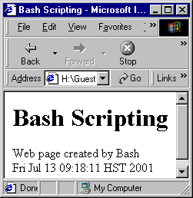
#!/bin/sh

echo "Content-type: text/html"
echo
echo "<html>"
echo "<head>"
echo "<title>Bash Scripting</title>"
echo "</head>"
echo "<body>"
echo "<h1>Bash Scripting</h1>"
echo "Web page created by Bash<br>"
echo "`date`"
echo "</body>"
echo "</html>"

In this simple example the bash echo command is used to produce the HTML for a web page that contains the current date/time. Notice that the first line of the script specifies the path to the bash interpreter and the first echo line instructs the browser that the content will be an HTML page.

While it is possible to write many web applications with shell scripts, shell scripts are not designed to be full featured programming languages, therefore most developers turn to other languages for CGI programs. Here is an example of a CGI program written in C designed to handle data from the form we described earlier:
#include <stdio.h>
#include "cgi.h"

int main(int argc, char *agrv[]) {
int contentLength = 0;
char *input, *output, *tok;
FILE *fp;

printf("Content-type: text/html\n\n");
printf("<html>");
printf("<head>");
printf("<title>C Form</title>");
printf("</head>");
printf("<body>");

contentLength = atoi(getenv("CONTENT_LENGTH"));
input = (char *)malloc(contentLength+1);
output = (char *)malloc(contentLength+1);
fgets(input,contentLength+1,stdin);
fp = fopen("formdata.txt","a");
if (fp) {
for (tok=strtok(input,"&");tok!=NULL;tok=strtok(NULL,"&")) {
urlencxlate(output, tok);
fprintf(fp,"%s\n",output);
}
fclose(fp);
printf("Form data recorded.");
} else {
printf("An error has occurred, please contact the web server
adminstrator.");
}
printf("</body>");
printf("</html>");
}

In this example we see a char pointer being allocated to hold the number of characters indicated by the environment variable "CONTENT_LENGTH." The data is then read from standard in, and the strtok() function is used to separate the data from the different form elements which is then decoded by the urlencxlate() function (a custom function written specifically to decode URL encoded data). The data from each form element is then appended to the text file "formdata.txt." If everything goes as planned a web page is returned containing the text "Form data recorded." If the program is unable to create or open the file formdata.txt, a web page is returned containing the text "An error has occurred, please contact the web server administrator."

While CGI is not the newest technology, CGI applications with Perl are still among the most common type of server side application in existence. Thousands of programmers have coded extensions to the Perl language for specialized tasks, such as CGI applications. We leave the topic of CGI with a Perl example that places the data from our example form into a MySQL database:

#!/usr/bin/perl -T
# the T refuses to run code with tainted input
use CGI;
use DBI;

print "Content-type:text/html\n\n";
print "<html>";
print "<head>";
print "<title></title>";
print "</head>";
print "<body bgcolor=\'#aaffee\'>";

$q = new CGI;
$txtName = $q->param('txtName');
$txtEmailAddress = $q->param('txtEmailAddress');
$txtComments = $q->param('txtComments');
$time = time();

$table = "visitors";
$db = "web_data";
$user = "web_user";
$password = "password";

$drh = DBI->install_driver("mysql");
$dbh = $drh->connect($db, $user, $password);

$sql_statement = "insert into $table (Name, EmailAddress, Comments) values (\"$txtName\", \"$txtEmailAddress\", \"$txtComments\")";
$sth = $dbh->do($sql_statement);

print<<HTMLEND;
Form data recorded to database.
</body>
</html>
HTMLEND

In the preceding Perl example a CGI object is created to retrieve the form data. Statements are then issued to open a connection to the database using the DBI library. Finally an SQL INSERT statement is executed. The web page returned will contain the text "Form data recorded to database."

The Java response to CGI is a technology called Java Servlets. A Servlet is a program that is made by sub classing the HttpServlet object and overriding certain methods. In the case of applications involving forms, this would most often involve overriding doGet() or doPost() depending on which form method is being used. The following code demonstrates a basic framework for Java Servlets:

public class MyServlet extends HttpServlet {
public void doPost(HttpServletRequest req, HttpServletResponse res)
throws ServletException, IOException {
res.setContentType("text/html");
PrintWriter out = res.getWriter();
out.println("<html>" +
"<head>" +
"<title>My Page</title>" +
"<head>" +
"<body>");

// code here to do custom processing such as connecting to
// databases or other server resources
// http request variables and form data is available in the
// request object

out.println("</body>" +
"</html>");
out.close();
}
}

Java Servlets have several key advantages over other server side programming techniques. One advantage is platform independence. Servlets can execute on any platform that has a Java Virtual Machine. A second advantage is efficiency. Because the Java Virtual Machine can be kept running in memory, each request can be handled by a lightweight thread. A third advantage is the power, simplicity, and safety of the object oriented Java language.

Another server side technology designed to make web development easier is embedded scripting languages such as Active Server Pages (ASP), Java Server Pages (JSP), and PHP. These languages are characterized by code that is directly embedded into an HTML page, separated by special tags. When a request for such a web page, identified by file extension, is made by a client, the web server sends the page to a preprocessor that constructs a returned web page by combining the static HTML parts of the page with the results from executing the embedded code on the page. The following diagram represents the process that occurs on the server when a page with embedded code is accessed:
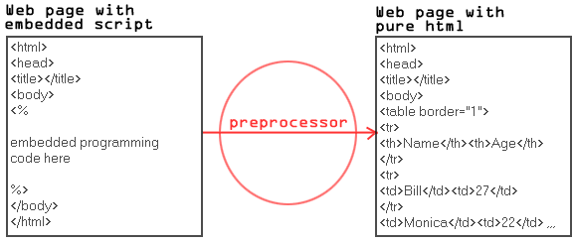
JSP is a technology from Sun that, of course, uses the Java programming language. PHP is an open source technology that uses a language that has similarities to C and Perl. ASP is a Microsoft technology that is language neutral, that is you can use any language for which a preprocessor has been written, however, most ASP code is in VBScript or JavaScript. Because these technologies were developed specifically for the web, they all contain functions or object libraries that help with specific web tasks like retrieving form and http request data.

Here is a PHP example that stores the data from our example form above into a MySQL database:

<html>
<head>
<title></title>
</head>
<body>

<?
$db = mysql_connect("localhost", "user", "password");
mysql_select_db("web_data",$db);
$sql_statement = "insert into visitors (Name, EmailAddress, Comments)
values ('$txtName', '$txtEmailAddress', '$txtComments')";
$result = mysql_query($sql_statement);
?>

<font size="5">Form data entered into database.</font>

</body>
</html>

This simple example connects to the MySQL database and executes an INSERT statement. Notice that in PHP the form control values are automatically available in variables of the same name.

Our final server side example shows an ASP application written in VBScript that retrieves lunch menu information from a database.

<!--#include file="../common/constants/const.inc.asp"-->
<html>

<head>
<meta http-equiv="Content-Type" content="text/html; charset=windows-1252">
<title>Lunchomatic</title>
</head>

<body topmargin="0" leftmargin="0" bgcolor="#FFFFFF">
<!--#include file='../common/header/header.asp'-->

<table border="0" width="100%" cellspacing="0" cellpadding="5">
<tr>
<td width="100%"><table border="0" width="100%">
<tr>
<td width="815" valign="top">
<%
Set con = Server.CreateObject("Adodb.Connection")
con.Open "DSN=SchoolData"
Dim rs 'As Recordset
Dim sSQL 'as String
Dim nDays 'as Integer
theDate = Date()
if Hour(Now) > 12 then
theDate = theDate + 1
end if
if request.form("sentinel") = "submittedpost" then
nDays = request.form("cboDays")
else
nDays = 1
end if
sSQL = "select top " & nDays & " LunchMenu.Entree, LunchMenu.SideDishes, LunchSchedule.Date"
sSQL = sSQL & " from LunchMenu inner join LunchSchedule on LunchMenu.LunchID = LunchSchedule.LunchID
sSQL = sSQL & " where LunchSchedule.[Date]>=#" & theDate & "#"
Set rs = con.Execute(sSQL)
if rs.eof and rs.bof then
response.write "Sorry, the 2000-2001 school year is over."
else
response.write "<table border='1' width='100%' bordercolor='#ff0000'>"
response.write "<tr><th>Entree</th><th>Side Dishes</th><th>Date</th></tr>"
do until rs.eof
response.write "<tr>"
response.write "<td>" & rs("Entree") & "</td><td>" & rs("SideDishes") & "</td><td>" & FormatDateTime(rs("Date"),1) & "</td>"
response.write "</tr>"
rs.movenext
loop
response.write "</table>"
end if
%>
<form method="POST" action="lunchomatic.asp">
<input type="hidden" name="sentinel" value="submittedpost"><p>Extended Lunch Planner:<br>
Select the number of days you wish to view the lunch menu for and press fetch menu.<br>
<select name="cboDays" size="1">
<option selected value="1">1</option>
<option value="2">2</option>
<option value="3">3</option>
<option value="4">4</option>
<option value="5">5</option>
<option value="6">6</option>
<option value="7">7</option>
<option value="8">8</option>
<option value="9">9</option>
<option value="10">10</option>
</select><input type="submit" value="Fetch Menu" name="cmdFetchMenu"></p>
</form>
</td>
</tr>
</table>
</td>
</tr>
</table>
</body>
</html>

This more advanced example uses Microsoft's ActiveX Data Objects (ADO) to connect to a Microsoft Access database. You will also find the familiar request and response objects being used. The resulting web page would look like this:
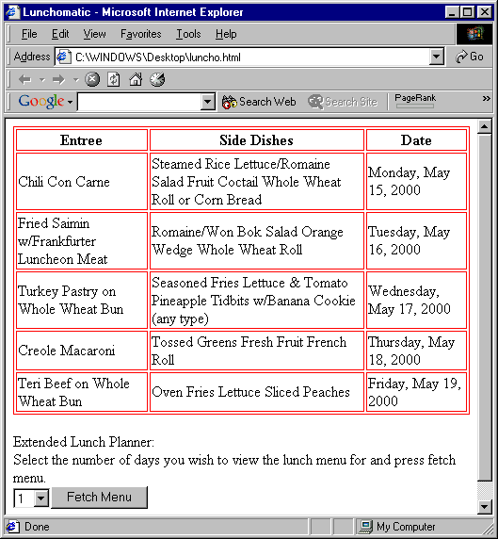

The major benefit of using server side programming languages is that you can incorporate any resources available to the server. With it, you can accomplish tasks that would be difficult to do any other way. Another benefit of server side code is that because the processing takes place on the server, browser compatibility issues are reduced as you can send back standard HTML.

The drawbacks of using server side code fall into three major areas. First, server side code places a heavier processing burden on the web server. Second, all requests require a round trip to the server which can be very important when many users are still using 56k dialup accounts. Third, and most important, server side applications open up the possibility of hackers executing rogue code on your server using tactics like buffer overflows. While different programming environments have different levels of vulnerability, it is important to understand the weaknesses of the environment you are working on, and to code accordingly.

Client Side Programming

On the browser side, Netscape and Microsoft developed competing scripting products for embedding script language into a web page to be executed on the client. Netscape called their product JavaScript while Microsoft's product was called JScript. Microsoft also developed a langauge for the client called VBScript to attract Visual Basic programmers. In 1997, several companies joined forces to create the standard scripting language ECMAScript-262. The latest versions of Internet Explorer and Netscape Navigator both claim full ECMAScript-262 compliance.

Client side scripts are very useful for doing quick calculations or form validation. Here we give an example that validates the data from our form given earlier. If the email address text box is blank the form will not be submitted to the server. First we must make a small modification to our form code:

<form method='post' action='weblang.html' onSubmit='return validateForm(this);'>

And now the JavaScript code:

<script language="JavaScript">
<!--
function validateForm(form) {
if (form.txtEmailAddress.value=="") {
alert("Please enter an email address.");
form.txtEmailAddress.focus();
return false;
} else
return true;
}
-->
</script>

The form tag now has an additional attribute onSubmit() that calls a our validateForm() Javascript function, passing the function a reference to the form. The validateForm() function checks the value of the txtEmailAddress control. If it is blank, an alert message is shown on the screen prompting the user to enter an email address. Then focus is placed in the txtEmailAddress text box. Returning false prevents the form data from being posted to the server.

Advanced client interfaces can be developed using Java Applets or ActiveX programs. Java Applets are Java programs that can be executed in a browser window. Java Applets have a security model designed to prevent them from doing damage to the system on which they run. This includes preventing file access to the client file system and from making network connections except to the originating host. ActiveX programs are programs that can be written in C++ or Visual Basic. While ActiveX doesn't have a security model like Java Applets, both ActiveX and Java Applets provide a method of signing trusted programs.

Here is an example of the type of client program possible with Java Applets, a function plotter Applet.

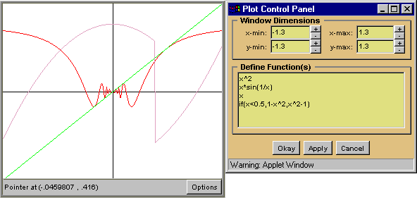

Client side code, like server side code, has its advantages and disadvantages. One major advantage is the ability to reduce the load on the server by doing the processing locally as was done in our form validation example. This also produces the benefit of requiring fewer roundtrips to the server, something that is very important to users on 56k dialup accounts.

One of the major disadvantages of client side code is the incompatibilities among different browser environments. If you are going to use client side script, it makes sense to use the core of ECMAScript-262 available on most browsers. Java support among browsers continues to improve while ActiveX remains an Internet Explorer only product. These compatibility problems can be reduced or eliminated in corporate environments where the desktop is controlled. A second disadvantage for client side scripts is that unlike the rich data environment available on the server, client side scripts are limited to the data that can be stored in cookies. Another disadvantage for Java Applets and ActiveX is the long download time necessary to retrieve the program to the client. This inconvenience can be reduced if it is necessary to download the program only on the first visit to the hosting web page.

Conclusion

Web programming languages available on the server and client offer methods to accomplish tasks that would be difficult or impossible to accomplish any other way. On the server, just about any language can be used to incorporate server resources into web content. On the client side, scripts and programs can be used to reduce the workload on the server. Knowledge of web programming languages is a valuable skill for any computer professional.

Resources used for this project:

Unix Unleashed, Burke and Douba, Sams, 1998
http://hoohoo.ncsa.uiuc.edu/cgi/overview.html
http://tech.irt.org/articles/js184/
Core Servlets and Java Server Pages, Hall, Prentice Hall, 2000
http://java.sun.com
http://www.msdn.microsft.com
http://www.php.net
http://pirate.shu.edu/~wachsmut/Java/IRA/Plot.html
Internet & World Wide Web How to Program, Deitel, Deitel, & Nieto, Prentice Hall, 2000

