Usability Study
By David J. Burger
ICS 664 – Spring 2002

1.) A particular usability “task” that you will have the users perform.
The author’s of the fisheye menu state that:
“We expect that the fisheye menu is nearly as efficient as the hierarchical menu for directed tasks (where you know what you are looking for), but much better for browsing tasks.”
Therefore, in addition to general menu interface testing, the usability study was designed around the idea of either reaffirming or rejecting these expectations. For a directed task I had each participant pick three countries from each type of menu. The countries used were pre-determined by a random number generator and while each user got the same four sets of three countries, I rotated them around so that the same set of three countries was not being used with the same menu type every time. Time measurements were kept to determine the efficiency of each type of menu for this directed task. For a browsing task I made four copies of the fisheye example applet and modified each copy independently. I changed the country lists so that three country strings on each list would have a” +” appended to the end. The users were instructed to locate and select the three countries with the plus symbol appended to the end. Once again times were kept to give an indicator of the efficiency of the menu for this task and error clicks were recorded to help determine if the interface was more or less susceptible to such errors. The details on measurement and data collection are more fully explained below.

Note that both of the above tasks were carefully thought out to measure the menu being used in a specific way and to test the authors’ expectations. For the directed task the decision was easy, merely pick some countries randomly and time the user in locating and clicking on them. Making a suitable browsing task was a little more involved. After considerable thought, I decided that the only way to simulate a browsing task was to modify the menus in some way so that the user would have to browse through them to find the distinguishing characteristic. This led me to creating five separate versions of the fisheye demo which were all published on my website during user testing. These tests worked out very well and seemed to test the exact the exact menu qualities I was shooting for.

2.) A description of at least one “objective” measurement you’ll collect. An example would be time-to-complete-task.

Time measurements were kept for both the directed and browsing tasks. For the directed task a stopwatch was used to record the time from the moment the top layer menu was clicked upon until the target item was located and clicked. The three times taken for each menu type were then aggregated in various ways as shown in the data collection tables and charts shown below. Similar objective measurements were used for the browsing task. In this case the user was asked to locate the three menu item strings that had the “ +” appended to the end. A stopwatch was used to record the time from when the user clicked on the top level menu until he correctly clicked on the last of the three correct items. Data was also kept regarding the number of mis-clicks as preliminary testing indicated that the fisheye menu design may be susceptible to such errors. All of this data is summarized in the data tables and charts shown in item four of this document.

3.) A description of at least one “subjective” measurement. An example would be “What was the most surprising thing about fisheye menus?”

For subjective measurement I relied on two basic means of data collection. The first one was the “talking aloud” technique as described in Nielsen’s “Usability Engineering.” Before the users were given the timed tasks that were allowed to familiarize themselves with the various types of menus. I had the users express their thoughts about the menus and the interaction techniques during this phase. The second technique I used was the follow up interview. After the tests were complete I asked the users the following questions:

- “Did you find any of the menu types to be difficult to use?”
- “Would you like to use one of these specific types of menu in an application that you use regularly?”
- “Which menu was the best for locating a known item quickly?” (directed task)
- “Which menu was the best for browsing to find what you want?” (browsing task)
- “Would further practice with any of these menus make you more efficient with them?”

I also gave the users an opportunity to express any other feelings they had about the menu interfaces. You will find the users suggestions, comments, and responses in the data collected below.

4.) The objective and subjective data you collected, organized in a way that makes sense.

Data was collected for both directed tasks, where the user was told what to look for and click on, and browsing tasks, where the user was asked to locate menu items with a certain feature. In each case the timed trial involved locating three menu items with the total time to locate all three items being kept. The data collected for the directed task follows:

 | Arrow Menu | Scroll Menu | Hierarchical Menu | Fisheye Menu | AVERAGE
User A | 20.93 | 14.05 | 11.72 | 19.99 | 16.6725
User B | 17.83 | 15.22 | 11.05 | 20.87 | 16.2425
User C | 17.23 | 14.15 | 12.91 | 21.65 | 16.485
User D | 23.24 | 18.53 | 10.01 | 13.74 | 16.38
User E | 19.71 | 12.74 | 17.49 | 16.49 | 16.6075
AVERAGE: | 19.788 | 14.938 | 12.636 | 18.548

Table 1: Directed task data, worst average in red, best in green
The hierarchical menu is best for directed tasks

The data collected for the browsing task follows:

 | Arrow Menu | Scroll Menu | Hierarchical Menu | Fisheye Menu | AVERAGE
User A | 23.71 | 12.28 | 26.31 | 17.39 | 19.9225
User B | 16.44 | 17.22 | 19.28 | 28.2 | 20.285
User C | 14.16 | 16.03 | 29.75 | 16.51 | 19.1125
User D | 12.03 | 12.51 | 14.03 | 19.74 | 14.5775
User E | 20.18 | 11.22 | 20.09 | 17.03 | 17.13
AVERAGE: | 17.304 | 13.852 | 21.892 | 19.774

Table 2: Browsing task data, worst average in red, best in green
The scroll menu is the best for browsing tasks

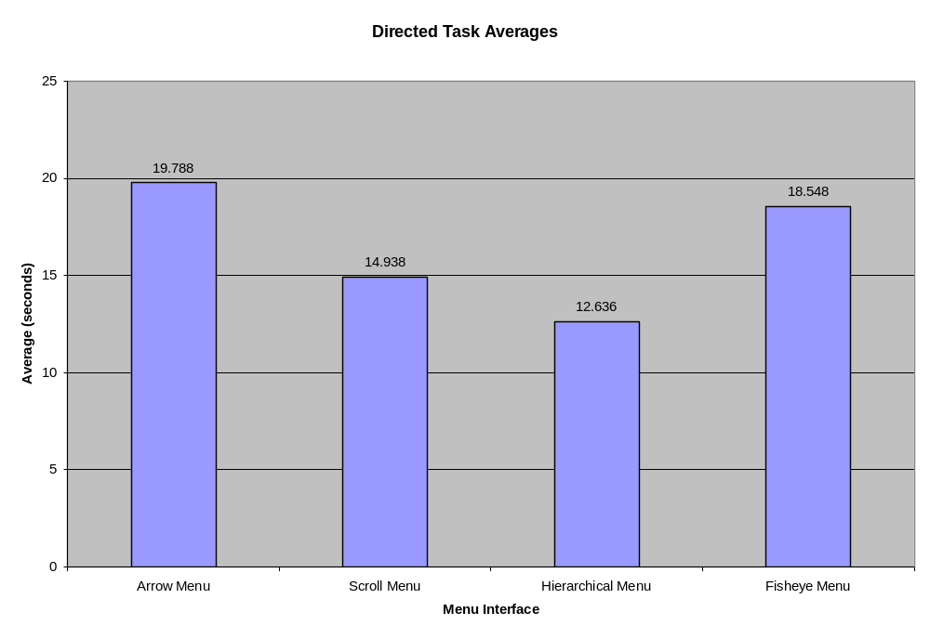

Chart 1: Directed task averages, in seconds
The hierarchical menu is the clear winner
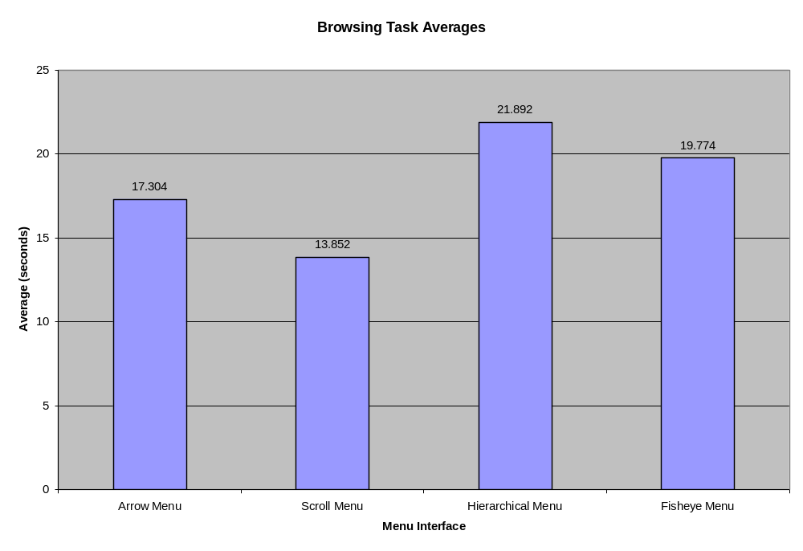
Chart 2: Browsing task averages, in seconds
The scroll menu comes out on top

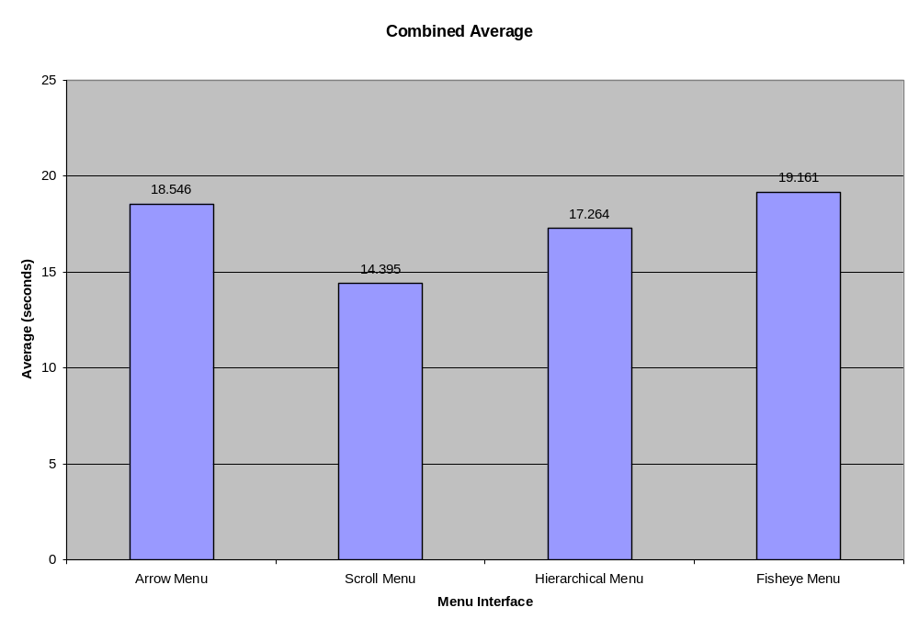
Chart 3: Combined averages, in seconds. Scroll menu best overall

The summary of the subjective data questions follows:

Question | Response
Did you find any of the menu interfaces to be difficult to use? | A | No
 | B | Yes – fisheye
 | C | Yes – fisheye, too fast
 | D | Yes –fisheye, hard to find items, and arrow menu, difficult to locate extremes
 | E | Yes – fisheye
Which of these menu types would you like to use in applications that you use regularly? | A | Scroll menu
 | B | None specified
 | C | None specified
 | D | Depends on the application
 | E | Scroll menu
Which menu was best to use when told to pick a certain item from the list? | A | Scroll menu
 | B | Hierarchy
 | C | Hierarchy
 | D | Hierarchy
 | E | Hierarchy
Which menu was best to use when browsing to locate menu items with certain traits? | A | Scroll menu
 | B | Scroll menu
 | C | Fisheye
 | D | Hierarchy
 | E | Scroll menu
Would further practice with any of these menus make you more efficient with them? | A | Maybe
 | B | Yes – fisheye
 | C | Yes – fisheye
 | D | Maybe – fisheye
 | E | Yes

User elaboration:

User A: The scroll menu is the easiest menu interface to use. It is what I am used to and it works well for both locating a known item and browsing for the unknown item.

User B: I found the fisheye menu to be difficult to use. For the other menus, the hierarchy menu was best when locating a pre-determined item while the scroll menu style was best for browsing for an item.

User C: The fisheye is an interesting idea but it moves too fast. Sometimes I would locate my item quickly with the fisheye menu, but would have trouble clicking on it. The behavior from the left to right sides of the fisheye menu seems unnatural. Even with these drawbacks I feel it is best for a browsing type of task.

User D: I like hierarchy menus the best, however, it would depend on the application. My second favorite would be the scroll menu.

User E: The hierarchy menu is best for finding a known item. The scroll menu is best for general browsing. I found the fisheye menu difficult to use.

5.) A one-page discussion/analysis of the data. Does the data support or refute the authors’ expectation given above?

As previously stated I designed my usability test around the authors’ statement that they expect the fisheye menu to be nearly as efficient as the hierarchical menu for directed tasks and to be much better for browsing tasks. The authors did not, however, indicate how they felt the fisheye menu would fair against the arrow or scroll menus. I included all four menu types in my usability tasks. The usability tasks were carefully planned to simulate directed and browsing menu usage as explained above.

The data clearly indicates that the hierarchical menu is far superior for directed tasks while the scroll menu was far superior for browsing tasks. The margins involved in these comparisons are quite astonishing. For directed tasks, the hierarchical menu was 15% faster than the second place menu interface, the scroll menu, and 36% faster than the slowest directed task menu interface, the arrow menu. For browsing tasks, the scroll menu was 20% faster then the second place menu interface, the arrow menu, and 37% faster than the slowest browsing task menu interface, the hierarchical menu.

These numbers, while surprising, are not entirely unexpected. Computer scientists are well aware of the efficiencies inherent in a binary search, and in a similar way the hierarchical menu is capable of reducing the items left to search. Therefore when using the menus for a directed task, the user is able to quickly limit the search and find the correct item. The arrow menu, with its slow access to the extremes of the menu as mentioned by User D, was the slowest menu interface for directed tasks. The scroll menu came in with a respectable second place time. The surprising part was that the fisheye menu came in with a very poor, and almost last place time refuting the authors’ expectations. It seemed as if users had difficulty operating the menu as it was necessary to use fine motor movements to move between the last few menu items even though I explained the right side / left side issue of the fisheye menu and allowed the user to become comfortable with it before starting the test.

For browsing tasks, the scroll menu was superior to all other options by a sizeable margin. The fisheye menu was able to edge the hierarchical menu for browsing tasks by a 9% margin, however, the authors’ claims of “much” better were not entirely on target.

The subjective data lines up quite nicely with the numeric data. Most users indicated that they felt comfortable with and performed well with the scroll bar menu. The other menu winning high marks was the hierarchical menu.

It is interesting to note that the majority of the users indicated that the fisheye menu was difficult to use. Watching the users it was apparent that this was the case. The fisheye has a tendency to scroll through several menu items with only a few pixels of mouse cursor movement. Most of the users were uncomfortable with this interaction and it showed in the end results. Several of the users stated that they could use a little practice with the fisheye menu. The users were obviously more familiar and comfortable with the other menus, and it would be interesting to see if users would accept and excel at the interaction style provided by the fisheye menu with more practice.

In summary, overall it seems that scroll menu would be the best choice for general application development, while the hierarchical menu would be superior for applications that necessitate repetitive directed menu choices. My test results seem to refute the authors’ expectations of the fisheye menu being almost as good as the hierarchical menu for directed tasks. The expectation of the fisheye menu being superior to the hierarchical menu for browsing tasks held true, but only by a small margin.

6.) Further notes
I felt that it was very important for me to keep the guidelines of chapter 6 of Usability Engineering when designing and executing this usability study. Some of the items from that chapter that influenced my decisions were:
- Have a goal – summative evaluation.
- What are you trying to test? – the authors’ expectations, that is, best for directed task, best for browsing?
- Budget – hey, I’m a college student so the budget was $0, but I have access to nice facilities in the POST building. The one thing that would have been really helpful would have been to have video equipment.
- Pilot testing – this is a must. I had a practice run with a user before doing the real test to work the kinks out of my test technique. It also helped to make everything flow smoothly in the real tests.
- Choice of words – when talking to the user I was very careful to go pretty much through the same script with each one. Specifically, I wanted them to know that this wasn’t my code and I didn’t care which menu they liked and which they didn’t.
- Choice of tasks – the tasks were carefully chosen, as described above.

