Interface Design Assignment
David J. Burger
ICS 664 – Spring 2002

1. Describe the device you are designing for: Win98, TiVo, WinXP, Macintosh, Palm OS, Sega, ... It's your choice. Is your interface closely tied to a particular recording medium, or is it independent of whether the device is a VCR
or solid state memory?

I call the device I have designed the Divo, that is Digital Video Recorder. It is primarily designed to record television video. The target market for my device would be typical computers with video inputs. Therefore it would run on any modern operating system such as Windows, Mac OS X, or Linux. This type of system could also be implemented on any modern day computer system with a good display and appropriate storage such as the video game devices from Sega, Sony, and Microsoft. Because of encoding speed requirements the recording media would likely be the hard disk. This interface is not, however, tied to any particular storage medium as we can easily imagine that with the speed of technological change we would be able to record directly to a CD and the DVD format in the future.

2. Write a one or two paragraph description of a typical user experience. Write this completely from the point of view as a user and how they believe the system "works".

Here is the typical user, thinking aloud...

I want to play some video. I think there is an application on my XBox called the Divo. It is a digital video recorder and player. I start the program. Let’s see, how do I play my video. Oh, ok, there is a button called load with a picture of a disk on it, I must press that button. A dialog box appears that allows me to choose a video file. I have seen this type of dialog box in many programs. This must work like any other program that opens a file. I choose the video file I wish to view. Now I locate the play button. The play button is green for go. I press it and the video begins. I would like to fast forward to the car chase scene. Hmm, here is a timeline. I drag the handle and it changes my play point in the video. At the end of the timeline there are fast forward and rewind buttons.

I’m done watching the video and I would like to set Divo up to record my favorite soap opera daily. I scan the interface and locate the stop button. It is red, that makes sense. Most of these buttons look like VCR controls that I am used to. Ok, here is a button labeled record with a picture of a clock on it. I press it and a list view appears that I can add shows to. I quickly fill out the information on the show I want to record, start time, duration, etc., and choose record daily. That was easy.

3. Describe the core functionality to be accessed through your interface: specifying a specific channel, tape speed, recurring broadcasts... Illustrate (sketches, screen dumps) your interface.

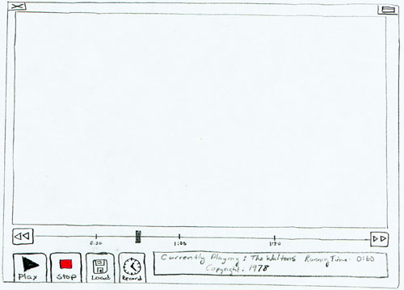
My device is primarily a player and a recorder of television video. Therefore it has interface elements to play, stop, record, and move through a video. Here is a drawing (sorry, I’m not the best artist!), of the screen interface:

The interface has 5 major areas. The main functionality is accessible through the button controls in the lower left corner of the interface. The buttons are play, stop, load, and record. In the lower right corner is a status window that displays messages about the current video. Above that we find a timeline with fast forward and rewind buttons located at the logical ends of the timeline. An area that displays the video of course occupies the majority of the space. Finally we have windowing components, close and maximize, located at the top of the interface.
Pressing the record button will change the interface to display a list of the scheduled recordings. This list is the typical computer list view with things like drop down boxes to make data entry easier. Here is a drawing of what this interface might look like:

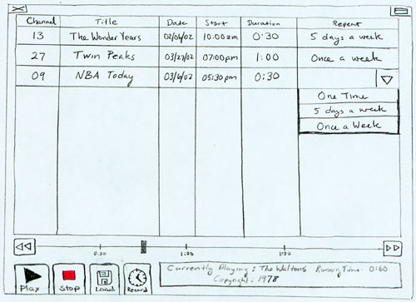
The first column of the data entry specifies the channel that is to be recorded. The second column allows you to enter a name for the recording so that it can be easily identified in the future. The starting date, starting time, and duration are the next three columns. Lastly a column labeled repeat allows you to select what type of recording this will be. That is it will allow you to choose a one time, 5 days a week, or once a week recording.

I have designed my interface with the design principles I have been learning in ICS 664 in mind. That means striving for visibility, a good conceptual model, natural mappings, and providing feedback. The following three examples represent such design choices:

a.) My primary guiding force in the design of this device was to keep the device simple. That provides visibility by limiting the number of controls that are available. You will notice that the device only contains 4 primary interface controls. Norman states in “The Design of Everyday Things” that the difficulty of dealing with novel situations is directly related to the number of possibilities.” Novice users should be greatly assisted by this simplified interface.

b.) I have placed many of the controls in such a manner so as to benefit from Fitts’ law which states that the time to point at an object is proportional to the logarithm of the distance to the object. The major controls, play, stop, load, and record, have all been placed so that they would reach the very edge of the screen. It is interesting to note that I just checked Windows 2000 and they did not follow such a convention for the buttons on the task bar missing a perfect opportunity to improve the usability of the operating system. This is hard to believe when so much information is widely available on HCI principles.

c.) I have followed standards when possible. For example, the icons shown on the play and stop buttons follow the standard that has been set by other designers for recording and playback devices. In addition, I have used green (It was green! It apparently didn’t scan too well.) for the play button and red for the stop button. Nielsen’s statement that we should follow standards unless we have a very good reason not too applies here. The standard look will also help the user to understand how to use the interface from their knowledge of other similar devices.

4. Describe all of the necessary error messages. Cite appropriate sections of the Bloopers paper.

I agree very strongly with Seiden when he says errors are mistakes and should be avoided at all cost. I would design my interface to avoid the possibility of errors. Data entry is an area where this can be very effective. Why warn about inappropriate data when you can prevent inappropriate data in the first place? For example, I would not allow the user to select a recording date/time that was already past. With this said, it seems to me that some errors are still unavoidable. An example of this in my interface would be if the user attempted to play a file that was not an appropriate video format. While it may be possible to filter out inappropriate files in dialog boxes interface features such as drag and drop may allow a user to drop any type of file on the interface. The user would need to be notified that the file that they tried to play is not an appropriate video file format. This should be done in such a manner that all levels of users would understand the message. The Textual Bloopers article contains many trouble spots to avoid. Many of these have to do with understanding that the user does not have the same terminology or technical background as the programmer/designer. Therefore messages must be made that refrain from using specialized technical jargon but give the user the feedback to understand what went wrong and how to avoid it in the future. My wrong file type message could simply say “The file you attempted to play was not a video file, please select a different file and press play.”

5. Look at Nielsen's suggested "modification". Show the modifications to your user interface assuming that the recording device itself has real-time access to the schedule of television shows for the next two weeks. Describe and illustrate special features you want to add to the core functionality.

This type of modification would work perfectly with my Divo recording device. The record button could now be used to link into a web page like view with the interaction of hypertext and the searchability of a database system. Users would be able to “drill down” to get more detail on a show they are interested. The would even be able to cross link to relevant information. Programs could be located by producer, director, genre, actor, and year. The recording feature would also be greatly enhanced as specifying the program to be recorded could be as simple as “one-click” after the program had been located.

As an example the recording screen could link directly to the TV Guide online web site. It would look something like this (superimposed screen shot of TV Guide site and what the Divo interface could do when configuring recordings):
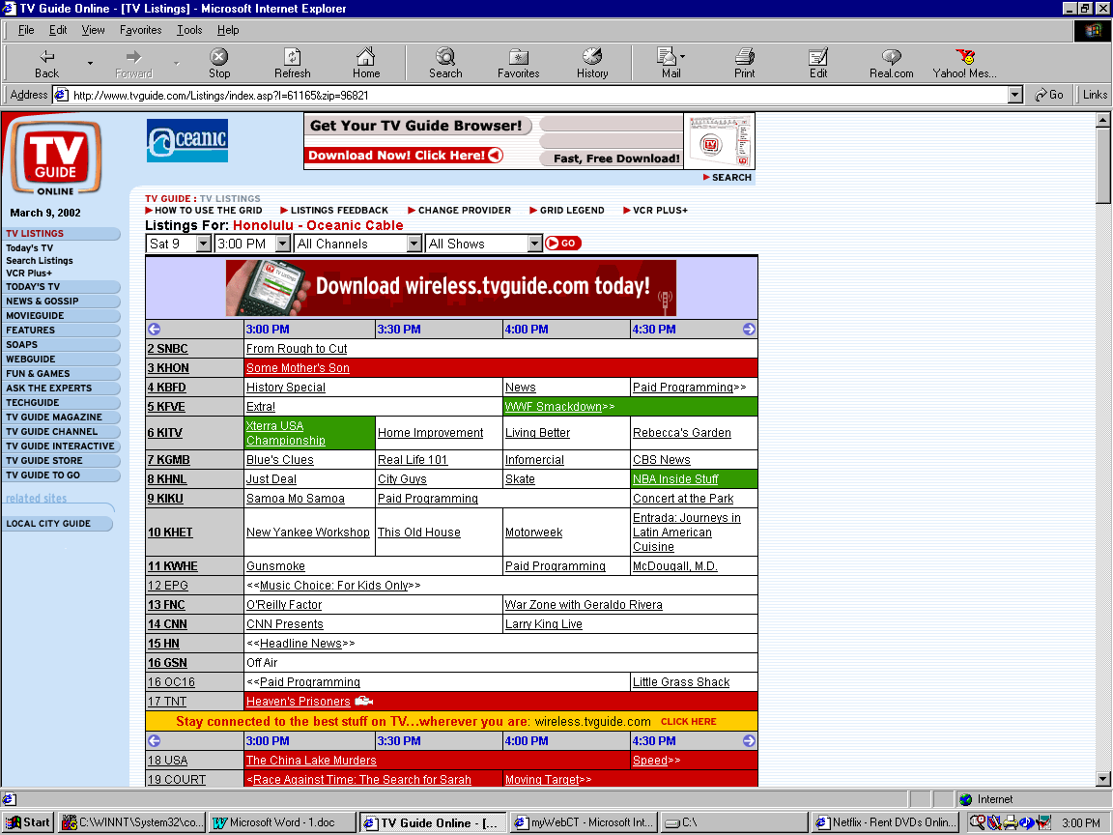

The advertising slogan would be simple: “Scroll, Pick, and Click!”

6. Describe the intended audience(s) for your interface. Suppose you could randomly select five people from the intended audience(s). Your boss reminds you that your company is interested in "usability", so you can have the entire group of five people in the same room for an hour, or have each person in their own room for 15 minutes. Describe what you would have these five users do to give you feedback. Remember that you do not have a fully functional system at this point. In fact, you may only have sketches on paper.

The intended audience for my interface is anyone who wants to record televised video. This makes the design challenge more difficult as this would involve a range that spans from children wishing to record their favorite cartoons to senior citizens that want to get a digital copy of the movie of the week and everyone in between. After selecting five people at random, I would want to see each one separately for 15 minutes instead of the whole group for an hour. With a random sampling one person would probably end up being more technologically advanced and it would be difficult to suppress the influence they would have on the rest of the group. Not having an actual interface but only having sketches would make the task more difficult, but still fruitful. What I would do is to make mock ups of what various screens would look like in the interface. I would ask the user to “think aloud” as I videotaped the session. They would be shown interfaces and asked what they thought the controls were for and what they thought they did. After that they would be asked to describe what they would do to perform a certain task. When they described their next action they would be presented with a sketch of the appropriate next step of the interface. In this manner it is possible, even without a working prototype, for the designer to get a tremendous amount of useful feedback as to the successes and failures of his usability efforts. This type of usability testing in described in detail in Jakob Nielsen’s book, “Usability Engineering.” The feedback would allow the design to proceed with the incremental development that can lead to a highly usable design.

