[Earth and Space Science]
Supporting Information for
Remote sensing large wood storage downstream of reservoirs during and after dam removal: Elwha River, WA, USA.
Buscombe, D.¹, J.A. Warrick², A. Ritchie², A. East², M. McHenry³, R. McCoy³, A. Foxgrover², and E. Wohl⁴
¹Marda Science LLC, contracted to U.S. Geological Survey Pacific Coastal & Marine Science Center, Santa Cruz, CA, USA; ²U.S. Geological Survey Pacific Coastal & Marine Science Center, Santa Cruz, CA, USA; ³Lower Elwha Klallam Tribe, WA, USA ; ⁴Colorado State University, Fort Collins, CO, USA

Contents of this file

Figures S1 to S9

Introduction
The following nine figures support findings and interpretations presented in the manuscript and are each referenced in the manuscript to make a minor point to bolster arguments. All raw data used to generate these additional figures are the same as those data reported in the main manuscript.

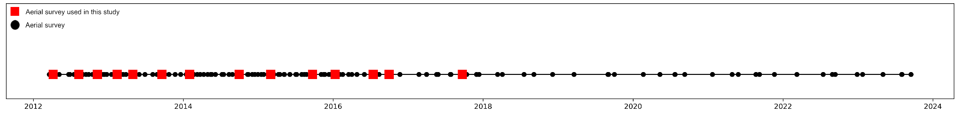Figure S1. The occurrence in time of Elwha aerial surveys conducted to date, indicating which of these are used in the present study.

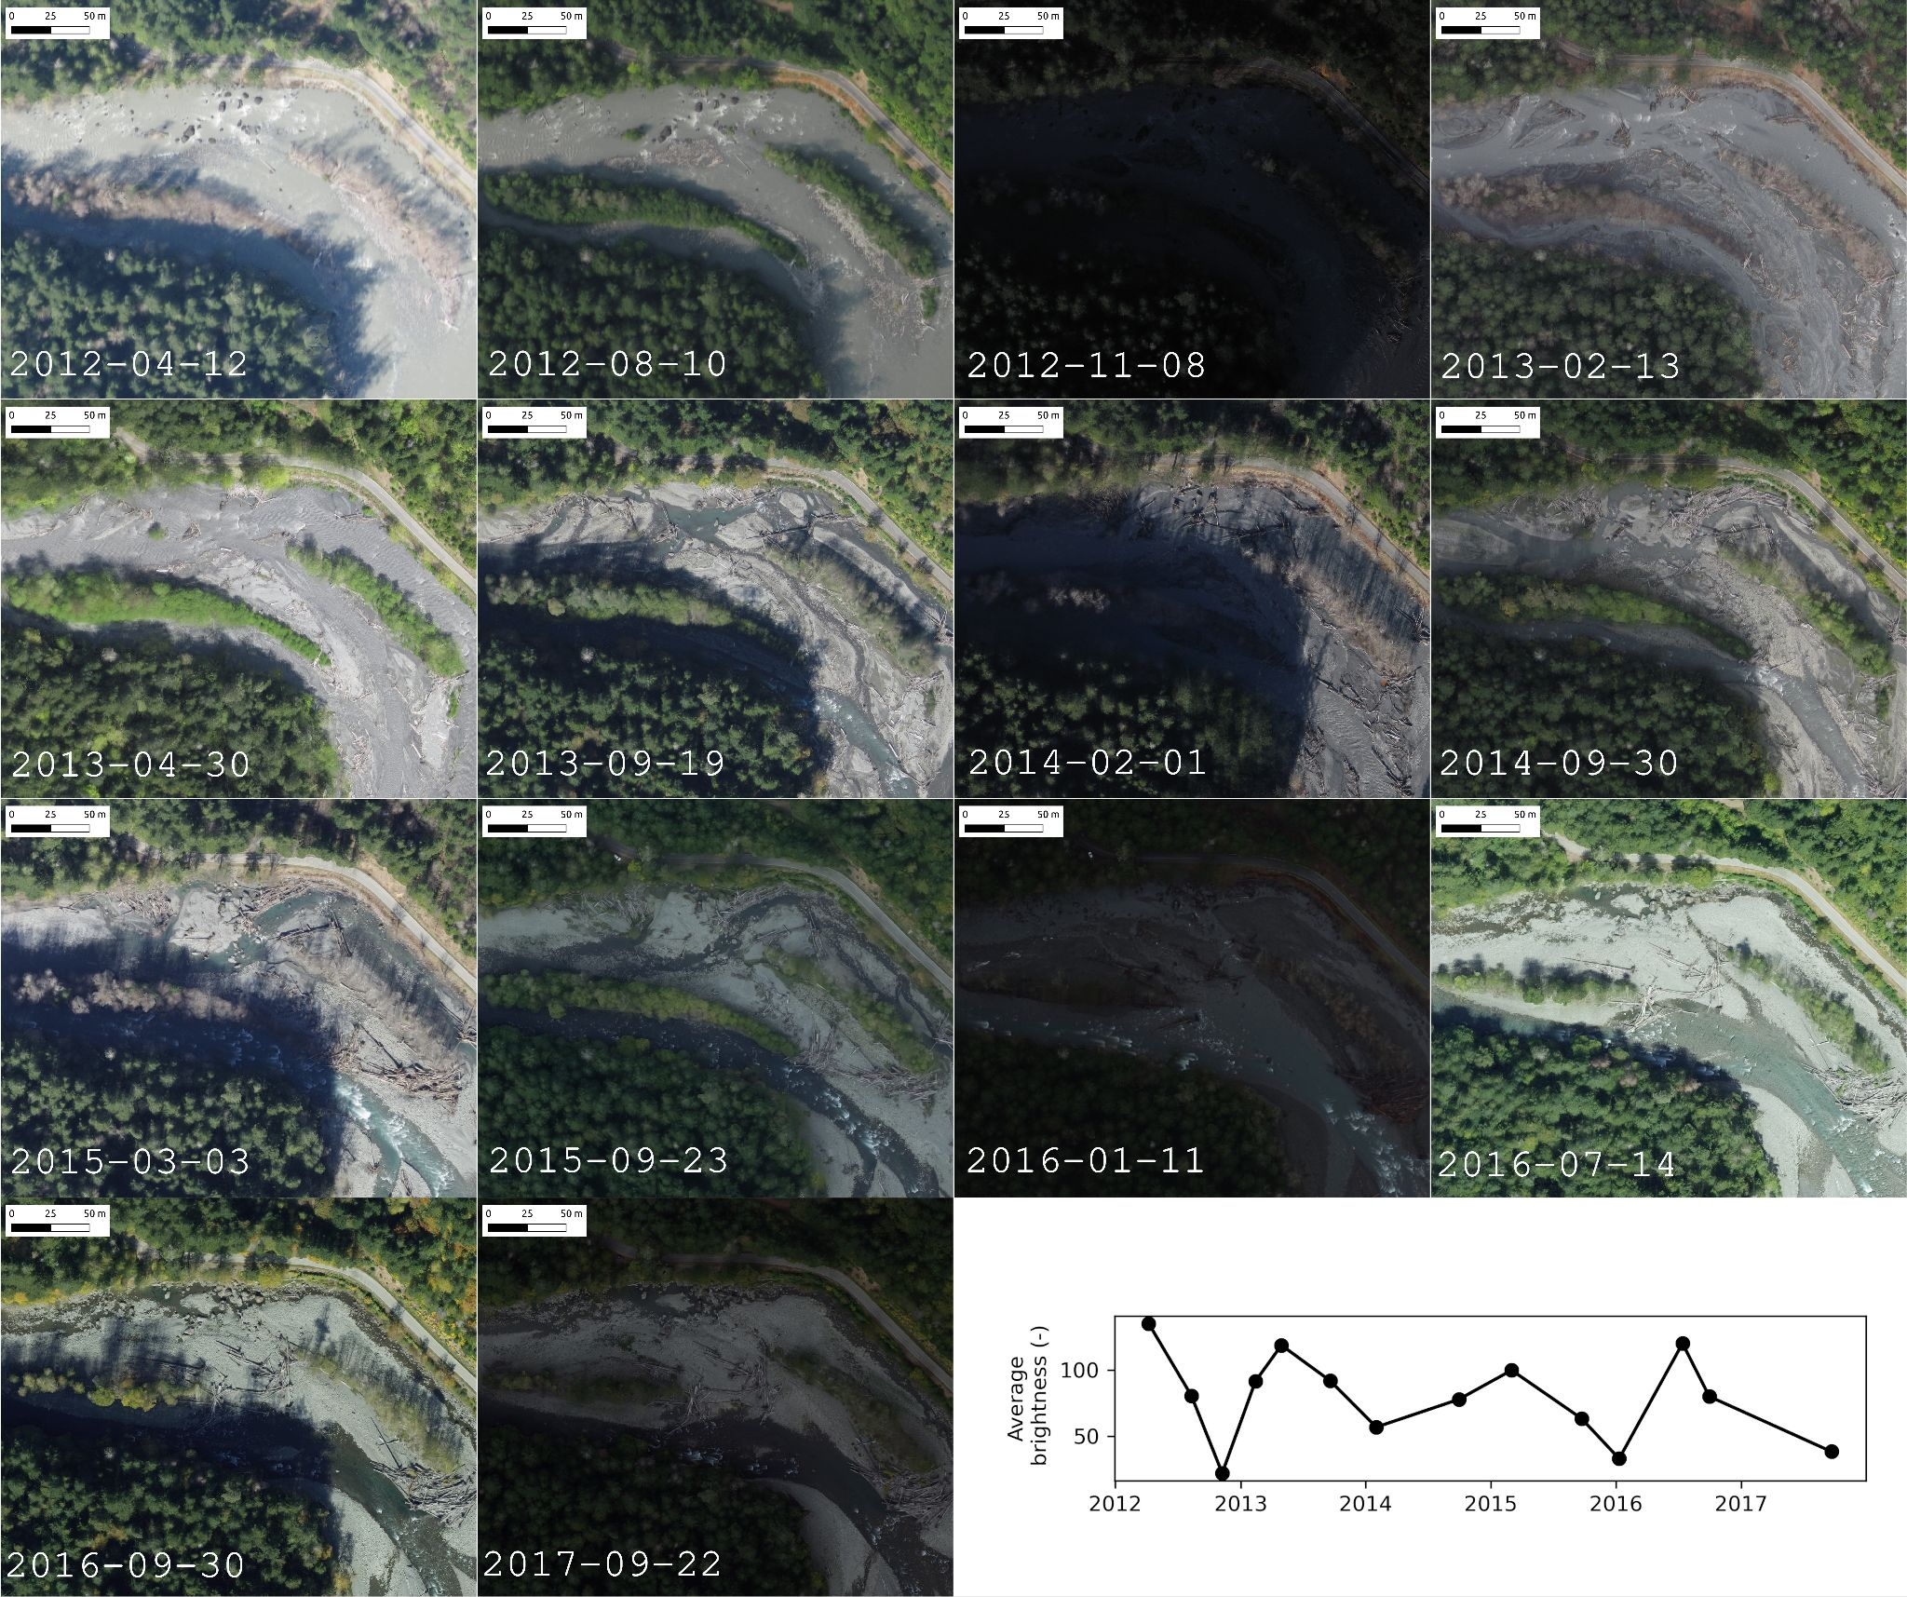

Figure S2. Example orthoimagery at a typical location (located in the middle reach), showing the variation in color and brightness, as well as the nature of the channel, wood deposition, and bar growth.
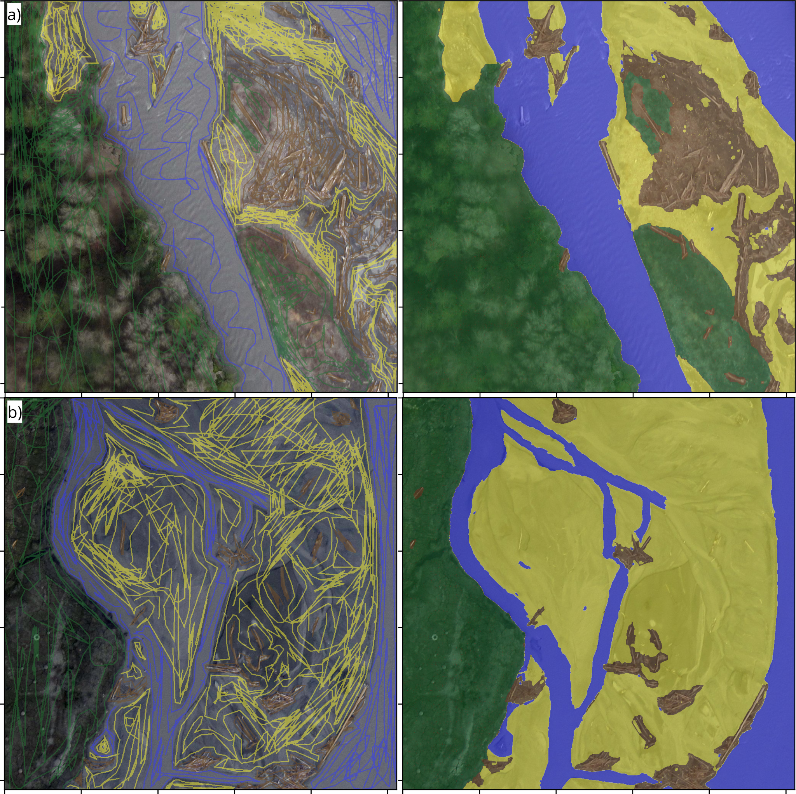

Figure S3. Examples of labeled imagery created using Doodler, an interactive image labeling program. Each 1024x1024 pixel image tile is annotated, or ‘doodled’ (left column), by selecting pixels of each class on screen, and Machine Learning is used to complete the scene (right column). Users of the program can adjust settings and add/remove doodles for label optimization.

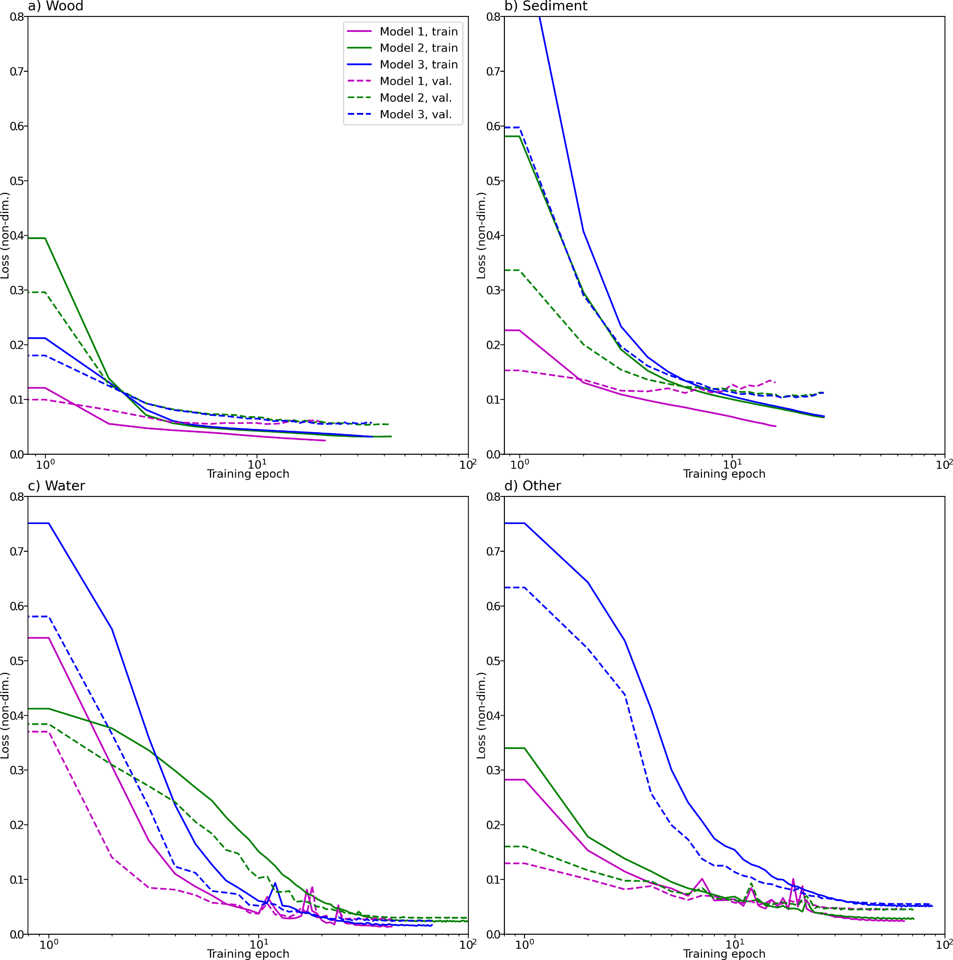

Figure S4. Train and validation loss curves are shown from separate realizations (model training with different learning rates) of binary (class/other) models for estimating wood (a), sediment (b), water (c) and ‘other’ (d) classes, respectively.

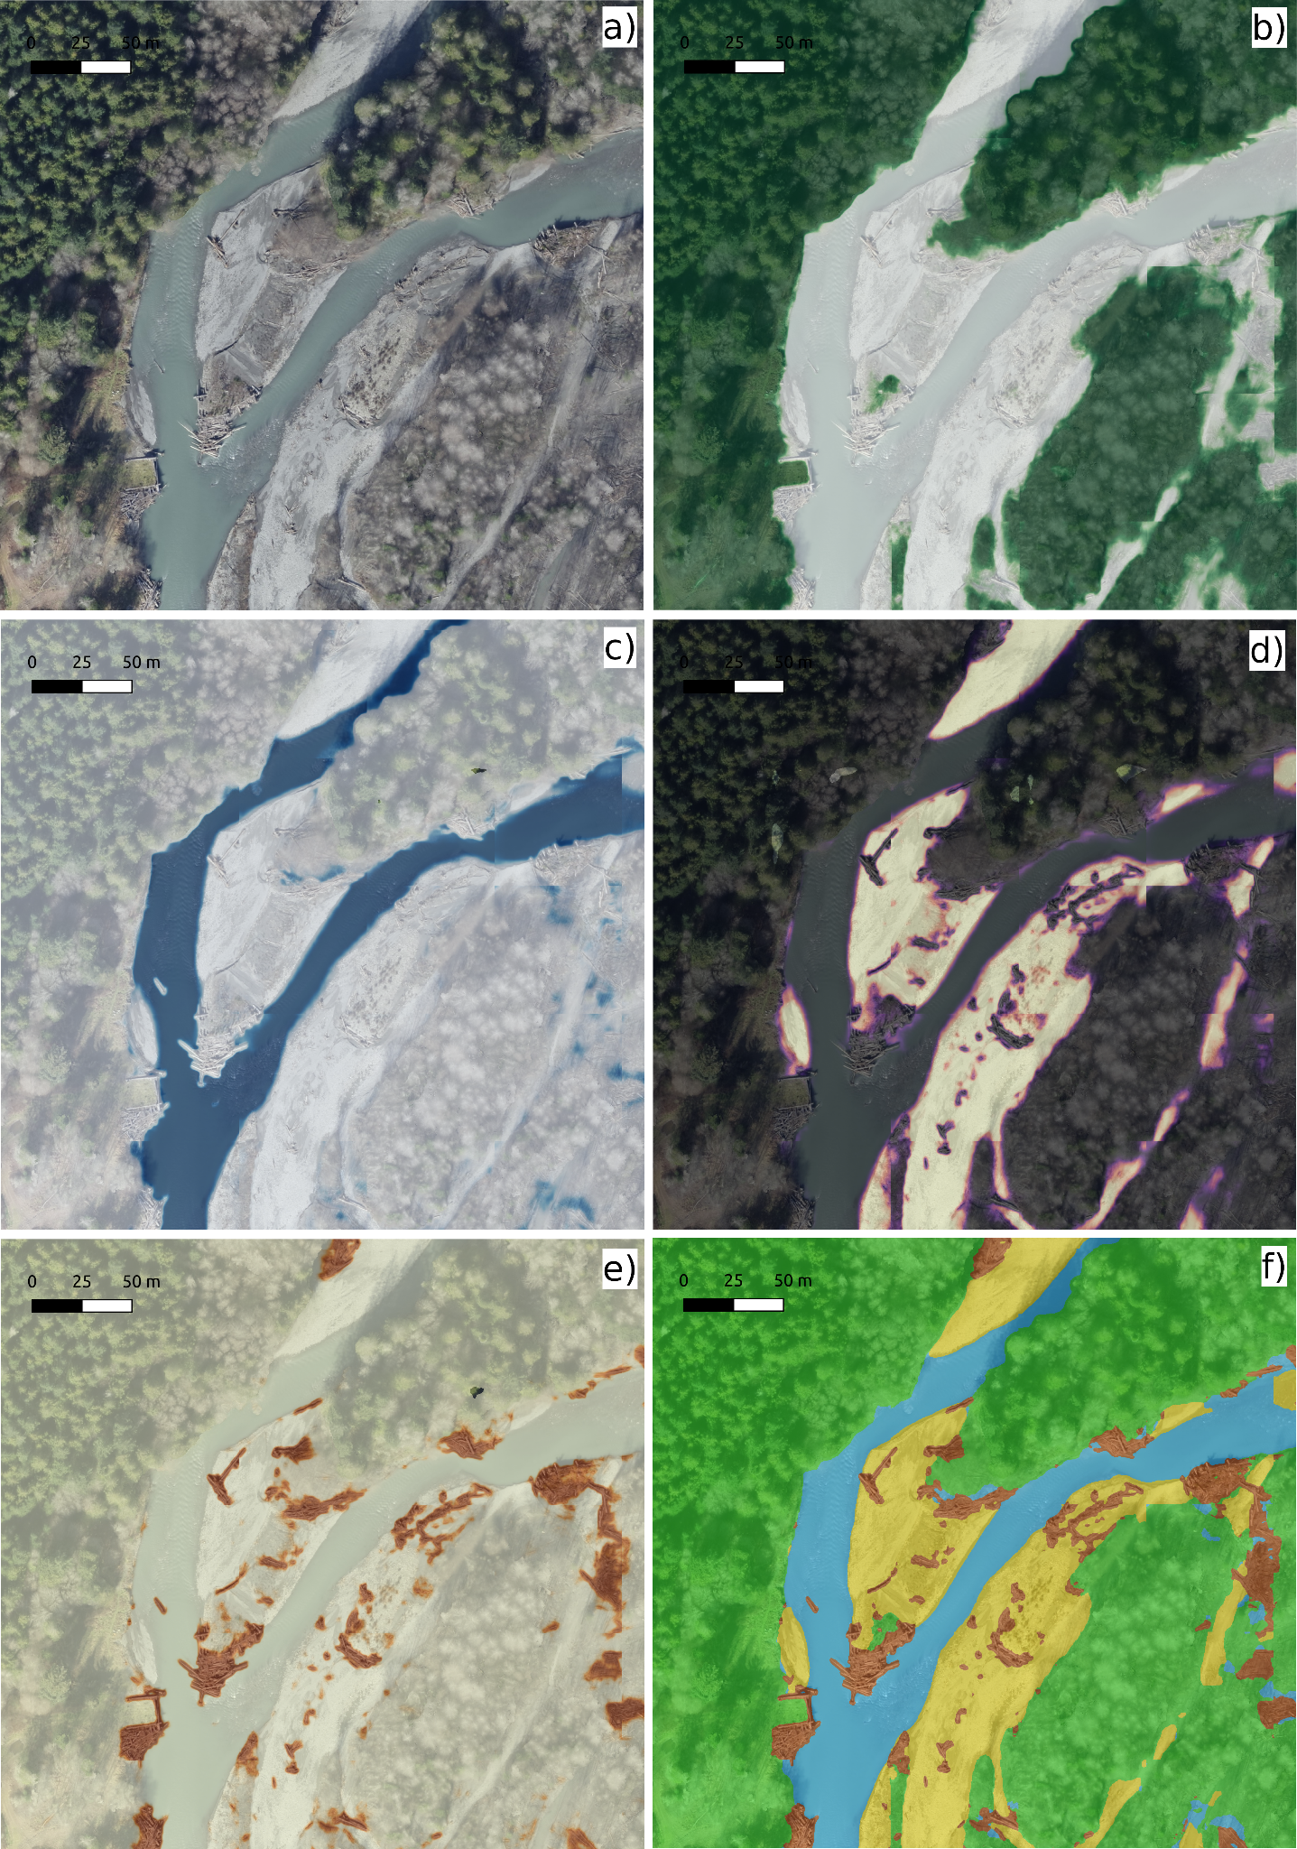

Figure S5. Example model output probabilities derived from input image (a) for four classes, namely ‘other’ (b), water (c), sediment (d), and wood (e). The argmax function is applied across these four probability rasters to produce the final label estimate (f).

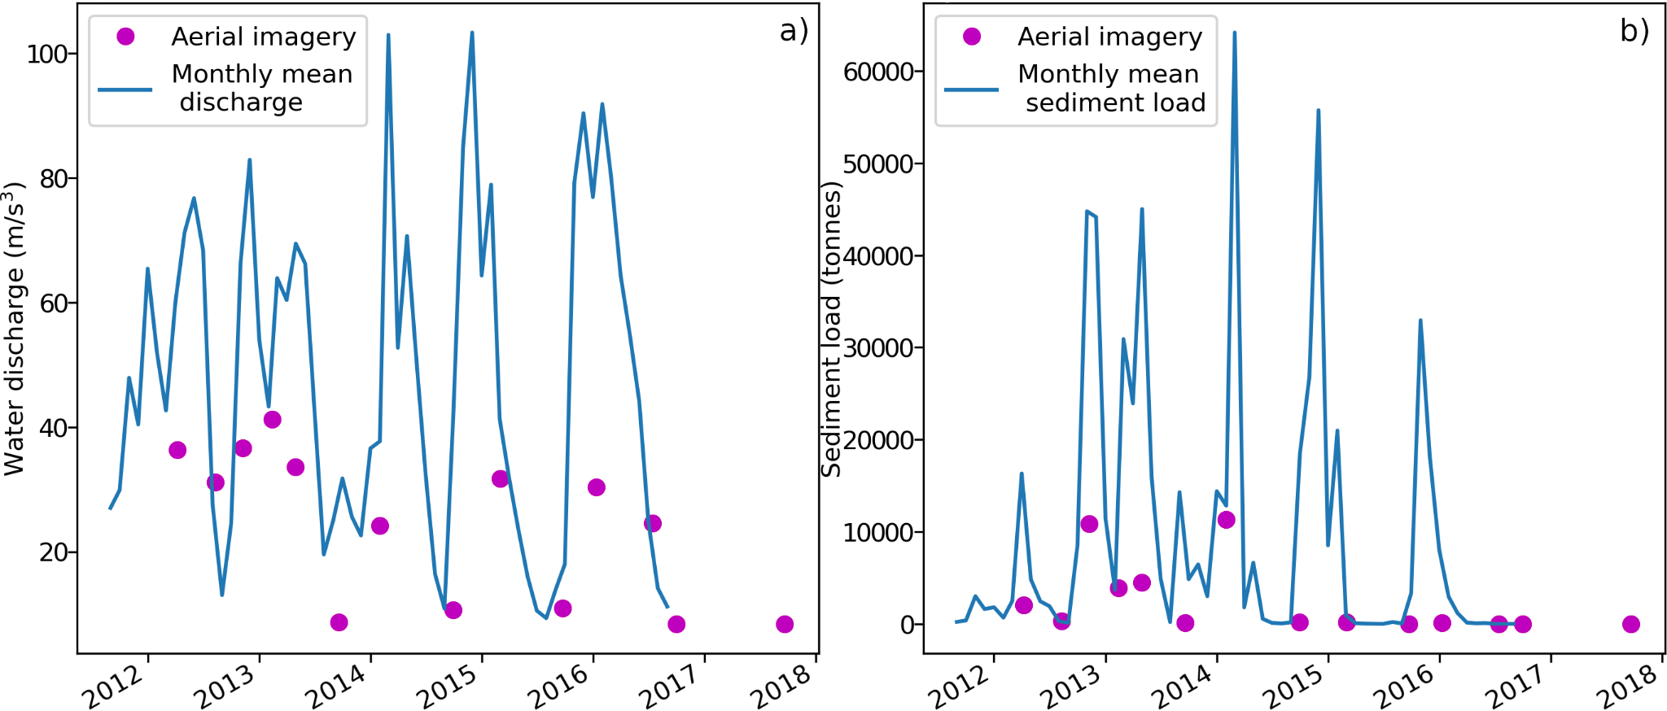

Figure S6. Monthly mean river discharge (a) and sediment load (b), and instantaneous measurements of those quantities at time of aerial survey (red dots) are provided for context.

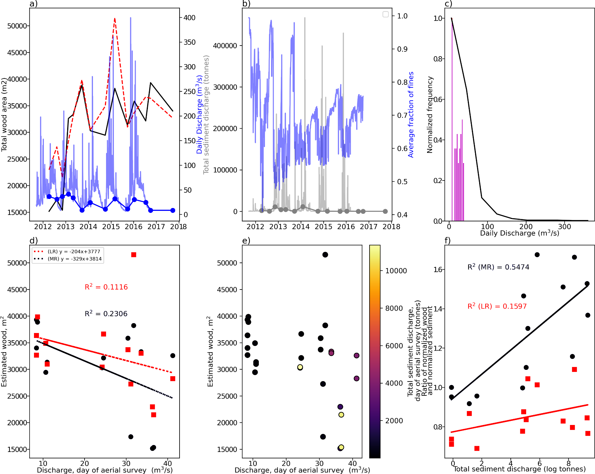

Figure S7. Sampling of our measurements compared to time-series of river discharge and sediment load. a) Time-series of total wood area in the middle reach (MR; black line) and lower reach (LR; dashed red line), daily flow discharge (blue faded line), and discharge on day of survey (blue line with dots); b) Time-series of total sediment load (grey), average fraction of fines (blue), and total sediment load (grey dots); c) normalized histogram of river flow (black line) and flow (red bars); d) relationship between total wood and discharge; e) relationship between total wood, total sediment load, and discharge; and f) Ratio of normalized wood and sediment as a function of total sediment discharge for middle reach (blue dots) and lower reach (red squares).

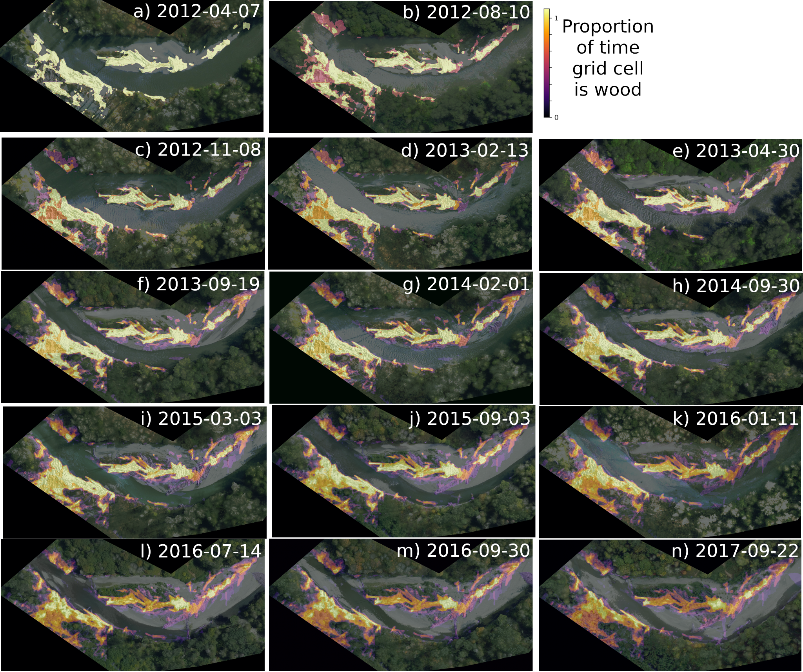

Figure S8. Large wood persistence in an example location within the lower portion of the lower reach in which there was relatively large amounts of pre-existing wood. Each panel shows an orthoimage at a different time in the 14-point time-series. The brightness of the superimposed persistence map is proportional to the proportion of cumulative time wood has been present at that location.

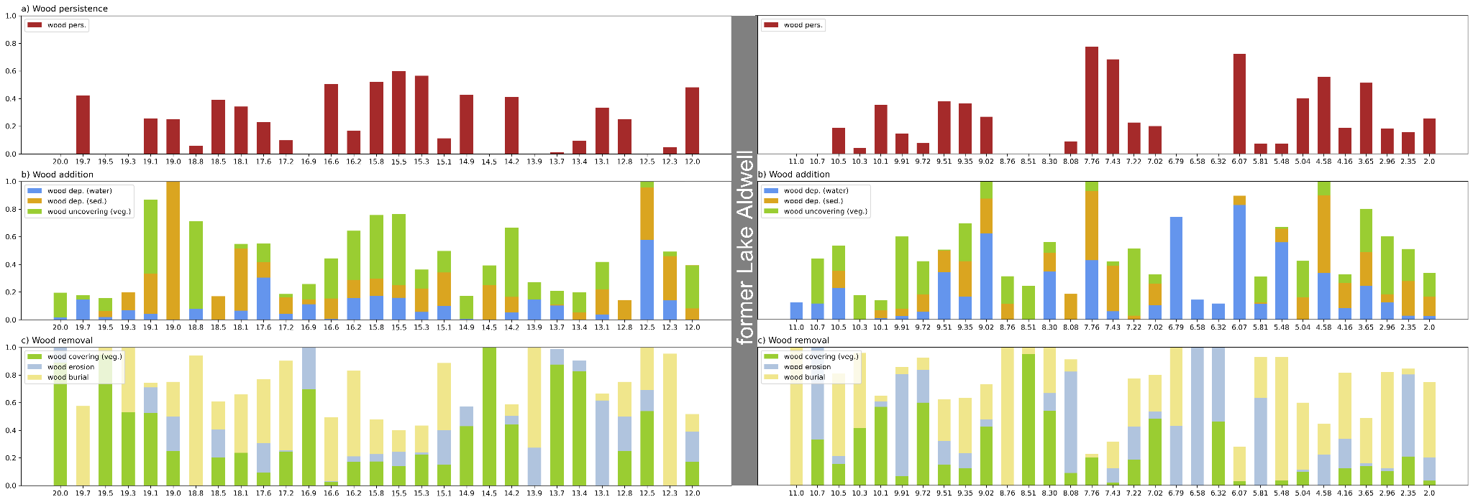

Figure S9. Sub-reach scale transition probabilities plotted as a function of downstream distance. There are sixteen processes encoded in every transition probability matrix for every sub-reach. Different groups of processes are represented by each subplot: a) persistence of the wood class, b) processes that add or unobscure wood, c) processes that remove or obscure wood. In subplots b through c, each stacked bar represents the relative propensity of classes in that sub-reach to carry out a specific transition, itself represented by a color, as noted in the legend of the subplot.

