Supplemental Information: Remote sensing large wood storage downstream of reservoirs during and after dam removal: Elwha River, WA, USA.

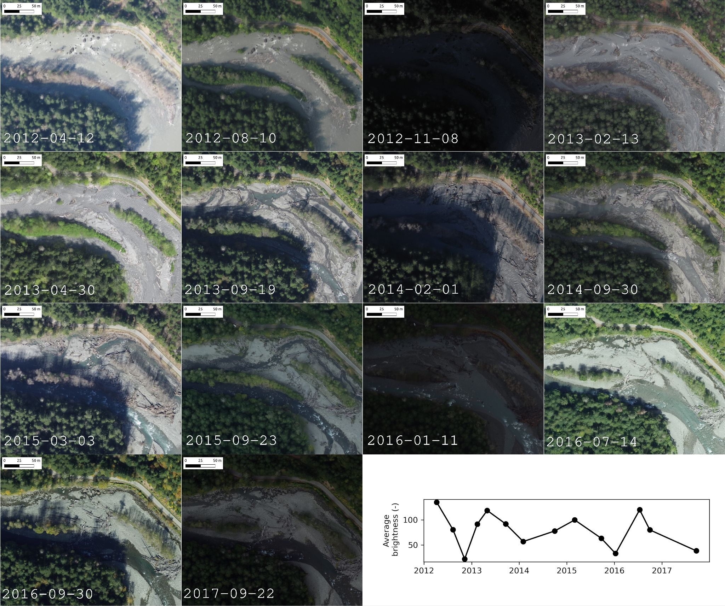
Figure S1: To determine the relative elevation of all detected wood, the closest-in-time DEM was used, detrended using a 2nd-order polynomial trend surface constructed using elevation of the river level

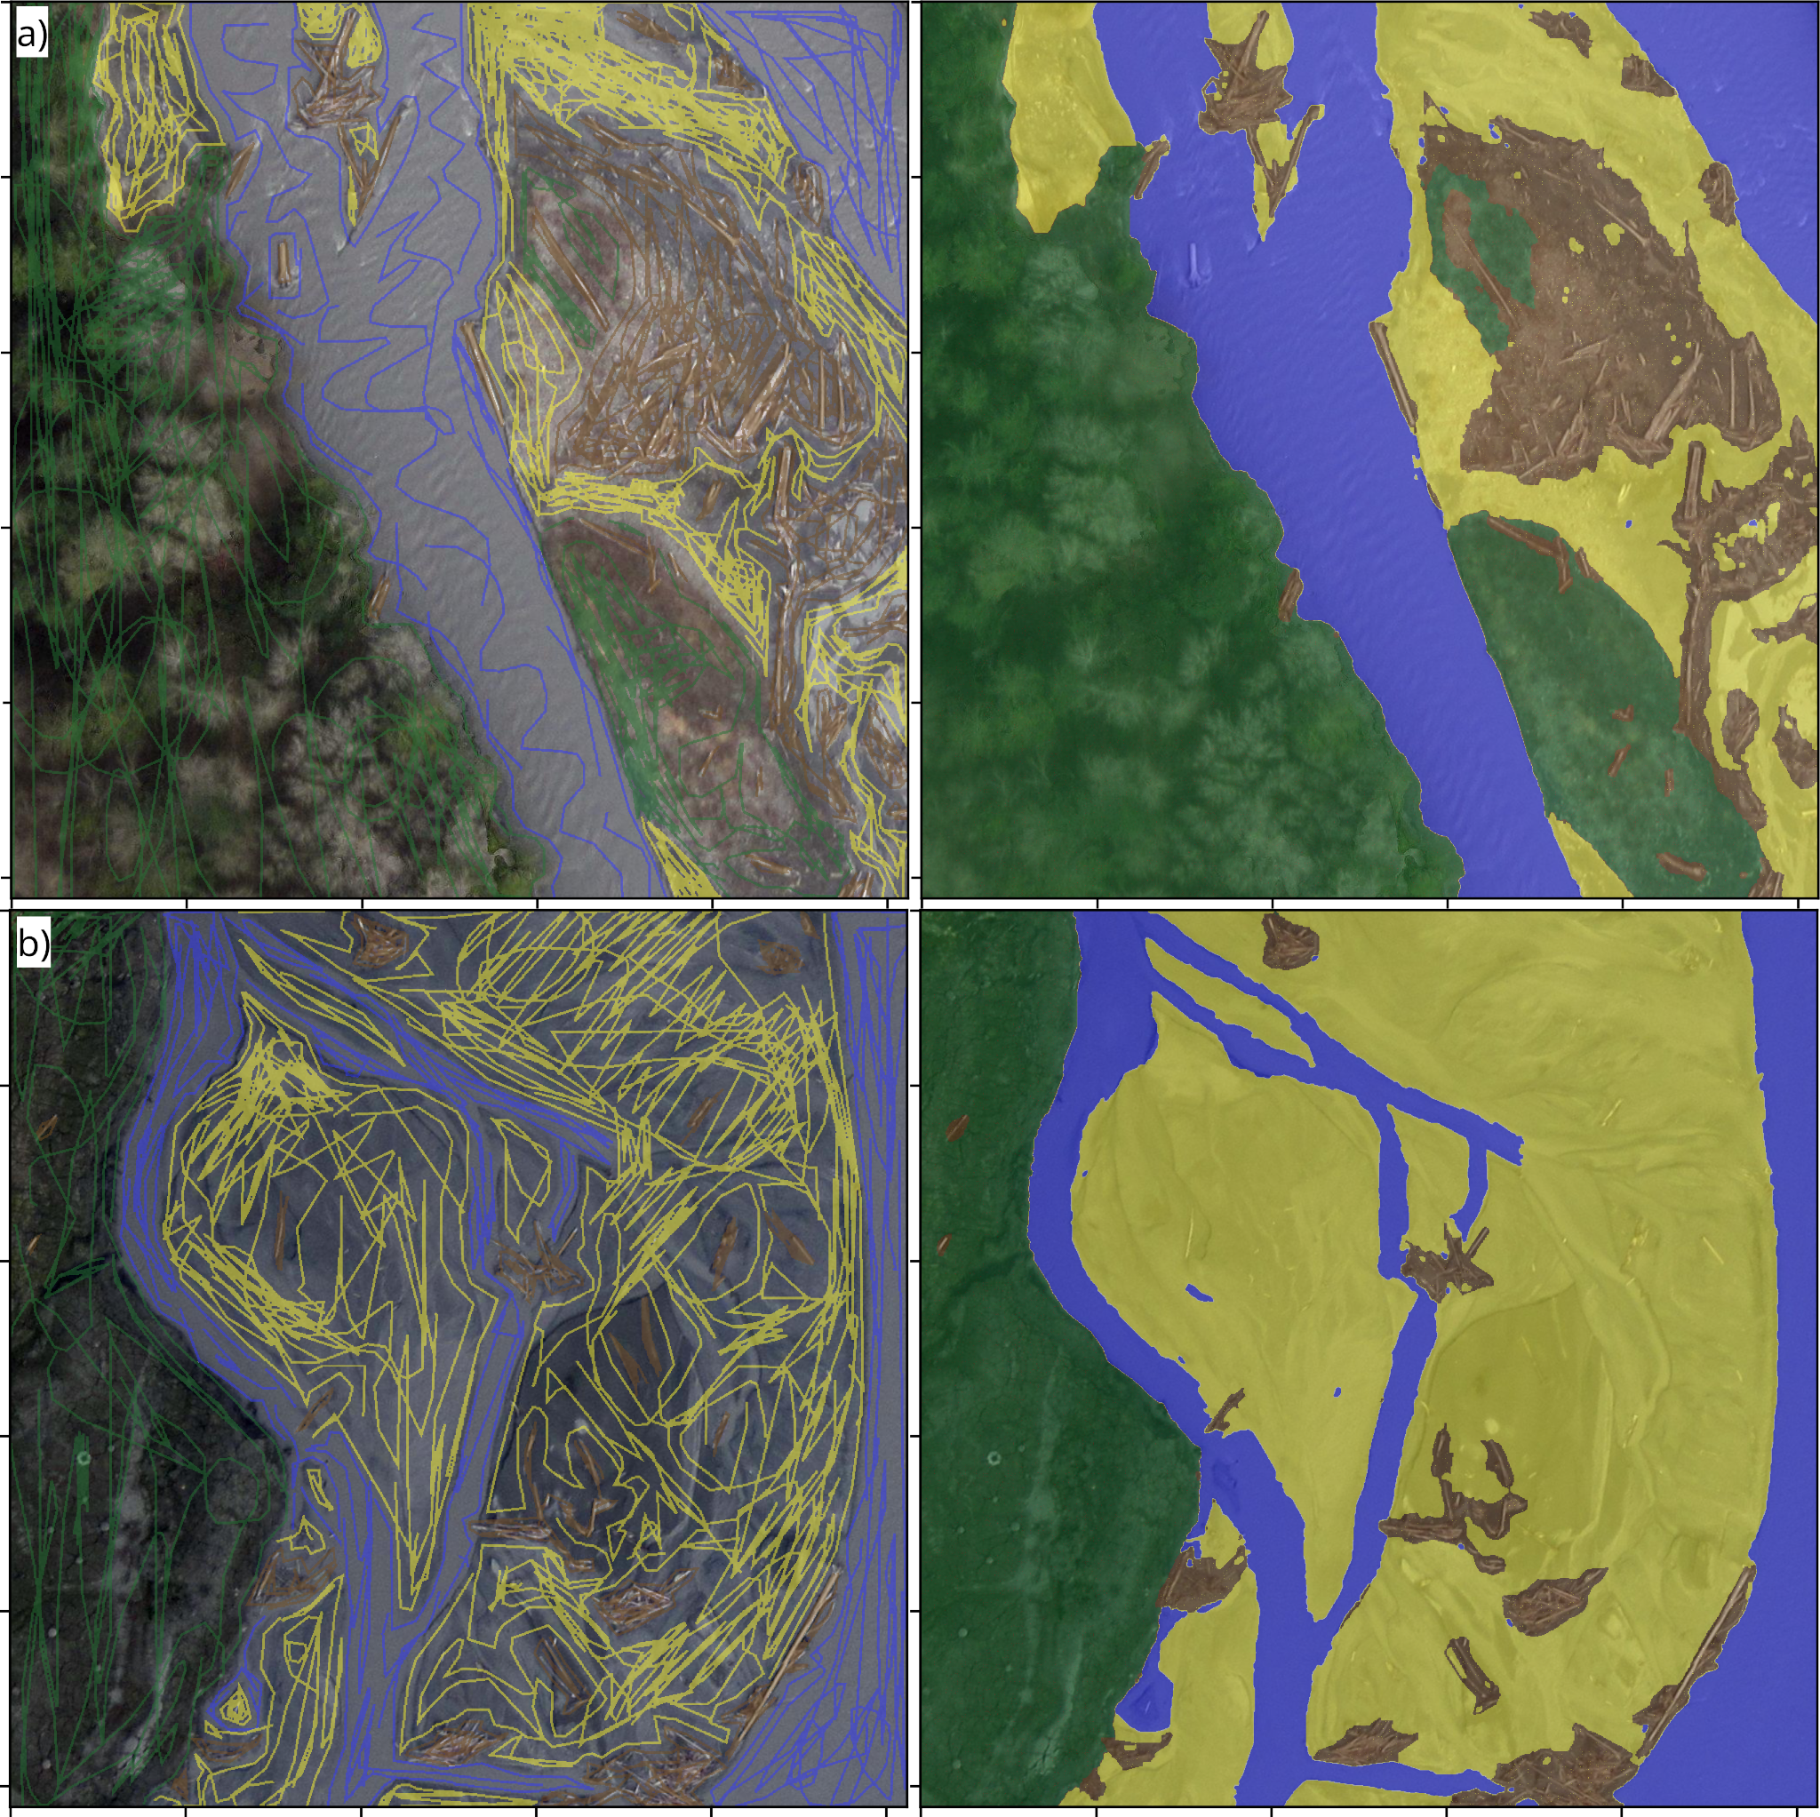
Figure S2: Examples of labeled imagery created using Doodler, an interactive image labeling program. Each 1024x1024 pixel image tile is annotated, or ‘doodled’ (left column), by selecting pixels of each class on screen, and Machine Learning is used to complete the scene (right column). Users of the program can adjust settings and add/remove doodles for label optimization.

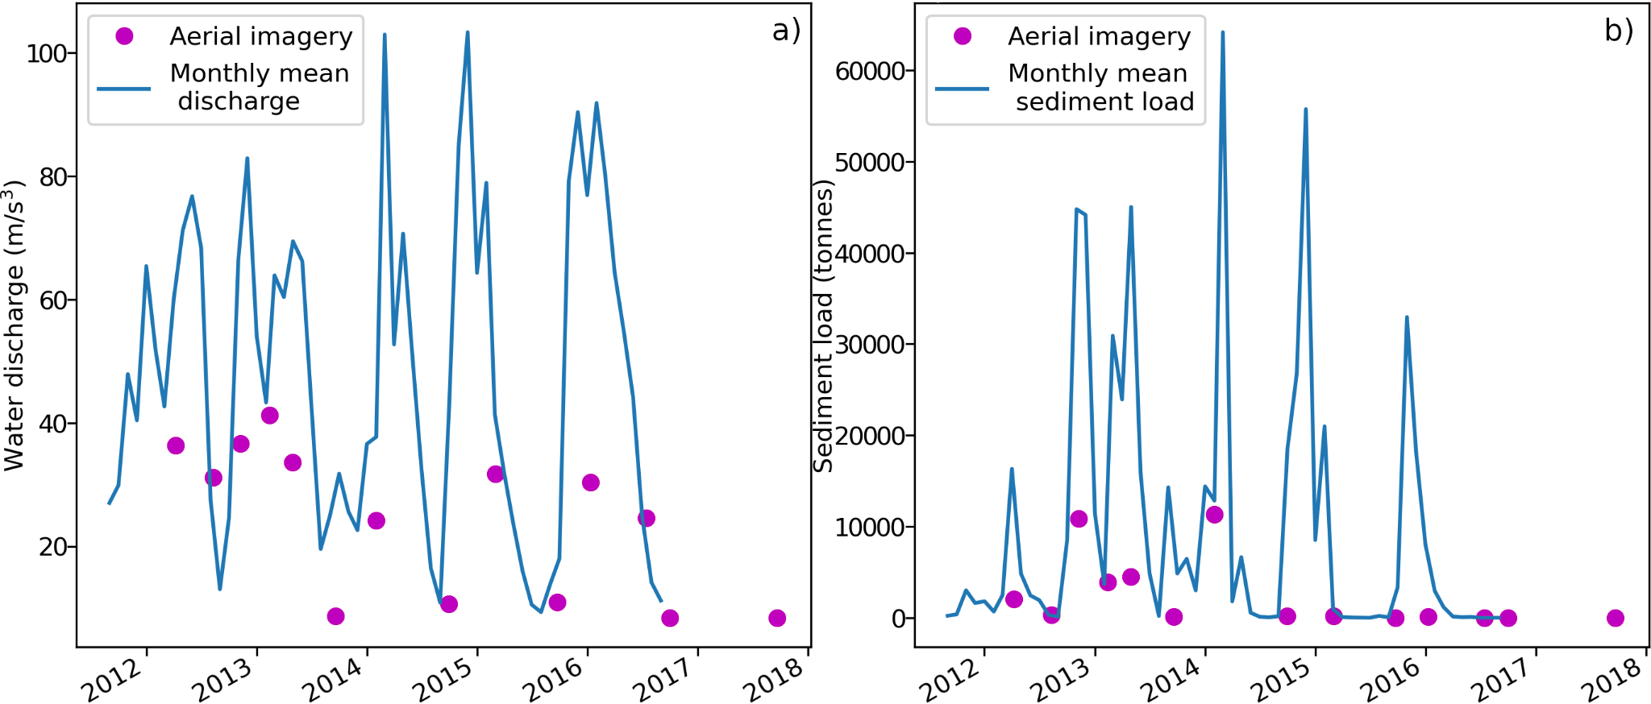

Figure S3: Monthly mean river discharge (a) and sediment load (b), and instantaneous measurements of those quantities at time of aerial survey (red dots) are provided for context.

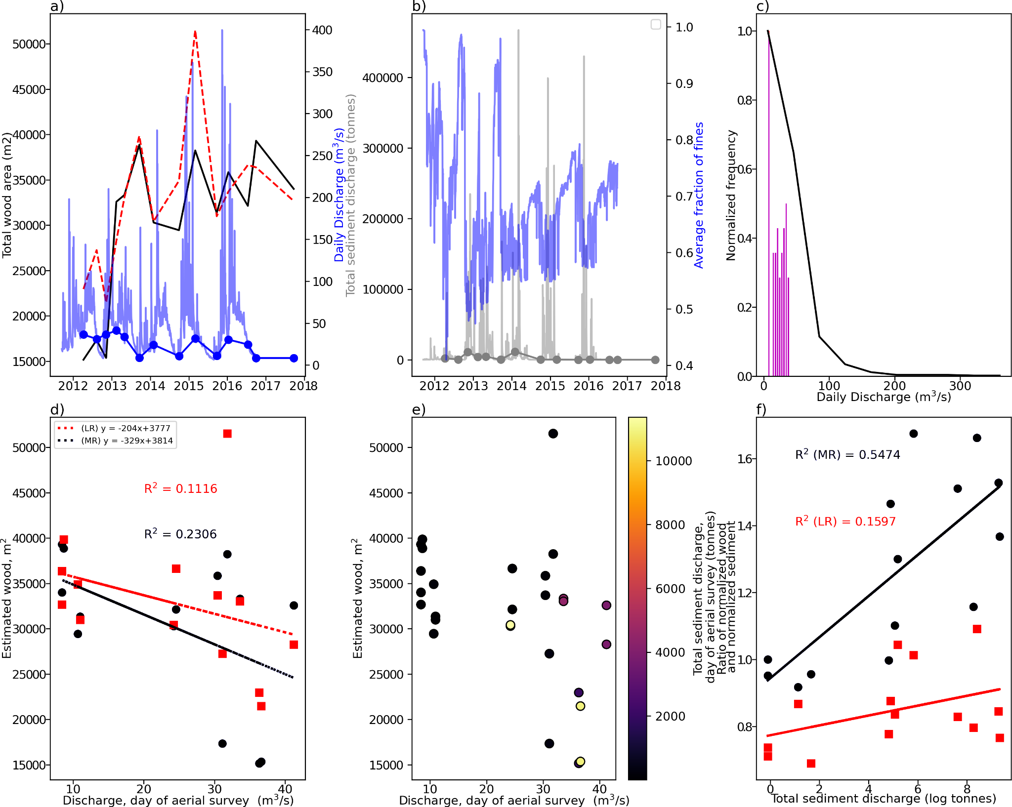
Figure S4: Sampling of our measurements with respect to time-series of river discharge and sediment load. a) Time-series of total wood area in the MR (solid black line) and LR (dashed red line), daily flow discharge (blue faded line), and discharge on day of survey (blue line with dots); b) Time-series of total sediment load (grey), average fraction of fines (blue), and total sediment load on day of survey (grey dots); c) normalized histogram of river flow (black line) and flow on survey days (red bars); d) relationship between total wood and discharge on day of survey; e) relationship between total wood, total sediment load, and discharge on day of survey; and f) Ratio of normalized wood and sediment as a function of total sediment discharge on day of survey for MR (blue dots) and LR (red squares).

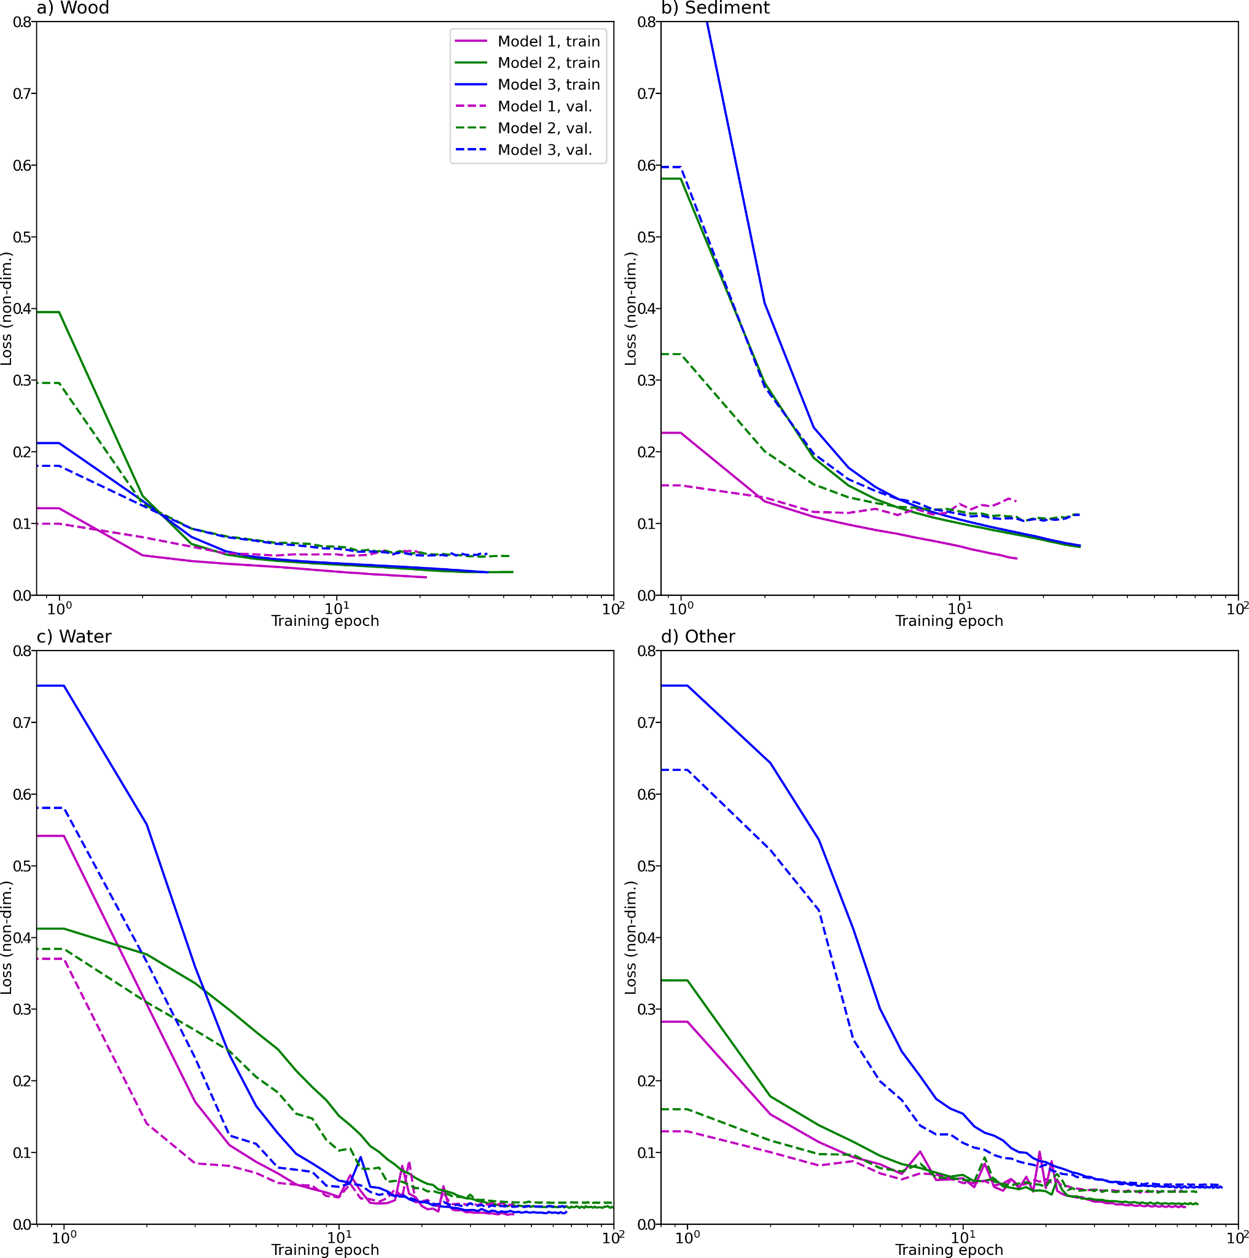
Figure S5: Train and validation loss curves are shown from separate realizations (model training with different learning rates) of binary (class/other) models for estimating wood (a), sediment (b), water (c) and ‘other’ (d) classes, respectively.

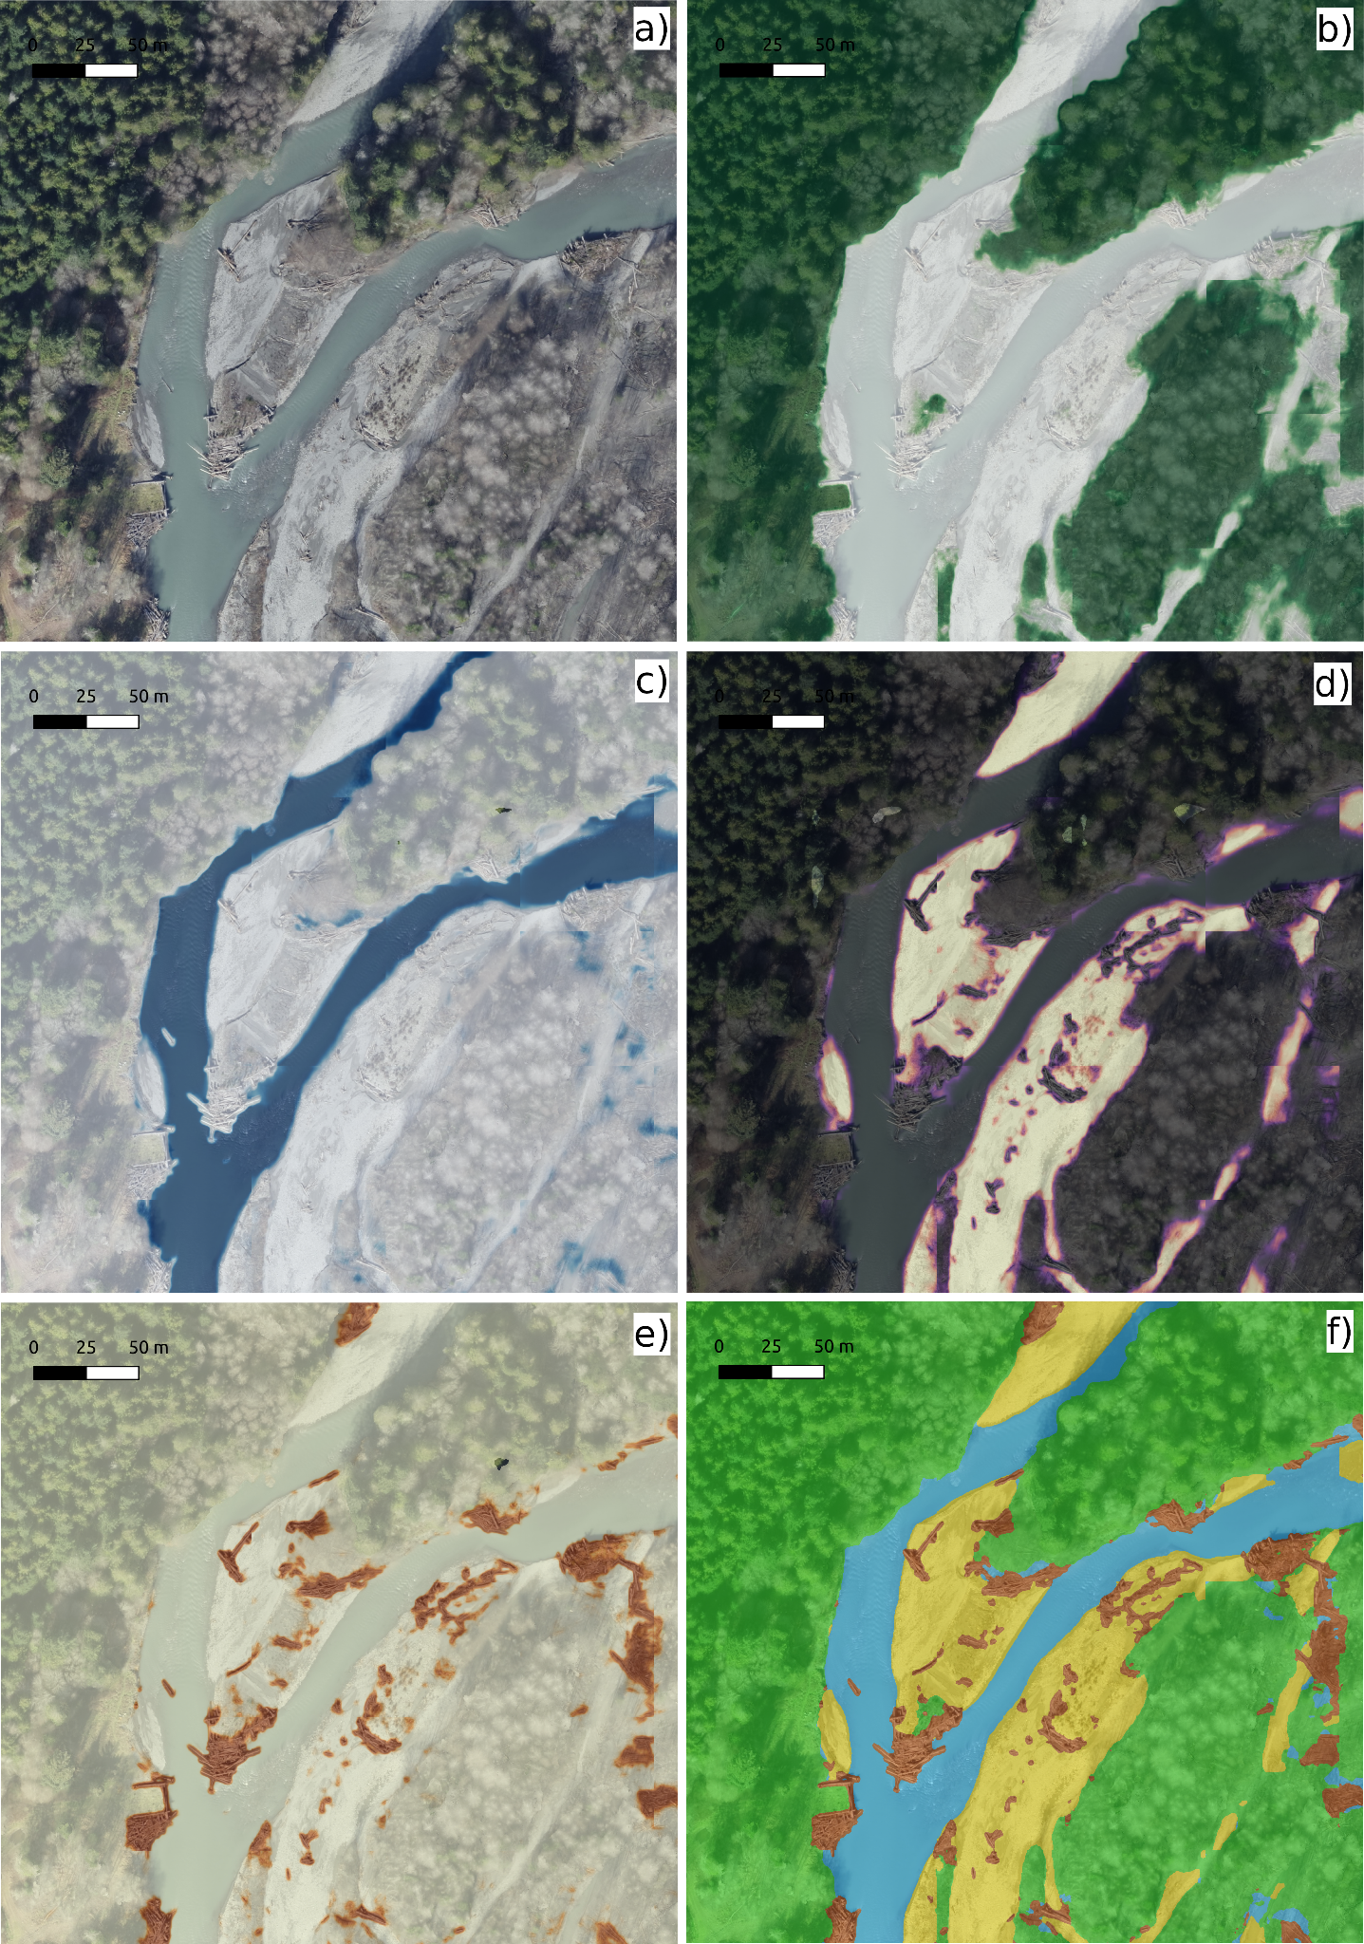
Figure S6: Example model output probabilities derived from input image (a) for 4 classes, namely ‘other’ (b), water (c), sediment (d), and wood (e). The argmax function is applied across these 4 probability rasters to produce the final label estimate (f).

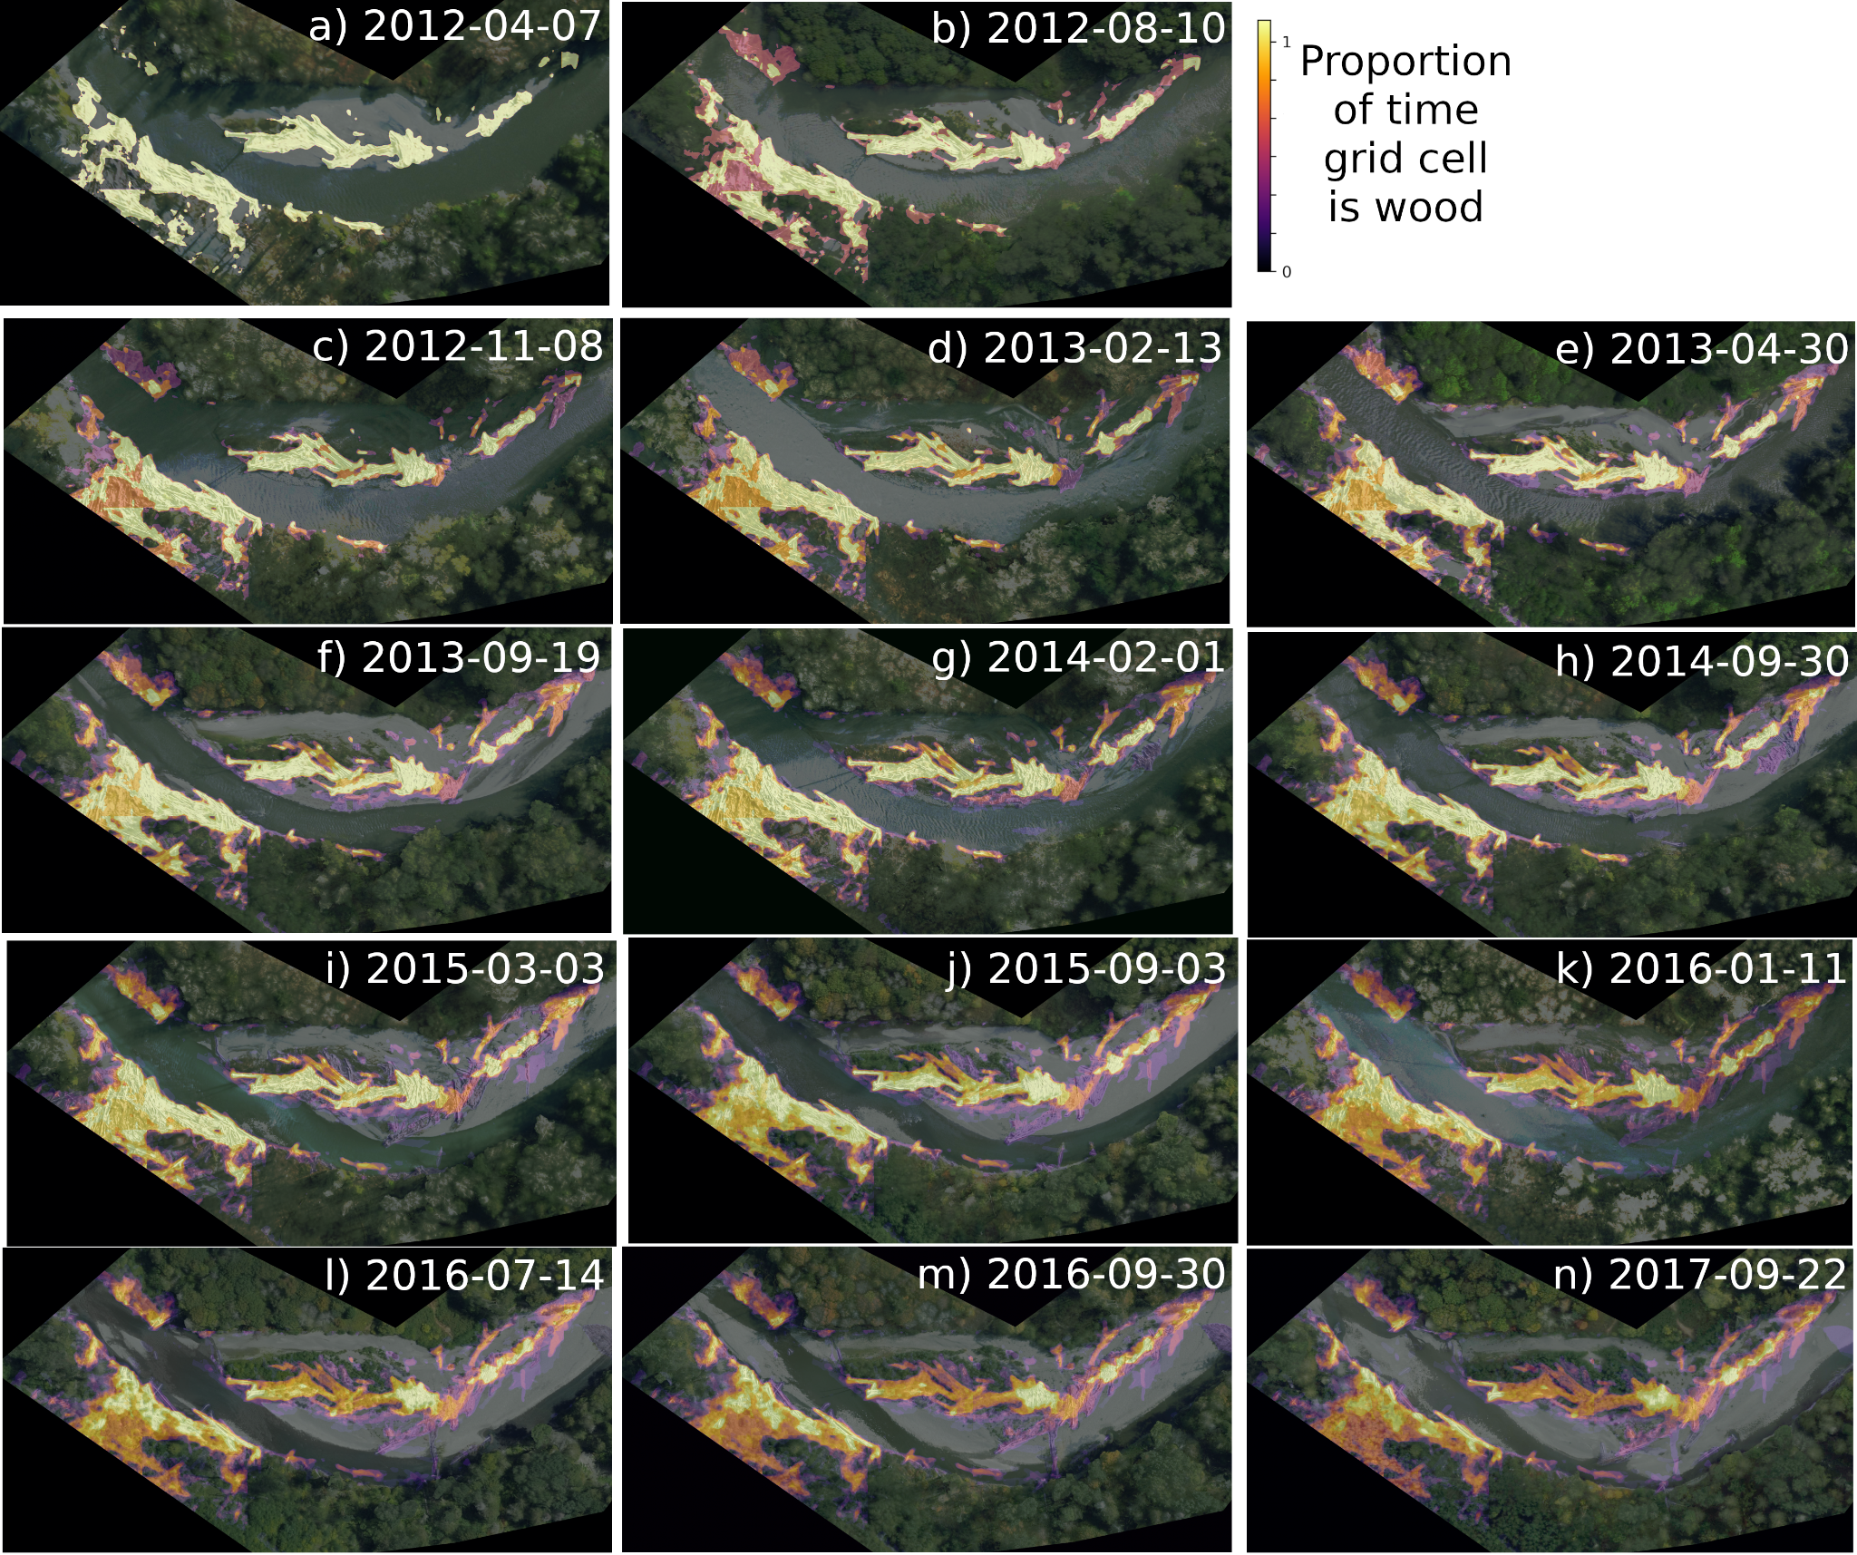
Figure S7: Large wood persistence in an example location within the lower portion of the LR in which there was relatively large amounts of pre-existing wood. Each panel shows an orthoimage at a different time in the 14-point time-series. The brightness of the superimposed persistence map is proportional to the proportion of cumulative time wood has been present at that location.

