**Supplemental 2: Confusion Matrices**

Buscombe et al. “How good are retrained deep neural networks at classifying images of landscapes?”

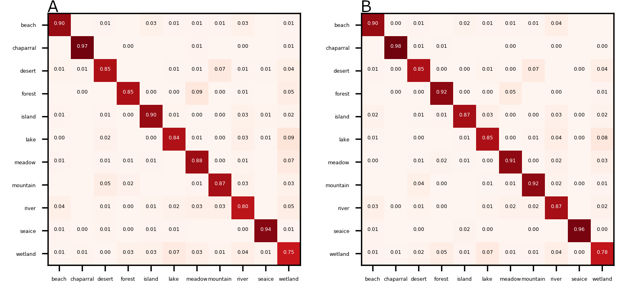

**Figure S2A.** Confusion matrix between true (left axis) and DCNN-estimated (bottom axis) labels, based on tiles generated from NPWU imagery, on size 96 (A) and 224 (B) pixels. Numbers are proportion classified.

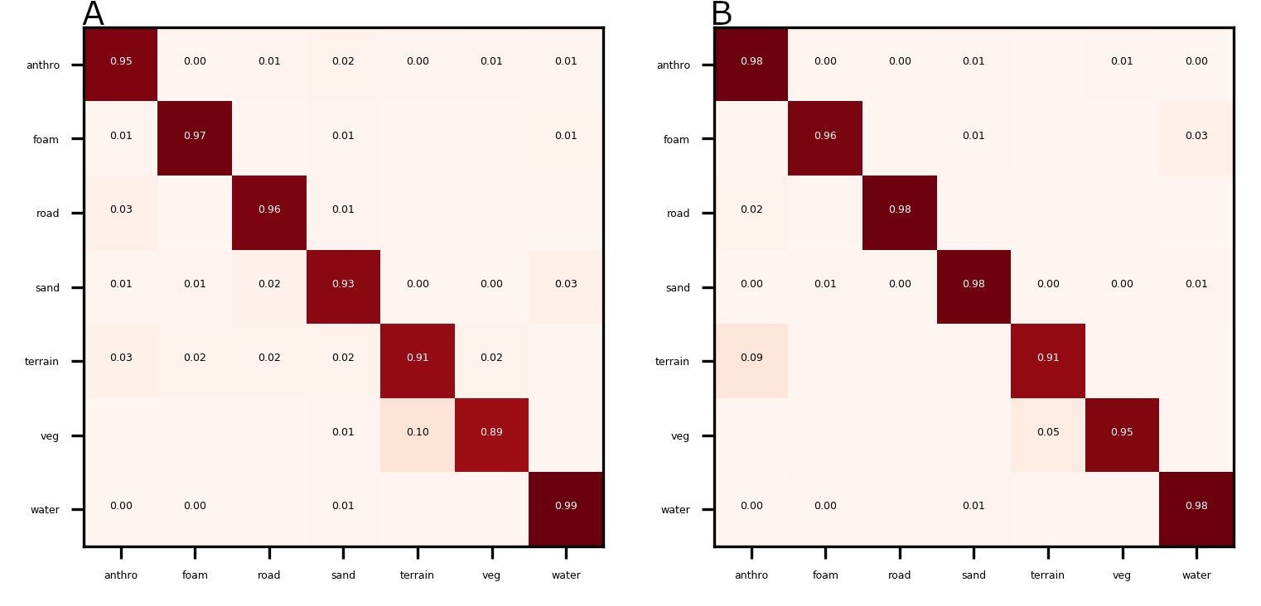

**Figure S2B.** Confusion matrix between true (left axis) and DCNN-estimated (bottom axis) labels, based on tiles generated from Seabright imagery, on size 96 (A) and 224 (B) pixels. Numbers are proportion classified.

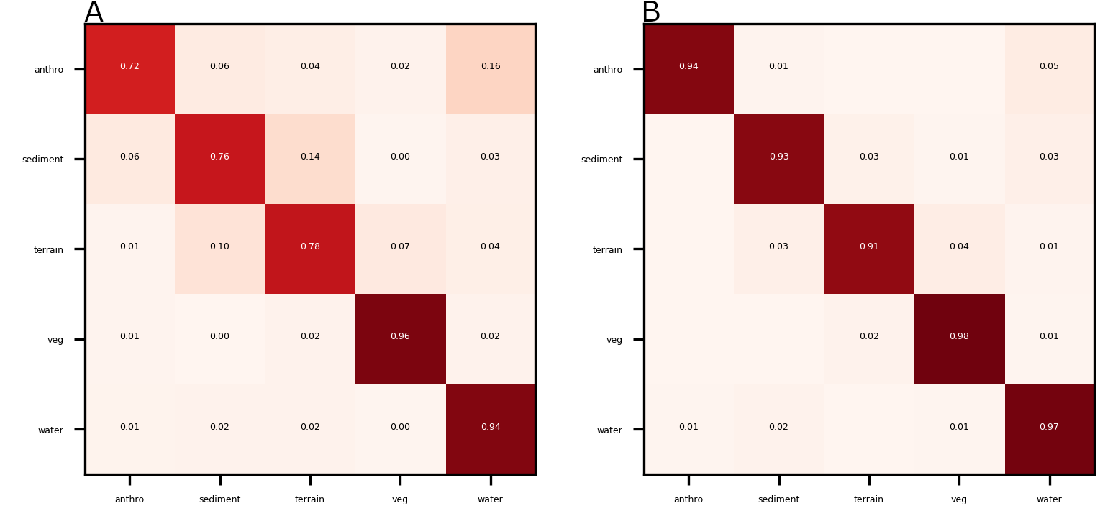

**Figure S2C.** Confusion matrix between true (left axis) and DCNN-estimated (bottom axis) labels, based on tiles generated from Lake Ontario imagery, on size 96 (A) and 224 (B) pixels. Numbers are proportion classified.

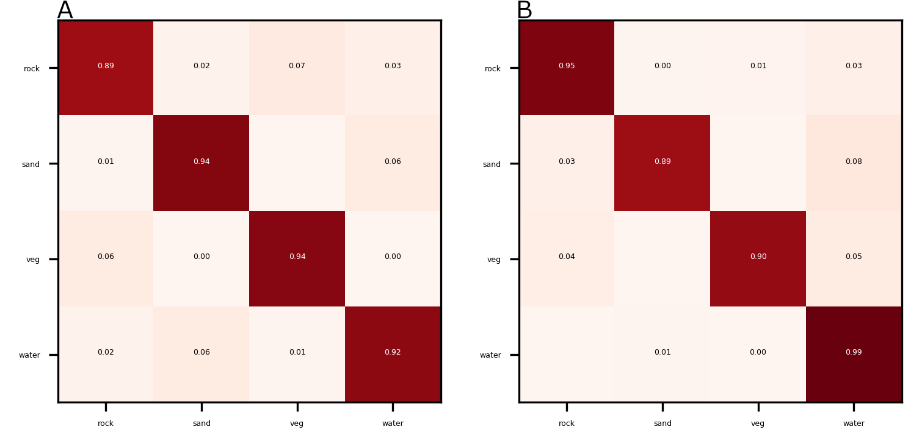

**Figure S2D.** Confusion matrix between true (left axis) and DCNN-estimated (bottom axis) labels, based on tiles generated from Grand Canyon imagery, on size 96 (A) and 224 (B) pixels. Numbers are proportion classified.

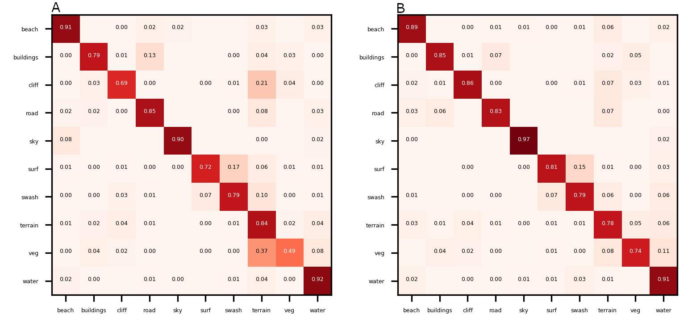

**Figure S2E.** Confusion matrix between true (left axis) and DCNN-estimated (bottom axis) labels, based on tiles generated from California Coastal Records imagery, on size 96 (A) and 224 (B) pixels. Numbers are proportion classified.

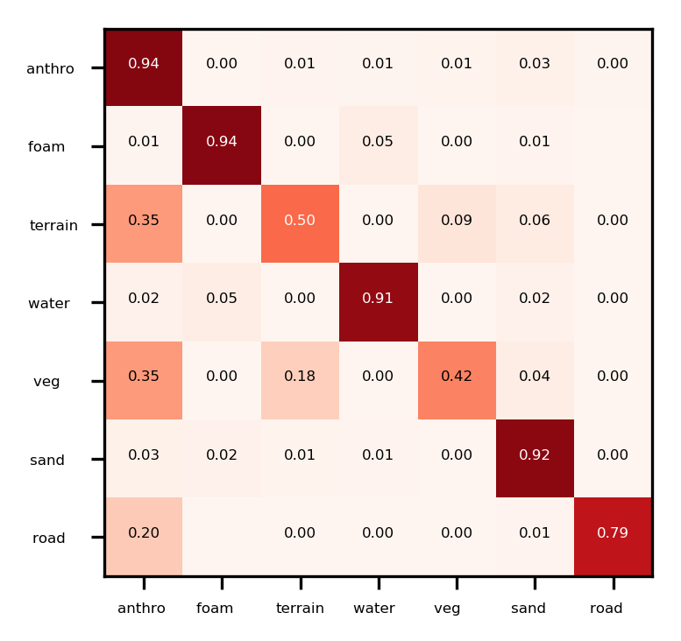

**Figure S2F.** Confusion matrix between true (left axis) and DCNN-CRF-estimated (bottom axis) pixelwise labels, using test imagery at Seabright beach. Numbers are proportion classified.

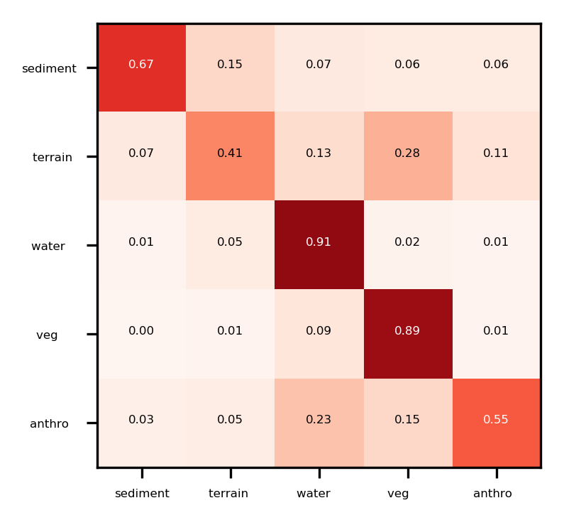

**Figure S2G.** Confusion matrix between true (left axis) and DCNN-CRF-estimated (bottom axis) pixelwise labels, using test Lake Ontario imagery. Numbers are proportion classified.

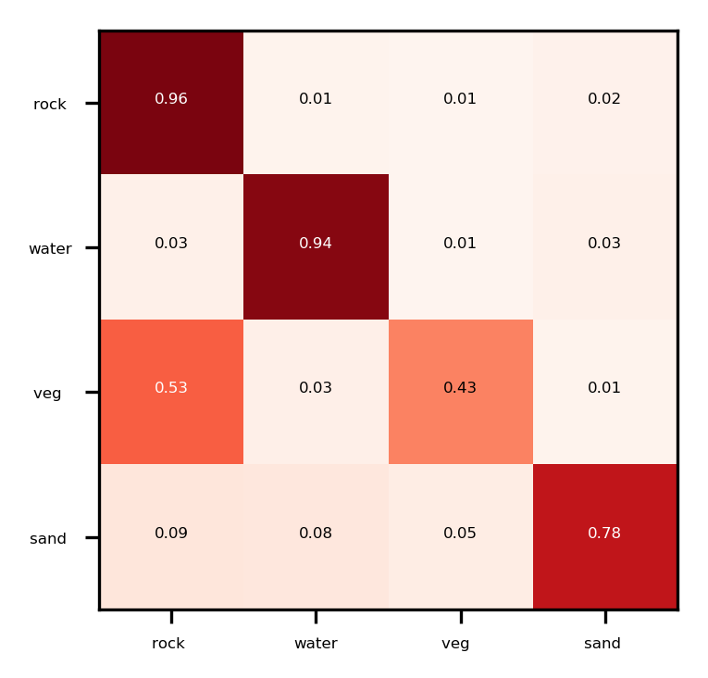

**Figure S2H.** Confusion matrix between true (left axis) and DCNN-CRF-estimated (bottom axis) pixelwise labels, using test imagery at Grand Canyon. Numbers are proportion classified.

**Figure S2I.** Confusion matrix between true (left axis) and DCNN-CRF-estimated (bottom axis) pixelwise labels, using test California coastal records imagery. Numbers are proportion classified.