**Name** Dmytro Busko

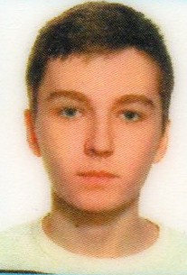

**Date of birth** 6-th of November 2002

**Address** 77411 58 Shevchenka St, Jezupil, Tysmenytskyi

district, Ivano-Frankivsk Region, Ukraine

**Phone number** +380-95-039-31-85

**Email** [dmytrobusko1106@gmail.com](mailto:dmytrobusko1106@gmail.com)

**Skype** dimama103

**Marital status** Single

**Objective**

I would like to learn a lot of new information to improve my qualifications. I want to be a good programmer. My knowledge and high learning ability allow me to make a significant contribution to the development of the company.

**Education**

2019 - to this day

Ivano-Frankivsk National Technical University of Oil and Gas

BA (Hons) in Software Engineering

**Work experience**

No work experience.

**Skills**

In-depth knowledge of Windows 10, MS Office, SQL, С#, WordPress, WooCommerce. Basic knowledge of C, C++, Java, HTML, Photoshop.   
Languages:  
Native Ukrainian  
Basic Russian  
Pre-intermediate English.

**Extracurricular activities**

I am а quick learner, dependable, hardworking, keep deadlines successfully, open to change and well-organized. Able to prioritize and adapt well to new situations.

**References**

Silver medal for graduation, the presence of letters of commendation.