BADM 225 · PROFESSIONAL COMMUNICATION FOR BUSINESS · STUDY GUIDE

Chapter 2: Planning Business Messages
Purpose, audience analysis, reader benefits, tone, and the decisions that happen before you write a word.
Original instructional material written by the instructor. Not affiliated with, and containing no content from, any textbook or publisher.

How to use this guide
This chapter is about the invisible half of writing — the thinking that happens before drafting. Read it once through, complete the message-planner worksheet on a real message you need to send this week, then work the Chapter 2 practice questions on the course site. The self-check quiz near the end tells you whether you are ready for the graded homework.

The most expensive sentence in business
It is the sentence that has to be sent twice. Every unclear message generates a reply asking what you meant, a correction, a meeting to untangle the confusion, or — worst — silent wrong action. Multiply that by the dozens of messages professionals send daily and you find one of the quietest costs in any organization: rework caused by writing that was fast to send and slow to understand. Planning is how you buy back that time. The minutes spent deciding what you want, who you are asking, and why they would care are repaid every time the first version of your message does its job.
Writing research backs the intuition: skilled writers differ from novices less in vocabulary than in process — they spend far more effort setting goals, representing the audience, and planning before and during composition (Flower & Hayes, 1981). Novices start typing; experts start deciding.
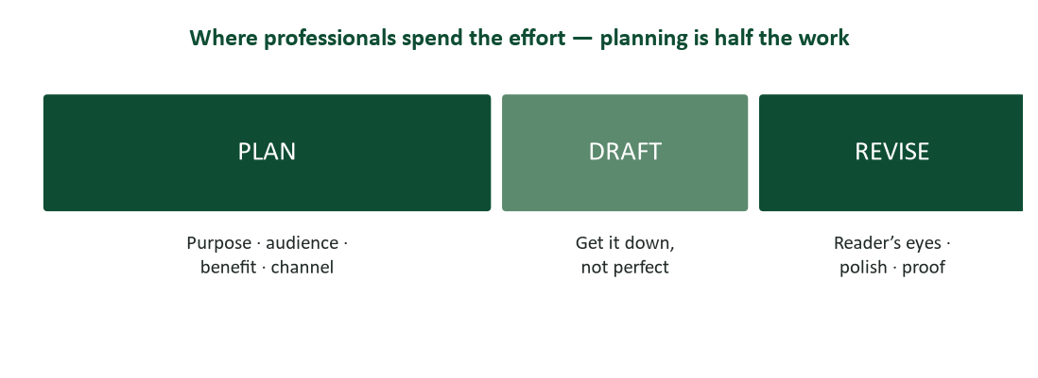
Figure 1. The three-phase writing process. Planning carries the most weight — drafting is the fast part.
The three phases also unbundle three different mental jobs — deciding, generating, and judging — which is exactly why drafting improves when you refuse to edit while you write, and editing improves when the draft has cooled. Chapter 3 covers drafting and Chapter 4 covers revision; this chapter is about the phase that determines whether those chapters have good material to work with.

Purpose: one message, one job
Before drafting anything, answer the only question that matters: what should the reader know or do after reading this? Not "what do I want to talk about" — what changes in the world if this message works. Most business messages have one of two purposes: to inform (the reader knows something new and needs no action) or to persuade (the reader does something — approves, buys, changes, replies). Many failed messages die of purpose overload: three asks, two announcements, and a question, all competing in one email. One message, one job.
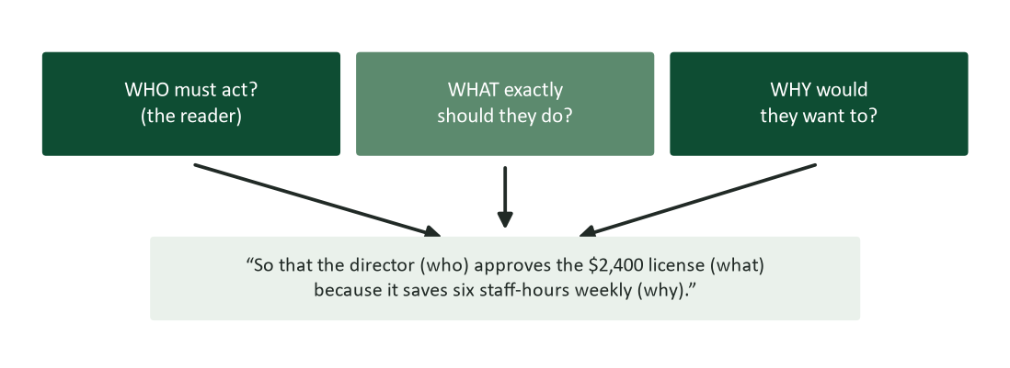
Figure 2. Anatomy of a working purpose statement: who must act, what exactly they should do, and why they would want to.

Worked examples: purpose statements
- Weak: “Update everyone on the project.” No actor, no action, no test for success.
- Working: “So that my manager approves two extra days for testing, because shipping untested risks the client relationship.”
- Weak: “Tell the team about the new expense system.” Inform them of what, to what end?
- Working: “So that every team member submits May expenses in the new system by May 31, because late entries won’t be reimbursed until July.”
The template. Notice the template hiding in the working versions: so that [reader] does [specific act] because [their reason]. If you cannot complete that sentence, you are not ready to draft — and no amount of polished prose will rescue a message that does not know its job.

Audience analysis: writing for the person who is actually there
Chapter 1 established that meaning is reconstructed through the receiver’s frame of reference. Planning is where you act on that: profile the audience before you draft. Three questions cover most of it. What do they already know? (Determines vocabulary and how much background to give.) How will they feel about this message? (Receptive, neutral, resistant — this decides your organization strategy in Chapter 3.) What do they need in order to act? (Deadlines, links, authority, reassurance.)
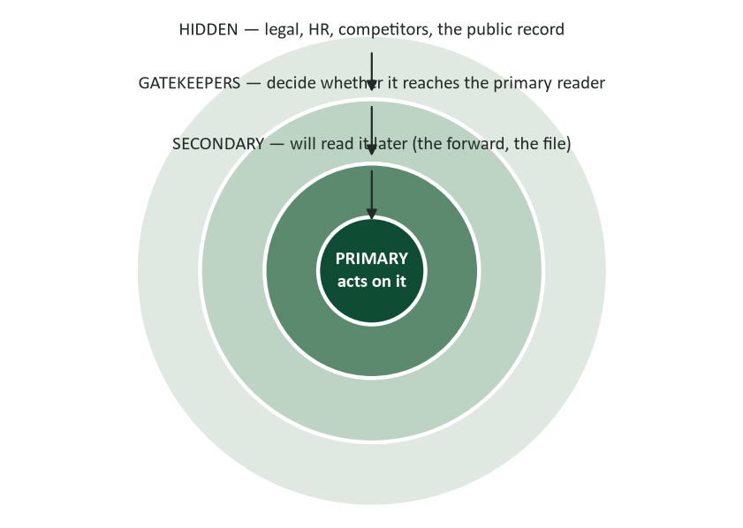
Figure 3. Your audience is bigger than your addressee: primary, secondary, gatekeeper, and hidden readers.
The rings in Figure 3 matter because business messages travel. The email you write to one teammate gets forwarded to their manager; the memo you write today becomes evidence in next year’s dispute; the report you address to your director is skimmed by her boss. Write to the primary reader, but write in the knowledge that secondary and hidden readers exist: define terms the forwarded-to reader will not know, and never put in writing what a hidden reader should not see. The forwardability test — “could this be forwarded, unedited, without embarrassing me?” — is audience analysis compressed into one question.

Theory corner: the rhetorical situation
The planning discipline in this chapter has ancient and modern roots. Aristotle’s Rhetoric organized persuasion around three appeals — ethos (the credibility of the speaker), pathos (the emotions and values of the audience), and logos (the logic of the argument) — and insisted that the available means of persuasion depend on the audience at hand (Aristotle, trans. 2007). Twenty-three centuries later, Lloyd Bitzer formalized the idea that discourse arises from a rhetorical situation with three parts: an exigence (the problem that calls for words), an audience (the people capable of acting on it), and constraints (rules, relationships, deadlines, and beliefs that shape what can be said) (Bitzer, 1968).
The practical translation: every message you plan sits inside a situation you did not fully choose. The exigence tells you your purpose. The audience tells you your appeals — a numbers-first CFO wants logos; a burned-once team needs ethos rebuilt before logic lands. The constraints tell you your form: what the syllabus, the contract, the culture, or the moment allows. Planning is simply reading the situation before speaking into it — and writers who skip it are answering a question nobody asked, in a voice the room does not trust, at a length the moment will not bear.

The you-view: the reader is the main character
The single most visible mark of a planned message is that it faces the reader. Writer-view prose reports what I did and we decided; you-view prose states what the reader gets, owes, or can do. It is not cosmetic — it is the purpose statement (“why would they want to?”) surfacing in the grammar.
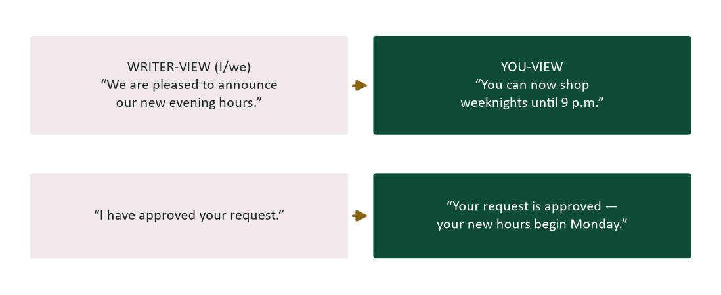
Figure 4. Writer-view to you-view: the same facts, re-anchored on the reader.
Two cautions keep the you-view honest. First, it is not about sprinkling the word “you” — it is about organizing the content around reader benefit; “you will be terminated” is technically you-view and diplomatically radioactive. Second, in negative or accusatory contexts, competent writers pivot away from “you” precisely to avoid blame language (“the report needs sources” rather than “you forgot the sources”). The principle underneath both: face the reader’s interests, protect the reader’s dignity.

Tone: one voice, dialed to the occasion
Tone is the reader’s impression of your attitude, and it is planned, not accidental. The reliable model is a dial, not a costume change: the same professional voice, adjusted for formality by occasion.
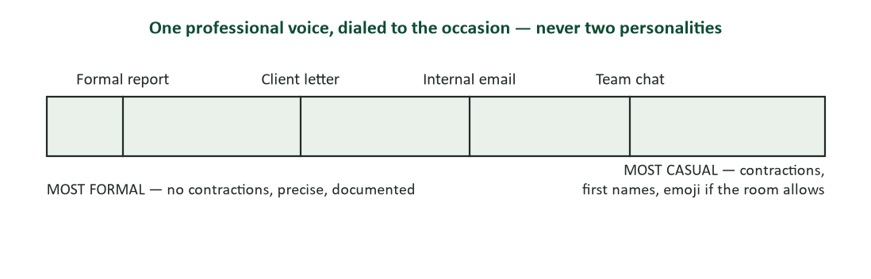
Figure 5. The formality dial. Same voice, adjusted to the occasion — never two personalities.
- Prefer positive framing. “Your order ships Friday” beats “We cannot ship before Friday” — identical facts, opposite experience.
- Retire the fossils. “Per my last email,” “as per,” “please be advised,” “enclosed please find” — inherited noise that adds formality without adding respect.
- Use bias-free language. Gender-neutral job titles, person-first descriptions, and names/pronouns people actually use — precision and respect, which are the same professional value.
- Match the reader’s stakes, not your mood. Cheerful tone on a message about someone’s billing error reads as indifference; measured tone earns trust.

Writing for the skeptical reader
Receptive audiences forgive planning shortcuts; skeptical ones punish them. When you anticipate resistance — budget requests, policy changes, anything that costs the reader time, money, or comfort — plan the objections before you draft.
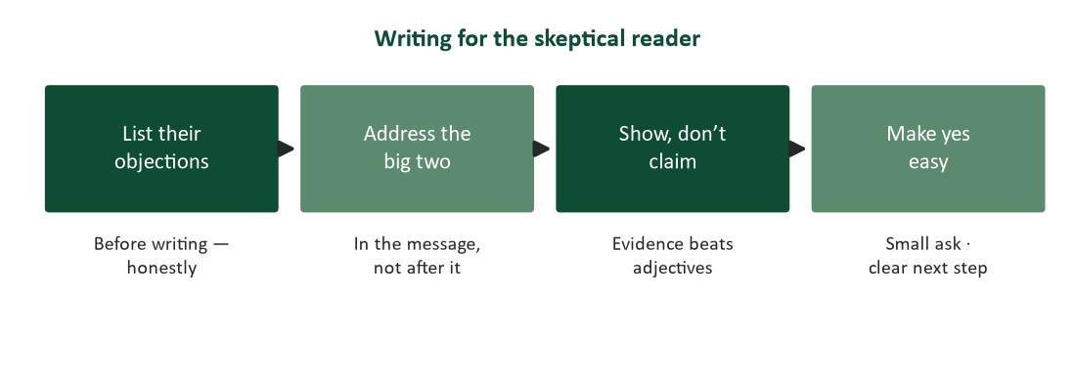
Figure 6. Planning for resistance: surface the objections early and answer the big ones inside the message.
The counterintuitive move is naming the objection yourself: “This costs $2,400, and here is why it pays back in six weeks” outperforms hoping nobody notices the price. Readers trust writers who have obviously considered the other side — that is ethos, manufactured honestly. And psychology is on the side of modest asks: attention is scarce and effort is aversive (Kahneman, 2011), so a specific, small, deadline-bearing request (“reply with your preferred slot by Thursday”) converts far better than a vague large one (“let me know your thoughts”).

Plain language is the law (really)
If planning for the reader ever feels optional, consider that for U.S. federal agencies it is legally required: the Plain Writing Act of 2010 obligates agencies to write public-facing documents in “clear, concise, well-organized” language suited to the audience (Plain Writing Act, 2010; plainlanguage.gov). The private sector has no such statute — just the same economics: documents that readers understand the first time cost less, convert better, and generate fewer complaints. The federal guidelines at plainlanguage.gov are a free, excellent style reference for any business writer.

Worked example: planning one real message
Situation: you coordinate a student org and need faculty volunteers to judge a case competition on a Saturday morning. Run the canvas (Figure 7):
- Purpose: so that at least four faculty reply “yes, I’ll judge” by Friday, because judging showcases their expertise to 80 students and takes only three hours.
- Audience: busy faculty; receptive to student success, resistant to weekend time; they need the exact time commitment and what judging involves before they can say yes.
- Benefit: visible mentorship, listed program recognition, coffee and lunch provided — their reasons, stated early.
- Channel: individual emails (not a mass BCC — gatekeeper-free, personal, forwardable to their calendar).
- Opening: the ask and the date in sentence one; background afterward for those who read on.
- Call to action: “Could you reply by Friday with a yes/no? Judging runs 9–noon on the 14th; rubric and coffee provided.”
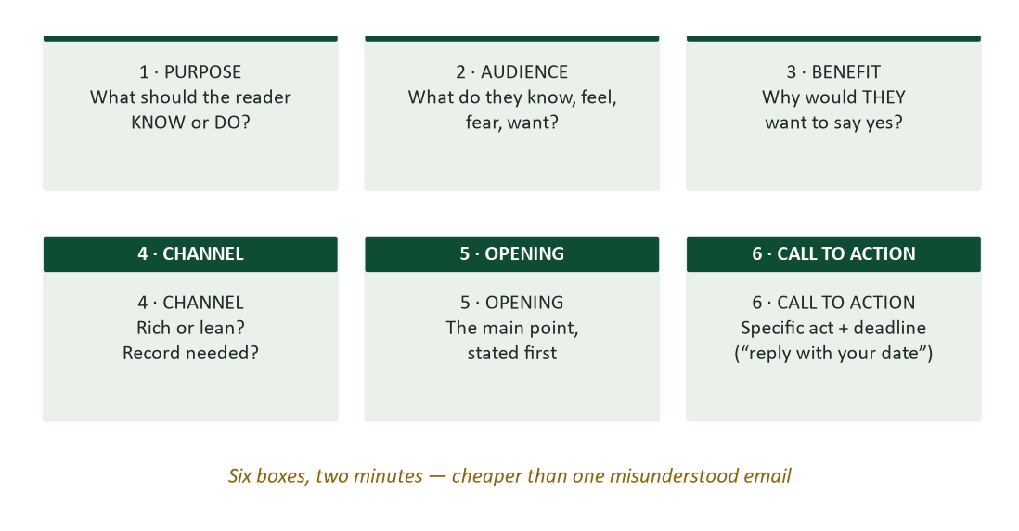
Figure 7. The six-box message planner. Two minutes here is cheaper than one misunderstood email.

Research corner: what readers actually do with your message
Plan for the reading you will actually get, not the reading you deserve. Eye-tracking research on screen reading famously found that users scan in rough F-shaped patterns — reading the first lines fully, then less of each following line, then skimming down the left edge (Nielsen, 2006). Translation for planners: your first sentence gets read; your first words of each paragraph get sampled; the middle of paragraph four effectively does not exist. This is why journalists have written in the inverted pyramid — most important first, detail descending — for over a century, and why this course keeps repeating “frontload.”
The planning consequences are concrete: put the ask and the benefit in the zone that gets read (subject line, sentence one); start paragraphs with their point, because first words are the skim path; use white space, bolded deadlines, and lists to give scanners handholds; and treat anything below the first screen as optional reading — never hide required action there. None of this dumbs writing down. It is designing for the real behavior of busy readers, which is the entire ethic of this chapter.

Planning under time pressure: the 60-second plan
Real inboxes do not allow a canvas for every message. Compress the discipline into one minute, three questions: What do I want? (the purpose template, spoken silently) — Why would they care? (one reader benefit, moved into sentence one) — What exactly happens next? (act plus date at the end). Sixty seconds, three answers, and your routine messages inherit most of the value of full planning. Reserve the six-box canvas for stakes: money, strangers, resistance, permanence, or anything a hidden reader might someday see.

Planning for global and multicultural readers
Chapter 1’s context continuum (Hall, 1976) becomes a planning checklist the moment your audience rings include readers from other cultures — which, in modern organizations, is always.
- Strip idioms at the planning stage. “Circle back,” “low-hanging fruit,” and every sports metaphor force non-native readers to translate twice.
- Make dates unambiguous. “5 March 2026,” never “3/5/26” — half the world reads that backwards.
- Plan more context for high-context readers. Relationship acknowledgment before business is not padding; it is the message working.
- Expect indirect yes/no. Plan follow-up questions that let a reluctant “no” surface safely (“what obstacles should we plan around?”).
- Confirm agreements in writing, gently. A short summary respects both styles: explicit for low-context readers, face-saving for high-context ones.

Format signals: email, memo, or letter?
The container is part of the plan, because format signals weight before a word is read. Email is the default for nearly everything internal and much external — fast, filed, forwardable. A memo (or memo-formatted PDF) signals institutional weight: policies, formal announcements, anything that will be referenced later; its To/From/Date/Subject block is a promise of documentation. A letter on letterhead is the heavyweight: external, formal, personal — offers, recommendations, official notices, apologies that must feel signed. Choosing a heavier container than the content warrants reads as pompous; choosing a lighter one than the occasion demands reads as careless. When in doubt, ask what the reader will need to DO with the document — file it, forward it, frame it — and pick the container built for that verb.

AI as a planning partner
Planning is the writing phase where AI helps most safely, because you are generating hypotheses rather than facts. Useful prompts: “List the objections a hospital CFO might raise to this proposal” (widens your resistance list); “What does a first-year employee likely NOT know in this announcement?” (audience knowledge check); “Rewrite this opening so the reader benefit comes first” (you-view drill). The boundaries from Chapter 15 still hold — the AI does not know your actual reader, so treat its output as a brainstormed list to verify against the human you know, and never paste confidential context into public tools. Used this way, AI makes the planning phase faster without touching the part that must stay yours: the judgment about which hypothesis is true.

Three readers you will meet everywhere
Audience analysis gets faster with pattern recognition. Three archetypes cover a remarkable share of business readers — learn to spot them and plan accordingly.

The executive skimmer
Reads the subject line, the first two sentences, and any bolded deadline — on a phone, between meetings. Wants the decision surfaced immediately and the reasoning available but not mandatory. Plan for them by frontloading the ask, keeping one screen of text, and structuring the support so it can be skipped without missing the point. If your main point is in paragraph three, the executive skimmer never met it.

The expert scrutinizer
Reads everything, checks your numbers, and notices what you left out. Wants completeness, sources, and honest limitations. Plan for them with precise claims (“reduces run time about 30% in our pilot” beats “dramatically faster”), cited evidence, and the objection section — because they will raise the objections whether you address them or not, and addressing them first is ethos. Skimping on rigor to “keep it simple” insults this reader; layering (summary up front, detail behind) serves both them and the skimmer.

The anxious stakeholder
Reads your message asking one question: what does this mean for me? Change announcements, policy updates, and reorganizations all land on this reader. Plan for them by answering the personal impact question explicitly and early (“your role, pay, and location are unchanged”), never leaving the most personal implication to be inferred — inference under anxiety always selects the worst reading. This is the reader the wellness-memo case (below) forgot.

Features vs. benefits: the “which means” ladder
The most common planning failure in persuasive messages is listing features — attributes of the thing — where the reader needs benefits: outcomes in their life. The repair tool is a two-word ladder: after every feature, force the phrase “which means…” and climb until you reach the reader.
- “The new LIMS auto-logs samples” → which means no manual entry → which means your techs save about an hour a day and transcription errors disappear from audits.
- “I am a certified quality auditor” → which means your findings close in-house → which means no more $1,800 external reviews.
- “The course is asynchronous” → which means you complete modules on your schedule → which means the certificate fits around a full-time job.
Two rungs is usually enough; stop when the sentence contains something the reader would put in their own status report. If you cannot complete the ladder for a feature, the feature may not belong in the message at all — planning is also deciding what to leave out.

The opening-line playbook
Openings are where planning pays first. Match the first sentence to the message type:
- Routine request. The ask, immediately: “Could you send the Q2 vendor list by Thursday noon?”
- Good news. The news itself: “Your proposal is approved — funding starts May 1.”
- Information / update. The one-line takeaway: “The migration finished last night; all systems are normal.”
- Meeting follow-up. The decisions: “Three decisions from today’s call:”
- Request to a stranger. The connection plus the reason for THIS person: “Dr. Rios suggested I contact you about the co-op program.”
- Gentle reminder. Assume good faith: “Resending in case this got buried — the form is due Friday.”
- Complex proposal. The recommendation, then the roadmap: “I recommend renewing with TechServe; the comparison below covers cost, support, and risk.”
- Bad news (preview of Chapter 7). A buffer of honest context — the one opening on this list that does NOT lead with the point.
- Thanks / recognition. The specific act: “Your triage of Saturday’s outage saved the launch.”
- Apology. Ownership without hedging: “I missed the deadline I committed to, and it delayed your review.”

Planning self-assessment
Score yourself: 2 = usually, 1 = sometimes, 0 = rarely.
- Before important messages, I can state in one sentence what the reader should do.
- I identify the primary reader by name or role — not “everyone.”
- I consider who might see the message beyond the addressee.
- My first two sentences contain the point, not the preamble.
- I name reader benefits, not just my request or my features.
- I anticipate the top objection and answer it in the message.
- I choose the channel deliberately for sensitivity and record.
- My requests carry a specific action and a date.
- I adjust formality to the occasion rather than writing one way always.
- I reread important drafts once as the least-informed likely reader.
Scoring: 16–20, your planning habit is a professional asset — refine, don’t overhaul. 10–15, choose the two lowest items and drill them for two weeks; the purpose template and the call-to-action rule pay fastest. Below 10, adopt exactly one habit this week: complete the purpose template before every message that matters. Retake at midterm.

Case study 1: the wellness memo that backfired
An HR director launches a wellness initiative with an all-staff memo: two paragraphs celebrating the company’s investment, a bulleted list of program features (biometric screenings, an app, lunchtime seminars), and a closing line — “We are excited about this journey!” Participation after one month: eleven percent. The grapevine version: “they’re making us do health screenings so insurance can raise our rates.”
- Diagnose the planning failures: what did the memo know about its audience’s fears, and whose benefits did it list?
- Which ring of Figure 3 did the writer forget, and how did that ring end up writing the message’s real meaning?
- Re-plan the message with the six-box canvas: what changes in the opening, the benefit, and the call to action?

Case analysis
The memo was planned for the sender: its benefits list was the company’s feature list, its tone celebrated the company’s generosity, and it never addressed the one thing a skeptical employee audience actually asks — what happens to my data? Silence on the top objection handed the interpretation to the grapevine (Chapter 1’s rule: informal channels fill every silence). A planned version opens with the employee’s benefit (“a $40 monthly premium credit and free screenings, on work time”), addresses the privacy objection by name (“results go to you alone; the company sees only anonymous participation counts — here is the policy”), and makes the first yes small (“fifteen-minute screening, four slots Thursday”). Same program; opposite message; the difference is entirely in the planning.

Case study 2: two versions of the same request
A lab supervisor wants the department to fund her Certified Quality Auditor exam ($545). Version A, to her manager: “I have been developing my skills in quality systems and feel this certification would be a great next step in my professional growth. The exam costs $545. I hope the department can support my development.” Version B: “Funding my CQA exam ($545) would let our lab close audit findings in-house instead of hiring the external reviewer we used twice last year at $1,800 per visit. The exam is in March; passing it makes us self-sufficient by Q2. Could you approve by the 15th so I can register at the early rate?”
- Both versions are polite and truthful. Map each against the purpose-statement template and the six-box canvas: what is missing from Version A?
- Whose benefits appear in each version? Count them.
- Version B names money going out and money saved. Which of Aristotle’s appeals is that, and why does it need to be paired with the deadline in the call to action?

Case analysis
Version A is a writer-view message: its subject is the writer’s growth, its benefit list is empty from the manager’s side, and its call to action (“I hope…”) asks for nothing checkable by any date. It plans to be appreciated, not approved. Version B passes the template — who (manager) does what (approve by the 15th) because (saves $1,800 visits, self-sufficiency by Q2) — and its logos is concrete: a cost paired against a larger recurring cost. The deadline converts goodwill into action by giving the yes a place to land. The deeper lesson: the writer’s real reasons (growth, ambition) are legitimate — but the message’s reasons must be the reader’s. Plan the overlap, and both people get what they want.

Teardown: the finished email, annotated
Here is the faculty-judges message from the worked example, drafted from its plan — with the planning visible in brackets.
Subject: Judge our case competition? 3 hours, Sat. May 14 [ask + size of ask visible before the email is even opened]
“Dr. Alvarez — Could you serve as a judge for our undergraduate case competition on Saturday, May 14, 9:00–noon? [the full ask, sentence one: act, date, duration] Eighty students will present strategy recommendations, and your supply-chain expertise is exactly what the final round needs. [benefit + why THIS reader — ethos returned to the reader] Judging is structured and simple: a one-page rubric, four presentations, coffee and lunch on us. [objection handling: effort, ambiguity, and Saturday-morning logistics answered before asked] Faculty judges are listed in the program and event photos go to the college’s newsletter. [second benefit: visible mentorship] Could you reply by Friday the 6th so we can confirm the panel? [call to action: specific act, specific date, reason for the date] Happy to answer anything — and thank you for considering it. [warm close, door open]”
The point. Count what the plan bought: the ask is in the subject line and first sentence (executive skimmer served), the effort objection is answered inside (expert scrutinizer served), every benefit belongs to the reader, and the yes has a date to land on. One hundred twenty words, nothing wasted — because the deciding happened before the drafting.

Watch list: three short talks worth your time
All free, public TED talks — search the titles. Watch for how each speaker plans around an audience, not a topic.
- Simon Sinek, “How Great Leaders Inspire Action.” His “start with why” is this chapter’s purpose statement scaled up to organizations — notice that the why is always the audience’s reason to care.
- Nancy Duarte, “The Secret Structure of Great Talks.” A presentation designer maps famous speeches as journeys designed around what the audience believes now versus what they could believe — audience analysis made visible.
- Chimamanda Ngozi Adichie, “The Danger of a Single Story.” The deepest version of frame-of-reference: what happens when a writer or a reader knows only one story about the other.

Message planner worksheet
Photocopy this mentally onto every message that matters. For a message you actually need to send this week:
- Purpose (template): so that __________ does __________ because __________.
- Primary reader’s current knowledge of the topic (one line): __________.
- Their likely feeling about it (receptive / neutral / resistant): __________.
- Their top objection, stated honestly: __________. Where in the message will you answer it?
- Secondary or hidden readers who could see this: __________. Anything to adjust?
- Reader benefit, in their words, appearing in the first two sentences: __________.
- Channel and why: __________.
- Call to action — specific act + deadline: __________.

Journal prompts
- Find a message you received recently that was clearly planned for the sender, not for you. What did it feel like to read — and what one planning question would have fixed it?
- Recall a time you wrote something long because you had not decided what you wanted. What was the real purpose, and when did you discover it?
- Aristotle says credibility (ethos) is an appeal you carry into the message. What is your current ethos with your manager, professor, or team — and what messages built it?
- Write the purpose statement for the next important message of your real life — a job application, a difficult family email, a pitch. Notice what deciding it changes.

How your writing will be graded (and read at work)
The course standard — could a supervisor send this as-is? — is applied at planning level before sentence level. A beautifully worded message with no discernible purpose, no reader benefit, and no call to action is not sendable; a plain message that knows its job usually is. Before submitting any assignment, verify: the purpose statement is completable, the opening faces the reader, the top objection is answered, and the ask has a date.

Common mistakes and their fixes
- Drafting first, deciding later. Fix: complete the purpose template before typing; if you cannot, gather what you are missing — that is the actual task.
- Writing to “everyone.” Fix: name the primary reader; write to them; let the rings read over their shoulder.
- Listing your features instead of their benefits. Fix: after every feature, force the phrase “which means you…” and finish the sentence.
- Purpose overload. Fix: one message, one job. The second ask gets its own message — or a clearly separated section.
- Vague calls to action. Fix: a specific act plus a date. “Thoughts?” is not a call to action; it is a donation request for attention.
- Tone by mood. Fix: set the dial deliberately for the occasion and the reader’s stakes, then hold it for the whole message.

Frequently asked questions
- “Planning feels slow. I write fine on the fly.” For routine messages you probably do — habit is compiled planning. The discipline is for messages with stakes: new audiences, money, resistance, or permanence. Those are exactly the ones instinct gets wrong.
- “What if I don’t know what the audience thinks?” That is a finding, not a dead end: ask someone who knows, or write the message to earn the answer (“what would need to be true for this to work for your team?”). Guessing is the only wrong option.
- “Isn’t the you-view manipulative?” Framing real benefits in the reader’s terms is respect; inventing benefits is manipulation. The test from Chapter 16 applies: if the reader could see your technique, would they still feel respected?
- “Can AI do my audience analysis?” It can generate hypotheses — “what objections might a CFO have?” is a great prompt. It cannot know your actual CFO. Use it to widen your list, then verify against the human you know. See Chapter 15.
- “How long should planning take?” For a routine email: the ten seconds it takes to complete the purpose template in your head. For a proposal: as long as the drafting. Scale it to stakes, not to guilt.

Crosswalk: this chapter → your course work
- Practice questions (course site, Chapter 2). The question bank drills purpose, audience rings, you-view transformations, and channel choice.
- Writing prompts (course site). The purpose-statement and dual-audience prompts rehearse Figures 2 and 3 directly.
- Your major assignments. Every graded document this term — market research, letters, the executive summary — will be graded first on the planning layer this chapter teaches.
- Next chapter. Chapter 3 takes the plan and organizes the draft: direct versus indirect strategy, paragraphs, and sentences that carry weight.
- The lecture deck. The Chapter 2 slides follow this guide section-for-section — use them as your review pass.

Key terms
- Purpose statement — one sentence naming who must do what, and why they would want to — the test of readiness to draft.
- Primary / secondary audience — the reader who acts, and the readers who receive it later by forward, file, or record.
- Gatekeeper — a reader who decides whether the message reaches the primary audience at all.
- Hidden audience — readers you did not address but must assume: legal, HR, the public record.
- Rhetorical situation — Bitzer’s trio of exigence, audience, and constraints that every message answers to.
- Ethos / pathos / logos — Aristotle’s appeals: credibility, audience values and emotion, and logical argument.
- You-view — organizing content around reader benefit and dignity rather than writer activity.
- Tone — the reader’s impression of your attitude — planned via the formality dial, not left to mood.
- Forwardability test — “Could this be forwarded unedited without embarrassing me?” — audience analysis in one question.
- Call to action — the specific act plus deadline that converts agreement into behavior.

Chapter summary
- Planning is half the work: experts decide before they draft (Flower & Hayes, 1981).
- One message, one job: complete “so that [reader] does [act] because [their reason]” before typing.
- Audiences come in rings — primary, secondary, gatekeeper, hidden. Write to the first; write knowing the rest exist.
- Every message sits in a rhetorical situation: an exigence, an audience, constraints (Bitzer, 1968) — and persuades through ethos, pathos, and logos (Aristotle).
- The you-view organizes content around reader benefit and protects reader dignity; it is planning made visible in grammar.
- Tone is one professional voice on a formality dial — positive framing, no fossils, bias-free, matched to the reader’s stakes.
- For skeptical readers: name the objections, answer the big two inside the message, show evidence, make yes small and dated.
- Plain language is codified law for U.S. agencies (Plain Writing Act, 2010) and plain economics for everyone else.

Self-check quiz
Answer before looking at the key on the final page. If you miss one, reread that section — then take the full practice set on the course site.
1. The first question to answer before drafting any business message is:
a) How long should it be?
b) What is my purpose — what should the reader know or do?
c) Which font looks professional?
d) Should I copy my manager?
2. A complete purpose statement names:
a) The topic and the deadline
b) Who must act, what they should do, and why they would want to
c) The sender’s credentials
d) The channel and the tone
3. The reader who will act on your message is the primary audience. A gatekeeper is:
a) Anyone who dislikes the message
b) A reader who decides whether the message reaches the primary audience
c) The IT department
d) The most senior reader
4. The forwardability test asks:
a) Whether the message is short enough to forward
b) Whether the message could be forwarded unedited without embarrassing you
c) Whether reply-all is enabled
d) Whether attachments are included
5. In Bitzer’s rhetorical situation, the exigence is:
a) The audience’s mood
b) The problem that calls the message into being
c) The formatting rules
d) The deadline
6. “You can now shop weeknights until 9 p.m.” demonstrates:
a) Writer-view
b) You-view — the fact framed as the reader’s benefit
c) Purpose overload
d) A gatekeeper strategy
7. When delivering criticism, skilled writers often avoid “you” because:
a) The you-view is always wrong
b) “You” in accusatory contexts becomes blame language that triggers defense
c) Readers prefer passive voice
d) It shortens the message
8. Which revision uses positive language most effectively?
a) “We cannot ship your order until Friday.”
b) “Your order will ship on Friday.”
c) “Unfortunately, shipment is impossible before Friday.”
d) “Do not expect your order before Friday.”
9. Aristotle’s three appeals are:
a) Purpose, audience, channel
b) Ethos, pathos, logos
c) Plan, draft, revise
d) Exigence, audience, constraints
10. For a skeptical audience, naming the biggest objection yourself:
a) Weakens your case
b) Builds credibility — readers trust writers who have considered the other side
c) Is legally required
d) Should wait for the follow-up email
11. An effective call to action includes:
a) A warm closing
b) A specific act plus a deadline
c) At least three options
d) An apology for asking
12. “Please be advised that enclosed please find…” is an example of:
a) Required legal phrasing
b) Fossil phrases — inherited formality that adds noise, not respect
c) You-view writing
d) Plain language
13. The Plain Writing Act of 2010:
a) Applies to all U.S. businesses
b) Requires federal agencies to write clearly for the public
c) Banned passive voice
d) Regulates email length
14. Expert writers differ from novices chiefly in:
a) Vocabulary size
b) Typing speed
c) How much they plan — setting goals and representing the audience (Flower & Hayes, 1981)
d) Avoiding revision

Answer key
1. b 2. b 3. b 4. b 5. b 6. b 7. b 8. b 9. b 10. b 11. b 12. b 13. b 14. c

Discussion questions
- Write the purpose statement for a message you sent recently that did not get the response you wanted. Did the sent version actually serve that purpose?
- Describe a real gatekeeper or hidden audience in your work or campus life. How does knowing they exist change one message you might send this month?
- Take a marketing email you received today and rewrite its opening in genuine you-view. What did the company’s version reveal about who it was planned for?
- Which of Aristotle’s appeals do you lean on by habit — and which audience in your life requires the one you use least?
- Find a public-facing document (university policy, utility notice, terms of service) that fails the plain-language standard. Re-plan its first paragraph with the six-box canvas.

References
The following published sources inform this chapter and are recommended for deeper study.
Aristotle. (2007). On rhetoric: A theory of civic discourse (G. A. Kennedy, Trans., 2nd ed.). Oxford University Press. (Original work ca. 350 BCE)
Bitzer, L. F. (1968). The rhetorical situation. Philosophy & Rhetoric, 1(1), 1–14.
Flower, L., & Hayes, J. R. (1981). A cognitive process theory of writing. College Composition and Communication, 32(4), 365–387.
Hall, E. T. (1976). Beyond culture. Anchor Press/Doubleday.
Kahneman, D. (2011). Thinking, fast and slow. Farrar, Straus and Giroux.
Nielsen, J. (2006). F-shaped pattern for reading web content. Nielsen Norman Group. https://www.nngroup.com/articles/f-shaped-pattern-reading-web-content/
National Association of Colleges and Employers. (2025). Job Outlook 2025. NACE. https://www.naceweb.org/
Plain Writing Act of 2010, Pub. L. No. 111-274, 124 Stat. 2861. https://www.plainlanguage.gov/
Practice what you just read: course site → this chapter → Practice, then the graded homework before the weekly deadline.

