BADM 225 · PROFESSIONAL COMMUNICATION FOR BUSINESS · STUDY GUIDE

Chapter 12: Business Presentations
One takeaway · slides as billboards · delivery you can rehearse · nerves you can manage
Original instructional material written by the instructor. Not affiliated with, and containing no content from, any textbook or publisher.

Why this chapter exists
You will write perhaps a hundred documents for every presentation you give — and the presentations will shape your reputation out of all proportion to that ratio. A talk is the one professional moment when the organization watches you think in real time: selecting what matters, structuring it under a clock, holding composure when the projector dies or the third question has teeth. Every skill this course has built — the pyramid, the audience analysis, the revision discipline, the persuasive machinery — performs in public here, compressed into twenty minutes with your name on the door.
Two beliefs sabotage most student presenters, and this chapter is engineered against both. The first is that presenting is a talent — some people “are” good speakers — when every component of a talk is buildable with technique: the structure is Chapter 9’s pyramid spoken aloud, the slides follow rules you can check, and delivery responds to rehearsal the way any physical skill does. The second is that the fear is disqualifying. Public-speaking anxiety is among the most commonly reported fears in survey after survey; the professionals you admire are not unafraid — they are rehearsed, and rehearsal is available to you at the same price they paid.
The chapter runs the full arc: building the talk (backward, from one sentence), framing it (openings, roadmaps, closings), proving it (numbers, stories, demonstrations), showing it (slides as billboards), delivering it (voice, body, nerves), and surviving its unscripted parts (Q&A, hostile questions, dead demos, team handoffs). Two extended cases and a complete worked example close it out.

Build backward from one sentence
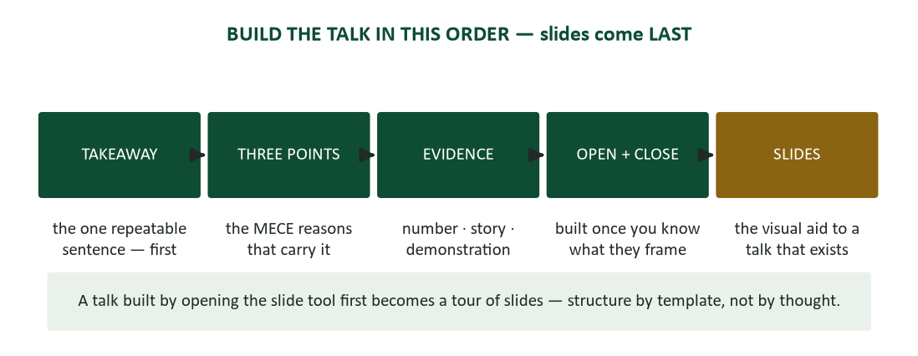
Figure 1. The build order — takeaway first, slides last.
The takeaway first. Before anything else, write the sentence a listener could repeat tomorrow to someone who wasn’t there: “Renew with TechServe — it saves $23K a year.” “The pilot worked; roll it out to both benches.” “Our response times are the reason we’re losing renewals, and the fix costs less than one lost account.” That sentence is the pyramid summit from Chapter 9, spoken. If you cannot write it, you are not ready to build slides — you have material in search of a point, and twenty minutes of someone else’s attention is a rude place to go searching.
Everything in the talk then auditions against the sentence. Each candidate slide, story, statistic, and tangent either serves it or leaves — the unity test from Chapter 2, applied at podium stakes. This audition is where good talks are actually made, because the discipline of cutting fascinating-but-off-point material is what separates a briefing from a tour of everything the presenter knows. Say the takeaway early, prove it in the middle, and say it again at the end: audiences remember what is stated, supported, and repeated — not what is implied.
Why slides come last. Slides come last in the build order for a structural reason: the slide tool imposes its own sequence — title layout, bullet layout, next slide — and a talk born inside it becomes slide-shaped: structure by template rather than by thought. Build the argument first, in an outline or on index cards; the deck is then a set of visual aids for a talk that already exists, which is the only thing a deck should ever be.

Audience analysis, standing up
Chapter 2’s machinery transfers whole, with three live-room additions. First, authority: pitch the decision this room can actually make. An ask above the room’s authority is a rehearsal nobody needed; an ask below it wastes the assembled seniority. Second, starting position: you are moving the audience FROM somewhere — what do they currently believe about this topic, and who in the room is invested in the current answer? A talk that ignores the starting point moves no one, however elegant. Third, attention: the thirty-minute slot with phones on the table is a ten-minute attention budget wearing a longer calendar hold. Build for the real number: your strongest material in the first third, and structural landmarks (the roadmap, the mini-summaries) that let drifting attention re-board.
Distinguish, too, which of two genres you are performing. The briefing informs: its takeaway is a finding, its structure is answer-first evidence, and its success test is whether the audience can explain the matter afterward. The pitch persuades: its takeaway is an ask, its structure is Chapter 8’s AIDA on its feet, and its success test is whether the audience does something. Most bad talks are category errors — a pitch built like a briefing (all context, no ask) or a briefing built like a pitch (advocacy where analysis was owed, which Chapter 9 taught you to treat as a completeness violation).

The frame: openings, roadmaps, closings
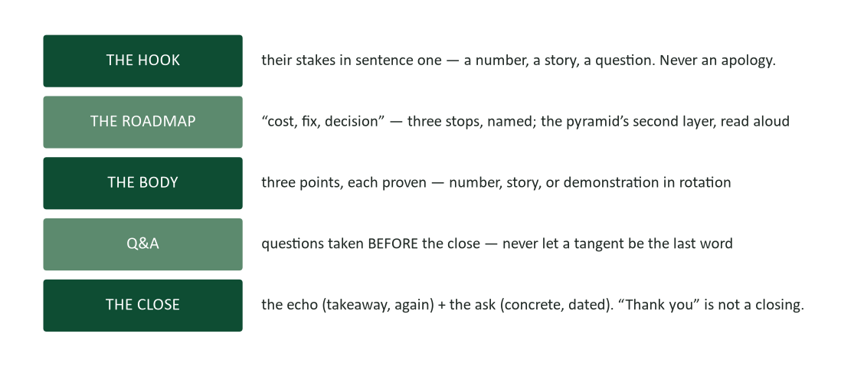
Figure 2. The frame of a talk — hook, roadmap, body, Q&A, then the close.
Audiences disproportionately retain beginnings and endings — the primacy and recency effects that Chapter 3 exploited on the page operate even more strongly in the air, because listeners cannot scroll back. The frame is therefore where preparation concentrates: the first minute and the last are the two stretches every competent presenter scripts word for word.
The hook. Open with the audience’s stakes, not your own credentials: “Every week, this lab loses thirty tech-hours to duplicate entry” beats “Hi, I’m… and today I’d like to talk about workflow optimization” by the full distance between attention and patience. The working openers are a short list: the striking number, the sixty-second story, the question the room can’t unhear, the before-and-after. All of them point at the takeaway. And one anti-rule outranks the rest: never open with an apology — for your nerves, your slides, or your preparation time. An apologetic opening teaches the room exactly how little to expect, and rooms are obedient students.
The roadmap. After the hook, the map: “I’ll show you what the problem costs, the fix we piloted, and the decision I’m asking for.” Three stops, named memorably — the pyramid’s second layer read aloud. The roadmap is a promise, and keeping it visibly (“that’s the cost; now the fix”) is the navigation system listeners otherwise lack. On the page, a lost reader re-reads; in a talk, a lost listener is simply gone, politely nodding, until something signals where they are. Signposting is not style. It is the only scroll bar the audience gets.
Transitions. Between points, land and launch: “So the current process costs $67K a year — that’s the problem. Here’s the fix we tested.” The landing sentence is a save point for everyone who drifted; the launch sentence is the next chapter’s title, spoken. Number the journey (“the second of three reasons”), and let silence transition too: a two-second pause before a big point is a spotlight, and a room that has been listening to continuous talking will look up at the quiet.
The close. Take questions BEFORE the close, never after. A talk that ends on Q&A ends on a stranger’s tangent — or worse, on the hostile question’s echo. Answer the last question, then close: the echo (“renew with TechServe — $23K a year”) and the ask (“I need the committee’s decision by the 25th”). The ask is concrete and dated, exactly as Chapter 6 taught for written requests; “think it over” converts nobody, while “approve the pilot today” converts everyone who was already persuaded and flushes out the objections of everyone who wasn’t. And “thank you” is not a closing — it is a signal that you ran out of material one sentence too early. Close with the takeaway; gratitude can ride along behind it.

The body: three points, proven three ways
Miller’s working-memory constraint (Chapter 3) applies to listeners at double strength: they cannot re-read, so three chunked points is a ceiling, not a style preference. Depth beats coverage — three points with real evidence outperform seven points with adjectives, because the dilution effect (Chapter 8) works on rooms exactly as it works on readers: audiences average your arguments rather than summing them. When the material genuinely is eleven things, you are holding a document, not a talk. Send the memo; present the three things that matter; put the rest in the leave-behind.
Each point then gets its best-fit proof, and the strongest talks rotate three kinds. Numbers convince the analysts: one strong figure per point, sourced, and rounded for the ear — “$67K a year” lands; “$66,847.13” evaporates somewhere over the third row. (Precision that works on the page dies in the air; the exact figure lives on the slide or in the leave-behind for the skeptic who wants it.) Stories convince everyone else: sixty to ninety seconds, a named human, real stakes, no subplot — and the point announced when it lands: “that’s what thirty lost hours a week looks like.” A story that entertains without attaching to the argument is a pleasant hole in your time budget. Demonstrations convince the skeptics: the live before-and-after beats both other proofs when it works — and it requires the backup recording for when it doesn’t, a rule the first case study will price for you.
Business storytelling deserves its own caution: the story must be true and checkable. “A lab tech named Priya, on the Tuesday shift” is evidence; an invented composite presented as fact is a time bomb with your name on it, because someone eventually asks Priya. Chapter 8’s truth test governs the podium as it governs the page — and one story per talk, doing real argumentative work, is the right dose. Three stories is a variety show.

Slides: billboards, not documents
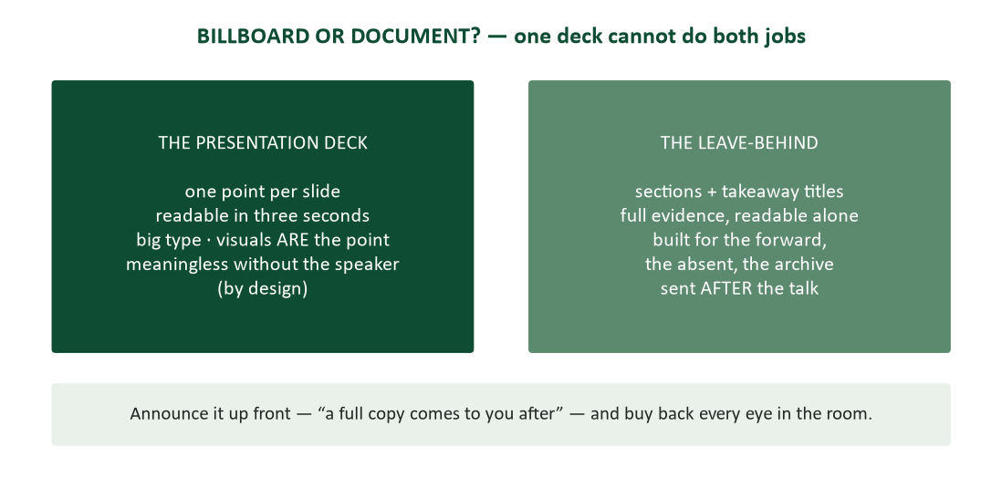
Figure 3. Billboard or document — the presentation deck and the leave-behind are different artifacts.
One fact of attention physics generates every slide rule: the audience reads faster than you talk, and it cannot read and listen at once. Whatever is on the screen, the room has finished it before you have — and while they read, you are background audio. The choice is therefore structural: either the slide is a billboard (one point, three-second read, then eyes back on you) or the slide is the show and you are its narrator. The billboard rules follow directly.
- One point per slide. The slide makes the claim; you carry the detail. A slide making four points is a document leaking into the room.
- Readable in three seconds, from the back row. If it must be studied, it competes with you — and the slide always wins.
- Big type, few words. Sentence-fragment bullets, generous space. If the content needs 14-point type to fit, the slide needs fewer words, not smaller type.
- Visuals that ARE the point. The chart, the photo, the diagram — decoration is noise wearing a picture costume, and stock-photo handshakes fool no one.
- The empty slide is legal. Blank the screen (most presenter tools map it to the B key) for the story and the big ask: nothing on screen means every eye on you, which is sometimes exactly the design.
The two artifacts. The deck you present and the document you send afterward are different artifacts, and one deck cannot do both jobs. The presentation deck is billboards — deliberately meaningless without you. The leave-behind (Chapter 9’s slide-doc) carries sections, takeaway titles, and the full evidence, readable alone by the absent, the forwarded-to, and the archive. Build both when stakes justify it, and announce the leave-behind in your first minute: “a full copy comes to you after this.” That one sentence buys back every eye that would otherwise spend your talk transcribing it.
Takeaway titles. Slide titles carry takeaways, exactly as chart titles did in Chapter 9: “Pilot cut intake time 38%” — never “Pilot Results.” Run the titles-only test before you rehearse: read the deck by its title lines alone. If the sequence tells the whole story, the deck is built; if it reads “Background, Approach, Data, Discussion,” you have section labels where claims should be. Takeaway titles also survive the skim: the executive who flips your leave-behind in ninety seconds gets the entire argument from titles — which, for that reader, IS the presentation.
Data slides. Data slides obey Chapter 9’s full canon at projection distance: one chart, one point, announced in the title, axes honest. Then strip for the back row — gridlines lightened, legends replaced by direct labels, and of six data series, THE line highlighted while the rest gray into context. Say the round number; let the slide hold the precise one. And never apologize for a busy slide: “I know this is hard to read” is a confession that you knew and showed it anyway. Rebuild it or cut it.
Slide hygiene. Last, hygiene — invisible when right, loud when wrong. One template throughout: same fonts, colors, and title positions, because every deviation is a speed bump the audience feels without naming. Contrast tested at distance under real light: the elegant pale gray that worked on your laptop vanishes under conference-room fluorescents. Accessibility as part of craft: 24-point body floors, color never carrying meaning alone, alt text in the shared copy. And the deck proofread like a document (Chapter 4), because a typo at billboard scale has witnesses.

Delivery: instruments you can tune
Delivery intimidates because it feels like personality — but it decomposes into voice, body, and nerves, and each responds to specific technique. Start with the finding that reframes everything: stage fright is arousal, not verdict. The racing pulse and cold hands are the same physiology as readiness; preparation is what flips the label your brain applies. Performance psychology has demonstrated the reframe repeatedly — speakers who relabel “I’m anxious” as “I’m ready” perform measurably better with identical adrenaline. You do not need less arousal. You need more rehearsal and a better label.

Rehearsal that actually works
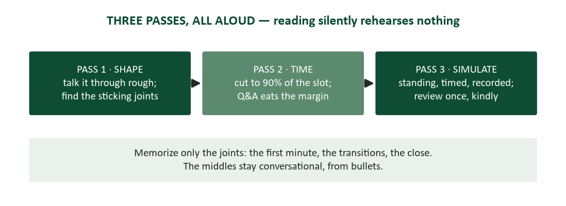
Figure 4. Three rehearsal passes, all aloud — shape, time, simulate — memorizing only the joints.
Three aloud passes are the reliable minimum, and “aloud” is the load-bearing word: reading slides silently rehearses nothing — the mouth, the transitions, and the clock only train out loud. Pass one finds the shape: talk it through rough, discover where the joins stick and what runs long. Pass two fixes and times: cut to ninety percent of the slot, because Q&A and reality always eat the margin — the talk that fits exactly in rehearsal runs over in the room, and running over is stealing (from the next presenter, from the room’s calendar, from your own close). Pass three simulates: standing, projecting, with the clicker and a timer, ideally recorded on a phone — then review the recording once, kindly, with the delivery checklist beside you.
Memorize selectively. Full-script memorization produces recitation and catastrophic failure modes (one lost sentence strands you); pure improvisation wastes the frame. The professional pattern scripts the joints — the first minute (which carries you through peak adrenaline on autopilot), the transitions (where talks actually stumble), and the close (which must land verbatim) — and leaves the middles conversational, delivered from bullet-level notes. Joints scripted, spans conversational: it is the same division of rigidity and flexibility that makes bridges work.

The voice
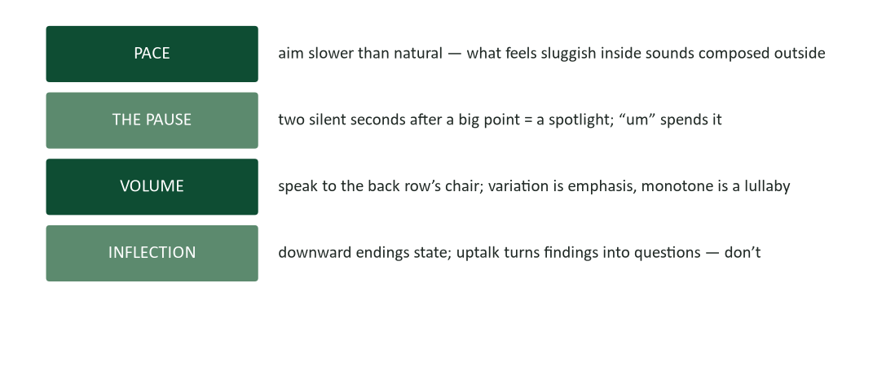
Figure 5. The voice toolbox — pace, pause, volume, inflection.
Nerves accelerate everyone, so aim slower than feels natural — what registers as sluggish from inside sounds composed from the fifth row. The pause is the most underused tool in the kit: two silent seconds after a big point function as a spotlight, while the same gap filled with “um” spends the emphasis on nothing. (Filler words are not a moral failure; they are what the mouth does while the brain loads. The pause is simply choosing to load in silence, and one rehearsal pass focused on it moves most speakers dramatically.) Project to the back row’s chair, and vary — volume variation is emphasis, monotone is a lullaby with data in it. And watch inflection: downward endings state claims with authority; uptalk turns findings into questions and confidence into a request for permission.

The body
Plant the stance — weight even, shoulders open — because the sway and the lean broadcast exactly the nerves you are managing. Make eye contact in sentences: land one complete thought on one person, then move to another; the lighthouse sweep that “covers” the room connects with nobody. Keep hands above the waist, describing — gesture reinforces shape and size naturally when you let it; pockets and clasped hands read as guarded. Move with purpose or stand still: crossing the stage to mark a topic change is punctuation; pacing is a metronome the audience cannot unsee. And on every slide glance, run touch-turn-talk: look at the screen, turn back to the room, THEN speak. The screen cannot hear you, and a room addressed via projection wall stops trying to.

The nerves field kit
For the hour before: slow exhales, twice as long as the inhale — the one physiological lever that reliably downshifts arousal on demand. For the first minute: the script (see rehearsal) carries you through the adrenaline spike on autopilot. For the room: find the three friendly faces — every room has them — and open to them; confidence is borrowable. For the blank moment, have the protocol BEFORE you need it: pause, look at the slide title, breathe, resume. The room reads two silent seconds as thoughtfulness; the panic is only visible from inside. And hold the base truth: the audience wants you to succeed. Nobody came hoping for a bad talk. The room is on your side until proven otherwise, and it almost never has to be proven otherwise.

On camera: live calls and recorded talks
The webcam presentation is now a permanent professional genre with its own physics. Live on camera: lens at eye level and LOOK at it for key lines — the lens is the room’s eyes, and notes taped just beneath it keep your gaze honest (Chapter 1’s virtual nonverbals). Energy up roughly twenty percent: the camera flattens affect, so conversational-you arrives as flat-you, and slightly-too-much arrives as engaged. Shorter arcs with more checkpoints: screen attention decays faster than room attention, so structure twenty minutes as three chapters with questions between rather than one pour. Run the tech rehearsal ten minutes early — screen share, audio, slide advance — because the fumbling open costs more on camera than in person. And pre-send the deck: a dead screen-share then becomes “go to slide four” instead of dead air. The failure plan is part of the presentation.
The recorded (asynchronous) presentation inverts several live rules. Viewers hold a skip bar, so front-load harder than you would live: takeaway inside the first thirty seconds or the viewer is gone. Chapter the recording — timestamps or section markers make the roadmap clickable. Shorter is a feature: the eight-minute focused recording beats the forty-minute meeting capture for every future viewer, forever. Pair it with text (Chapter 5’s rule): the video carries tone and demonstration; the written summary carries the searchable decisions. And accept one clean take: minor stumbles read as human; re-record only for structural failure. Five takes chasing flawlessness produce a stiff sixth take and a lost afternoon.

Q&A: where credibility is confirmed or refunded
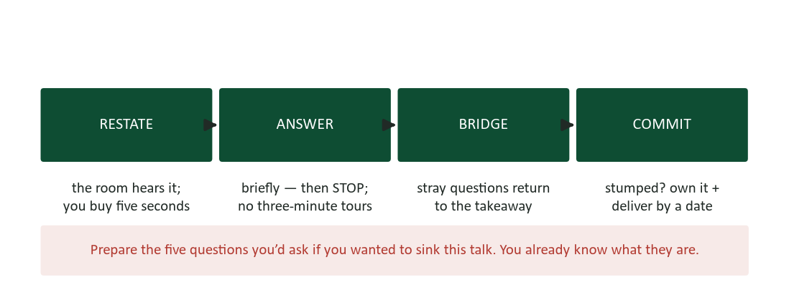
Figure 6. The Q&A protocol — restate, answer briefly, bridge home, commit when stumped.
Audiences discount the scripted portion of a talk — they know you rehearsed it — and weight the unscripted portion, because Q&A is where they watch you think without a net. The protocol: restate or repeat each question first (the room hears it, the recording captures it, and you buy five seconds of thought). Answer the question asked, briefly, then stop — the three-minute answer to a ten-second question loses the room you just won, and rambling answers read as insecurity even when they are thorough. Bridge stray questions home: “that’s really phase two — for today’s decision, here’s what matters,” courteous and back on the takeaway. And when stumped, never bluff: “good catch — I’ll verify and reply to the group by Friday” is credible, while an improvised statistic is a time bomb that Chapter 4’s verification rules already taught you not to plant. Then actually reply by Friday: the follow-through IS the answer (Chapter 11).
The hostile question. The hostile question gets Chapter 7’s machinery, standing up. Depersonalize on arrival: answer the substance inside the hostility and let the bait fall — the room is watching your temperature, not the questioner’s. Concede what is true (“you’re right that the pilot was one team”) and attach the context (“which is why the metrics were agreed with finance in advance”) — the two-sided move earns more credibility under attack than any defense. Cap exchanges at two: “let’s take this offline — I want the detail” returns the room to everyone who owns it, and refuses the duel that hijacks talks. Prepare all of this in advance by writing the five questions you would ask if you wanted to sink your own talk. You already know what they are; the only question is whether you draft the answers before or after the room asks.

Team presentations: one talk, several voices
The team talk fails in predictable ways — four solo acts stapled together, handoffs improvised as “um, I guess now Maya will…”, six presenters shrugging at each other during Q&A — and each failure has a structural fix. Build ONE talk: a single pyramid with one designer, divided after the structure exists (Chapter 10’s team-writing rules on their feet). Script the handoffs as rehearsed lines: “…and that’s the cost case. Maya will show you the pilot that answers it” — name, topic, momentum. Route Q&A through a lead who assigns each question by name: “Priya ran that analysis — Priya?” Match register across speakers: one deck, one formality level, one pace zone. And remember that idle presenters are still on stage: the teammate checking his phone during your section is the slide the audience remembers. Team rehearsal is where all five fixes install — one full simulate pass together is the minimum, handoffs included.

Case study: the demo that died and the talk that didn’t
A vendor team presented to a client’s leadership: the contract hinged on a live demonstration of the sample-intake workflow. Ninety seconds in, the staging server began returning errors — in front of the CTO, the CFO, and the quality director, on the vendor’s own product. The junior engineer reached for the keyboard to debug. The presenter did something better rehearsed: one sentence — “the demo gods have voted; here’s the recording from this morning” — and the backup video was playing within twenty seconds, the same workflow narrated live over it, the schedule intact.
Unpack what made the recovery possible, because none of it was improvised. The backup recording existed BECAUSE the team treated the demo as evidence with a failure mode (this chapter’s evidence rotation) — recorded that morning, on the same build, queued on a second laptop. The one-liner was scripted: the team had literally rehearsed the failure branch, the way pilots rehearse engine-out procedures. And the narration skills — voice, pacing, takeaway titles on the video’s chapters — were the same delivery craft the live demo would have used. The talk’s architecture survived because the demo was a proof INSIDE the structure, not the structure itself.
The contract closed that month, and the client’s CTO later told the account manager which moment had sold it: not the workflow, the recovery. “That’s how they’ll handle OUR incidents.” Audiences evaluate the unscripted moment as a sample of future behavior — which means composure under failure is not damage control. It is a product feature, and it is rehearsable.
- The lesson about evidence: every live demonstration is a bet; the backup recording is the hedge that costs twenty minutes and saves contracts.
- The lesson about rehearsal: rehearse the failure branches, not just the happy path — the scripted recovery line is what keeps ninety seconds of server errors from becoming the story.
- The lesson about audiences: the room prices your worst moment, not your average one — and a well-handled worst moment can outsell a flawless run.

Case study: the conference talk, rebuilt
An operations manager was invited to present her team’s intake-automation project at a regional industry conference — twenty minutes, two hundred strangers, her first talk outside her own building. Draft one was the internal deck: forty-one slides, dense with implementation detail, titled things like “Phase 2 Architecture” and “Validation Approach.” It had served the ops committee well. It would have died at the conference, and her rehearsal recording told her so: eleven minutes in, she was on slide nine, narrating configuration decisions to an audience that, she suddenly realized, would never configure anything of hers.
The rebuild started where this chapter starts: the sentence. For THIS audience — peers from other labs, shopping for ideas — the takeaway was not her architecture. It was “a two-person team can automate intake in ninety days without buying a platform — here’s the map.” Three points assembled under it: what it cost (the honest number, including the two failed weeks), what it returned (38% intake-time reduction, zero transcription findings), and what she would do differently (the validation sequencing that cost the two weeks). Forty-one slides became fourteen billboards; the implementation detail moved to a leave-behind with her contact information — announced in minute one, which converted note-takers back into listeners.
She scripted the joints and rehearsed three passes, the last one recorded standing in a conference-room simulation of the venue. The hook came from her own incident log: “Last March, one transposed sample ID cost us eleven days and a client. This March, that error is impossible. Twenty minutes, and I’ll show you the ninety days between those sentences.” Q&A produced the sink-the-talk question she had prepped — “this only worked because your volume is small” — and the two-sided answer (“you’re right that 600 samples a week is the ceiling for this design; here’s the fork I’d take at higher volume”) earned her the hallway conversation that mattered: two labs asked for the map, and one of them, eight months later, asked for her. The talk was a job interview she didn’t know she was giving — most good talks are.

Worked example: a ten-minute pitch, end to end
Because structure is easier to copy than invent, here is a complete outline for a ten-minute internal pitch — the analyst from Chapter 8’s pilot case, asking the ops committee to approve the full rollout. Ten minutes, eight billboards, every joint scripted.
- Minute 0–1, the hook (scripted): “Six months ago this committee bet $2,400 on a pilot. This morning the pilot finished paying that back for the ninth time. I’m here for the other two benches.” Slide 1: title billboard — “Roll out barcode intake: $23K/yr, 14-month payback.”
- Minute 1–2, the roadmap: “Three things: what the pilot proved, what the rollout costs, and the one risk worth discussing.” Slide 2: three named stops.
- Minute 2–4, point one — the pilot’s numbers. Slide 3: one chart, takeaway title (“Intake time fell 38% and stayed there”), THE line highlighted. Slide 4: “Zero transcription findings in 90 days” with the auditor’s one-sentence quote. Transition (scripted): “Those are the returns. Here’s the bill.”
- Minute 4–6, point two — cost, framed. Slide 5: “$24K against the $67K the current process burns annually” — the status quo priced, Chapter 8 style. Verbal detail: itemization exists in the leave-behind; the room hears only the frame.
- Minute 6–8, point three — the risk, conceded first. Slide 6: “The honest risk: two benches migrate during Q4 audit prep.” The two-sided move: “here’s the mitigation we already tested — staggered cutover with the old system running until sign-off.”
- Minute 8–9, Q&A (before the close, always). The five prepared hostile questions include the sink question: “what breaks at 900 samples a week?” — answer drafted, with its number.
- Minute 9–10, the close (scripted): echo — “the pilot proved it: $23K a year is sitting in the intake queue” — then the ask: “I need this committee’s approval today to hold the vendor’s pricing through the 25th.” Slide 8: the ask, dated, alone on the screen.
Note what the outline does NOT contain: an agenda slide, a company history, an architecture tour, or a “questions?” slide as the final frame. Every minute serves the sentence, the evidence rotates (chart, quote, frame, concession), and the last thing on screen is the decision. Steal the skeleton; replace the numbers.

Deep dive: speaking without a deck

Impromptu answers: the PREP skeleton
Most professional speaking is not presentations — it is the meeting moment when someone turns to you and says “what do you think?” The unprepared answer rambles toward a point it discovers en route; the professional answer runs a pocket structure. PREP: Point (“I’d renew, not rebid”), Reason (“the switching costs eat two years of any savings”), Example (“when we rebid the courier contract in 2024, the transition consumed the entire first-year discount”), Point again (“so I’d renew, and spend our leverage on terms instead”). Thirty seconds, shaped like the pyramid, and deliverable with zero notice because the shape is memorized even when the content is fresh.
PREP also buys composure: the structure occupies the panicked first second (“what’s my Point?”) that would otherwise fill with “um, well, I mean, it depends.” It depends is where impromptu answers go to die — everything depends; the room asked what you THINK. State the point, flag the dependency inside the reason (“unless the vendor’s Q3 pricing surprises us”), and let the caveat live inside a committed answer rather than in place of one. Chapter 9’s calibration vocabulary — “my read is,” “I’d want to verify, but directionally” — lets you commit honestly at every confidence level.

Panels: the shared stage
Panel appearances reward different craft than solo talks. Prepare three portable points — takeaway-grade sentences you can deploy whatever the moderator asks — and bridge to them the way politicians do, but honestly: answer the actual question first, then connect it to your point. Keep answers to sixty seconds; panels are conversations, and the panelist who monologues becomes the panelist the moderator stops calling on. Disagree with fellow panelists the way Chapter 11 taught — about the idea, by name, warmly: “Maria’s right about the cost curve; where I’d push back is the timeline.” Panel disagreement, done well, is the most watchable thing on any stage, and the audience remembers who made it generative rather than awkward. And when you are NOT speaking, you are still on camera: the visible listening — notes, nods, attention — is your slide.

Introducing a speaker, and being introduced
The introduction is a sixty-second genre with exactly three jobs: why this topic matters to THIS audience, why this speaker has the standing to address it, and the handoff by name. Write it with the speaker’s input, keep credentials to the two that matter (Chapter 10’s staffing rule at podium scale), and land the name last, clearly — it cues the applause. When you are the one introduced, send the introducer that sixty-second draft yourself: the speakers who seem effortlessly well-introduced wrote the introduction. That is not vanity; it is the same courtesy as briefing your references (Chapter 13).

Deep dive: the slide makeover clinic
Theory teaches slower than examples. Here is one slide, rebuilt in three passes — the makeover sequence you can run on any inherited deck.
The original. Title: “Q3 Support Metrics Review.” Body: eleven bullets mixing ticket volumes, response times, staffing notes, and one buried sentence — “escalations from the Meridian account tripled after the June migration.” A 6-series line chart with a legend, gridlines, and no highlighted line. Font: 16-point, shrinking to 12 where the bullets ran long. This slide is a document page wearing a projector. The room will read it for forty silent seconds, find eleven facts and no point, and check their phones.
Pass one: find the claim. Ask the Chapter 9 question: what is the ONE claim this slide exists to make? The presenter, pressed, says: “support is fine overall, but the Meridian escalations are a fire.” That is two claims — so it is two slides. The eleven bullets sort into three piles: evidence for claim one, evidence for claim two, and detail that belongs in the leave-behind (most of it).
Pass two: rebuild as billboards. Slide A gets the takeaway title “Support held steady through Q3 — one exception,” a single summary figure, and nothing else. Slide B gets “Meridian escalations tripled after the June migration,” the chart cut from six series to one highlighted line (Meridian) with the other five grayed to context, the June migration marked with a vertical line, and the legend replaced by a direct label. The claim, the evidence, the cause candidate — three seconds, readable from the back.
Pass three: relocate the evidence. The eleven bullets, the staffing notes, and the full six-series data move to the leave-behind, where they gain headings and takeaway titles of their own (Chapter 9’s slide-doc rules). The presenter’s speaking notes absorb the connective tissue. Total content lost: zero. Total content findable: all of it, for the first time. The makeover took eleven minutes, and the Meridian fire — the thing the original slide had buried in bullet nine — became the meeting’s decision item, which was the point of having a meeting.

Deep dive: walking an audience through a chart
Data slides fail live in a way they never fail on paper: the presenter throws a full chart onto the screen and keeps talking, while the room stops listening to decode axes. The fix is progressive disclosure — narrating the chart the way you would give directions, one landmark at a time.
- Orient before data: “On the left, intake time in minutes; along the bottom, the twelve weeks of the pilot.” Two seconds that buy the whole room a shared map. Skipping orientation is why half of any audience is still decoding your axes when your point arrives.
- Anchor the baseline: “The flat line at nine minutes is where we started — that’s manual intake.” Now every future movement has meaning.
- Reveal the story in beats, building the chart in stages if the tool allows: “Week three, barcode goes live — watch the drop. Week five, it stabilizes at 5.6. And this gap” — pointing — “is the 38%.”
- Land the takeaway title out loud, verbatim: “Intake time fell 38% and stayed there.” The title, the chart, and the sentence now agree, which is what makes the point stick.
- Preempt the axis skeptic: if the axis is cropped or the period selected, SAY so before the sharpest analyst in the room says it for you (Chapter 9’s honest-display rules, performed).
One chart, walked well, outperforms five charts flashed. If the talk needs five charts, it usually needs two charts and a leave-behind — the data version of three points, not eleven.

Deep dive: presenting to every room
A talk built for the median listener quietly taxes everyone else. Inclusive presenting is mostly a checklist of small mechanics with large reach — and every item also improves the talk for the median listener, which is the pattern accessibility usually follows.
- Say what the slide shows. Screen-reader users, phone-bridge listeners, and the back row all depend on the narration carrying the visual: “the highlighted line — Meridian — triples after June.” If your talk works as a podcast, it works.
- Repeat audience questions into the microphone before answering — the room’s hard-of-hearing contingent is always larger than it looks, and recordings without repeated questions are half a conversation.
- Color never carries meaning alone (Chapter 9): the highlighted line is also thicker and labeled; the red/green status pair gets icons or words.
- Caption every recording. Auto-captions are near-free and imperfect; a five-minute cleanup makes the recording usable by everyone, searchable by anyone, and skimmable by the impatient — which is everyone.
- Mind the idiom load for global audiences. Sports metaphors, cultural references, and speed are the three walls non-native listeners hit (Chapter 1’s plain-language rule, spoken). Slower, plainer, and with the takeaway on the slide in text — the same moves that serve the distracted native listener.
- Offer the material two ways. The leave-behind plus the recording plus the live talk is not redundancy; it is the same argument at three attention budgets.

Case study: the webinar half the audience heard
A product manager ran a customer webinar — two hundred registrants, a forty-minute walkthrough of the new release, a genuinely strong deck. The failure was invisible from inside: she presented from a dual-monitor setup, shared the wrong screen for the first six minutes (the audience watched her email client while she narrated slides only she could see), and never knew, because she had disabled the chat to “reduce distraction.” When a colleague finally phoned her, she recovered the share — flustered — and spent the rest of the session behind her own agenda, rushing the demo, skipping the Q&A she had promised. The recording, unedited and uncaptioned, went out anyway. Attendance at the NEXT webinar was ninety-one.
Run the diagnosis with this chapter’s checklist and the failure decomposes into five skipped rules, none of them exotic. No tech rehearsal (the wrong-screen share dies in a ten-minute soundcheck). No monitored chat — the parallel channel existed precisely to catch what she could not see, and she had turned it off. No co-pilot: webinars at scale need a second human watching the audience’s experience, exactly as team presentations assign Q&A routing. No failure plan — a pre-sent deck would have made even six broken minutes survivable (“slide four, everyone”). And no recovery composure: the rushed remainder cost more than the broken opening, because audiences forgive glitches and remember panic (the demo case’s lesson, inverted).
The repair for round two was mechanical, not motivational: a fifteen-minute tech rehearsal with the co-pilot, chat on and owned by the co-pilot, deck pre-sent, captions on the recording, and — the detail worth stealing — a printed index card taped below her webcam reading “SHARE CHECK: what do THEY see?” Attendance recovered in two cycles. Virtual presenting is not harder than live presenting; it is differently instrumented, and the instruments have to be checked because the feedback loop that a live room provides for free — two hundred faces — is exactly what the screen removes.

The week-of timeline: a presenter’s checklist
Preparation distributes badly under deadline pressure — everything crowds into the anxious final evening unless it is scheduled earlier on purpose. The timeline below front-loads what benefits from distance and leaves the final day almost empty, which is itself a nerve-management strategy.
- A week out: takeaway sentence final; three points and evidence chosen; the deck drafted as billboards; the leave-behind split off. Run the titles-only test and the first aloud pass (shape).
- Three days out: second aloud pass (time) — cut to 90% of the slot. Draft the five sink-the-talk questions and outline their answers. Send pre-reads if the format uses them.
- Two days out: third pass (simulate), standing and recorded. Review the recording once, kindly, for pace and filler only. Fix the two worst joints; resist rebuilding the deck — late structural surgery creates more failure than it removes.
- The day before: logistics only. Room or platform tested, backup recording queued, deck pre-sent where applicable, clothes chosen, clicker batteries confirmed. No new content after tonight: the talk is what it is, and the remaining variable is you, rested.
- The day of: arrive or log in early enough to breathe. Tech check. The slow-exhale protocol in the final ten minutes. First minute rehearsed once, quietly, from memory. Then trust the preparation — the room wants you to succeed, and this time you have given it every reason to.
Notice the shape: content freezes 48 hours out. The single most common self-inflicted wound in presenting is the night-before rebuild — new slides that have never been rehearsed, delivered by a presenter who traded sleep for them. The checklist exists to make that rebuild structurally unnecessary, because everything it would fix was fixed on Tuesday.

Workshop: building the ninety-second story
The story slot in the evidence rotation deserves a construction sequence, because “tell a story” is advice the way “be confident” is advice — true and unusable. Here is the build, run on a real example for the intake-automation pitch.
- Start from the point, not the anecdote: the story must prove “manual intake produces expensive errors.” Inventory your true material for the incident that best carries exactly that weight — not the funniest incident, the load-bearing one.
- Cast one named human: “Priya, our senior tech on the Tuesday shift.” Named people carry stakes; “a staff member” carries paperwork.
- Compress to four beats (Chapter 12’s skeleton): the person and the normal (“Priya, mid-shift, forty samples in the queue”); the problem (“two vials, one transposed digit”); what it cost (“eleven days of rework and a client who now audits everything we send”); what changed (“under barcode intake, that transposition is physically impossible”).
- Cut the subplot. The vendor’s role, the meeting that followed, the policy memo — all true, all gone. Ninety seconds holds one arc.
- Land it, out loud: “that’s what one digit costs at manual speed.” The point, announced, is what converts a story the room ENJOYED into a story the room USES.
- Verify it like a claim (Chapter 4): would Priya recognize this telling? Would the client? Stories travel — tell only the version that survives arrival.
Rehearse the story separately from the talk — it is the one component that improves most per pass, because timing and emphasis are the whole craft. And retire stories that stop being true: the “current process” anecdote from two systems ago, still circulating in a veteran’s talks, is the spoken version of the stale wiki page (Chapter 5).

The recognition moment: toasts, thanks, and send-offs
Sooner than you expect, someone will hand you a glass or a microphone and thirty seconds: the retirement send-off, the launch toast, the award introduction. The genre has exactly three beats — the specific (one true, concrete detail: “Dana answered my 2 a.m. audit question in nine minutes”), the meaning (what that detail says about the person or the moment), and the raise (“to Dana — who never once made a question feel small”). Thirty to sixty seconds, no biography, no inside jokes that exclude half the room, and absolutely no improvised roasting — the recognition moment runs on Chapter 6’s five-S rules, spoken, and “specific” is what separates the toast people remember from the generic warmth they forget before the glasses land. Prepare it in the hallway if that is all the notice you get: one detail, one meaning, one raise. PREP’s gentler cousin.

The executive readout: presenting to the people with the pen
Presenting upward compresses every rule in this chapter. Executive audiences are the most time-poor, the most interruption-prone, and the most decision-oriented room you will face — and they reward a specific adaptation of the standard build. The takeaway moves even earlier: many executive readouts open with the ask on slide one, before any context, because the room may be down to fifteen minutes at any moment and the decision must survive the truncation. (This is Chapter 3’s direct pattern at its logical extreme: assume the meeting could end after your first ninety seconds, and front-load accordingly.)
Expect and welcome interruption. Executives navigate by question, not by roadmap — the talk you rehearsed as a sequence will be consumed as a conversation, and the presenters who thrive treat every interruption as the room steering toward what it needs. This changes rehearsal: instead of practicing the linear run, practice entering each slide cold (“if they jump to cost, slide five stands alone”), which billboards with takeaway titles make possible and document-slides make impossible. Keep a backup-appendix section — the detail slides you hope not to need — and jump to them by number when the CFO asks the depth question: “slide fourteen has that breakdown.” Nothing builds executive confidence faster than a presenter who anticipated the question and can navigate to its answer in four seconds.
Two more adaptations. First, pre-wire (Chapter 8): the executive readout should ratify conversations already had, not ambush the room — surprises produce deferrals, and “let’s revisit next quarter” is where asks go to die. Second, end with the decision restated and OWNED: “so we’re approved for the two-bench rollout, vendor pricing held through the 25th — I’ll confirm in writing this afternoon.” The written confirmation (Chapter 6) converts the room’s nod into a record before the nod fades. Executive yeses are perishable; refrigerate them in email.

After the talk: the follow-through
The talk ends; the genre does not. Within the hour, the promised artifacts move: the leave-behind to the full list, the decision confirmation to the approvers, the “I’ll get you that number by Friday” items into your own tracker with dates (Chapter 11’s follow-through list — the place presentation reputations are actually finished). Within the day, the specific thank-yous: the colleague who staged the demo, the sponsor who pre-wired the room (five-S rules, Chapter 6). And within the week, the self-review: watch the recording once if one exists, note the two joints that stuck, and file the improvements where your NEXT talk’s checklist will find them. Presenters improve between talks or not at all — the room only ever sees the result.

Five myths, retired
Myth: good presenters are naturally calm. Retired by the arousal-reframe research and by every green room in the world. The pros are not calm; they are rehearsed, and their adrenaline is running the same chemistry as yours. The myth is harmful because it converts normal physiology into evidence of unfitness — students feel the pulse and conclude they are “not presenters,” when the pulse is the species, not the verdict.
Myth: open with a joke. The most tired advice in the genre, and structurally wrong: a joke that lands buys you ten seconds; a joke that dies costs the first minute you most needed. Humor that emerges from real material — the honest aside, the self-aware recovery — outperforms the imported opener every time. Open with their stakes; be funny later, if you are.
Myth: look just over their heads. Eye contact with humans, in sentences, is the actual skill (and looking at foreheads reads as exactly what it is). The over-the-heads trick survives because it feels safer for the speaker — which is the tell: it is anxiety management disguised as technique, and the audience can feel the vacancy.
Myth: keep your hands still. Gestures suppressed die hard: speakers who pin their hands broadcast tension from every other channel instead. Hands above the waist, describing what the words describe, is both more natural and more persuasive — the nonverbal channel agreeing with the verbal one (Chapter 1).
Myth: better slides make a better talk. The deck is the cheapest part of the talk and the most-fiddled, because slide polishing FEELS like preparation while requiring no courage. An evening spent on pass-three rehearsal moves a talk further than a week of template surgery. Budget accordingly: the audience remembers one sentence and the hard moment — neither lives in the deck.

Frequently asked questions
How fast should I talk? Slower than yesterday, as a starting bias — nerves accelerate everyone, and nobody in the history of business presentations has been criticized for being slightly too clear. The real metric is variation: a deliberately slowed sentence before the big number, a quicker pass through the familiar. Constant anything — fast or slow — is the actual enemy.
Can I use notes? Yes, and openly: bullet-level cards or the presenter view, glanced at joints. What reads as unprofessional is not notes — it is READING, head down, in document sentences. If your notes are takeaway fragments, glancing at them looks like exactly what it is: a prepared person checking the map.
How many slides for a twenty-minute talk? Aim for one slide per 45–90 seconds of billboard-style talk, but treat the number as a smell test, not a law: a talk that needs 60 slides in 20 minutes is flipping too fast to land anything, and a talk with 4 slides in 30 minutes had better be an extraordinary story. The real constraint is the takeaway test, slide by slide.
Script or wing it? Neither. Memorize the joints — first minute, transitions, close — and converse the middles from bullets. Full scripts produce recitation and catastrophic single-point failure; pure improvisation squanders the two moments (first and last) that audiences weight most.
What if people start checking phones? Take it as data about the slide, not the audience: phones come out when the screen stopped earning attention. Land a pause, change the energy, move to the story or the demonstration — the recovery tools are the same ones that would have prevented the drift. And check the clock honestly: rooms have attention budgets (this guide’s audience section), and running long is the fastest way to spend one.

Putting it to work this week
- Write the one-sentence takeaway for your course presentation — before touching the slide tool. Test it: could a classmate repeat it tomorrow?
- Run the titles-only test on any deck you have — yours or a colleague’s. If the titles read as section labels, rewrite three of them as claims and watch the deck improve without touching a chart.
- Record ninety seconds of yourself presenting anything, phone propped on books. Review once, kindly, for two items only: pace and filler. One targeted rehearsal pass beats general anxiety every time.
- Draft the five questions that could sink your next talk, and outline the concede-then-context answer to the worst one.
- Build your backup plan: for any demo, the recording; for any screen-share, the pre-sent deck. Twenty minutes of hedge, permanently installed.

Discussion questions
- Recall the best presentation you have ever seen. Which of this chapter’s choices was it making — and which rule, if any, did it break successfully? What let it get away with that?
- The chapter claims slides come last. Argue the strongest case for the opposite workflow — then identify which kind of presenter, preparing which kind of talk, that case actually fits.
- Where is the line between rounding for the ear (“$67K”) and misleading simplification? Construct the test, using Chapter 9’s honest-display rules as the base.
- Uptalk, filler words, and vocal fry attract disproportionate criticism — sometimes fairly, sometimes as bias wearing a style guide. Which delivery feedback is legitimate craft, and which is policing? Build your standard.
- The demo case argues that audiences price your worst moment. Does that make live demonstrations irrational? When is the live demo still worth the bet, and what makes it so?

Key terms
- Takeaway — the one sentence a listener could repeat tomorrow to someone who wasn’t there — written first, proven in the middle, echoed at the close.
- Build order — takeaway → three points → evidence → frame → slides. The slide tool comes last so the talk’s structure comes from thought, not template.
- Roadmap — the three named stops announced after the hook — the pyramid’s second layer, read aloud; the only navigation listeners get.
- Billboard rule — one point per slide, readable in three seconds, with the speaker carrying the detail — because audiences read faster than you talk and cannot do both.
- Leave-behind (slide-doc) — the standalone document version of the talk — full evidence, takeaway titles — sent after, and announced up front to buy back the room’s eyes.
- Titles-only test — reading a deck by its title lines alone; if they tell the whole story as claims, the deck is built (the headings-only test of Chapter 3, ported).
- Evidence rotation — proving points with a mix of numbers (for analysts), stories (for everyone), and demonstrations (for skeptics) — each with its failure mode hedged.
- Joints and spans — the selective-memorization pattern: script the first minute, transitions, and close; leave the middles conversational from bullets.
- Touch-turn-talk — the slide-glance discipline: look at the screen, turn back to the room, then speak — never presenting to the projection wall.
- Bridge — the Q&A move that returns stray questions to the takeaway: acknowledge, then “for today’s decision, here’s what matters.”
- Arousal reframe — relabeling pre-talk adrenaline as readiness rather than fear — the performance-psychology finding that identical physiology performs differently under different labels.
- Failure branch rehearsal — practicing the recovery moves — backup recording, scripted recovery line, blank-moment protocol — with the same seriousness as the happy path.

Self-check quiz
Answer before looking at the key on the final page. If you miss one, reread that section — then take the full practice set on the course site.
1. The correct first step in building a presentation is:
a) Choosing a slide template
b) Writing the one repeatable takeaway sentence
c) Drafting the opening story
d) Booking the room
2. Slides come last in the build order because:
a) Slide software is unreliable
b) The slide tool imposes template-shaped structure on talks born inside it
c) Slides are optional in business talks
d) Designers should build them instead
3. A talk should end with:
a) Q&A, so the audience leaves engaged
b) The echo of the takeaway plus a concrete, dated ask — after questions
c) “Thank you” and contact information
d) A summary of every slide
4. The billboard rule exists because:
a) Projectors distort small text
b) Audiences read faster than speakers talk and cannot read and listen at once
c) Templates default to large fonts
d) Executives dislike detail
5. “Pilot cut intake time 38%” beats “Pilot Results” as a slide title because:
a) It is shorter
b) It carries the claim — surviving both the skim and the room’s three-second read
c) It includes a number, which templates require
d) It avoids the passive voice
6. The rehearsal spec calls for cutting the talk to 90% of its slot because:
a) Rehearsals always run fast
b) Q&A and reality eat the margin — the exactly-fitting talk runs over
c) Shorter talks need less evidence
d) Timers are unreliable
7. When stumped in Q&A, the professional move is:
a) A confident approximate answer
b) Acknowledging, committing to a dated follow-up, and delivering it
c) Deferring to a teammate immediately
d) Ruling the question out of scope
8. The hostile-question protocol caps direct exchanges at two because:
a) Three exchanges exceed most time limits
b) Longer duels hijack the room from everyone who owns it
c) Hostile questioners tire quickly
d) Moderators require it
9. For recorded (async) presentations, the takeaway belongs in the first thirty seconds because:
a) Recording software trims openings
b) Viewers hold a skip bar — unearned patience does not exist asynchronously
c) Async audiences are less intelligent
d) Titles cannot carry takeaways
10. The demo case’s deepest lesson is that:
a) Live demos should be abandoned
b) Audiences price the worst moment — and a rehearsed recovery can outsell a flawless run
c) Staging servers are unreliable
d) Backup recordings are legally required

Answer key
1. b 2. b 3. b 4. b 5. b 6. b 7. b 8. b 9. b 10. b

References
The following published sources inform this chapter and are recommended for deeper study.
Anderson, C. (2016). TED talks: The official TED guide to public speaking. Houghton Mifflin Harcourt.
Brooks, A. W. (2014). Get excited: Reappraising pre-performance anxiety as excitement. Journal of Experimental Psychology: General, 143(3), 1144–1158.
Duarte, N. (2008). Slide:ology: The art and science of creating great presentations. O’Reilly Media.
Mayer, R. E. (2009). Multimedia learning (2nd ed.). Cambridge University Press.
Miller, G. A. (1956). The magical number seven, plus or minus two. Psychological Review, 63(2), 81–97.
Minto, B. (2009). The pyramid principle (3rd ed.). Financial Times Prentice Hall.
Reynolds, G. (2011). Presentation zen (2nd ed.). New Riders.
Practice what you just read: course site → this chapter → Practice, then the graded homework before the weekly deadline.

