BADM 225 · PROFESSIONAL COMMUNICATION FOR BUSINESS · STUDY GUIDE

Chapter 6: Positive and Neutral Messages
Requests, replies, claims, adjustments, and goodwill — the everyday mail that quietly builds your reputation.
Original instructional material written by the instructor. Not affiliated with, and containing no content from, any textbook or publisher.

How to use this guide
This chapter covers the messages you will send most and think about least: asking for things, answering people, granting requests, fixing problems, and saying thank you. None of them is hard, which is exactly why they are diagnostic — everyone can see whether yours are good. Read with the direct strategy from Chapter 3 in hand; every pattern here is a variation on it.

The direct request: asking so people can say yes
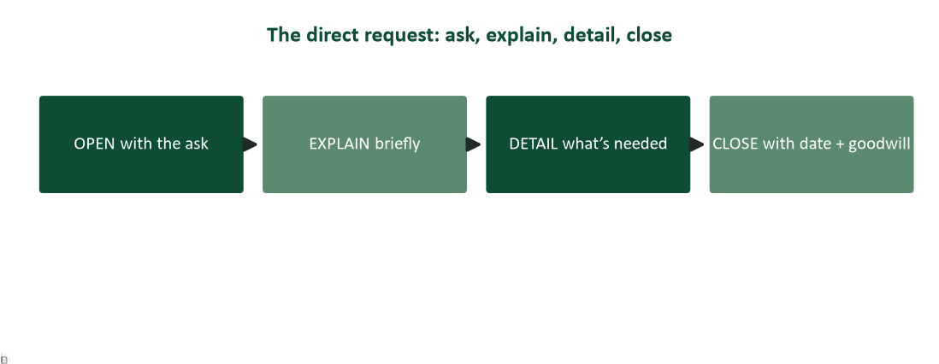
Figure 1. The direct request pattern: ask, explain, detail, close with a date.
Requests fail two ways: the buried ask (three paragraphs of context before the reader learns what is wanted — Chapter 3’s buried lead in request costume) and the incomplete ask (the reader must reply with questions before they can comply). The pattern in Figure 1 prevents both. Open with the ask in question form — questions politely demand answers in a way statements do not. Explain briefly why, and why them: “you ran last year’s audit” tells the reader they are chosen, not spammed. Detail what compliance requires — format, scope, access — as a list they can work down. Close with the deadline and its reason. A request that can be satisfied without a single clarifying question is a professional artifact; count yours.

Replies: answer first, then anticipate
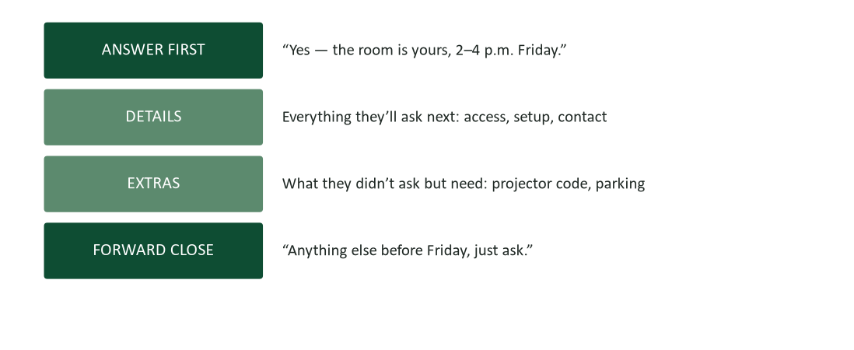
Figure 2. The reply skeleton: answer first, details next, extras they did not ask for, forward close.
When someone asks a yes/no question, the first word of your reply should be yes or no — everything before it is suspense nobody ordered. After the answer, anticipate: what will they ask next? Answer it now, in the same message, and you have saved a round trip (the answerable-asynchronously rule from Chapter 1 in action). The bar to clear: your reply should end the thread, not extend it. And when the answer is partly no — you can have the room but not the projector — lead with the yes you can give: “The room is yours; the projector is booked, but here are two options.” That is not spin; it is Chapter 2’s positive framing doing honest work.

Claims: complaining like a professional
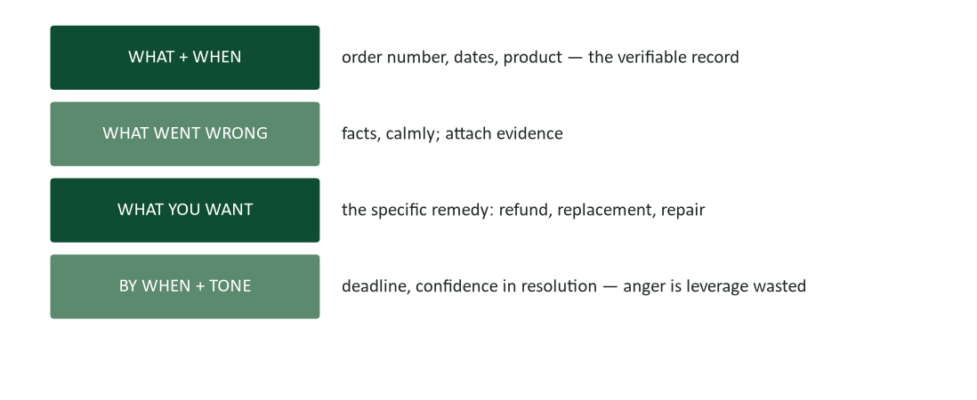
Figure 3. Claim anatomy: the record, the problem, the remedy, the deadline — delivered calm.
A claim is a request wearing a grievance, and the request part is what gets results. The anatomy: open with the verifiable record (order number, date, product — the reader must be able to find you in their system from sentence one); state what went wrong in facts, with evidence attached; name the specific remedy you want — sellers grant specific requests and stall vague unhappiness; close with a reasonable deadline and confident courtesy. The tone discipline matters most: anger feels powerful and reads as noise. The customer-service representative reading your claim did not break your product — make it easy for them to become your advocate. Confidence (“I’m sure you’ll want to make this right”) recruits; sarcasm entrenches.

Adjustments: granting claims so the customer stays
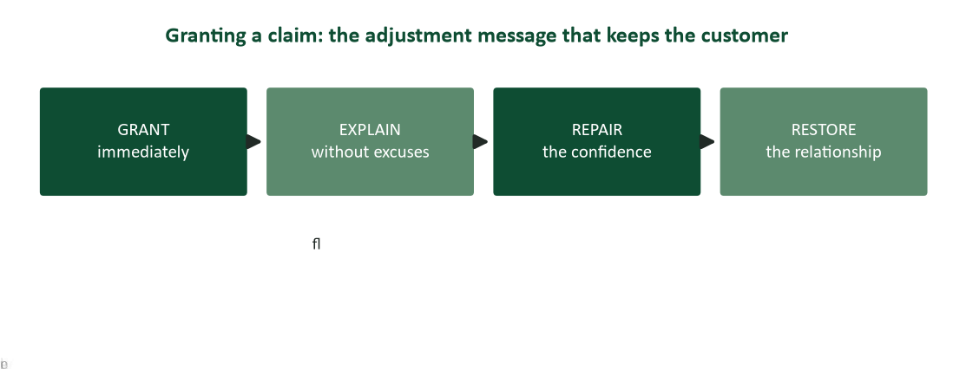
Figure 4. The adjustment grant: lead with the fix, explain without excuses, repair confidence, restore the relationship.
When you are granting a claim, the news is good — so the message is direct: the grant in sentence one. Delay it and the customer reads your explanation as the wind-up to a refusal, experiencing thirty seconds of manufactured dread you then bill as service. After the grant: explain what happened briefly and without the blame opera (customers want competence, not someone punished), say what prevents a repeat — this is the sentence that actually restores confidence — and close forward, without groveling. Over-apology (“we deeply regret the unacceptable failure…”) keeps the spotlight on the failure; the confident version keeps it on the fix. Research on reciprocity explains why generous adjustments pay: people repay treatment in kind, and a customer rescued gracefully often becomes more loyal than one never disappointed (Cialdini, 2021).

Goodwill messages: the highest-return mail you will ever send
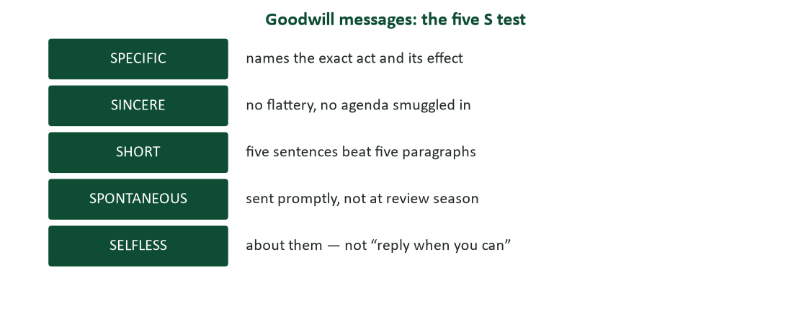
Figure 5. The five-S test for goodwill messages: specific, sincere, short, spontaneous, selfless.
Thanks, congratulations, and sympathy are the messages nobody requires and everybody remembers. The five-S test keeps them potent. Specific: “your triage of Saturday’s outage saved the launch” — the named act is the proof you actually noticed (the appreciation-versus-flattery line from Chapter 16). Sincere: no agenda in the envelope; a thank-you that pivots to a favor was an invoice all along. Short, spontaneous, selfless complete the set. Two notes on the hard one: sympathy. Send it — silence from colleagues wounds more than clumsy words ever could; keep it brief, warm, and unhurried (“no reply needed”); and handwrite it if the relationship warrants, because in a digital century, ink is the costly signal. This is also the one message category AI should never draft (Chapter 15): the entire content is that a human paused.
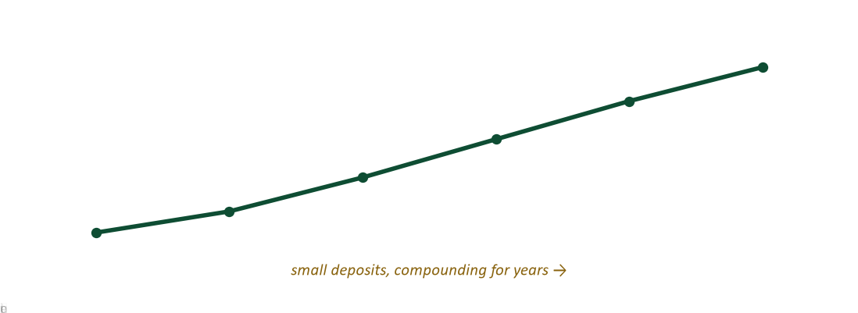
Figure 6. Goodwill capital compounds: small deposits, made promptly, for years.
Organizational research finds that habitual givers — people who help, credit, and thank without keeping score — end up disproportionately represented at the top of success distributions, provided they pair generosity with boundaries (Grant, 2013). Goodwill messages are the five-minute version of that strategy: deposits in Chapter 16’s influence account, made before any withdrawal is imagined.

Instructions: messages people can follow with their hands
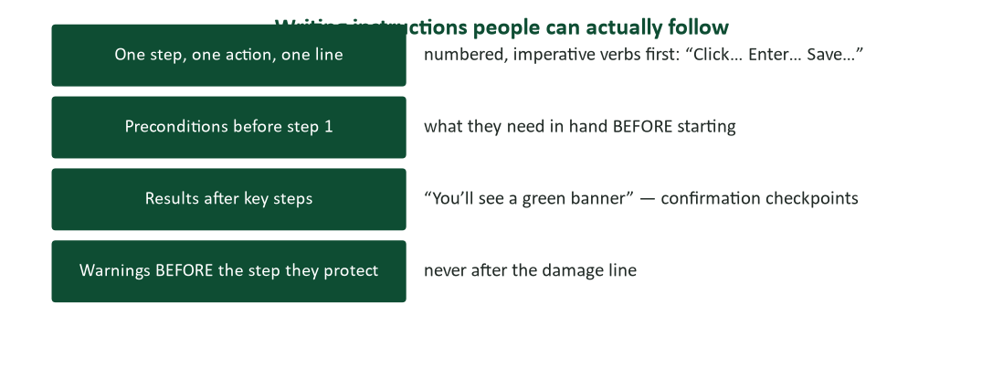
Figure 7. Instructions that work: one step per line, preconditions first, checkpoints after key steps, warnings before the step they protect.
Instructional messages — how to submit the expense report, how to book the lab — are judged by a brutal metric: the support questions they generate. The craft: number the steps and start each with an imperative verb (“Click… Enter… Save…”); one action per step, because two actions in one line is where readers fall off; list preconditions before step one (the VPN password needed at step six is a landmine if discovered at step six); insert checkpoints (“you’ll see a green banner”) so readers know they are still on the path; and place warnings before the step they protect — a caution after the damage line is an autopsy. Test on one real novice before shipping to fifty; their first confusion is your revision list.

Research corner: why granting well beats never failing
The counterintuitive finding behind adjustment strategy is that well-recovered failures can leave customers more loyal than uninterrupted service — the recovery demonstrates the relationship’s value in a way routine transactions never test. The mechanism is reciprocity, among the most robust findings in influence research: humans feel obligated to return good treatment, and a generous, fast, unbegrudging fix is good treatment delivered at the moment of maximum attention (Cialdini, 2021). The practical rules it generates: err generous on borderline claims (the margin on one order is smaller than the value of the relationship); grant fast, because speed is read as sincerity; and never make the customer litigate — a grant delivered grudgingly (“as a one-time courtesy, although our records show…”) spends the money and forfeits the credit.

Worked examples: four everyday messages, done properly

1. The complete request
“Could you send me the Q2 vendor performance report by Thursday noon? I’m compiling the renewal recommendation (due Friday) and yours is the last dataset. What I need: the summary tab as PDF plus the raw sheet — same format as Q1. Thursday noon keeps the review on schedule; thank you!” Ask, why-and-why-them, detail, dated close: nothing to clarify, easy to grant.

2. The reply that ends the thread
“Yes — the conference room is yours Friday 2:00–4:00. Details: your badge opens it from 1:30; the projector code is 4417; capacity is 14. You didn’t ask, but parking validation is at the front desk if your clients drive. Anything else before Friday, just ask.” Answer first, anticipations included, thread closed.

3. The adjustment grant
“A replacement unit ships today by expedited freight, at no charge — you’ll have it Wednesday. The damage happened in transit; we’ve switched your account to the reinforced packaging we use for lab equipment so this doesn’t recur. Thanks for the clear photos, which made this fast. We appreciate the chance to make it right.” Grant, cause without opera, prevention, forward close.

4. The goodwill note that costs five minutes
“Dana — your catch on the calibration drift saved us a failed audit finding; the assessor specifically noted the logs were clean. I’ve told Dr. Reyes the same. Thank you.” Specific act, named effect, credit passed upward, no agenda. Five sentences would have been fine; three are better.

Case study 1: the refund that built a customer
A small analytical-instruments supplier ships a $1,900 pH-meter kit to a university lab; it arrives with a cracked electrode housing. The lab manager emails a textbook claim (record, photos, specific remedy: replacement by month-end, before a teaching practicum). The supplier’s first-draft reply, written by a new hire, opens: “While our packaging meets industry standards and damage of this kind is typically carrier-caused, we are willing on this occasion to…” The sales director intercepts it and rewrites: replacement ships same day with a loaner electrode included, packaging upgraded for the account, a thanks for the photos, and one forward sentence about the practicum. Cost of the intercept: about $60 in freight. Eighteen months later the lab has standardized on the supplier for three courses, citing “how they handle problems” in the department’s vendor review.
- Diagram both drafts against Figure 4. Where does the first draft violate each stage?
- “While our packaging meets industry standards…” — what is this sentence doing, who is it for, and what does the customer hear?
- The rewrite added a loaner and upgraded packaging unprompted. Using reciprocity (Cialdini, 2021), explain the economics.
- Draft the same grant for a case where the customer is partly at fault — what changes, and what must not?

Case analysis
The first draft is a refusal’s skeleton wearing a grant’s conclusion: it opens by defending the company (an audience-of-one message — the writer’s own anxiety), implies the customer’s claim is dubious (“on this occasion”), and buries the yes where the dread has already done its damage. The rewrite is Figure 4 executed: the grant leads, the cause is one clause, the prevention sentence (“upgraded packaging for your account”) does the confidence repair, and the practicum sentence proves a human read the claim. The $60 arithmetic is the whole strategy: the supplier bought, at freight cost, an outcome no marketing spend reliably produces — a customer who retells the story. When the customer is partly at fault, the grant can shrink (repair at cost, say) but the tone rules hold absolutely: no litigating the past, and the prevention sentence becomes a shared one — “here’s a setup step that protects the housing” — which teaches without indicting.

Case study 2: the instructions that generated forty tickets
Facilities emails all staff: “We are pleased to announce the rollout of the new visitor management system. Visitors must now be pre-registered via the portal accessible through the intranet under Services, after which a QR code will be generated for the visitor which should be presented at the kiosk, though for visitors arriving by vehicle the parking module must first be completed, noting that international visitors require the extended form, and hosts should allow additional time accordingly.” Within a week the help desk logs forty tickets, three VIP visitors are stranded in the lobby, and Facilities sends a follow-up beginning “To clarify our previous communication…”
- Count the actions hiding in the announcement’s single sentence. What does Figure 7 say each needed?
- Identify the three distinct audiences with three different paths (standard visitor, vehicle, international). How should the message have handled them?
- Rewrite the announcement: subject line, one-line purpose, then the numbered procedure(s). Where do the preconditions and the warning about extra time belong?
- What testing step would have caught all forty tickets before they existed?

Case analysis
One 68-word sentence contains five actions, two branches, and a warning — each of which Figure 7 assigns its own numbered line. The rewrite: subject “Registering visitors — new required steps (2 minutes)”; purpose line; then a numbered path for the standard case (1. Open Services → Visitor Portal. 2. Enter the visitor’s name and date — you’ll see a QR code generate. 3. Forward the code; they scan it at the kiosk), with the branches as labeled variants (“Arriving by car? Complete the parking module first — before step 1” — the warning placed before the step it protects) and the international form flagged with its time cost up front. The testing step is Figure 7’s last line: one real novice — any staff member outside Facilities — walking the instructions cold would have hit the parking landmine and the buried QR-forward step in the first five minutes. Forty tickets are what “test on one novice” costs when skipped.

Watch list: three short talks worth your time
- Adam Grant, “Are you a giver or a taker?” (TED). The research behind goodwill capital — and why givers with boundaries finish first (Grant, 2013).
- Laura Trice, “Remember to say thank you” (TED). Three minutes on why people secretly need the praise they never request — the case for sending the note you keep drafting mentally.
- Drew Dudley, “Everyday leadership” (TED). The “lollipop moment”: the outsized impact of small acknowledgments — this chapter’s thesis in a story.

Everyday-message self-assessment
Score yourself: 2 = usually, 1 = sometimes, 0 = rarely.
- My requests open with the ask, in question form.
- My requests can be satisfied without a clarifying question.
- My replies answer in the first word or sentence.
- My replies anticipate the next question and end the thread.
- My claims include the record, the evidence, and a specific remedy.
- I keep claim tone confident — the reader becomes my advocate, not my adversary.
- When granting, the grant is my first sentence.
- My adjustment messages include the prevention sentence.
- I send goodwill notes promptly — and they pass the five-S test.
- My instructions are numbered, imperative, one action per line, tested on a novice.
Scoring: 16–20, your everyday mail is building a reputation on purpose. 10–15, adopt “answer first” and the five-S habit this week. Below 10, start with one rule: the ask or the answer goes in sentence one. Retake at midterm.

Journal prompts
- Find the last request you sent that generated a clarifying question. What was missing against Figure 1, and what did the round trip cost?
- Recall the best complaint outcome you ever got. Which elements of Figure 3 were present — and which tone choices helped?
- Write (and actually send) one five-S goodwill note this week. Record what it cost you and what came back.
- Take instructions you recently struggled to follow. Autopsy them against Figure 7: where were the preconditions, checkpoints, and warnings?

How your writing will be graded (and read at work)
These are the messages the course rubric was built for: routine, sendable, judged instantly. Top-band work here means the ask or answer in sentence one, completeness that ends threads, remedies and deadlines made specific, grants that lead with the grant, and goodwill that passes five-S. The introductory-letter assignment in this unit is graded exactly on Figure 1’s pattern plus Chapter 4’s zero-error standard.

Common mistakes and their fixes
- Burying the ask under context. Fix: ask first, in question form; context gets two lines after.
- Requests that require a reply-before-compliance. Fix: detail format, scope, access — the complete-ask test.
- The suspense reply. Fix: yes or no is the first word; reasons follow.
- Angry claims. Fix: record, facts, remedy, deadline — confidence recruits the reader; anger is leverage wasted.
- The defensive grant. Fix: if you’re saying yes, say it first. “While our packaging meets standards…” is a refusal’s opening on a grant’s body.
- Goodwill with an agenda. Fix: if there’s an ask inside, it’s an invoice. Send the ask separately, later.
- Paragraph-prose instructions. Fix: numbered, imperative, one action per line, warnings first, tested on a novice.

Frequently asked questions
- “Isn’t answer-first blunt for sensitive replies?” If the answer is genuinely bad news, it’s not this chapter — it’s Chapter 7, and the indirect pattern applies. The test: will the reader’s day get worse? If it’s routine, answer first; if it wounds, buffer first.
- “How generous is too generous on adjustments?” Set policy by customer lifetime value, not order margin — then let front-line writers grant to policy without escalation. Grudging grants cost double: the money and the credit.
- “Handwritten notes: charming or outdated?” For milestone goodwill — a mentor’s retirement, a colleague’s loss — ink is the costly signal that lands hardest precisely because it’s rare. For routine thanks, fast beats fancy: send the email today rather than the card never.
- “Can AI draft these?” Requests, replies, instructions: yes, with your verification (Chapter 15). Adjustment grants: draft carefully — tone is the product. Sympathy and personal goodwill: no. The entire message is that a human paused.
- “What if my claim deadline passes with no response?” Escalate one level with the original attached, same calm anatomy, new sentence: “I’d like to resolve this before involving [card issuer / consumer bureau].” Confidence, not threat — you’re still recruiting an advocate, now a more senior one.

Crosswalk: this chapter → your course work
- Practice questions (course site, Chapter 6). Request patterns, reply order, adjustment stages, and goodwill judgment calls.
- Introductory letter assignment. A direct request wearing letter formatting: Figure 1 plus Chapter 2’s you-view plus Chapter 4’s zero errors.
- Complaint-handling presentations. The claim and adjustment patterns are the written half of the “Influencing Positively / complaint handling” work in this course.
- Next chapter. Chapter 7 — negative messages: when the answer is no, and the reader’s day is about to get worse.
- The lecture deck. The Chapter 6 slides follow this guide section-for-section.

Key terms
- Direct request pattern — ask (as a question), explain briefly, detail completely, close with a dated goodwill line.
- Complete-ask test — the request can be satisfied without a single clarifying question.
- Answer-first reply — yes or no leads; details and anticipations follow; the thread ends.
- Claim — a request wearing a grievance: record, facts, specific remedy, deadline, calm confidence.
- Adjustment — the response granting a claim: grant first, explain without excuses, prevent, restore.
- Prevention sentence — the line naming what stops a repeat — the sentence that actually restores confidence.
- Goodwill message — thanks, congratulations, or sympathy passing the five-S test: specific, sincere, short, spontaneous, selfless.
- Reciprocity — the robust human tendency to repay treatment in kind (Cialdini, 2021) — the economics of generous adjustments.
- Giver advantage — habitual, boundaried generosity predicting long-run success (Grant, 2013).
- Checkpoint — the “you’ll see a green banner” line telling instruction-followers they are still on the path.

Chapter summary
- Everyday messages are diagnostic: everyone can see whether yours are good, and reputations compound from them.
- Requests: ask first in question form, explain why-and-why-them, detail to the complete-ask standard, close with a dated reason.
- Replies: answer in the first word, anticipate the next question, end the thread.
- Claims: record, facts, specific remedy, deadline — delivered with the confidence that recruits an advocate.
- Adjustments: grant first, explain without opera, include the prevention sentence, close forward. Generosity is economics (Cialdini, 2021).
- Goodwill: five-S — specific, sincere, short, spontaneous, selfless. Send it; ink for milestones; never AI (the pause is the message).
- Instructions: numbered, imperative, one action per line, preconditions first, checkpoints included, warnings before the step — tested on one novice.

Self-check quiz
Answer before looking at the key on the final page. If you miss one, reread that section — then take the full practice set on the course site.
1. A direct request should open with:
a) Background context
b) The ask, in question form
c) The writer’s credentials
d) An apology for asking
2. The complete-ask test is passed when:
a) The request is under 100 words
b) The reader can comply without asking a clarifying question
c) The deadline is generous
d) The tone is warm
3. A reply to a yes/no question should begin with:
a) Context
b) The answer
c) A greeting paragraph
d) The reasons
4. A good reply ends the thread by:
a) Being brief
b) Anticipating and answering the reader’s next question now
c) Promising to follow up
d) CCing a manager
5. The first element of a professional claim is:
a) The emotional impact
b) The verifiable record — order number, dates, product
c) A threat to escalate
d) The remedy
6. Claims name a specific remedy because:
a) It’s legally required
b) Sellers grant specific requests and stall vague unhappiness
c) It shortens the message
d) Templates require it
7. When granting a claim, the grant belongs:
a) After the explanation
b) In sentence one — delay reads as the wind-up to a refusal
c) In the postscript
d) In a separate message
8. The sentence that actually restores customer confidence is:
a) The apology
b) The prevention sentence — what stops a repeat
c) The discount offer
d) The greeting
9. “While our packaging meets industry standards, we are willing on this occasion…” fails because:
a) It’s too short
b) It defends the company first and makes the grant grudging — spending the money and forfeiting the credit
c) It lacks a signature
d) It’s passive voice
10. Generous adjustments pay because of:
a) Tax deductions
b) Reciprocity — customers repay treatment in kind (Cialdini, 2021)
c) Legal precedent
d) Faster shipping
11. The five-S test for goodwill messages is:
a) Specific, sincere, short, spontaneous, selfless
b) Smart, swift, simple, safe, signed
c) Subject, salutation, summary, signature, send
d) Specific, serious, structured, standard, sent
12. The one message category AI should never draft is:
a) Meeting recaps
b) Instructions
c) Personal sympathy and goodwill — the pause is the message
d) Routine requests
13. In instructions, warnings belong:
a) At the end, as notes
b) Before the step they protect
c) After the step, as review
d) In an appendix
14. The cheapest way to catch instruction failures is:
a) Longer review meetings
b) Testing on one real novice before shipping to fifty
c) Adding more warnings
d) A FAQ section

Answer key
1. b 2. b 3. b 4. b 5. b 6. b 7. b 8. b 9. b 10. b 11. a 12. c 13. b 14. b

Discussion questions
- Bring a real request you received that failed the complete-ask test. What round trips did it cause, and what would Figure 1 have saved?
- When has a company’s handling of your complaint changed your loyalty — in either direction? Map their message against Figure 4.
- Why do so few professionals send goodwill notes, when everyone agrees they matter? Name the frictions honestly — and the one you’ll remove for yourself.
- Find instructions in your workplace or university that generate repeated questions. Which Figure 7 element is missing?
- Debate: “Companies should empower front-line staff to grant borderline claims without approval.” Costs, risks, and the reciprocity math.

References
The following published sources inform this chapter and are recommended for deeper study.
Cialdini, R. B. (2021). Influence, new and expanded: The psychology of persuasion. Harper Business.
Grant, A. (2013). Give and take: Why helping others drives our success. Viking.
Practice what you just read: course site → this chapter → Practice, then the graded homework before the weekly deadline.

