BADM 225 · PROFESSIONAL COMMUNICATION FOR BUSINESS · STUDY GUIDE

Chapter 3: Organizing and Drafting Business Messages
Direct and indirect strategy, outlines that think, paragraphs that hold together, and sentences that carry weight.
Original instructional material written by the instructor. Not affiliated with, and containing no content from, any textbook or publisher.

How to use this guide
Chapter 2 decided what your message is for; this chapter builds it. You will learn the two master patterns for organizing any business message, then work down through outlines, paragraphs, and sentences — the load-bearing structures of professional writing. Read once through, do the sentence-workshop exercises with a pen, then hit the Chapter 3 practice bank on the course site.

The organizing decision: direct or indirect?
Every business message makes one structural choice before any other: does the main point come first, or do the reasons come first? That choice — direct versus indirect strategy — is decided by one input from your Chapter 2 planning: how will the reader feel about the message?
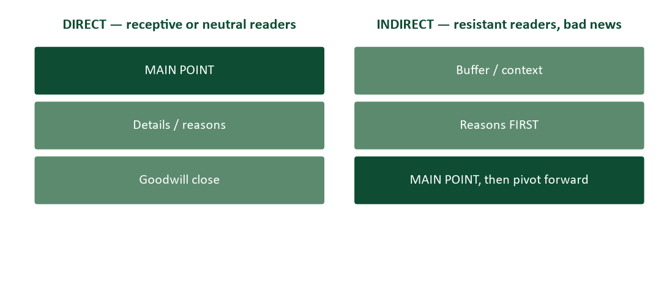
Figure 1. The two master patterns. Reader reaction — not writer comfort — picks the pattern.
The direct pattern serves receptive and neutral audiences — which is most business communication, most days. Main point in the first sentence; explanation after; goodwill close. It respects the F-pattern scanning behavior from Chapter 2, survives forwarding, and reads as confidence. The indirect pattern serves resistance: bad news, refusals, and persuasion against the grain, where a blunt opening would slam the reader’s mind shut before your reasons get a hearing. There, honest context and reasons precede the point, so the conclusion arrives pre-justified. Chapters 7 and 8 develop the indirect arts in full; this chapter’s job is the decision itself.
The abuses. Two abuses to avoid. Do not use indirect structure to hide from routine clarity — burying an ordinary request under three paragraphs of preamble is not diplomacy; it is fog. And do not use directness as a license for bluntness in sensitive moments — “your project is cancelled, details below” is a wound with a bibliography. Strategy follows the reader’s stakes.

Outlining: thinking before formatting
An outline is not paperwork — it is the cheapest place to discover that your message does not hold together. The working method takes three steps: dump every point you might make (the scratch list); group the points into three-ish families and name each family (these names become your headings or topic sentences); then sequence the families direct or indirect, per Figure 1.
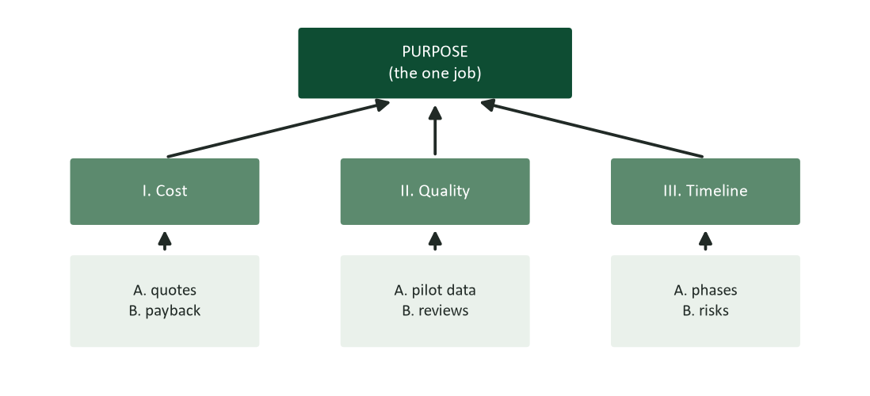
Figure 2. An outline is your purpose, decomposed. Every branch must serve the box above it.
The discipline that makes outlines work is the same unity test paragraphs use: every branch must serve the box above it. A fascinating fact that serves no family gets cut, however fond of it you are — Chapter 2 already warned that planning is also deciding what to leave out. And keep the families few: working memory comfortably juggles about seven items, plus or minus two (Miller, 1956), and tired readers on phones hold fewer. Three main points is a business classic for a reason.

Paragraphs: one claim, held together
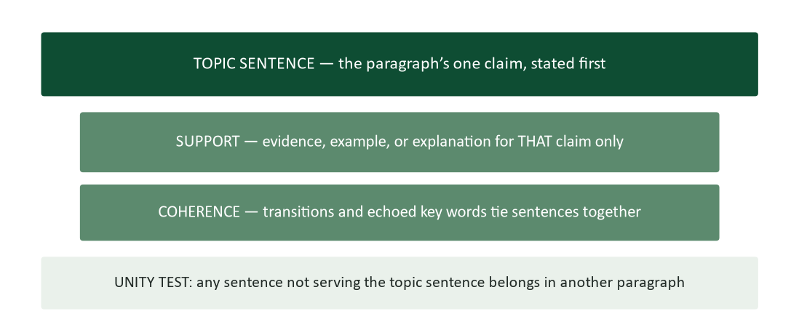
Figure 3. Paragraph anatomy: topic sentence first, support that serves it, coherence that ties it, and the unity test.
Business paragraphs open with their point — the topic sentence is the paragraph’s thesis, and everything after it is employed by it. Three properties make a paragraph professional. Unity: one claim per paragraph; the sentence that wanders off supports some other claim and should live there instead. Coherence: sentences connect through transitions (however, therefore, for example) and through echoed key words — if sentence one is about “turnaround time,” sentence two should say “that time,” not “this issue.” Brevity: on screens, four to six lines is a paragraph; eight is a wall. White space is not wasted space — it is the reader’s handhold.
The coherence machinery has a scientific description worth knowing. Readers expect the opening of a sentence (the topic position) to carry familiar information — the thing we are already talking about — and the end of a sentence (the stress position) to carry the news (Gopen & Swan, 1990). Prose that honors old-before-new feels lucid without the reader knowing why; prose that violates it feels choppy even when every sentence is grammatical.
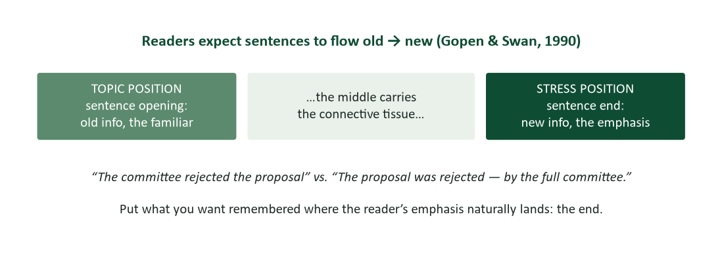
Figure 4. Topic and stress positions: readers expect old information first and the news at the end (Gopen & Swan, 1990).
Use it. The stress position is also your emphasis dial. “The committee rejected the proposal” stresses the proposal; “The proposal was rejected by the full committee” stresses who did it. Put what you want remembered where the reader’s emphasis naturally lands: last.

Sentences: the units that carry weight

Voice: active by default, passive on purpose
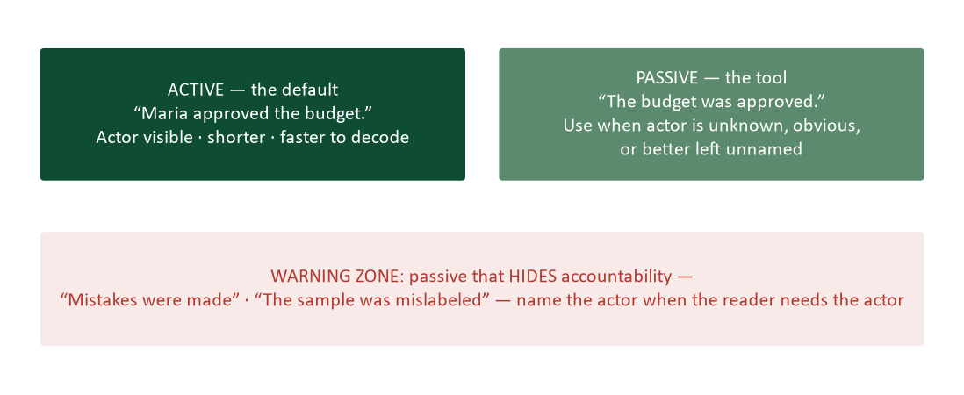
Figure 5. Active is the default; passive is a tool; passive that hides accountability is the hazard.
Active voice — actor, verb, object — is shorter, faster to decode, and honest about who did what: the professional default. Passive voice is not an error; it is a tool with three legitimate jobs: the actor is unknown (“the shipment was damaged in transit”), the actor is irrelevant or obvious (“the samples were stored at −80 °C”), or diplomatic construction deliberately spotlights the action over the person (“the figures were transposed” in a message where blame is not the point). The hazard is the fourth use: passive as accountability camouflage. “Mistakes were made” is the most famous evasion in political history precisely because everyone hears the hidden actor. When the reader needs to know who, name who.

Rhythm: vary the length
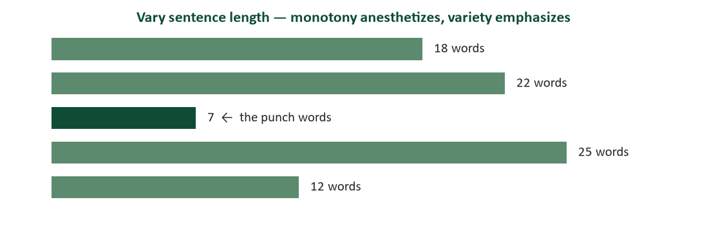
Figure 6. Sentence-length variety. After several long sentences, a short one lands like a verdict.
Uniform sentences anesthetize — fifteen 20-word sentences in a row read like a metronome. Professionals vary length deliberately, and they know the trick hiding in Figure 6: after two or three long sentences, a short one lands like a verdict. It works. Reserve very short sentences for the points that deserve the spotlight, or the spotlight stops meaning anything.

Parallelism: same job, same form
Items doing the same grammatical job must wear the same grammatical form. “The training covers safety procedures, report filing, and client communication” — three noun phrases, one clean series. “The training covers safety procedures, how to file reports, and communicating with clients” breaks the pattern three ways and the reader feels every seam. Parallelism matters double in the places business readers actually look: bulleted lists, headings, and resume lines. Start every bullet in a list with the same part of speech and your document looks edited before anyone reads a word.

Chunking: design for working memory
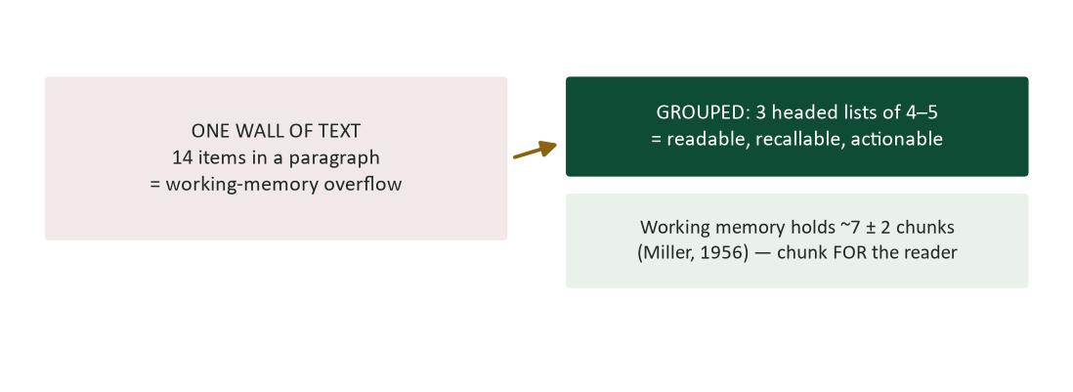
Figure 7. Chunk for the reader: grouped, labeled lists respect the limits of working memory (Miller, 1956).
Fourteen requirements in a paragraph is a memory test; three headed lists of four to five is a document. Miller’s famous “magical number seven, plus or minus two” (Miller, 1956) is the reason phone numbers come pre-chunked and the reason your reader cannot follow your unbroken paragraph of conditions. Group, label, list — the outline logic of Figure 2, applied at the smallest scale.

Drafting: permission to write badly, briefly
With plan and outline in hand, draft fast and forgive yourself. The draft’s only job is to exist — judging while generating stalls both (the phase separation from Figure 1 of the chapter’s process). Practical drafting habits: write the easy section first, not necessarily the opening — momentum transfers; keep the outline visible and let topic sentences come straight from it; when a wording fight breaks out, type the clumsy version, mark it [FIX], and keep moving; and never stop at the end of a section — park mid-thought so re-entry is easy tomorrow. Rudolf Flesch, whose readability research shaped plain-language practice for decades, preached the same underlying ethic: write for the reader’s ease, not the writer’s ceremony (Flesch, 1949).

Research corner: what makes prose feel clear
Clarity has been studied, and three findings recur. First, readers process actor-action sentences fastest — prose whose grammatical subjects are characters and whose verbs are actions reads as “clear,” while prose built on abstractions performing abstract verbs reads as “academic” (the central lesson of Joseph Williams’ classic style curriculum; Williams & Bizup, 2017). Second, nominalizations — verbs frozen into nouns — are the main machine of murk: “make a decision about the implementation of” is “decide to implement” wearing three coats. Unfreeze the verb and sentences shrink and quicken. Third, familiar-before-new ordering (Gopen & Swan, 1990) does more for flow than any transition word. None of this requires talent; all of it is checkable in revision — which is Chapter 4’s whole business.

Worked examples: three repairs

1. Unburying the lead (direct strategy)
Before: “Our team met twice this month to evaluate vendors. We considered many options and several had competitive prices. After careful discussion of the criteria, we recommend TechServe for the contract.” After: “We recommend TechServe for the contract. Our team compared five vendors across two meetings; TechServe offered the best combination of price and support coverage.” The recommendation moves from the stress position of paragraph three to the topic position of sentence one — where a neutral, busy reader will actually meet it.

2. Unfreezing the nominalizations
Before: “The implementation of the utilization of the new scheduling system will result in a reduction of conflicts.” After: “Using the new scheduling system will reduce conflicts.” Nine words gone, no meaning lost: implementation, utilization, and reduction were all verbs in witness protection.

3. Repairing the series
Before: “The new hires will learn safety procedures, how to file reports, and communicating with clients.” After: “The new hires will learn safety procedures, report filing, and client communication” — or, all verbs: “…will learn to follow safety procedures, file reports, and communicate with clients.” Either form works; mixing forms never does.

Headings: the skeleton that skims
Anything longer than a screen needs headings — they are the document’s outline, left visible for the reader. Two crafts matter. First, make headings informative, not categorical: “Cost: TechServe saves $22,000/year” outworks “Cost Analysis,” because a skimmer reading only headings should still receive your argument. (Test your next document exactly that way: read the headings alone. Do they tell the story?) Second, keep heading levels parallel and shallow — two levels serve almost every business document; four levels is a filing system, not a message. Headings also discipline the writer: a section that cannot be honestly summarized in its heading is usually two sections, or none.

The transitions toolbox
Coherence between paragraphs is built with the same two tools as coherence within them: signposts and echoes. Signpost transitions declare the logical relationship — addition (moreover, also), contrast (however, on the other hand), cause (therefore, as a result), sequence (first, next, finally), example (for instance). Echo transitions repeat a key word from the previous paragraph’s stress position in the new paragraph’s topic position: a paragraph ending on “…which raises the question of cost” hands off perfectly to “That cost has three components.” Echoes are the stronger tool — invisible, unfakeable, and impossible to sprinkle on afterward, because they only exist where the thinking actually connects. If you cannot write the echo, the paragraphs may not belong next to each other.

From outline to draft: a 20-minute walkthrough
Here is the full pipeline on a real task: recommending a vendor to a neutral VP (the Riverside-style memo every analyst eventually writes).
- Minutes 0–2 — the plan (Chapter 2): “So that the VP approves renewing with TechServe by Friday, because renegotiated terms save $22,000 a year.” Reader: executive skimmer, neutral, will forward to finance (secondary ring).
- Minutes 2–6 — the scratch list: fifteen points, dumped without order: pricing history, the two meetings, competitor quotes, support-response data, migration risk, contract deadline, the pilot glitch, renewal discount…
- Minutes 6–9 — grouping: three families emerge and get names that will become headings: “Cost: renewal saves $22K” · “Risk: switching costs exceed savings” · “Quality: support metrics beat all bidders.” The pilot glitch joins Quality; the meeting history joins nothing and dies.
- Minutes 9–10 — strategy call: neutral reader → direct. Sentence one is the recommendation plus the strongest number; the families follow in decreasing order of decision weight; the contract deadline becomes the dated call to action.
- Minutes 10–20 — the sprint draft: topic sentences copied straight from the family names, support filled beneath each, [FIX] marks left where wording fought back. Draft exists. Judging is scheduled for tomorrow — that is Chapter 4’s appointment.
The math. Twenty minutes, and the hard intellectual work — deciding, grouping, sequencing — is finished before the prose pressure starts. Writers who skip to minute ten spend an hour lost in their own scratch list, formatting sentences that the outline would have deleted.

Teardown: the finished memo opening, annotated
“I recommend renewing the TechServe contract on the renegotiated terms attached, which save $22,000 annually. [main point + strongest number, topic position of the entire document] The decision is due Friday the 20th; details below support a same-week approval. [deadline surfaced early; permission to skim granted explicitly] Cost: renewal beats all three competing bids… [informative heading carries the argument; topic sentence = family name] Risk: switching would cost more than it saves for at least 26 months… [second family, decision-weight order] Quality: TechServe’s support response averaged 2.1 hours in our pilot versus an industry median of 9… [concrete over adjectival — the scrutinizer is served] Could you approve by Friday so we lock the renewal discount? [call to action: act, date, reason]”
Count the rules. Every structural rule in this chapter appears in eleven lines: direct strategy, frontloaded stress-worthy number, informative headings, topic sentences from the outline, evidence in the body, and a dated ask. The VP can decide from the first two sentences — and audit everything beneath them.

Case study 1: the buried recommendation
A financial analyst spends two weeks evaluating whether her firm should renew a $180,000 software contract. Her email to the decision-making VP opens with the project’s history, walks through the evaluation criteria, discusses each of four alternatives in paragraph-long detail, notes some pricing nuances, and concludes — in the final paragraph, sentence three — that renewal on renegotiated terms is clearly best. The VP, triaging email between flights, reads the first paragraph, skims the second, files it “to finish later,” and asks a colleague that afternoon: “Did the software evaluation ever reach a conclusion?” The analyst hears about the comment and is stung — the conclusion was right there.
- Where was the main point relative to the reader’s actual reading behavior (Chapter 2’s F-pattern)?
- This reader was neutral-to-receptive. Which strategy did the message need, and which did it get?
- Sketch the direct-strategy outline (Figure 2 style) for the same content: what becomes sentence one? What becomes skippable?
- The analyst chose indirect structure because she wanted to “show the work.” What legitimate need was she serving, and where does that content belong in a direct message?

Case analysis
The message was organized as an archaeology of the analysis — the order in which the work was done — rather than for the decision the reader needed to make. Neutral reader, direct pattern: “I recommend renewing with TechServe on renegotiated terms, saving $22,000 annually; the comparison below supports it.” The two weeks of diligence is not wasted by frontloading — it moves into a labeled, skimmable body (Criteria · Alternatives · Pricing) that the VP can audit if she wishes and skip if she trusts. Showing the work is a legitimate ethos need; the stress position of the final paragraph is simply the wrong warehouse for it. The professional heartbreak in this case is common and avoidable: excellent analysis, invisible conclusion.

Case study 2: the incident report that named no one
After a minor chemical spill, a lab supervisor files the incident report: “The secondary containment was found to have been compromised. The transfer was performed without the checklist having been completed. Corrective measures have been identified and will be implemented.” Legal is satisfied. The safety committee is not: reading it, they cannot tell who transferred, who skipped the checklist, whether “corrective measures” have an owner, or whether anything will be different by Friday. At the review meeting, the supervisor explains each item easily — the facts were never in doubt. The report simply hid them.
- Identify every passive construction and classify it against Figure 5: legitimate tool or accountability camouflage?
- Rewrite the three sentences in active voice with named roles (not necessarily named individuals) and dated actions.
- When WOULD passive voice be appropriate in an incident report? Give one example.
- What does this case add to Chapter 1’s lesson about upward communication and bad news?

Case analysis
Every sentence passes the grammar check and fails the reader. “Was found to have been compromised” hides who found it and when; “was performed without the checklist having been completed” hides the transfer technician’s training gap (the actual root cause); “measures have been identified” hides that no one yet owns them. Active rewrite: “During Tuesday’s transfer, the on-duty technician skipped the pre-transfer checklist; the secondary containment tray had a crack that inspection would have caught. The lab manager will retrain all transfer-qualified staff by March 14 and has replaced the tray.” Passive remains right where actors are genuinely irrelevant (“the tray was manufactured in 2019”). The deeper point joins this chapter to Chapter 1: organizations learn from incidents only when reports carry actors, causes, and owners — grammar is a safety system.

Watch list: three short pieces worth your time
- Helen Sword, “Beware of Nominalizations” (TED-Ed). Five animated minutes on the “zombie nouns” that deaden prose — the unfreezing drill from this chapter, made memorable.
- Larry McEnerney, “The Craft of Writing Effectively” (University of Chicago Leadership Lab). An hour that reframes writing around value to the reader rather than display by the writer — the most recommended writing lecture on the internet, for good reason.
- TED-Ed, “Grammar’s great divide: the Oxford comma.” A short, fair fight over one comma — and a painless introduction to the idea that punctuation choices are clarity choices.

Drafting self-assessment
Score yourself: 2 = usually, 1 = sometimes, 0 = rarely.
- I choose direct or indirect structure deliberately, based on the reader’s likely reaction.
- My main point appears in the first two sentences of routine messages.
- I outline (even three scratch lines) before drafting anything substantial.
- My paragraphs open with topic sentences.
- I can name the one claim each of my paragraphs makes.
- My default voice is active; my passives are chosen, not accidental.
- I vary sentence length — and save short sentences for points that deserve them.
- My lists are parallel: same job, same grammatical form.
- I chunk dense content into labeled groups instead of walls.
- I draft without editing, and edit without drafting.
Scoring: 16–20, your structural instincts are strong — Chapter 4 will sharpen the polish. 10–15, drill the two lowest items; topic sentences and active voice pay fastest. Below 10, adopt one rule this week: main point first, in every routine message. Retake at midterm.

The drafting playbook
- Blocked at the opening? Draft the easiest section first; openings are easier to write once the middle exists.
- Sentence fighting back? Type the clumsy version, mark [FIX], keep moving — revision is a separate appointment.
- Paragraph sprawling? Find its topic sentence. If it has two, it is two paragraphs.
- Sentence feels muddy? Find the actor and the action; make them subject and verb; unfreeze nominalizations.
- Series feels bumpy? Check parallelism: same job, same form.
- List longer than seven? Group and label — Miller’s limit is the reader’s limit.
- Want emphasis? Short sentence, stress position, or a heading — not bold everything.
- Ending a work session? Park mid-thought; tomorrow’s re-entry will thank you.

Sentence workshop: ten repairs (answers follow)
Fix each with this chapter’s tools before checking the answers below. Name the tool as you use it — diagnosis is the skill.
- “A decision was made to implement a postponement of the launch.”
- “Our team met twice. Many vendors were considered. Prices were compared carefully. We recommend Apex.”
- “The new policy affects vacation requests, how overtime is approved, and employees wanting to swap shifts.”
- “The report, which include last months figures, are due to the manger by Friday.”
- “It should be noted that there is a requirement for all visitors to sign in.”
- “The failure of the experiment was due to the contamination of the sample by the technician.” (The reader is the safety board.)
- “We provide innovative solutions leveraging synergistic capabilities to optimize outcomes.”
- “Employees must complete the form. The form is available on the portal. The portal requires your ID badge number. Badge numbers are printed on the badge back.”
- “Although the budget, which had been under review for several weeks by the committee that oversees departmental spending, was approved.”
- “The meeting is at 3. Bring the numbers. Don’t be late. It’s important. See you there.”

Workshop answers
- Unfreeze the nominalizations: “We decided to postpone the launch.”
- Bury nothing: lead with “We recommend Apex,” then one supporting sentence — direct strategy plus active voice.
- Parallelism: “…affects vacation requests, overtime approvals, and shift swaps.”
- Proofreading layer (preview of Chapter 4): include→includes, months→month’s, are→is, manger→manager.
- Cut the throat-clearing and unfreeze: “All visitors must sign in.”
- Voice as accountability: for a safety board, name roles and causes — “The technician’s sampling procedure contaminated the sample, which invalidated the experiment.” (Diplomatic contexts might justify the original; safety review does not.)
- Buzzword fog: say the actual service — “We build scheduling software that cuts clinic wait times.” If you cannot replace the fog, the sentence had no cargo.
- Chunk and sequence: one numbered list, four steps, in doing-order — the reader should never assemble your process from prose shards.
- The sentence never lands: “Although” promises a contrast that never arrives. “After several weeks of committee review, the budget was approved.”
- Rhythm inverted: five staccato sentences bury the one that matters. “The 3:00 meeting decides next year’s budget — bring the numbers.” One verdict sentence beats five fragments.

Research corner II: measuring readability
Readability can be estimated, and Word will do it for you (File → Options → Proofing → “Show readability statistics”). The classic measures descend from Rudolf Flesch’s work: Flesch Reading Ease scores 0–100 (higher is easier; most successful business prose lands roughly 50–70), and the Flesch-Kincaid Grade Level translates the same arithmetic into U.S. school grades (Flesch, 1949). Both formulas run on just two inputs — sentence length and syllables per word — which is both their utility and their limit. They cannot detect a buried lead, a broken parallel, or a lie; they only notice long sentences and long words. Use them as a smoke detector, not a judge: a grade level of 16 on a customer email is a real alarm; a grade level of 9 does not certify clarity. The deeper measures of this chapter — strategy, unity, old-to-new flow — still require a human reading like a reader.

The emphasis toolbox
Everything in a message cannot be important, or nothing is. Professionals create emphasis with position and structure, in roughly this order of power:
- Position. First sentence of the message; last position of the sentence (the stress position); first line after a heading. Real estate is emphasis.
- Isolation. A one-sentence paragraph. Used once, it is a spotlight; used often, it is confetti.
- Sentence length. The short sentence after long ones — the verdict effect from Figure 6.
- Labeled structure. A heading or a bolded lead-in (“Deadline:”) — signage the F-pattern cannot miss.
- Typography, sparingly. Bold for the one deadline or decision. Italics for gentle stress. ALL CAPS for nothing — it reads as shouting and scans worse.
- What does NOT work: exclamation points, “very/really/extremely,” and bolding whole paragraphs — inflation that devalues the currency.

Structure by container: email, memo, report
The same architecture scales across containers; only the furniture changes. Email: subject line = the message’s job; sentence one = main point; one screen; lists over paragraphs; the call to action stands alone at the end where the F-pattern terminates. Memo: the To/From/Date/Subject block does your bibliographic work; a one-line summary tops anything over a page; informative headings carry the argument; the file-ability is the point — write for next year’s reader. Report (previewing Chapters 9–10): the executive summary IS the direct strategy — the whole argument in miniature, written last, placed first; sections follow the outline tree with headings as its visible branches; every exhibit earns its place by serving a named section. One skeleton, three bodies — master the skeleton and the containers stop being separate skills.

Journal prompts
- Find a message you wrote that buried its lead. Reorganize it direct. What resisted — the content, or the feeling that showing your work first was safer?
- Collect three passive sentences from real documents around you and classify each: legitimate tool or camouflage? What does each hide?
- Take one paragraph you are proud of and map its topic/stress positions. Does information flow old → new? Where does it break?
- Time yourself drafting 200 words with editing forbidden, then 200 words editing as you go. Compare the clocks — and the drafts.

How your writing will be graded (and read at work)
At this chapter’s level, the supervisor test gets structural teeth. Sendable-as-is now means: strategy matched to the reader’s reaction; the main point findable by a skimmer; paragraphs that each make one claim, opened by it; active voice except where passive is doing a chosen job; parallel series; no walls. A message can pass Chapter 2’s planning test and still fail here — right purpose, right audience, wrong architecture. Both layers get graded, in this course and in every inbox after it.

Common mistakes and their fixes
- Organizing by chronology of your work. Fix: organize by the reader’s decision. History goes in a skippable labeled section, if anywhere.
- Indirect structure as procrastination. Fix: indirect is for resistance and bad news, not for nerves about routine asks.
- Paragraphs without topic sentences. Fix: state the claim first; audition every other sentence against it.
- Accidental passives. Fix: circle every “was/were + verb-ed”; keep only the ones you can defend.
- Fourteen-item paragraphs. Fix: group, label, list (Figure 7).
- Uniform sentence lengths. Fix: read aloud; where you drone, split or combine. Save a short sentence for the verdict.
- Broken parallelism in lists. Fix: first word of every bullet, same part of speech.

Frequently asked questions
- “Isn’t indirect structure just manipulation?” It is sequencing, not deception: every fact still arrives. Ordering reasons before a hard conclusion is how humans stay listening — the manipulation line is crossed by hiding facts, not by ordering them.
- “My professor said never use passive voice.” A useful exaggeration for beginners. The mature rule: active by default, passive on purpose, never as camouflage.
- “How long should a paragraph be?” One claim long. On screens that usually means 3–6 lines. If unity is intact, length is style; if unity is broken, even three sentences are too many.
- “Do these micro-rules matter once AI drafts for me?” More. AI produces grammatical prose with generic structure; the value you add is exactly this chapter — strategy, emphasis, and rhythm chosen for a real reader (Chapter 15).
- “Three main points always?” No — but if you have nine, the reader will remember three of them chosen at random. Better you choose which three, and group the rest beneath them.

Crosswalk: this chapter → your course work
- Practice questions (course site, Chapter 3). Direct/indirect calls, topic sentences, parallelism repairs, and voice choices — the bank mirrors this guide.
- Writing prompts (course site). The reorganization and market-research outline prompts apply Figures 1 and 2 directly.
- Your market research assignment. Its required sections are an outline handed to you — this chapter is how you fill them so each section holds together.
- Next chapter. Chapter 4 is the judging phase: revising for conciseness and clarity, and proofreading like a professional.
- The lecture deck. The Chapter 3 slides follow this guide section-for-section.

Key terms
- Direct strategy — main point first, details after — for receptive and neutral readers.
- Indirect strategy — buffer and reasons before the main point — for resistant readers and bad news.
- Frontloading — placing the main point where scanning readers will actually meet it: first.
- Topic sentence — the paragraph’s one claim, stated first; everything after works for it.
- Unity / coherence — one claim per paragraph; sentences tied by transitions and echoed key words.
- Topic position / stress position — sentence opening (old information) and sentence end (the news and the emphasis) (Gopen & Swan, 1990).
- Active / passive voice — actor-verb-object versus acted-upon constructions; default versus tool.
- Nominalization — a verb frozen into a noun (“utilization”) — the main machine of murky prose.
- Parallelism — items with the same job wearing the same grammatical form.
- Chunking — grouping content into labeled sets sized for working memory (Miller, 1956).

Chapter summary
- One structural decision precedes all others: direct (main point first) for receptive readers, indirect (reasons first) for resistance and bad news.
- Outlines are thinking tools: dump, group into ~3 named families, sequence — and cut what serves no family.
- Paragraphs make one claim, open with it, and hold together through transitions and echoed key words.
- Sentences flow old-information-first to news-last; the stress position at the end is your emphasis dial (Gopen & Swan, 1990).
- Active voice is the default; passive is a tool for unknown, irrelevant, or diplomatically unnamed actors — never camouflage.
- Vary sentence length; save short sentences for verdicts. Keep series parallel. Chunk for working memory (Miller, 1956).
- Draft fast and judge later — generating and judging are different jobs, and doing both at once stalls both.

Self-check quiz
Answer before looking at the key on the final page. If you miss one, reread that section — then take the full practice set on the course site.
1. The choice between direct and indirect strategy is decided by:
a) Message length
b) The reader’s likely reaction to the message
c) The writer’s seniority
d) The time of day
2. The direct pattern opens with:
a) A buffer
b) The reasons
c) The main point
d) An apology
3. Indirect strategy is appropriate for:
a) All internal email
b) Bad news and resistant readers
c) Any message to executives
d) Routine requests you feel nervous about
4. A topic sentence is:
a) The last sentence of a paragraph
b) The paragraph’s one claim, stated first
c) Any sentence containing the topic word
d) A transition
5. “The training covers safety procedures, how to file reports, and communicating with clients” fails on:
a) Unity
b) Parallelism
c) Voice
d) Chunking
6. Readers expect the END of a sentence to carry:
a) Old information
b) The new information and emphasis (the stress position)
c) The subject
d) Transitions
7. Which is a legitimate use of passive voice?
a) Hiding who made an error
b) “The samples were stored at −80 °C” — actor obvious/irrelevant
c) Making prose sound formal
d) Avoiding topic sentences
8. “Mistakes were made” is famous as:
a) Good diplomacy
b) Passive voice used as accountability camouflage
c) A topic sentence
d) Parallel structure
9. Miller’s (1956) “magical number” tells writers to:
a) Use seven paragraphs
b) Chunk content into labeled groups sized for working memory
c) Write seven-word sentences
d) Limit documents to seven pages
10. A nominalization is:
a) A named actor
b) A verb frozen into a noun, like “utilization”
c) A proper noun
d) A parallel series
11. “Using the new system will reduce conflicts” improves on “the implementation of the utilization of…” chiefly by:
a) Adding detail
b) Unfreezing nominalizations into verbs
c) Passive voice
d) A buffer
12. After several long sentences, a very short sentence:
a) Is an error
b) Lands with emphasis — variety creates the spotlight
c) Must be deleted
d) Needs a semicolon
13. The analyst’s buried recommendation failed because the message was organized by:
a) The reader’s decision
b) The chronology of her work
c) Direct strategy
d) Parallel structure
14. In the incident-report case, the safety committee needed:
a) More formal language
b) Actors, causes, and owners — grammar as a safety system
c) Longer paragraphs
d) Indirect strategy

Answer key
1. b 2. c 3. b 4. b 5. b 6. b 7. b 8. b 9. b 10. b 11. b 12. b 13. b 14. b

Discussion questions
- Find a real message organized by the writer’s process instead of the reader’s decision. Rebuild its outline direct. What earns sentence one?
- Collect three passives from documents around you and classify each: tool or camouflage? Rewrite the camouflage.
- Take your most recent substantial paragraph and audition every sentence against its topic sentence. What gets cut or moved?
- When has bluntness-as-directness hurt a message you sent or received? Where was the line between direct and merely abrupt?
- Chunk this: rewrite a dense policy paragraph from your workplace or university as labeled lists. What did the grouping decisions force you to understand?

References
The following published sources inform this chapter and are recommended for deeper study.
Flesch, R. (1949). The art of readable writing. Harper & Brothers.
Gopen, G. D., & Swan, J. A. (1990). The science of scientific writing. American Scientist, 78(6), 550–558.
Miller, G. A. (1956). The magical number seven, plus or minus two: Some limits on our capacity for processing information. Psychological Review, 63(2), 81–97.
Nielsen, J. (2006). F-shaped pattern for reading web content. Nielsen Norman Group. https://www.nngroup.com/articles/f-shaped-pattern-reading-web-content/
Williams, J. M., & Bizup, J. (2017). Style: Lessons in clarity and grace (12th ed.). Pearson.
Practice what you just read: course site → this chapter → Practice, then the graded homework before the weekly deadline.

