REGIONAL FULFILLMENT PARTNERSHIP PROPOSAL
Harbor & Pine Supply Co. (fictional sample company)

1. Executive Summary
Harbor & Pine Supply Co. proposes a regional fulfillment partnership that consolidates inbound freight, shortens delivery times, and gives the client a single point of accountability for order handling.

Based on the order volumes shared during discovery, we expect average delivery time to fall from 4.1 days to under 2 days within four quarters, while reducing split shipments and customer service contacts.

2. Background and Objectives
The client currently ships from three separate warehouses, each with its own cut-off times and carrier contracts. This creates inconsistent delivery promises and makes exceptions difficult to trace.

The objectives of this proposal are to: unify order cut-off times, consolidate carrier management, and provide weekly performance reporting.

3. Proposed Solution
We will operate a single regional hub with same-day pick and pack for orders received before 2 p.m. Inventory will be synchronized with the client's storefront every 15 minutes.

Exceptions such as damaged goods, address errors, and stock-outs will be logged in a shared tracker with an owner and a resolution deadline.

4. Implementation Timeline
The rollout is divided into four phases so that service continues without interruption.

Phase | Scope | Duration
1. Discovery | Volume audit, SKU mapping | 2 weeks
2. Setup | Hub configuration, storefront sync | 3 weeks
3. Pilot | 20% of orders routed to hub | 4 weeks
4. Full rollout | All orders, weekly reporting | Ongoing

5. Pricing
Pricing is per order and includes pick, pack, standard packaging, and carrier label generation.

Service | Unit | Price
Pick and pack | per order | $1.80
Additional item | per item | $0.35
Storage | per pallet / month | $18.00
Returns handling | per return | $2.50
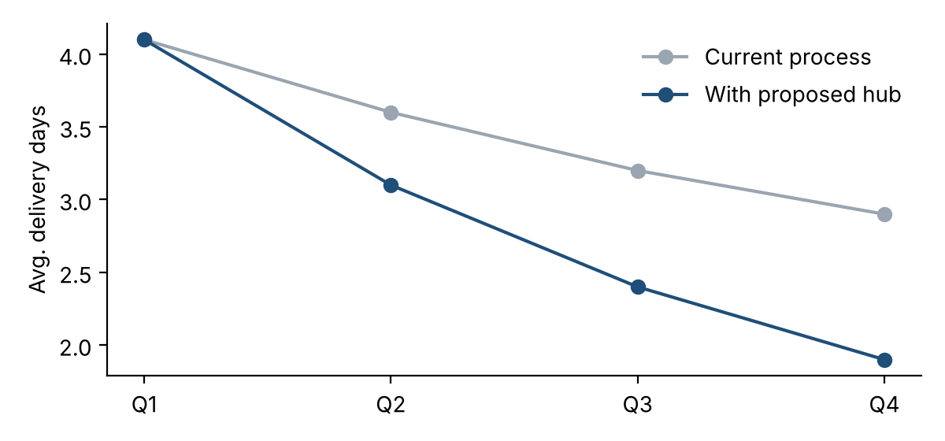
chart - delivery days
6. Next Steps
Upon approval, we will schedule a kickoff meeting within five business days and share a detailed migration checklist.

