andorid

|  |
| --- |
| **Student No. 17301152** |
| **Student Name: 段柄宇** |
| **Assignment number: 1** |
| **Due date: 2019-10-14** |

The content of design

E-Learning App design 2

一 functional module 2

1.1User information management module. 3

1.2 Course management module 4

1.3 Learning resource management module 5

1.4Community 6

# E-Learning App design

## 一 functional module

1.1User information management module.

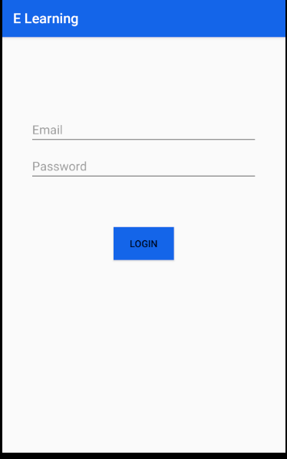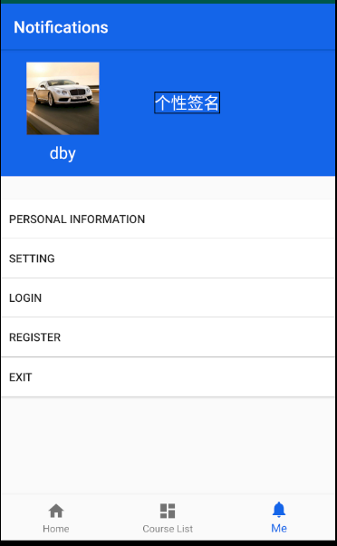

In this module, users can log in and register their E-learning account and view and modify personal information.

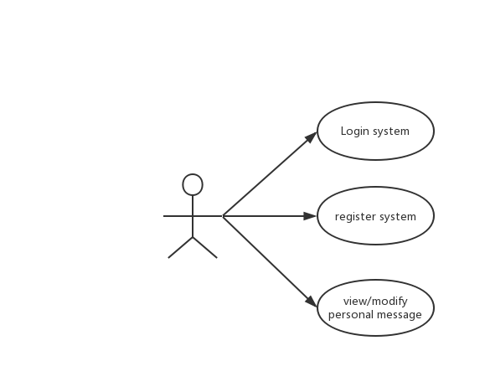

1.2 Course management module

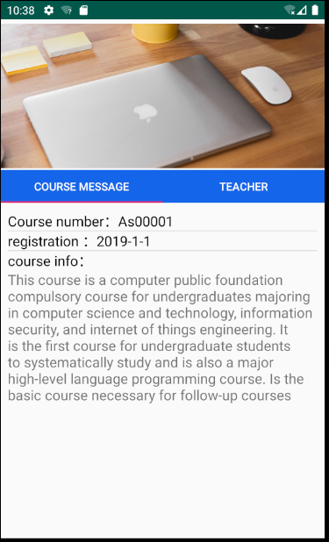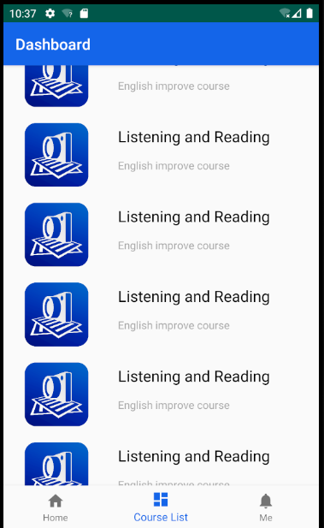



In this module, users can browse and select the currently available courses, view course information and classroom information, and listen online.

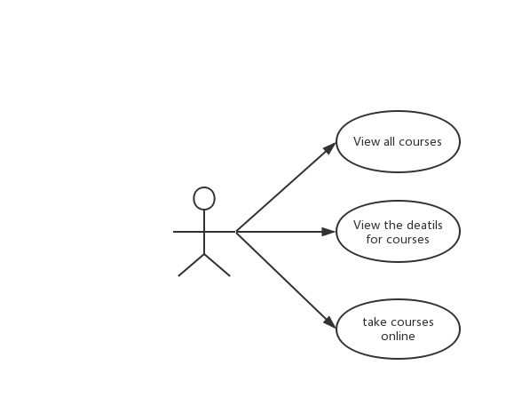

1.3 Learning resource management module

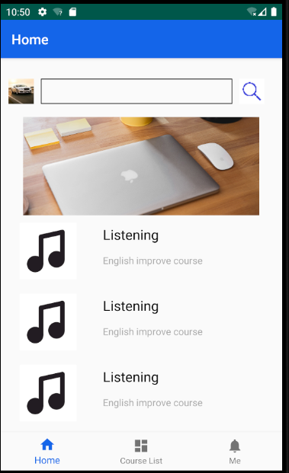

In this module, users can browse and download various forms of learning materials.

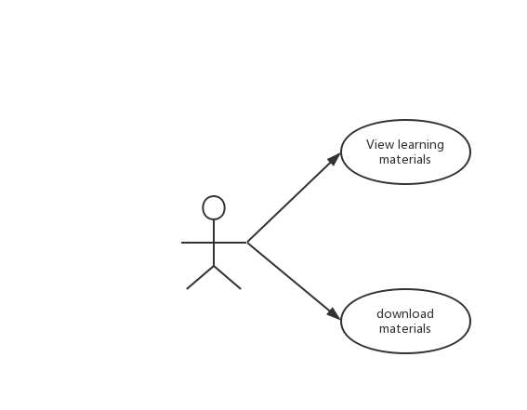

1.4Community

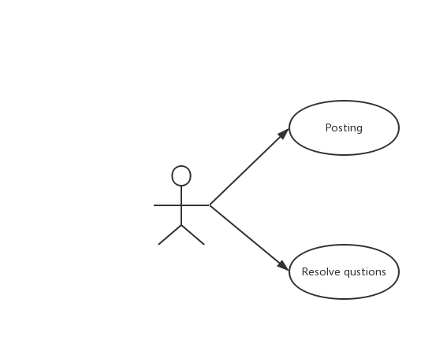If users encounter some difficulties in learning, they can ask for help from people in communities by , Also they can help person who meet difficult to resolve the question.