Android

|  |
| --- |
| Student No. 17301152, 1731059 |
| Student Name: 段柄宇, 陈春荣 |
| Assignment number: 2 |
| Due date: 2020.1.5 |

E-Learning App design

1.User Login/Register Model

## 1.1.UI design

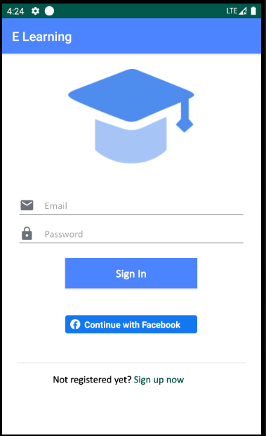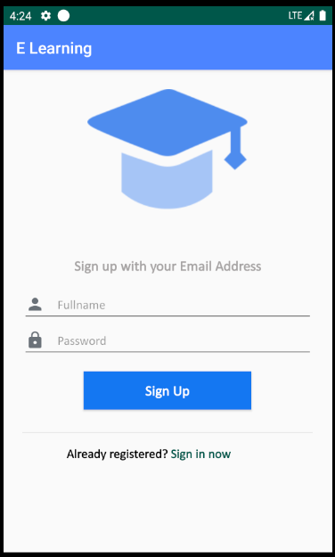

## 1.2. Use case

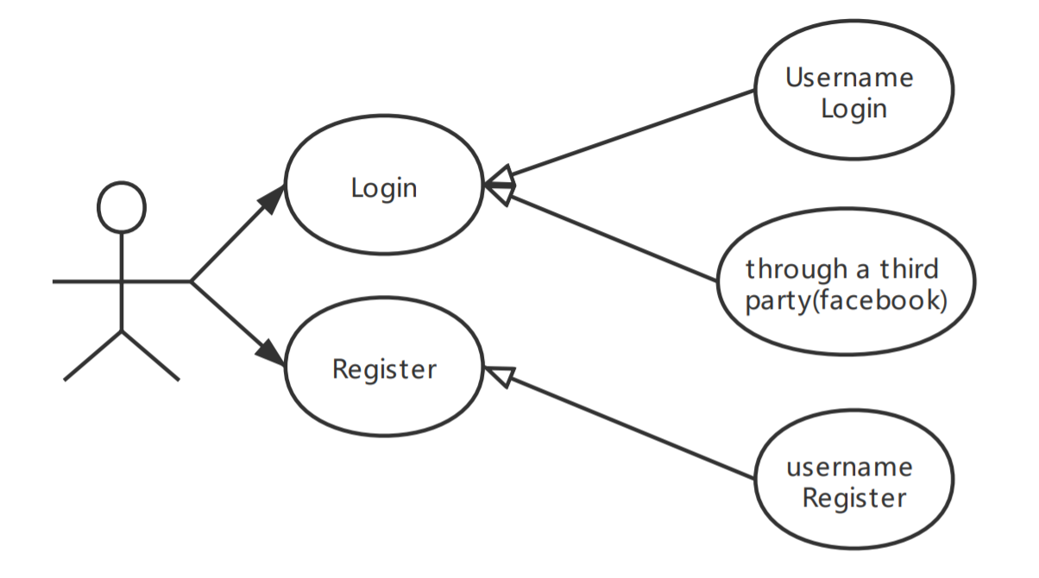

## 1.3. function Design

1.3.1. Login

User can login our E-Learning platform by username and password. Also, users can log in through a third party, we support facebook to login our platform.

1.3.2.Register

User can register a account number, If the username which user registering exists, We will remand user to change another username to register.

1.3.3.Save the login status.

When user login in our platform, our platform will save the user’ login status. So when user open the app next time, APP will return the last status.

We use shared preferences api to save the user information and status.

# 2.Course display module

## 2.1. UI Design

2.1.1.course list window

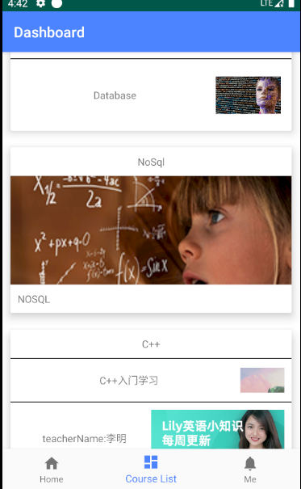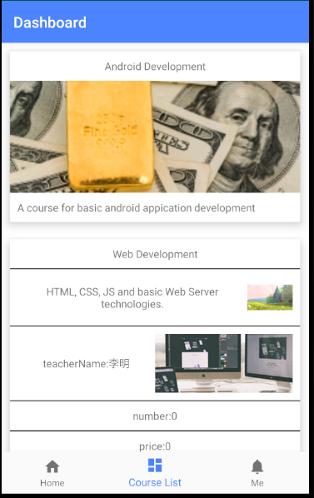

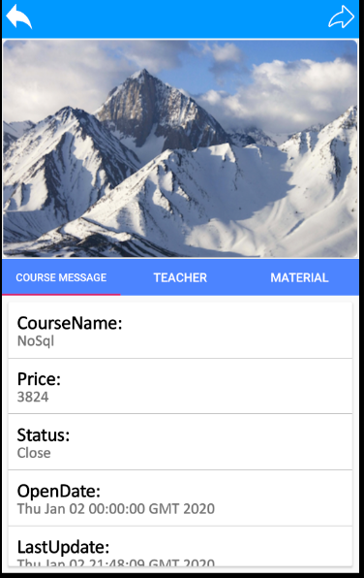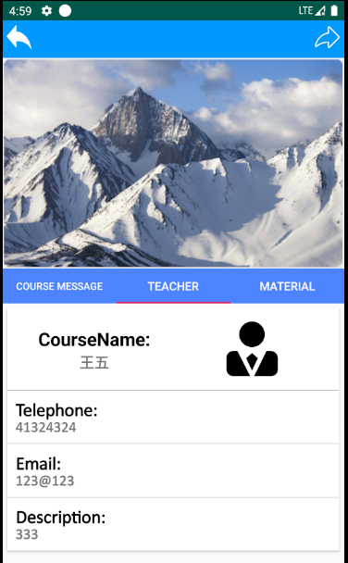2.1.2.course detail message window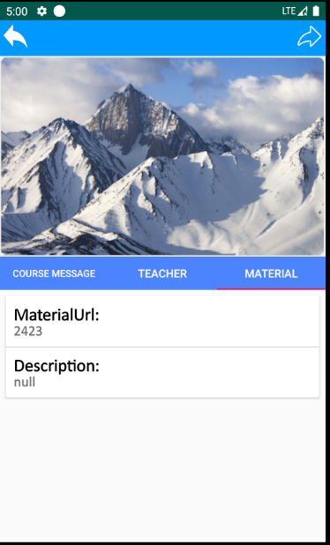

2.1.3.course shared window

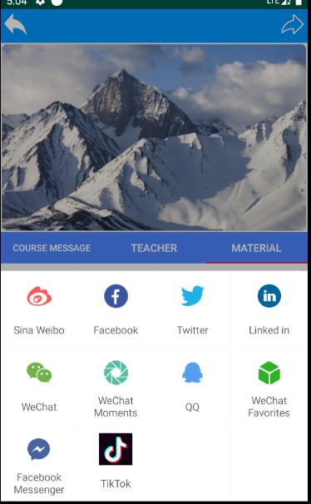

## 2.2.Use Case

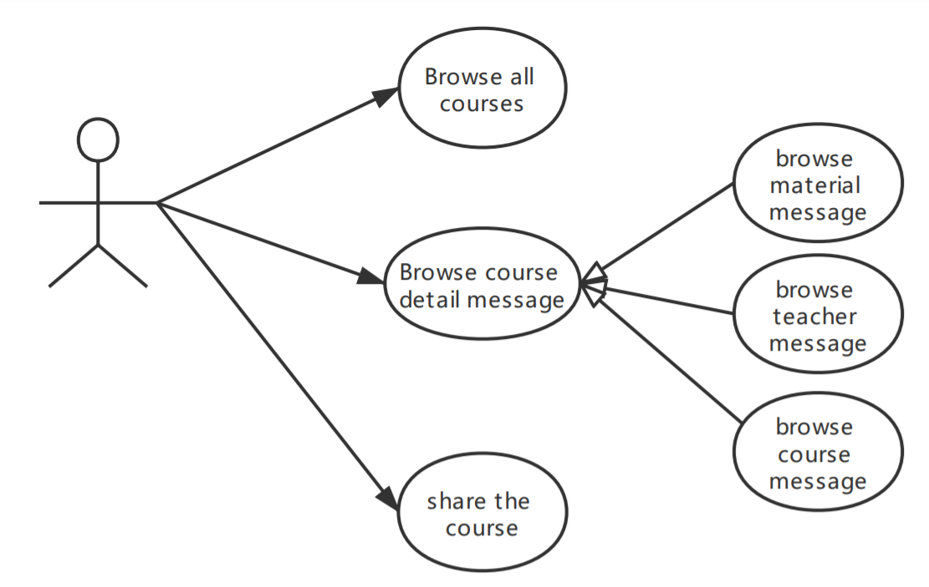

## 2.3.function design

2.3.1.browse course list

User can browse the all Brief course message by list.

We user recyclerView to achieve this function, In the recyclerView, We achieve some Animation. For example users can move entries up and down to swap their places. Also, If use don’t like some course, they can delete them by swiping right or left.

We design three type to show course message, In the UI Design model, we can see the three pattern. And as for each item, in order to make them become beautiful, we user the CardView Layout.

As for loading the message, we use multithreads to load the data form server. So that the window is frequent.

2.3.2. browse course detail Message.

In the detail Message Module, We can view the course detail message, teacher detail message and the material message.

We use the TabView PageView, fragment to achieve the function.

2.3.3. share the course.

User could shared the course through many third platform.