Android

|  |
| --- |
| Student No. 17301152, 1731059 |
| Student Name: 段柄宇, 陈春荣 |
| Assignment number: 4 |
| Due date: 2020.1.5 |

1.Introduction slide page

1.1UI design

1.1function

It is a introduce page when users first open the app, witch is simple introduce our app.

# 2.User login with faceBook

# 2.1.UI design

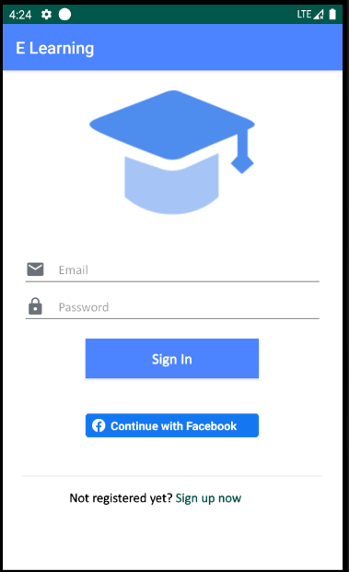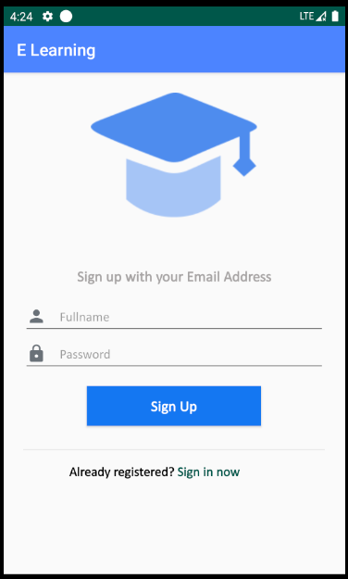

## 2.2. function Design

users can login in through a third party, we support facebook to login our platform.

3.Share course announcements to WeChat/SMS

3.1UI Design

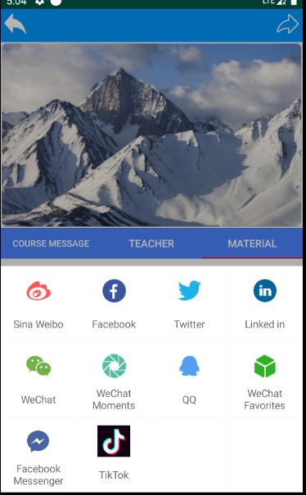

3.2function

Users can shared the course by many third platform.