

**Lesson 2**

**Functions & Comparison Operators**

# Summary

For this lesson, we will be reviewing the comparison operators used in Python syntax. As well as, their ability to be applied within functions using **‘if-elif-else’** statements, **‘for’** loops, and **‘while’** loops.

# If-Else Statements

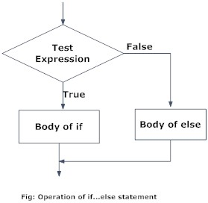if test expression:

Body of if

else:

Body of else

# If-ElIf-Else Statements

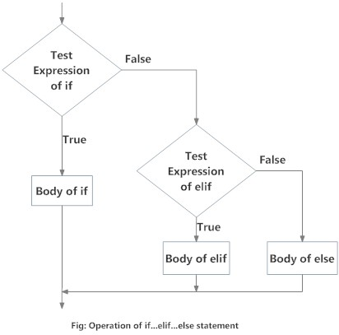if test expression:

Body of if

elif test expression:

Body of elif

else:

Body of else

# Comparison & Logical Operators

***Comparison Operators***

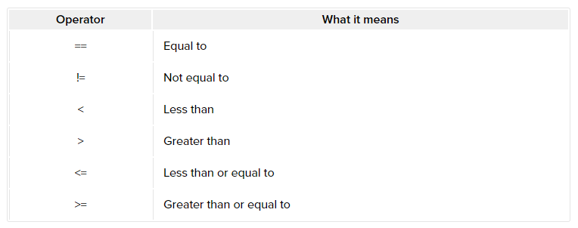

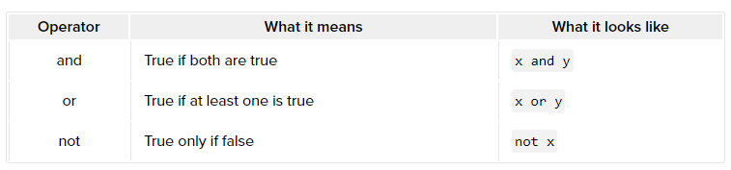***Logical Operators***

# logical example

print((-0.2 > 1.4) and (0.8 < 3.1)) # One original expression is False

print((7.5 == 8.9) or (9.2 != 9.2)) # Both original expressions are False

print(not(-5.7 <= 0.3)) # The original expression is True

# conditional comparison example

if foo == 'abc' and bar == 'bac' or zoo == '123':

# do something

# For Loops

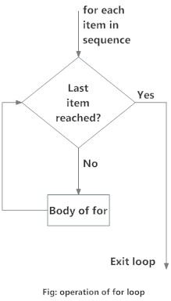# List of numbers

numbers = [6, 5, 3, 8, 4, 2, 5, 4, 11]

# Variable to store the sum

sum = 0

# Iterate over the list

for val in numbers:

sum = sum+val

# Output: The sum is 48

print("The sum is", sum)

# List of strings

genre = ['pop', 'rock', 'jazz']

# Range function

# Iterate over the list using index

for i in range(len(genre)):

print("I like", genre[i])

# Output:

# I like pop

# I like rock

# I like jazz

# While Loops

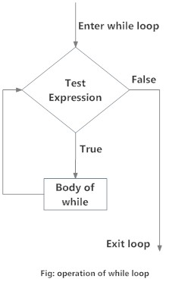n = 10

# initialize sum and counter

sum = 0

i = 1

while i <= n:

sum = sum + i

i = i+1 # update counter

# print the sum

print("The sum is", sum)

# Defining Functions

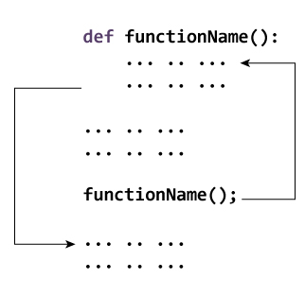name = ‘Billy’

def greet(name):

"""This function greets

the person whose name

was passed in as a parameter."""

print("Hello, " + name + ". Good morning!")

# Exercise Your Python

1. **Write a Python program to print only the *even* numbers from the provided list.**Sample List: [1, 2, 3, 4, 5, 6, 7, 8, 9] Expected Result: [2, 4, 6, 8]
2. **Write a Python function that checks whether a string is a palindrome or not.**

## Note

*A palindrome is a word, phrase, or sequence that reads the same backward as forward (i.e. “madam” or “nurses run”)*

# Challenge

**Write a Python function that prints out the first ‘n’ rows of Pascal's triangle.**

*Sample Pascal's Triangle*

