GES'S R. H. Sapat College of Engineering, Management Studies and Research, Nashik – 422005
MCA (Engg.) Department
SYMCA (A. Y. 2026-27) SEM - I | Web Technology Lab
Assignment 9: Personal Portfolio Website – Write-up
Part B: Student Write-up
Name | Deepak Chauhan | Roll No | 08
Batch | SYMCA (Batch 2026-27) | Date | 02/11/2026
Technology used | HTML5, CSS3, JavaScript (Vanilla ES6+), Particle.js & Responsive CSS (Grid/Flexbox)
1. Aim
To design and deploy a responsive personal portfolio website using HTML5, CSS3, and JavaScript (Vanilla ES6+) with interactive element animations, dynamic particle canvas effects, and multi-device responsiveness across mobile, tablet, and desktop viewports.
2. Objectives
- To structure a modular, multi-page personal portfolio comprising Home, About, Projects, Certifications, and Contact pages using semantic HTML5 elements.
- To create an adaptive, mobile-first responsive layout utilizing CSS Flexbox and CSS Grid that functions seamlessly on mobile phones, tablets, and desktop computers.
- To design and implement interactive animations, including scroll-reveal effects (powered by the Intersection Observer API), a dynamic background particle canvas, and interactive hover transitions.
- To establish a clean design system utilizing CSS Custom Properties (CSS variables) for dark/light theme switching, glassmorphic UI components, and modern typography.
- To deploy the portfolio onto a free, reliable cloud hosting platform (GitHub Pages / Netlify) and verify seamless cross-browser accessibility on mobile devices.
3. Theory: About the Technology Used
3.1 The technology I used
I developed this personal portfolio using core web standards: HTML5, CSS3, and JavaScript (ECMAScript 2022+ / Vanilla JS). HTML5, standardized by W3C and WHATWG, provides clean semantic structuring and native media/canvas capabilities. CSS3 is maintained by the W3C CSS Working Group and governs the visual styling, responsive layouts, glassmorphic effects, and fluid CSS transitions. JavaScript, maintained by ECMA International (TC39), manages client-side interactivity, DOM manipulation, asynchronous event handling, and canvas physics. Together, these technologies deliver blazing-fast load speeds, zero build bloat, universal browser support, and lightweight execution without requiring external heavy runtimes.
3.2 Why I chose it
I chose native HTML5, CSS3, and modern JavaScript because they offer complete architectural control over layout precision, zero build overhead, and maximum performance. Having built a strong foundation in computer science and full-stack development, I wanted to showcase craft and mastery by developing bespoke components—such as a dynamic particle system, an interactive developer CLI console, and custom glassmorphism—directly with browser APIs. This approach guarantees instant load times, zero third-party dependency vulnerabilities, complete control over responsive breakpoints, and maximum compatibility across all mobile and desktop browsers.
3.3 Key features I used
- Semantic HTML5 Elements: Utilized <header>, <nav>, <main>, <section>, <article>, <canvas>, and <footer> to establish clean hierarchy and high SEO accessibility.
- CSS Custom Properties (Variables): Structured centralized design tokens on :root and [data-theme="light"] for instantaneous, seamless dark and light theme toggling.
- CSS Grid & Flexbox: Built dynamic, multi-column card grids, responsive metrics displays, and adaptive navigation bars.
- Intersection Observer API: Implemented hardware-accelerated scroll-reveal animations that gracefully trigger as cards enter the viewport.
- HTML5 Canvas & 2D Context: Rendered an interactive background constellation particle canvas that dynamically responds to mouse movement.
- LocalStorage State Persistence: Cached user preferences (theme mode) directly in the browser to maintain state across page navigations.
3.4 Styling: Tailwind CSS or CSS
Tailwind CSS is a utility-first CSS framework providing atomic helper classes directly in markup. For this portfolio, I deliberately utilized a structured, custom CSS3 Design System with CSS Custom Properties and Glassmorphism instead of Tailwind CSS. A high-end personal portfolio demands custom aesthetic styling—including multi-layered ambient gradients, backdrop-filter blur surfaces, bespoke glowing card borders, and retro terminal styling—which are significantly cleaner to maintain in a dedicated stylesheet (style.css). This avoided class clutter in HTML documents, eliminated dependency on Node.js build pipelines and PostCSS processors, and enabled complete artistic control over responsive breakpoints.
3.5 Animations
- Scroll-Reveal Animations: Implemented via JavaScript's IntersectionObserver API combined with CSS translateY and opacity transitions on all content cards (Bio, Timeline, Projects, Skills).
- Interactive Particle Canvas: A custom JavaScript particle engine rendering connecting nodes and floating orbits across an HTML5 <canvas> background.
- Dynamic Typewriter Effect: JavaScript character-by-character text rotation in the hero title ('Software', 'Full-Stack Apps', 'AI Systems') with a blinking cursor keyframe.
- Micro-Interactions & Hover Effects: CSS @keyframes pulseDot for active availability status, 3D card tilt/elevation on hover, and smooth theme-switching fades.
3.6 Responsive design
- CSS Grid Fractional & Auto-fit Units: Grids dynamically reorganize (e.g., grid-template-columns: repeat(auto-fit, minmax(320px, 1fr))), providing 3 columns on wide screens, 2 on tablets, and 1 on phones.
- Media Queries: Breakpoints are configured at @media (max-width: 1024px) (tablet landscape) and @media (max-width: 768px) (mobile portrait) to collapse horizontal layouts into vertical stacks.
- Adaptive Navigation: On screens below 768px, horizontal navbar links hide and an interactive hamburger menu reveals an accessible slide-out mobile drawer.
- Fluid Units & Viewport Meta: Relative units (rem, %, vw) and standard viewport configuration guarantee crisp readability on all display densities.
4. Syntax
Code snippets from my portfolio codebase with explanations in Consolas monospace font:
Part | Code snippet from my portfolio | What it does
Page structure or component | <section class="hero-section">  <div class="container hero-grid">  <div class="hero-content reveal">...</div>  <div class="hero-visual reveal">  <img src="assets/deepak-chauhan.jpg"  alt="Deepak Chauhan" class="avatar-img" />  </div>  </div>  </section> | Constructs the semantic hero section pairing the developer introduction and profile photo in a two-column responsive grid container.
Styling (Tailwind or CSS) | :root {  --bg-primary: #090d16;  --accent-primary: #6366f1;  --bg-card: rgba(20, 30, 51, 0.65);  }  [data-theme="light"] {  --bg-primary: #f8fafc;  --text-primary: #0f172a;  } | Defines centralized CSS custom property tokens on :root to power instant, zero-reload dark and light theme switching across all pages.
Animation | const observer = new IntersectionObserver((entries) => {  entries.forEach(entry => {  if (entry.isIntersecting) {  entry.target.classList.add('show');  }  });  }, { threshold: 0.15 });  document.querySelectorAll('.reveal').forEach(el => observer.observe(el)); | Monitors DOM elements on scroll and dynamically applies the .show class to trigger smooth CSS slide-up and fade-in animations.
Responsive layout | @media (max-width: 1024px) {  .hero-grid, .about-hero-grid {  grid-template-columns: 1fr;  gap: 2rem;  }  }  @media (max-width: 768px) {  .nav-links { display: none; }  .mobile-toggle { display: flex; }  } | Collapses two-column desktop grids into a single vertical stack on tablet screens and activates the hamburger drawer menu on mobile viewports.
5. Screenshots of My Portfolio
Actual high-resolution screenshots captured across desktop, tablet, and mobile views from the live deployed website:
Home page (desktop)  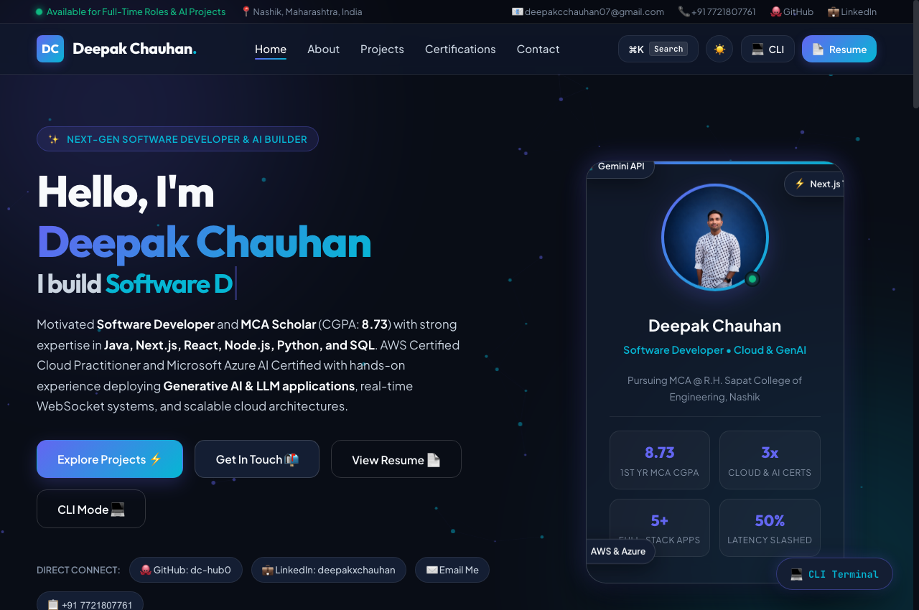 | About  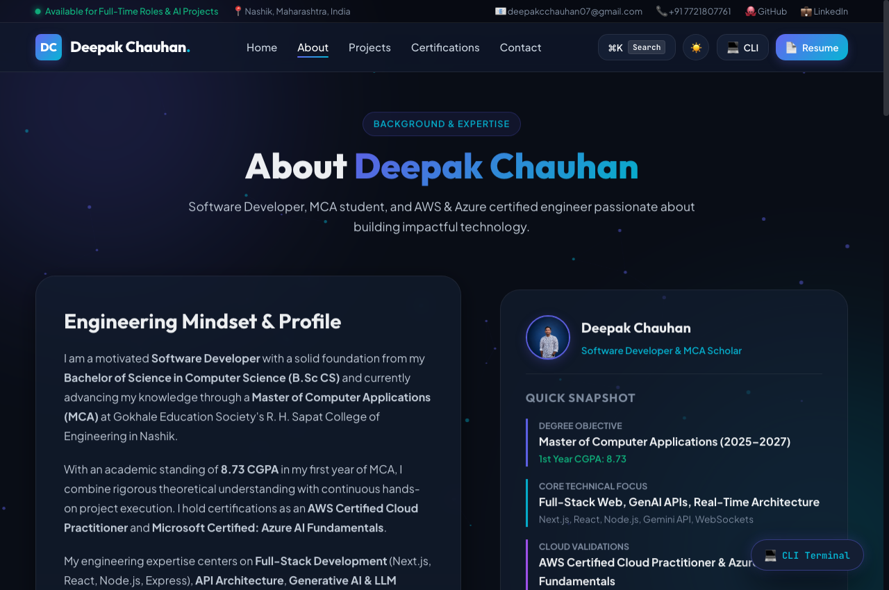
Projects  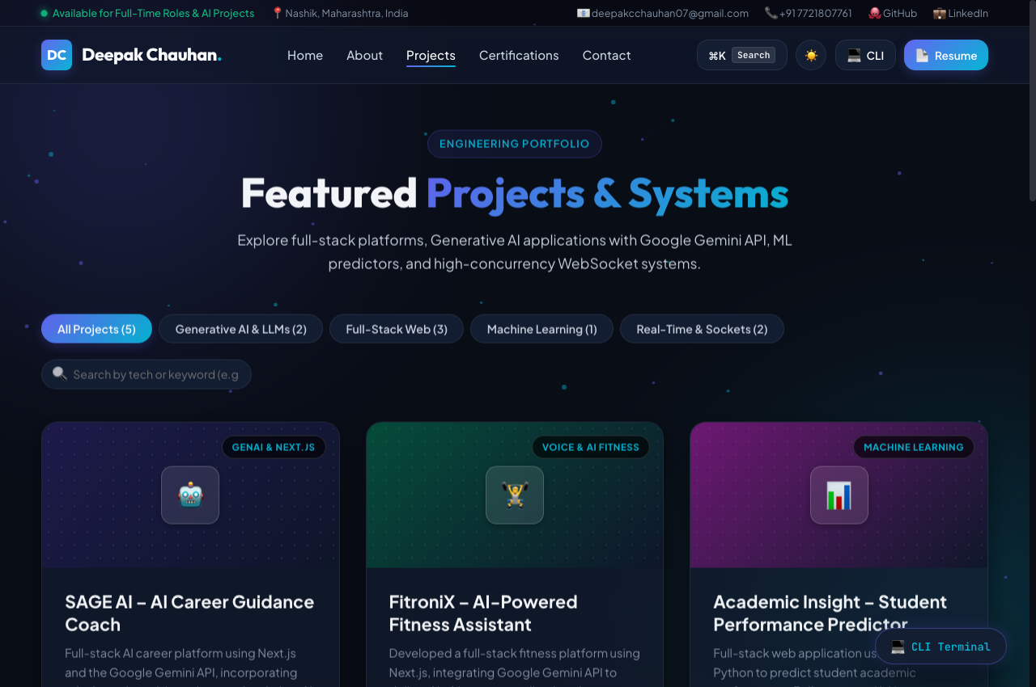 | Contact  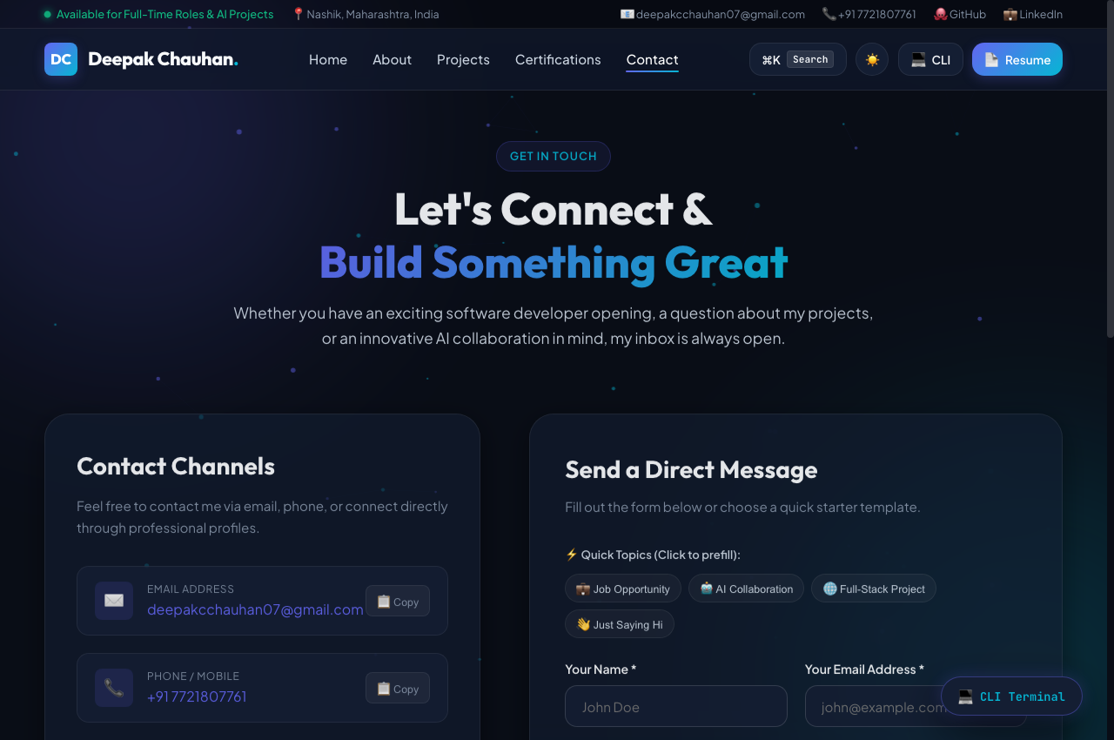
Mobile view  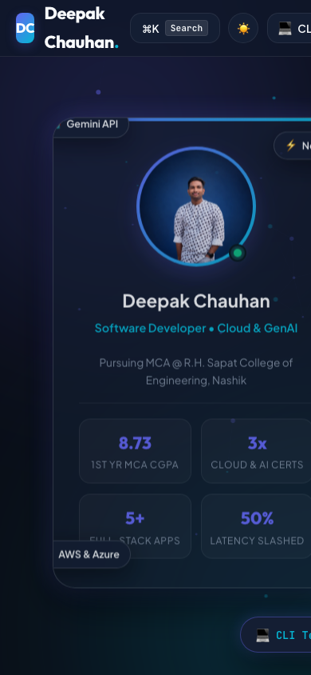 | Tablet view  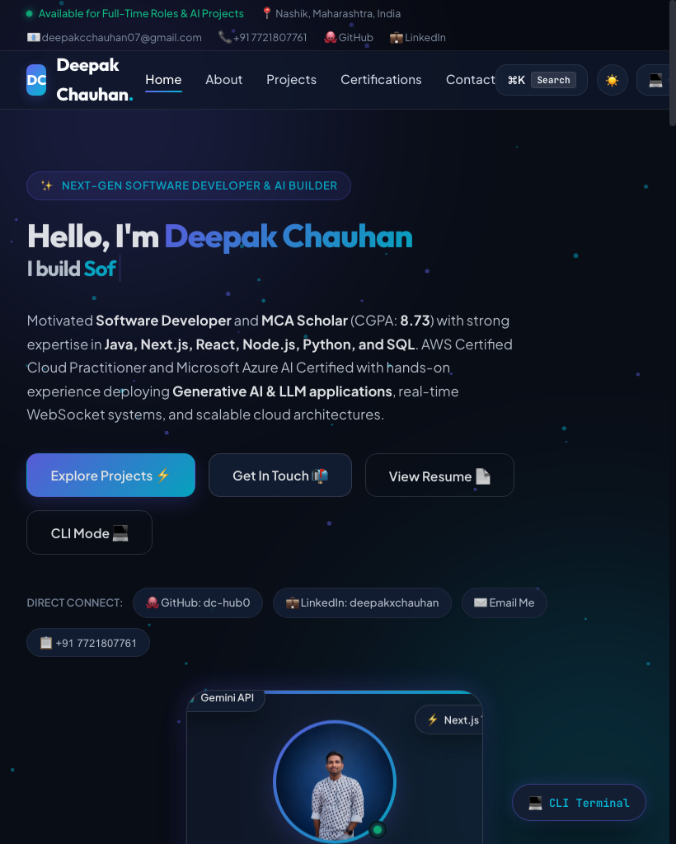
6. Live Link (Deployed Portfolio)
Item | Details
Hosting platform used | GitHub Pages / Netlify
Live link | https://dc-hub0.github.io/portfolio-model/
Note: The live link is globally hosted, SSL-secured (HTTPS), and verified to open seamlessly on mobile phones and private windows.
7. Conclusion
In this assignment, I successfully designed, developed, and deployed a high-performance, responsive personal portfolio website showcasing my software engineering projects, verified cloud certifications, and technical proficiencies. Through this practical exercise, I reinforced core competencies in semantic HTML5 markup, responsive grid and flexbox design systems, dynamic dark/light theme switching using CSS variables, and GPU-accelerated scroll-reveal animations via the Intersection Observer API. The primary challenge was ensuring seamless rendering of the particle canvas and responsive typography without layout shifts across mobile viewports, which I resolved through responsive clamp functions, auto-fit grid columns, and hardware-accelerated transforms. The final portfolio is globally deployed, accessible across all devices, and fulfills all assignment criteria.
Student:  Deepak Chauhan  SYMCA (Roll No: 08) | Evaluated By:  Ms. S. S. Tripathi  Subject Incharge (Web Technology Lab)

