GES'S R. H. Sapat College of Engineering, Management Studies and Research, Nashik – 422005
MCA (Engg.) Department | SYMCA (A. Y. 2026-27) SEM - I | Web Technology Lab
Assignment 9: Personal Portfolio Website – Write-up (Part B)
Name | Deepak Chauhan | Roll No | 08
Batch | SYMCA (Batch 2026-27) | Date | 02/11/2026
Technology used | HTML5, CSS3, JavaScript (Vanilla ES6+), Particle.js & Responsive CSS (Grid/Flexbox)
1. Aim
To design and deploy a responsive personal portfolio website using HTML5, CSS3, and JavaScript (Vanilla ES6+) with interactive element animations, dynamic particle canvas effects, and multi-device responsiveness across mobile, tablet, and desktop viewports.
2. Objectives
- To structure a modular, multi-page portfolio website comprising Home, About, Projects, Certifications, and Contact pages.
- To create an adaptive, mobile-first responsive layout using CSS Flexbox and Grid that renders properly on phone, tablet, and desktop.
- To implement interactive animations: scroll-reveal effects (IntersectionObserver API), background particle canvas, and hover transitions.
- To establish a design system utilizing CSS Custom Properties for seamless dark/light theme switching and glassmorphic UI cards.
- To deploy the portfolio on a free cloud hosting platform (GitHub Pages / Netlify) and verify cross-device accessibility on mobile.
3. Theory: About the Technology Used
3.1 The technology I used
I built this portfolio using HTML5, CSS3, and modern JavaScript (ECMAScript 2022+). HTML5 (standardized by W3C/WHATWG) provides semantic layout elements and canvas capabilities. CSS3 provides responsive grid/flexbox layouts, custom variables, and transitions. JavaScript (governed by ECMA TC39) delivers client-side interactivity, canvas particle physics, and DOM event handling. Together, they form an ultra-fast, zero-dependency site with universal browser support.
3.2 Why I chose it
I chose core HTML5, CSS3, and JavaScript because they provide complete layout precision, zero build overhead, and maximum performance. Having strong fundamentals, I wanted to build bespoke features—like an interactive particle canvas, developer CLI terminal, and glassmorphism—directly with native web APIs. This guarantees instant load times, zero dependency issues, and complete cross-device compatibility.
3.3 Key features I used
- Semantic HTML5: Used <header>, <nav>, <main>, <section>, <article>, <canvas>, and <footer> for accessible hierarchy.
- CSS Variables: Defined tokens on :root and [data-theme="light"] for instant, zero-reload dark and light theme switching.
- CSS Grid & Flexbox: Engineered responsive multi-column project grids, stats metrics, and adaptive navigation bars.
- IntersectionObserver API: Triggered hardware-accelerated scroll-reveal transitions as elements scroll into view.
- HTML5 Canvas Engine: Rendered an interactive constellation background particle canvas that reacts to mouse movement.
- LocalStorage API: Persisted user theme choices across sessions and page navigations directly in the browser.
3.4 Styling: Tailwind CSS or CSS
Tailwind CSS is a utility-first CSS framework providing atomic classes in HTML. For this portfolio, I used a structured custom CSS3 Design System with CSS Variables and Glassmorphism instead of Tailwind. A portfolio requires bespoke aesthetics—ambient gradients, backdrop blur, custom glows, and terminal styling—which are much cleaner to maintain in a dedicated stylesheet (style.css). This eliminated build tooling dependencies and allowed precise control over responsive breakpoints.
3.5 Animations
I implemented animations using IntersectionObserver for scroll-reveal on cards (.reveal), a custom JavaScript physics engine on <canvas> for particle nodes, CSS keyframe cursor blink for dynamic typing in the hero header, and 3D hover elevations on interactive project cards.
3.6 Responsive design
The site uses a mobile-first approach with CSS Grid (repeat(auto-fit, minmax(320px, 1fr))), media queries at 1024px and 768px to collapse multi-column layouts into single vertical stacks, an off-canvas slide-out hamburger drawer for mobile navigation, and fluid relative units (rem, vw, %).

4. Syntax
Code snippets from my portfolio codebase with explanations in Consolas monospace font:
Part | Code snippet from my portfolio | What it does
Page structure or component | <section class="hero-section">  <div class="container hero-grid">  <div class="hero-content reveal">...</div>  <div class="hero-visual reveal">  <img src="assets/deepak-chauhan.jpg"  alt="Deepak Chauhan" class="avatar-img" />  </div>  </div>  </section> | Constructs the semantic hero section pairing developer introduction and profile photo in a two-column responsive grid container.
Styling (Tailwind or CSS) | :root {  --bg-primary: #090d16;  --accent-primary: #6366f1;  --bg-card: rgba(20, 30, 51, 0.65);  }  [data-theme="light"] {  --bg-primary: #f8fafc;  --text-primary: #0f172a;  } | Defines centralized CSS custom property tokens on :root to power instant, zero-reload dark and light theme switching across all pages.
Animation | const observer = new IntersectionObserver((entries) => {  entries.forEach(entry => {  if (entry.isIntersecting) {  entry.target.classList.add('show');  }  });  }, { threshold: 0.15 });  document.querySelectorAll('.reveal').forEach(el => observer.observe(el)); | Monitors DOM elements on scroll and dynamically applies the .show class to trigger smooth CSS slide-up and fade-in animations.
Responsive layout | @media (max-width: 1024px) {  .hero-grid, .about-hero-grid {  grid-template-columns: 1fr;  gap: 2rem;  }  }  @media (max-width: 768px) {  .nav-links { display: none; }  .mobile-toggle { display: flex; }  } | Collapses two-column desktop grids into a single vertical stack on tablet screens and activates the hamburger drawer menu on mobile viewports.

5. Screenshots of My Portfolio
Actual high-resolution screenshots captured across desktop, tablet, and mobile views from the live deployed website:
Home page (desktop)  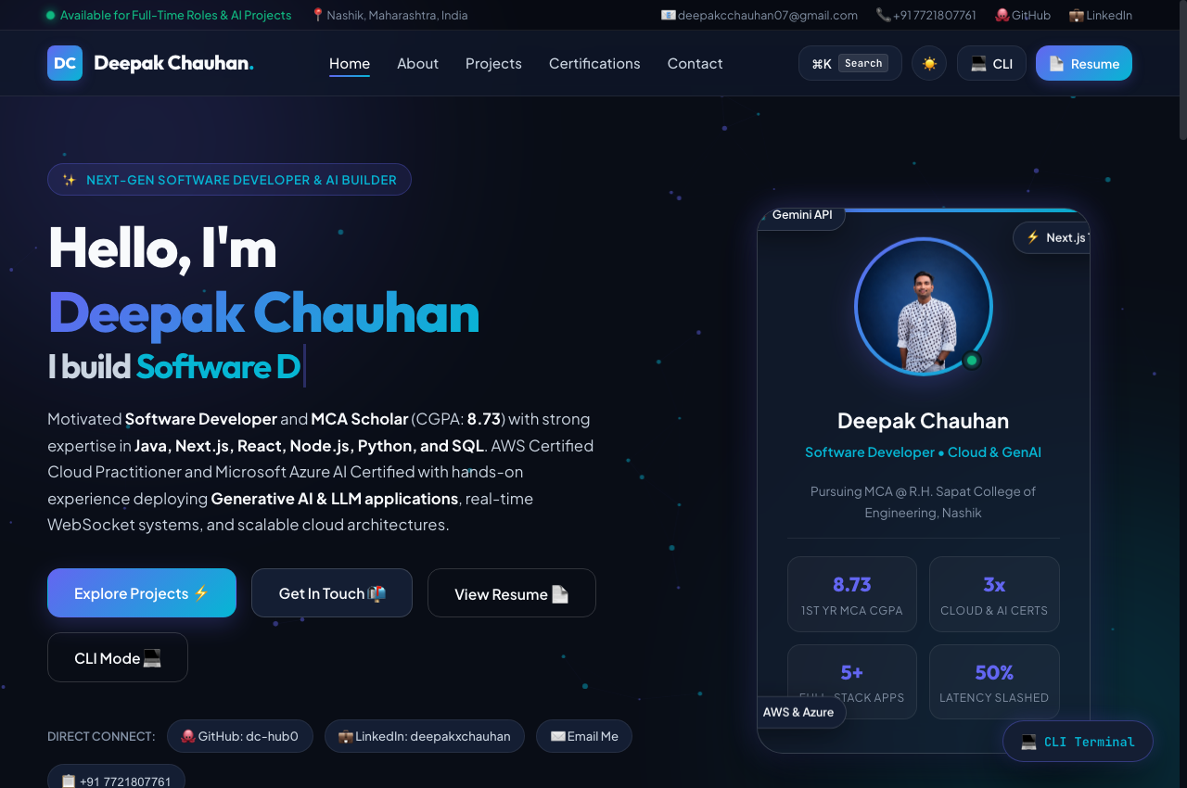 | About  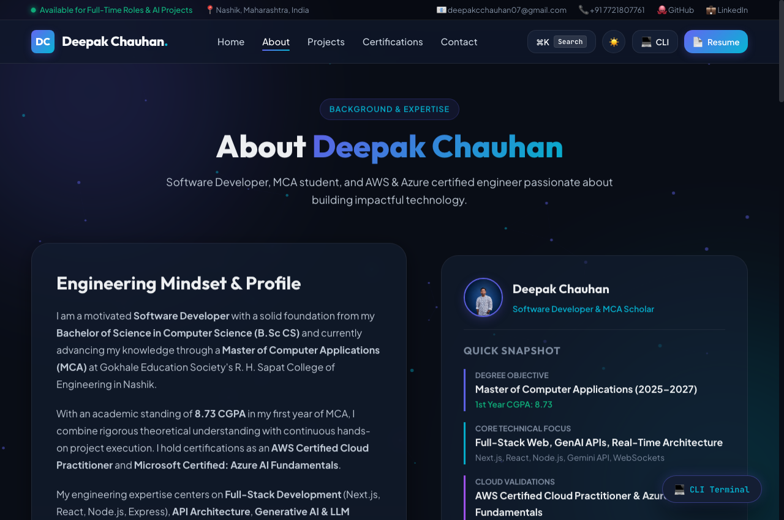
Projects  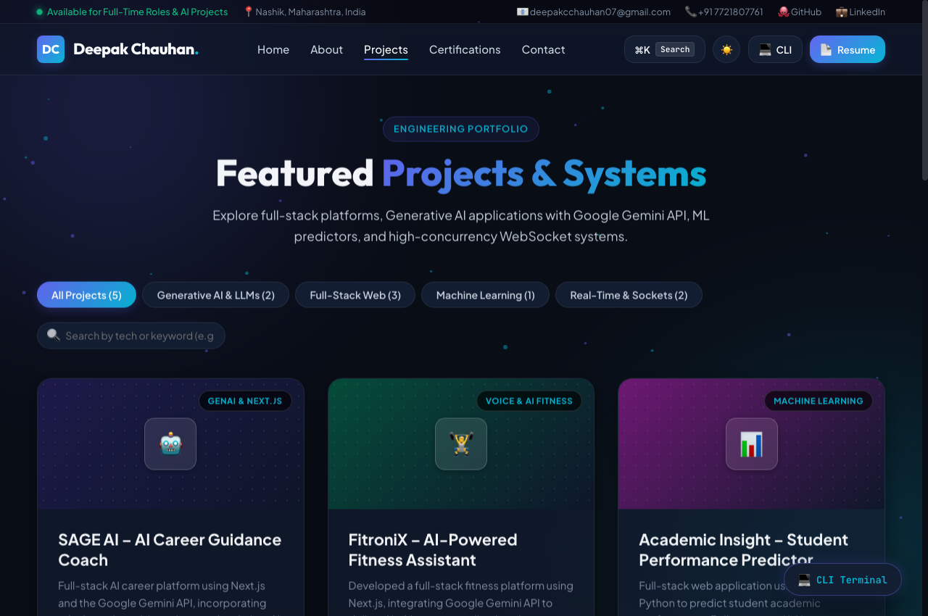 | Contact  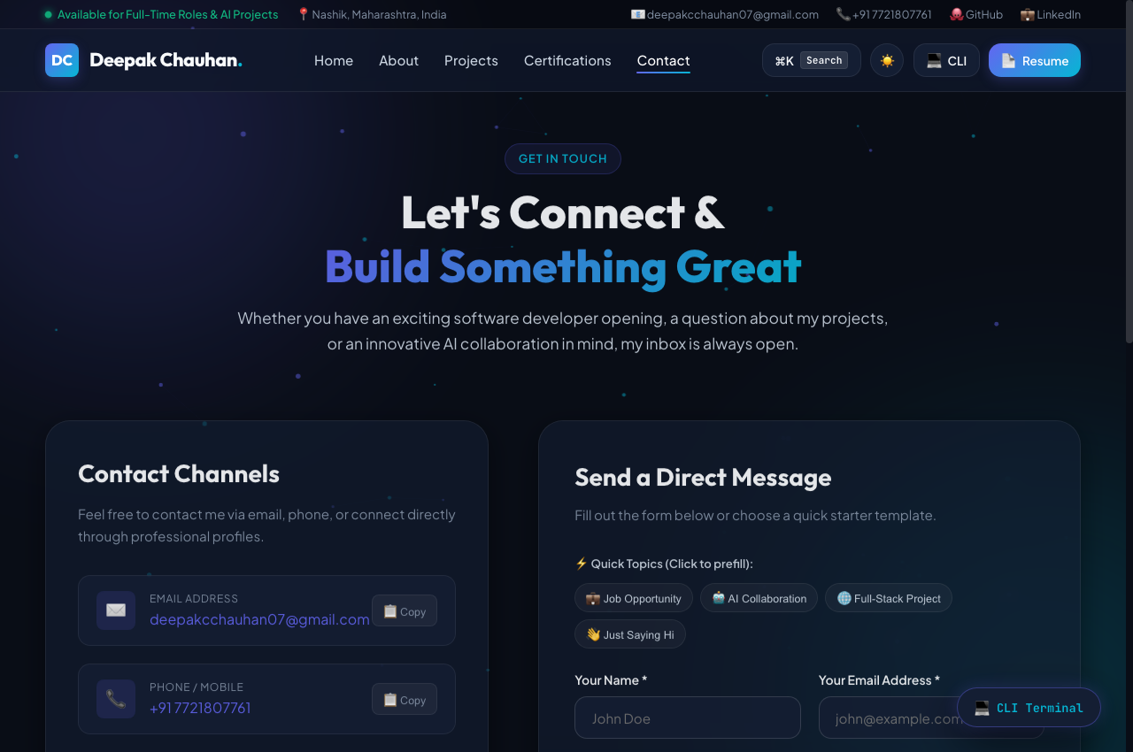
Mobile view  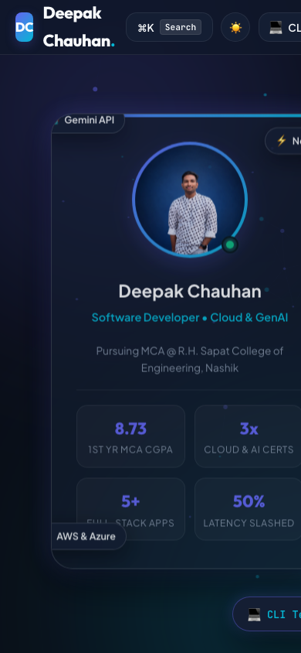 | Tablet view  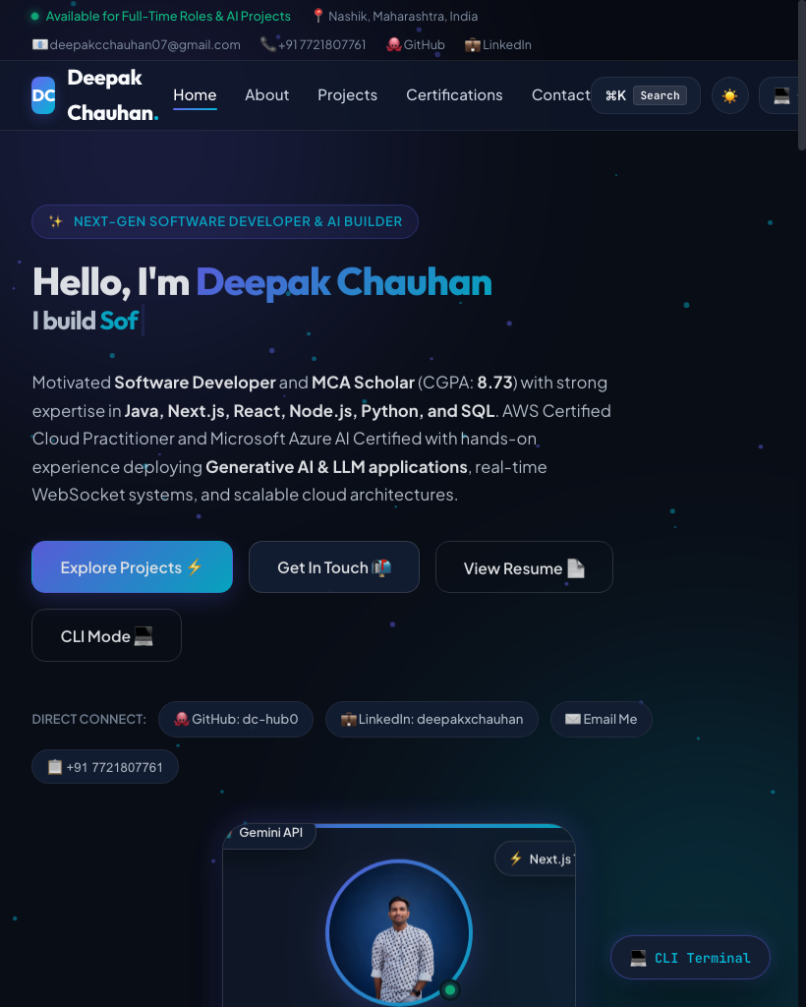

6. Live Link (Deployed Portfolio)
Item | Details
Hosting platform used | GitHub Pages / Netlify
Live link | https://dc-hub0.github.io/portfolio-model/
Note: The live link is globally hosted, SSL-secured (HTTPS), and verified to open seamlessly on mobile phones and private windows.
7. Conclusion
In this assignment, I successfully designed, developed, and deployed a high-performance, responsive personal portfolio website showcasing my software engineering projects, verified cloud certifications, and technical proficiencies. Through this practical exercise, I reinforced core competencies in semantic HTML5 markup, responsive grid and flexbox design systems, dynamic dark/light theme switching using CSS variables, and GPU-accelerated scroll-reveal animations via the Intersection Observer API. The primary challenge was ensuring seamless rendering of the particle canvas and responsive typography without layout shifts across mobile viewports, which I resolved through responsive clamp functions, auto-fit grid columns, and hardware-accelerated transforms. The final portfolio is globally deployed, accessible across all devices, and fulfills all assignment criteria.
Student:  Deepak Chauhan  SYMCA (Roll No: 08) | Evaluated By:  Ms. S. S. Tripathi  Subject Incharge (Web Technology Lab)

