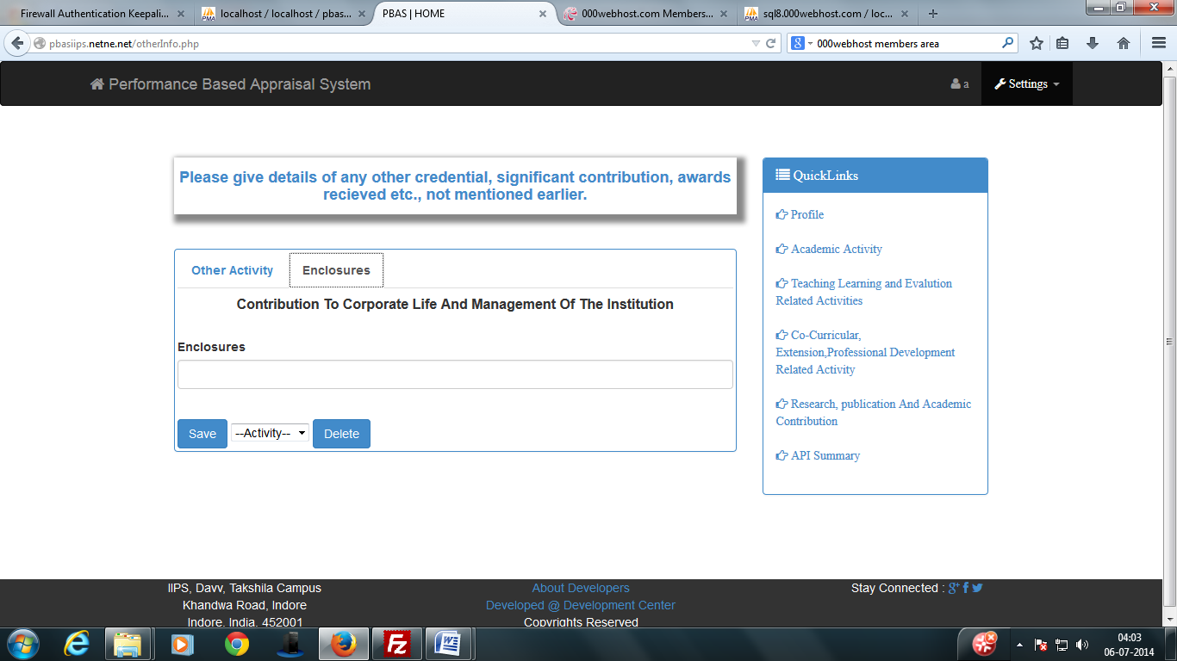
Bug No. 1
BUG REPORT:
Bug Name: Select query
Area Path: http://pbasiips.netne.net/otherInfo.php
Build Number: Version Number 1.2
Severity: Critical
Priority: High
Assigned to: Shivshankar
Reported By: Shivshankar
Reported On: 05/07/2014
Status: Active
Environment: Windows 7
Description: When user save his/her data. The data get inserted but not retrieve from database so user was unable to see his/her data.
Current Status: Bug Resolved now by modify table name in select query.

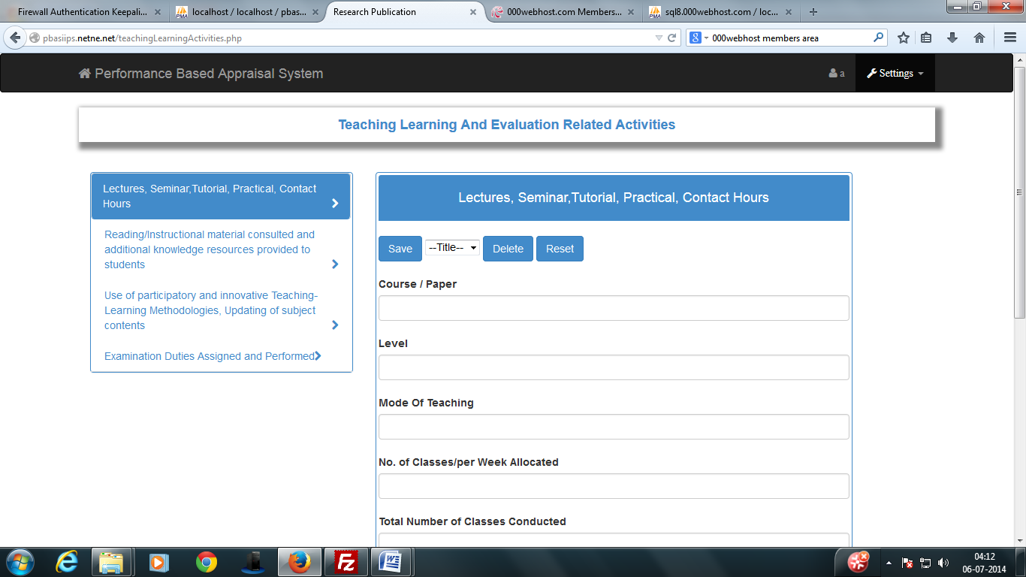
Bug No. 2
BUG REPORT:
Bug Name: Select query
Area Path: http://pbasiips.netne.net/teachingLearningActivities.php
Build Number: Version Number 1.2
Severity: Critical
Priority: High
Assigned to: Shivshankar
Reported By: Shivshankar
Reported On: 05/07/2014
Status: Active
Environment: Windows 7
Description: When user save his/her data. The data get inserted but not retrieve from database so user was unable to see his/her data.
Current Status: Bug Resolved now by modify table name in select query.

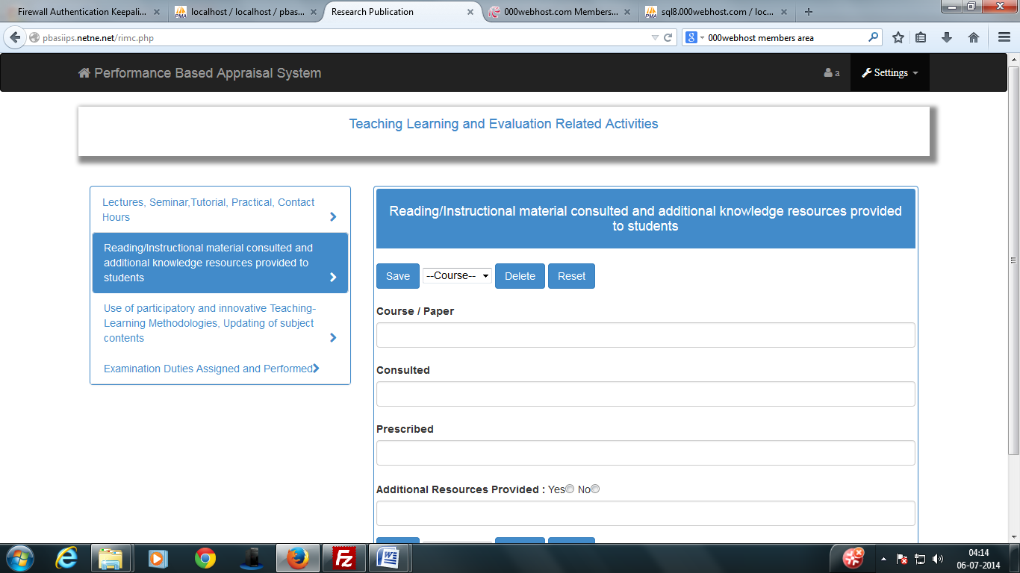
Bug No. 3
BUG REPORT:
Bug Name: Select query
Area Path: http://pbasiips.netne.net/rimc.php
Build Number: Version Number 1.2
Severity: Critical
Priority: High
Assigned to: Shivshankar
Reported By: Shivshankar
Reported On: 05/07/2014
Status: Active
Environment: Windows 7
Description: When user save his/her data. The data get inserted but not retrieve from database so user was unable to see his/her data.
Current Status: Bug Resolved now by modify table name in select query.

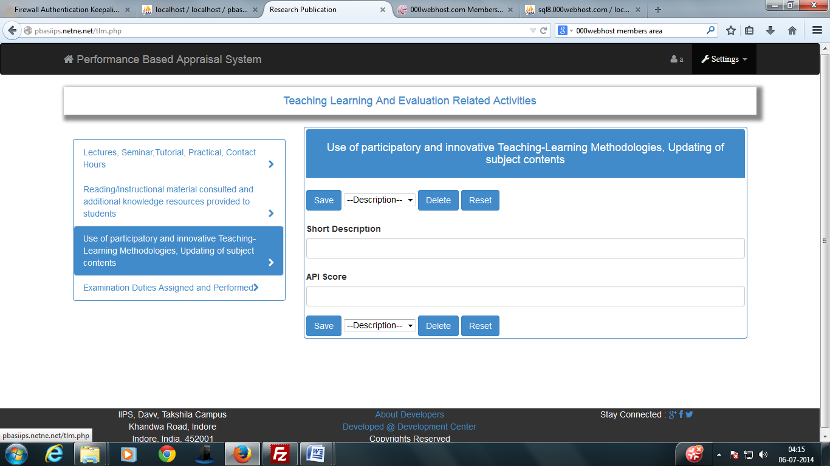
Bug No. 4
BUG REPORT:
Bug Name: Select query
Area Path: http://pbasiips.netne.net/tlm.php
Build Number: Version Number 1.2
Severity: Critical
Priority: High
Assigned to: Shivshankar
Reported By: Shivshankar
Reported On: 05/07/2014
Status: Active
Environment: Windows 7
Description: When user save his/her data. The data get inserted but not retrieve from database so user was unable to see his/her data.
Current Status: Bug Resolved now by modify table name in select query.

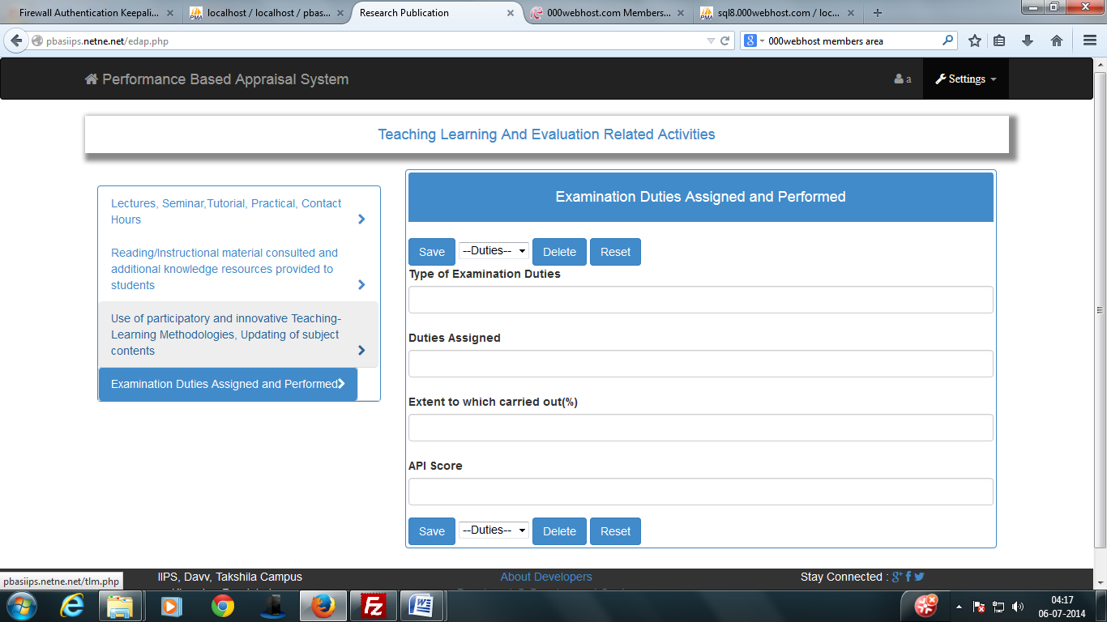
Bug No. 5
BUG REPORT:
Bug Name: Select query
Area Path: http://pbasiips.netne.net/edap.php
Build Number: Version Number 1.2
Severity: Critical
Priority: High
Assigned to: Shivshankar
Reported By: Shivshankar
Reported On: 05/07/2014
Status: Active
Environment: Windows 7
Description: When user save his/her data. The data get inserted but not retrieve from database so user was unable to see his/her data.
Current Status: Bug Resolved now by modify table name in select query.

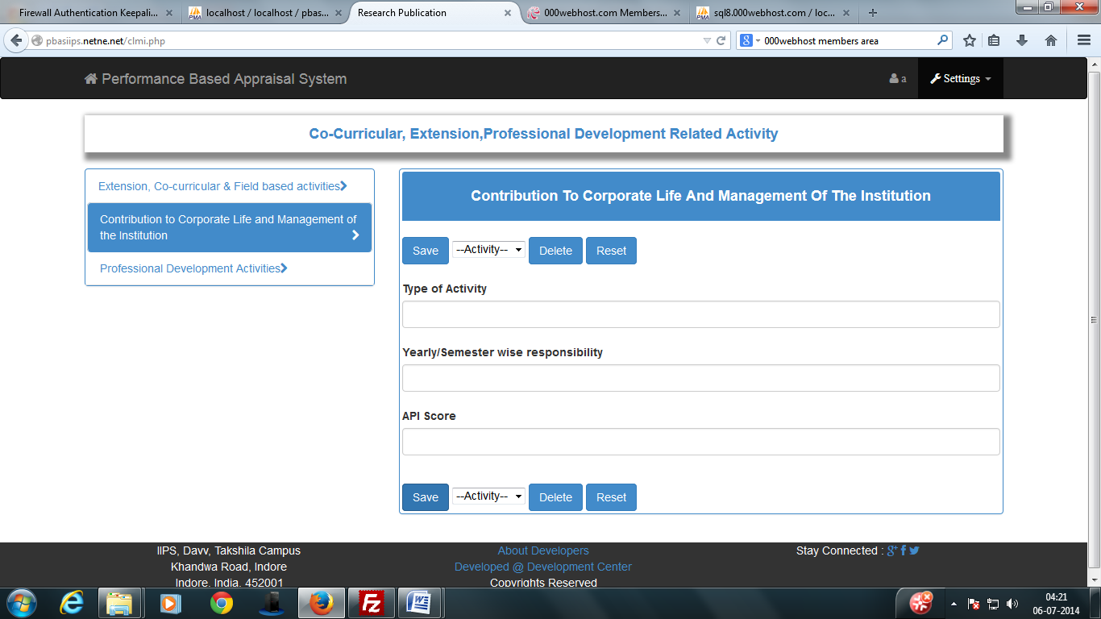
Bug No. 6
BUG REPORT:
Bug Name: Select query
Area Path: http://pbasiips.netne.net/clmi.php
Build Number: Version Number 1.2
Severity: Critical
Priority: High
Assigned to: Shivshankar
Reported By: Shivshankar
Reported On: 05/07/2014
Status: Active
Environment: Windows 7
Description: When user save his/her data. The data get inserted but not retrieve from database so user was unable to see his/her data.
Current Status: Bug Resolved now by modify table name in select query.

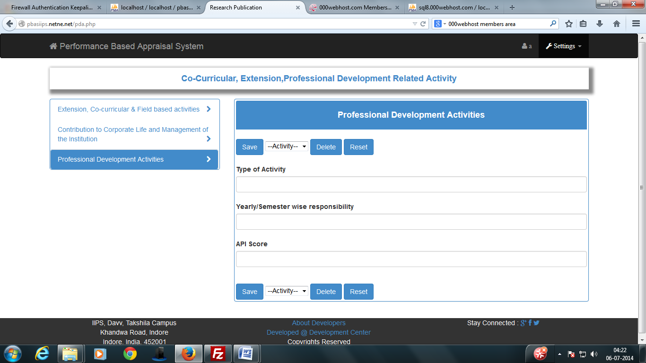
Bug No. 7
BUG REPORT:
Bug Name: Select query
Area Path: http://pbasiips.netne.net/pda.php
Build Number: Version Number 1.2
Severity: Critical
Priority: High
Assigned to: Shivshankar
Reported By: Shivshankar
Reported On: 05/07/2014
Status: Active
Environment: Windows 7
Description: When user save his/her data. The data get inserted but not retrieve from database so user was unable to see his/her data.
Current Status: Bug Resolved now by modify table name in select query.

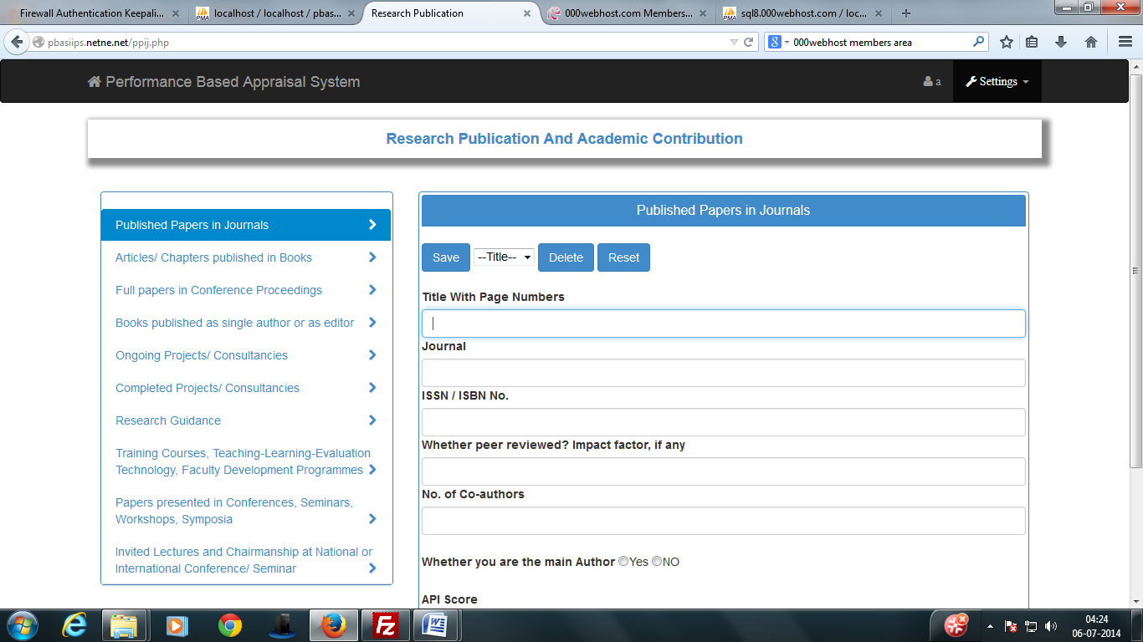
Bug No. 8
BUG REPORT:
Bug Name: Select query
Area Path: http://pbasiips.netne.net/ppij.php
Build Number: Version Number 1.2
Severity: Critical
Priority: High
Assigned to: Shivshankar
Reported By: Shivshankar
Reported On: 05/07/2014
Status: Active
Environment: Windows 7
Description: When user save his/her data. The data get inserted but not retrieve from database so user was unable to see his/her data.
Current Status: Bug Resolved now by modify table name in select query.

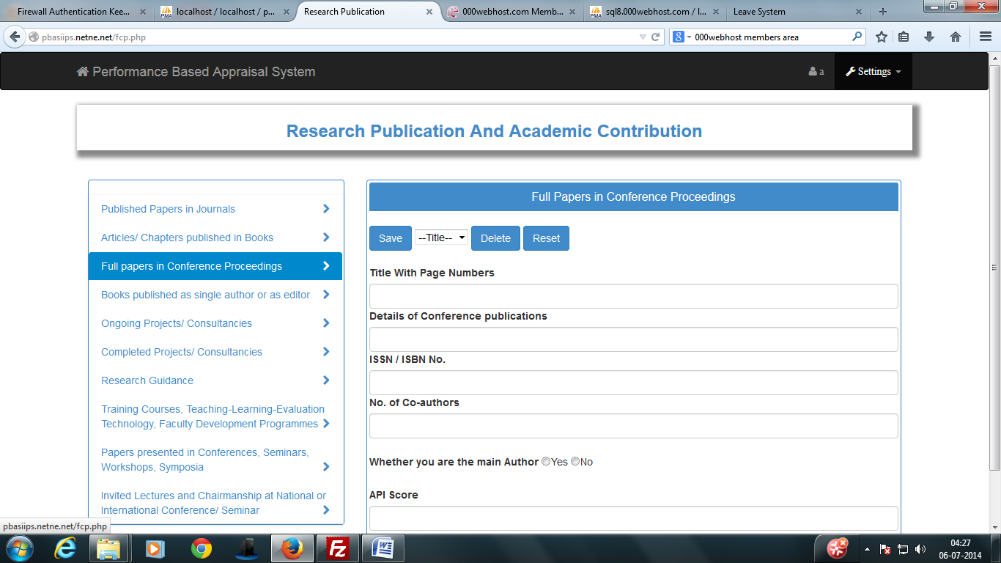
Bug No. 9
BUG REPORT:
Bug Name: delete query
Area Path: http://pbasiips.netne.net/fcp.php
Build Number: Version Number 1.2
Severity: Critical
Priority: High
Assigned to: Shivshankar
Reported By: Shivshankar
Reported On: 05/07/2014
Status: Active
Environment: Windows 7
Description: When user delete his/her data. Data was not deleted from database.
Current Status: Bug Resolved now by modify type value ‘submit’ in delete query.

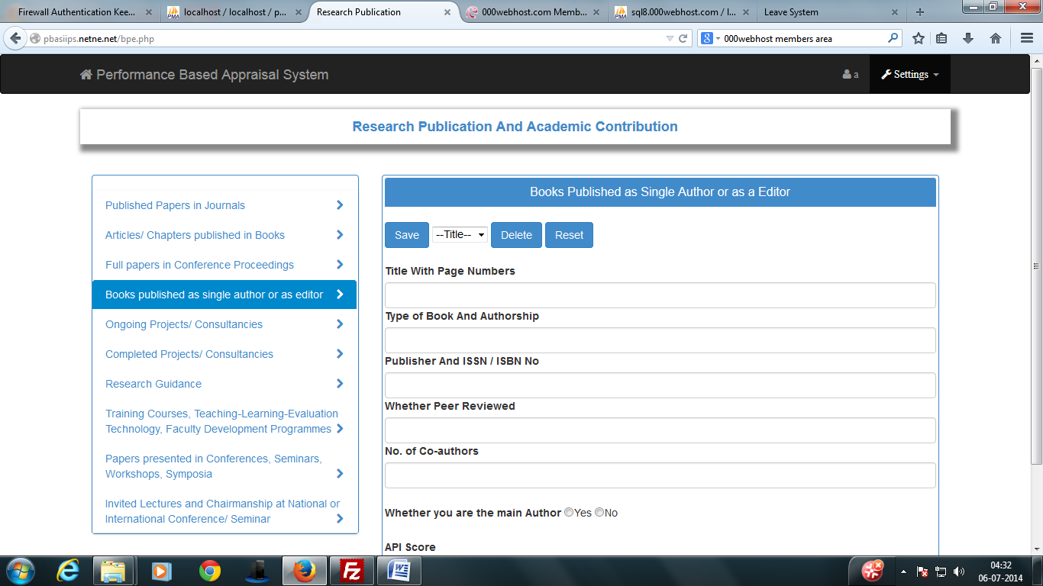
Bug No. 10
BUG REPORT:
Bug Name: insert query
Area Path: http://pbasiips.netne.net/bpe.php
Build Number: Version Number 1.2
Severity: Critical
Priority: High
Assigned to: Shivshankar
Reported By: Shivshankar
Reported On: 05/07/2014
Status: Active
Environment: Windows 7
Description: When user save his/her data. The insert query not work so data of the user not stored in database.
Current Status: Bug Resolved now by modify div id “book published” in script part of page bpe.php and change field name in database Teach_BPE_YN under table teach_bpe.

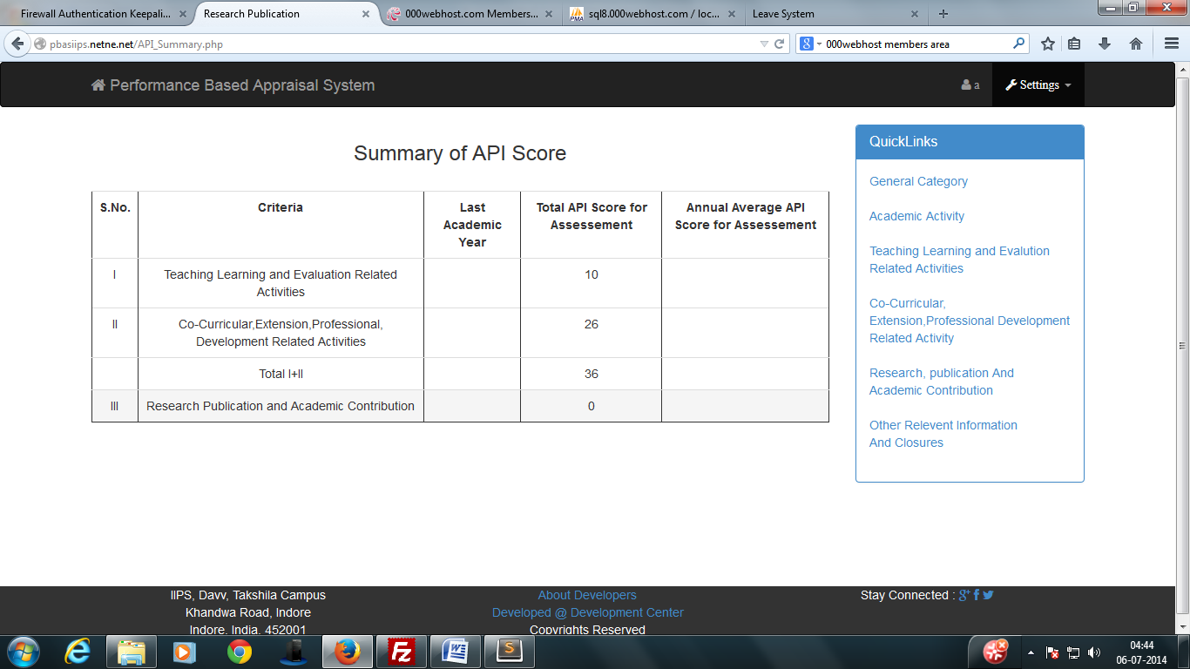
Bug No. 11
BUG REPORT:
Bug Name: select query
Area Path: http://pbasiips.netne.net/API_Summary.php
Build Number: Version Number 1.2
Severity: Critical
Priority: High
Assigned to: Shivshankar
Reported By: Shivshankar
Reported On: 05/07/2014
Status: Active
Environment: Windows 7
Description: When user see his/her API_Summary show an php error message in (Total API Score for Assessement) field.
Current Status: Bug Resolved now by modify table name in select query at 17 places in API_Summary.php page.

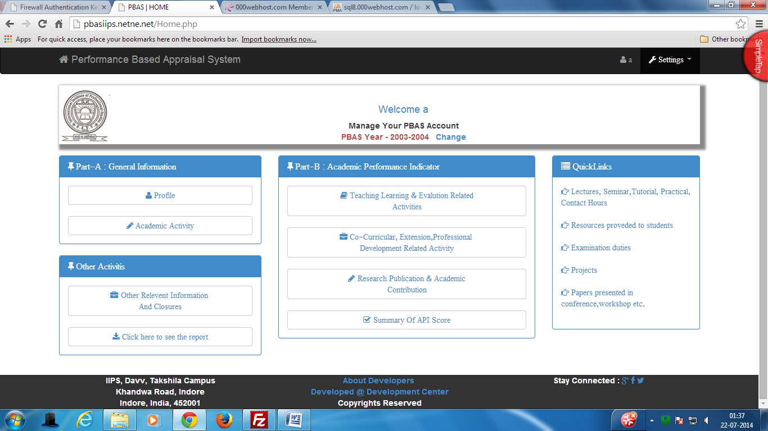
Bug No. 12
BUG REPORT:
Bug Name: select query
Area Path: http://pbasiips.netne.net/dompdf/pdf1.php
Build Number: Version Number 1.2
Severity: Critical
Priority: High
Assigned to: Shivshankar
Reported By: Shivshankar
Reported On: 22/07/2014
Status: Active
Environment: Windows 7
Description: When user download it’s report report was downloaded but not open because report was damaged.
Current Status: Bug Resolved now by modify table name in select query in pdf1.php page.

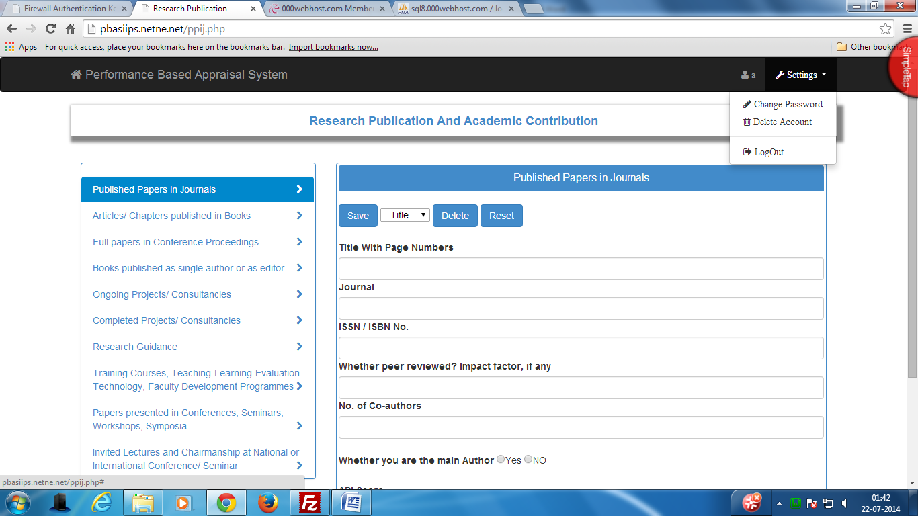
Bug No. 13
BUG REPORT:
Bug Name: setting button not work
Area Path: http://pbasiips.netne.net/ppij.php
Build Number: Version Number 1.2
Severity: Critical
Priority: High
Assigned to: Shivshankar
Reported By: Shivshankar
Reported On: 22/07/2014
Status: Active
Environment: Windows 7

Description: On all Research Publication And Academic Contribution forms setting button is not work due to jsfile is include above the footer so button was not perform their related task.
Current Status: Bug Resolved now by modify change java script file position in all form of rpac.

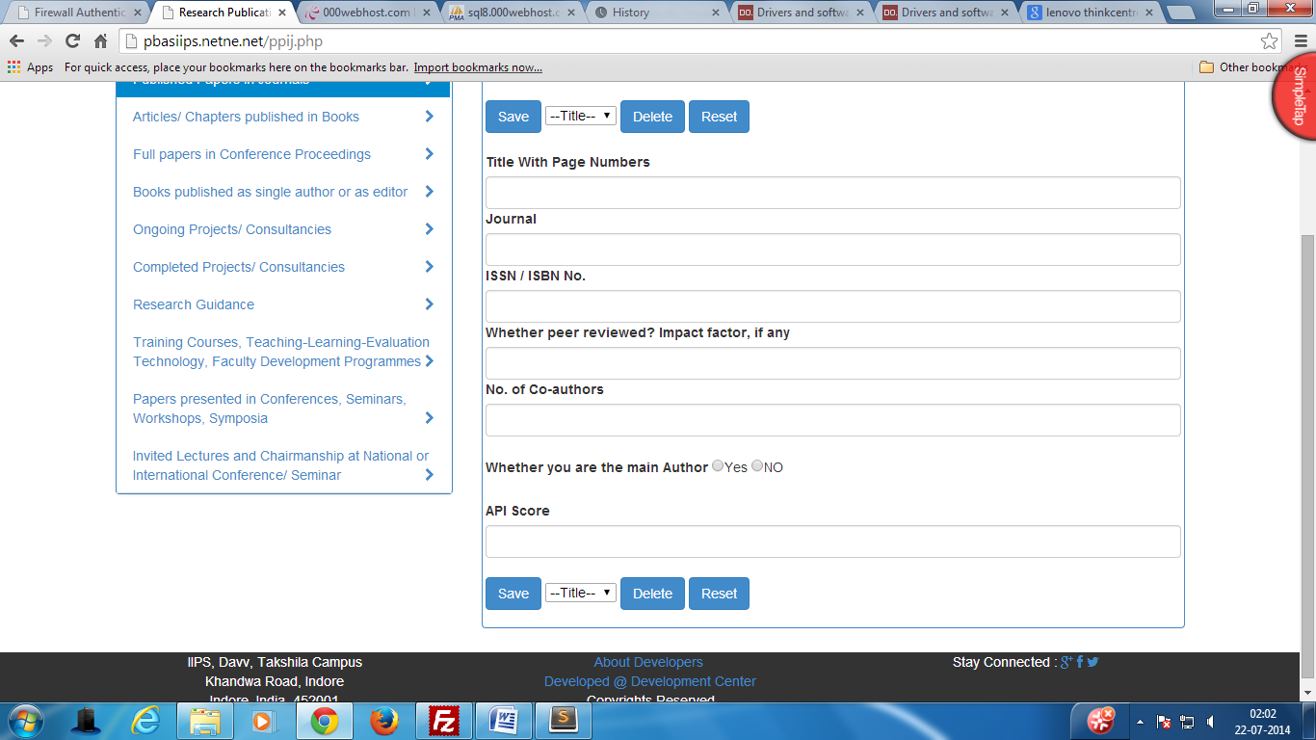
Bug No. 14
BUG REPORT:
Bug Name: footer position not shows their proper position.
Area Path: http://pbasiips.netne.net/ppc.php
Build Number: Version Number 1.2
Severity: Critical
Priority: High
Assigned to: Shivshankar
Reported By: Shivshankar
Reported On: 22/07/2014
Status: Active
Environment: Windows 7

Description: closing tag of wrap div is not present so footer are not show their proper position.
Current Status: Bug Resolved now by add a closing div.

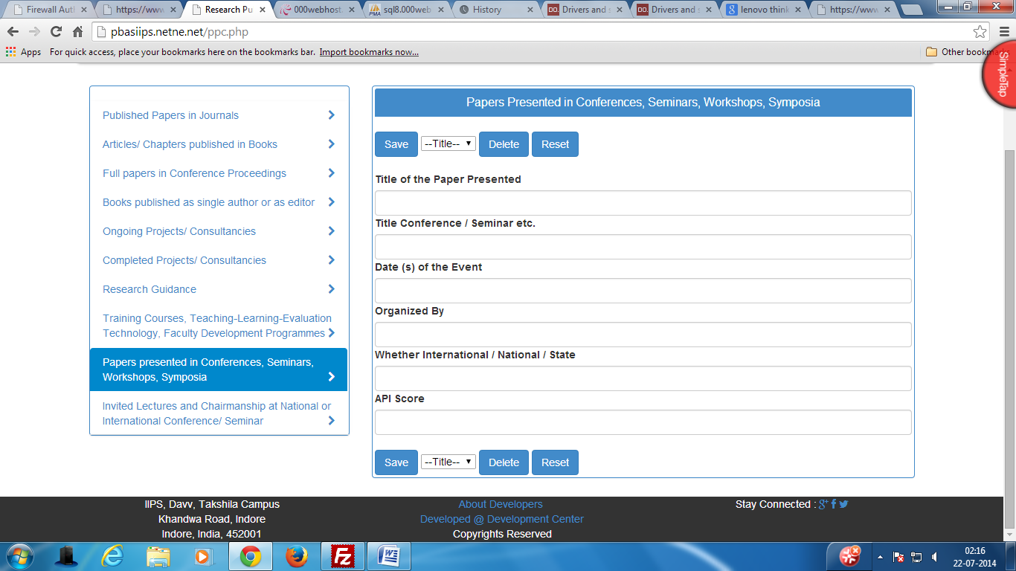
Bug No. 15
BUG REPORT:
Bug Name: footer position not shows their proper position.
Area Path: http://pbasiips.netne.net/ppij.php
Build Number: Version Number 1.2
Severity: Critical
Priority: High
Assigned to: Shivshankar
Reported By: Shivshankar
Reported On: 22/07/2014
Status: Active
Environment: Windows 7

Description: one extra closing tag is add in file so footer cover full body of the page.
Current Status: Bug Resolved now by remove a closing div.

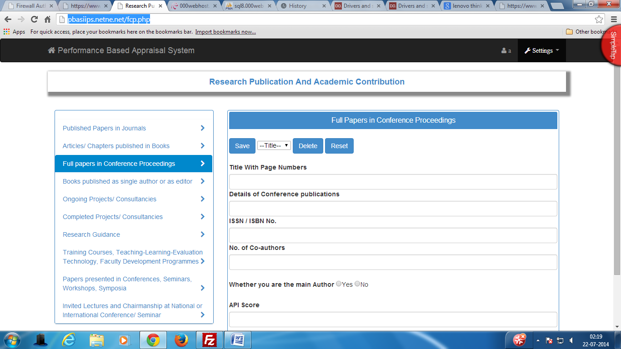
Bug No. 16
BUG REPORT:
Bug Name: Different heading of same group pages.
Area Path: http://pbasiips.netne.net/fcp.php
Build Number: Version Number 1.2
Severity: Critical
Priority: High
Assigned to: Shivshankar
Reported By: Shivshankar
Reported On: 22/07/2014
Status: Active
Environment: Windows 7

Description: Heading of page is not similar to other pages of same group.
Current Status: Bug Resolved now by modify heading div of page.

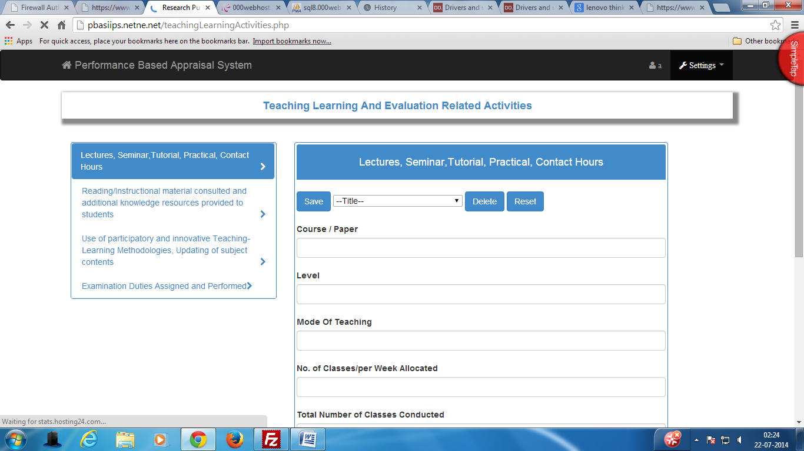
Bug No. 17
BUG REPORT:
Bug Name: Different heading of same group pages.
Area Path: http://pbasiips.netne.net/teachingLearningActivities.php
Build Number: Version Number 1.2
Severity: Critical
Priority: High
Assigned to: Shivshankar
Reported By: Shivshankar
Reported On: 22/07/2014
Status: Active
Environment: Windows 7

Description: Heading of page is not similar to other pages of same group.
Current Status: Bug Resolved now by modify heading div of page.

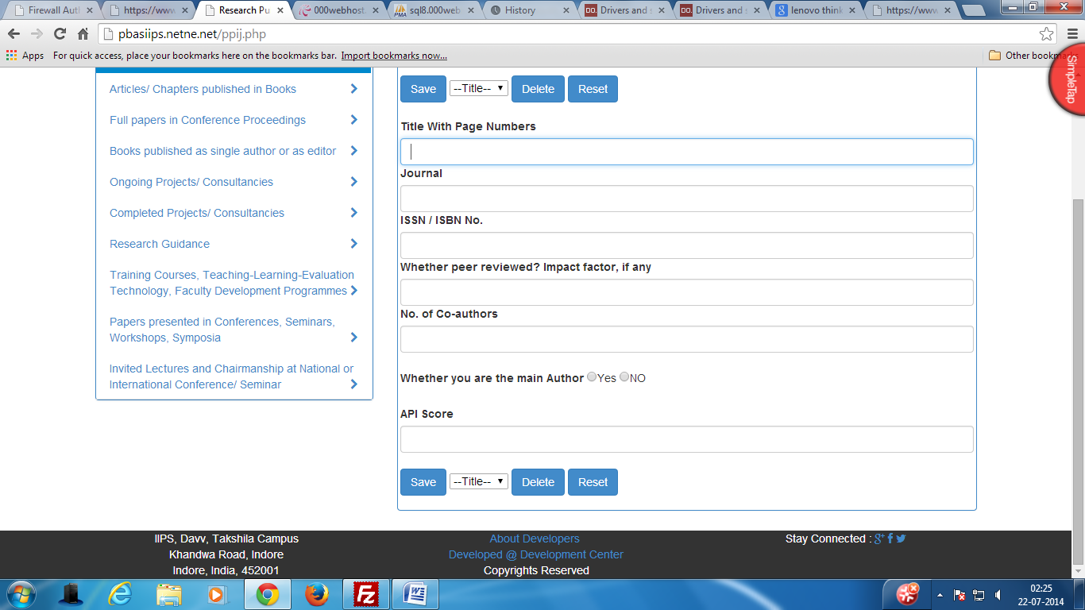
Bug No. 18
BUG REPORT:
Bug Name: Add footer.
Area Path: http://pbasiips.netne.net/ppij.php
Build Number: Version Number 1.2
Severity: Critical
Priority: High
Assigned to: Shivshankar
Reported By: Shivshankar
Reported On: 22/07/2014
Status: Active
Environment: Windows 7

Description: Footer is not add in all form of Research Publication And Academic Contribution group.
Current Status: Bug Resolved now by adding footer.

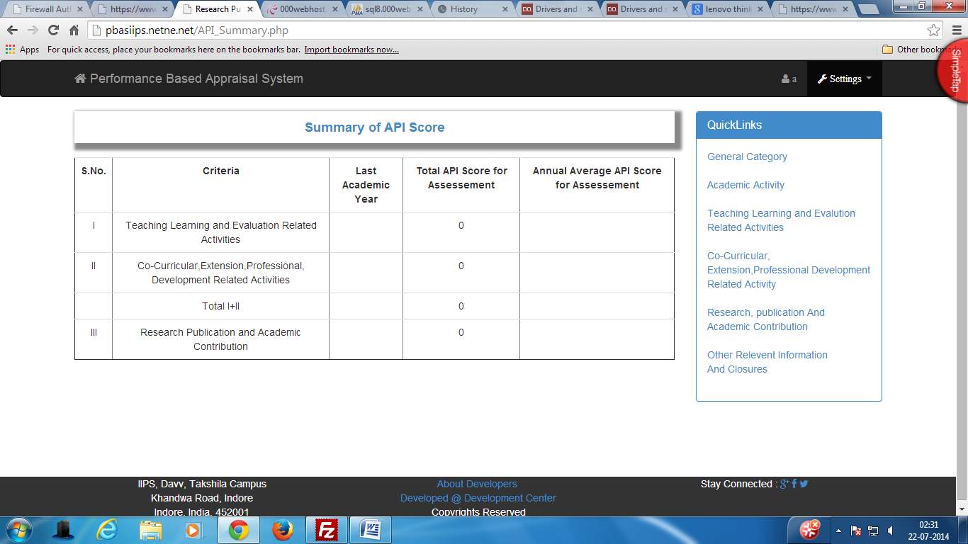
Bug No. 19
BUG REPORT:
Bug Name: Add header.
Area Path: http://pbasiips.netne.net/API_Summary.php
Build Number: Version Number 1.2
Severity: Critical
Priority: High
Assigned to: Shivshankar
Reported By: Shivshankar
Reported On: 22/07/2014
Status: Active
Environment: Windows 7

Description: heading div is not add in API_SUMMARY page only simply text is write on place of header.
Current Status: Bug Resolved now by adding heading div.

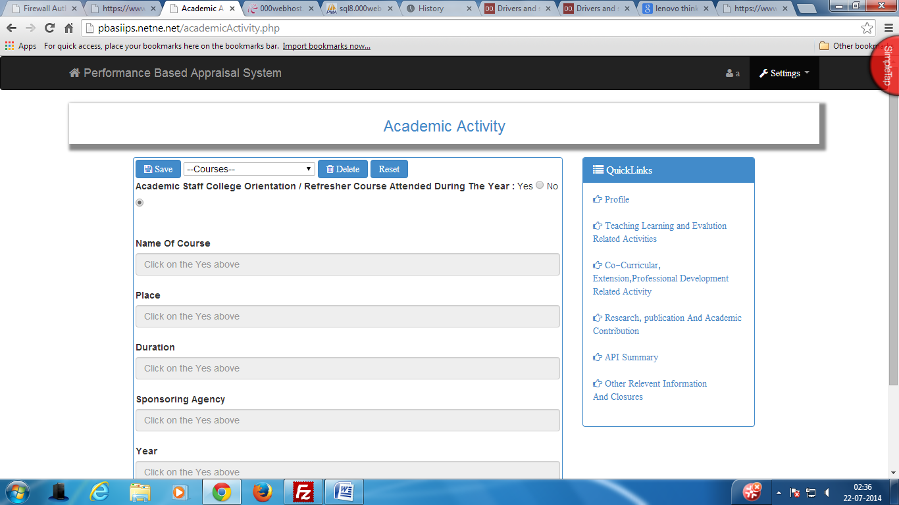
Bug No. 20
BUG REPORT:
Bug Name: Reset button.
Area Path: http://pbasiips.netne.net/academicActivity.php
Build Number: Version Number 1.2
Severity: Mandatory
Priority: High
Assigned to: Shivshankar
Reported By: Shivshankar
Reported On: 22/07/2014
Status: Active
Environment: Windows 7

Description: reset button is show different from other button of page.
Current Status: Bug Resolved now by adding icon property of reset field.

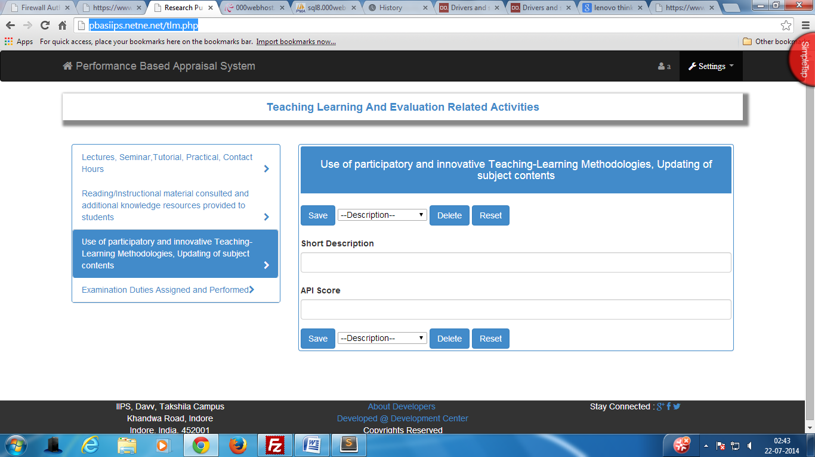
Bug No. 21
BUG REPORT:
Bug Name: Div position.
Area Path: http://pbasiips.netne.net/tlm.php and http://pbasiips.netne.net/edap.php
Build Number: Version Number 1.2
Severity: Critical
Priority: High
Assigned to: Shivshankar
Reported By: Shivshankar
Reported On: 22/07/2014
Status: Active
Environment: Windows 7

Description: edap and tlm page div are not show in a row with its form position.
Current Status: Bug Resolved now by add br tag between link’s div and form.

