7COM1079-0901-2025 - Team Research and Development Project

Final report title: (Is there a difference in the mean product rating between product categories?)

Group ID: Group A99

Dataset number: ds057

Prepared by: Dhwani Hiren Chavda (2309741),
Malav Nilesh Shah (24118794),
.Deepanshu (24062364)
Maruti Abhaykumar Jani (24089714)

University of Hertfordshire
Hatfield, 2025

Table of Contents

- Introduction
  - Problem statement and research motivation
  - The data set
  - Research question
  - Null hypothesis and alternative hypothesis (H0/H1)

- Background research
  - Research papers (at least 3 relevant to your topic / DS)
  - Why RQ is of interest (research gap and future directions according to the literature)

- Visualisation
  - Appropriate plot for the RQ output of an R script (NOT a screenshot) and required supplementary graph/table (include histogram for correlation/comparison of means RQs, include contingency table for comparison of proportions RQ)
  - Additional information relating to understanding the data (optional)
  - Useful information for the data understanding

- Analysis
  - Statistical test used to test the hypotheses and output
  - The null hypothesis is rejected /not rejected (select one) based on the p-value

- Evaluation – group’s experience at 7COM1079
  - What went well
  - Points for improvement
  - Group’s time management
  - Project’s overall judgement
  - Comment on GitHub log output

- Conclusions
  - Results explained.
  - Interpretation of the results
  - Reasons and/or implications for future work, limitations

- Reference list
Harvard (author, date) format.
- Appendices
- R code used for analysis and visualisation.
- GitHub log output.

1. Introduction

  - Problem statement and research motivation (100 words)
- In online shopping the customer rating plays a major role, especially on platforms like Amazon. Ratings may not be same across all product categories as customers have different expectation for different products. For example, people rate household items differently than electronics. Understanding these differences in product is useful for sellers and online platforms for customer satisfaction. From this there is a need to study whether average product ratings differ between categories using large Amazon dataset. Kurz, V., Efendić, E., & Goukens, C. (2023). Price affects expectation but not quality perceptions and likings.
  - The data set (75 words)
- The Amazon dataset includes information on more than one thousand products. It consists of variables such as product category, price, discount, and customer rating. In this, the variable used mainly are Product Category, which shows type of product, and product rating which shows customer satisfaction. The includes many different categories making it suitable for studying how ratings differ across different type of products on Amazon.

  - Research question (50 words). Is there a difference in the mean product rating between product categories? (50 words)
- The study tries to find out if customer ratings are different across product categories on amazon. The research question leading this analysis is: - “Is there a difference in the mean product rating between product categories?”. This question allows a simpler statistical comparison of ratings between categories.

  - Null hypothesis and alternative hypothesis (H0/H1) (100 words)
- The null hypothesis (H0) says that there is no difference in average product ratings between Amazon product categories. This means that any changes in ratings happen by chance. The alternative hypothesis (H1) says that there is a difference in average product rating between at least two product categories. These hypotheses allow statistical testing for product category affects the customer ratings. By comparing ratings across categories, this analysis also helps to determine if the observed differences are meaningful or simply random.

- Background research
  - Research papers (at least 3 relevant to your topic / DS) (200 words)
- Research on online consumer behaviour showcases that product prices and customer ratings interact in ways that shape product quality. Li and Hitt (2010) found that higher-priced products are more preferred and favoured even when objective quality remains unchanged, suggesting a “price-induced review bias”. This highlights how consumer preference may influence rating behaviour with products actual performance. Sun, Xiang and Ye (2020) further showed that price and rating work together and influence perceived quality. Their experiment revealed that products who have both high price and high ratings were assessed more positively, showcasing that these factors are not independent in shaping consumer evaluations. From Amazon sales data we can see it also supports category-based differences. Cui, Kui and Guo (2008) analysed hundreds of new products and found that how ratings affect on sales between products, such as search goods and experience-based goods. This can reveal the product characteristics and category context can influence customers ratings on items. Altogether, these study shows expectations, price and product category shapes customer ratings, but none can compare mean ratings across multiple categories in large dataset, having a large research gap.

  - Why RQ is of interest (research gap and future directions according to the literature) (100 words)
- Although previous studies show that price, expectation and product characteristics influence customer ratings, these research focuses more on psychological factors or specific product rather than comparing rating across all different categories. None reviewed statistical test that if mean on customer ratings differs between categories in large dataset. This is important as product category vary in highly quality expectation and consumer usage, which can influence their product evaluation. Exploring across Amazon’s product category helps to understand how customer satisfaction differs between types of products.

- Visualisation
  - Appropriate graphs for the RQ (50 words)
- A boxplot is main visualisation used because it clearly comparing rating distributions across multiple product categories. By highlighting the difference in medians. While a histogram of product rating is considered as supplementary plot to examine the distribution of ratings and assess normality before selecting a statistical test.
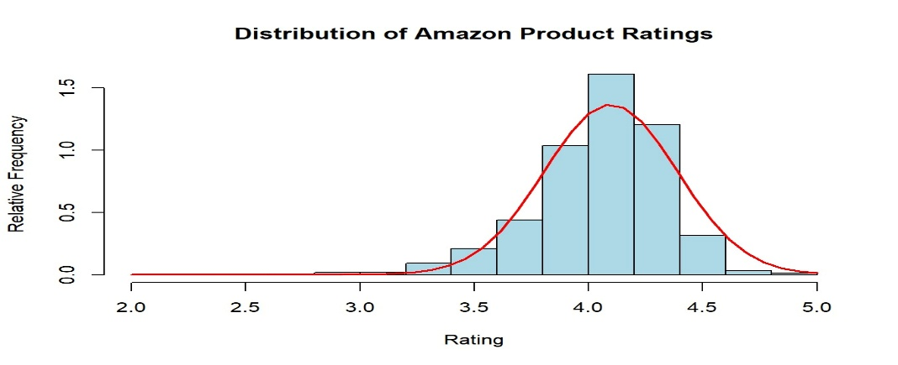

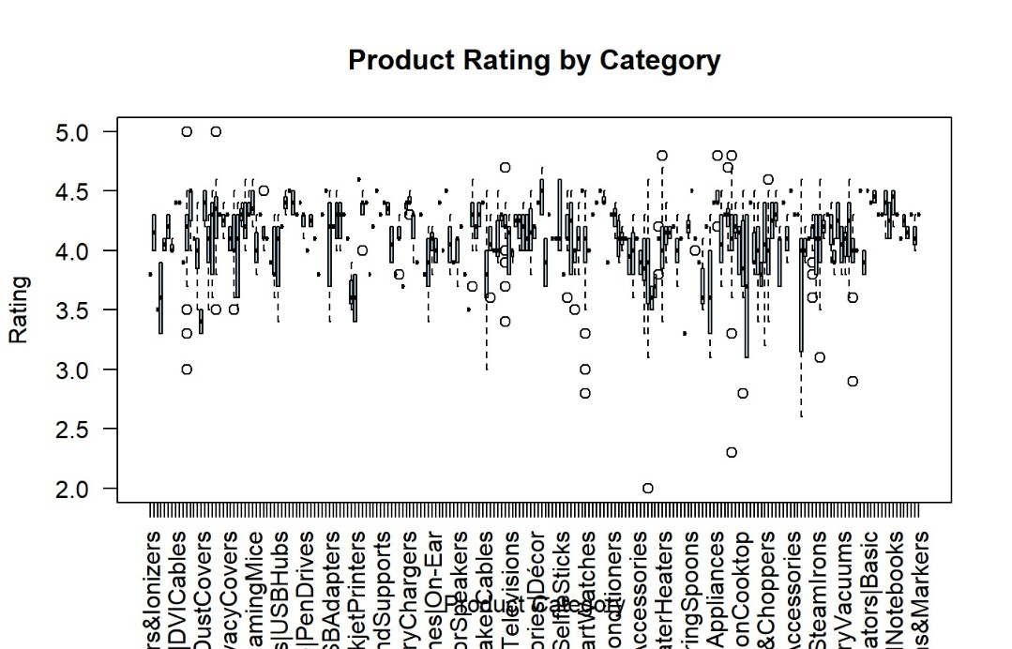

  - Additional information relating to understanding the data (optional) (50 words)

- The boxplot shows ratings among across different categories by displaying medians, ranges and outliners. The histogram shows that ratings are around between 4 and 5, indicating a skewed distribution. Altogether, these plot gives a clear overview of rating behaviour before statistical analysis.

  - Useful information for the data understanding (50 words)
- The boxplot in some categories have slightly higher average rating than other, but also there is an overlap among categories. The histogram shows ratings are not normally distributed and are also skewed towards higher values. These can support the use of non-parametric statistical test instead of a parametric test.

- Analysis
  - Statistical test used to test the hypotheses and output (75 words)
- The Kruskal Wallis test used to check whether product rating differ across Amazon product categories. This is suitable as the ratings are not normally distributed, as shown in histogram. It compares ratings distributions across many independent categories without assuming normality. The test produced a chi-squared value of 515.24 with 210 degrees of freedom, making it appropriate than ANOVA for this dataset.

  - The null hypothesis is rejected /not rejected based on the p-value (100 words)
- The Kruskal Wallis test gives us a p-value of 1.17x10⁻²⁷, which is smaller than 0.05 significance level. The null hypothesis is rejected. This shows that there is a significant difference in ratings across Amazon product categories. This result suggest that customer rating is influenced by category rather than being randomly distributed. Categories gradually receive higher or lower rating than others, showing difference in customer satisfaction.

- Evaluation – group’s experience at 7COM1079
  - What went well (75 words)
- Our group collaborated throughout the project and by dividing the task and supporting one another during analysis and writing. We all were able to understand the dataset clearly, selected a strong research question, and applied the appropriate statistical tests. Visualisation and R code were completed on time and reviewed together for better understanding. Moreover, due to help of team we were able to complete it as a team.

  - Points for improvement (75 words)
- Even our collaboration was working, we recognised places for improvement. Few times. Our group could have started tasks earlier to reduce last-minute pressures. Few members required additional time to understand R coding, which slowed the progress at initial stages. Few members working styles were different from others which also came with add-ons. Although improving familiarity with statistical test earlier in module would have provided more time during analysis phase.

  - Group’s time management (50 words)
- Time management improved eventually. Early delays were happening due to different understanding. Once responsibilities were assigned, work was completed accordingly and timely. Better planning has reduced the stress among all members, but the group managed to meet all deadlines successfully.

  - Project’s overall judgement (50 words)
- The project was successful in addressing the research question by applying statistical methods. Our results were clear while visualising and analysing. The group also improved while working. Moreover, the project demonstrated strong teamwork, good analytical skills and effective problem solving.

  - Comment on the GitHub log output (50 words)
- In this part I did basic data cleaning change: In the whole first part of this project, first I convert real data to data frame and then I change Columns and row names and also cleaned and prepared variables .Commit Message: [Insert Commit Message] Brief explanation of the broader impact of the change
- visualizations and Kruskal–Wallis test: This commit introduces a boxplot to compare product ratings across categories, a histogram with a normal curve to examine rating distribution, and a Kruskal–Wallis test to assess statistically significant differences between categories.
- Full Merged Script: This commit completes the full analysis of Amazon product ratings, including data loading, cleaning, and preparation of key variables such as category, rating, and price, along with summary statistics and category-wise aggregates. It also adds exploratory visualizations (boxplot and histogram with normal curve) and applies a Kruskal–Wallis test to assess statistical differences in ratings across product categories.

- Conclusions
  - Results explained (75 words)
- The analysis shows statistically significant difference in product rating across Amazon categories mentioned by Kruskal Wallis test. This means that some categories regularly receive higher or lower ratings than other. The boxplot illustrates clear variation in rating distributions, whereas histogram shows different normality. These results can say that customer satisfaction is measured by ratings and is influenced by product categories instead of evenly distributed among all other products in dataset.

  - Interpretation of the results (75 words)
- The results suggest that customer rating is different depending on the type of product they are being evaluated on. While certain categories can easily meet customer expectations leading to higher ratings, while other products must present great performance. These results throw light on the importance of considering product category while showcasing ratings, as averages cannot reflect overall customer satisfaction. The study can show that customer ratings are easily influenced by product category, not by quality.

  - Reasons and/or implications for future work, limitations of your study (50 words)
- This is limited as it is more biased in customer reviews and missing factors such as price, brand reputation and review. Further research can analyse to know the exact and proper category difference more accurately. Expanding the dataset and emotional analysis review can help to provide accurate customer satisfactory patterns.

- Reference list (not included in the word count)
Harvard (author, date) format.

- Cui, G., Lui, H.K. & Guo, X. (2008) The effect of online consumer reviews on new product sales. Decision Support Systems, 45(1), pp. 113–127.
Available at: https://www.researchgate.net/publication/258846979_The_Effect_of_Online_Consumer_Reviews_on_New_Product_Sales
- Kurz, V., Efendić, E. & Goukens, C. (2023) Pricey therefore good? Price affects expectations but not quality perceptions and liking. Psychology & Marketing, 40(3), pp. 503–520.
Available at: https://onlinelibrary.wiley.com/doi/10.1002/mar.21799
- Li, X. & Hitt, L. (2010) Price effects in online product reviews: An analytical model and empirical analysis. SSRN Electronic Journal.
Available at: https://papers.ssrn.com/sol3/papers.cfm?abstract_id=1282303
- Sun, M., Xiang, Z. & Ye, Q. (2020) The joint influence of online rating and price on consumer perception of product quality. International Journal of Hospitality Management, 87, 102–123.
Available at: https://pmc.ncbi.nlm.nih.gov/articles/PMC7102909/

- Appendices
- R code used for analysis and visualisation (not included in the word count)
Analysis.R code with the appropriate statistics to test the hypotheses.

- # PART 1 — CLEANING + SUMMARY (UH STYLE)

- # Load libraries
library(readr)
library(tidyverse)

- # 1. LOAD DATA

df <- read_csv("Amazon.csv")
View(df)

- # 2. READ COLUMNS AND ROWS

- colnames(df)
nrow(df)
head(df, 10)

- # 3. CLEANING AND PREPARING VARIABLES

- # Create shorter variable names
df$Category <- df$category
df$Rating <- df$rating

- # FIX: create Price from discounted_price
df$Price <- df$discounted_price

- # Convert Rating and Price to numeric
df$Rating <- as.numeric(df$Rating)
df$Price <- as.numeric(gsub("[^0-9\\.]", "", df$Price))

- # Replace missing values
df$Category[is.na(df$Category)] <- "Unknown"

- # Remove rows with missing or invalid ratings
df <- subset(df, !is.na(Rating))
df <- subset(df, Rating > 0 & Rating <= 5)

- # Remove rows with missing or invalid prices
df <- subset(df, !is.na(Price))
df <- subset(df, Price > 0)

- # Convert Category to factor
df$Category <- as.factor(df$Category)

- # 4. SUMMARY STATISTIC

- summary(df$Rating)
sd(df$Rating)
mean(df$Rating)
median(df$Rating)

- summary(df$Price)
sd(df$Price)
mean(df$Price)
median(df$Price)

- # Mean and median rating by category
aggregate(Rating ~ Category, data = df, FUN = mean)
aggregate(Rating ~ Category, data = df, FUN = median)

- # 5. SAVE CLEANED DATA

- write.csv(df, "Amazon_clean.csv", row.names = FALSE)

- # 6. BOXPLOT (MAIN VISUALISATION)

- boxplot(Rating ~ Category,
data = df,
main = "Product Rating by Category",
xlab = "Product Category",
ylab = "Rating",
col = "lightblue",
las = 2)

- # 7. HISTOGRAM (SUPPLEMENTARY VISUALISATION)

- hist(df$Rating,
prob = TRUE,
breaks = 20,
xlab = "Rating",
ylab = "Relative Frequency",
main = "Distribution of Amazon Product Ratings",
col = "lightblue")

- # Normal curve
x <- seq(min(df$Rating), max(df$Rating), length = 40)
f <- dnorm(x, mean = mean(df$Rating), sd = sd(df$Rating))
lines(x, f, col = "red", lwd = 2)

- # 8. STATISTICAL TEST — KRUSKAL–WALLIS

- kw_result <- kruskal.test(Rating ~ Category, data = df)
kw_result
kw_result$p.value

- GitHub log output.



