DC325022 – Pan Yangshen

This file is to help you for setting up environments to run my individual work.

**Environment settings**:

1. Download XAMPP from [XAMPP Installers and Downloads for Apache Friends](https://www.apachefriends.org/).

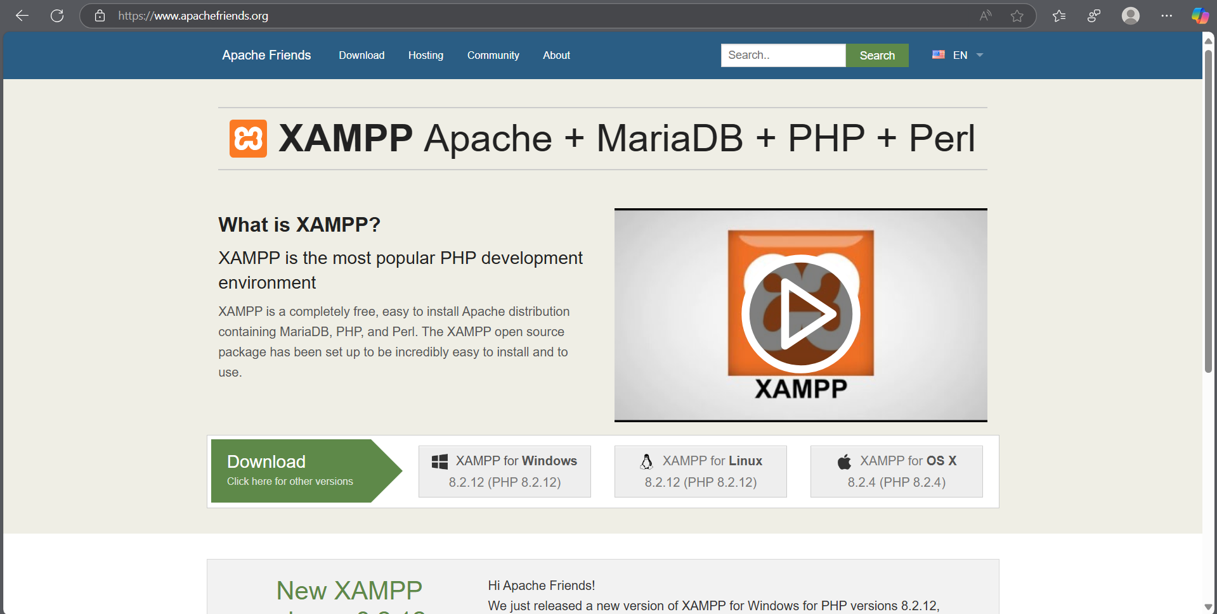

1. Download my individual zip folder and decompress it. You will see two folder “Part A” and “Part B” after decompression. A screenshot of a computer

   AI-generated content may be incorrect.
2. For each website, you need to copy its all files and paste on “XAMPP/htdocs”.

1. Click “Start” button of Apache and MySQL in XAMPP Control.

**Database Settings**:

Click “Admin” button from XAMPP of MySQL, wait for getting in “localhost/phpmyadmin”.

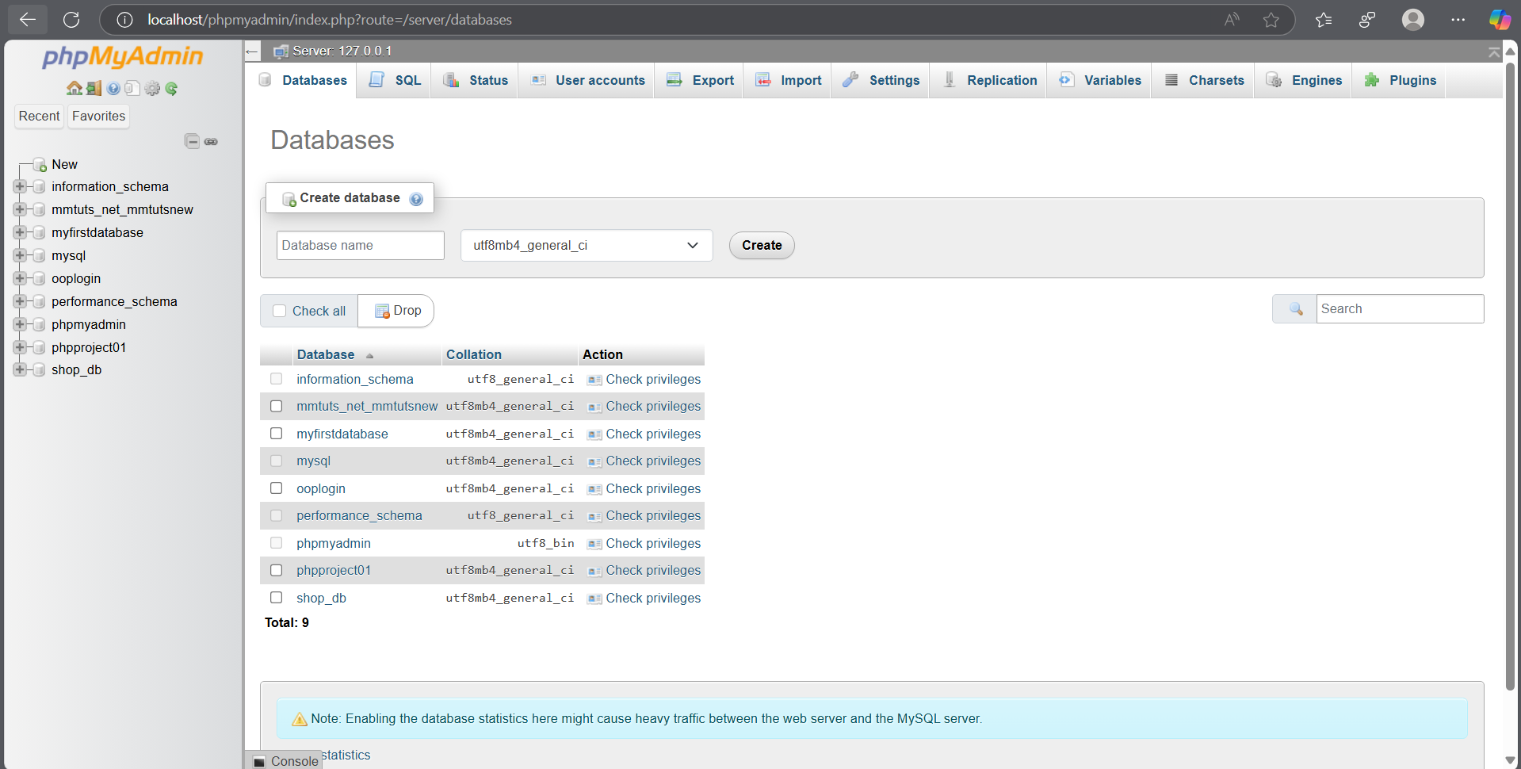

Create database if you don’t have corresponding database to each website. Make sure you have the corresponding database!

Part A 🡪 shop_db

Part B website 1 🡪 B_1

Part B website 2 🡪 B_2

Part B website 3 🡪 B_3

Part B website 4 🡪 B_4

Part B website 5 🡪 B_5

For each database, you need to insert tables from each database folder.

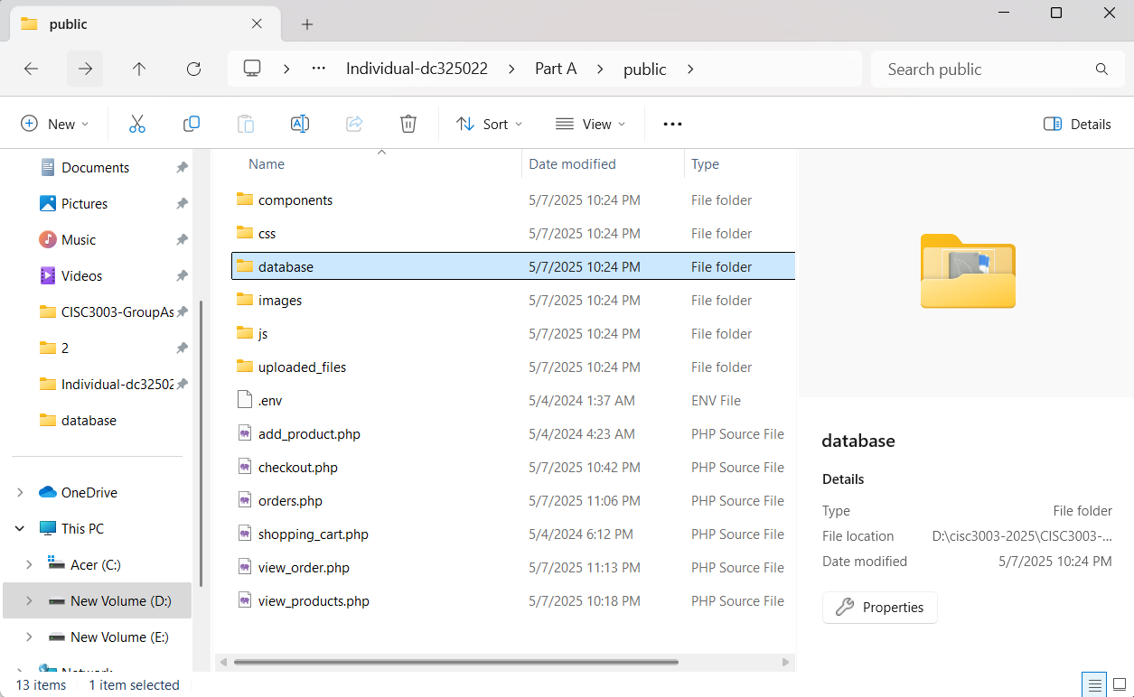

To insert tables, you need to click “import” button from phpmyadmin. Select database file(.sql) from database folder. Then click “import” button at the same page of bottom.

Here is the successful insertion.

You can use my website now! Congratulations!!!