LAB ASSIGNMENT V : HUERISTIC EVALUATION
SYSTEM EVALUATED: TravelWise – Flight Booking Website Prototype (Figma Make)
Design Team Members: Diya Chordiya, Diya Kumari, Virajas Khapli
Evaluation to be completed by another group. Assessment is based on the TravelWise screens provided; live functionality was not independently tested.
PART I: HEURISTIC EVALUATION BASED ON THE PROVIDED INTERFACE (0 = no/minimal violation; 5 = most severe violation)
S.No. | Heuristic Evaluation Parameter | Mention Violation if any | Severity 0-5 (0- minimum and 5 is maximium) | Ways to improve
1 | User Control: users should feel in control | Back arrows are visible on some steps, but editing a previous choice or leaving a step without losing details is not consistently evident. | 1 | Keep Back and Edit options visible at every stage; preserve entered passenger and search details when users return.
2 | Human Limitations: avoid overloading cognitive, auditory and motor skills | Flight cards show several details and match badges at once. The confirmation checklist is long and partly extends below the visible screen. | 2 | Use progressive disclosure for secondary details, keep primary actions prominent, and ensure the full checklist is easy to scroll and scan.
3 | Accommodation: fit different user groups and personas | The prototype supports common flight preferences and vegetarian meal preference, but different accessibility needs and traveller types are not clearly catered for. | 2 | Add accessible text sizing, clearer support for senior/first-time travellers, child/assistance needs, and more flexible traveller preferences.
4 | Linguistic Clarity: communicate efficiently | Labels such as “Smart Travel Match” and “True Cost” are understandable, but “Match” may not explain exactly how the percentage is calculated. | 1 | Add a short “How match is calculated” explanation and use plain-language descriptions for fees, baggage and cancellation rules.
5 | Aesthetic Integrity: attractive and appropriate design | The navy, white and orange palette, cards and spacing create a coherent travel interface. Some pages use many badges and cards, making them slightly busy. | 1 | Keep the current visual style but reduce decorative elements and reserve strong colours for primary actions and important status.
6 | Simplicity: simple design | The booking journey is divided into clear screens, but the home screen combines search, recent searches and price alerts in one view. | 1 | Keep the booking search as the main focus and allow optional sections such as recent searches and alerts to collapse.
7 | Predictability: users can anticipate what happens next | The progress indicator on passenger and payment screens helps users understand their place in the flow. Not every screen visibly explains the next step. | 1 | Use the same step indicator throughout booking and label each primary button with the next action.
8 | Accuracy: interface should help prevent errors | The screens show a fare breakdown and passenger fields, but validation for invalid dates, missing details or incorrect contact information is not demonstrated. | 2 | Add inline validation, clear required-field labels, date and passenger checks, and a final review before payment.
9 | Technical Clarity: interface should have high fidelity | The prototype looks polished on mobile. However, the supplied screens do not prove that all controls, calculations or booking actions work with real data. | 2 | Test every control and route, verify total-price calculations, and label sample flight/PNR details as demo data if not connected to a live service.
10 | Fulfillment: provide a satisfying user experience | Smart Travel Match, True Cost pricing and the Trip Ready Checklist make the concept useful beyond basic flight search. | 1 | Explain the benefit of each novelty feature briefly and ensure the checklist can be completed and saved by the user.
11 | Consistency: maintain consistent patterns | Cards, typography, colours and bottom navigation are generally consistent across the supplied screens. Some screens use different header and footer layouts. | 1 | Standardise page headers, spacing, button sizes and navigation placement across all screens.
12 | User Support: provide help when needed | Help & Support appears in the profile screen, but contextual help is not prominent during passenger entry, payment or fare selection. | 2 | Add small help links beside baggage, cancellation, fare and payment information, plus a clear way to recover from payment failure.
13 | Precision: allow users to perform tasks exactly | Flight times, route, baggage and itemised price are shown clearly. Seat, date and traveller choices may need more explicit review and edit controls. | 2 | Provide an editable booking summary before payment and clearly show selected date, passenger count, seat and add-ons.
14 | Forgiveness: make actions recoverable | Back navigation is present in parts of the flow, but undo/cancel behaviour and recovery after an accidental selection are not clear in the screenshots. | 2 | Allow users to edit or remove add-ons, change payment method, and return to earlier steps without re-entering details.
15 | Responsiveness: communicate action results and system status | The confirmation page shows booking and payment status, and the checklist displays completion. Loading, errors and failed-payment states are not shown. | 2 | Add loading indicators, success/error messages, payment retry guidance and clear status updates for every important action.
 | Total Severity Score (lower is better) | 23 / 75 |  | Main opportunities: validation, recovery, contextual help and tested interactions.

Screenshots of the evaluated TravelWise interface are included in the appendix.

PART II: OTHER OBSERVATIONS (OUTSIDE THE LISTED HEURISTICS)

S.NO | OBSERVATIONS | COMMENTS
1 | Smart Travel Match | Shows a preference-based match score and lets users prioritise price, duration, non-stop flights or baggage. Make the match calculation transparent.
2 | True Cost View | The itemised fare breakdown supports price transparency. Ensure every mandatory and optional fee is included before payment.
3 | Trip Ready Checklist | The post-booking checklist supports preparation after confirmation. Make progress savable and reminders actionable.
4 | Prototype and accessibility testing | Test with keyboard/screen-reader users and different screen sizes; verify colour contrast, text scaling, button tap targets and all navigation paths.

Evaluating Team Members: ______________________________________________

Conclusion: TravelWise has a clear visual style and useful differentiators. The highest-priority improvements are form validation, recovery/edit options, contextual help, and testing the prototype across devices. Scores reflect only the screens supplied, not a live usability test.

APPENDIX: TRAVELWISE INTERFACE SCREENS
Screen 1 — Home  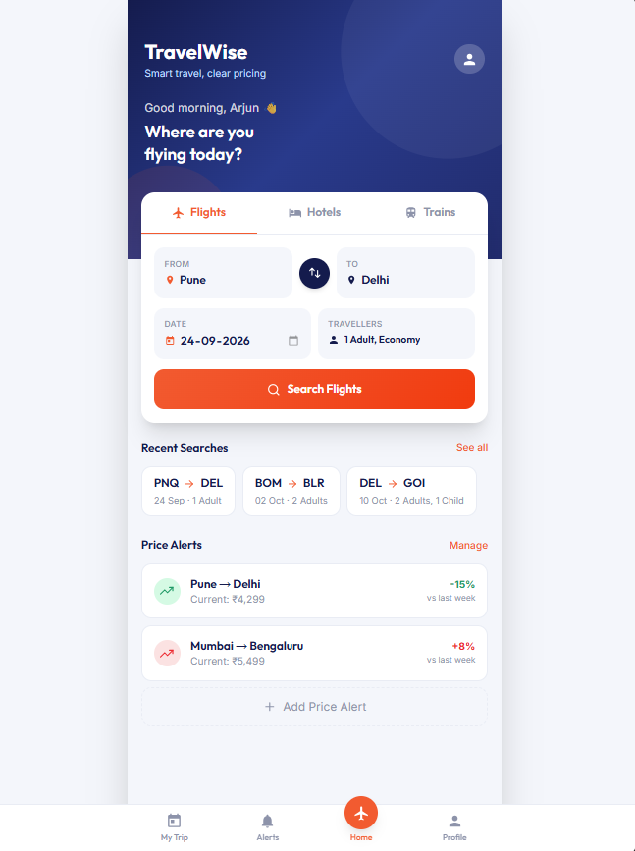 | Screen 2 — Search Results / Smart Travel Match  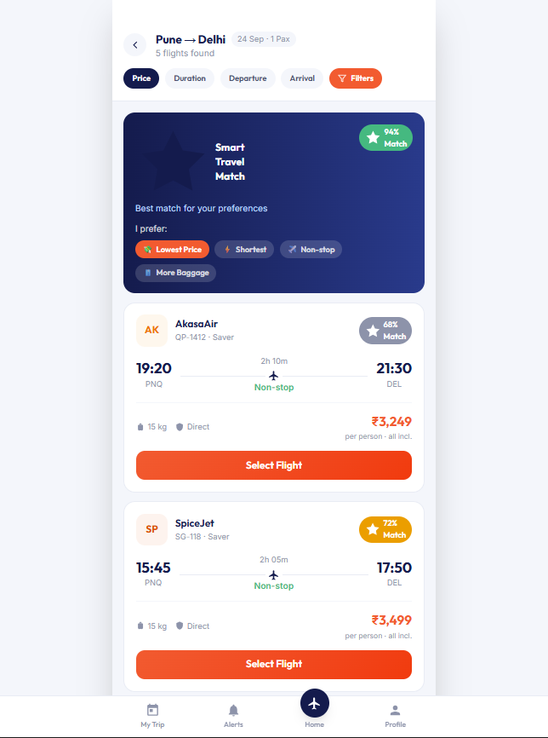
Note: The provided materials contain 8 screenshots. Filters and Flight Details screens were not included in the uploaded images.

APPENDIX: TRAVELWISE INTERFACE SCREENS
Screen 3 — Passenger Details  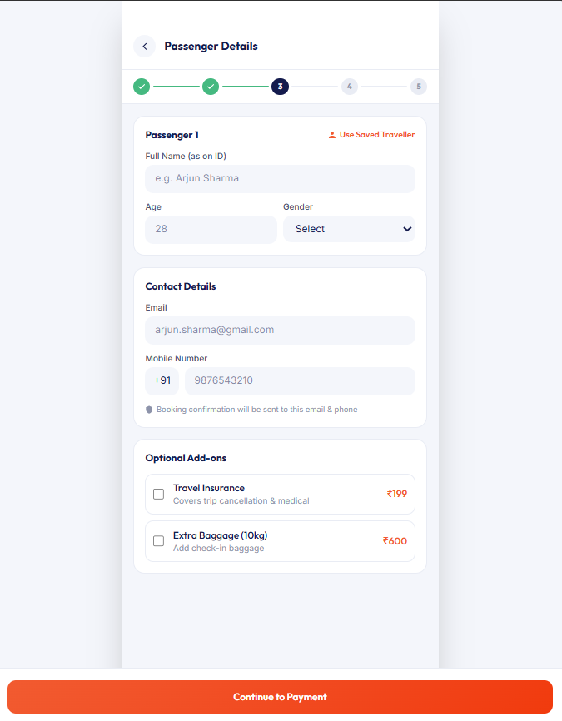 | Screen 4 — Payment / True Cost View  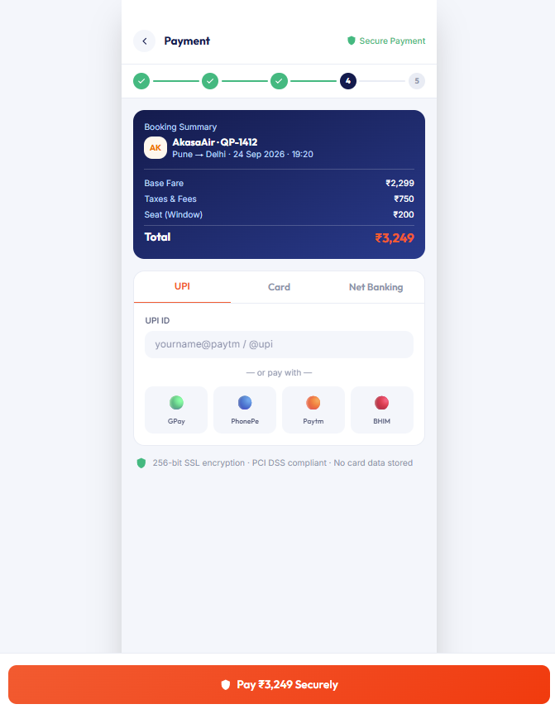
Note: The provided materials contain 8 screenshots. Filters and Flight Details screens were not included in the uploaded images.

APPENDIX: TRAVELWISE INTERFACE SCREENS
Screen 5 — Booking Confirmation / Trip Ready Checklist  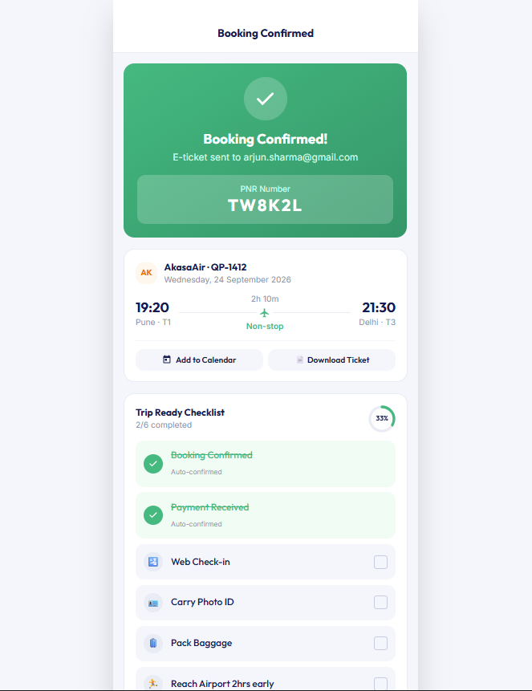 | Screen 6 — My Trips  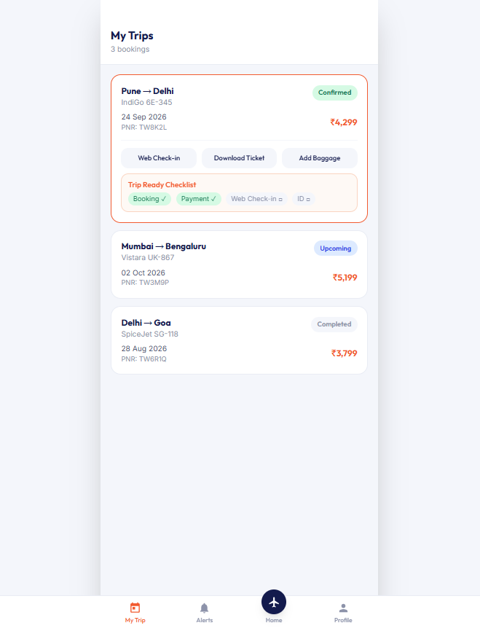
Note: The provided materials contain 8 screenshots. Filters and Flight Details screens were not included in the uploaded images.

APPENDIX: TRAVELWISE INTERFACE SCREENS
Screen 7 — Profile  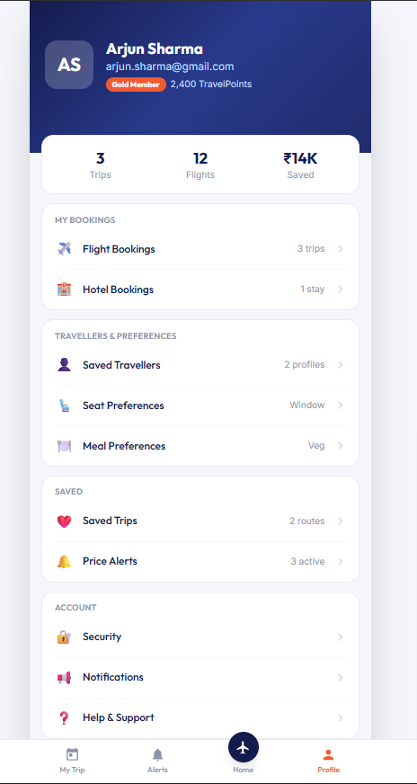 | Screen 8 — Price Alerts  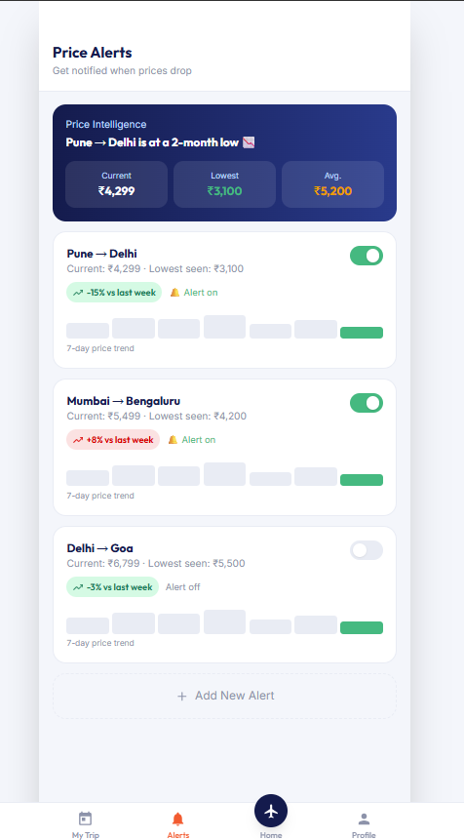
Note: The provided materials contain 8 screenshots. Filters and Flight Details screens were not included in the uploaded images.

