UIUX

Assignment 1
{Self-Analysed Version)

Name: Diya Chordiya
PRN: 1262242873
Batch: F1
Roll number: 17
Critical Analysis of Interface
Introduction
MakeMyTrip and IRCTC are two of the most popular travel booking websites in India. It allows users to book flights, hotels, trains, buses and holiday packages from one platform. I explored the website and analysed its interface to understand what works well and what could be improved from a user's point of view.

MakeMyTrip (MMT)

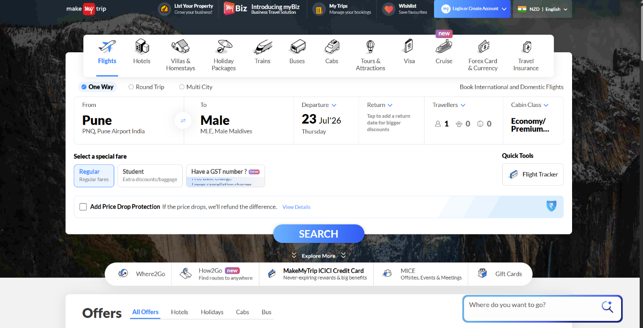
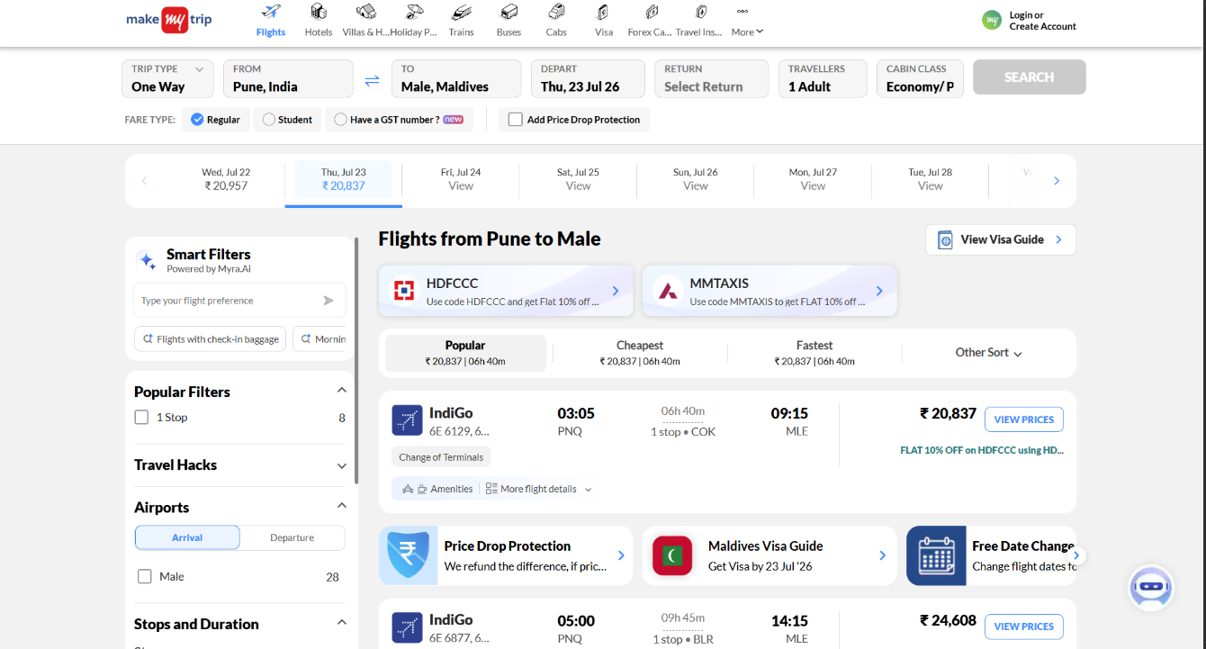
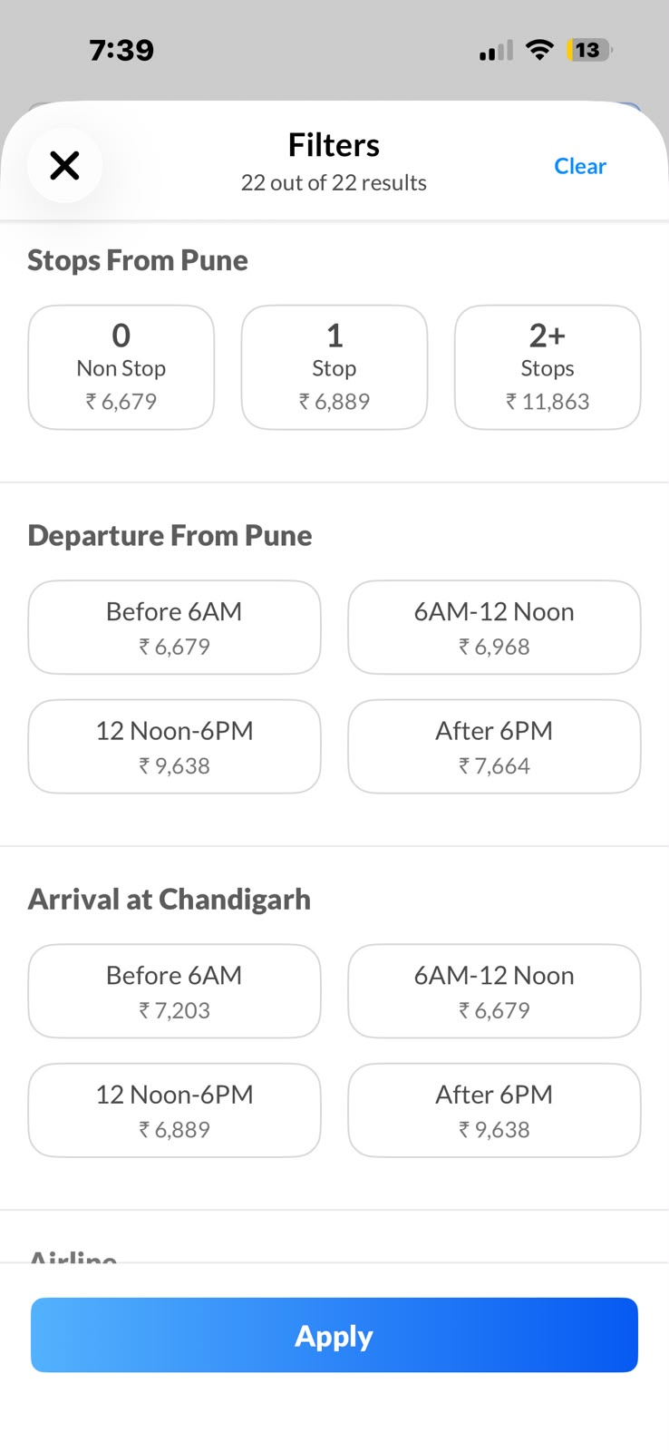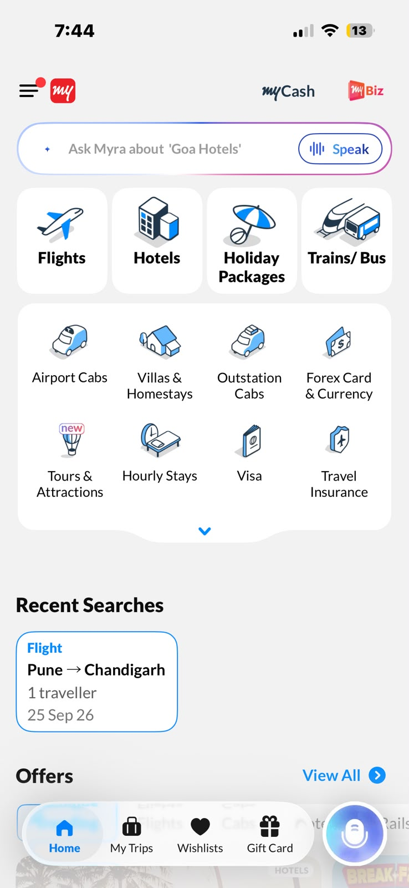

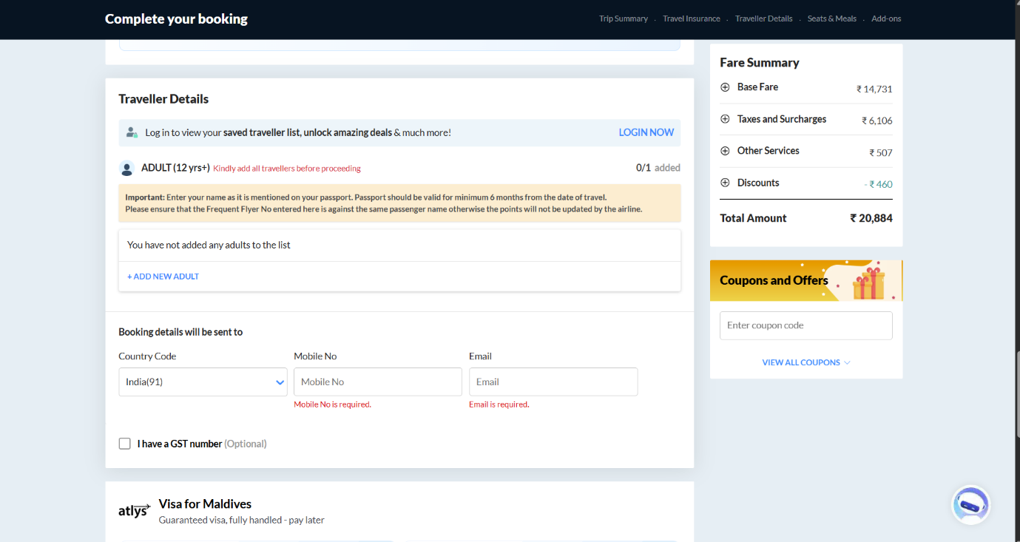
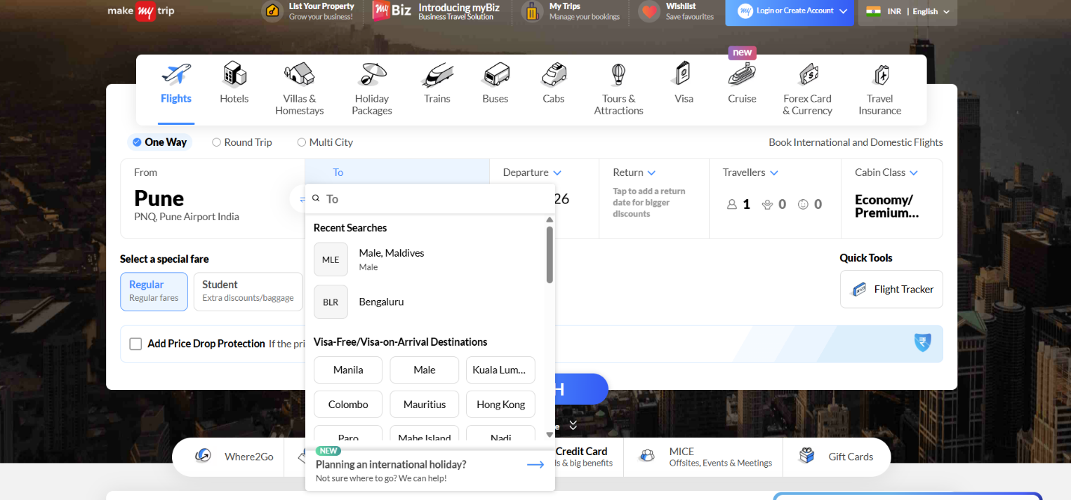
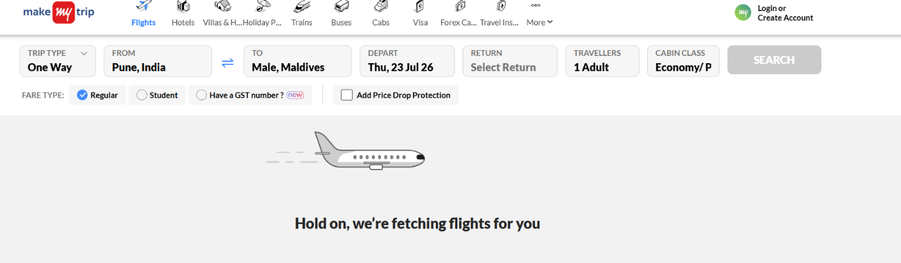
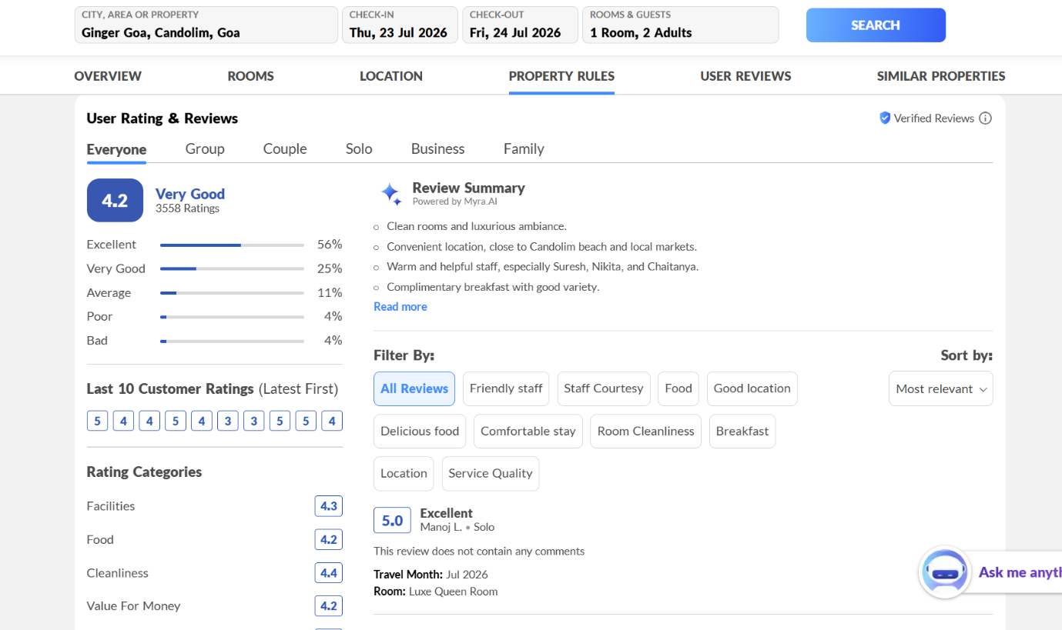
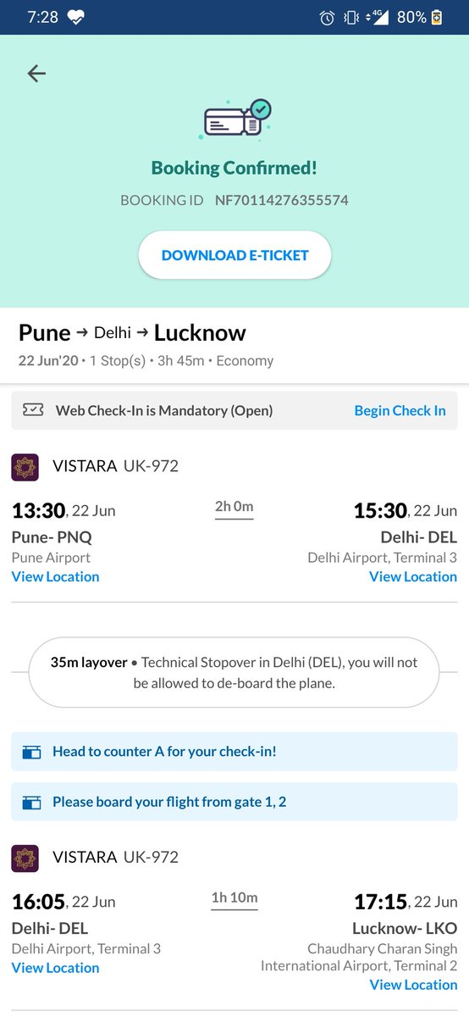

Parameter | Rating | Justification
Learnability | 9 | The Homepage shows the search box and the top menu which has Flights, Hotels, Trains, Buses, Cabs. This is what you see when you use the website for the time. It helps you know where to start.
Usability | 8 | The Flight search results page has filters like Price, Airline, Stops and Departure Time. These filters make it easy for you to find flights.
Consistency | 9 | Homepage and Flight Results page display same colours, fonts, buttons and icons.
Use of Metaphors | 9 | Homepage displaying icons such as Airplane, Hotel, Train, Calendar and Location icons are symbols of actual objects.
Navigation Structure | 8 | Navigation bar on top displays categorised items clearly, like Flights, Hotels, Trains, Buses and Cabs.
Parameter | Rating | Justification
Visual Hierarchy | 8 | Homepage displaying the large search box. Search area is highlighted to grab attention.
Accessibility | 7 | Page displaying any text size and buttons uses fonts that are legible and have good contrast but promotional text are small.
Responsiveness | 10 | Desktop view besides mobile view (or browser responsive mode) display proper layout according to the screen sizes.
Efficiency of Interaction | 8 | Booking page displaying saved Traveller Details or Autofill makes rebooking faster.
Feedback and System Status | 9 | The loading screen or Booking Confirmation page displays progress and confirmation notifications to inform the user.
Error Prevention and Recovery | 8 | Invalid date or missing information fields are displayed as error message as website prevents users from doing mistakes.
Aesthetic and Minimalist Design | 7 | Homepage with promotional banners. Modern design, but multiple offers make the page look crowded.
Content Readability | 8 | Information organised clearly with spacing and font sizes. Information organised clearly with spacing and font sizes.
Search and Discoverability | 10 | Suggestions while searching for a city and auto-suggestions give better search experience.
Performance Perception | 9 | Loading spinner during search operation makes users feel that the system is loading.
Trust and Credibility | 9 | The payment page has secure payment icons with rating or verified reviews. The secure payment options make the payment more trustworthy.
Personalization | 9 | The homepage displays recent searches or saved travellers (if logged in). The website has user preferences.
User Satisfaction | 8 | The confirmation page on the booking of flights gives satisfaction to the customers.

Indian Railway Catering and Tourism Corporation (IRCTC)

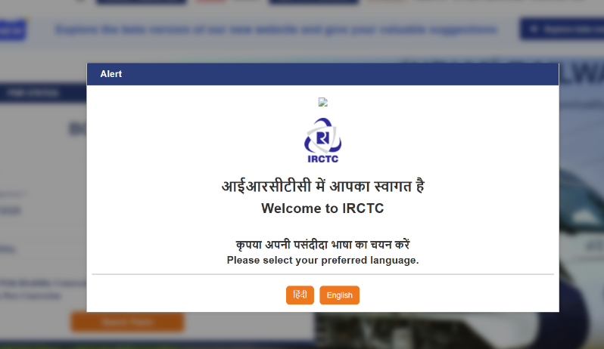
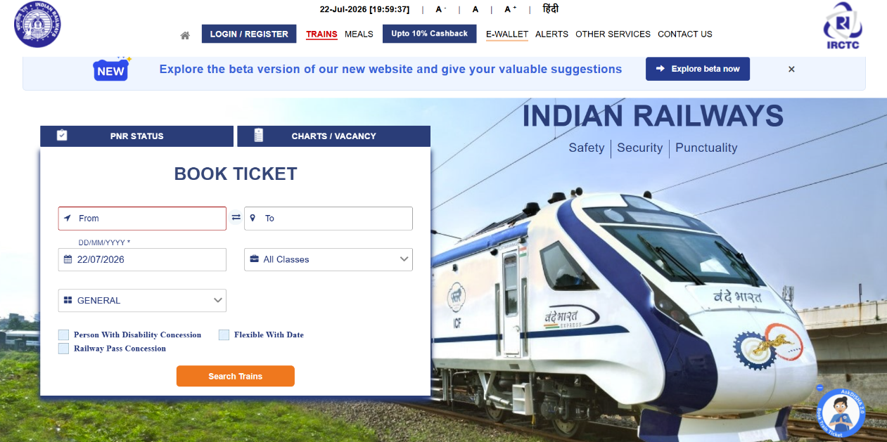
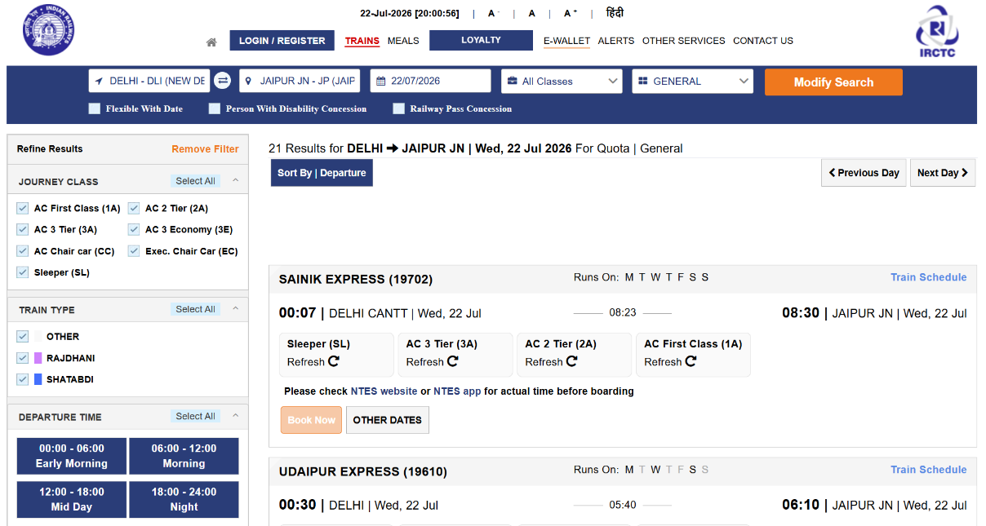
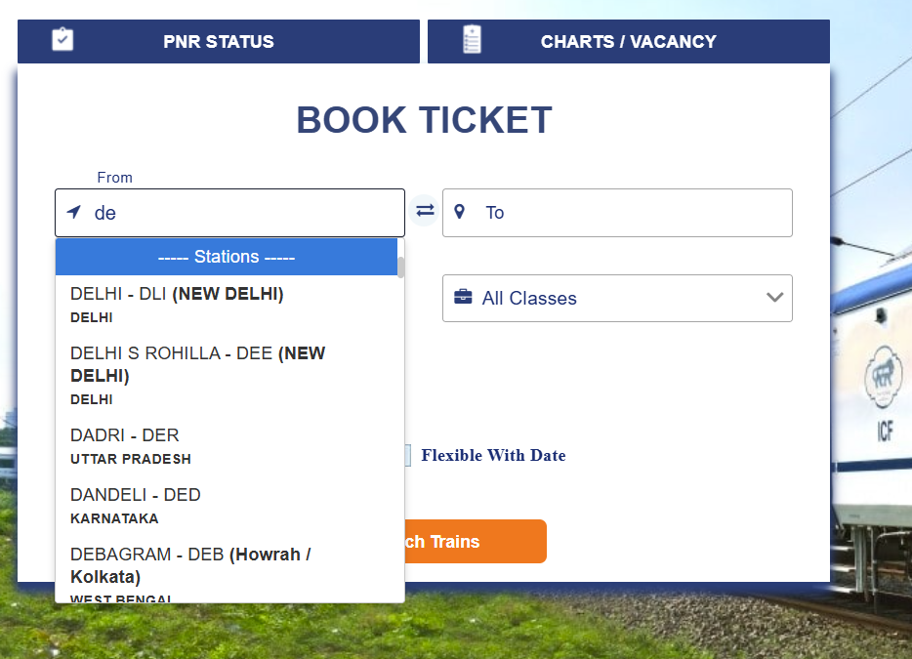
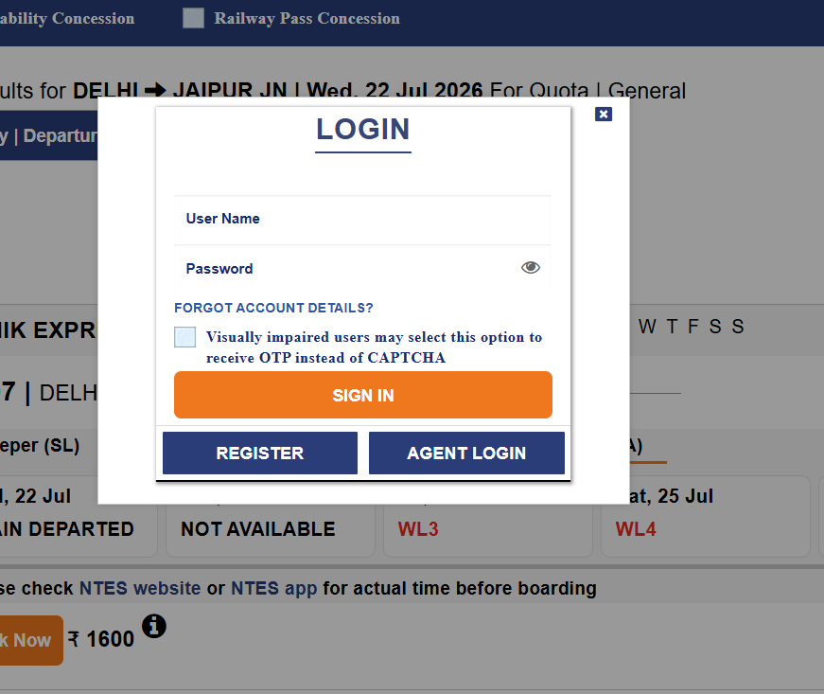

Parameter | Rating | Justification
Learnability | 7 | Homepage with the Book Ticket section, From/To stations, Journey Date and top menu. The booking form is easy to locate, thus showing the user where to start from. Nevertheless, the homepage has much information that may confuse a new user.
Usability | 7 | This website allows to see the schedule of the trains, seat availability and travel classes at once which is quite convenient. The high amount of information makes the page seem crowded.
Consistency | 8 | There are similar colours, fonts and style of buttons on all pages of the website.
Use of Metaphors | 8 | Familiar icons such as a train, calendar, pin and profile help understand the functionality of the web page better.
Navigation Structure | 7 | On the top navigation bar, the most important options are found easily, nevertheless, the menu seems a little bit overloaded because there are many links there.
Visual Hierarchy | 7 | The booking form on the homepage is clearly visible, however, banners and notices around distract from it.
Accessibility | 8 | The texts are clearly readable, and the buttons are big enough. Thus, the layout of the website could be made simpler to improve the navigation.
Responsiveness | 8 | This website is well adapted for use from different devices and adapts to the screen size, although some pages look compact on the mobile version.
Efficiency of Interaction | 7 | Although the stored passenger details make it unnecessary to type, ticket reservation remains an activity that involves several procedures before making any payment.
Feedback and System Status | 8 | Loading status, booking status, and confirmation are shown to the users on the web pages to let them know what is happening.
Error Prevention and Recovery | 9 | Error message when providing invalid station name or missing information. The system identifies errors in the entered information before proceeding to another step, helping users to avoid mistakes.
Aesthetic and Minimalist Design | 7 | The website is working fine, however, an abundance of notifications and sections creates a cluttered design rather than clean one.
Content Readability | 7 | Train number, timings, and availability are easily found, however, the webpage includes plenty of information at once.
Parameter | Rating | Justification
Performance Perception | 7 | Loading indicators inform users that the website is working with the request, however, during peak booking time it takes a while.
Trust and Credibility | 10 | The IRCTC logo, secure payment options and detailed booking information like ticket details make the website feel reliable.
Personalization | 6 | The website saves passenger information and previous bookings, but provides very little in personalization and recommendations.
User Satisfaction | 7 | The booking process is reliable and all information is provided to users after payment.

Cleartrip

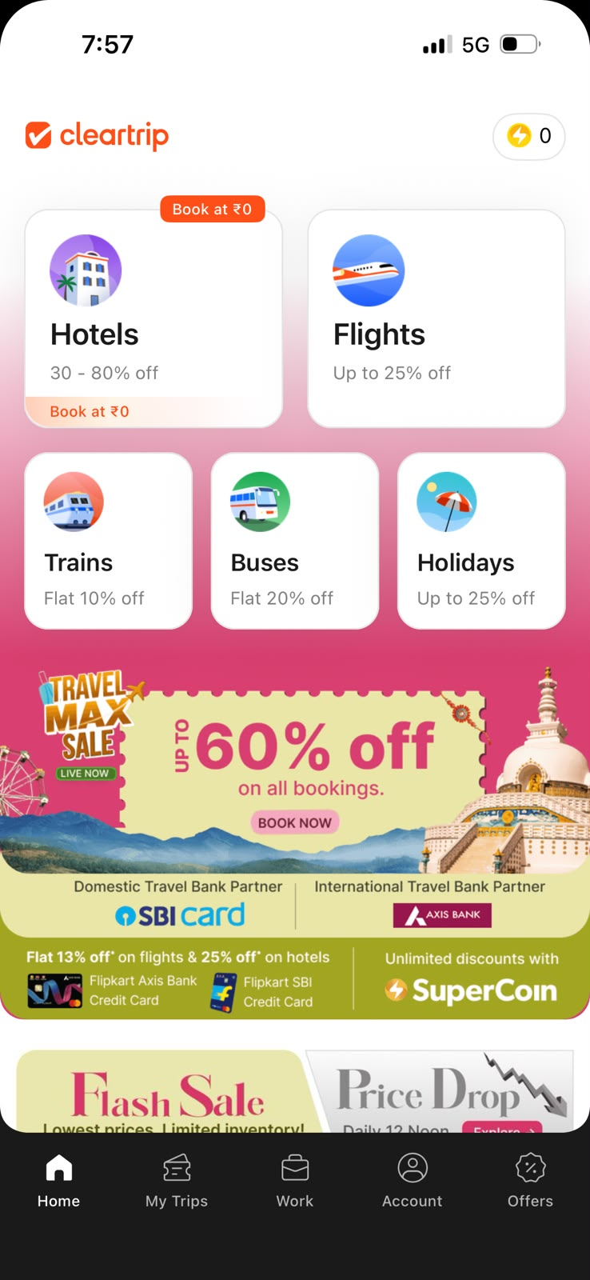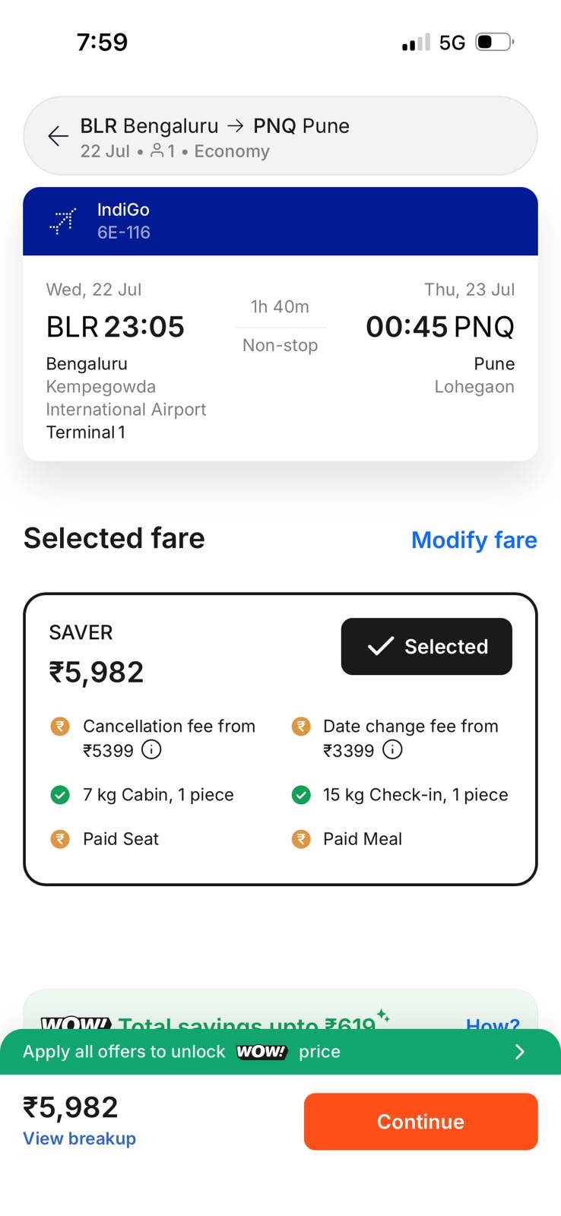
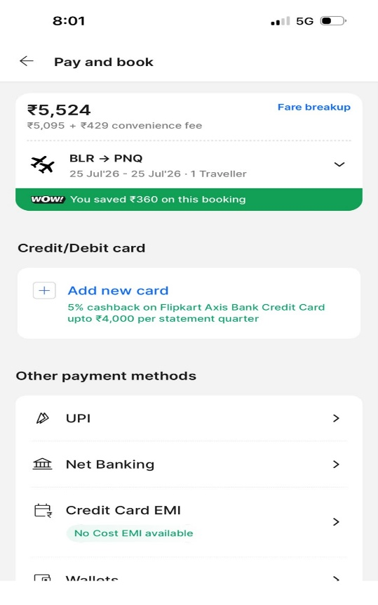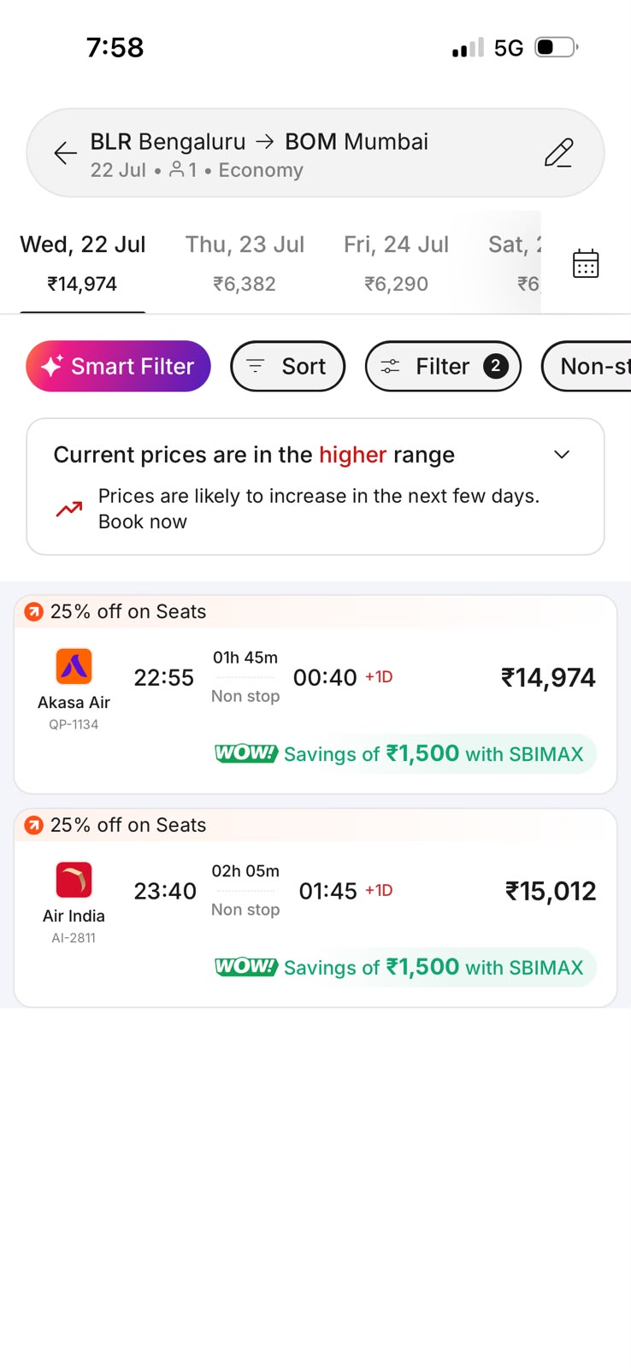
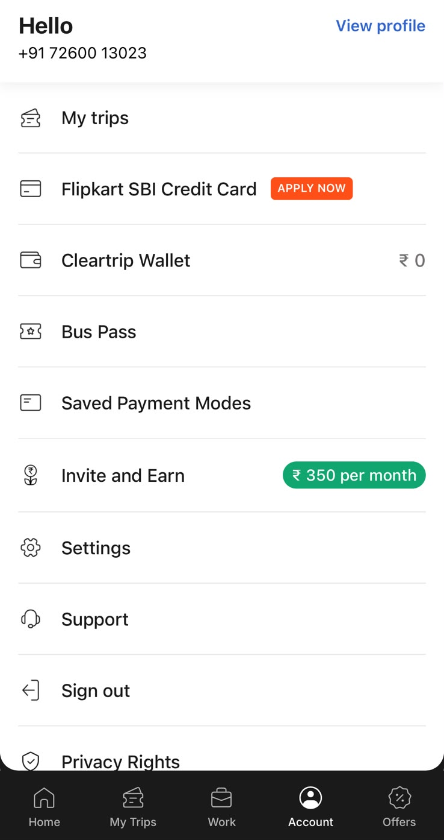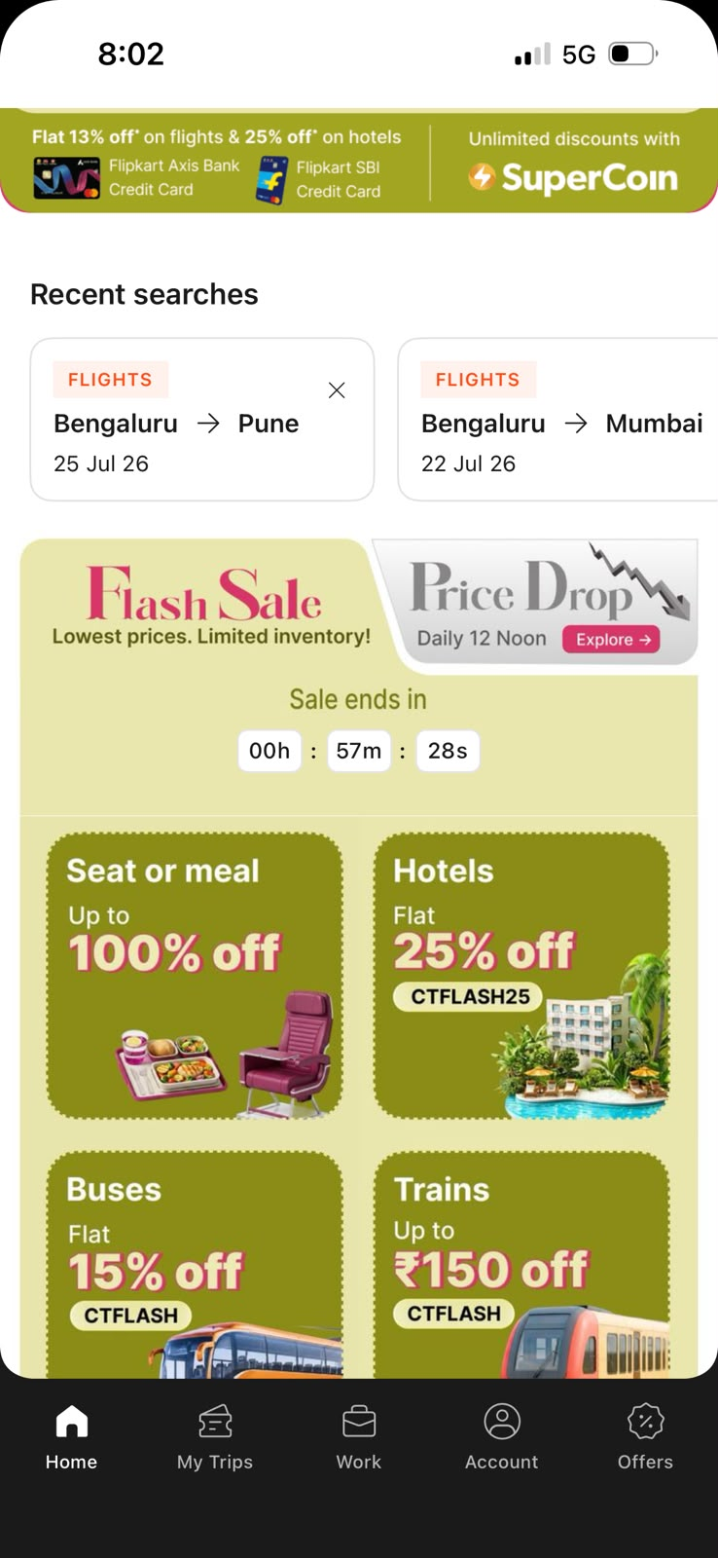

Parameter | Rating | Justification
Learnability | 8 | The flight search form is very simple to fill in. The fields are understandable. The date picker is quite easy to open. One does not need any extra guidance to fill in the fields.
Usability | 9 | The flight booking process is quick and easy. The filters make it easier for users to choose the right flight.
Consistency | 6 | The app does not seem homogeneous. The interface of the flights part is quite modern. The interface of the hotels part is different. The filters and buttons for hotel searching are not the same as those for flights booking. It may cause confusion.
Use of Metaphors | 9 | The app contains images that have clear meanings. To understand that the airplane symbol indicates air travel is possible immediately. The bed symbol represents lodging options in a similar way. The coupon symbol shows that price reductions are available.
Navigation Structure | 9 | The menu follows a logical structure. It enables the traveller to change between services in a short amount of time.
Visual Hierarchy | 9 | The search box seems to be the most noticeable part, which helps users to understand from which point to start.
Accessibility | 6 | The app is not convenient for people with poor eyesight since some important information is presented in grey on white background.
Responsiveness | 8 | The app is compatible with various devices. The application is adapted to work on different gadgets. There are no problems with switching from a computer to a smartphone because the app works properly. Flight grids look great on different gadgets.
Efficiency of Interaction | 5 | The checkout procedure takes too much time. It is necessary to refuse from many additional services which you do not need.
Feedback and System Status | 8 | While loading, the website displays the message such as "Searching for flights... " and the user can be sure that everything is fine.
Error Prevention and Recovery | 7 | The application provides the possibility to make a reservation without mistakes. It is impossible to book a return flight before the departure one. If it happens, the website just states that something goes wrong.
Aesthetic and Minimalist Design | 7 | The homepage is overloaded with various advertisements. Search results look great. The rest of the interface is messy.
Content Readability | 8 | The fonts used on the website are appropriate. Important information such as flight time and price is written in readable font.
Search and Discoverability | 8 | The search field is rather smart. It is enough to enter several letters and it will show the right destination. For instance, if you type "BOM" it means "Mumbai".
Parameter | Rating | Justification
Performance Perception | 9 | The search results come quickly, and there are loading indications to show that the website is functioning properly. This means that the entire process feels very smooth and quick.
Trust and Credibility | 9 | The website provides all necessary information regarding the total price, reservation and secure payment methods, making people feel safe about their reservation.
Personalization | 5 | The app doesn't recognize you, if you close it at any point, you will need to start from the beginning the next time you use the application.
User Satisfaction | 7 | The use of the application may be tiresome. Although it's quite intuitive to search for flights through it, booking flights might be challenging due to various options.

SkyScanner

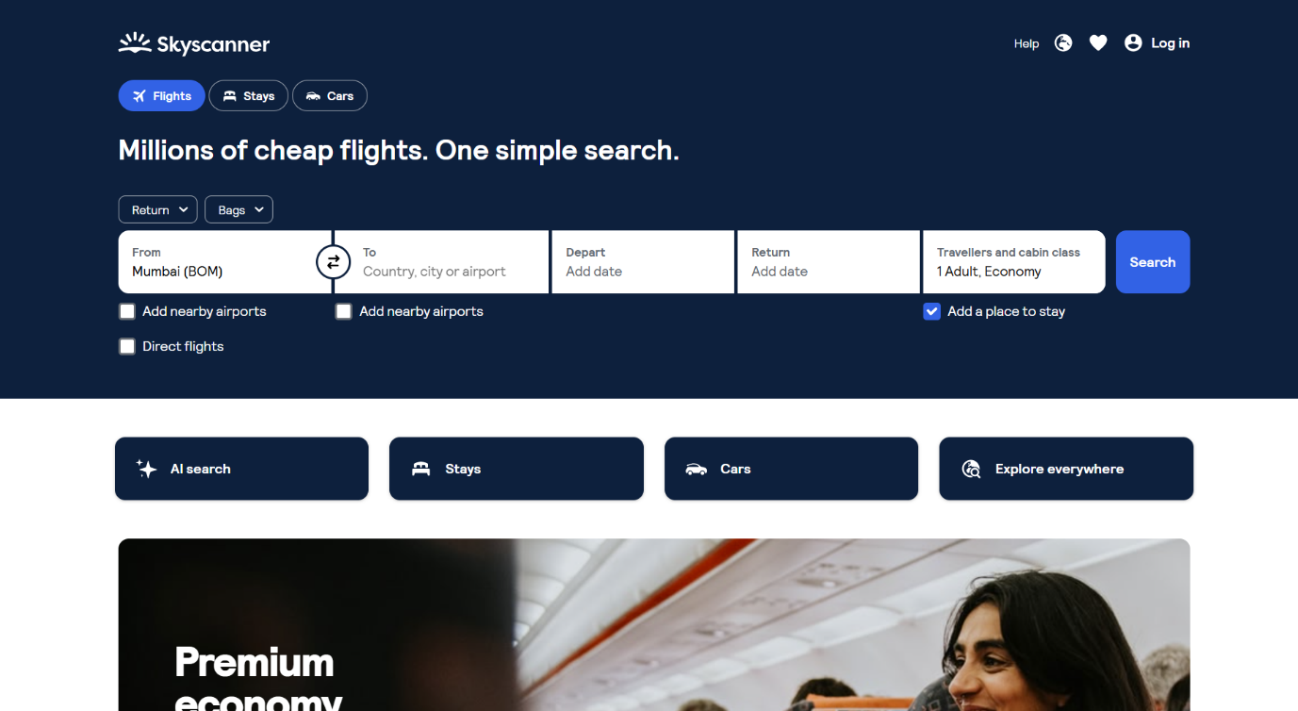

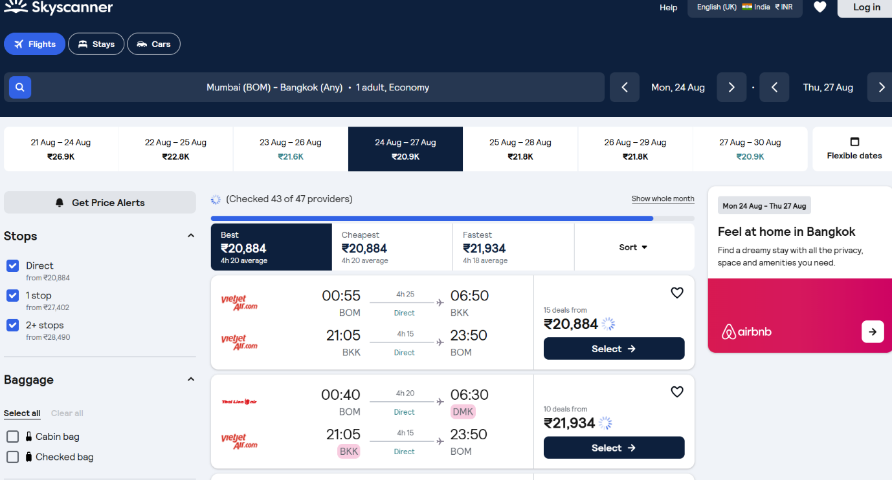
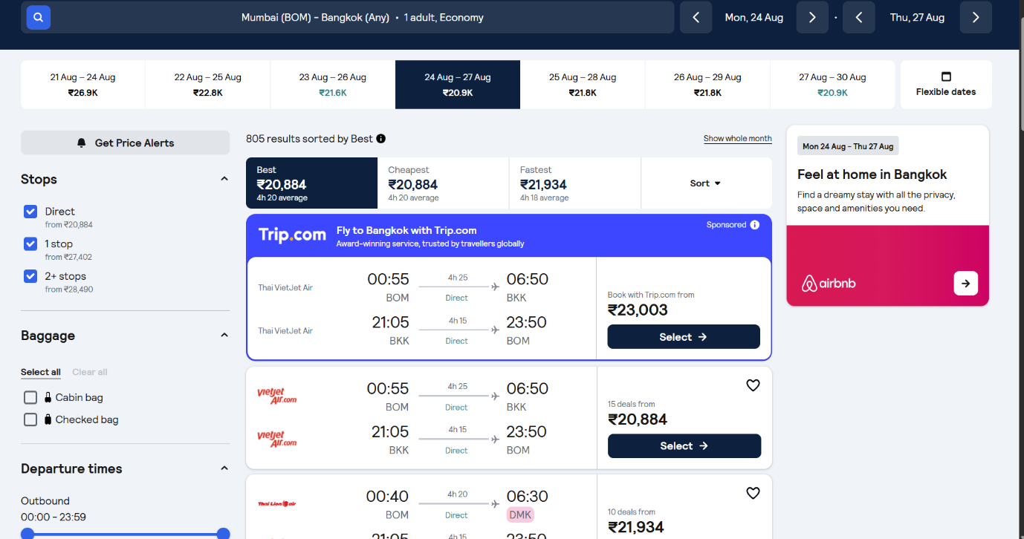
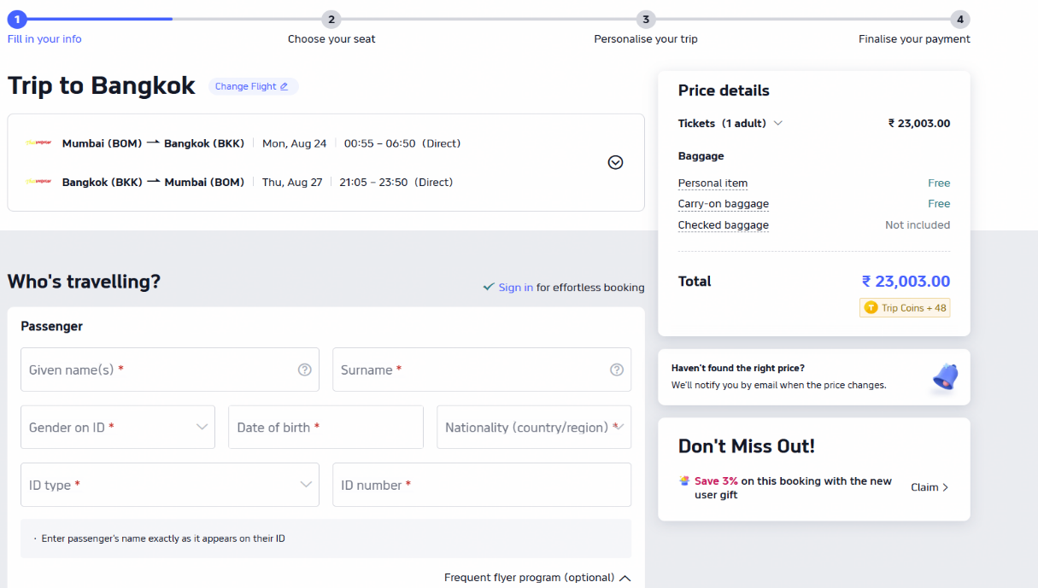
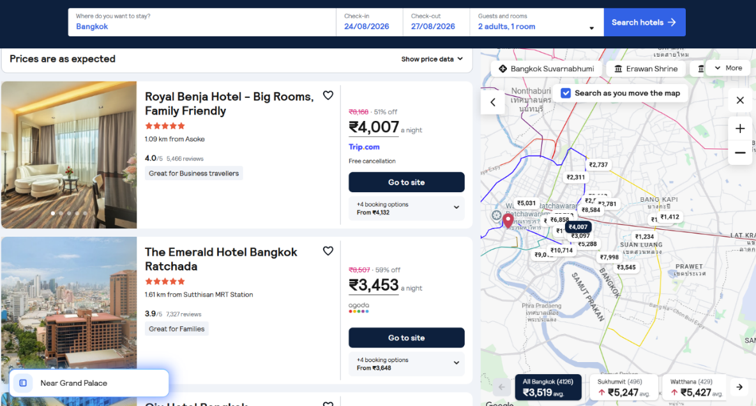

Parameter | Rating | Justification
Learnability | 9 | Homepage design is quite clear and unobtrusive, allowing one to navigate the site easily. Search is the first element a user notices on the homepage.
Usability | 9 | Comparison of flight tickets is rather fast due to the user-friendly interface and filters which are convenient and intuitive.
Consistency | 9 | The same colours fonts, icons and button styles are present across every page of the site. The design of the interface is consistent because those visual elements repeat.
Use of Metaphors | 9 | On the screen icons of an airplane, a calendar and a map pin represent specific tasks - those symbols are clear because they match the actions that travellers expect.
Navigation Structure | 9 | The menu is organised properly and allows switching between Flights, Hotels and Car Hire effortlessly.
Visual Hierarchy | 9 | The search field is highlighted properly and the flight information and filters are well organized, thus creating a convenient structure of the page.
Accessibility | 8 | The text is legible, buttons are big enough to click and there is sufficient colour contrast.
Responsiveness | 9 | There are no substantial differences when using the website on the desktop version and mobile device.
Efficiency of Interaction | 9 | There are several filters and sorting options allowing narrowing down the search result quickly, thus saving users' time.
Feedback and System Status | 8 | Loading and search result update indicators give users the feeling that the website processes their request quickly.
Error Prevention and Recovery | 8 | The website informs users about any information gaps and gives them an opportunity to fix errors and continue.
Aesthetic and Minimalist Design | 9 | The interface is quite simple and uncluttered, which enables users to concentrate on searching.
Content Readability | 9 | Flight prices, times and airlines are arranged in a proper way, which facilitates comparison.
Search and Discoverability | 10 | The search system is outstanding as it provides users with auto-suggestions, flexible dates and filters, which speed up the search process.
Parameter | Rating | Justification
Performance Perception | 9 | The website works quite well in terms of smooth loading of pages and rapid updates of the search results.
Trust and Credibility | 8 | It is clear on the user interface how airlines are listed, the booking sites, the rating system, and pricing. It increases trust and makes users more confident to book the tickets on the site.
Personalization | 8 | The user interface comes with great features such as Price Alerts, search history, and saved itineraries. Users find it easy to continue from where they stopped and find flights that suit them.
User Satisfaction | 9 | Users are able to discover simple design, the functionality it offers and also use the convenient function to compare the fares. The negative point is, in order for booking flight users need to switch the other website and book there.

