David Ciorra

Gabrielle Sabbatino

Types of Baseball throws

As a group, would have to search on the types of throws in baseball. We have looked in the excellent sources starting from the book of Giordano. We will definitely be analyzing the fast ball since it is the most classic type of pitch. We will also be look at the effects of drag, air resistance and at the spin factor.

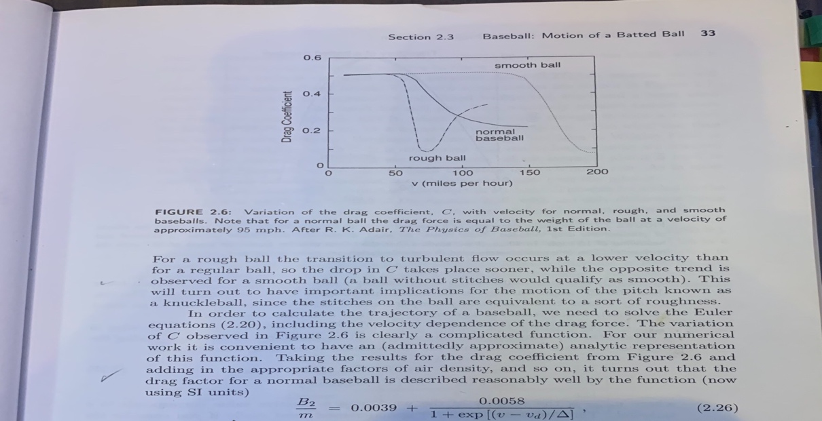

Another aspect that is shown in the book and well documented is the spin factor like this. We are planning on testing which type of ball thrown would better do against people around the ages of 35 in a baseball game. Some official numbers of RBI’s need to be found online so that they can be compared to our theoretical values.

