Ministry of Education and Science

Technical University of Moldova
CIM Faculty

R E P O R T

Laboratory work #3
Procedures.
V-3

Done by FAF-151 student: Verified by senior lecturer
Calancea Daniel Sudacevschi Viorica

Chişinău 2017

Laboratory work #3
V-3
- Declare a 10-size array X with integer DW numbers.
- Calculate their sum (use procedure).
- Use two procedures to calculate the requested condition.

S<0 | Generate a substring with odd numbers
S≥0 | Generate a substring with even numbers

Program code:
.data
x dw 1h, -2h, -2h, -1h, -1h, -1h, -2h, -2h ,-1h, -1h
res dw 10 dup(?)

.code
start:
mov ax, @data
mov ds, ax

call sum
cmp ax, 0
jng smaller

call genEven
jmp final

smaller:
call genOdd

final:
mov ah, 4Ch
int 21h
end start

Sum procedure:
sum proc
mov si, 2
mov cx, 9
mov ax, x[0]
repeat:
add ax, x[si]
add si, 2
loop repeat
ret
sum endp

GenEven procedure:
genEven proc
mov si, 0
mov di, 0
mov cx, 10
mov bx, 2
r1:
mov ax, x[si]
idiv bl
cmp ah, 0
jne f1
mov ax, x[si]
mov res[di], ax
add di, 2
f1:
add si, 2
loop r1
ret
genEven endp

GenOdd procedure:
genOdd proc
mov si, 0
mov di, 0
mov cx, 10
mov bx, 2
r2:
mov ax, x[si]
idiv bl
cmp ah, 0
je f2
mov ax, x[si]
mov res[di], ax
add di, 2
f2:
add si, 2
loop r2
ret
genOdd endp

Results:
In case when our sum is negative:
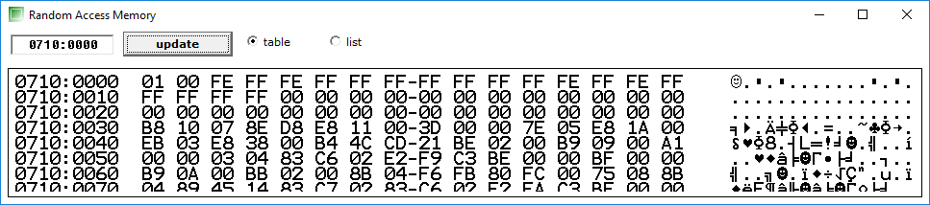
This is our array X without results.

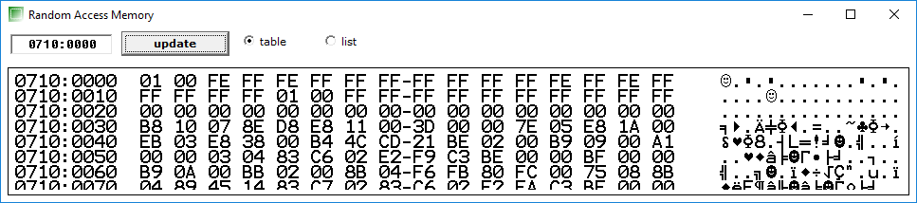
At the end are added the results. We can observe that number 1 was added and 5 numbers -1. These are the exact number of odd numbers we have in array.

When we change our array to :
x dw 1h, 2h, -2h, 1h, 1h, 1h, 2h, 2h , 1h, -1h

We obtain the results:

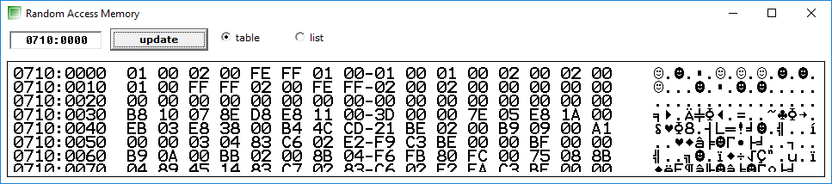

And the result array is : 2, -2, 2, 2.

Conclusion
Procedures are very useful when we want to structure our data, to make it more readable. We also use procedures to use the same part of the code multiple times without rewriting it.

