Ministry of Education and Science

Technical University of Moldova
CIM Faculty

R E P O R T

Laboratory work #2
Arithmetic and logic instructions.
Conditional and unconditional jumps.
V-3

Done by FAF-151 student: Verified by senior lecturer
Calancea Daniel Sudacevschi Viorica

Chişinău 2017

Laboratory work #2
V-3
I. Arithmetic and logic instructions
- Calculate 5 DW elements of the string according to the following rule:
x_{i}=x_{i-1}+(a-b)*4
Find the sum of the elements.

Program code:
.data
x dw 5 dup(?)
a db 0FFh
b db 0h
sm dw 1 dup(?)

.code
start:
mov ax, @data
mov ds, ax

mov bx, 4

xor ax, ax
mov al, a
sub al, b
mul bx
mov di, ax
mov x[0], ax
mov dx, ax

mov si, 2
mov cx, 4

rec:
xor ax, ax
mov ax, di
add ax, dx
mov x[si], ax
mov dx, ax
add si, 2
loop rec

mov cx, 5
mov si, 0
mov ax, 0
sum:
add ax, x[si]
add si, 2
loop sum
mov sm, ax

mov ah, 4Ch
int 21h
end start

Results:
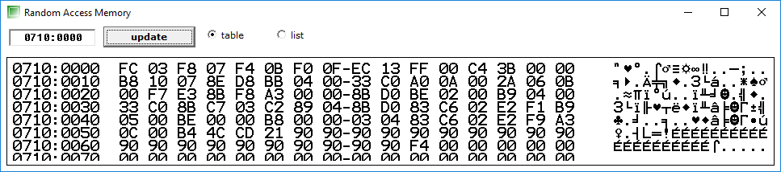
Where first 5 words are the results of the elements calculated by the formula above.
X1 = 03FCh
X2 = 07F8h
X3 = 0BF4h
X4 = 0FF0h
X5 = 13ECh

And the sum is:
SM = 3BC4h

II. Conditional and unconditional jumps.

Calculate the expression.
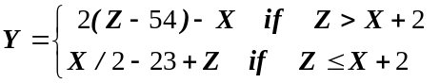
With X, Y, Z being DW.

Program code:
.data
x dw 1234h
z dw 1200h
y dw 1 dup(?)

.code
start:
mov ax, @data
mov ds, ax

mov ax, x
add ax, 2
mov bx, z
cmp ax, bx
jg greater

mov ax, x
shr ax, 1
sub ax, 23
add ax, bx
mov y, ax
jmp final

greater:
mov ax, z
sub ax, 54
shr ax, 1
sub ax, x

final:
mov ah, 4Ch
int 21h
end start

Results:
When we have X = 1234h and Z = 1200h we obtain the result:
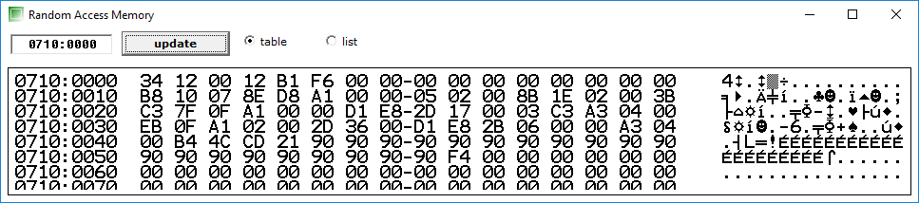
Y = F6B1h

When we change X = 1200h and Z = 1234h we obtain the result:
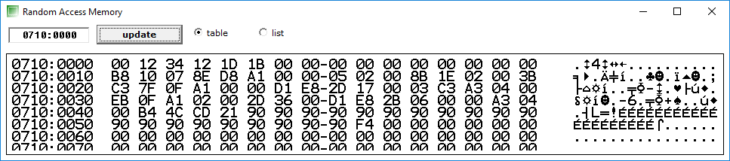
Y = 1B1Dh

Conclusion
In this laboratory work we learned how to use loops, conditional and unconditional jumps. We also learned how to compare two numbers and jump if certain flags are set. The jumps and the flags are essential tools in order to use conditions and without them we wouldn’t be able to do the first and the second problem.

