Ministry of Education and Science

Technical University of Moldova
CIM Faculty

R E P O R T

Laboratory work #4
Software Interrupts.
V-3

Done by FAF-151 student: Verified by senior lecturer
Calancea Daniel Sudacevschi Viorica

Chişinău 2017

Laboratory work #4
V-3
- Elaborate a program that performs the search of the characters that correspond to the student name and surname in the defined string of characters.
- Use software interrupts to visualize the results (arrange characters in a column, string, diagonal, change background color, use messages in case if the certain character is not finding).

Our program is divided into:
- getLength macro
- printString macro
- printDiagonal macro
- printColumn macro
- checkStrings proc

getLength macro is used to determine the length of a string from memory that is sent as parameter. The result is stored in the register SI and can be used after the macro usage.
getLength macro s1
local l1, f1
mov si, 0
mov al, s1[si]
l1:
cmp al, 0
je f1
add si, 1
mov al, s1[si]
jmp l1
f1:
endm

checkStrings procedure is used to compare if string y contains substring x, the result of this procedure is stored in array resIndex that contains the starting position of the found substrings.
checkStrings proc
mov si, 0
mov di, 0
mov bx, 0
l2:
cmp si, ylen
jg f2
mov al, y[si]
cmp al, x[di]
je eq
mov di, 0
inc si
jmp l2
eq:
inc si
inc di
cmp di, xlen
je found
jmp l2
found:
mov ax, si
sub ax, di
mov resIndex[bx], ax
add bx, 2
jmp l2
f2:
ret
checkStrings endp

printString macro takes as input 4 parameters: the string, length of string, color of the text, starting column of the text. It prints on the screen the input string with the selected color and at the specific position.

printString macro string, length, color, startPos
local loop1
mov si, 0
mov di, length
mov bp, startPos
loop1:
mov dh, 0 ;row
mov dx, bp ;column
mov bh, 0 ;page
mov ah, 2
int 10h

mov al, string[si]
xor bx, bx
mov bl, color ;color
mov ah, 09h
mov cx, 1
int 10h

inc si
inc bp
dec di
cmp di, 0
jne loop1
endm

printDiagonal macro is similar to printString however it prints characters on a diagonal.

printDiagonal macro string, length, color, startPos
local loop1
mov si, 0
mov di, length
mov bp, startPos
loop1:
mov ax, bp
mov dh, al ;row
mov dl, al ;column
mov bh, 0 ;page
mov ah, 2
int 10h

mov al, string[si]
xor bx, bx
mov bl, color ;color
mov ah, 09h
mov cx, 1
int 10h

inc si
inc bp
dec di
cmp di, 0
jne loop1
endm

printColumn macro does the same thing but it prints one character per row.

printColumn macro string, length, color, startPos
local loop1
mov si, 0
mov di, length
mov bp, startPos
loop1:
mov ax, bp
mov dh, al ;row
mov dl, 0 ;column
mov bh, 0 ;page
mov ah, 2
int 10h

mov al, string[si]
xor bx, bx
mov bl, color ;color
mov ah, 09h
mov cx, 1
int 10h

inc si
inc bp
dec di
cmp di, 0
jne loop1
endm

Program code:

start:
mov ax, @data
mov ds, ax

getLength x
mov xlen, si
getLength y
mov ylen, si
getLength notFound
mov notFoundLen, si
mov bx, 0
call checkStrings
cmp bx, 0
je nFound
sub bx, 2
push bx
printString y, ylen, 0Fh, 0h
loop2:
pop bx
cmp bx, -2
je final
mov ax, resIndex[bx]
push bx
printString x, xlen, 0Eh, resIndex[bx]
pop bx
sub bx, 2
push bx
jmp loop2
nFound:
printString notFound, notFoundLen, 0Eh, 0h

final:

mov ah, 4ch
int 21h

checkStrings proc
mov si, 0
mov di, 0
mov bx, 0
l2:
cmp si, ylen
jg f2
mov al, y[si]
cmp al, x[di]
je eq
mov di, 0
inc si
jmp l2
eq:
inc si
inc di
cmp di, xlen
je found
jmp l2
found:
mov ax, si
sub ax, di
mov resIndex[bx], ax
add bx, 2
jmp l2
f2:
ret
checkStrings endp

end start

Results:
When we have:
x db 'Calancea Daniel', 0
y db 'asdaswqeasdqwjijqirjiasdaCalancea Daniel', 0
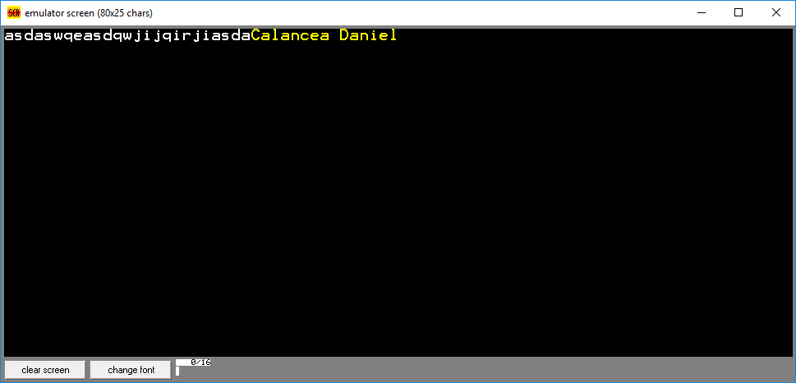

If we place a x string that is not in y we get:

x db 'Calancea Daniel', 0
y db 'asdaswqeasdqwjijqirjiasdasda', 0

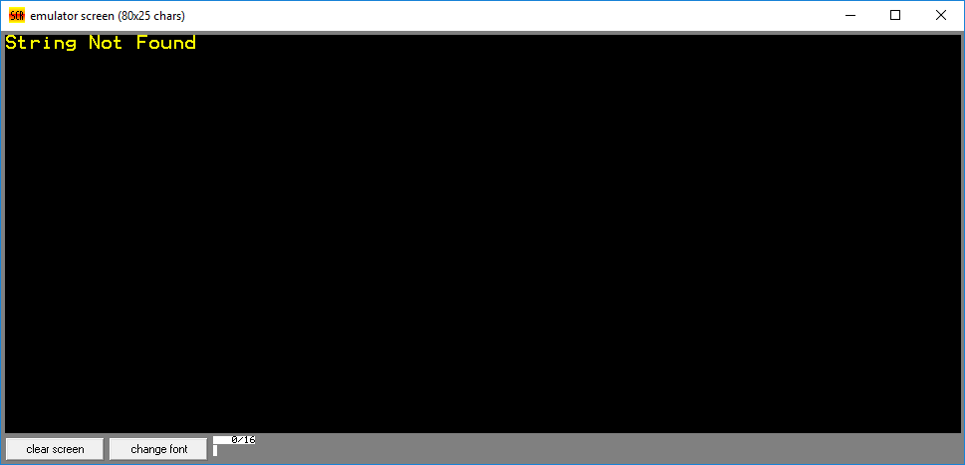

Conclusion:
We learned how to use software interrupts and we have access now to multiple options like outputing data on screen, inputing data, working with files, getting system data. These features are crucial in order to make a advanced application where you need more than just data processing.

