Ministry of Education and Science

Technical University of Moldova
CIM Faculty

R E P O R T

Laboratory work #1
Adressing Modes
V-3

Done by FAF-151 student: Verified by senior lecturer
Calancea Daniel Sudacevschi Viorica

Chişinău 2017

Laboratory work #1
V-3
- Declare memory spaces for 3 variables (DB, DW and DD). Use immediate addressing mode to load these variables in general purpose registers.

- We declare variables x,y,z as follows:
x db 10h
y dw 2345h
z dd 12345678h
- We load them into the memory using command mov
mov ax, @data
mov ds, ax
mov ax, z[2]
mov bx, z
mov cx, y
mov dl, x
mov dh, 0
- We can observe the changes and analyze them.

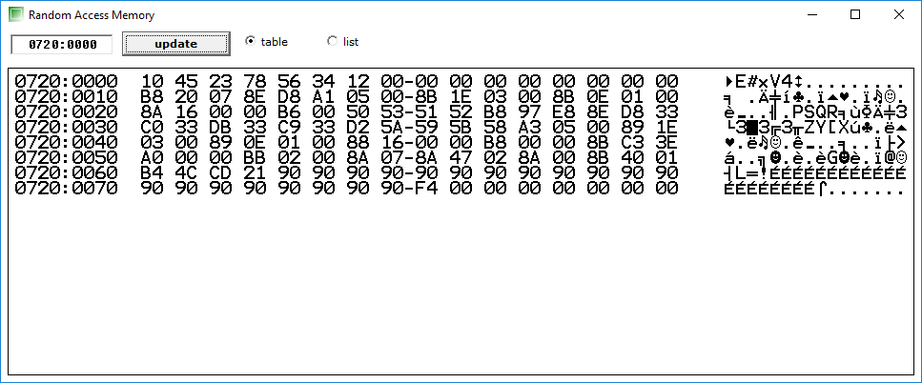
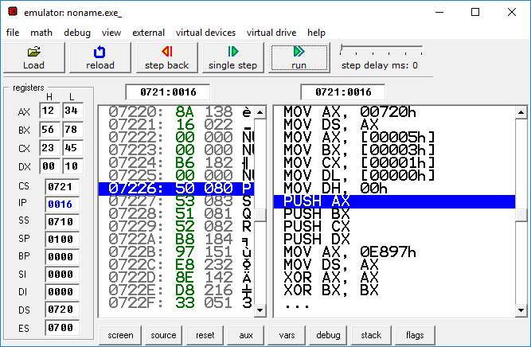
- Store the content of the used registers in stack, reset registers then restore the content of the registers from stack.

- We store them to stack using command push, in our case we declared .stack 100h:
push ax
push bx
push cx
push dx
- We can observe our data in the stack:

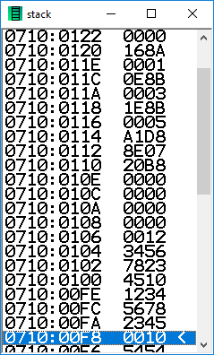

- We reset registers using xor instruction:
xor ax, ax
xor bx, bx
xor cx, cx
xor dx, dx

- We restore the content of registers from stack:
pop dx
pop cx
pop bx
pop ax

- Use as many memory addressing modes as is possible to store the content of the registers in memory and vice-versa. Consider DS=ADDRESS. Reset each time registers with xor instruction.

- We change the data segment value to E987H:
mov ax, 0E897h
mov ds, ax

- We copy the data into new part of the memory:
mov si, 2h
mov z[si], ax
mov z, bx
mov y, cx
mov x, dl

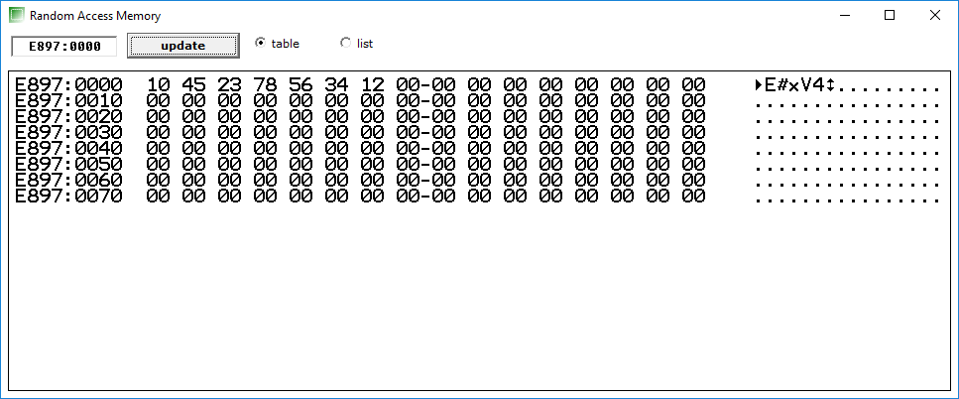

- Some examples of adressing modes:
mov ax, 0 ;immediate adressing mode
mov ax, bx ;register adressing mode
mov al, ds:[0000h] ;direct adressing mode
mov bx, 0002h
mov al, [bx] ;indirect adressing mode
mov al, [bx+2] ;based adressing mode
mov al, [bx+si] ;based indexed adressing mode
mov ax, [bx+si+y] ;based indexed plus displacement adressing mode

Conclsuion:
In this laboratory work we learned how to create our first assembly program. We saw that variables are represented just as offsets so we can change the data segment and use the same offsets. We also learned different addressing modes and their positive and negative sides. We learned how to work with stack.

