**Ministry of Education and Science**

**Technical University of Moldova**

**CIM Faculty**

**R E P O R T**

**Laboratory work #2**

Done by: Verified by:

Calancea Daniel Turcanu Victor

You suddenly hear the awesome news that your grand-grand-uncle's cousin, that left to Nigeria a long time ago, has left you with quite a piece of land in the wonderful Telenești area near Budăi (total area is about 1,2 sq. km). You, a huge fan of linear programming, have built this map in order to see things more clearly.

At some point you have decided to grow some crops on this field. Upon consulting the specialists, you arrive to the following options:

* Each 0.1 sq. km of land (not forest) needs 200 lei/month to be taken care of
* Each 0.1 sq. km of the forest costs 100 lei/month for its care
* Keep in mind that you have limited territory for forests! Measure it! Note: Consider that you pay these two at the end of the year out of the profits.
* At least 0.5 sq km of the forest needs to be kept
* You can invite hunters into the forest. The estimated profit there is around 20K lei/sq.km/year
* The potato seeds cost you 100 lei/sq. km
* From each 0.1 sq km of the field you can collect 1 ton of potatoes
* Potatoes can be farmed twice a year.
* A potato tractor costs 500lei/sq. km (It collects your potatoes)
* A ton of potatoes can be sold on the market with 2K lei
* You can also make wine (of course!). Grape seeds cost you 800 lei/sq. km. For simplicity, let’s consider that it’s a yearly investment. (You kill all the grape plants each year)
* Each 0.1 sq. km of land can give you 2 tons of grapes / year
* The people that collect the grapes need to be paid (there’s no wine yet). They ask for 5000lei/sq. km
* You can make 400 litres of wine with 1 ton of grapes
* The wine is sold at 6 lei/litre

Unfortunately, although your kind uncle gave you the land, he didn’t give you the money, so you put together three months worth of student’s scholarships (a total of 1500 lei) and set out to create the greatest farming empire Budăi has ever seen.

Considering that you’re a fan of linear programming, how do you go about organizing this area? What will you farm and how much of the area will you farm?

Using your result, develop a simulation that will show your income over time. Use per-year estimations to develop your method. How will this method change if you consider that you won’t have to put the grapes in again each year? How will this change considering that you will pay the grape collectors 2 times less, but give them 100 liters of wine instead?

# Simplex method

In order to be able to solve such a problem we had to implement a simplex method solver, but not a simple one since we have constraint with greater and equal.

To make this work we implemented a two-phased simplex algorithm that works in 2 phases:

* Translates the problem to a standard maximization problem with normal constraints using artificial variables. Also checks if the problem has solutions.
* Solves the modified problem to obtain the results.

The idea is that we input our greater than constraint with slack -1 and our algorithm does all the job for us.

**In first phase** we add artificial variables for every row that has slack equal to -1 and changes the maximization equation to MIN(sum of artificial variables). We do this because we need to make our artificial variables equal to 0. After finishing applying standard simplex algorithm we check if all artificial variables are 0.

**In second phase** if all artificial variables are 0 we copy the newly obtained constraints to the original table and calculate the result using standard simplex algorithm.

Let’s take a look at our example:

* Initial input:

|  |  |  |  |  |  |  |
| --- | --- | --- | --- | --- | --- | --- |
| 0 | 1200 | 5800 | 1 | 0 | 0 | 1500 |
| 1 | 1 | 1 | 0 | 1 | 0 | 1.2 |
| 1 | 0 | 0 | 0 | 0 | -1 | 0.5 |
| 8000 | 16000 | 24000 | 0 | 0 | 0 | 0 |

* After first phase we obtain:

|  |  |  |  |  |  |  |
| --- | --- | --- | --- | --- | --- | --- |
| 0 | 1200 | 5800 | 1 | 0 | 0 | 1500 |
| 0 | 1 | 1 | 0 | 1 | 1 | 0.7 |
| 1 | 0 | 0 | 0 | 0 | -1 | 0.5 |
| 8000 | 16000 | 24000 | 0 | 0 | 0 | 0 |

* Our artificial variable was 0 and our second constraint changed. We can solve now this problem using simplex method.

# Case 1 (replanting grapes every year)

We have to form our maximization equation with constraints and they will look like this:

MAX 8000x1 + 16000x2 + 24000x3

0x1 + 1200x2 + 5800x3 <= 1500

x1 + x2 + x3 <= 1.2

x1 >= 0.5

To make a simulation of every year income we just calculate the maximum profit and replace it in our first constraint:

0x1 + 1200x2 + 5800x3 <= Profit

Let’s take a look at the results:

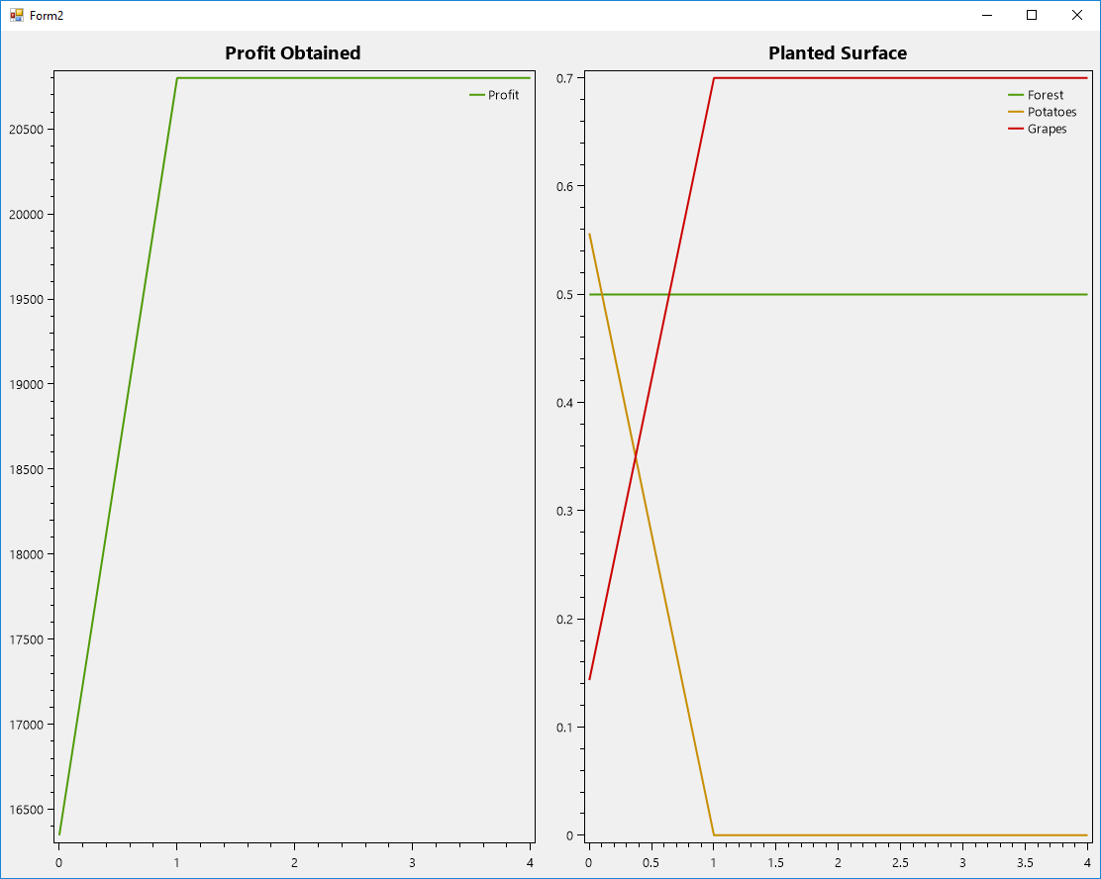

We can observe that we obtain maximum profit possible in 1 year since our forest income is huge and expenses very little, because of this other cases will look similar.

# Case 2 (planting grapes only once)

In this case our initial conditions will be the same:

MAX 8000x1 + 16000x2 + 24000x3

0x1 + 1200x2 + 5800x3 <= 1500

x1 + x2 + x3 <= 1.2

x1 >= 0.5

However, after first iteration we have to make a change in our expenses:

0x1 + 1200x2 + 5800x3 – 800*plantedGrapes*x3 <= Profit

In this way we will pay for planting grapes only once.



# Case 3 (planting grapes once, paying workers with 100l of wine)

In this case we have to change our maximization problem and add as expenses in it these 600 lei and change the amount of money we pay to them.

MAX 8000x1 + 16000x2 + 24000x3 – 600x3

0x1 + 1200x2 + (2500 + 800)x3 <= 1500

x1 + x2 + x3 <= 1.2

x1 >= 0.5

And after our first iteration we have to make changes like in case 2.

0x1 + 1200x2 + 2500 + 800)x3 – 800*plantedGrapes*x3 <= Profit

We obtain the results:

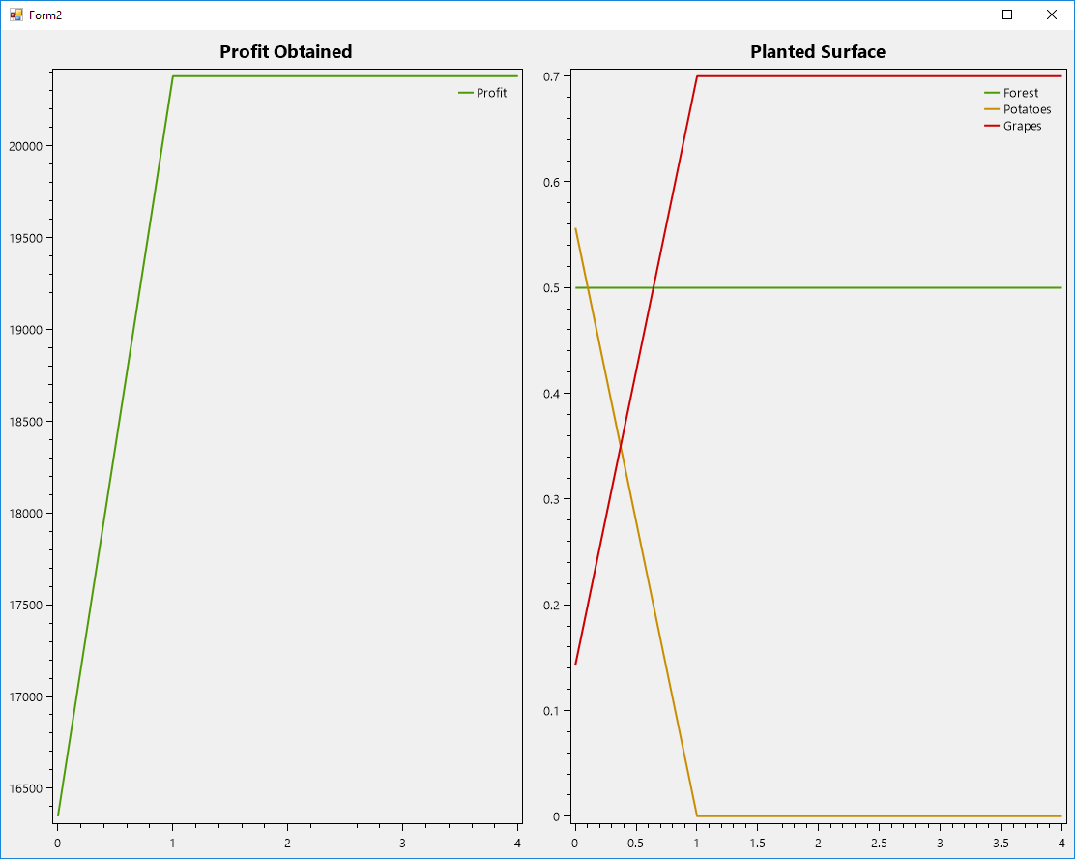

Conclusion:

This laboratory work was harder than I expected at first, probably because I didn’t listen to teacher at courses. I learned how to implement a simplex method and how to get and calculate results. I learned how to make maximization equation and constraints and how to deal with constraints that are not strandard.